Math, Actually

Volume 4 - From Category Theory to the Frontier
A Volume in the Math, Actually Series

Lothar J. Musiol

Copyright © 2026 Lothar J. Musiol
All rights reserved. No part of this publication may be reproduced, distributed, or transmitted in any form or by any means, including photocopying, recording, or other electronic or mechanical methods, without the prior written permission of the author, except in the case of brief quotations embodied in critical reviews and certain other non-commercial uses permitted by copyright law.
First edition, 2026.
The mathematics in this book has been checked with care. No book of this size is entirely free of error, and the author would rather hear about a mistake than have it quietly inherited by the next reader. The useful report names the volume, the chapter, and the section.
Math, Actually series

Table of Contents
Also in This Series 1
About This Volume 1
How to Use This Book 1
How This Book Is Organized 1
Where the Foundations Are 1
This Volume’s Chapters 1
Chapter 38: Category Theory 1
Section 38.1: What Category Theory Is 1
Section 38.2: Categories, Functors, and Natural Transformations 1
Section 38.3: Universal Properties and Representable Functors 1
Section 38.4: Limits and Colimits 1
Section 38.5: Adjoint Functors 1
Section 38.6: The Yoneda Lemma 1
Section 38.7: Monads and Algebras 1
Section 38.8: Looking Ahead: From Categories to Higher Categories, Topoi, and Applied Category Theory 1
Section 38.9: Abelian Categories and Homological Algebra (Optional, Advanced) 1
Chapter 39: Information Theory 1
Section 39.1: What Information Theory Is 1
Section 39.2: Entropy and Its Properties 1
Section 39.3: Typical Sets and the Asymptotic Equipartition Property 1
Section 39.4: Source Coding and Data Compression 1
Section 39.5: Mutual Information and Channel Capacity 1
Section 39.6: The Channel Coding Theorem 1
Section 39.7: Rate-Distortion Theory 1
Section 39.8: Continuous Channels and Gaussian Channels 1
Section 39.9: Looking Ahead: From Classical Information Theory to Networks, Quantum Information, and Learning 1
Chapter 40: Wavelets & Signal Analysis 1
Section 40.1: What Wavelets and Signal Analysis Are 1
Section 40.2: Time-Frequency Analysis and the Uncertainty Principle 1
Section 40.3: The Continuous Wavelet Transform 1
Section 40.4: Multiresolution Analysis 1
Section 40.5: Orthonormal Wavelet Bases 1
Section 40.6: The Discrete Wavelet Transform and Filter Banks 1
Section 40.7: Vanishing Moments, Approximation, and Compression 1
Section 40.8: Applications: Denoising, Images, and Beyond 1
Section 40.9: Looking Ahead: From Classical Wavelets to Frames, Shearlets, and Learned Representations 1
Chapter 41: Game Theory & Decision Mathematics 1
Section 41.1: Decision Theory: Utility and Expected Utility 1
Section 41.2: Games in Normal Form 1
Section 41.3: Dominance, Best Responses, and Nash Equilibrium 1
Section 41.4: Mixed Strategies and Existence of Equilibrium 1
Section 41.5: Extensive-Form Games and Sequential Rationality 1
Section 41.6: Repeated Games and the Folk Theorems 1
Section 41.7: Cooperative Games and Bargaining 1
Section 41.8: Auctions and Mechanism Design 1
Section 41.9: Looking Ahead: From Classical Game Theory to Evolutionary, Algorithmic, and Behavioral Extensions 1
Chapter 42: Statistics & Probability 1
Section 42.1: Probability Spaces and Random Variables 1
Section 42.2: Expectation, Variance, and Conditioning 1
Section 42.3: Independence and Classical Limit Theorems 1
Section 42.4: Parametric Models and Likelihood 1
Section 42.5: Estimation and Confidence Intervals 1
Section 42.6: Hypothesis Testing 1
Section 42.7: Linear Models and Regression 1
Section 42.8: Bayesian Inference 1
Section 42.9: Looking Ahead: From Classical Statistics to Modern Inference and Probability Theory 1
Chapter 43: Probability Theory (Advanced) 1
Section 43.1: Probability Measures and Random Variables Revisited 1
Section 43.2: Independence, Product Spaces, and Kolmogorov’s Extension 1
Section 43.3: Conditional Expectation 1
Section 43.4: Martingales in Discrete Time 1
Section 43.5: Convergence Theorems and the Strong Law 1
Section 43.6: Brownian Motion 1
Section 43.7: Continuous-Time Martingales and Stopping Times 1
Section 43.8: Markov Processes and Generators 1
Section 43.9: Looking Ahead: From Advanced Probability to Stochastic Calculus, SPDEs, and Ergodic Theory 1
Chapter 44: Computational Geometry 1
Section 44.1: What Computational Geometry Is 1
Section 44.2: Convex Hulls 1
Section 44.3: Line-Segment Intersection and Arrangements 1
Section 44.4: Polygon Triangulation and Art Galleries 1
Section 44.5: Voronoi Diagrams and Delaunay Triangulations 1
Section 44.6: Geometric Searching and Range Queries 1
Section 44.7: Arrangements of Lines and Hyperplanes 1
Section 44.8: Robustness, Degeneracies, and Exact Computation 1
Section 44.9: Looking Ahead: From Classical CG to Motion Planning, Meshing, and High-Dimensional Geometry 1
Chapter 45: Control Theory 1
Section 45.1: What Control Theory Is 1
Section 45.2: Linear State-Space Models 1
Section 45.3: Controllability and Observability 1
Section 45.4: Stability: Lyapunov and Input-Output 1
Section 45.5: State Feedback, Pole Placement, and Observers 1
Section 45.6: Optimal Control: LQR and the Maximum Principle 1
Section 45.7: Frequency-Domain Methods 1
Section 45.8: Nonlinear and Robust Control 1
Section 45.9: Looking Ahead: From Classical Control to Hybrid, Networked, and Learning-Based Control 1
Chapter 46: Dynamical Systems & Chaos 1
Section 46.1: What Dynamical Systems Actually Are 1
Section 46.2: Flows, Maps, and Phase Portraits 1
Section 46.3: Linearization and Local Structure 1
Section 46.4: Periodic Orbits and Poincaré Maps 1
Section 46.5: Lyapunov Stability and Invariant Sets 1
Section 46.6: Chaos in One-Dimensional Maps 1
Section 46.7: Strange Attractors and Lyapunov Exponents 1
Section 46.8: Bifurcations 1
Section 46.9: Looking Ahead: From Classical Dynamics to Ergodic Theory, Hyperbolicity, and Applications 1
Chapter 47: Mathematical Physics 1
Section 47.1: What Mathematical Physics Is 1
Section 47.2: Lagrangian and Hamiltonian Mechanics 1
Section 47.3: Symplectic Geometry and Integrable Systems 1
Section 47.4: Continuum Mechanics and Classical Field Theories 1
Section 47.5: Electromagnetism and Maxwell’s Equations 1
Section 47.6: Special Relativity and Minkowski Space 1
Section 47.7: General Relativity and Curved Spacetime 1
Section 47.8: Quantum Mechanics: Operators, Spectra, and States 1
Section 47.9: Looking Ahead: From Classical Mathematical Physics to Quantum Field Theory and Beyond 1
Chapter 48: Optimization (Advanced) 1
Section 48.1: The Landscape of Nonconvex Optimization 1
Section 48.2: Critical Points, Saddles, and Landscape Geometry 1
Section 48.3: Stochastic Gradient Methods 1
Section 48.4: Variance Reduction and Adaptive Methods 1
Section 48.5: High-Dimensional and Structured Nonconvex Problems 1
Section 48.6: Minimax Optimization and GANs 1
Section 48.7: Complexity Lower Bounds and Optimal Rates 1
Section 48.8: Optimization for Statistical Learning 1
Section 48.9: Looking Ahead: From Advanced Optimization to Deep Learning, Distributed Methods, and Open Problems 1
Chapter 49: Numerical Methods (Advanced) 1
Section 49.1: What Advanced Numerical Methods Actually Are 1
Section 49.2: Iterative Methods for Linear Systems 1
Section 49.3: Preconditioning and Multigrid 1
Section 49.4: Sparse Eigenvalue Problems and SVD 1
Section 49.5: Spectral and High-Order Methods 1
Section 49.6: Adaptive Finite Elements and Multilevel Methods 1
Section 49.7: Uncertainty Quantification 1
Section 49.8: Structure-Preserving and Geometric Integration 1
Section 49.9: Looking Ahead: From Advanced Numerics to Exascale, Machine Learning, and Verified Computation 1
Chapter 50: Where Mathematics Meets the World 1
Section 50.1: What Mathematical Modeling Is 1
Section 50.2: The Modeling Process: From Phenomenon to Equation 1
Section 50.3: Scaling, Dimensional Analysis, and Dimensionless Models 1
Section 50.4: Discrete and Continuous Models 1
Section 50.5: Stochastic Models and Uncertainty 1
Section 50.6: Case Studies: Mechanics, Biology, and Epidemiology 1
Section 50.7: Data-Driven and Hybrid Modeling 1
Section 50.8: Validation, Falsification, and Model Selection 1
Section 50.9: The Capstone Case Study, in Ten Steps 1
Section 50.10: Looking Back and Looking Ahead: The Series and What Lies Beyond 1
Epilogue — Looking Back over the Whole 1
Answer Key 1
Solutions to the Problems 1
Answers to the Practice Sets 1
Symbol & Notation Glossary 1
Appendix — Further Reading 1
Subject Index 1
Also by Lothar J. Musiol 1
A Note Before You Go 1

Also in This Series
Volume 1 — From Arithmetic to Calculus
Counting and number theory, algebra, functions and graphs, coordinates, Euclidean geometry, trigonometry, logarithms, systems of equations, vectors, limits, the derivative, and the integral. Chapters 1–12; it reads on its own through single-variable calculus.
Volume 2 — From Multivariable Calculus to Set Theory & Logic
Multivariable functions and calculus, vector calculus, series, Fourier and Laplace transforms, integral geometry, matrices, linear algebra, analytic geometry, complex analysis, counting, and set theory and logic. Chapters 13–25.
Volume 3 — From Differential Equations to Abstract Algebra
Differential and integro-differential equations, partial differential equations, optimization and the calculus of variations, numerical methods, differential geometry, topology, advanced integral geometry, tensors and manifolds, functional analysis, measure theory, and abstract algebra. Chapters 26–37.
Also by Lothar J. Musiol: Physics, Actually, the companion series on the physical world, and Quanta, Actually, on the quantum world. Every title is listed on the Also by Lothar J. Musiol page at the back of this volume.

About This Volume
This is Volume 4 of Math, Actually, one continuous fifty-chapter book about mathematics published in four volumes. Volume 1 (Chapters 1–12) begins at arithmetic and holds the full preface; Volume 2 (Chapters 13–25) extends calculus to many variables and lays the foundations in set theory and logic; Volume 3 (Chapters 26–37) covers differential equations, geometry, analysis, and abstract structure. If this is your first volume, the short notes that follow explain how the book is organized and where its foundations are; references to earlier volumes are given as a topic name with its volume, for example “Limits (Volume 1)”.
This volume covers Chapters 38 through 50: category theory; information theory; wavelets and signal analysis; game theory and decision mathematics; statistics and probability, in their standard and advanced forms; computational geometry; control theory; dynamical systems and chaos; mathematical physics; advanced optimization; advanced numerical methods; and mathematical modeling. Thirteen chapters, from the most abstract structures in the whole series to the discipline that points all of it back at the physical world.
Volume 3 ended with abstract algebra. This volume opens with category theory, the language that describes what all of those structures have in common, and it closes where the series has been heading from the first page: mathematics put to work on the world.

How to Use This Book

What this book is, and what it is not
A word on what the series is trying to do, so that it can be judged for that rather than for something it never attempted. This is a map of mathematics, not a replacement for the mathematics it maps. Fifty chapters cannot do the work of fifty textbooks, and this book does not pretend otherwise.
What it offers instead is a single continuous walk through the entire book, so that afterwards no section in it is entirely unfamiliar. That is a different achievement from expertise, and a more useful one than it sounds. Mathematics punishes the reader who meets an idea cold and rewards the one who has met it before, however briefly. A reader who half-remembers what a tensor is will read a physics paper very differently from one who has never seen the word.

How each section is built
Every chapter and section uses the same parts, so you always know where you are and what to do next. Exercises are the backbone: you meet one every few pages, graded from easy to challenging, and every one has a full worked answer.
Before you begin. At the start of each chapter: what you will be able to do, which earlier sections you need (each is a link), and a realistic study time.
Worked examples. Blue boxes. Cover the solution and attempt the example first.
Try it now. A short check inside the section, marked by a gold bar. Do it before you read on; the answer is one click away.
Keep only this. A gold box at the end of each section: the one idea, the core formulas, the most common mistake, a minimal example, and three practice questions graded Easy, Medium and Challenge. Every practice question is answered in full, with its common mistake named, in Answers to the Practice Sets.
Before this section. A navy box at the start of the harder sections: what you need, with links, and why the section matters.
Connection boxes. Teal boxes titled You have seen this before, Same structure, new language, Why this abstraction exists, and Where this returns. They tie the section to earlier and later chapters, in this volume and in the others.
Running examples. Plum boxes that follow one example through several chapters: one pendulum through Chapters 45, 46, 47 and 49, and one fishery model through the ten-step case study in Chapter 50.
Chapter recap. A navy box just before Check Your Understanding: the chapter on one screen.
Check Your Understanding and Problems. At the end of each chapter. Every item carries one of six tags: [Concept] and [Explain] ask what an idea means or why it holds; [Compute] asks for a calculation; [Model] applies one to a real situation with units; [Prove] asks for a complete argument; [Challenge] goes beyond the section. Every answer and every solution is worked in full.

The worked examples are the exercises
There are 1,585 worked examples in the series, 359 of them in this volume, and they are the most valuable thing in it — but only if you use them properly.
When you reach one, stop. Cover everything below the first line, take a pencil, and attempt it yourself before reading on. A worked example read passively teaches almost nothing. The same example, attempted first and then checked against the book, teaches a great deal, because the value lies wholly in comparing your reasoning against the book’s and noticing where the two diverged.
This is not a moral instruction. It is the closest thing to a free lunch that the study of mathematics offers, and it costs about two minutes per example. Read that way, the series contains 1,585 such exercises, 359 of them in this volume, the worked solution attached — which is rather more practice than most textbooks provide, and all of it already checked. The problems at the end of each chapter are worked in Solutions to the Problems.

The questions at the end of each chapter
Every chapter closes with a short set of Check Your Understanding questions, and full answers are collected in the Answer Key at the back of the volume.
Those questions are deliberately conceptual rather than mechanical. They tend to ask why something is true, or why a plausible-looking claim is false — why mixing does not rescue a coordination game, why a supercritical population can still die out, why floating-point arithmetic can destroy a geometric predicate. Answers to questions of that kind survive; answers to “differentiate the following” tend not to.

When a chapter genuinely interests you, read beyond the book
The Further Reading appendix names one or two real textbooks for each region of the series — chosen because they are the ones people actually finish rather than the ones that look most impressive unopened.
Working through one of them properly, slowly, with a pencil and a certain amount of suffering, is the only method anyone has ever found that reliably turns acquaintance into competence. No survey substitutes for it, and this one does not try to. The series’ job is to help you decide which book to pick up, and to make sure that when you open it, the vocabulary is already familiar.

How This Book Is Organized
The fifty chapters of Math, Actually run continuously across the four volumes, so Chapter 13 opens Volume 2 and Chapter 50 closes Volume 4. Each chapter is one broad territory of mathematics. Each section within a chapter is one idea, numbered by its chapter: Section 6.3 is the third section of Chapter 6. Each chapter ends with Check Your Understanding questions and a set of Problems; their answers are at the back of the volume.
Whenever a section uses an idea from somewhere else, it names that section by its topic. Inside this volume the name is a link: follow it and you land on the section, and the Back button of your reader brings you home again. An idea from another volume cannot be linked across files, so it is named with its volume instead — “Limits (Volume 1)” — and the Subject Index of that volume will find it.
Every section is built in the same order. It opens in plain language: what the idea is, why it matters, and what it feels like, usually with numbers you can check by hand. The definitions and formulas come next, once you have seen why they are needed. The worked examples follow and put the formulas to use.
One more convention, purely visual. Worked examples appear in shaded boxes rather than running paragraphs, so that your eye can find them again on a later skim. A blue box marks an example that works through actual numbers, or through the general case when numbers would not illuminate anything — either way, one clean argument from start to finish. A purple box marks the rarer case where you get both: the concrete instance and the general pattern beside it, on the theory that seeing the same idea twice, once with numbers and once without, is worth the extra half-page far more often than authors like to admit.

Where the Foundations Are
One structural confession, best made early. The book begins with counting, because that is where a human being begins. But the logical foundations of mathematics — the axioms of set theory, the rules of inference, the machinery that says what a proof is — are not in Chapter 1. They are in Chapter 25, at the end of Volume 2, which is an odd place to put a foundation.
This is deliberate, and it is not a compromise. Mathematics was not discovered in logical order. Counting is some tens of thousands of years old; the axioms that justify it were written down in the 1920s. Children learn arithmetic long before they learn what a set is, and the ones who go on to learn what a set is do not thereby discover that their arithmetic was wrong. The foundations were laid underneath a subject that was already well established and doing perfectly well.
So you do not need Chapter 25 to read the chapters before it. You will want to read it eventually, for the same reason anyone eventually looks at foundations: not because anything is falling down, but because you have started to wonder what is holding it all up. Readers who prefer their logic first are welcome to read Chapter 25 early. It assumes very little and says so.

This Volume’s Chapters
Every chapter in this volume, one line each, with what it assumes you already know. Follow a title to jump straight there.
Volume 4 — From Category Theory to the Frontier
Chapter 38 — Category Theory
Chapter 37 (Volume 3) is essential groundwork: this chapter opens by explicitly building on groups, rings, and homomorphisms from it, and later recovers Cayley’s theorem from group theory as a special case of the Yoneda embedding. A solid working command of basic linear algebra (vector spaces, dual spaces, matrices) and elementary set theory is assumed throughout as well, since examples lean on Vect, dual spaces, matrix composition, and Russell’s-paradox-style set/class distinctions without re-deriving them.
Chapter 39 — Information Theory
Chapter 7 (Volume 1) is essential throughout, since every entropy, capacity, and rate-distortion formula here is built from logarithms and the base-conversion identity between them; Chapter 12 (Volume 1) is needed for the differential-entropy integrals in Continuous Channels and Gaussian Channels. Beyond that, this chapter builds its own probability toolkit (distributions, expectation, i.i.d. sequences, convexity) from scratch rather than leaning on an earlier probability chapter, though readers who have already met convex functions and Jensen’s inequality will find the entropy-maximization arguments in Entropy and Its Properties immediately familiar.
Chapter 40 — Wavelets & Signal Analysis
You should be comfortable with Chapter 39, since this chapter opens by picking up directly where it left off (“In the previous chapter, we spent our time weighing uncertainty in bits”) and contrasts Shannon’s bit-counting with the time-blind Fourier transform. You’ll also want the Fourier transform and the basic machinery of square-integrable (L²) function spaces already at your fingertips — both are used constantly and without re-explanation throughout, from the admissibility condition in The Continuous Wavelet Transform to the orthonormal-basis arguments of Orthonormal Wavelet Bases.
Chapter 41 — Game Theory & Decision Mathematics
Chapter 30 (Volume 3) (Optimization) is the direct prerequisite: its single-agent “choose the best action” framework is explicitly recast here as the one-player warm-up in Decision Theory before a second decision-maker enters the game, and the differentiation techniques of Chapter 11 (Volume 1) (Differential) are used throughout the worked examples (maximizing the Nash bargaining product, minimizing Pigou’s total travel cost) to find those optima. The chapter also leans freely on elementary probability and expectation from its very first equation, well before their formal axiomatic treatment arrives in Chapter 42 (Statistics & Probability), so some prior comfort with basic probability will help even though the chapter itself never stops to justify it.
Chapter 42 — Statistics & Probability
Chapter 36 (Volume 3) (Measure Theory) is assumed almost immediately — bring the σ-algebra, the null sets, the integral, and the Radon–Nikodym derivative, which Chapter 36 (Volume 3) said would return here. Probability spaces are introduced explicitly as measure spaces with total mass one, and expectation is defined as Lebesgue integration, without re-deriving either. You should also be comfortable with differentiation and integration from Chapter 11 (Volume 1) and Chapter 12 (Volume 1) (needed for maximizing likelihoods and computing densities) and with vectors from Chapter 9 (Volume 1) and with matrices and projections from Chapter 21 (Volume 2) (needed for the least-squares regression section).
Chapter 43 — Probability Theory (Advanced)
Read Chapter 42 first — this chapter explicitly rebuilds and supersedes its “provisional” treatment of distributions, densities, and the central limit theorem. You should also be comfortable with Chapter 36 (Volume 3) (measure theory), on which the whole construction is built from the first section onward, and it will help to have met Chapter 35 (Volume 3) (functional analysis) for the Hilbert-space/L² projection picture of conditional expectation and Chapter 21 (Volume 2) (linear algebra) for the eigenvector diagonalization used with Markov generators.
Chapter 44 — Computational Geometry
This chapter leans directly in Chapter 43: its opening explicitly builds the expected-running-time proofs behind randomized incremental algorithms (used for convex hulls, Voronoi diagrams, and point-location structures) on the conditional-expectation and martingale-convergence machinery assembled there. Beyond that explicit dependency, a reader should already be at ease with elementary linear algebra (coordinates, determinants) and asymptotic/big-O reasoning, since every algorithm here is judged by a running-time bound rather than by a diagram.
Chapter 45 — Control Theory
This chapter leans directly on three earlier chapters, evoked in its opening pages only as scaffolding assembled “many chapters ago” without chapter numbers attached: Chapter 26 (Volume 3) (differential equations) for the dynamics that every plant obeys, Chapter 21 (Volume 2) (linear algebra) for the matrix bookkeeping — eigenvalues, rank, the matrix exponential — that runs through the state-space sections, and Chapter 23 (Volume 2) (complex analysis) for the pole-and-frequency-domain reasoning in the Bode/Nyquist section. A reader coming from Chapter 44 (Computational Geometry) needs none of that chapter’s content specifically, only ordinary comfort with the three subjects above.
Chapter 46 — Dynamical Systems & Chaos
Come to this chapter straight from Chapter 45 (Control Theory), whose central question — what happens once you take the engineer’s hand off the feedback dial — is just this chapter’s starting premise, and with Chapter 26 (Volume 3) (Differential and Integro-Differential Equations), Chapter 21 (Volume 2) (Linear Algebra), and Chapter 32 (Volume 3) (Topology) already solid, since flows, eigenvalue-based linearization, and homeomorphisms/conjugacy are all used here without re-explanation.
Chapter 47 — Mathematical Physics
This chapter opens as a direct continuation of Chapter 46 (Dynamical Systems & Chaos), and its own What Mathematical Physics Is names its other debts explicitly: come comfortable with Chapter 23 (Volume 2) (Complex Analysis), Chapter 31 (Volume 3) (Differential Geometry), Chapter 35 (Volume 3) (Functional Analysis), and Chapter 37 (Volume 3) (Abstract Algebra), since Hilbert spaces, self-adjoint operators, differential forms, and Lie-group symmetry are all used here as built there, with no re-derivation. Also worth having under your belt: Chapter 21 (Volume 2) (Linear Algebra) and Chapter 34 (Volume 3) (Tensors & Manifolds) for the eigenvalue and curvature-tensor arguments, and Chapter 28 (Volume 3) (Optimization & Calculus of Variations) for the stationary-action derivation that opens Lagrangian and Hamiltonian Mechanics.
Chapter 48 — Optimization (Advanced)
Read Chapter 28 (Volume 3) and Chapter 30 (Volume 3) first — this chapter states outright that “the convergence proofs of Chapter 30 (Volume 3) remain the load-bearing walls,” building directly on their convex optimization theory, gradient descent, and Newton’s method (Chapter 30 (Volume 3)’s Nesterov acceleration is invoked by name in Complexity Lower Bounds and Optimal Rates). Comfort with basic linear algebra (eigenvalues, the Hessian matrix) and probability (expectation, variance) is also assumed throughout, since strict-saddle analysis (from Critical Points, Saddles, and Landscape Geometry onward) and stochastic gradient methods (from Stochastic Gradient Methods onward) lean on both.
Chapter 49 — Numerical Methods (Advanced)
Chapter 29 (Volume 3), where root-finding, interpolation, quadrature, and the discretization of differential equations were first introduced, is essential preparation — this chapter explicitly resumes that program once the same problems grow too large, sparse, or uncertain for the elementary approach to handle. A working comfort with linear algebra (matrices, eigenvalues, vector spaces) and basic probability is also assumed throughout, since Krylov subspaces, spectral decompositions, and uncertainty quantification all lean on them from the very first section.
Chapter 50 — Where Mathematics Meets the World
This capstone chapter assumes the whole journey behind it: it draws directly in Chapter 49’s numerical methods (the chapter it says was “lately passed through,” dealing with approximating what can’t be solved by hand) whenever a model must be simulated rather than solved in closed form, and it quietly redeploys differential equations, linear algebra (eigenvalues, in particular), and probability built up since Chapter 1 (Volume 1), where the journey began with three apples and two apples. No new mathematics is introduced here — only the application of everything that came before, so comfort with the series’ calculus, linear-algebra, and probability chapters is the real prerequisite.

Math, Actually

Chapter 38

Category Theory
Objects, Arrows, and the Art of Structure-Preserving Maps
The last chapter left us surrounded by groups, rings, and fields, having learned the useful trick of stripping a mathematical object down to its axioms and discarding everything else. A group, we discovered, is not really a set of rotations of a triangle or a set of integers under addition; it is a set equipped with three unglamorous rules, and once you have the rules you can forget where you found them. That was, in its way, an exercise in tidying: fold up the specifics, keep the skeleton, label the box neatly and put it on the shelf. This chapter performs the same maneuver one chapter later, and with considerably less mercy. We are going to strip away the axioms too, and keep only the arrows.
Category theory is what happens when a mathematician notices that groups, topological spaces, vector spaces, partially ordered sets, and a hundred other structures all obey the same four-part etiquette — a stock of objects, a stock of maps between them that preserve whatever there is to preserve, a way of composing those maps, and a do-nothing map at every object — and decides to study the etiquette itself, rather than any of the guests attending the party.
The result is routinely accused of being abstract nonsense, an accusation its practitioners have long since stopped bothering to deny, because it is both true and beside the point: the nonsense turns out to have teeth. Once you can say what a product, a free object, or a limit is without reference to any particular category, you can recognize the same construction wearing different disguises in algebra, topology, logic, and — as we shall not resist mentioning near the end — a fair slice of theoretical computer science.
This chapter climbs from the bare definition of a category up to the Yoneda lemma, which has a strong claim to being the single most useful fact in the subject, and on past monads and abelian categories to a final section that gestures, with appropriate vertigo, at higher categories and topoi. Throughout, we keep our feet on recognizable ground: Set, Grp, Vect, and the humble poset make repeat appearances, not because category theory needs them, but because you do, and because every abstract claim in this chapter is cashed out below in an example with actual numbers or an actual small structure you can hold in your hand and turn over.
One warning before we begin, delivered in the spirit of full disclosure rather than reassurance: mathematicians who spend long enough doing this eventually stop asking what an object is and start asking only how it behaves toward its neighbors, which is either a profound philosophical advance or a mild personality disorder, depending on how the department meeting goes. One chapter from now, in Information Theory, the arrows will start carrying bits instead of abstract nonsense, and structure-preserving maps will turn into channels that try not to lose your message on the way through. For now, though, let us follow the arrows.
Before you begin — Chapter 38
By the end of this chapter you will be able to:
1. Say what a category, a functor and a natural transformation are, and check each axiom on a small example by hand.
2. Recognize the same construction — product, coproduct, free object — in sets, groups, vector spaces and topological spaces.
3. Describe an object by a universal property and explain why that pins it down up to a unique isomorphism.
4. Compute small limits and colimits (pullbacks, pushouts, equalizers) in Set by listing elements.
5. State an adjunction as a natural bijection of hom-sets and find the unit of the free–forgetful pair.
6. Explain the Yoneda lemma as “an object is known by the maps into it” and count natural transformations in a small example.
Prerequisites. Groups and homomorphisms from Abstract Algebra (Volume 3); vector spaces and linear maps from Linear Algebra (Volume 2); continuous maps from Topology (Volume 3); sets and functions from Set Theory & Logic (Volume 2).
Estimated study time. About 14 hours, exercises included. This chapter is paced slowly on purpose: work every Try it now and every Keep only this practice before moving on, because each section reuses the last.

Section 38.1: What Category Theory Is
In which we study almost nothing, extremely precisely
You have been checking whether two collections match since you were small, and the method has never let you down: pair them off. Five sweets in this hand, five in that one — line them up, none left over, same number. Mathematics does the same thing with larger objects. Two vector spaces of the same dimension can be matched up vector for vector, so we call them isomorphic and move on.
Now watch that method fail, on an object that needs a sentence of introduction first. Take V = ℝ², the ordinary plane of arrows from the origin. Alongside it sits a second space, written V*, whose members are not arrows at all but measuring devices: each one a rule that swallows an arrow and returns a single number, and does so linearly. The rule reporting an arrow’s first coordinate is one such device. So is the rule reporting its second, and so is any combination of those two.
V* is two-dimensional as well — two numbers pin down any such measuring rule — so the old method applies. Pair them off. Using the standard directions e₁ = (1, 0) and e₂ = (0, 1), let the arrow (3, 5) correspond to the device 3e₁* + 5e₂*, where e₁* reports the first coordinate and e₂* the second. It works.
Now run the whole construction again with different directions, f₁ = (1, 0) and f₂ = (1, 1). Measured against those, the same arrow (3, 5) has coordinates −2 and 5, since −2f₁ + 5f₂ = (3, 5). So this time the recipe hands it the device −2f₁* + 5f₂*. Are the two devices the same? Feed each of them the arrow (1, 0) and look:
3e₁* + 5e₂* applied to (1, 0) gives 3
−2f₁* + 5f₂* applied to (1, 0) gives −2
Three, against minus two. Same arrow, same construction, two different answers, and nothing inside either space to prefer one set of directions over the other. The match exists and it is arbitrary — an uncomfortable thing to say about an equality. Categories, Functors, and Natural Transformations is where the difference between a match like this and an honest one is made precise.
So the question changes. Not ‘can these two be matched up?’, but ‘can they be matched up without anyone making a choice?’
That looks unanswerable, and it is worth feeling why before we get out of it. The choice happened at the moment you reached inside V and picked a basis. To avoid it you would have to compare V with V* without mentioning what is in them. But everything you know about a vector space is phrased in terms of its vectors — that is what a vector space is for. Take away the right to mention them and there appears to be nothing left to say.
The way round it looks like a cheat and turns out not to be one. Say nothing whatever about the inside of an object. Describe it only by the arrows running into it and out of it — the maps to and from everything else — and see how much survives.
Numbers first, before any of that hardens into notation. Take the three numbers 1, 2 and 4, and draw an arrow a → b whenever a divides b. Primary-school arithmetic settles every case:
1 → 1 1 → 2 1 → 4
2 → 2 2 → 4
4 → 4
Six arrows, three of them the do-nothing arrow from a number to itself. Composition arrives without being asked for: 1 → 2 followed by 2 → 4 can only be 1 → 4, because 1 divides 2 and 2 divides 4 forces 1 to divide 4. Follow three arrows in a row and it never matters which pair you combine first.
Now notice what that picture never does: it never uses the fact that 1, 2 and 4 are numbers. Nothing in it would change if they were three boxes, ordered by which fits inside which. The arrows carry the whole content and the objects have become labels — which is the trade the previous paragraph proposed, made concrete on six arrows you can check by hand.
That is a category, and nothing more alarming is going on: objects, arrows between them, a way of composing two arrows that meet, and a do-nothing arrow at every object. The formal version follows, and the rest of this chapter is an argument that the trade pays.
Category theory is the mathematical study of structures and of the maps that preserve them. That sentence sounds almost too modest to be a whole field, so it is worth being blunt about what it means in practice.
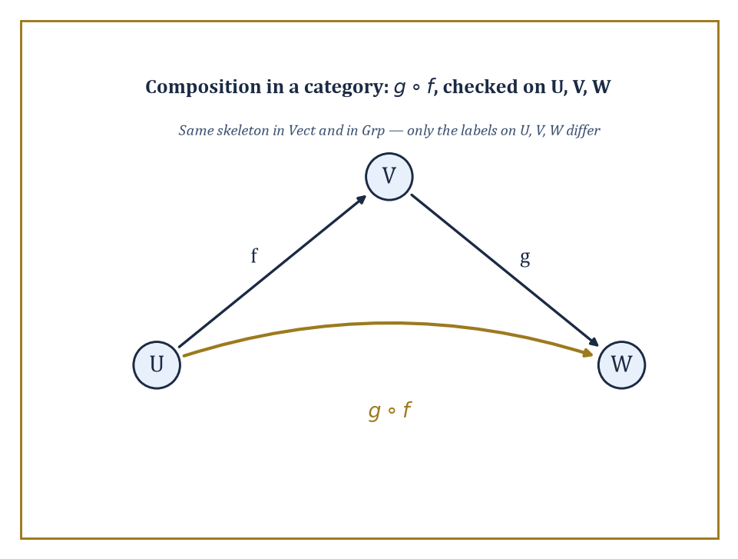
Figure 38.1 — Strip the labels off U, V, W and the diagrams for Vect and Grp become identical — objects, arrows, composition, nothing more.
Abstract algebra, as the last chapter demonstrated at some length, studies groups, rings, and fields, together with the homomorphisms between them that respect multiplication or addition. Topology studies spaces and the continuous maps between them. Linear algebra studies vector spaces and the linear maps between them. Each of these subjects, on its own, has a favorite kind of object and a favorite kind of map.
Category theory notices that in every case the same four ingredients are present — objects, maps (called morphisms or arrows), a rule for composing two compatible arrows into one, and a do-nothing arrow sitting at every object — and that these four ingredients obey the same two laws in every case: composition is associative, and the do-nothing arrows really do nothing. A category is that data, and nothing more.
Abstract example — Same skeleton, different flesh. Consider the category Vect of real vector spaces and linear maps, and the category Grp of groups and homomorphisms. On the face of it these have nothing in common: one is about scaling and adding vectors, the other about combining group elements. But look only at the skeleton.
In Vect, take three objects U, V, W (vector spaces), a linear map f: U → V, and a linear map g: V → W; composing gives a linear map g∘f: U → W, and every space V carries an identity map that does nothing:
id_V(v) = v
In Grp, take three groups A, B, C, a homomorphism f: A → B, and a homomorphism g: B → C; composing gives a homomorphism g∘f: A → C, and every group B carries an identity homomorphism that likewise does nothing:
id_B(b) = b
Strip the labels vector space and group off the objects, and homomorphism and linear map off the arrows, and the two pictures are identical: objects, arrows, composition, identity. That identical picture, and nothing about vectors or group elements specifically, is what a category theorist actually studies.
Try it now — In Set, how many isomorphisms are there from {1, 2, 3} to {a, b, c}? In Vect, is the map ℝ² → ℝ², (x, y) ↦ (y, x) an isomorphism? Answer →
The subject did not spring from a desire to be difficult; it grew out of a very concrete headache in algebraic topology in the 1940s, when Samuel Eilenberg and Saunders Mac Lane needed a rigorous way to say that a certain isomorphism was natural, meaning it did not depend on any arbitrary choices, as opposed to one that merely happened to exist.
The distinction sounds pedantic until you meet a genuine example of it, at which point it becomes indispensable, because plenty of isomorphisms in mathematics exist but are, so to speak, dishonest: they only work once you have made a choice you cannot justify, and a different choice gives a different isomorphism.
Abstract example — An honest isomorphism versus a dishonest one. Let V be a finite-dimensional real vector space, say V = ℝ², and let V* be its dual space, the space of linear maps V → ℝ. It is a true fact that V is isomorphic to V*: both have dimension 2.
But to write down an actual isomorphism V ≅ V* you must first choose a basis of V, use it to build a dual basis of V*, and match vectors to the corresponding dual basis vectors — choose a different basis and you get a different isomorphism, with no way to prefer one over the other.
Contrast this with the double dual V**, the space of linear maps V* → ℝ. There is a map η_V: V → V** that needs no choices at all: send a vector v to the map evᵥ that evaluates each linear functional at v, that is:
evᵥ(f) = f(v)
Take v = (3, 5) in V = ℝ², with dual basis e₁*, e₂* dual to the standard basis e₁, e₂. Then:
evᵥ(e₁*) = e₁*(3,5) = 3
evᵥ(e₂*) = e₂*(3,5) = 5
— the same two numbers we started with, recovered without ever picking a basis to do it. This η_V is an isomorphism for finite-dimensional V, and it is natural: it is built the same way for every vector space, with no arbitrary decisions along the way. Making that difference — honest construction versus lucky coincidence — precise for arbitrary categories is exactly what natural transformations, met properly in the next section, were invented to do.
One should mention, in the interest of full disclosure, that letting objects be things like all sets invites a very old headache. The category Set has every set as an object, but the collection of all sets is too big to be a set itself — trying to assemble it runs straight into Russell’s paradox, the same one that sank naive set theory earlier in the series.
Category theorists cope with this by drawing a line between small categories, whose objects and morphisms form sets, and large categories such as Set, Grp, and Top, whose objects only form a class, a well-behaved kind of too-big-to-be-a-set collection that set theorists have agreed to tolerate. Nothing in this chapter collapses because of it, but it is worth knowing the fine print is filed away somewhere, rather like tenure in that respect: a great deal of quiet paperwork happened once so that nobody currently working the arrows has to think about the foundations giving way underneath them. Mostly.
Abstract example — Small enough to hold, too big to hold at all. The poset {1, 2, 4} under divisibility, met properly two sections from now, is a small category: three objects, a handful of morphisms, the whole thing small enough to draw on a napkin and small enough that its objects form a set, namely {1,2,4}.
Set itself is not like this. Among the objects of Set are ℕ, ℝ, the power set of ℝ, the power set of that power set, and so on with no end in sight, growing through an unbounded hierarchy of ever-larger infinities; there is, provably, no set large enough to contain them all as elements, on pain of reconstructing Russell’s paradox inside it.
So the objects of Set form a class rather than a set — a distinction invisible while working with any one small piece of Set, such as the napkin-sized example above, and unavoidable the moment you try to gather up the entire category and ask what kind of thing it is.
Because of this history, category theory is both a technical toolkit and a change of habit of mind. The technical toolkit is what fills the rest of this chapter: definitions, universal properties, limits, adjoints, the Yoneda lemma.
The change of habit is simpler to state and harder to unlearn once acquired: stop asking what an object is, inside itself, and start asking how it relates to every other object via arrows. A group is not its elements; it is everything you can say about it using homomorphisms in and out.
This is either the most liberating idea in twentieth-century mathematics or a sign that the author has spent altogether too long around category theorists — the reader may form their own opinion over the course of the chapter, and is warmly invited to change it more than once.
Four running examples for this chapter
Every new idea in this chapter is shown in at least two of these four categories. Keep them in view; when a definition feels thin, test it on one of them.
Set — objects: sets; arrows: functions; isomorphisms: bijections.
Grp — objects: groups; arrows: homomorphisms; isomorphisms: group isomorphisms. Built in Abstract Algebra (Volume 3).
Vect — objects: real vector spaces; arrows: linear maps; isomorphisms: invertible linear maps. Built in Linear Algebra (Volume 2).
Top — objects: topological spaces; arrows: continuous maps; isomorphisms: homeomorphisms. Built in Topology (Volume 3).
Why this abstraction exists
In Abstract Algebra (Volume 3) the first isomorphism theorem was proved for groups, then again for rings, then again for modules, and each proof had the same shape: a map, its kernel, its image, and an induced isomorphism. Three proofs of one idea is a sign that the idea lives one level up. Category theory is that level. It states the pattern once, in terms of arrows, and each subject inherits it.
Keep only this · Section 38.1: What Category Theory Is
The idea. Category theory studies mathematical objects through the structure-respecting maps between them, so that the same pattern can be recognized in sets, groups, vector spaces and spaces at once.
Core.
objects + arrows f: A → B + composition + identities
isomorphism: f: A → B with g: B → A, g∘f = id_A, f∘g = id_B
Typical mistake. Thinking that two isomorphic objects are “equal” and that the choice of isomorphism does not matter. V ≅ V* holds, but only after choosing a basis; V ≅ V** needs no choice.
Minimal example. In Set the isomorphisms are the bijections; in Grp they are the bijective homomorphisms; in Top they are homeomorphisms, and a continuous bijection need not be one.
Practice. Easy to challenge; full worked answers, with the usual mistake, are in Answers to the Practice Sets at the back.
Easy — Name the isomorphisms in Set, Grp, Vect and Top. Answer →
Medium — Let V = ℝ². A basis e₁, e₂ gives an isomorphism V → V* sending e₁ to e₁* and e₂ to e₂*. Using the basis e₁, 2e₂ instead, where does 2e₂ go, and where does e₂ go? Is it the same map? Answer →
Challenge — Show that the category with one object and with arrows the elements of a group G (composition = group multiplication) is a groupoid: every arrow is an isomorphism. Answer →

Section 38.2: Categories, Functors, and Natural Transformations
The three nouns that run the entire subject
Before this section
What you need. Composition of functions; group homomorphisms from Abstract Algebra (Volume 3); linear maps and matrices from Linear Algebra (Volume 2).
Why it matters. Every later idea in this chapter — universal properties, limits, adjoints, Yoneda — is stated with the three nouns defined here. Read the definitions slowly and check each axiom on the first example by hand.
Formally, a category C consists of: a collection of objects; for every pair of objects A, B, a set Hom(A, B) of morphisms (or arrows) from A to B, written f: A → B; a composition operation that takes f: A → B and g: B → C and produces g∘f: A → C; and for every object A an identity morphism id_A: A → A. Two laws are demanded.
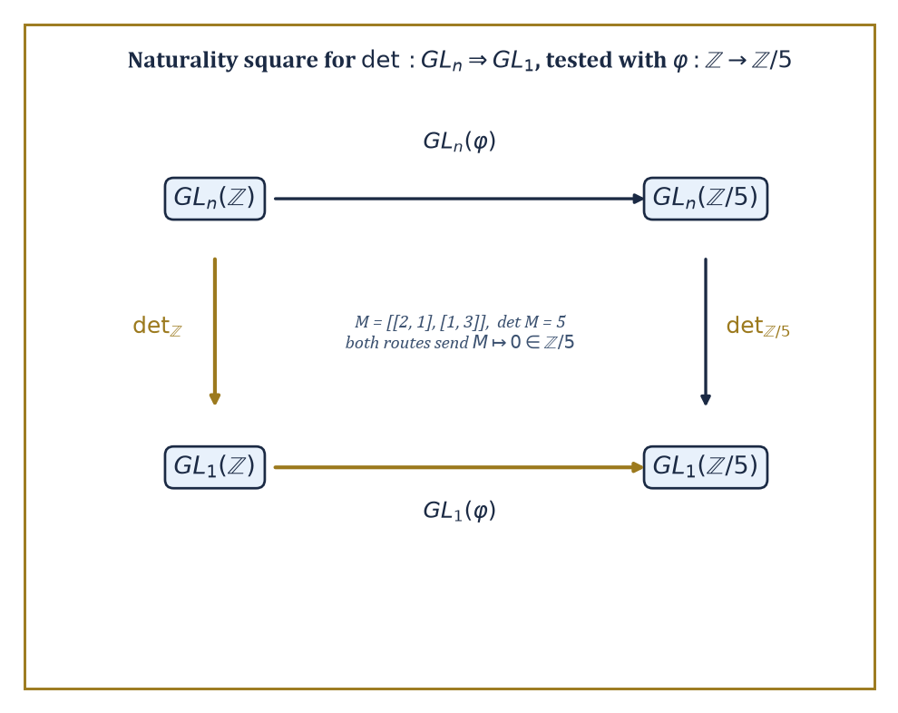
Figure 38.2 — The naturality square for det, tested on an actual integer matrix reduced mod 5 — both routes land on 0, honestly.
Associativity: a chain of arrows composes to one answer regardless of how you bracket it, whenever the composites make sense.
(h∘g)∘f = h∘(g∘f)
Unit laws: the identity arrow really is a no-op under composition, for every f: A → B.
f∘id_A = f
id_B∘f = f
Familiar examples include Set (sets and functions), Grp (groups and homomorphisms), Top (topological spaces and continuous maps), Vect (vector spaces and linear maps), and Pos (posets and order-preserving maps); less apparent at first, any single group or monoid is a category with one object, and any preorder is a category in which there is at most one arrow between any two objects.
Numeric example — Composition and identity, checked by hand. Let A = {1, 2}, B = {a, b, c}, C = {x, y}, D = {α, β} be four finite sets, objects of Set. Define f: A → B by f(1) = a, f(2) = b; g: B → C by g(a) = x, g(b) = y, g(c) = x; h: C → D by h(x) = α, h(y) = β.
First, compose g and f:
(g∘f)(1) = g(a) = x
(g∘f)(2) = g(b) = y
So g∘f sends 1 ↦ x, 2 ↦ y. Now check associativity two ways.
Left path, h∘(g∘f): apply g∘f first, then h.
(h∘(g∘f))(1) = h(x) = α
(h∘(g∘f))(2) = h(y) = β
Right path, (h∘g)∘f: first compute h∘g.
(h∘g)(a) = h(x) = α
(h∘g)(b) = h(y) = β
(h∘g)(c) = h(x) = α
Then apply that to f.
((h∘g)∘f)(1) = (h∘g)(a) = α
((h∘g)∘f)(2) = (h∘g)(b) = β
Both paths give 1 ↦ α, 2 ↦ β: associativity holds, as it must for ordinary function composition, but now checked explicitly rather than taken on faith.
For the unit law:
id_A(1) = 1
id_A(2) = 2
And f∘id_A sends 1 ↦ f(1) = a and 2 ↦ f(2) = b, f itself.
Try it now — With f, g, h as in the first example, compute (h∘g)(c), and say which of the three composites h∘g, g∘f, h∘g∘f is defined on the element c. Answer →
Numeric example — A category where the arrows are matrices. Not every category has sets as objects. Let Mat have as objects the natural numbers 0, 1, 2, …, and let a morphism n → m be an m×n real matrix, thought of as a linear map ℝⁿ → ℝᵐ; composition of f: n → m and g: m → p is ordinary matrix multiplication g·f, a p×n matrix, and idₙ is the n×n identity matrix.
Take f: 2 → 3 given by the 3×2 matrix with rows (1,0), (0,1), (1,1), and g: 3 → 1 given by the 1×3 matrix (row vector) (2, 1, −1). The composite g∘f: 2 → 1 is the 1×2 matrix g·f. Its single row is computed entrywise:
first entry = 2·1 + 1·0 + (−1)·1 = 2 + 0 − 1 = 1
second entry = 2·0 + 1·1 + (−1)·1 = 0 + 1 − 1 = 0
g∘f = (1, 0)
Associativity of this composition is the associativity of matrix multiplication, which linear algebra already guarantees — category theory is not claiming anything new here, only pointing out that ℝⁿ-and-matrices was secretly a category all along.
A functor F: C → D is a structure-preserving map between categories: it sends each object A of C to an object F(A) of D, and each morphism f: A → B of C to a morphism F(f): F(A) → F(B) of D, in such a way that:
F(g∘f) = F(g)∘F(f)
F(id_A) = id_(F(A))
Functors are to categories what homomorphisms are to groups, or continuous maps are to spaces — the maps that respect the relevant structure, except that here the structure being respected is the entire pattern of composition itself.
A single functor can forget structure (the forgetful functor U: Grp → Set remembers the underlying set of a group and forgets the multiplication), or it can freely generate structure (the free functor F: Set → Grp, met properly three sections from now, builds the freest possible group on a set), or it can do something more elaborate still.
Numeric example — A forgetful functor, watched forgetting something. Let U: Grp → Set be the forgetful functor. Take the group G = ℤ/4 = {0, 1, 2, 3} under addition modulo 4. Then U(G) is the four-element set {0, 1, 2, 3}, with no memory that 2+3=1 in G.
Now take the homomorphism φ: ℤ/4 → ℤ/2 given by φ(x) = x mod 2, so:
φ(0)=0, φ(1)=1, φ(2)=0, φ(3)=1
Check it really is a homomorphism on a couple of awkward-looking cases.
φ(3+3 mod 4) = φ(2) = 0
φ(3)+φ(3) mod 2 = 1+1 = 0
— matches.
φ(1+2 mod 4) = φ(3) = 1
φ(1)+φ(2) mod 2 = 1+0 = 1
— matches. The functor U sends this homomorphism to U(φ), which as a function {0,1,2,3} → {0,1} is described by the same table of values — but U(φ) is now merely a function, with no obligation to respect any addition, because U has thrown the group structure away on both sides. Nothing about the four numbers changed; everything about what we are allowed to say about them did.
A natural transformation α: F ⇒ G between two functors F, G: C → D is a family of morphisms α_A: F(A) → G(A), one for every object A of C, chosen so that for every morphism f: A → B in C the square built from α_A, α_B, F(f), and G(f) commutes:
G(f)∘α_A = α_B∘F(f)
This single commuting-square condition, called naturality, is the formal replacement for the vague phrase the same construction, done the same way, for every object — the property that separated the honest isomorphism V ≅ V** from the choice-dependent V ≅ V* two examples ago.
Numeric example — A naturality square that commutes. Let GLₙ and GL₁ be functors from CRing (commutative rings and ring homomorphisms) to Grp, sending a ring R to the group of invertible n×n matrices over R, respectively the group of invertible 1×1 matrices over R (that is, the units of R). The determinant gives a natural transformation det: GLₙ ⇒ GL₁:
det_R(M) = det(M)
Naturality says that for any ring homomorphism φ: R → S, applying φ entrywise to a matrix and then taking the determinant in S agrees with taking the determinant in R and then applying φ. Test it: let R = ℤ, S = ℤ/5, and φ: ℤ → ℤ/5 the reduction-mod-5 map. Take M = the 2×2 integer matrix with rows (2, 1) and (1, 3).
Its determinant is:
det(M) = 2·3 − 1·1 = 6 − 1 = 5
φ(det M) = φ(5) = 0 in ℤ/5
Now go the other way: φ(M) reduces every entry mod 5, but every entry of M is already below 5, so φ(M) has the same rows (2,1), (1,3), now read as a matrix over ℤ/5, and:
det(φ(M)) = 2·3 − 1·1 = 6 − 1 = 5 ≡ 0 (mod 5)
Both routes around the square land on 0 in ℤ/5: the square commutes, as naturality demands, and not by luck — it would have commuted for any integer matrix and any reduction map, which is the entire content of calling det natural rather than merely true.
With these three words in hand — category, functor, natural transformation — the earlier promise starts to look concrete.
Any two constructions that can be phrased as functors, and any two functors that admit a natural transformation between them that is invertible at every object, are naturally isomorphic: identified not by an accident of counting, but by a uniform recipe that works the same way everywhere.
That is the precise meaning behind the informal claim, heard throughout mathematics, that two things are really the same construction in disguise.
Same structure, new language — functors and natural transformations in the running examples
Forgetful functors. Grp → Set, Vect → Set and Top → Set all keep the underlying set and the underlying function, and forget the rest.
Free functors. Set → Vect sends a finite set X to the space with basis X (a 3-element set gives ℝ³); Set → Grp sends X to the free group on X.
A functor out of Top. The fundamental group, built in Topology (Volume 3), sends a pointed space to a group and a continuous map to a homomorphism. That is why a homeomorphism forces isomorphic fundamental groups: functors preserve isomorphisms.
Natural transformations. In Vect, V → V** is natural; in Grp, the quotient map G → G/[G, G] onto the abelianization is natural, because a homomorphism sends commutators to commutators.
Keep only this · Section 38.2: Categories, Functors, and Natural Transformations
The idea. A category is a collection of objects and composable arrows with identities; a functor maps one category to another preserving composition and identities; a natural transformation is a family of arrows that commutes with every arrow of the source.
Core.
(h∘g)∘f = h∘(g∘f), f∘id_A = f = id_B∘f
F(g∘f) = F(g)∘F(f), F(id_A) = id_(F(A))
naturality: G(f)∘α_A = α_B∘F(f)
Typical mistake. Checking naturality only on objects. A natural transformation must make the square commute for every arrow f: A → B, not just provide one map per object.
Minimal example. The determinant det: GLₙ(R) → R× is natural in the ring R: reducing a matrix mod 5 and then taking det gives the same as taking det and reducing mod 5.
Practice. Easy to challenge; full worked answers, with the usual mistake, are in Answers to the Practice Sets at the back.
Easy — Is “send each set X to its power set P(X), and each function f: X → Y to the map S ↦ f(S)” a functor Set → Set? Check the identity law. Answer →
Medium — Let U: Grp → Set forget structure. For ℤ/6 and the homomorphism φ(x) = 2x mod 6 from ℤ/6 to itself, write U(φ) as a table and check φ(4 + 5) = φ(4) + φ(5). Answer →
Challenge — For vector spaces, the map ev_V: V → V, v ↦ (φ ↦ φ(v)), is natural. Verify the naturality square for a linear map T: V → W, using T (θ) = θ∘T* where T*(ψ) = ψ∘T. Answer →

Section 38.3: Universal Properties and Representable Functors
Defining a thing by what talks to it, rather than what it contains
An object is defined by a universal property when it is characterized, up to a unique isomorphism, by the morphisms into it or out of it, rather than by any description of its internal contents. This is a genuinely different style of definition from the ones met earlier in the series.
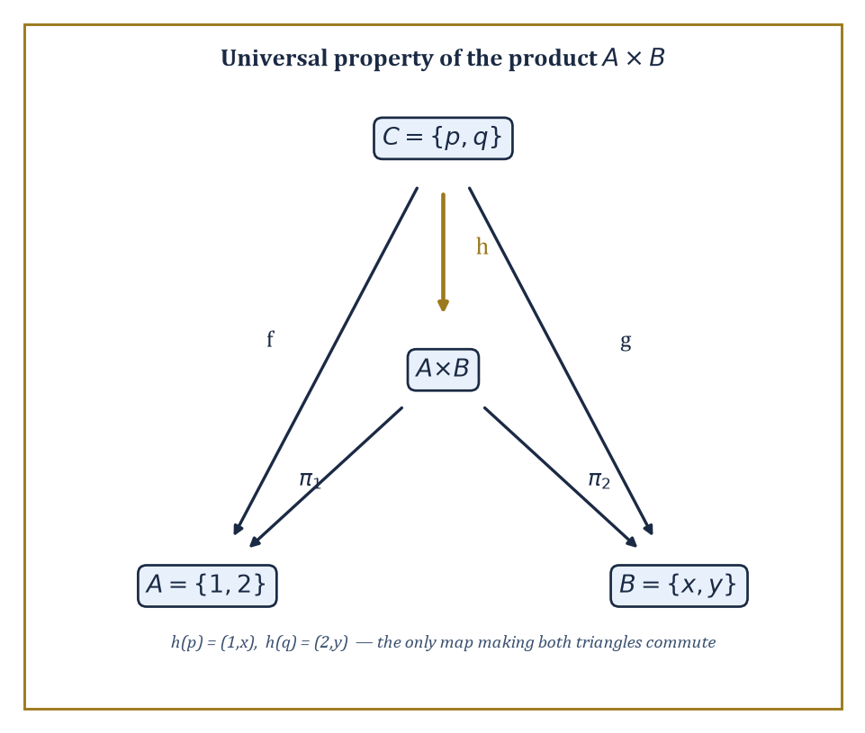
Figure 38.3 — The universal property of the product, with the one map h that makes both triangles commute pinned down exactly.
Instead of building an object and then proving it has some property, you specify the property first — usually a formula stating that maps to or from some test object correspond precisely to maps to or from your object — and the object, if it exists at all, is pinned down uniquely by that specification alone. Products, coproducts, equalizers, free objects, and tensor products are all defined this way.
Numeric example — The product of two sets, built and verified. Let A = {1, 2} and B = {x, y}.
A × B = {(1,x), (1,y), (2,x), (2,y)}
The categorical product A × B in Set is this ordinary Cartesian product, equipped with projections π₁: A×B → A and π₂: A×B → B sending a pair to its first, respectively second, coordinate.
The universal property says: for any set C with a map f: C → A and a map g: C → B, there is exactly one map h: C → A×B with
π₁∘h = f and π₂∘h = g
Test it with C = {p, q}, where
f(p) = 1, f(q) = 2, g(p) = x, g(q) = y
The only candidate is
h(p) = (1,x), h(q) = (2,y)
since π₁(h(p)) must equal f(p)=1 and π₂(h(p)) must equal g(p)=x, forcing h(p)=(1,x); the same logic forces h(q)=(2,y). No other function C → A×B satisfies both projection conditions, which is just what unique means here — the pairing map is forced, not chosen:
h(c) = (f(c), g(c))
Try it now — For A = {1, 2, 3} and B = {x, y}, how many elements does A × B have, and which element does the pair of maps p(∗) = 3, q(∗) = y from a one-point set pick out? Answer →
The coproduct is the mirror image: instead of maps into two objects, we ask about maps out of them.
The coproduct A ⊔ B comes with inclusions ι_A: A → A⊔B and ι_B: B → A⊔B, and its universal property says that a map out of A⊔B corresponds to a compatible pair of maps, one out of A and one out of B.
In Set, A ⊔ B is the disjoint union, formed by tagging elements so that copies from A never collide with copies from B even if the original sets overlapped.
Numeric example — A disjoint union, tags and all. Let A = {1, 2} and B = {3, 4}, which happen not to overlap already, but to see the general recipe we tag anyway.
A⊔B = {(1,A), (2,A), (3,B), (4,B)}
ι_A(1) = (1,A), ι_A(2) = (2,A)
and similarly for ι_B.
Had A and B instead both contained the element 1, the tags (1,A) and (1,B) would keep the two copies distinct — the whole point of the construction is that it never loses information by collision, unlike an ordinary set union.
Given any set D with maps p: A → D and q: B → D — say D = {•}, the one-point set, with p and q both the unique constant maps.
There is exactly one map A⊔B → D agreeing with p on the A-tagged elements and with q on the B-tagged elements, namely the constant map sending everything to •.
A third universal construction, the equalizer, is worth seeing because it looks less symmetric than a product or coproduct and is correspondingly more useful in practice: it is the universal way of forcing two parallel maps to agree.
Numeric example — The equalizer of two functions, found by inspection. Let f, g: {1, 2, 3} → {a, b} be given by
f(1)=a, f(2)=a, f(3)=b, and g(1)=a, g(2)=b, g(3)=b
The equalizer of f and g is the largest subset of {1,2,3} on which f and g agree, together with its inclusion map. Check each point:
at 1: f(1) = a = g(1) — they agree
at 2: f(2) = a, g(2) = b — they disagree
at 3: f(3) = b = g(3) — they agree
So the equalizer is {1, 3}, included into {1,2,3} in the obvious way.
The universal property says that any map h: D → {1,2,3} with f∘h = g∘h must land entirely inside {1,3} — which is obvious once you see it: if h(d)=2 for some d, then
f(h(d)) = a while g(h(d)) = b
contradicting f∘h = g∘h. So {1,3} is not merely a subset that happens to work; it is forced to be the equalizer by the requirement itself.
A functor F: C → Set is representable when it is naturally isomorphic to a Hom-functor Hom(c, –) for some fixed object c of C — that is, F(A) looks, naturally in A, like the set of morphisms c → A.
Representability is the categorical way of saying an entire functor, however defined, is secretly nothing more than probing objects with maps out of one fixed object c.
It turns questions about F into questions about morphisms into or out of c, which are usually far easier to get a grip on.
Numeric example — The identity functor on Set is representable. Let 1 = {*} be a one-element set, and consider Hom(1, –): Set → Set, sending a set X to the set of functions {*} → X.
Any such function is determined wholly by where it sends *, and it can send ∗ to any element of X whatsoever — so Hom(1, X) is in natural bijection with X itself: the identity functor on Set is represented by the singleton set 1.
Check the count on X = {a, b, c}: there are exactly three functions {*} → X, one for each choice of image of *, matching |X| precisely:
|X| = 3
This is not a coincidence dressed up in fancy language; it is the precise statement that picking out an element of a set is the same activity as mapping a single point into it, which is obvious the moment it is said aloud and yet turns out, once generalized, to organize a remarkable amount of the rest of this chapter.
The practical value of universal properties is that they replace an explicit, often fiddly construction with a characterizing property that is frequently much easier to check.
If you can show two objects both satisfy the same universal property, a short formal argument — build the maps each way using the two universal properties, compose them, and note the composite must be an identity by uniqueness — proves they are isomorphic, without your ever having to compare their internal descriptions directly.
This is the trick that makes constructions functorial almost for free, and it is the trick that limits and colimits, in the next section, apply on an industrial scale.
Same structure, new language — products and coproducts in the running examples
Product. Set: pairs. Grp: the direct product G × H. Vect: the direct sum V ⊕ W. Top: the product space with the product topology.
Coproduct. Set: disjoint union. Grp: the free product G ∗ H, far larger than G × H. Vect: again V ⊕ W. Top: the disjoint union of spaces.
One definition, four answers. In Vect the product and coproduct coincide; in Grp they differ wildly. The universal property is the same; the category decides what it produces.
Keep only this · Section 38.3: Universal Properties and Representable Functors
The idea. A universal property defines an object by how every other object maps into it (or out of it), which fixes it up to a unique isomorphism without saying what its elements are.
Core.
product: for f: X → A, g: X → B there is exactly one ⟨f, g⟩: X → A × B
coproduct: for f: A → X, g: B → X there is exactly one [f, g]: A ⊔ B → X
Typical mistake. Forgetting the word “unique”. Without it, many objects qualify (A × B × B also has maps to A and B), and the definition no longer pins anything down.
Minimal example. In Set the product of {1, 2} and {x, y} is the 4-element set of pairs; in Vect the product of ℝ and ℝ² is ℝ³ with the two projections.
Practice. Easy to challenge; full worked answers, with the usual mistake, are in Answers to the Practice Sets at the back.
Easy — In Vect, what are the product and coproduct of ℝ² and ℝ³? Give their dimensions. Answer →
Medium — Find the equalizer of f, g: {1, 2, 3, 4} → {a, b} with f = (a, a, b, b) and g = (a, b, b, a) (values at 1, 2, 3, 4). Answer →
Challenge — Show that any two products of A and B are isomorphic by a unique isomorphism compatible with the projections. Answer →

Section 38.4: Limits and Colimits
One universal property to rule the products, equalizers, and their kin
Before this section
What you need. Products, coproducts and equalizers from Universal Properties and Representable Functors.
Why it matters. A limit is one recipe that produces every one of those constructions. Once you can read a diagram and ask for its limit, you will recognize pullbacks in geometry, inverse limits in algebra and gluing in topology as the same move.
Products and equalizers, from the previous section, turn out to be special cases of a single notion: the limit of a diagram.
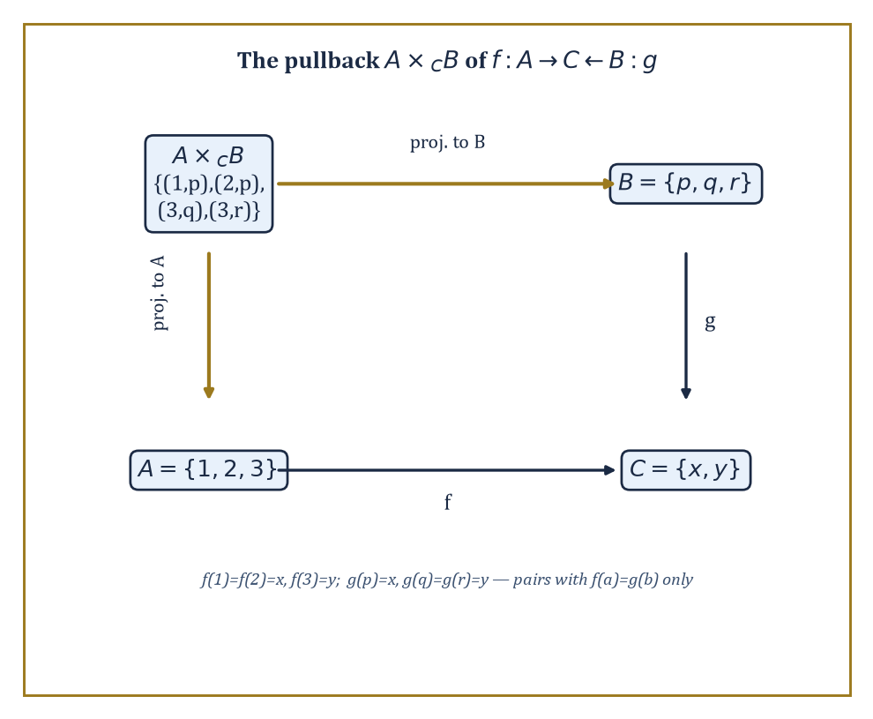
Figure 38.4 — The pullback square, worked by brute force: only the pairs where f and g agree survive.
A diagram in a category C is a collection of objects and morphisms among them, indexed by some shape; a cone over the diagram is an object with maps to every object of the diagram, compatible with the diagram’s own arrows; and a limit is a universal cone — one through which every other cone factors uniquely.
Reverse every arrow and you get a cocone and a colimit, the universal object receiving maps from every object of the diagram.
Products, equalizers, and inverse limits are all limits of different diagram shapes; coproducts, coequalizers, and direct limits are all colimits.
Numeric example — A pullback, computed by brute force. The pullback of f: A → C and g: B → C is the limit of the diagram A → C ← B, and it is one of the most-used limits in all of mathematics.
A ×_C B = {(a,b) ∈ A×B : f(a) = g(b)}
Let A = {1,2,3}, B = {p,q,r}, C = {x,y}, with the maps f and g defined as follows:
f(1)=x, f(2)=x, f(3)=y
g(p)=x, g(q)=y, g(r)=y
Go through A element by element: for a=1, f(1)=x, so we need g(b)=x, which holds only for b=p, giving the pair (1,p); for a=2, f(2)=x also, giving (2,p); for a=3, f(3)=y, so we need g(b)=y, which holds for b=q and b=r, giving (3,q) and (3,r).
A ×_C B = {(1,p), (2,p), (3,q), (3,r)}
The pullback is this set — four pairs in total — together with the two projections down to A and B. This is the universal cone: any set D mapping compatibly into A and B so that the two composites into C agree must factor uniquely through these four pairs.
Try it now — With A = {1, 2}, B = {p, q}, C = {x, y}, f(1) = x, f(2) = y, g(p) = g(q) = y, list the pullback A ×_C B. Answer →
Numeric example — A pushout, glued along a shared piece. Dually, the pushout of f: C → A and g: C → B is the colimit of A ← C → B, computed as the disjoint union A⊔B with f(c) glued to g(c) for every c in C.
Let A = {1,2,3}, B = {4,5,6}, C = {c₁,c₂}, with the maps defined as follows:
f(c₁)=1, f(c₂)=2, g(c₁)=4, g(c₂)=5
The disjoint union A⊔B has six tagged elements; the gluing relation identifies 1 with 4 (both images of c₁) and 2 with 5 (both images of c₂), and forces nothing else, since 3 and 6 are not in the image of either f or g.
The pushout therefore has four elements: the class {1,4}, the class {2,5}, the singleton class {3}, and the singleton class {6} — six elements minus two gluings, four classes, as the universal property of a colimit demands: it is the smallest thing you can build by taking A and B and forcing them to agree wherever C tells them to.
A category is complete when every diagram indexed by a small (set-sized, as opposed to unmanageably large) shape has a limit, and cocomplete when every such diagram has a colimit.
Set, Grp, Top, and Vect are all complete and cocomplete; this single fact packages up the existence of arbitrary products, equalizers, intersections, inverse limits, coproducts, coequalizers, quotients, and direct limits in each of those categories into one theorem, rather than requiring a separate ad hoc construction for each.
Abstract example — The empty diagram, and the limit nobody expects. The empty diagram, with no objects and no arrows, still has a limit in any complete category: the limit over nothing at all is the terminal object, the object with exactly one map in from every other object.
In Set, the terminal object is any one-element set {*}, since for any set X there is exactly one function X → {*} — send everything to *.
Dually, the colimit over the empty diagram is the initial object; in Set this is the empty set ∅, since there is exactly one function ∅ → X for every set X (the empty function, vacuously well-defined, doing nothing because there is nothing to do it to).
It is a mildly delightful fact that completeness, a grand-sounding property, secretly guarantees the existence of the emptiest and loneliest objects in the category as a free consequence.
Not every functor gets on well with limits and colimits, and the ones that do are worth naming: a functor preserves limits if it sends limiting cones to limiting cones, and preserves colimits if it sends colimiting cocones to colimiting cocones.
Preservation is not automatic, and knowing which functors preserve which kind of construction is one of the main organizing questions of the subject — indeed the whole of the next section is essentially an answer to it.
Numeric example — The forgetful functor preserves products. Let U: Grp → Set be the forgetful functor again, and let G = ℤ/2 = {0,1} and H = ℤ/3 = {0,1,2}.
The product G×H in Grp is the direct product group, with underlying set:
{(0,0),(0,1),(0,2),(1,0),(1,1),(1,2)}
That’s six elements under componentwise addition — for example:
(1,1)+(1,2) = (0,0)
since 1+1=2≡0 mod 2 in the first coordinate and 1+2=3≡0 mod 3 in the second.
Apply U: U(G×H) is just this six-element set.
Compare with U(G)×U(H), the ordinary Cartesian product of the two-element set {0,1} and the three-element set {0,1,2}, which also has six elements, and in fact the identical six pairs.
U(G×H) = U(G)×U(H)
So this holds precisely: the forgetful functor preserves this particular product, and in fact preserves all limits — a general fact about forgetful functors into Set that makes them extremely convenient to compute with, because they let you check a limit’s size by simply counting elements.
The same forgetful functor is considerably less obliging about colimits, and the contrast is worth seeing, because it is the first hint of the general pattern the next section makes precise: functors that behave well with limits often behave badly with colimits, and vice versa.
A colimit in Grp need not have an underlying set that looks anything like the corresponding colimit of the underlying sets in Set.
Numeric example — The forgetful functor does not preserve coproducts. Let G = H = ℤ/2 = {0,1}, two separate copies of the two-element group.
In Set, U(G) ⊔ U(H) is the disjoint union of two two-element sets, which has exactly four elements.
But the coproduct in Grp, the free product G ∗ H, is not the four-element group one might naively expect — it is the infinite dihedral group, generated by the two order-2 elements of G and H with no relation imposed between them beyond each individually squaring to the identity, so that products such as ab, abab, ababab and so on are all forced to be distinct, giving infinitely many elements.
So U(G*H) is infinite, while U(G) ⊔ U(H) has only four elements: the forgetful functor emphatically does not preserve this coproduct.
Since U is a right adjoint (to the free functor F of Adjoint Functors), this is no accident and no failure of the theorem — right adjoints are only ever guaranteed to preserve limits, and this is the kind of colimit they are permitted, indeed expected, to mangle.
Where this returns
Pushouts are how topologists glue. Two intervals glued at both ends give a circle, and the Seifert–van Kampen theorem of Topology (Volume 3) says that, for open pieces with a path-connected overlap, the fundamental group of the glued space is the pushout of the pieces’ groups. Limits return in Independence, Product Spaces, and Kolmogorov’s Extension: Kolmogorov’s theorem builds a whole random process from consistent finite-dimensional distributions, and that consistency is exactly the shape of a limit over finite sets of times.
Keep only this · Section 38.4: Limits and Colimits
The idea. Limits and colimits are the universal answers to “combine this diagram”: limits (products, equalizers, pullbacks, terminal object) are cones into the diagram, colimits (coproducts, coequalizers, pushouts, initial object) are cocones out of it.
Core.
pullback: A ×_C B = {(a, b) : f(a) = g(b)}
pushout: A ⊔ B with f(c) glued to g(c)
limit over the empty diagram = terminal object
Typical mistake. Assuming a functor that preserves limits also preserves colimits. The forgetful functor Grp → Set preserves products but sends the free product ℤ/2 ∗ ℤ/2 (infinite) to an infinite set, not to the 4-element disjoint union.
Minimal example. In Set the terminal object is any one-point set; in Grp it is the trivial group; in Top it is a point; in Vect it is the zero space.
Practice. Easy to challenge; full worked answers, with the usual mistake, are in Answers to the Practice Sets at the back.
Easy — What are the initial and terminal objects in Set, Grp and Vect? Answer →
Medium — Compute the pushout of {a} → {1, 2} (a ↦ 1) and {a} → {3, 4} (a ↦ 3) in Set. How many elements does it have? Answer →
Challenge — Show that the pullback of f: A → C along the identity id_C: C → C is isomorphic to A. Answer →

Section 38.5: Adjoint Functors
The closest thing category theory has to true love, requited on both sides
Before this section
What you need. Free objects (the free group and the free vector space from the functor examples in Categories, Functors, and Natural Transformations) and the idea of a natural bijection.
Why it matters. Adjoint pairs are everywhere: free and forgetful, product and exponential, discrete and indiscrete. Recognizing one tells you, for free, which limits or colimits a functor preserves.
Some constructions come in matched pairs, one building structure freely and the other forgetting it. Start with a plain set of letters and form every word you can spell with them: that is the free monoid on those letters. Going the other way, take any monoid and forget its multiplication, keeping only the underlying set. The two are linked by a perfect correspondence. Choosing where each letter should go inside a monoid is exactly the same as choosing a structure-respecting map from the free monoid into it, because once the letters are placed, every word’s image is forced. Pairs like this, one free and one forgetful, are adjoint functors, and they turn up in every corner of mathematics.
An adjunction between categories C and D is a pair of functors F: C → D and G: D → C, together with a natural bijection, for every object c of C and d of D.
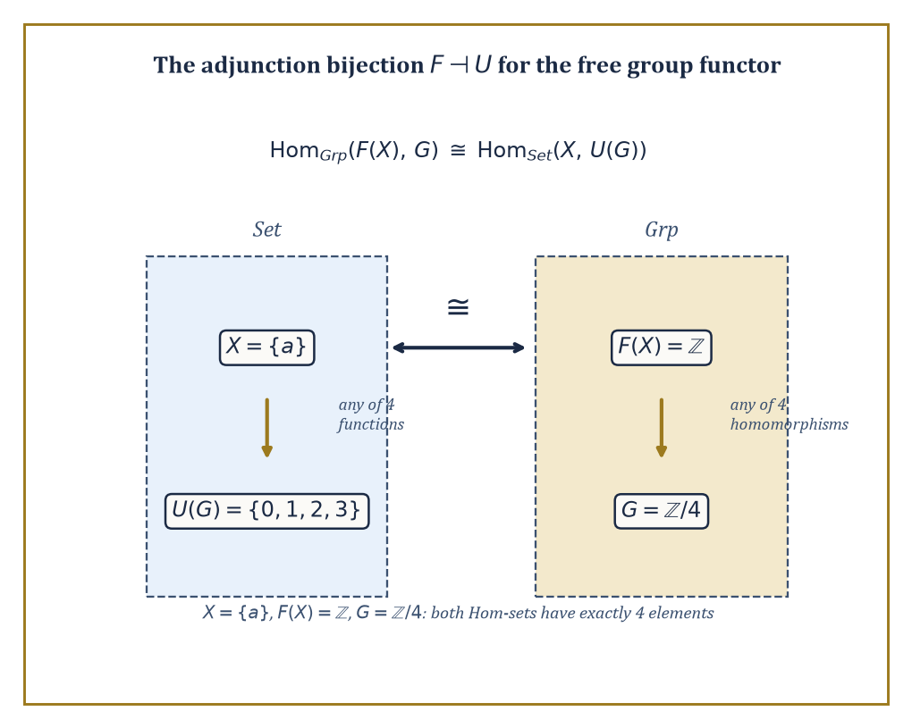
Figure 38.5 — The adjunction bijection, made countable: four functions on one side, four homomorphisms on the other, matched precisely.
Hom_D(F(c), d) ≅ Hom_C(c, G(d))
F is called the left adjoint, G the right adjoint, and the relationship is written F ⊣ G. This single bijection is one of the most productive ideas in the whole of mathematics: an enormous number of pairs of constructions that look, on the surface, entirely unrelated — free objects and forgetful functors, tensor product and function space, existential quantifiers and substitution — turn out to be an adjoint pair once you look closely enough, and once you know that, a long list of formal consequences follows automatically, without further work.
Numeric example — Free group, forgetful functor, and a bijection you can count. Let F: Set → Grp send a set X to the free group on X, and let U: Grp → Set be the forgetful functor. The adjunction claims that the following holds naturally.
Hom_Grp(F(X), G) ≅ Hom_Set(X, U(G))
Take X = {a}, a single-element set. The free group on one generator is the infinite cyclic group, since with only one generator and no imposed relations, every element is just some integer power of a.
F({a}) = ℤ
Let G = ℤ/4 = {0,1,2,3}.
The right-hand side, Hom_Set({a}, U(G)), is the set of functions from a one-element set into the four-element set {0,1,2,3} — there are exactly four such functions, one for each choice of where a lands.
The left-hand side, Hom_Grp(ℤ, ℤ/4), is the set of group homomorphisms from ℤ to ℤ/4; since ℤ is generated freely by 1, such a homomorphism is wholly determined by the image of 1, and any of the four elements 0,1,2,3 may be chosen with no relation to violate (ℤ has none). That is again exactly four homomorphisms.
Both sides have four elements, and the adjunction’s bijection matches them up in the obvious way: the function a ↦ k on the right corresponds to the homomorphism sending 1 ↦ k on the left. Freeness, in other words, is the statement that choosing where generators go is the only choice you ever have to make.
Try it now — For X = {a, b} and the group G = ℤ/3, how many homomorphisms F(X) → G are there from the free group on X? Answer →
Two structural facts about adjunctions are worth committing to memory, because they explain why adjoints are so useful rather than merely elegant: left adjoints preserve colimits, and right adjoints preserve limits.
A free construction, being a left adjoint, therefore automatically plays well with unions and gluings; a forgetful functor, being a right adjoint, automatically plays well with products and intersections — which is precisely the fact used two sections ago to show the forgetful functor from Grp preserves products, now revealed not to be a lucky accident about groups specifically but a consequence of a general theorem about all right adjoints whatsoever.
Abstract example — Free functors turn disjoint unions into free products. Since F: Set → Grp is a left adjoint, it preserves colimits, and in particular sends the coproduct in Set (disjoint union) to the coproduct in Grp (free product, the group built by combining two groups with no relations imposed between their generators beyond what each already had internally).
Concretely, {a,b} is the coproduct of the singletons {a} and {b} in Set, so F({a,b}) must be the coproduct, in Grp, of F({a}) and F({b}) — that is, the free group on two generators is the free product of two copies of ℤ.
F({a,b}) ≅ ℤ ∗ ℤ
This matches the direct definition of the free group on {a,b} exactly, but the adjunction handed us the fact without requiring a fresh construction — it fell out of a theorem that has nothing to do with groups in particular.
Every adjunction comes with two natural transformations that encode the bijection at its most basic level: the unit and the counit.
η: id_C ⇒ G∘F
ε: F∘G ⇒ id_D
These satisfy two triangle identities that essentially say applying the unit and then the counit, in either order, does nothing extra. The unit is usually the more intuitive of the two — it is the canonical way of feeding an object of C into the round trip C → D → C.
Numeric example — The unit of the free-forgetful adjunction, made explicit. For the adjunction F ⊣ U above, the unit at X = {a} is a function from {a} into the underlying set of the free group ℤ.
η_X: X → U(F(X))
It is the generator: the single element a is sent to the integer 1, which generates the free group F(X) = ℤ.
η_X(a) = 1
This looks almost too obvious to deserve a name, and that is rather the point — the unit is the officially sanctioned way of regarding a raw element as a generator of the freest possible group built from it, and the triangle identity guarantees that if you then apply U to any homomorphism out of F(X) and restrict along η_X, you recover the function you started with, nothing gained, nothing lost, no accidental side effects.
A single functor is not limited to one adjoint on one side; some have a left adjoint and a right adjoint simultaneously, sitting on opposite sides of it like bookends, and comparing the two is instructive.
The forgetful functor U: Top → Set has both: a left adjoint that equips a set with the discrete topology (every subset declared open), and a right adjoint that equips it with the indiscrete topology (only the empty set and the whole space declared open).
Numeric example — Two adjoints, one set, two very different topologies. Let X = {1,2,3}. The discrete topology on X takes every one of the 2³ = 8 subsets of X to be open.
∅, {1}, {2}, {3}, {1,2}, {1,3}, {2,3}, {1,2,3}
The indiscrete topology on X takes only 2 of those subsets to be open, and declares nothing else open, however tempting.
∅, {1,2,3}
Both are genuine topologies on the same three-point set, sitting at opposite extremes of how much structure gets imposed, and the adjunctions say precisely why each deserves to be called canonical: the discrete topology is the freest possible topology making the identity function on X continuous when mapping out of it, and the indiscrete topology is the laziest possible topology making the identity function continuous when mapping into it.
Left adjoint gives you the most structure compatible with a universal property about maps out; right adjoint gives you the least structure compatible with a universal property about maps in — and the humble forgetful functor from topology to sets sits in the middle, watching both extremes get generated automatically from nothing more than the two triangle identities.
You have seen this before
In Linear Algebra (Volume 2) a linear map was determined by where it sends a basis, and any choice of images worked. That is the free–forgetful adjunction for Vect: Hom(free space on X, W) ≅ Hom(X, underlying set of W). The same sentence for Grp says a homomorphism out of a free group is a free choice of images for the generators. For Top, the discrete topology is left adjoint to forgetting, and the indiscrete topology is right adjoint: every function out of a discrete space is continuous, and every function into an indiscrete space is.
Keep only this · Section 38.5: Adjoint Functors
The idea. An adjunction F ⊣ U is a natural one-to-one correspondence between maps F(X) → A and maps X → U(A): building freely on the left is the same as choosing on the right.
Core.
Hom_D(F X, A) ≅ Hom_C(X, U A) (natural in X and A)
unit η_X: X → U F X, counit ε_A: F U A → A
left adjoints preserve colimits; right adjoints preserve limits
Typical mistake. Getting the sides backward. The free functor is the left adjoint: maps out of a free object are easy (choose images of generators), maps into it are not.
Minimal example. The free vector space on a 2-element set is ℝ²; a linear map ℝ² → W is a choice of two vectors in W, the images of the basis.
Practice. Easy to challenge; full worked answers, with the usual mistake, are in Answers to the Practice Sets at the back.
Easy — Over the field ℤ/2, how many linear maps (ℤ/2)³ → (ℤ/2)² are there? Use the fact that (ℤ/2)³ is the free ℤ/2-vector space on three basis vectors. Answer →
Medium — Write down the unit η_X: X → U F(X) for the free-monoid (word) adjunction at X = {a, b}, and give the image of b. Answer →
Challenge — Use “right adjoints preserve limits” to explain why the underlying set of a product of groups G × H is U(G) × U(H), and why the analogous claim fails for coproducts. Answer →

Section 38.6: The Yoneda Lemma
Everything an object is, is what talks to it
You can learn a great deal about a person from the company they keep, and category theory takes that idea to its limit. The Yoneda lemma says that an object is determined, up to isomorphism, by the maps going out of it to every other object, and it gives an exact count of the ways that pattern of maps can be matched with any other structure. Concretely, every natural way of turning maps out of an object into elements of some set is fixed by a single element of that set: the one to which the identity map is sent. It sounds abstract, but on a small example with three objects you can check it by counting.
Yoneda before the formula
Before the statement, the intuition. You can learn everything about an object by probing it with test objects and recording what comes back.
Set. The elements of X are exactly the maps {∗} → X. Probing with a one-point set reads off the elements.
Grp. The elements of G are exactly the homomorphisms ℤ → G (send 1 to the element). Probing with ℤ reads off the elements.
Vect. The vectors of V are exactly the linear maps ℝ → V (send 1 to the vector).
Top. The points of a space are the maps from a point; its paths are the maps from [0, 1]. One test object is no longer enough, which is why topologists use many.
Yoneda says: probe with all objects at once, record all the maps, and you have captured the object completely, up to isomorphism. The bookkeeping trick that makes it exact is to follow where the identity map goes.
The Yoneda lemma states: for any category C, any object c of C, and any functor F: C → Set, the natural transformations from the representable functor Hom(c, –) to F correspond exactly, and naturally, to the elements of F(c).
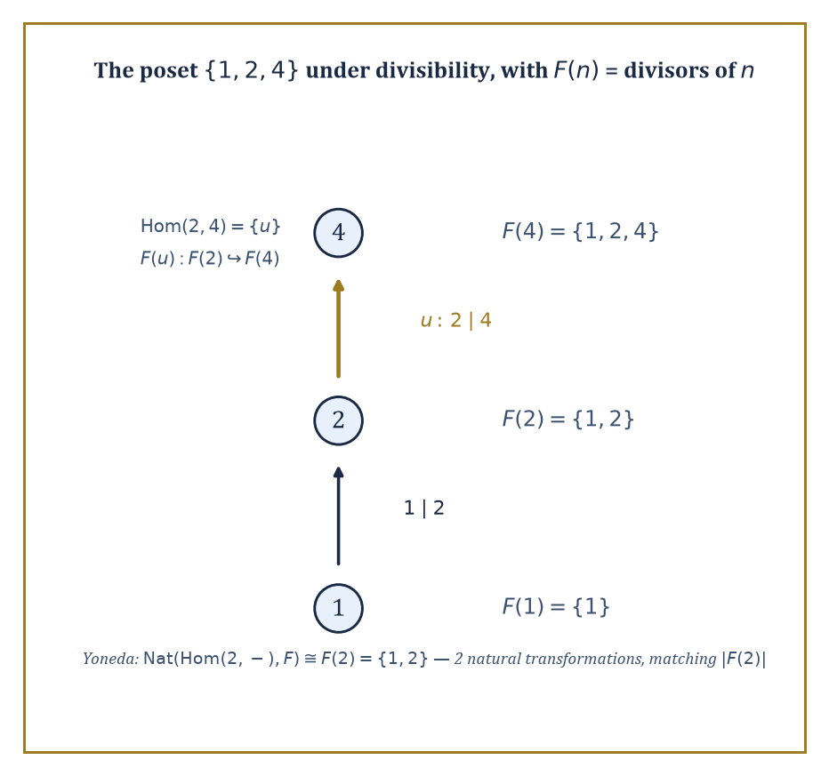
Figure 38.6 — The three-object poset that makes the Yoneda lemma countable by hand: two natural transformations, matching |F(2)| on the nose.
Nat(Hom(c,–), F) ≅ F(c)
This is often introduced as the single most important theorem in category theory, a claim that sounds like hyperbole until you have watched it work on a genuine example, at which point the claim starts to look, if anything, understated: an entire set of natural transformations — potentially infinite, potentially fearsome to construct directly — collapses to something as simple as picking one element of one set.
Worked example — Yoneda, worked completely on a three-object category. Let C be the poset {1, 2, 4} ordered by divisibility, viewed as a category: there is exactly one morphism a → b when a divides b, and none otherwise.
Hom(2,1) = ∅, Hom(2,2) = {id₂}, Hom(2,4) = {u}
There is no morphism from 2 to 1, since 2 does not divide 1; there is exactly one morphism from 2 to 2, the identity id₂; and exactly one morphism from 2 to 4, the unique morphism u witnessing 2 | 4.
Let F: C → Set send each n to its set of divisors, and send a morphism a → b (i.e. a | b) to the inclusion of divisor-sets F(a) ⊆ F(b) — a genuine functor, since a | b implies every divisor of a is also a divisor of b.
F(1) = {1}, F(2) = {1,2}, F(4) = {1,2,4}
Yoneda predicts that the natural transformations from Hom(2,–) to F correspond to the elements of F(2), a two-element set:
Nat(Hom(2,–), F) ≅ F(2) = {1,2}
Check this directly by hand. A natural transformation α assigns to each object n a function αₙ: Hom(2,n) → F(n), compatibly.
At n=1, Hom(2,1) = ∅, so α₁ is the unique empty function — no freedom, no choice.
At n=2, Hom(2,2) = {id₂}, so α₂ is determined by the single value α₂(id₂), which may be any element of F(2) = {1,2} — two choices here.
At n=4, naturality forces the value of α₄(u), where F(u): F(2) → F(4) is the inclusion {1,2} ⊆ {1,2,4}:
α₄(u) = F(u)(α₂(id₂))
So if α₂(id₂) = 1 then α₄(u) = 1, and if α₂(id₂) = 2 then α₄(u) = 2 — no further freedom, entirely dictated by the earlier choice.
The upshot: the whole natural transformation, at every one of the three objects, is fully pinned down by the single choice of α₂(id₂) ∈ {1,2}. There are exactly two natural transformations Hom(2,–) ⇒ F, matching |F(2)| = 2 on the nose, and matching it for the structural reason Yoneda predicts, not by coincidence of counting.
Try it now — In the poset {1, 2, 4} under divisibility, how many morphisms are there from 2 to each object? Write Hom(2, –) as three sets. Answer →
A corollary follows almost immediately, and it is the corollary most often invoked in practice: the Yoneda embedding, sending an object c to the functor Hom(c,–), is full and faithful.
Applying the lemma itself with F = Hom(d,–) gives the following, where the right-hand side deserves a careful look at which way the arrow points:
Nat(Hom(c,–), Hom(d,–)) ≅ Hom(d,–)(c) = Hom(d,c)
A morphism d → c in C corresponds to a natural transformation Hom(c,–) ⇒ Hom(d,–), the direction having reversed without comment, precisely as it must once you notice that probing with maps out of c and probing with maps out of d have swapped roles.
Full and faithful then means this: the collection of morphisms between two objects, however complicated the category, is recovered exactly, with nothing lost and nothing invented, as the collection of natural transformations between the two functors those objects represent — an object is determined, up to isomorphism, wholly by the maps other objects make into it and out of it.
Abstract example — Full faithfulness, checked in both directions on the same poset. Continue with C = {1,2,4} under divisibility. Take c = 4 and d = 2. There is a morphism d → c, namely 2 → 4, since 2 | 4; call it u. The corollary predicts exactly one natural transformation Hom(4,–) ⇒ Hom(2,–).
Check directly: such a transformation β assigns βₙ: Hom(4,n) → Hom(2,n) for each n.
At n=1, Hom(4,1) = ∅ and Hom(2,1) = ∅, so β₁ is the unique empty function, no information gained.
At n=2, Hom(4,2) = ∅ (4 does not divide 2) and Hom(2,2) = {id₂}, so β₂ is again the unique empty function.
At n=4, Hom(4,4) = {id₄} and Hom(2,4) = {u}, so β₄(id₄) is forced to be u, the only available element — one choice, and it is not really a choice at all.
So there is exactly one such natural transformation, matching Hom(2,4) = {u} exactly, as the corollary demanded.
Now try the reverse: is there a morphism 4 → 2? No, since 4 does not divide 2, so Hom(4,2) = ∅, and the corollary predicts zero natural transformations Hom(2,–) ⇒ Hom(4,–).
Direct check confirms it: any such transformation would need a function Hom(2,2) → Hom(4,2), that is {id₂} → ∅, and no function exists from a nonempty set into the empty set.
Zero morphisms in, zero natural transformations out, on both sides, in both directions — the embedding never loses a morphism and never invents one that was not there.
It is worth pausing on one special case of the Yoneda embedding, because it turns out to be an old friend from several chapters ago wearing a new coat. Recall from Categories, Functors, and Natural Transformations that a single group G can be viewed as a category BG with exactly one object, written *, whose morphisms Hom(*,*) are the elements of G, composed by the group operation.
Applying the Yoneda embedding here — there being only one object to embed — sends ∗ to the functor Hom(*,–), which, since there is nowhere else to send it, is the set G itself, with every element g of G acting on that set by post-composition, i.e. left multiplication by g.
Full faithfulness of the Yoneda embedding, in this one-object special case, says that this action of G on itself by left multiplication is faithful — different group elements give different permutations of the underlying set of G.
That statement has a name from ordinary group theory, met long before this chapter: it is Cayley’s theorem, that every group embeds into the symmetric group on its own underlying set.
Numeric example — Yoneda recovers Cayley’s theorem, verified on ℤ/3. Let G = ℤ/3 = {0,1,2} under addition modulo 3. The Yoneda-flavored action of G on its own underlying set, by left multiplication (here, addition), sends each g to the permutation x ↦ x + g (mod 3).
g = 1: 0↦1, 1↦2, 2↦0
This is the 3-cycle (0 1 2).
g = 2: 0↦2, 1↦0, 2↦1
This is the 3-cycle (0 2 1), the inverse of the first. For g = 0, the result is the identity permutation.
These three permutations of {0,1,2} are pairwise distinct, just as faithfulness demands, and they form a subgroup of the symmetric group S₃ isomorphic to ℤ/3 itself — the familiar embedding ℤ/3 ↪ S₃ as the cyclic subgroup of rotations, arrived at here not by an ad hoc trick but as a direct instance of the Yoneda embedding applied to a one-object category.
What looked, several chapters back, like a clever standalone observation about permutations turns out to be the smallest possible case of a single unifying lemma.
Yoneda is often summarized, slightly flippantly but not inaccurately, as: an object is nothing but the collection of ways it relates to everything else.
That collapses a great deal of mathematical practice — recognizing two constructions as isomorphic by checking they represent the same functor, computing an unfamiliar Hom-set by identifying it with a familiar one, proving a functor is representable at all — into applications of a single lemma whose proof, once you have done the bookkeeping exercise above by hand, is really just careful accounting and nothing more mysterious than that.
Keep only this · Section 38.6: The Yoneda Lemma
The idea. The Yoneda lemma says an object is completely known by the maps into it (or out of it): natural transformations from Hom(c, –) to any functor F correspond exactly to elements of F(c).
Core.
Nat(Hom(c, –), F) ≅ F(c), α ↦ α_c(id_c)
Hom(c, –) ≅ Hom(d, –) ⇒ c ≅ d
Typical mistake. Reading Yoneda as “an object has no inside”. It says the maps determine the object up to isomorphism; the elements are still there, recovered as maps from a test object.
Minimal example. In Set, elements of X are the maps {∗} → X; in Grp, elements of G are the homomorphisms ℤ → G (send 1 to the element).
Practice. Easy to challenge; full worked answers, with the usual mistake, are in Answers to the Practice Sets at the back.
Easy — In Grp, the homomorphisms ℤ → G correspond to elements of G. How many homomorphisms ℤ → ℤ/5 are there, and which one corresponds to 3? Answer →
Medium — With F = the divisor-set functor on {1, 2, 4} (F(1) = {1}, F(2) = {1, 2}, F(4) = {1, 2, 4}), how many natural transformations Hom(4, –) ⇒ F are there? Answer →
Challenge — In Vect over ℝ, use Yoneda-style probing to show that V is determined by the maps ℝ → V: explain why linear maps ℝ → V correspond to vectors of V, and why two spaces with “the same” such maps naturally are isomorphic. Answer →

Section 38.7: Monads and Algebras
What an adjunction leaves behind when it goes home
Before this section
What you need. Adjunctions, with their unit and counit, from Adjoint Functors.
Why it matters. A monad is what is left of an adjunction when you stay on one side. Lists, optional values and probability distributions are all monads, which is why the idea travelled from algebra into programming languages.
A shopping list of shopping lists is still, in practice, one shopping list: you flatten it and get on with the shopping. And any single item can be treated as a list of one. Those two operations, wrapping a thing up and flattening nested layers, are the whole idea of a monad, provided they fit together sensibly: flattening three layers should give the same result whichever pair you flatten first, and wrapping then flattening should change nothing. Lists, optional values, probability distributions and computations with side effects all have this shape, which is why monads organize programming languages as well as algebra, where they appear as the shadow that every adjunction leaves behind.
A monad on a category C is an endofunctor T: C → C equipped with two natural transformations, a unit and a multiplication:
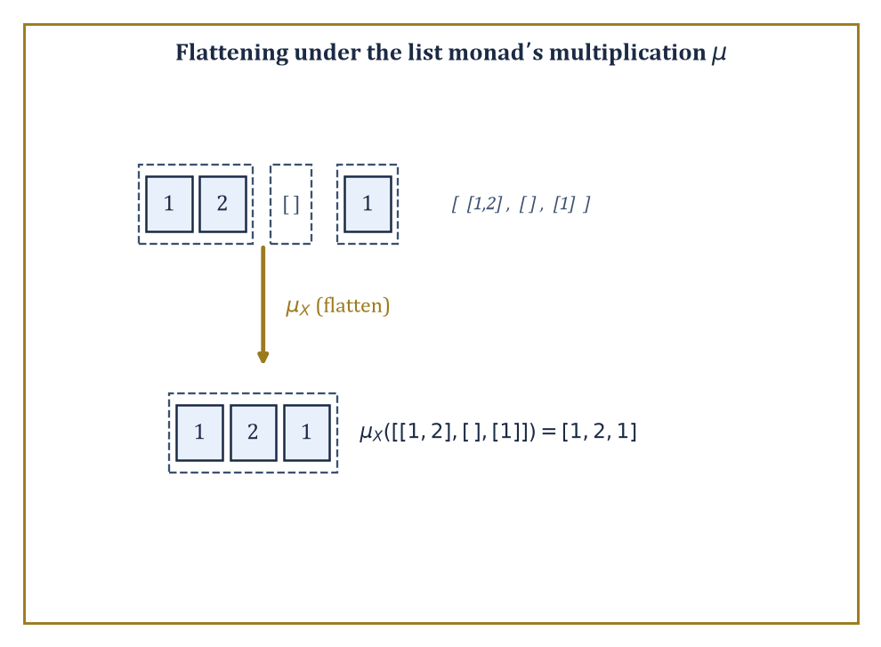
Figure 38.7 — The list monad’s multiplication, flattening three nested lists into one — no abstraction required, just concatenation.
η: id_C ⇒ T, μ: T² ⇒ T
These satisfy associativity and unit laws that mirror, almost word for word, the axioms of an ordinary monoid — which is why a monad is often described as a monoid in the category of endofunctors of C, a description that sounds like a joke until you check it truly is just that.
Every adjunction F ⊣ G produces a monad on C by setting
T = G∘F
with unit the adjunction’s unit and multiplication built from the counit; conversely every monad arises this way from at least one adjunction, sometimes several.
Numeric example — The list monad, flattened by hand. Let T: Set → Set send a set X to List(X), the set of finite lists of elements of X.
The unit wraps an element as a one-item list:
η_X(x) = [x]
The multiplication μ_X: List(List(X)) → List(X) flattens a list of lists by concatenation.
Take X = {1,2}, and the list of lists [1 2; ; 1] ∈ List(List(X)) — three sub-lists, of lengths 2, 0, and 1. Concatenating in order: [1,2] followed by [] followed by [1] gives:
μ_X([1 2; ; 1]) = [1,2,1]
This is the monad multiplication computed on an actual example: three nested lists become one flat list of length
2+0+1 = 3
with the elements kept in the same left-to-right order they appeared in the nesting.
Try it now — Flatten the list of lists [[1, 2], [], [3]] with the list monad’s μ, and wrap 5 with η. Answer →
Every monad T gives rise to a category of T-algebras (the Eilenberg-Moore category), whose objects are pairs (A, α) with A an object of C and α: T(A) → A a structure map satisfying the evident associativity and unit laws. The unit law says:
α(η_A(a)) = a
and the associativity law says α applied after flattening equals α applied twice.
These algebras are the categorical way of saying an algebraic theory such as group, or ring, or monoid, is secretly a monad on Set in disguise: the operations of the theory become the structure map, and the equational laws of the theory become the two algebra axioms.
Numeric example — Summation as an algebra for the list monad. Take A = ℕ, and let α: List(ℕ) → ℕ be the sum of a list (with the empty list summing to 0):
α([n₁,...,nₖ]) = n₁+...+nₖ
Check the unit law on n=7:
α(η_ℕ(7)) = α([7]) = 7
Correct. Check associativity on the nested list [3 5; 2] ∈ List(List(ℕ)) two ways. Direct route: flatten first with μ, giving [3,5,2], then sum:
α([3,5,2]) = 3+5+2 = 10
Indirect route: sum each inner list first (apply T(α), the functor T applied to the morphism α, meaning map α over the outer list), giving:
[α([3,5]), α([2])] = [8, 2]
Then sum that:
α([8,2]) = 8+2 = 10
Both routes give 10 — the associativity law for a monad algebra, checked with real numbers rather than merely asserted from the general theory.
What this is secretly saying is that ℕ, with addition and the number 0, is a monoid, and the list-algebra structure is precisely a repackaging of the monoid axioms: sum-then-sum equals sum-all-at-once, in whatever order you group the summation, which every schoolchild already knows and category theory now knows how to say for any algebraic theory whatsoever, not only addition.
The Kleisli category of a monad T has the same objects as C, but a morphism X → Y in the Kleisli category is a morphism X → T(Y) in C, composed by feeding the output of one Kleisli map through T and then multiplying with μ.
This is the category of free algebras for T, and — outside pure mathematics — it is also the structure that programming languages exploit to model computations that produce a value together with some side effect, such as possible failure, nondeterminism, or logging, without polluting ordinary function composition with the bookkeeping for that effect.
Numeric example — A Kleisli morphism for the list monad. In the Kleisli category of the list monad T = List, a Kleisli morphism f: {a} → {1,2,3} is an ordinary function {a} → List({1,2,3}), say:
f(a) = [1,2]
Read as: a produces two possible outputs, 1 and 2. Given a second Kleisli morphism g: {1,2,3} → {10,20}, say:
g(1)=[10,20], g(2)=[20], g(3)=[10]
The Kleisli composite g∘_K f sends a to the flattened concatenation of g applied to each element of f(a):
g(1)++g(2) = [10,20]++[20] = [10,20,20]
So the composite Kleisli morphism reports that a, via the intermediate nondeterministic choice of 1 or 2, can ultimately produce 10, 20, or 20 again — a computation that branches, tracked automatically by the monad’s bookkeeping, with the underlying List structure doing all the work of collecting up the possibilities that an ordinary function could never represent.
The list monad tracks the effect of nondeterminism; a smaller and even more common monad tracks the effect of possible failure.
Let T(X) be the set X with one extra element ⊥ (read: none, or failure) bolted on:
T(X) = X ⊔ {⊥}
The unit wraps a value as a definite success:
η_X(x) = x
The multiplication μ_X: T(T(X)) → T(X) collapses any failure at either level down to the single failure ⊥ of the outer type.
Numeric example — Flattening nested failure, counted explicitly. Let X = {1,2}, so:
T(X) = {1, 2, ⊥}
three elements. Then T(T(X)) has four elements: three of the form just(y) for y ∈ T(X) = {1,2,⊥} — namely just(1), just(2), just(⊥) — plus one further outer failure, written ⊥ again but now living one level up.
Apply μ_X to each of the four.
μ_X(just(1)) = 1
A genuine success passed straight through.
μ_X(just(2)) = 2
Likewise.
μ_X(just(⊥)) = ⊥
An inner failure surfacing as an outer one.
μ_X(⊥) = ⊥
An outer failure that was never going to become anything else.
So μ_X sends the four elements to the following:
{just(1), just(2), just(⊥), ⊥} → {1, 2, ⊥, ⊥}
Two of the four inputs collapse onto the same output ⊥, which is exactly the desired behavior: however failure arose, at whatever depth of nesting, there is only ever one flavor of it once you flatten, never two different kinds of nothing to keep track of.
Keep only this · Section 38.7: Monads and Algebras
The idea. A monad is a functor T with a way to wrap (η: X → T X) and a way to flatten (μ: T T X → T X) that fit together associatively; every adjunction produces one.
Core.
μ∘T(μ) = μ∘μ_T (flattening is associative)
μ∘η_T = id = μ∘T(η) (wrapping then flattening does nothing)
T = U∘F from an adjunction F ⊣ U
Typical mistake. Treating any wrapper as a monad. The unit and associativity laws must hold; a “list” that flattens by reversing would break μ∘T(η) = id.
Minimal example. Maybe monad: T X = X ⊔ {nothing}. η(x) = just(x); μ sends just(just(x)) to just(x), and both just(nothing) and nothing to nothing.
Practice. Easy to challenge; full worked answers, with the usual mistake, are in Answers to the Practice Sets at the back.
Easy — Check the unit law μ∘η = id for the list monad on the list [4, 7]. Answer →
Medium — For the summation algebra α: List(ℕ) → ℕ, verify the algebra law α∘μ = α∘T(α) on [[1, 2], [3, 4, 5]]. Answer →
Challenge — Show that the list monad arises from the free-monoid adjunction: identify T = U∘F, η and μ. Answer →

Section 38.8: Looking Ahead: From Categories to Higher Categories, Topoi, and Applied Category Theory
The series continues, and so, alarmingly, does the abstraction
We have now acquired the core of category theory: categories, functors, natural transformations, universal properties, limits and colimits, adjoint functors, the Yoneda lemma and monads, with abelian categories waiting in the optional final section. Each of these is, on its own, already load-bearing throughout the rest of mathematics; together they form a language flexible enough to describe entire fields — algebraic topology, algebraic geometry, representation theory, and a growing share of theoretical computer science — as instances of the same handful of ideas, rather than as unrelated bodies of technique that happen to share some vocabulary by coincidence.
The most immediate direction beyond what we have covered is higher category theory, where the objects-and-arrows picture is extended by adding arrows between arrows, called 2-morphisms, and then arrows between those, and so on, potentially forever. A 2-category has objects, 1-morphisms between objects, and 2-morphisms between parallel 1-morphisms, composable both along the 1-morphisms and along the 2-morphisms, subject to a compatibility condition called the interchange law, which is exactly as fussy as it sounds and is enforced without exception.
Abstract example — Cat as a 2-category, using arrows we have already met. The category Cat, whose objects are (small) categories and whose morphisms are functors, is itself a 2-category: its 2-morphisms are natural transformations between parallel functors. Take the two functors GLₙ and GL₁ from CRing to Grp met in Categories, Functors, and Natural Transformations, and the determinant natural transformation between them:
det: GLₙ ⇒ GL₁
In the language of 2-categories, CRing and Grp are the 0-cells (objects of Cat), GLₙ and GL₁ are 1-cells (functors, i.e. morphisms of Cat) from CRing to Grp, and det is a 2-cell, a natural transformation, sitting between those two parallel 1-cells.
The naturality square verified numerically in Categories, Functors, and Natural Transformations, with the matrix reducing mod 5, was in this light a direct, hands-on computation inside a 2-category, performed before the 2-category itself had even been named — which is rather the recurring experience of climbing this series: the general theory, once it finally arrives, usually turns out to have been quietly present in the examples all along.
Try it now — In Cat, a 2-morphism is a natural transformation. If α: F ⇒ G and β: G ⇒ H are natural transformations between functors C → D, what is the component of β∘α at A? Answer →
A second direction is topos theory: a topos is a category that behaves, structurally, like the category of sheaves on a topological space, and in particular has enough internal structure — including its own internal notion of true and false — to serve as an alternative foundation for mathematics, competing with, and in some respects generalizing, the usual set-theoretic foundation used throughout the rest of the series. The key extra piece of structure is a subobject classifier.
Numeric example — The subobject classifier in Set. In the topos Set, the subobject classifier is Ω, standing for the two truth values false and true:
Ω = {0, 1}
A subset A of a set X is classified by its characteristic function χ_A: X → Ω, defined by:
χ_A(x) = 1 if x ∈ A, and χ_A(x) = 0 otherwise
Take X = {1,2,3,4,5} and A = {1,3,5}. Then:
χ_A(1)=1, χ_A(2)=0, χ_A(3)=1, χ_A(4)=0, χ_A(5)=1
This is a completely explicit five-value table recovering A from Ω-valued data.
The universal property is that A, together with its inclusion into X, is recovered as the pullback of the arrow {*} → Ω (picking out the value 1, true) along χ_A — every subset of every set, in other words, is secretly the answer to a yes-or-no question, and Ω is the object where all such answers live.
Richer topoi replace the two truth values 0 and 1 with more elaborate structures, encoding logics stranger than ordinary true-or-false, which is a substantial part of why topos theory has found use well outside pure mathematics, wherever a notion of partial or context-dependent truth is wanted.
A third direction, newer and still very much in motion, is applied category theory: using functors, monoidal categories, and string-diagram calculi to give compositional, checkable models of systems in computer science, physics, chemistry, biology, and even linguistics, in each case treating how the parts combine as the primary mathematical object rather than an afterthought. Modern algebraic geometry, via schemes and stacks, and modern homotopy theory are likewise now written natively in the language introduced in this chapter, to the point where reading either subject without it is possible only in the sense that reading a novel is possible one unglossed foreign word at a time.
Numeric example — A monoidal category, sized up by hand. Applied category theory leans heavily on monoidal categories: categories equipped with a way of combining two objects into one, written ⊗, alongside ordinary composition — the extra structure needed to draw the string diagrams (boxes and wires) used to model circuits, processes, and resource flows compositionally.
The category Vect of real vector spaces is monoidal under the tensor product, with dimension given by:
dim(V ⊗ W) = dim(V) · dim(W)
Take V = ℝ² and W = ℝ³, so dim(V) = 2 and dim(W) = 3:
dim(V ⊗ W) = 2 · 3 = 6
meaning V ⊗ W ≅ ℝ⁶.
Composing two such combinations associatively — (U ⊗ V) ⊗ W against U ⊗ (V ⊗ W) — checks out immediately on dimensions alone:
(dim U · dim V) · dim W = dim U · (dim V · dim W)
This is ordinary multiplication being associative, which is the numerical shadow of the coherence isomorphisms a monoidal category is required to carry between the two ways of bracketing a triple tensor product.
The lesson to carry up the series is simple to state and, as promised at the start, does change how one reads mathematics afterwards: the maps between objects are frequently more informative than the objects themselves, and a systematic study of those maps — objects, arrows, composition, identity, and nothing more assumed — produces a language of remarkable unifying power, capable of noticing that a determinant, a divisor lattice, a free group, and a list of lists are, from a sufficient height, doing the same small number of things. Category theory is the mathematics of structure-preserving maps. We have learned to follow the arrows; the next chapter hands them a payload of bits and asks how much of the message survives the trip.
We arrived at the top of this chapter having thrown away rather a lot: no elements, no interiors, no privileged descriptions of what an object contains, only objects, arrows, composition, and identity, and the promise that anything worth saying can be said with those four ingredients alone. What we gained back was a single lens sharp enough to bring products in Set, free groups, matrix multiplication, determinants, and Ext groups into simultaneous focus, plus one lemma — Yoneda’s — sturdy enough to hold the entire enterprise up. If that trade sounds suspiciously good, category theorists would be the first to agree it occasionally feels that way even from the inside, usually right up until the referee report arrives.
The next chapter turns from structure-preserving maps in general to one very particular, very demanding kind: channels that carry a message from a sender to a receiver and are graded, ruthlessly, on how much of that message survives noise, compression, and the sheer cost of transmission. Information Theory measures exactly the kind of thing category theory prefers to leave unmeasured — not whether a structure-preserving map exists, but how many bits it costs you to describe one. The arrows are about to start counting.
Onward, then, and with the usual caution issued at every chapter of this series: the view improves the further you go, but so, regrettably, does the difficulty.
Keep only this · Section 38.8: Looking Ahead: From Categories to Higher Categories, Topoi, and Applied Category Theory
The idea. Category theory keeps going upward: categories of categories (2-categories), topoi where sets are replaced by sheaves, and monoidal categories for processes that combine side by side.
Core.
2-category: objects, 1-morphisms, 2-morphisms
subobject classifier in Set: Ω = {false, true}
Typical mistake. Thinking a topos is “a kind of topology”. A topos is a category that behaves enough like Set to do mathematics inside it; topological spaces give examples via their sheaves.
Minimal example. Subsets S ⊆ X correspond exactly to maps χ_S: X → {false, true}; that is the subobject classifier of Set.
Practice. Easy to challenge; full worked answers, with the usual mistake, are in Answers to the Practice Sets at the back.
Easy — How many subsets does X = {1, 2, 3} have, and how many maps X → Ω = {false, true}? Answer →
Medium — In the monoidal category (Set, ×), what is the unit object, and why is {∗} × A isomorphic to A? Answer →
Challenge — Explain why vertical composition of natural transformations is again natural, for α: F ⇒ G and β: G ⇒ H and an arrow f: A → B. Answer →

Section 38.9: Abelian Categories and Homological Algebra (Optional, Advanced)
Where kernels and cokernels finally get the respect they deserve
Optional, advanced
This section can be skipped on a first reading. It needs everything above plus comfort with modules and exact sequences, and nothing later in this volume depends on it. It is the doorway to homological algebra, the machinery behind homology in algebraic topology and derived functors in algebraic geometry.
An abelian category is a category that behaves, structurally, like the category of modules over a ring — the two running examples throughout this section will be abelian groups (ℤ-modules) and vector spaces.
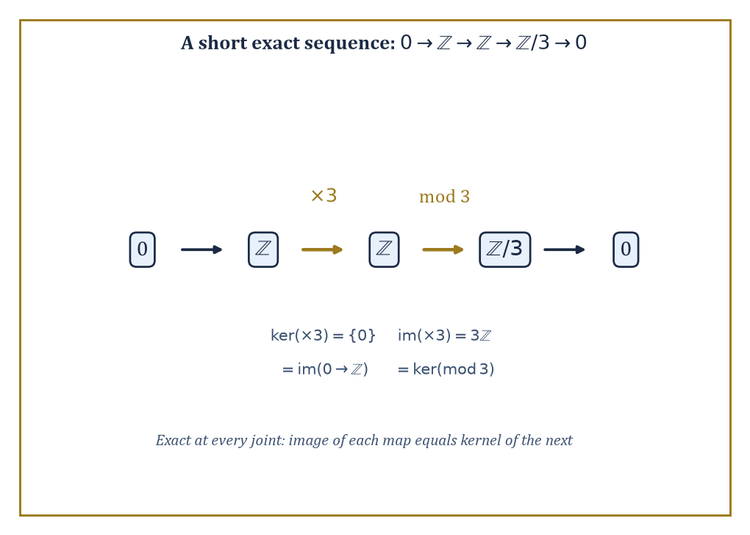
Figure 38.8 — A short exact sequence, checked at every joint: image of each map lands on the kernel of the next.
Formally, it has a zero object (both initial and terminal at once), every pair of objects has a biproduct, every morphism has a kernel and a cokernel, and every monomorphism arises as a kernel while every epimorphism arises as a cokernel.
Once these axioms hold, the entire apparatus of exact sequences and diagram-chasing lemmas familiar from a first course in module theory becomes available in any abelian category whatsoever, not merely in modules — a considerable saving of effort, since the same lemma no longer needs to be reproved from scratch in every new setting where it happens to apply.
Numeric example — A biproduct: product and coproduct, forced to coincide. In an abelian category, the product of two objects and their coproduct are always the same object, called the biproduct — a coincidence that fails badly outside the abelian world, as Section 38.4’s infinite free product ℤ/2 ∗ ℤ/2 already demonstrated for Grp.
Check it holds in Ab with A = ℤ/2 = {0,1} and B = ℤ/3 = {0,1,2}. The product A×B is the direct product group, with underlying set given by all ordered pairs, six elements in total, under componentwise addition:
A×B = {(0,0),(0,1),(0,2),(1,0),(1,1),(1,2)}
The coproduct in Ab of two abelian groups is also computed as the direct sum, which for finitely many finite groups is literally the same underlying set and operation as the direct product — so A⊕B has the same six elements.
Moreover, since gcd(2,3) = 1, the Chinese Remainder Theorem identifies this six-element group with ℤ/6 directly, via n ↦ (n mod 2, n mod 3):
ℤ/6 = {0,1,2,3,4,5}
0↦(0,0), 1↦(1,1), 2↦(0,2), 3↦(1,0), 4↦(0,1), 5↦(1,2)
Each of the six elements of ℤ/6 lands on a distinct pair, so the map is a bijection, and it is easily checked to respect addition in both coordinates.
Either way, product and coproduct agree on the nose:
|A×B| = |A⊕B| = 6 = |ℤ/6|
This is in flat contradiction to what happened with two copies of ℤ/2 in the non-abelian category Grp two sections ago.
Try it now — For φ: ℤ → ℤ/6, n ↦ n mod 6, what are the kernel and the cokernel? Answer →
Numeric example — Kernel and cokernel, computed for a genuine homomorphism. Work in Ab, the abelian category of abelian groups. Let φ: ℤ → ℤ/6 send n to n mod 6.
Its kernel is:
{n ∈ ℤ : φ(n) = 0} = {n : n ≡ 0 (mod 6)} = 6ℤ = {…,−12,−6,0,6,12,…}
the subgroup of multiples of 6 — a completely explicit computation, no abstraction required.
For a cokernel, let ψ: ℤ → ℤ send n to 3n, an injective homomorphism (multiplication by 3 never sends two different integers to the same place).
Its cokernel is the target modulo the image:
ℤ / 3ℤ
which has exactly three cosets, 0+3ℤ, 1+3ℤ, 2+3ℤ, so
coker(ψ) ≅ ℤ/3ℤ
a group of order 3 — the precise measure of how far ψ is from being surjective, expressed as an actual group you can write down.
Numeric example — A short exact sequence, checked at every joint. Consider the sequence:
0 → ℤ –(×3)→ ℤ –(mod 3)→ ℤ/3 → 0
Exactness at the first ℤ requires ker(×3) = image of the zero map, i.e.
ker(×3) = {0}
since ×3 is injective (3n=0 forces n=0), this holds.
Exactness at the middle ℤ requires image(×3) = ker(mod 3):
image(×3) = 3ℤ
ker(mod 3) = {n : n ≡ 0 (mod 3)} = 3ℤ
also — they match precisely.
Exactness at ℤ/3 requires image(mod 3) = ker(ℤ/3 → 0); the mod-3 map is surjective, so its image is all of ℤ/3, and the kernel of the map to the zero group is trivially all of ℤ/3 as well.
Every joint checks out: this is a genuine short exact sequence, the standard way of saying ℤ/3 is built from ℤ by killing the multiples of 3.
Derived functors, and in particular Ext and Tor, are built by resolving an object with a chain of nicer (projective, or free) objects and then applying a functor to the resolution instead of to the object directly; the failure of the resulting sequence to stay exact measures something new about the object, invisible if you only ever apply the functor once.
This machinery is the working foundation of modern algebraic topology, algebraic geometry, and representation theory, and it is worth seeing run to completion on a small case rather than only described.
Numeric example — Ext¹(ℤ/5, ℤ), computed from a free resolution. The abelian group ℤ/5 has a short free resolution:
0 → ℤ –(×5)→ ℤ → ℤ/5 → 0
This means ℤ/5 = ℤ / 5ℤ, presented using two copies of the free module ℤ and the multiplication-by-5 map between them.
To compute Ext¹_ℤ(ℤ/5, ℤ), apply the contravariant functor Hom_ℤ(–, ℤ) to the resolution:
0 → ℤ –(×5)→ ℤ → 0
Since Hom_ℤ(ℤ, ℤ) ≅ ℤ, identifying a homomorphism with the image of 1, this turns into the cochain complex:
ℤ –(×5)→ ℤ
Precomposing with ×5 corresponds again to multiplying by 5, because for φ: ℤ → ℤ:
(φ∘(×5))(1) = φ(5) = 5·φ(1)
Ext⁰(ℤ/5, ℤ) is the kernel of this ×5 map, which is {0} since ×5 is injective on ℤ.
Ext¹(ℤ/5, ℤ) is the cokernel of the same ×5 map, which is ℤ / 5ℤ, a group of exactly five elements.
So:
Ext¹_ℤ(ℤ/5, ℤ) ≅ ℤ/5
This is computed, not merely quoted, and matches the general pattern Ext¹_ℤ(ℤ/n, ℤ) ≅ ℤ/n for any n, here made concrete with n = 5 and every arrow in the resolution written out.
The point of isolating the abelian category axioms, rather than just working inside Ab or a category of modules directly, is that the same kernel-cokernel-exact-sequence machinery, and the same Ext and Tor computations, then apply verbatim to sheaves of abelian groups, to chain complexes, to representations of a group, and to any other category that happens to satisfy the same short list of structural axioms — the exactness properties are what make homological algebra work, and they were there all along, independently of which particular category of modules you first learned them in.
Keep only this · Section 38.9: Abelian Categories and Homological Algebra (Optional, Advanced)
The idea. An abelian category is one that behaves like modules over a ring — kernels, cokernels and exact sequences make sense — and homological algebra measures how far exactness fails (Ext, Tor, homology).
Core.
0 → A → B → C → 0 exact: injective, image = kernel, surjective
Ext¹(ℤ/n, ℤ) ≅ ℤ/n
Typical mistake. Assuming the middle term of a short exact sequence is the direct sum of the ends. 0 → ℤ → ℤ → ℤ/2 → 0 (multiply by 2) is exact, but ℤ is not ℤ ⊕ ℤ/2.
Minimal example. 0 → ℤ –(×5)→ ℤ → ℤ/5 → 0 is exact: ×5 is injective, its image 5ℤ is the kernel of reduction mod 5, and reduction is onto.
Practice. Easy to challenge; full worked answers, with the usual mistake, are in Answers to the Practice Sets at the back.
Easy — Is 0 → ℤ/2 → ℤ/4 → ℤ/2 → 0, with the first map 1 ↦ 2 and the second reduction mod 2, exact? Answer →
Medium — Use the resolution 0 → ℤ –(×3)→ ℤ → ℤ/3 → 0 to compute Ext¹(ℤ/3, ℤ). Answer →
Challenge — In an abelian category the product A × B and the coproduct A ⊔ B coincide. Show that in Grp, which is not abelian, they differ for A = B = ℤ/2. Answer →
Chapter 38 recap · Category Theory
• A category is objects plus composable arrows with identities; most of mathematics already lives in one (Set, Grp, Vect, Top).
• Functors carry arrows to arrows and respect composition; natural transformations compare two functors uniformly, one component per object.
• Universal properties define products, coproducts, equalizers, pullbacks and pushouts by the maps in or out, so the answer is unique up to unique isomorphism; limits and colimits are the general pattern.
• Adjunctions F ⊣ U pair a free construction with a forgetful one: Hom(F X, A) ≅ Hom(X, U A), naturally. Left adjoints preserve colimits, right adjoints limits.
• Yoneda: an object is determined by the maps into it (or out of it); natural transformations out of Hom(c, –) are elements of F(c).
• Monads are what an adjunction leaves on one side: wrap and flatten. The optional last section adds the abelian-category machinery behind homology.

Check Your Understanding — Chapter 38
Answers are in the Answer Key at the back of the book — have a go before you look.
1. [Explain] Why is the evaluation map η_V: V → V** (sending v to evᵥ) considered a ‘natural’ isomorphism, while an isomorphism V ≅ V* is not, even though both exist for finite-dimensional V?
See the answer →
2. [Compute] For the pullback example with A={1,2,3}, B={p,q,r}, C={x,y}, f(1)=x, f(2)=x, f(3)=y, g(p)=x, g(q)=y, g(r)=y, list the elements of A ×_C B and explain why (2,q) is not among them.
See the answer →
3. [Compute] For the poset C = {1,2,4} under divisibility and the divisor-set functor F (F(1)={1}, F(2)={1,2}, F(4)={1,2,4}), how many natural transformations Hom(2,–) ⇒ F are there, and why that many?
See the answer →
4. [Compute] Using the free resolution 0 → ℤ –(×5)→ ℤ → ℤ/5 → 0, compute Ext¹_ℤ(ℤ/5, ℤ).
See the answer →
5. [Concept] A monoid — a set with an associative binary operation and an identity, such as strings under concatenation with the empty string — can be seen as a category with exactly one object. What are the arrows, and what does composition become?
See the answer →
6. [Compute] In the category Set, take A = {a, b} and B = {1, 2, 3}. How many elements does their product A × B have, and how many does their coproduct A ⊔ B have? Why are the two answers different in kind, not merely in size?
See the answer →
7. [Prove] Show that any functor F preserves isomorphisms: if f: A → B is an isomorphism in C, then F(f) is an isomorphism in D.
See the answer →
8. [Explain] The Yoneda lemma is often summarized as “an object is completely determined by the maps out of it”. Why is that a statement about testing rather than about structure?
See the answer →
9. [Prove] Let α: F ⇒ G and β: G ⇒ H be natural transformations. Show that their componentwise composite (β ∘ α)_A = β_A ∘ α_A is natural.
See the answer →
10. [Challenge] Category theory is sometimes dismissed as “abstract nonsense”. When is that label fair, and when does it miss the point?
See the answer →

Problems — Chapter 38
The questions above test whether the ideas landed. These ask you to use them. Solutions are in Solutions to the Problems at the back. Work them before you look.
1. [Concept] A category with exactly one object is a familiar algebraic structure. Which one, and which two axioms of the category become its axioms?
2. [Compute] In the category of sets, what is the product of a set with 2 elements and a set with 3, and how many elements does it have?
3. [Concept] A functor from groups to sets forgets the multiplication. What must it do to a group homomorphism?
4. [Explain] Why is “there is a morphism from A to B” not, by itself, a reason to call A and B isomorphic?

Math, Actually

Chapter 39

Information Theory
Entropy, Codes, and the Art of Quantifying Uncertainty and Communication
After the vertiginous heights of Category Theory — where we stopped asking what mathematical objects are and started asking, with mounting existential unease, what they only do to one another — the reader may be glad of a chapter with numbers in it again. Entropy still has an equals sign. It sits still long enough to be computed with a pencil, which is more than could be said for some of the commutative diagrams two chapters back, several of which required a small aircraft hangar and a strong nerve.
This chapter belongs to Claude Shannon, who in 1948 did something almost indecent for an engineer: he wrote down a precise, provable, mathematically airtight answer to the question ‘how much information is in this message?’ — and then, having answered it, discovered the answer also told you the absolute fastest rate at which you could ever hope to send that message down a noisy wire without garbling it. Before Shannon, ‘information’ was a word people used the way they used ‘vibes’ — evocatively, and without units. After Shannon, it had units. Bits, to be precise, which is a pleasing pun that he did not, so far as history records, make on purpose.
We will work through entropy (the measurement of uncertainty), the asymptotic equipartition property (a law of large numbers wearing a trench coat), source coding (how far you can squeeze a message before it screams), mutual information and channel capacity (how much a noisy channel will actually let through), the channel coding theorem (Shannon’s two miracles: the achievable and the impossible, in the same breath), rate-distortion theory (compression when you’re willing to lose a little), and finally continuous and Gaussian channels, home of the single most quoted formula in all of engineering.
It is worth flagging early that this chapter’s subject is unusually well-behaved for a mathematical theory: its central theorems are not just elegant, they are the numbers your internet connection is quietly trying to approach right now. The next chapter, on Wavelets and Signal Analysis, will pick up more or less where we leave off — swapping Shannon’s discrete symbols for continuous signals and asking not just how much information a signal carries, but where in time and frequency it is hiding. Onward, then, and let us quantify some uncertainty.
Before you begin — Chapter 39
By the end of this chapter you will be able to:
1. Compute the self-information of an event and the entropy of a finite distribution in bits.
2. Explain the asymptotic equipartition property and use it to estimate how many sequences are typical.
3. Check the Kraft inequality and build a Huffman code by hand.
4. Compute mutual information and the capacity of the binary symmetric and erasure channels.
5. State the channel coding theorem and say which side of capacity a given code rate falls on.
6. Use the rate-distortion and Gaussian-capacity formulas, including water-filling over two sub-channels.
Prerequisites. Logarithms (Volume 1); discrete probability and expectation from Probability Spaces and Random Variables and Expectation, Variance, and Conditioning; the law of large numbers from Independence and Classical Limit Theorems. You can read this chapter before Chapter 42 if you know what an average is.
Estimated study time. About 12 hours, exercises included. Keep a calculator with log₂ at hand.

Section 39.1: What Information Theory Is
In which we learn to put a number on surprise
You have played twenty questions, and you already know the winning strategy even if nobody ever named it for you. Do not guess. Ask a question that cuts what is left in half. Animal or not? Bigger than a breadbox? Every answer throws away half the remaining possibilities, and a half of a half of a half gets small at a rate that still feels slightly unfair.
It is a good strategy, and you can say how good. A thousand possibilities fall to five hundred, then two hundred and fifty, and ten questions in you are down to one — ten halvings clear 1024 possibilities, the first power of two past a thousand. Ten questions, a thousand possibilities. That is the whole trick, and it has served you well since childhood.
Now watch it fail. Tomorrow’s weather in the Sahara has two possibilities, sunny or not. A fair coin has two possibilities, heads or tails. Counting says each needs one question. But you would not spend a question on the Sahara — you already know the answer, and asking feels faintly ridiculous. Two possibilities each, and one of them is worth asking about while the other is not.
So a different question is needed. Not ‘how many possibilities are there?’, but ‘how much do I learn when I am told which one happened?’
Here is the wall, and it is worth standing in front of it before we get past it. Whatever answers that question has to be a number of questions, and a number of questions is a whole number. A coin takes one. A die takes two if you are lucky and three if you are not, and there is no whole number that describes a die honestly. Rounding up to three discards something real, because three questions would also settle eight possibilities, and a die is not as hard as eight.
What rescues this will look like moving the goalposts. Stop counting questions and start counting halvings, and let the count come out fractional. A quantity that reports two and a half questions sounds like nonsense. It is the right answer.
Numbers before notation. How many times can you halve N down to one?
2 possibilities → 1 halving
4 possibilities → 2 halvings
6 possibilities → 2.585 halvings
8 possibilities → 3 halvings
100 possibilities → 6.644 halvings
The fractional entries carry a catch. Not one of them matches a question anybody could ask. Nobody has asked 0.585 of a question. That number is not a count of anything you will do on Tuesday — it is an exchange rate between possibilities and questions, and it turns back into a count of real questions only when averaged over a long run of repetitions. Typical Sets and the Asymptotic Equipartition Property is where that promise is made good. Until then the fraction is a bookkeeping device, and an honest one.
That halving count is the self-information of an outcome, and its unit is the bit. For N equally likely possibilities the count is log₂N, and since each carries probability p = 1/N, the same number is written −log₂ p, because log₂(1/N) = −log₂N. The minus sign is bookkeeping for the reciprocal and nothing more. Rare outcome, small p, large −log₂ p, much learned.
Information theory is the mathematical study of how information can be quantified, stored, and communicated. Its founding insight — Shannon’s, though the groundwork was prepared by Nyquist and Hartley in the 1920s — is that the ‘amount of information’ carried by an event is a function purely of how surprising that event is, which is to say, how improbable.
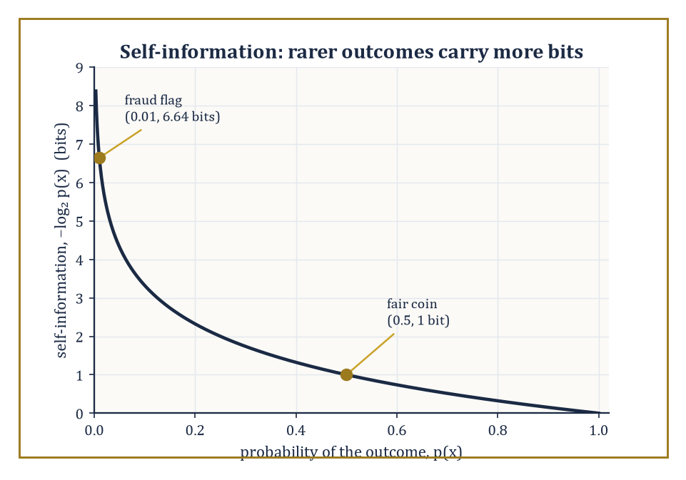
Figure 39.1 — The self-information curve −log₂p(x): a fair coin’s flip is worth one modest bit, a one-in-a-hundred fraud flag is worth nearly seven.
An event you were certain would happen (the sun rising, your college’s endowment growing) tells you nothing when it occurs. An event you thought vanishingly unlikely (your college’s endowment shrinking) tells you a great deal, solely by virtue of having defied expectation.
The formal quantity is the self-information of an outcome x with probability p(x), defined as follows, measured in bits.
−log₂ p(x)
Rare events have large self-information; certain events have none at all.
Numeric example — surprise in bits. A fair coin lands heads with probability p = 0.5. Its self-information is:
−log₂(0.5) = −(−1) = 1 bit
That is the amount of information needed to specify one of two equally likely outcomes, which is a satisfying place for the unit ‘bit’ to come from.
A fair six-sided die landing on any particular face has probability 1/6, so its self-information is:
−log₂(1/6) = log₂6 = ln6/ln2 ≈ 1.791759/0.693147 ≈ 2.585 bits
You need more than two but fewer than three bits to pin down which of six equally likely faces came up, which matches the intuition that six possibilities is ‘more surprising’ to resolve than two.
Now consider a rare event: a fraud-detection system flags a transaction with prior probability p = 0.01 (one in a hundred). Its self-information is:
−log₂(0.01) = −ln(0.01)/ln(2) = −(−4.60517)/0.693147 ≈ 6.644 bits
The rarer the event, the more bits it takes to say ‘that just happened’ — which is just why your insurer charges so little for a policy that almost never pays out, and so much for one that might.
Try it now — How many bits of surprise does an event of probability 1/8 carry? And one of probability 1/4? Answer →
Information theory answers two questions that sound like engineering but turn out to be pure mathematics wearing overalls. First: how far can a message be compressed before information is lost? Second: how fast can information be sent reliably down a channel that insists on corrupting some of it?
Both answers are asymptotic statements — they describe what happens as the length of the message (the ‘block length’) grows without bound, in the same spirit as the law of large numbers describing what happens to an average as the number of samples grows.
This is not a flaw in the theory; it is the theory’s central discovery, that reliability and efficiency are only perfectly achievable in a limit, but that the limit can be approached as closely as engineering nerve and patience allow.
The two limiting quantities that answer these questions — entropy for compression, channel capacity for communication — are the subjects of the next several sections.
Abstract example — why frequent symbols deserve short codes. Suppose a source emits English text, where the letter ‘e’ occurs roughly 12.7% of the time and the letter ‘z’ occurs roughly 0.07% of the time (these are the standard frequency estimates used in cryptography and typography). Intuitively, a smart code should give ‘e’ a short codeword and ‘z’ a long one, because ‘e’ needs to be written down constantly and ‘z’ almost never.
This is the intuition self-information formalizes: ‘e’ has low self-information, it is not very surprising.
−log₂0.127 ≈ 2.98 bits
‘z’ has high self-information, it is a genuine event when it turns up.
−log₂0.0007 ≈ 10.48 bits
A code that assigns codeword lengths roughly proportional to self-information — short for ‘e’, long for ‘z’ — will, on average, use far fewer bits per letter than a code that gives every letter a flat 5 bits (needed to distinguish 26 letters uniformly). This intuition, made rigorous, is the content of the source coding theorem in Source Coding and Data Compression.
It is worth saying plainly that information theory is both a branch of pure mathematics — built on probability theory, with theorems and proofs as rigorous as anything else in this series — and the working theoretical foundation underneath every digital device the reader owns.
The compression ratio your phone achieves on a photograph, the error-correcting code protecting the bits on a hard drive, the maximum data rate advertised for a Wi-Fi router: these are not vague engineering folklore, they are numbers computed, or bounded, by the theorems in this chapter.
Few branches of mathematics can claim their central theorem is checked, in practice, several billion times a second, somewhere on Earth, right now.
One further piece of vocabulary earns its place here before the formal machinery starts, because it will otherwise ambush the reader in Entropy and Its Properties: the base of the logarithm in every formula in this chapter is a choice of unit, not a mathematical necessity.
Base 2 gives bits, the natural unit when the underlying question is ‘how many binary yes/no questions does this take to pin down’, which is why it dominates a subject born to serve digital circuits that only ever ask binary questions.
Base e gives nats, the natural choice when the surrounding mathematics is calculus-heavy (differentiating a natural logarithm is pleasanter than differentiating one in an arbitrary base), and base 10 gives the rarely-used hartleys, named for the Bell Labs engineer whose 1928 paper anticipated much of what follows.
Converting between them is nothing more than multiplying by a fixed constant, since the following holds for any base b.
log_b(x) = log₂(x)/log₂(b)
That is a fact so mechanically simple that it is easy to forget it is the only thing standing between ‘bits’ and ‘nats’ ever disagreeing about anything substantive.
Numeric example — converting bits to nats. The self-information of the fraud-detection event above, p = 0.01, was computed as roughly 6.644 bits. To express the same quantity in nats (base e), use the conversion logₑ(x) = log₂(x) × ln(2).
6.644 × 0.693147 ≈ 4.605 nats
Sanity check directly:
−ln(0.01) = −(−4.60517) = 4.60517 nats
That matches to four decimal places (the tiny discrepancy above is only rounding in the intermediate 6.644 figure). Every formula in this chapter could equally well have been written with ‘ln’ in place of ‘log₂’ throughout — entropy, mutual information, capacity, all of it — and every inequality and every theorem would remain true, simply measured in nats instead of bits. The only reason this chapter sticks doggedly to base 2 is that bits are the unit the reader’s devices bill in, and a chapter about quantifying information ought, where it can, to quantify it in units the reader recognizes.
Keep only this · Section 39.1: What Information Theory Is
The idea. Information is surprise, measured on a log scale: an outcome of probability p carries −log₂ p bits, so that independent surprises add.
Core.
I(p) = −log₂ p bits
1 nat = 1/ln 2 ≈ 1.443 bits
Typical mistake. Measuring information by meaning. A fair coin toss carries one bit whether it decides a war or a coffee order.
Minimal example. A fair coin: p = 1/2, I = 1 bit. Two independent fair coins: p = 1/4, I = 2 bits = 1 + 1.
Practice. Easy to challenge; full worked answers, with the usual mistake, are in Answers to the Practice Sets at the back.
Easy — A card is drawn from a well-shuffled 32-card deck. How many bits does learning its identity give you? Answer →
Medium — Learning that a die shows an even number, then learning which even number: compute the bits for each step and check that they add up to the bits for learning the face directly. Answer →
Challenge — Show that if a surprise function I(p) is continuous, satisfies I(pq) = I(p) + I(q), and I(1/2) = 1, then I(1/2ⁿ) = n and I(1/2^(m/n)) = m/n, which forces I(p) = −log₂ p. Answer →

Section 39.2: Entropy and Its Properties
The single most overworked scalar in mathematics
What Information Theory Is put a number on one outcome: an outcome of probability p carries −log₂ p bits of surprise. Now ask about a whole source of outcomes. Take the biased coin this section uses, heads one time in ten. A head is a real surprise, −log₂ 0.1 ≈ 3.32 bits. A tail is barely news, −log₂ 0.9 ≈ 0.152 bits. Most flips are tails.
Average the surprise the way any average is weighted, by how often each outcome happens: 0.1 × 3.32 + 0.9 × 0.152 ≈ 0.469 bits per flip. That is less than half a bit, for an event that plainly needs a whole yes-or-no answer to report.
Here is the puzzle that number sets. Reporting one flip at a time, you cannot use less than one bit; there is no such thing as half a yes. So in what sense does this coin produce only 0.469 bits?
The answer is to stop reporting flips one at a time. Group them in blocks and give the common blocks short codes and the rare ones long codes, the scheme Source Coding and Data Compression builds properly. The best possible such code gives:
1 flip per block: 1 bit per flip
2 flips per block: 1.29 bits per block = 0.645 bits per flip
3 flips per block: 1.598 bits per block ≈ 0.533 bits per flip
4 flips per block: 1.9702 bits per block ≈ 0.493 bits per flip
The cost per flip falls with every larger block, heading for 0.469. Notice what it never does: it never reaches 0.469, and it never goes below it. No code of any block length can beat that number; Source Coding and Data Compression shows why.
That average surprise is the entropy of the source, written H(X). It is an average of the self-information of What Information Theory Is, weighted by probability, and its meaning is the one the table shows: the lowest number of bits per symbol that any code can approach.
The entropy of a discrete random variable X, written H(X), is the expected value of its self-information:
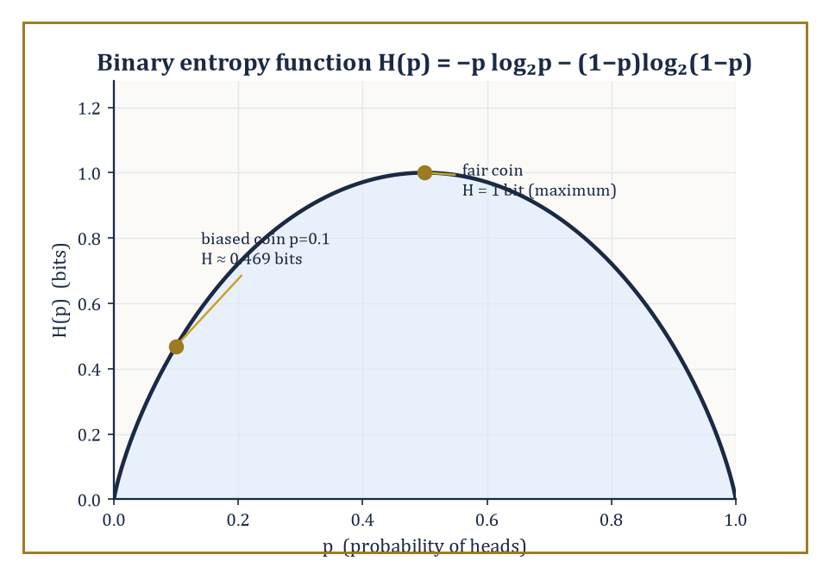
Figure 39.2 — The binary entropy function H(p), peaking at 1 bit for a fair coin and dropping to about 0.469 bits for the section’s p=0.1 example.
H(X) = E[−log₂ p(X)] = −Σₓ p(x) log₂ p(x)
The sum runs over all outcomes x with p(x) > 0 (by convention 0·log₂0 = 0, since an impossible outcome contributes neither surprise nor probability).
Entropy is the average number of bits of surprise a source generates per symbol — equivalently, and this is the operational meaning that makes the whole subject useful, it is the average number of bits needed to describe the outcome of X, once you’re allowed to be clever about how you assign codewords.
It is always non-negative, since −log₂ p(x) ≥ 0 whenever 0 ≤ p(x) ≤ 1, and it is maximized, among all distributions on a fixed finite set of outcomes, by the uniform distribution — spreading your uncertainty as thin as possible maximizes how surprised you are on average.
Numeric example — entropy of a biased coin. Take a coin biased so that heads occurs with probability p = 0.1 and tails with probability 1 − p = 0.9. Its entropy is given by:
H(X) = −0.1·log₂0.1 − 0.9·log₂0.9
Computing each term:
log₂0.1 = ln(0.1)/ln(2) ≈ −2.302585/0.693147 ≈ −3.321928, so −0.1·(−3.321928) = 0.332193
log₂0.9 = ln(0.9)/ln(2) ≈ −0.105361/0.693147 ≈ −0.152003, so −0.9·(−0.152003) = 0.136803
Summing:
H(X) ≈ 0.332193 + 0.136803 = 0.468996, or about 0.469 bits
Compare this to a fair coin (p = 0.5), whose entropy is exactly 1 bit — the biased coin, being far more predictable (it is heads only one time in ten), carries under half a bit of genuine uncertainty per flip, a little under half of what the fair coin carries. This 0.469-bit figure will recur throughout this chapter; it is worth remembering.
Try it now — Compute the entropy of a coin with P(heads) = 1/4. Answer →
Two structural facts about entropy are used constantly. First, additivity: if X and Y are independent random variables, then:
H(X, Y) = H(X) + H(Y)
— knowing two unrelated things is precisely as surprising as knowing each of them separately, no more, no less.
Second, the uniform-maximizes-entropy fact mentioned above is not a coincidence but a consequence of the strict concavity of the function −p log₂ p, via Jensen’s inequality; spreading probability mass more evenly always increases (or leaves unchanged) the entropy, and concentrating it always decreases entropy, all the way down to H = 0 for a variable that is certain (no surprise, no bits needed).
Numeric example — additivity for independent coins. Let X and Y each be independent fair coin flips.
H(X) = H(Y) = 1 bit
The joint variable (X, Y) has four equally likely outcomes — (H,H), (H,T), (T,H), (T,T) — each with probability 0.25. Its entropy is:
H(X,Y) = −4 × (0.25 · log₂0.25) = −4 × (0.25 × (−2)) = −4 × (−0.5) = 2 bits
This matches:
H(X) + H(Y) = 1 + 1 = 2
Contrast with the earlier biased coin: its entropy of 0.469 bits is strictly less than the fair coin’s 1 bit, confirming that the uniform distribution really does carry the maximum possible uncertainty for a two-outcome variable — the biased coin has thrown away potential surprise by being predictable.
When two random variables are correlated rather than independent, the relevant quantities are the joint entropy and the conditional entropy H(Y|X), the average remaining uncertainty in Y once X is known. The joint entropy is defined as:
H(X,Y) = −Σₓ,ᵧ p(x,y) log₂ p(x,y)
These are linked by the chain rule:
H(X,Y) = H(X) + H(Y|X)
The joint uncertainty is the uncertainty in X, plus whatever uncertainty in Y is left over after X has been revealed. This is the entropy version of the elementary probability identity
p(x,y) = p(x)p(y|x)
and it is the workhorse identity of the entire subject.
Numeric example — chain rule on a correlated pair. Let X and Y each be binary, with joint distribution:
p(0,0) = 0.5, p(0,1) = 0.1, p(1,0) = 0.1, p(1,1) = 0.3
This gives marginals p(X=0) = 0.6, p(X=1) = 0.4, and identically p(Y=0) = 0.6, p(Y=1) = 0.4 — check:
0.5+0.1 = 0.6 and 0.1+0.3 = 0.4 for X; 0.5+0.1 = 0.6 and 0.1+0.3 = 0.4 for Y
First, the joint entropy:
H(X,Y) = −[0.5log₂0.5 + 0.1log₂0.1 + 0.1log₂0.1 + 0.3log₂0.3]
We have:
log₂0.5 = −1, contributing 0.5
log₂0.1 ≈ −3.321928, contributing 0.1×3.321928 = 0.332193 twice, i.e. 0.664386
log₂0.3 = ln(0.3)/ln(2) ≈ −1.203973/0.693147 ≈ −1.736966, contributing 0.3×1.736966 ≈ 0.521090
Total:
H(X,Y) ≈ 0.5 + 0.664386 + 0.521090 = 1.685476 bits
Next, the marginal entropy:
H(X) = −[0.6log₂0.6 + 0.4log₂0.4]
log₂0.6 ≈ −0.736966, contributing 0.6×0.736966 ≈ 0.442180
log₂0.4 ≈ −1.321928, contributing 0.4×1.321928 ≈ 0.528771
So H(X) ≈ 0.970951 bits (and by symmetry H(Y) is the same). By the chain rule:
H(Y|X) = H(X,Y) − H(X) ≈ 1.685476 − 0.970951 ≈ 0.714525 bits
Knowing X still leaves about 0.71 bits of uncertainty about Y, less than Y’s own marginal entropy of 0.971 bits, as it should be — knowledge of a correlated variable can only reduce (or leave unchanged) uncertainty, never increase it.
A deeper structural fact, the data-processing inequality, says that if X, Y, Z form a Markov chain (written X → Y → Z, meaning Z depends on X only through Y — Z is computed from Y with no further peeking at X) then the mutual information satisfies:
I(X;Z) ≤ I(X;Y)
Processing can only destroy information about the original source, never manufacture more of it. This sounds obvious until you try to prove it (it follows from the chain rule and the non-negativity of conditional mutual information), and it is one of the two pillars — together with Fano’s inequality below — on which every converse proof in this chapter rests, including the impossibility half of the channel coding theorem in The Channel Coding Theorem.
Worked example — information degrading down a cascade of noisy channels. Let X be a uniformly random bit, sent through a binary symmetric channel (a channel that flips the bit with some fixed probability, defined properly in Mutual Information and Channel Capacity) with crossover probability 0.1 to produce Y, and then let Y be sent through a second, independent binary symmetric channel with crossover probability 0.2 to produce Z — so X → Y → Z is a genuine Markov chain, a cascade of two noisy links.
For a uniform input, the mutual information across a single binary symmetric channel with crossover ε is:
I = 1 − H(ε)
where H(ε) is the binary entropy function computed the same way as above. For the first link:
I(X;Y) = 1 − H(0.1) = 1 − 0.469 = 0.531 bits
(reusing the 0.469 figure from the worked example above). The cascade of two binary symmetric channels is itself a binary symmetric channel, with an effective crossover probability of:
ε_eff = 0.1(1−0.2) + 0.2(1−0.1) = 0.1×0.8 + 0.2×0.9 = 0.08 + 0.18 = 0.26
(a bit flips overall if exactly one of the two links flips it). So:
I(X;Z) = 1 − H(0.26)
Computing H(0.26):
log₂0.26 = ln(0.26)/ln(2) ≈ −1.347074/0.693147 ≈ −1.943416, contributing 0.26×1.943416 ≈ 0.505288
log₂0.74 = ln(0.74)/ln(2) ≈ −0.301105/0.693147 ≈ −0.434428, contributing 0.74×0.434428 ≈ 0.321477
So:
H(0.26) ≈ 0.826765, and I(X;Z) ≈ 1 − 0.826765 = 0.173235 bits
Indeed 0.173 ≤ 0.531: the second noisy link can only have thrown information away, never recovered it, just as the data-processing inequality demands.
Fano’s inequality is the quantitative partner to the data-processing inequality. It bounds how much residual uncertainty H(X|Y) can remain about X given an observation Y, in terms of the probability Pₑ that a best guess of X from Y is wrong:
H(X|Y) ≤ H(Pₑ) + Pₑ log₂(M − 1)
where M is the number of possible values X can take. Intuitively: if your error probability is small, the leftover uncertainty about X must also be small, because a low-error guesser is basically telling you what X was.
Numeric example — Fano’s inequality with four messages. Suppose a receiver is trying to identify which of M = 4 equally likely messages was sent, and guesses wrong with probability Pₑ = 0.1. Fano’s inequality bounds the leftover uncertainty:
H(X|Y) ≤ H(0.1) + 0.1 × log₂(4 − 1) = H(0.1) + 0.1 × log₂3
We already know H(0.1) ≈ 0.469 bits. And:
log₂3 = ln3/ln2 ≈ 1.098612/0.693147 ≈ 1.584963, so 0.1 × 1.584963 ≈ 0.158496
Adding:
H(X|Y) ≤ 0.469 + 0.158 = 0.627 bits
Since X itself, uniform over 4 messages, has entropy log₂4 = 2 bits, this says that a 10%-error guesser has left the receiver with at most 0.627 of the original 2 bits of uncertainty unresolved — most of the uncertainty about which message was sent has been eliminated by the observation. This is the exact inequality used, in reverse, to show that if the transmission rate exceeds channel capacity, Pₑ cannot be driven to zero — the converse half of the channel coding theorem in The Channel Coding Theorem.
Finally, relative entropy — also called Kullback–Leibler divergence, written D(p‖q) — measures the cost, in bits, of believing a distribution q when the true distribution is p:
D(p‖q) = Σₓ p(x) log₂(p(x)/q(x))
It is always non-negative (Gibbs’ inequality, itself a consequence of Jensen’s inequality applied to the concave logarithm), and it is zero exactly when p = q. Crucially, D(p‖q) ≠ D(q‖p) in general — mis-specifying in one direction is not the same mistake as mis-specifying in the other — which is why it is called a divergence and not a distance.
Relative entropy underlies large-deviations theory (how fast the probability of an atypical outcome decays) and reappears constantly as the currency of statistical inference and machine learning.
Numeric example — KL divergence is not symmetric. Let p = (0.5, 0.5) be the true (fair-coin) distribution and q = (0.9, 0.1) be a mistaken model of it. Then:
D(p‖q) = 0.5·log₂(0.5/0.9) + 0.5·log₂(0.5/0.1)
The first term:
log₂(0.5/0.9) = log₂(0.5556) ≈ −0.848, contributing 0.5×(−0.848) = −0.424
The second:
log₂(0.5/0.1) = log₂5 ≈ 2.321928, contributing 0.5×2.321928 ≈ 1.160964
Summing:
D(p‖q) ≈ −0.424 + 1.161 = 0.737 bits
Now swap the roles:
D(q‖p) = 0.9·log₂(0.9/0.5) + 0.1·log₂(0.1/0.5)
log₂(0.9/0.5) = log₂1.8 ≈ 0.847997, contributing 0.9×0.847997 ≈ 0.763197
log₂(0.1/0.5) = log₂0.2 ≈ −2.321928, contributing 0.1×(−2.321928) ≈ −0.232193
Summing:
D(q‖p) ≈ 0.763197 − 0.232193 ≈ 0.531 bits
So D(p‖q) ≈ 0.737 bits while D(q‖p) ≈ 0.531 bits — visibly unequal, confirming that relative entropy genuinely cares which distribution is ‘truth’ and which is ‘model’.
Entropy, then, is not one formula among many in this chapter — it is the load-bearing wall. Every theorem that follows, from the asymptotic equipartition property to the channel coding theorem, is either a statement about entropy directly or an inequality that bounds something else in terms of it.
Keep only this · Section 39.2: Entropy and Its Properties
The idea. Entropy is the average surprise of a source; it is largest for the uniform distribution and adds for independent parts.
Core.
H(X) = −Σ p(x) log₂ p(x)
0 ≤ H(X) ≤ log₂ n, H(X, Y) = H(X) + H(Y | X)
Typical mistake. Thinking KL divergence is a distance. D(p‖q) ≠ D(q‖p) in general, and neither obeys the triangle inequality.
Minimal example. (1/2, 1/4, 1/4): H = ½·1 + ¼·2 + ¼·2 = 1.5 bits.
Practice. Easy to challenge; full worked answers, with the usual mistake, are in Answers to the Practice Sets at the back.
Easy — Find the entropy of a fair eight-sided die. Answer →
Medium — For the joint distribution p(0,0) = 0.5, p(0,1) = 0.1, p(1,0) = 0.1, p(1,1) = 0.3, compute H(X, Y) and H(Y | X) = H(X, Y) − H(X). Answer →
Challenge — Prove H(X) ≤ log₂ n for a distribution p on n outcomes, using D(p‖u) ≥ 0 with u uniform. Answer →

Section 39.3: Typical Sets and the Asymptotic Equipartition Property
A law of large numbers, wearing a trench coat
You have seen this before
The AEP is the law of large numbers from Independence and Classical Limit Theorems applied to one particular average: the average surprise −(1/n) Σ log₂ p(Xᵢ). Its mean is H, so the average settles at H. Nothing new is assumed; only the quantity being averaged is new.
Flip a coin that lands heads nine times out of ten, a hundred times over. Any sequence at all is possible, but in practice you will see something close to 90 heads, and every sequence with about 90 heads has almost exactly the same, very small, probability. These overwhelmingly likely outcomes form the typical set, and although it holds nearly all the probability, it contains only a tiny fraction of the possible sequences. That observation is the reason data compression works. You only need short labels for the typical sequences, and the number of bits per flip needed to label them is the entropy of the coin, about 0.47.
The asymptotic equipartition property, universally abbreviated AEP, is the observation that if X₁, X₂, …, Xₙ are drawn independently from the same distribution (i.i.d.), then a particular quantity converges, in probability, to H(X) as n grows large:
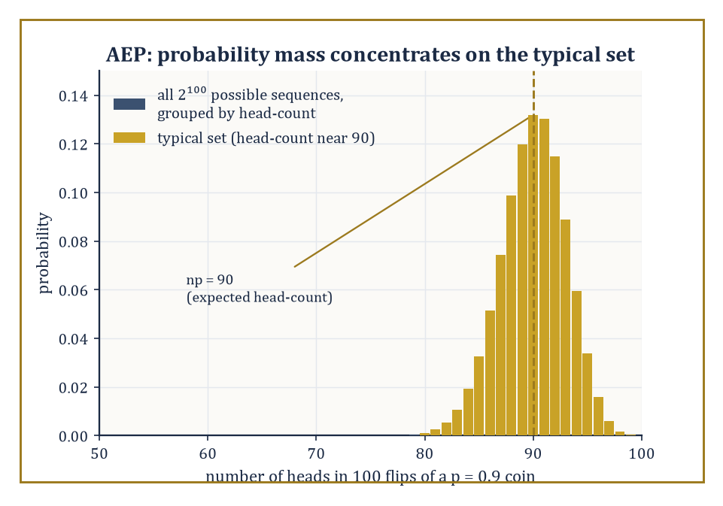
Figure 39.3 — One hundred flips of the p=0.9 coin: almost all the probability crowds around the expected 90 heads, the typical set the AEP describes.
−(1/n)log₂ p(X₁,…,Xₙ) → H(X)
This is nothing more exotic than the weak law of large numbers, applied to the random variables −log₂ p(Xᵢ), whose expected value is by definition H(X) — but its consequence is startling.
For large n, almost all of the probability mass concentrates on a set of sequences that are all roughly equally likely, each with probability close to 2^(−nH(X)).
This set is called the typical set, Aₙ(ε), and it has two remarkable properties simultaneously: its total probability approaches 1, and yet it typically contains only a tiny fraction of all possible sequences.
It is rather as if, of the millions of ways a long sequence of coin flips could in principle come out, nature agrees to use only a small, well-mannered subset of them, and everyone is too polite to mention the rest.
Worked example — the probability of a typical sequence. Take a coin biased toward heads with p = 0.9, and flip it n = 100 times. Its entropy, computed the same way as the p = 0.1 case in Entropy and Its Properties (binary entropy is symmetric, H(p) = H(1−p)), is H(0.9) ≈ 0.469 bits per flip.
Consider one specific sequence with exactly 90 heads and 10 tails (the ‘typical’ count, since 0.9×100 = 90). Its exact probability is:
p⁹⁰q¹⁰ = 0.9⁹⁰ × 0.1¹⁰
Taking logs is easier:
log₂(0.9⁹⁰×0.1¹⁰) = 90log₂0.9 + 10log₂0.1 = 90×(−0.152003) + 10×(−3.321928) = −13.680 − 33.219 = −46.900
So the probability of this exact sequence is 2^(−46.9). Notice this is exactly n×H(0.9):
n×H(0.9) = 100×0.469 = 46.9
For a sequence whose head-count precisely matches the expected count, the AEP estimate p(x) ≈ 2⁻ⁿᴴ is not merely approximate but exact, since:
−log₂p(x) = −[np log₂p + nq log₂q] = nH(p)
This holds precisely whenever the counts land on np and nq. Numerically, 2^(−46.9) ≈ 7.62×10⁻¹⁵ — a fantastically small number, but note that it is the same fantastically small number for every sequence with exactly 90 heads, which is the entire content of ‘equipartition’: typical sequences are not just probable in aggregate, they are all roughly equally probable individually.
Try it now — For 100 flips of the p = 0.9 coin, take one sequence with exactly 90 heads. Compute −(1/100) log₂ of its probability. Answer →
The second half of the AEP concerns how many typical sequences there are.
Since each typical sequence has probability roughly 2⁻ⁿᴴ, and their total probability is roughly 1, there must be roughly 2ⁿᴴ of them — far fewer, for H < log₂|alphabet|, than the total number of possible length-n sequences, which is |alphabet|ⁿ.
This is the ‘equipartition’: nature has quietly discarded almost all conceivable sequences and concentrated attention on a comparatively small, roughly-equiprobable club.
Numeric example — counting typical sequences. Continuing the n = 100, p = 0.9 example, the AEP estimate for the size of the typical set is roughly:
2ⁿᴴ = 2^(46.9)
Computing this:
2^(46.9) = 2⁴⁷ × 2^(−0.1)
Since 2⁴⁷ ≈ 1.4074×10¹⁴ and 2^(−0.1) ≈ 0.9330, we get:
2^(46.9) ≈ 1.313×10¹⁴
Compare this to the exact count of sequences with 90 heads out of 100, which is the binomial coefficient C(100,10) (choosing the positions of the 10 tails):
C(100,10) = 17,310,309,456,440 ≈ 1.731×10¹³
These are not equal — and should not be expected to be, since the AEP’s ‘2ⁿᴴ typical sequences’ is an asymptotic estimate that includes all sequences whose empirical statistics are only close to (90,10), not only the exact count — but they sit within the same order of magnitude, which is the qualitative behavior the AEP predicts and is enough to confirm the estimate is doing its job. As n grows larger still, the approximation (1/n)log₂|typical set| → H becomes exact in the limit.
This is the mechanism that turns entropy from an abstract expectation into an operational compression rate.
If nearly all the probability mass lives in a set of about 2ⁿᴴ sequences, one need only assign a fixed-length index to each member of that set — requiring about nH bits total, or H bits per symbol — and assign nothing (or an error flag) to the negligible remainder.
As n → ∞, the probability of landing outside the typical set vanishes, so the scheme’s failure probability vanishes too, while its rate approaches H exactly.
This single idea, sharpened, is the entire proof of the achievability half of the source coding theorem in the next section.
Numeric example — compression via typicality. Returning once more to n = 100 flips of the p = 0.9 coin: naive fixed-length encoding of 100 independent bits (treating each flip as needing its own bit) would cost 100 bits.
But indexing only the typical sequences costs about:
⌈nH⌉ = ⌈46.9⌉ = 47 bits
This is because there are roughly 2^(46.9) ≈ 1.313×10¹⁴ of them, and ⌈log₂(1.313×10¹⁴)⌉ = 47 bits suffices to give each a distinct label.
The compression ratio achieved is:
47/100 = 0.47
This matches the entropy rate H(0.9) ≈ 0.469 almost precisely (the small gap is the ceiling function rounding up to a whole number of bits). This is a concrete instance of the general promise: a source with entropy H bits per symbol can be compressed to just over H bits per symbol, and — this is the content of the converse, proved by the same typicality argument run backwards — no scheme can reliably do any better.
The idea of typicality extends naturally from single sequences to pairs. If (X,Y) are drawn i.i.d. from a joint distribution, a pair of sequences (xⁿ, yⁿ) is jointly typical if each marginal sequence is typical for its own distribution and the pair, taken together, is typical for the joint distribution — meaning:
p(xⁿ,yⁿ) ≈ 2^(−nH(X,Y))
This joint version of typicality is what makes channel coding possible: it lets a decoder search among roughly 2^(nH(X,Y)) plausible input-output pairs, out of a much larger space of 2^(nH(X))·2^(nH(Y)) combinations if X and Y were treated as independent, and this gap between the two counts is exactly what gives mutual information its operational meaning as a communication rate in Mutual Information and Channel Capacity.
Abstract example — joint typicality on a noisy link. Consider a uniformly random input bit X sent through a channel that flips it with probability 0.1 to produce output Y (a binary symmetric channel, formalized properly in the next section).
If a decoder receives a long output sequence yⁿ, it does not need to search among all 2ⁿ possible input sequences xⁿ for one that could plausibly have produced it — only among those jointly typical with yⁿ, of which there are roughly:
2^(nH(X|Y)) = 2^(n(H(X)−I(X;Y)))
Since I(X;Y) = 1 − H(0.1) ≈ 0.531 bits per use (computed in Section 39.2’s cascade example) and H(X) = 1 bit (uniform input), the decoder’s plausible-input search space shrinks to roughly:
2^(n(1−0.531)) = 2^(0.469n)
This is a dramatic reduction from the full 2ⁿ, and the reduction that lets a decoder narrow down the true input reliably as n grows, which is the seed of the channel coding theorem’s achievability proof.
Typicality, in short, is the technical engine hidden under the bonnet of nearly every asymptotic theorem in classical information theory.
It converts questions about expectations (entropy, mutual information) into questions about counting sets of roughly equal size, which is a far more tractable kind of mathematics — and it is why so many of Shannon’s proofs, for all their conceptual audacity, ultimately reduce to a careful application of the law of large numbers.
Keep only this · Section 39.3: Typical Sets and the Asymptotic Equipartition Property
The idea. For long runs of a source, almost all the probability sits on about 2ⁿᴴ “typical” sequences, each with probability close to 2⁻ⁿᴴ.
Core.
−(1/n) log₂ p(X₁,…,Xₙ) → H (in probability)
|typical set| ≈ 2ⁿᴴ
Typical mistake. Thinking the most likely sequence is typical. All heads is the single most likely sequence for the p = 0.9 coin, and it is not typical.
Minimal example. A fair coin, n = 10: H = 1, every sequence has probability 2⁻¹⁰, and all 2¹⁰ = 1,024 sequences are typical.
Practice. Easy to challenge; full worked answers, with the usual mistake, are in Answers to the Practice Sets at the back.
Easy — For n = 20 flips of a fair coin, how many sequences are typical, and how much compression does the AEP promise? Answer →
Medium — For p = 0.9 and n = 100, what fraction of all 2¹⁰⁰ sequences is typical? Answer →
Challenge — Explain why the all-heads sequence for the p = 0.9 coin, n = 100, is not typical, although it is the most likely single sequence. Answer →

Section 39.4: Source Coding and Data Compression
The first operational triumph, or: how to say less and mean the same
The source coding theorem is the formal promise implicit in the AEP argument of the previous section: a discrete memoryless source with entropy H can be compressed, with vanishing error probability, to any rate arbitrarily close to H bits per symbol — and it cannot be reliably compressed below H, no matter how ingenious the scheme.
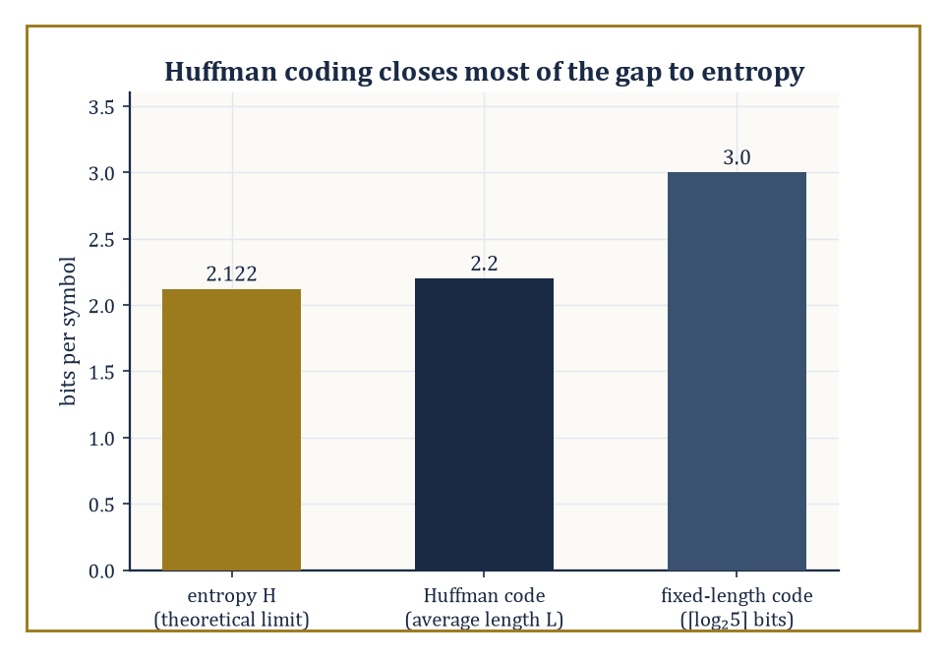
Figure 39.4 — For the section’s five-symbol source, Huffman coding lands within a tenth of a bit of the entropy limit, beating the naive fixed-length code by nearly a bit per symbol.
H is not merely a lower bound one hopes to approach; it is a wall.
Before reaching for Huffman coding or arithmetic coding, though, one needs the right vocabulary: a code assigns to each source symbol a string of bits (a codeword); it is uniquely decodable if no two symbol sequences ever produce the same bit string; and it is a prefix code (or instantaneous code) if no codeword is a prefix of another, which lets a decoder recognize the end of a codeword the instant it arrives, without needing to peek ahead.
The Kraft inequality characterizes which sets of codeword lengths admit a prefix code: lengths ℓ₁,…,ℓ_M admit one if and only if
Σᵢ 2^(−ℓᵢ) ≤ 1
Numeric example — checking the Kraft inequality. Suppose a source has four symbols and a proposed code assigns codeword lengths 1, 2, 3, and 3 bits respectively. Checking the Kraft inequality:
Σ2^(−ℓᵢ) = 2⁻¹ + 2⁻² + 2⁻³ + 2⁻³ = 0.5 + 0.25 + 0.125 + 0.125 = 1.0
Since the sum equals exactly 1 (not only ≤ 1), a prefix code with these lengths exists and is ‘complete’ — it uses the entire binary tree with no wasted leaves. A concrete instance: codewords 0, 10, 110, 111 have these lengths (1,2,3,3) and one can check directly that none is a prefix of another.
Had the proposed lengths instead been 1, 1, 2, 2, the sum would be
0.5+0.5+0.25+0.25 = 1.5 > 1
and no prefix code with those lengths could exist — the Kraft inequality is doing real work, ruling out impossible code designs before anyone wastes an afternoon trying to build one.
Try it now — Can a prefix code have codeword lengths 1, 1 and 2? Answer →
Huffman coding is the classical algorithm that constructs an optimal prefix code — optimal meaning it achieves the minimum possible average codeword length among all prefix codes for a given symbol distribution.
The construction is a simple greedy recipe: repeatedly take the two least probable remaining symbols (or merged groups of symbols), merge them into a single node with combined probability, and repeat until one node — the root — remains; the resulting binary tree gives every symbol a codeword equal to the path from root to leaf.
Huffman’s guarantee is a tight one: the resulting average length L satisfies
H ≤ L < H + 1
so a Huffman code is never more than one bit per symbol worse than the theoretical entropy limit, and is often much closer.
Numeric example — building a Huffman code by hand. Consider five symbols A, B, C, D, E with probabilities 0.4, 0.2, 0.2, 0.1, 0.1.
Step 1: merge the two smallest, D and E (0.1 each), into a node ‘DE’ with probability 0.2. Remaining nodes:
A=0.4, B=0.2, C=0.2, DE=0.2
Step 2: merge the two smallest among these — say B and C (0.2 each) — into ‘BC’ with probability 0.4. Remaining:
A=0.4, DE=0.2, BC=0.4
Step 3: merge the two smallest, DE (0.2) and A (0.4), into ‘ADE’ with probability 0.6. Remaining:
BC=0.4, ADE=0.6
Step 4: merge these into the root, probability 1.0.
Reading off tree depths: B and C sit at depth 2 (under BC, itself a direct child of the root); A and DE sit at depth 2 as children of ADE (itself a child of the root); D and E sit at depth 3, as children of DE.
So codeword lengths are:
A=2, B=2, C=2, D=3, E=3
The average length is
L = 0.4×2 + 0.2×2 + 0.2×2 + 0.1×3 + 0.1×3 = 0.8+0.4+0.4+0.3+0.3 = 2.2 bits/symbol
The source’s entropy is
H = −(0.4log₂0.4 + 0.2log₂0.2 + 0.2log₂0.2 + 0.1log₂0.1 + 0.1log₂0.1)
Computing:
0.4×1.321928 ≈ 0.528771
0.2×2.321928 ≈ 0.464386 (twice, for B and C, giving 0.928771)
0.1×3.321928 ≈ 0.332193 (twice, for D and E, giving 0.664386)
Total:
H ≈ 0.528771 + 0.928771 + 0.664386 = 2.121928 bits
Indeed
H ≈ 2.122 ≤ L = 2.2 < H+1 = 3.122
as Huffman’s guarantee promises — and compare this to the naive fixed-length code, which would need
⌈log₂5⌉ = 3
bits per symbol regardless of probabilities: Huffman’s 2.2 bits/symbol is a 27% reduction, achieved purely by giving the frequent symbol A a short codeword and the rare symbols D, E longer ones, precisely the intuition previewed in What Information Theory Is.
Huffman coding is optimal among prefix codes for a source whose symbols arrive independently with a known, fixed distribution — but real sources (English text, images, audio) have memory: the next symbol’s distribution depends on recent history.
Arithmetic coding and the Lempel–Ziv family of algorithms (LZ77, LZ78, and their many descendants) are designed to approach the entropy rate of such sources without needing to build an explicit codeword table for every possible context.
Arithmetic coding represents an entire message as a single high-precision fraction within [0,1), narrowing the interval at each symbol according to its (possibly context-dependent) probability; Lempel–Ziv methods instead build a dictionary of previously seen substrings on the fly and replace repeated substrings with short back-references.
Neither approach requires the source to hold still and be measured in advance, which is just as well, since English prose, unlike a fair coin, has never once in its history behaved itself.
Abstract example — dictionary compression by hand. Consider the eight-character string ‘ABABABAB’, which is highly redundant.
An LZ77-style encoder scans left to right: it emits the literal ‘A’ (nothing to reference yet), then the literal ‘B’, and upon reaching the third character finds that the remaining six characters ‘ABABAB’ exactly match a substring starting two positions back — so it emits a single back-reference ’(offset=2, length=6)’ instead of six more literal characters.
The output is then just two literals plus one back-reference, rather than eight literals — a substantial saving that grows without bound as the repeated pattern is extended, which is the behavior Huffman coding (a symbol-by-symbol scheme with no memory of context) cannot exploit, since it would assign ‘A’ and ‘B’ fixed-length codewords regardless of the fact that they keep repeating in lockstep.
Every lossless codec in daily use — ZIP, PNG, FLAC, and the entropy-coding stage inside MP3 and modern video codecs — is, underneath its engineering, a sophisticated approximation to the entropy limit, constrained by real-world demands for speed, memory, and low delay that the pure mathematics is free to ignore.
Shannon himself estimated the entropy of written English at somewhere around one to one-and-a-half bits per character (based on how well human readers could guess the next letter), a striking contrast to the eight bits per character that a naive ASCII encoding uses, and roughly in line with the five-to-eightfold compression ratios general-purpose text compressors routinely achieve in practice.
Numeric example — sanity-checking Shannon’s English-entropy estimate. Take Shannon’s estimate of one to one-and-a-half bits per character against the eight bits per character spent by naive fixed-width ASCII.
The implied compression ratio at the two ends of that range is
8/1 = 8-to-1
8/1.5 ≈ 5.33-to-1
which is the ‘five-to-eightfold’ figure quoted above, not a rounded-off approximation to it.
Ordinary general-purpose compressors (ZIP-style tools on plain English prose) typically land around four- to sixfold in practice, comfortably inside that theoretical envelope once the gap between an idealized per-character entropy estimate and a real compressor’s engineering overhead is allowed for.
It is a small but satisfying check that an entropy figure estimated from nothing more than letter frequencies and how well a human guesses the next character predicts, within a rounding error, the compression ratios that real software delivers on real text.
Lossless compression is, chronologically and conceptually, the first operational success of information theory: proof, sitting on every hard drive on Earth, that an abstract theorem about expected logarithms translates directly into engineering that works.
Keep only this · Section 39.4: Source Coding and Data Compression
The idea. Lossless compression cannot beat the entropy on average, and prefix codes such as Huffman’s get within one bit of it.
Core.
Kraft: Σ 2^(−ℓᵢ) ≤ 1
H ≤ L̄ < H + 1 (optimal prefix code)
Typical mistake. Breaking Huffman ties carelessly and then believing the code is wrong. Different tie-breaks give different codes with the same average length.
Minimal example. (1/2, 1/4, 1/4) gets lengths 1, 2, 2: average 1.5 bits, equal to the entropy.
Practice. Easy to challenge; full worked answers, with the usual mistake, are in Answers to the Practice Sets at the back.
Easy — Build a Huffman code for probabilities 0.5, 0.25, 0.25 and give its average length. Answer →
Medium — Build a Huffman code for 0.4, 0.3, 0.2, 0.1 and compare its average length with the entropy 1.846 bits. Answer →
Challenge — Show that the Shannon lengths ℓ = ⌈−log₂ p⌉ for 0.4, 0.3, 0.2, 0.1 satisfy Kraft, and compute their average length. Answer →

Section 39.5: Mutual Information and Channel Capacity
How much a noisy wire will actually let through
Before this section
What you need. Entropy and conditional entropy from Entropy and Its Properties.
Why it matters. Mutual information is the one number that says how much a measurement tells you. Capacity, the next section’s theorem and the generalization bounds of the last section are all built from it.
Read a string of bits to a friend down a bad telephone line. She writes down what she hears, and one bit in ten comes out wrong: you say 0 and she writes 1, or the other way round. Nobody can tell which ones were flipped. Her page looks like any other page of bits.
How much does she actually learn from each bit? The tempting answer is 0.9 of a bit, since nine bits in ten arrive correctly. Try that answer on a worse line, one that flips half the bits. It says she learns half a bit each time. But on that line what she writes is a coin toss, whatever you said, and she could have filled the page without listening. She learns nothing at all, so ‘half a bit’ is wrong.
So the question needs a better measure. Not ‘what fraction of the bits arrive correctly’, but ‘how much less uncertain is she about what you said, once she has heard it’?
The difficulty is that she cannot see her own errors. If she could, she would know which bits to throw away. Because she cannot, every bit she writes is under suspicion, the correct ones included.
The measure that works is a subtraction: her uncertainty about your bit before hearing it, minus her uncertainty after. Both are entropies, in the sense of Entropy and Its Properties. Before, a fair bit carries 1 bit of uncertainty. After, what is left is the uncertainty of the flip itself, H(0.1) ≈ 0.469 bits. What she has gained is the difference:
1 flip in 10: 1 − 0.469 = 0.531 bits per use (not 0.9)
1 flip in 5: 1 − 0.722 = 0.278 bits per use (not 0.8)
1 flip in 2: 1 − 1 = 0 bits per use (not 0.5)
The tempting answer is not useless, though. If the line did not flip bits but blanked them out, so that she heard a clear ‘missing’ instead of a wrong digit, she would know which bits to ignore, and 0.9 and 0.8 would be exactly right. The last worked example in this section makes that comparison.
The subtraction is the mutual information I(X;Y), and its largest possible value, over every way of choosing what to send, is the capacity of the line. The table above comes back below, row by row, as the capacity of the binary symmetric channel.
Mutual information I(X;Y) measures how much observing Y reduces uncertainty about X.
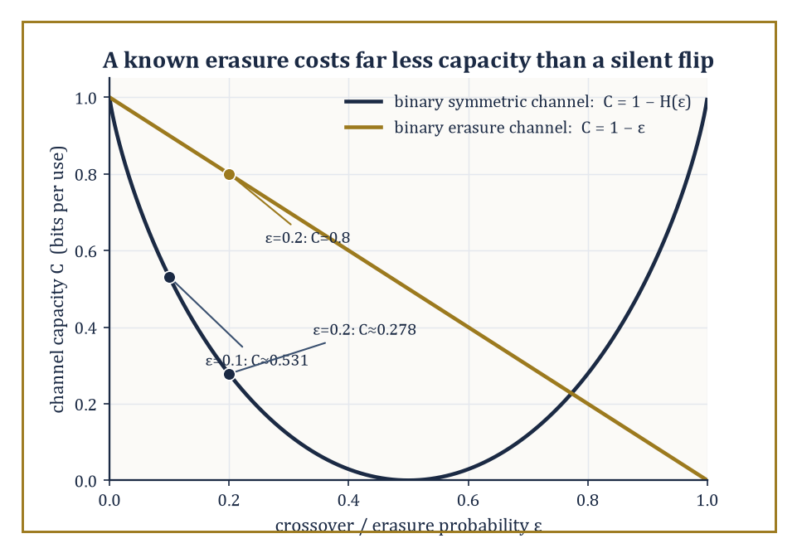
Figure 39.5 — Capacity against noise level for the binary symmetric channel and the binary erasure channel: at the same 20% corruption rate, a known erasure costs far less capacity than a silent flip.
I(X;Y) = H(X) − H(X|Y) = H(Y) − H(Y|X) = H(X) + H(Y) − H(X,Y)
These are three equivalent formulas expressing the same quantity — a symmetric one, since I(X;Y) = I(Y;X) despite the asymmetric-looking definition, and a non-negative one, vanishing when X and Y are independent (learning Y then tells you literally nothing new about X).
Numeric example — mutual information of a correlated pair. Return to the joint distribution from Entropy and Its Properties: p(0,0)=0.5, p(0,1)=0.1, p(1,0)=0.1, p(1,1)=0.3, with marginal entropies H(X) = H(Y) ≈ 0.970951 bits and joint entropy H(X,Y) ≈ 1.685476 bits.
I(X;Y) = H(X) + H(Y) − H(X,Y) ≈ 0.970951 + 0.970951 − 1.685476 ≈ 0.256426 bits
So the mutual information is about 0.257 bits. This modest but positive figure says: observing Y reduces the average uncertainty about X by roughly a quarter of a bit — consistent with the earlier finding that H(Y|X) ≈ 0.715 bits, noticeably less than H(Y)’s own 0.971 bits, the difference between the two being exactly this 0.257-bit mutual information.
Try it now — If X is a fair bit and Y = X exactly, what is I(X; Y)? What if Y is an independent fair bit? Answer →
A discrete memoryless channel is specified by an input alphabet, an output alphabet, and a fixed set of transition probabilities p(y|x) — the probability the channel outputs y given that x was sent, with each use of the channel statistically independent of every other use.
This is an abstraction, but a remarkably productive one: it strips away every engineering detail (voltage levels, modulation schemes, physical noise sources) and leaves only the bare statistical relationship between what goes in and what comes out.
The channel’s capacity is defined as the largest mutual information achievable by choosing the best possible input distribution:
C = maxₚ₍ₓ₎ I(X;Y)
This is a single number per channel, computed once and for all, independent of how long a message one intends to send.
Abstract example — a channel as a stochastic matrix. The simplest non-trivial discrete memoryless channel is the binary symmetric channel (BSC): input and output alphabets are both {0,1}, and the channel flips the input bit with probability ε (the crossover probability), leaving it unchanged with probability 1−ε. Its transition probabilities form a 2×2 matrix:
p(0|0)=1−ε, p(1|0)=ε, p(0|1)=ε, p(1|1)=1−ε
This tiny stochastic matrix is the abstract skeleton underlying every noisy binary link — a copper wire with thermal noise, a disk sector with the occasional flipped bit, a wireless link with fading — and its capacity, derived below, is one of the two formulas every communications engineer knows by heart.
For the binary symmetric channel with crossover probability ε, the capacity has the closed form:
C = 1 − H(ε)
Here H is the same binary entropy function used throughout this chapter. The intuition: a uniform input achieves
I(X;Y) = H(Y) − H(Y|X)
and H(Y|X) — the uncertainty in the output given the input, i.e. the uncertainty due purely to the channel’s own noise — is H(ε), the entropy of the flip itself. Since the best possible H(Y) is 1 bit (achieved by a uniform input, which also makes Y uniform by symmetry), the capacity is 1 − H(ε). Capacity, in this light, is the one bit you started with, minus whatever the channel insists on confiscating as its own private tax.
Numeric example — BSC capacity at three noise levels. At ε = 0.1 (the crossover probability used throughout this chapter):
C = 1 − H(0.1) = 1 − 0.469 = 0.531 bits per channel use
This is the mutual-information figure computed in the cascade example of Entropy and Its Properties, now identified as this channel’s capacity. At the noiseless extreme ε = 0, H(0) = 0 (no uncertainty in a flip that never happens), so:
C = 1 − 0 = 1 bit per use
An uncorrupted binary channel conveys exactly one bit per use, as a channel with no noise must. At the maximally noisy point ε = 0.5, H(0.5) = 1 bit (a coin-flip’s worth of uncertainty in every transmission), so:
C = 1 − 1 = 0
A channel that flips the bit with 50% probability is statistically indistinguishable from pure noise and can convey no information whatsoever, no matter how cleverly one codes for it — a coin flipped by the channel operator would serve the receiver just as well.
The binary erasure channel (BEC) offers an instructive contrast. Here the channel either passes the input bit through unchanged (probability 1−ε) or erases it, replacing it with a distinguishable ‘erasure’ symbol ‘?’ that the receiver can plainly see is not a 0 or a 1 (probability ε) — crucially, it never lies by flipping a bit silently.
Its capacity turns out to be a much gentler formula, because the receiver always knows which symbols were lost and which were received cleanly:
C = 1 − ε
Numeric example — erasures are far less damaging than silent flips. Take erasure probability ε = 0.2 for the BEC: capacity is
C = 1 − 0.2 = 0.8 bits per use
Now compare a BSC with the same numerical error rate, ε = 0.2: its capacity is C = 1 − H(0.2). Computing H(0.2):
log₂0.2 ≈ −2.321928, contributing 0.2×2.321928 ≈ 0.464386
log₂0.8 = ln0.8/ln2 ≈ −0.223144/0.693147 ≈ −0.321928, contributing 0.8×0.321928 ≈ 0.257542
So:
H(0.2) ≈ 0.721928
C_BSC ≈ 1 − 0.722 = 0.278 bits per use
The erasure channel’s capacity, 0.8 bits/use, dwarfs the symmetric channel’s 0.278 bits/use, even though both corrupt precisely 20% of transmissions — because a known erasure carries almost no ambiguity (the receiver simply asks for a retransmission or leans on redundancy elsewhere), while a silent bit-flip is corrosive because the receiver cannot tell it happened. This is why real systems go to considerable engineering lengths — checksums, parity, sequence numbers — to convert silent-failure channels into erasure-like ones wherever possible.
Capacity, in every case, is what information theorists call a single-letter quantity: it is computed entirely from the per-use transition probabilities, with no reference whatsoever to how long a codeword one intends to use.
That such a modest, per-symbol quantity should also be the ultimate, unbeatable ceiling on long-block communication rates is not obvious at all — it is the entire content of the channel coding theorem, to which the next section is devoted.
Keep only this · Section 39.5: Mutual Information and Channel Capacity
The idea. Mutual information measures how much one variable tells you about another; channel capacity is the most a channel can carry, maximized over the input distribution.
Core.
I(X; Y) = H(X) − H(X | Y) = H(X) + H(Y) − H(X, Y)
BSC: C = 1 − H(ε); BEC: C = 1 − ε
Typical mistake. Thinking a channel that flips 90% of bits is nearly useless. Invert every output and it becomes a channel that flips 10%: same capacity, 0.531 bits.
Minimal example. BSC with ε = 0.1: C = 1 − 0.469 = 0.531 bits per use.
Practice. Easy to challenge; full worked answers, with the usual mistake, are in Answers to the Practice Sets at the back.
Easy — Compute the capacity of a BSC with ε = 0.9. Answer →
Medium — Compare an erasure channel with ε = 0.25 and a BSC with ε = 0.25. Answer →
Challenge — For the BSC with uniform input, show that I(X; Y) = 1 − H(ε), using I = H(Y) − H(Y | X). Answer →

Section 39.6: The Channel Coding Theorem
Shannon’s two miracles, delivered in the same breath
Shannon’s channel coding theorem is arguably the single most surprising result in this chapter, because it asserts two things that sound like they ought to contradict each other. For every rate R below the channel capacity C, there exist coding schemes — that is, ways of mapping messages to codewords and codewords back to guessed messages — whose probability of decoding error tends to zero as the block length n tends to infinity. And for every rate R above capacity C, no coding scheme, however clever, can drive the error probability to zero; it stays bounded away from zero no matter how long the blocks are allowed to grow. Capacity, in other words, is not merely a good target — it is a perfectly sharp threshold, with reliable communication possible on one side and categorically impossible on the other, and nothing in between.
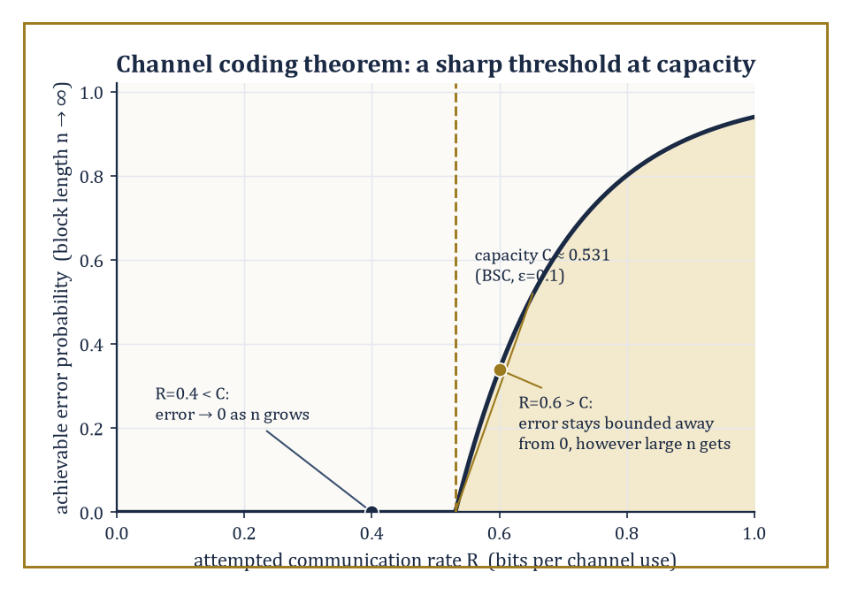
Figure 39.6 — Schematic of the sharp threshold at capacity: reliable communication is asymptotically free below C, categorically impossible above it, for the BSC(0.1) of the section’s own example.
Numeric example — which side of the threshold. Take the binary symmetric channel with ε = 0.1 from Mutual Information and Channel Capacity, whose capacity is
C = 1 − H(0.1) ≈ 0.531 bits per use
A designer attempting to communicate at rate R = 0.4 bits/use is operating below capacity (0.4 < 0.531): the channel coding theorem guarantees that, with a sufficiently long and well-chosen code, the error probability can be made as small as desired — 10⁻⁶, 10⁻¹², anything one likes, by using a longer block. A designer attempting R = 0.6 bits/use is operating above capacity (0.6 > 0.531): no matter how ingenious the code, how long the block, or how much computing power is thrown at decoding, the error probability cannot be pushed below some fixed positive floor. The theorem does not only say ‘it gets harder above capacity’ — it says the difficulty becomes an absolute wall.
Try it now — For the 3-fold repetition code over a BSC with ε = 0.2 (majority vote), what is the probability that a message bit is decoded wrongly? Answer →
The achievability half is proved by one of the most audacious arguments in mathematics: random coding. Rather than designing a clever code by hand, Shannon generated a codebook at random — each of the 2ⁿᴿ codewords drawn independently according to the input distribution that achieves capacity — and then showed that, averaged over all such random codebooks, the probability of decoding error (using a decoder that looks for the unique codeword jointly typical with the received sequence, the joint-typicality idea from Typical Sets and the Asymptotic Equipartition Property) vanishes as n → ∞, provided R < C. Since the average over all random codebooks is small, at least one specific codebook must perform at least as well as that average — so a good code is proved to exist, even though the proof gives no efficient recipe for finding it. This is achievability by pure existence proof, a style of argument that took the engineering world some decades to fully digest.
Abstract example — a small repetition code and its error rate. A far cruder illustration of the coding idea, well below capacity but easy to compute exactly: send each message bit three times over the BSC(0.1) channel — a ‘repetition code’ of block length n=3, rate R = 1/3 ≈ 0.333 bits/use, comfortably below the channel’s capacity of 0.531 bits/use. The decoder takes a majority vote of the three received bits. An error occurs only if two or three of the three transmissions are flipped.
P(exactly two flips) = C(3,2)×(0.1)²×(0.9) = 3×0.01×0.9 = 0.027
P(all three flip) = (0.1)³ = 0.001
Total error probability = 0.027 + 0.001 = 0.028
So a trivially simple code has already reduced the effective error rate from the channel’s raw 0.1 (10%) down to 0.028 (2.8%) — a real, computable coding gain, though nowhere near the vanishing error rates the full theorem promises are achievable at rates just below 0.531 with sufficiently long, cleverly random codes. Repetition coding is a poor code (its rate is far below what capacity permits for a given error target) but it is an honest, hand-computable glimpse of the same underlying phenomenon that random coding exploits far more efficiently.
The converse half — that rates above capacity are hopeless — is proved by chaining together precisely the two tools built in Entropy and Its Properties: the data-processing inequality and Fano’s inequality. Roughly: if a message of nR bits is sent, the mutual information between the message and the channel output can be at most nC (by the data-processing inequality, since the output can carry no more information about the input than the channel’s own single-use capacity permits, summed over n independent uses). But if R > C, then nR bits of message entropy is being asked to survive a channel offering only nC bits of mutual information — a shortfall of n(R−C) bits that grows without bound as n increases. Fano’s inequality then converts this growing entropy shortfall directly into a lower bound on the error probability that refuses to shrink to zero, however long the block.
Abstract example — the converse argument in miniature. Recall the Fano’s inequality worked example from Entropy and Its Properties: with M = 4 equally likely messages and observed error probability Pₑ = 0.1, the leftover uncertainty was bounded by
H(X|Y) ≤ 0.627 bits
well short of the full 2 bits of message entropy. The converse proof runs this logic in reverse and at scale: if the attempted rate R exceeds capacity C, then as block length n grows, the gap nR − nC (the entropy the channel physically cannot carry) grows linearly in n, while Fano’s inequality caps the achievable H(X|Y) — and hence the tolerable error probability Pₑ — from becoming arbitrarily small; algebraically rearranging Fano’s inequality to solve for Pₑ shows it must stay bounded below by a fixed positive number that depends only on R and C, never on how large n is allowed to grow. This is why the theorem states a hard threshold rather than a merely diminishing-returns difficulty.
The channel coding theorem is the second operational triumph of this chapter, after source coding, and arguably the more startling of the two: it says that noise, provided it is statistically well-behaved and known, is not an enemy that degrades communication gracefully as you push harder — it is an enemy with a precisely computable ceiling, below which perfect reliability is not just possible but asymptotically free. Everything in modern coding theory since 1948 — Reed–Solomon codes, turbo codes, low-density parity-check codes, the codes that let a spacecraft billions of kilometers away still be heard — is an attempt to find practical, efficiently decodable codes that get as close to this theoretical ceiling as engineering nerve allows.
Keep only this · Section 39.6: The Channel Coding Theorem
The idea. Every rate below capacity can be sent with error probability as small as you like, using long enough codes; no rate above capacity can.
Core.
R < C: Pₑ → 0 is achievable
R > C: Pₑ is bounded away from 0
Typical mistake. Thinking reliability requires redundancy that grows without bound. Repetition codes need it; Shannon’s codes keep the rate fixed.
Minimal example. BSC(0.1), C = 0.531: rate 1/2 is achievable with vanishing error; rate 0.6 is not.
Practice. Easy to challenge; full worked answers, with the usual mistake, are in Answers to the Practice Sets at the back.
Easy — Over the BSC with ε = 0.1, can a code of rate 0.6 achieve arbitrarily small error? Answer →
Medium — Compute the error probability of the 5-fold repetition code over BSC(0.1). Answer →
Challenge — Explain why repetition codes do not illustrate the channel coding theorem, though their error falls as n grows. Answer →

Section 39.7: Rate-Distortion Theory
Compression, but you’re allowed to lose a little
Lossless compression, the subject of Source Coding and Data Compression, insists on perfect reconstruction — every bit of the original recovered exactly.
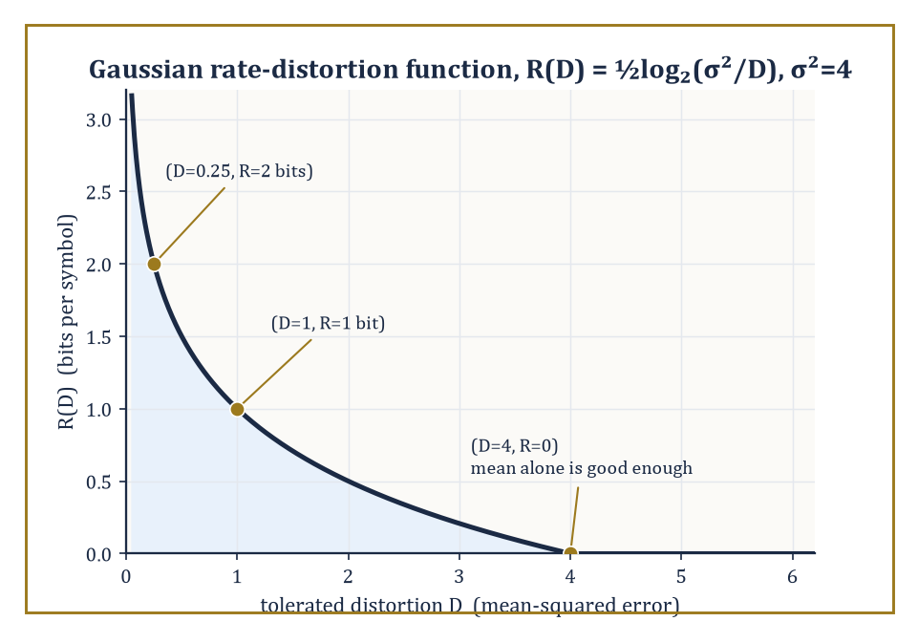
Figure 39.7 — The Gaussian rate-distortion curve for σ²=4, tracing the section’s three worked points: steep savings at first, logarithmic diminishing returns after.
Often this is neither possible (for a continuous source like an analog audio signal, exact reconstruction from a finite number of bits is a category error) nor even desirable (a photograph compressed to half its file size at an imperceptible loss of quality is, for almost every practical purpose, strictly preferable to an uncompressed original twice the size).
Rate-distortion theory is the mathematics of this trade-off. Given a distortion measure d(x, x̂) — a number quantifying how bad it is to reconstruct the true value x as the approximation x̂ — the rate-distortion function R(D) is defined as the minimum mutual information I(X;X̂) over all conditional distributions p(x̂|x) whose expected distortion E[d(X,X̂)] does not exceed D:
R(D) = min[p(x̂|x):\ E[d(X,X̂)] ≤ D]\ I(X;X̂)
It is, formally, a constrained convex optimization problem, and the rate-distortion theorem asserts both that R(D) is achievable (a scheme exists using roughly R(D) bits per symbol that achieves average distortion at most D) and that it cannot be beaten (no scheme using fewer bits can achieve distortion D or better).
Abstract example — the two boundary cases. Two limiting cases of R(D) are worth fixing firmly in mind before any formula appears, because they are checkable by pure common sense and any correct formula for R(D) must reduce to them.
At D = 0 (zero tolerated distortion, i.e. lossless reconstruction demanded), R(D) must equal H(X) exactly:
R(0) = H(X)
This is the source coding theorem of Source Coding and Data Compression, now revealed as the special case D=0 of the more general rate-distortion problem.
At the other extreme, once D is large enough that a receiver can achieve acceptable average distortion by simply ignoring the transmission entirely and always guessing some fixed default value (for instance, always guessing the source’s mean, for squared-error distortion), R(D) drops to exactly 0:
R(D) = 0, for D ≥ Dₘₐₓ
No bits at all need be sent, because blind guessing already meets the distortion target. Every rate-distortion function in this section, plotted against D, starts at H(X) when D=0 and decreases monotonically to 0 at some finite Dₘₐₓ, and it is this decreasing curve — more tolerance for error buys a lower required rate — that the theory makes precise.
Try it now — For a fair binary source, what rate does R(D) = 1 − H(D) give at D = 0.25? Answer →
For a binary source X ~ Bernoulli(p) with Hamming distortion (d(x,x̂) = 0 if x = x̂, else 1 — you are penalized once for every bit reconstructed wrong), the rate-distortion function has the closed form:
R(D) = H(p) − H(D), for 0 ≤ D ≤ min(p, 1−p)
R(D) = 0, for D > min(p, 1−p)
It is a striking fact — not a coincidence, but a genuine structural echo — that this formula has the same shape as the binary symmetric channel capacity formula from Mutual Information and Channel Capacity:
C = 1 − H(ε)
Both problems are, underneath, the same convex optimization over binary conditional distributions, one maximizing mutual information subject to a channel constraint, the other minimizing mutual information subject to a distortion constraint, and the binary entropy function governs both.
Numeric example — rate-distortion for a fair binary source. Take a fair binary source, p = 0.5, and a tolerated average bit-error rate (distortion) of D = 0.1. Then:
R(D) = H(0.5) − H(0.1) = 1 − 0.469 = 0.531 bits per symbol
This is the exact same numerical value, 0.531, computed for the BSC(0.1) channel capacity in Mutual Information and Channel Capacity.
This is the duality made concrete: a fair binary source willing to tolerate 10% bit errors can be compressed to 0.531 bits per symbol, the rate a BSC with 10% crossover probability can reliably carry — describing a source lossily at distortion D and communicating over a channel with matched noise level D turn out, for the binary case with these parameters, to be mirror images of the same underlying mathematics.
For a continuous Gaussian source with variance σ² and squared-error distortion d(x,x̂) = (x−x̂)², the rate-distortion function is known exactly:
R(D) = ½log₂(σ²/D), for 0 ≤ D ≤ σ²
R(D) = 0, for D ≥ σ²
Beyond that point, outputting the mean, incurring distortion σ², is as good as anything a positive bit rate could offer. This is one of the very few rate-distortion functions with a clean closed form, and it plays the same touchstone role for lossy compression that the AWGN capacity formula (next section) plays for channel capacity.
Numeric example — the Gaussian rate-distortion curve. Let σ² = 4. At a tolerated distortion of D = 1:
R(D) = ½log₂(4/1) = ½×2 = 1 bit per symbol
At a stricter tolerance of D = 0.25 (a quarter of the previous distortion):
R(D) = ½log₂(4/0.25) = ½log₂16 = ½×4 = 2 bits per symbol
As expected, demanding four times less distortion costs exactly one extra bit per symbol. And at the boundary D = σ² = 4:
R(D) = ½log₂(4/4) = ½log₂1 = 0 bits per symbol
This confirms the boundary case discussed above: at this distortion level, always guessing the source mean already meets the target, so no transmitted bits are needed at all. These three points — (D=4, R=0), (D=1, R=1), (D=0.25, R=2) — trace out the characteristic downward-curving shape of every Gaussian rate-distortion function: steep savings in bits for the first bit of tolerated error, with diminishing (logarithmic) returns thereafter.
Every lossy codec encountered in ordinary life — JPEG for still images, MPEG and its descendants for video, MP3 and its heirs for audio — is an engineering approximation to a rate-distortion limit, operating under the additional practical constraints of computational complexity and encoding delay that the pure theory is free to ignore.
A JPEG encoder at a typical ‘quality 80’ setting, for instance, routinely achieves compression ratios in the region of ten-to-one on photographic images while remaining close to visually lossless, a rough but well-known illustration of how far practical engineering has learned to approach these theoretical limits.
Numeric example — what ten-to-one costs in bits. An uncompressed color photograph is typically stored at 24 bits per pixel — 8 bits each for red, green, and blue.
At the ‘quality 80’ ten-to-one ratio quoted above, a JPEG encoder is spending only:
24/10 = 2.4 bits per pixel
on average — roughly a tenth of the raw bit-depth — while staying close to visually lossless.
That such a small fraction of the original bit budget suffices is precisely the rate-distortion moral of this section: a real photograph, its neighboring pixels heavily correlated in both space and color, carries far less genuine per-pixel entropy than its raw 24-bit encoding implies, and a good codec’s job is simply to stop paying for redundancy the eye was never going to miss.
Rate-distortion theory is, in short, the information-theoretic foundation underneath every ‘lossy’ file format the reader has ever opened — the mathematics that tells an engineer how many bits are truly required to throw away just enough detail, and no more, to hit a chosen quality target.
Keep only this · Section 39.7: Rate-Distortion Theory
The idea. If some distortion is allowed, fewer bits are needed; R(D) is the least rate that keeps the average distortion at most D.
Core.
binary(p): R(D) = H(p) − H(D), 0 ≤ D ≤ min(p, 1 − p)
Gaussian: R(D) = ½ log₂(σ²/D), 0 ≤ D ≤ σ²
Typical mistake. Applying the formula outside its range. Beyond D = min(p, 1 − p) (binary) or D = σ² (Gaussian), the rate is 0, not negative.
Minimal example. Gaussian, σ² = 4, D = 1: R = ½ log₂ 4 = 1 bit per sample.
Practice. Easy to challenge; full worked answers, with the usual mistake, are in Answers to the Practice Sets at the back.
Easy — Gaussian source, σ² = 16, D = 1: how many bits per sample? Answer →
Medium — For a Gaussian source, how many extra bits per sample does halving the allowed distortion cost? Answer →
Challenge — Why is R(D) = 0 for a binary source with p = 0.2 when D ≥ 0.2? Answer →

Section 39.8: Continuous Channels and Gaussian Channels
Home of the most quoted formula in engineering
Bridge: from discrete to continuous
Everything so far counted bits over finitely many symbols. A voltage can take any real value, and the honest count of bits needed to pin it down exactly is infinite. Differential entropy keeps the formula but changes its meaning: it measures spread relative to a unit interval, so it can be negative. What survives intact is mutual information, a difference of two such quantities in which the arbitrary unit cancels. That is why capacity, not entropy, is the headline number for continuous channels.
A telephone line, a Wi-Fi link or a deep-space radio carries a continuous signal blurred by random noise, and the question is how many bits each transmission can carry reliably. Claude Shannon answered it in 1948 with one of the most quoted formulas in engineering: the capacity depends only on the ratio of signal power to noise power. At a ratio of 3 the channel carries 1 bit per use; raising the ratio to 15, five times the power, buys only 2 bits. Capacity grows with the logarithm of the power, so each extra bit costs roughly a quadrupling of the ratio once it is large. This section builds the continuous version of entropy needed to prove it.
Every quantity so far has assumed a discrete alphabet — a finite (or countable) set of symbols. Real signals are often continuous, and extending entropy to continuous random variables requires a definition with a genuine subtlety attached: the differential entropy.
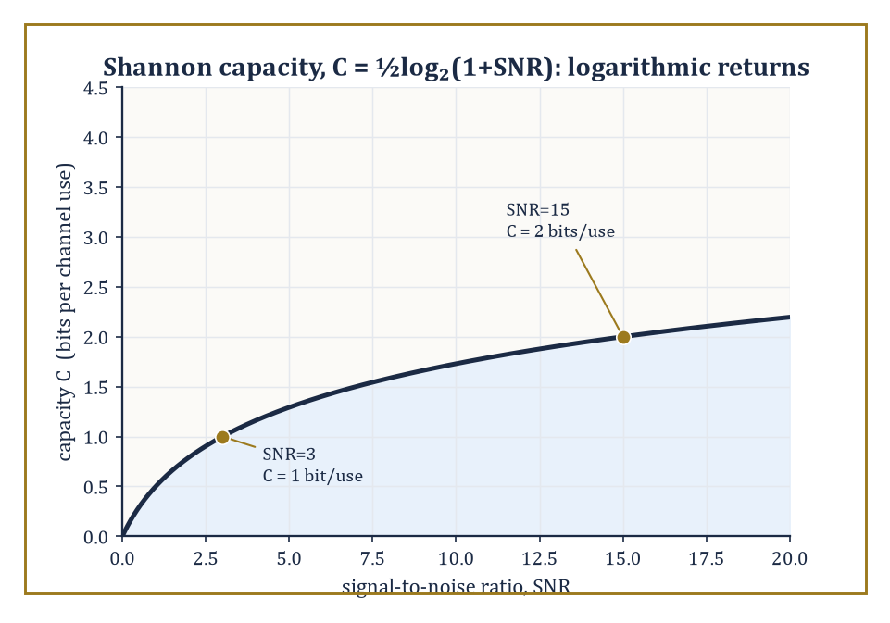
Figure 39.8 — The Shannon capacity curve C = ½log₂(1+SNR), marking the section’s SNR=3 and SNR=15 points — quadrupling the SNR buys only one more bit.
h(X) = −∫f(x)log₂f(x)dx
Here f is the probability density function of X. Unlike ordinary (discrete) entropy, differential entropy is not scale-invariant, is not bounded below by zero, and can in fact be negative — a fact that surprises newcomers every time, and which is worth demonstrating rather than merely asserting.
Numeric example — differential entropy can be negative. Let X be uniformly distributed on the interval [0,4], with constant density f(x) = 1/4 there. Its differential entropy is:
h(X) = −∫₀⁴ (1/4)log₂(1/4)dx = −log₂(1/4) = log₂4 = 2 bits
This is a sensible, positive number, reflecting that X can land anywhere across a comparatively wide interval. In general, for X uniform on [a,b]:
h(X) = log₂(b−a)
Now shrink the interval to [0, 0.5]:
h(X) = log₂(0.5) = −1 bit
Negative! This is not a mistake — it reflects that once the interval is narrower than one unit, the density f = 1/(b−a) exceeds 1, and −log₂f becomes negative, dragging the (density-weighted) average below zero. Differential entropy, unlike its discrete cousin, measures something closer to ‘spread relative to a fixed unit of length’ than ‘absolute uncertainty’, and differences of differential entropies — rather than their raw values — are what carry the physically meaningful, unit-independent content.
Try it now — What is the differential entropy of a uniform distribution on [0, 1/2]? Answer →
For a Gaussian random variable with variance σ², the differential entropy has the closed form:
h(X) = ½log₂(2πeσ²)
This distribution occupies a privileged position: among all continuous distributions with a fixed variance σ², the Gaussian is the one that maximizes differential entropy — the ‘least predictable’ shape a distribution can take once its spread is pinned down, which is precisely why Gaussian noise is the worst-case (and hence the standard, conservative) noise model in communications engineering.
Numeric example — entropy of the standard normal. For a standard normal variable, σ² = 1:
h(X) = ½log₂(2πe)
Computing the constant:
2πe = 2 × 3.14159265 × 2.71828183 ≈ 17.07946
log₂(17.07946) = ln(17.07946)/ln(2) ≈ 2.837877/0.693147 ≈ 4.094282
h(X) ≈ 4.094282 / 2 ≈ 2.047 bits
This well-known figure — the differential entropy of the standard normal is about 2.047 bits — recurs throughout information-theoretic treatments of Gaussian noise, because ‘Gaussian with variance σ²’ is the maximum-entropy, hence worst-case and most tractable, noise model available at that variance.
The single most famous formula in this entire chapter — arguably in the whole of electrical engineering — is the capacity of the additive white Gaussian noise (AWGN) channel:
C = ½log₂(1 + SNR)
Here SNR is the signal-to-noise power ratio. Every Wi-Fi router, every satellite downlink, every fiber-optic repeater is, at bottom, an attempt to approach this one formula as closely as the laws of physics and the cost of engineering will allow, and it has held its position unshaken since Shannon derived it in 1948.
Numeric example — Shannon capacity at two SNR levels. At a signal-to-noise ratio of SNR = 15 (the signal carries fifteen times the power of the noise, roughly 11.76 dB), capacity is:
C = ½log₂(1+15) = ½log₂16 = ½×4 = 2 bits per channel use
At a more modest SNR = 3:
C = ½log₂(1+3) = ½log₂4 = ½×2 = 1 bit per channel use
Notice that quadrupling the SNR (from 3 to roughly 12, say) only adds one further bit of capacity — this logarithmic law of diminishing returns is just why doubling a Wi-Fi router’s transmit power never comes close to doubling its data rate, and why communications engineers obsess over reducing noise rather than merely brute-forcing more signal power.
When a communication resource is split across several parallel Gaussian sub-channels, each with its own noise level, and a total power budget must be divided among them, the optimal allocation is the elegant water-filling solution: imagine pouring a fixed total amount of ‘water’ (power) over a landscape whose ground level at each sub-channel equals its noise variance — power flows preferentially to the quietest (lowest-noise) sub-channels, and any sub-channel whose noise floor sits above the resulting water level receives no power at all. This is the same circle of ideas, generalized, that governs power allocation across the many parallel sub-carriers of a MIMO wireless system or an OFDM broadcast signal.
Numeric example — water-filling across two sub-channels. Suppose two parallel Gaussian sub-channels have noise variances N₁ = 1 and N₂ = 4, and a total power budget of P = 10 must be split between them. Water-filling sets a common water level ν such that the power allocated to each active sub-channel is Pᵢ = ν − Nᵢ (whenever this is positive), with Σᵢ Pᵢ = P. Assuming both sub-channels are active:
(ν−1) + (ν−4) = 10 ⟹ 2ν − 5 = 10 ⟹ ν = 7.5
Then:
P₁ = 7.5 − 1 = 6.5, P₂ = 7.5 − 4 = 3.5
Both are positive, confirming both channels are indeed worth using, and P₁+P₂ = 10 checks out against the budget. The resulting total capacity is:
C = ½log₂(1+P₁/N₁) + ½log₂(1+P₂/N₂) = ½log₂(1+6.5) + ½log₂(1+0.875) = ½log₂7.5 + ½log₂1.875
Computing:
log₂7.5 = ln7.5/ln2 ≈ 2.014903/0.693147 ≈ 2.906891
log₂1.875 = ln1.875/ln2 ≈ 0.628609/0.693147 ≈ 0.906891
C ≈ ½×2.906891 + ½×0.906891 ≈ 1.453446 + 0.453446 ≈ 1.907 bits per pair of channel uses
Notice the quieter sub-channel (N₁=1) received nearly twice the power of the noisier one (N₂=4, receiving 3.5) — water-filling systematically favors quiet channels, because a given watt of power buys more capacity where the competing noise is weaker.
Continuous information theory, in the end, retains every operational promise of the discrete theory — compression limits, capacity ceilings, achievability and converse — while adding a genuine layer of analytic subtlety around infinite alphabets and the peculiarities of differential entropy. It is the natural mathematical home for the wireless and fiber-optic engineering that carries most of the world’s actual data traffic, and the natural bridge into the next chapter’s subject, where continuous signals are examined not just for how much information they carry, but for where in time and frequency that information is hiding.
Keep only this · Section 39.8: Continuous Channels and Gaussian Channels
The idea. For continuous signals in Gaussian noise, capacity is ½ log₂(1 + SNR) bits per use, and with several sub-channels power is poured into the quietest first.
Core.
C = ½ log₂(1 + P/N) bits per use
C = B log₂(1 + SNR) bits per second, bandwidth B
water-filling: Pᵢ = max(0, ν − Nᵢ), Σ Pᵢ = P
Typical mistake. Doubling power and expecting double capacity. Capacity grows only logarithmically in SNR, but linearly in bandwidth.
Minimal example. SNR = 15: C = ½ log₂ 16 = 2 bits per use.
Practice. Easy to challenge; full worked answers, with the usual mistake, are in Answers to the Practice Sets at the back.
Easy — Compute the capacity per use at SNR = 3. Answer →
Medium — A link has bandwidth 1 MHz and SNR 15. What is its capacity in bits per second? Answer →
Challenge — Two Gaussian sub-channels have noise N₁ = 1 and N₂ = 4. Water-fill a total power P = 2 and give the capacity. Answer →

Section 39.9: Looking Ahead: From Classical Information Theory to Networks, Quantum Information, and Learning
We have now worked through the essential architecture of classical information theory: entropy as the measure of uncertainty, the asymptotic equipartition property as the technical mechanism that turns entropy into an operational rate, source coding and Huffman’s construction as the answer to ‘how far can this be squeezed’, mutual information and channel capacity as the answer to ‘how fast can this be sent reliably’, the channel coding theorem as the sharp threshold separating the two, rate-distortion theory as the generalization permitting controlled loss, and Gaussian channels as the continuous-alphabet setting in which Shannon’s formula does its daily work.
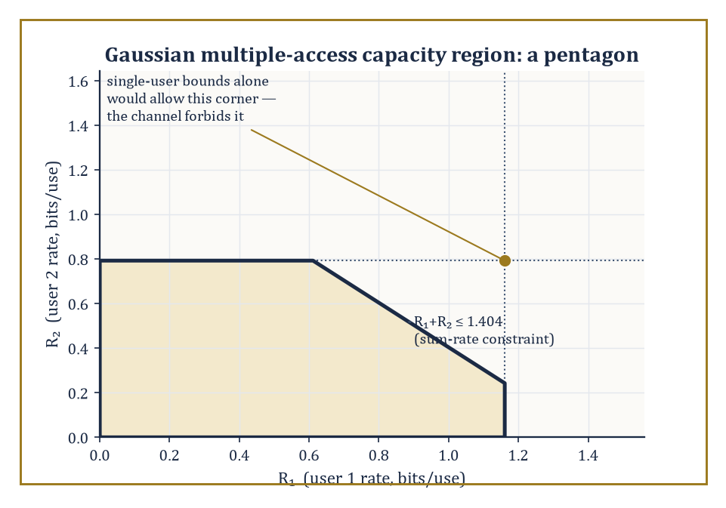
Figure 39.9 — The Gaussian multiple-access capacity region is a pentagon, not the rectangle the two single-user bounds alone would suggest — the sum-rate constraint shaves off the far corner.
Every one of these ideas has an operational meaning checkable, in principle, with pencil, paper, and patience — which is more than can be said for some chapters of this series, and no shade intended toward Category Theory, which merely lives at a different altitude.
Classical (single-user, single-channel) information theory is, however, a special case of something considerably larger. Network information theory extends the entire apparatus to settings with multiple senders and receivers — the multiple-access channel (several transmitters sharing one receiver, as in a crowded cellular uplink), the broadcast channel (one transmitter, several receivers with different channel qualities), and the general problem of distributed compression, where correlated sources must be compressed separately but decoded jointly.
Remarkably, the capacity region of even the simplest multi-user channel is, in general, still an open problem — a humbling reminder that Shannon answered the single-user question completely in 1948, and the field has been chasing the multi-user generalization ever since.
Abstract example — a two-user capacity region. In the simplest tractable multi-user setting, the Gaussian multiple-access channel, two transmitters with powers P₁ and P₂ share a single receiver against background noise N. Unlike the single-user case, there is no single capacity number — instead there is a capacity region, a set of jointly achievable rate pairs (R₁,R₂).
Each user individually is capped by the single-user AWGN formula from Continuous Channels and Gaussian Channels:
R₁ ≤ ½log₂(1+P₁/N)
R₂ ≤ ½log₂(1+P₂/N)
But the two users jointly face a third, tighter constraint on their combined rate — the sum rate cannot exceed what a single user with their combined power could achieve alone, since from the receiver’s point of view the two signals add:
R₁+R₂ ≤ ½log₂(1+(P₁+P₂)/N)
This three-constraint region, a pentagon rather than a rectangle when plotted, is the archetype of every richer network capacity region that follows — the geometry of ‘sharing’ made explicit.
Try it now — Two users share a Gaussian channel with P₁ = P₂ = 1 and noise N = 1. What is the largest possible sum rate? Answer →
A second and entirely different generalization replaces bits with qubits. Quantum information theory studies entanglement, quantum channels, and quantum error-correcting codes, and finds that many classical intuitions bend or break: information encoded in quantum states cannot be copied (the no-cloning theorem), yet entangled pairs of qubits can be used to boost classical communication rates in ways with no classical analogue (superdense coding), and the quantum analogue of mutual information behaves in stranger ways than its classical namesake.
It is, in a real sense, the natural next chapter after this one for anyone drawn specifically to communication theory rather than to signal analysis — though this particular series, as noted, heads next toward wavelets.
A third generalization runs not outward into networks or inward into quantum mechanics, but sideways into statistical learning theory. The information-theoretic analysis of generalization asks: how much does a trained model’s performance on new data depend on how much information its parameters retain about the specific training examples it saw?
A representative result, in the spirit of PAC-Bayes and mutual-information generalization bounds, states that the expected gap between training and test performance is bounded by:
√(2σ²·I(W;S)/n)
Here I(W;S) is the mutual information between the learned parameters W and the training sample S, σ² bounds the variance of the loss, and n is the number of training examples — in plain words, a model that has ‘memorized’ more bits about its specific training data (higher I(W;S)) is provably more likely to generalize poorly, a precise, information-theoretic version of the folk wisdom that overfitting is a kind of over-remembering.
Numeric example — a generalization bound in numbers. Suppose a trained model’s parameters retain I(W;S) = 10 bits of mutual information with the training sample (10 bits × ln2 ≈ 6.93 nats, since these bounds are typically stated in natural-log units), the loss function has variance bound σ² = 1, and the training sample has n = 1000 examples.
Plugging into the bound:
√(2×1×6.93/1000) = √(13.86/1000) = √0.01386 ≈ 0.1177
So the expected gap between training and test loss is bounded by roughly 0.118, in whatever units the loss is measured — a small number, reflecting that 10 bits of memorized information, spread thin over a thousand training examples, poses only a modest generalization risk.
Note how the bound shrinks as n grows for fixed I(W;S): more training data dilutes the harm of any fixed amount of memorization, matching the empirical observation that overfitting is far more dangerous on small datasets than large ones.
A fourth thread — the algorithmic and practical side of coding theory — asks how to build codes that approach the Shannon limits proved abstractly in this chapter, using decoders efficient enough to run in real time.
Low-density parity-check (LDPC) codes and turbo codes, both discovered decades after Shannon’s original 1948 paper, come astonishingly close to capacity on real channels with practically implementable decoding algorithms, and are the workhorses inside modern Wi-Fi, satellite links, and mobile phone standards; their story is as much about clever engineering and iterative probabilistic decoding as about the pure mathematics developed here.
The deeper lesson of this entire chapter, worth carrying forward past every one of these frontiers, is that information is a genuinely measurable quantity, with real physical and engineering units, and that the fundamental limits on how far it can be compressed and how fast it can be communicated are simultaneously mathematically exact and practically attainable — not asymptotic curiosities confined to a seminar room, but numbers that sit, unnoticed and precise, inside every modem, every hard drive, and every fiber-optic cable on the planet.
Information theory is the mathematics of communication and uncertainty, and it is, without much competition, the branch of this series most likely to be running silently in the device the reader used to find this sentence.
We have learned to quantify information: to measure uncertainty in bits, to name the sharp threshold below which reliable communication is free and above which it is impossible, and to trade bits for tolerated error with rate-distortion theory’s precise accounting. It is a rare corner of mathematics where the theorems are not merely beautiful but are, quite literally, the numbers an engineer designs toward on a Tuesday afternoon.
The series continues, and the next chapter turns from Shannon’s discrete symbols to continuous signals, asking a question this chapter deliberately set aside: not only how much information a signal carries, but where — in time, in frequency, or in some cleverly chosen mixture of both — that information is actually hiding. Wavelets and signal analysis await, and they will feel less like a change of subject than a change of lens on the same question.
Where this returns
Maximizing a likelihood is the same as minimizing the KL divergence from the data’s empirical distribution to the model, so this chapter’s D(p‖q) sits underneath Parametric Models and Likelihood and the losses of Optimization for Statistical Learning. Information also returns in chaos: the doubling map x ↦ 2x mod 1 of Chaos in One-Dimensional Maps reveals one more binary digit of its starting point at every step, one bit per iteration, which is its Lyapunov exponent ln 2 written in bits.
Keep only this · Section 39.9: Looking Ahead: From Classical Information Theory to Networks, Quantum Information, and Learning
The idea. Information theory extends to many users, to quantum systems and to learning, where the same quantities — entropy and mutual information — set the limits.
Core.
MAC: R₁ ≤ ½ log₂(1 + P₁/N), R₂ ≤ ½ log₂(1 + P₂/N), R₁ + R₂ ≤ ½ log₂(1 + (P₁ + P₂)/N)
1 bit = ln 2 ≈ 0.693 nats
Typical mistake. Treating a multi-user channel as several private channels. The sum-rate bound is usually the binding one.
Minimal example. P₁ = 3, N = 1: user 1 alone can reach ½ log₂ 4 = 1 bit per use.
Practice. Easy to challenge; full worked answers, with the usual mistake, are in Answers to the Practice Sets at the back.
Easy — Convert 10 bits of mutual information into nats. Answer →
Medium — With P₁ = 3, N = 1, what is user 1’s single-user limit in the multiple-access channel? Answer →
Challenge — With P₁ = P₂ = 3 and N = 1, can both users send at 1 bit per use at the same time? Answer →
Chapter 39 recap · Information Theory
• An outcome of probability p carries −log₂ p bits; entropy H is the average surprise, at most log₂ n for n outcomes.
• The AEP: long sequences are almost all typical, about 2ⁿᴴ of them, each with probability about 2⁻ⁿᴴ. That is why H bits per symbol suffice.
• Prefix codes obey Kraft, Σ 2⁻ˡ ≤ 1; Huffman codes come within one bit of H.
• Mutual information I(X;Y) = H(X) − H(X|Y); capacity is its maximum over inputs: 1 − H(ε) for the BSC, 1 − ε for the erasure channel.
• Below capacity, error can be made as small as you like at a fixed rate; above it, it cannot.
• Lossy coding trades rate for distortion, R(D); the Gaussian channel carries ½ log₂(1 + SNR) bits per use, and power is poured into the quietest sub-channels first.

Check Your Understanding — Chapter 39
Answers are in the Answer Key at the back of the book — have a go before you look.
1. [Model] A weather forecast gives a 25% chance of rain tomorrow. If it does rain, how many bits of self-information does that outcome carry?
See the answer →
2. [Explain] Why does entropy reach its maximum for the uniform distribution, and what does this tell you about a biased coin’s entropy compared to a fair coin’s?
See the answer →
3. [Compute] Using the Kraft inequality, can a prefix code exist with codeword lengths 1, 2, 2, and 3 bits?
See the answer →
4. [Challenge] What two claims does Shannon’s channel coding theorem make simultaneously, and why is ‘communication just gets harder above capacity’ not an accurate summary of it?
See the answer →
5. [Model] A wireless link flips each transmitted bit independently with probability 0.11. The radio sends 1,000,000 bits per second. What is the channel capacity in bits per use, and roughly what net rate can the link sustain reliably?
See the answer →
6. [Concept] A sensor’s reading Y is statistically independent of the quantity X you wanted to measure. What is I(X;Y), and what does that say about the sensor?
See the answer →
7. [Prove] Show that H(X,Y) = H(X) + H(Y|X).
See the answer →
8. [Prove] Show that H(X) ≤ log₂|χ| for a random variable on a finite alphabet χ, with equality only for the uniform distribution.
See the answer →
9. [Explain] The data-processing inequality says that for a Markov chain X → Y → Z, I(X;Z) ≤ I(X;Y). Why does this mean no clever algorithm can recover information that a noisy channel destroyed?
See the answer →
10. [Compute] A source emits symbol A with probability 0.9 and symbol B with probability 0.1. What is its entropy, and how many bits should 10,000 symbols occupy under ideal compression compared with a naive one-bit-per-symbol encoding?
See the answer →

Problems — Chapter 39
The questions above test whether the ideas landed. These ask you to use them. Solutions are in Solutions to the Problems at the back. Work them before you look.
1. [Compute] A fair coin. Compute its Shannon entropy in bits.
2. [Compute] A coin that always lands heads. Compute its entropy.
3. [Compute] Codeword lengths 1, 2, and 2. Check the Kraft inequality. Does equality hold?
4. [Concept] Mutual information I(X; Y) is 0. What does that say about the two variables, in one sentence?

Math, Actually

Chapter 40

Wavelets & Signal Analysis
Time-Frequency, Multiresolution, and the Art of Seeing Signals at Every Scale
In the previous chapter, we spent our time weighing uncertainty in bits, discovering that a fair coin flipped once contains exactly one shannon of surprise and not a grain more. Information theory told us how much a signal has to say. It was scrupulously uninterested in when the signal said it. A message is a message, whether its entropy arrives all at once in a single dramatic spike or is doled out evenly like a disappointing allowance — Shannon’s bookkeeping does not care, and frankly neither did we, at the time. We have some tidying up to do.
The tidying concerns an old friend from many chapters back: the Fourier transform, which decomposes a signal into pure frequencies with a thoroughness bordering on the obsessive. Its one great flaw, seldom advertised on the box, is that it is a hopeless gossip with no sense of chronology. Play it a single sharp click and a long, gentle, pure tone of exactly the same energy, and it will hand you back two spectra of comparable magnitude, because a click is (mathematically speaking) an extremely inclusive chord containing a little of every frequency there is. Ask the Fourier transform where the click happened, and it stares back blankly. It knows what. It has no idea when.
Wavelets are the fix, and a rather elegant one: instead of pure sinusoids that hum away identically from minus infinity to plus infinity — the mathematical equivalent of a dinner guest who never stops talking and never says anything about the section they’re in — we build our basis out of small, localized waveforms that can be stretched (scaled) and slid along the time axis (translated). Correlate a signal against a whole family of these, and you get a time-scale portrait: not just what frequencies are present, but where, and at what magnification. It is, we will see, the mathematics of knowing both what a signal is doing and when it is doing it, which turns out to be what nature, audio engineers, and radiologists all wanted from the beginning.
A confession before we begin: wavelets are one of the vanishingly few pieces of pure mathematics from the last fifty years that went from seminar-room curiosity to ubiquitous consumer technology within a single academic generation — most ideas take three generations merely to get a decent Wikipedia stub. The reason is unusually clean for mathematics: the very same construction that hands you a rigorous orthonormal basis of L² also hands you, for free, a fast, invertible, multiscale algorithm that happens to compress ordinary photographs rather better than anything before it. Theorem and product shipped in the same box. If the Fourier transform taught us to see frequency, wavelets teach us to see frequency and location at once. Let’s change the window size.
Before you begin — Chapter 40
By the end of this chapter you will be able to:
1. Compute one level of the orthonormal Haar transform by hand and check that energy is preserved.
2. Use Δf ≈ 1/T and the uncertainty principle to say what a window can and cannot resolve.
3. Evaluate a continuous wavelet transform at one scale and position, and explain why constants give zero.
4. Describe a multiresolution analysis as nested approximation spaces plus detail spaces.
5. Run the filter-bank DWT and the integer 5/3 lifting scheme forward and backward.
6. Choose between hard and soft thresholding and compute the universal threshold for denoising.
Prerequisites. Fourier series and the Fourier transform from Fourier Transforms and FFT (Volume 2); orthonormal bases and orthogonal projection from Linear Algebra (Volume 2); square-integrable functions from Functional Analysis (Volume 3).
Estimated study time. About 11 hours, exercises included.

Section 40.1: What Wavelets and Signal Analysis Are
In which a basis is finally permitted to have an address
Look at a page of sheet music. Whatever else you cannot read on it, you can see that it carries two kinds of information at once: which note, and when. The note is written as a position on the stave; the when is written as a position across the page. Nobody finds this remarkable, and every musician in the world relies on it.
Chapter 39 gave us a tool that does half of that. Break a sound into its frequencies and you learn, with great precision, which notes are present in it. What you do not learn is when any of them happened. Play a tune, then play the same notes in reverse order: the collection of frequencies is very nearly unchanged, and yet nobody would call them the same piece of music. A description that cannot tell those two apart has lost something a five-year-old with a recorder has not.
The question worth asking is therefore a double one. Not which frequencies are in this sound, but which frequencies, and at what moment.
The difficulty in answering it is worth meeting head-on, because it is not a matter of being clever enough. To say when something happened you must look at a short stretch of time. But a short stretch cannot recognize a slow wave, for the plain reason that it has never seen one go all the way round.
Some figures make the bind concrete. Fix a listening window five thousandths of a second long, and count how many complete cycles of a given tone fit inside it:
50 Hz one cycle every 20 ms 0.25 of a cycle fits
200 Hz one cycle every 5 ms 1 cycle fits
1000 Hz one cycle every 1 ms 5 cycles fit
4000 Hz one cycle every 0.25 ms 20 cycles fit
The top row is the problem. A quarter of a cycle tells you almost nothing about a pitch; the window is too brief to have heard the note as a note at all. Widen the window until the 50 Hz tone is comfortable and you will have widened it to a fifth of a second, over which a great deal can happen that you can no longer place in time.
So look at what no row of that table can offer: a single window length that serves the whole column. Sharpen the timing and the pitch blurs; sharpen the pitch and the timing blurs. This is not an engineering shortfall to be designed away, and Time-Frequency Analysis and the Uncertainty Principle makes the trade exact.
What breaks the deadlock is refusing to pick one window. Let the ruler change length according to what it is measuring: a long window for the low, slow notes, a short one for the high, quick ones, the same shape each time but stretched or squeezed to fit.
A wave built to be used that way is a wavelet: unlike a sine, which runs from the beginning of time to the end of it, a wavelet lives briefly and then stops, which is what lets it have an address as well as a pitch. The plainest one of all comes next.
A wavelet is a small waveform — a ‘little wave’, which is a slightly twee translation of the French ondelette but nobody involved in the 1980s renaming committee seems to have minded.
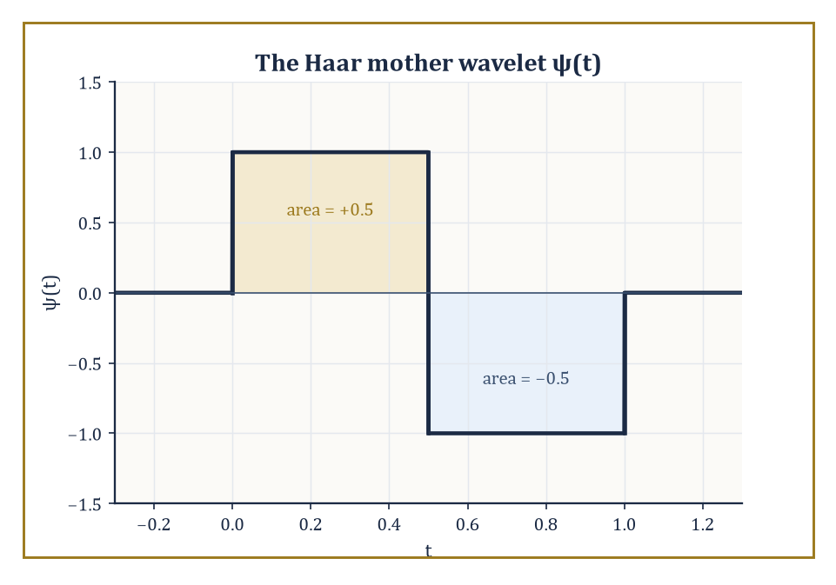
Figure 40.1 — The Haar mother wavelet: one up-lobe, one down-lobe, and a mean of exactly zero.
It is localized: it lives on a bounded stretch of the time axis and is essentially zero elsewhere, unlike a sine wave, which lives everywhere with equal enthusiasm and no self-restraint.
From a single ‘mother’ wavelet ψ we generate a whole family by scaling (compressing or stretching it) and translating (sliding it left or right).
Signal analysis with wavelets means expanding a function, or a discrete signal, in a basis — or a looser structure called a frame, which we will meet properly in Looking Ahead: From Classical Wavelets to Frames, Shearlets, and Learned Representations — built from such waveforms, and then reading the resulting coefficients as a time-scale portrait: which scales are active, and where.
Numeric example — the Haar wavelet, the simplest possible mother. The simplest mother wavelet of all is the Haar wavelet:
ψ(t) = +1 for t ∈ [0, 0.5), ψ(t) = −1 for t ∈ [0.5, 1), and ψ(t) = 0 everywhere else
It is a single up-down blip, roughly the mathematical equivalent of a doorbell. Check its mean:
∫₀¹ ψ(t) dt = ∫[0, 0.5] (1) dt + ∫[0.5, 1] (−1) dt = 0.5 − 0.5 = 0
Zero mean — we will see in The Continuous Wavelet Transform that this is not a coincidence but a requirement (admissibility) for any function that wants to call itself a wavelet.
Now scale it: ψ(2t) is the same blip compressed to live on [0, 0.5) instead of [0, 1) — squeeze the doorbell, and it rings twice as fast in half the space. Translate it: ψ(t − 1) is the identical blip, shifted to sit on [1, 2).
Scaling changes how fast it wiggles; translating changes where it wiggles. Together, scaled-and-translated copies ψ((t − b)/a) are the entire vocabulary of wavelet analysis.
Try it now — Apply one level of the orthonormal Haar transform to [4, 4, 1, 3]. Answer →
The subject sits at a three-way junction: harmonic analysis (the Fourier tradition), approximation theory (how well can we represent a function using few pieces?), and signal processing (how do we compute any of this on a finite string of numbers?).
From Fourier analysis it inherits the central idea of expanding a function in an orthonormal basis and reading off coefficients.
Where it departs from Fourier analysis is in refusing to use basis functions that are spread thinly across the whole time axis; a wavelet basis insists that each basis function be localized in time as well as (to varying degrees) in frequency.
Abstract example — two basis elements, two addresses. Compare a single Fourier basis element on the circle, exp(i2πkt) for some fixed k, against a single wavelet basis element:
ψ_(1,3)(t) = √2·ψ(2t − 3)
The Fourier element has constant modulus 1 everywhere on [0,1) — ask it ‘are you present near t = 0.05?’ and the honest answer is ‘I am present everywhere, equally, forever, thank you for asking.’
The wavelet element ψ_(1,3) is supported only on the interval where 2t − 3 ∈ [0,1), i.e. t ∈ [1.5, 2) — but that’s outside [0,1), so shift the index: ψ_(1,0)(t) is supported on t ∈ [0, 0.5).
Ask the same question of ψ_(1,0) and it can honestly say ‘yes, and nowhere else.’ Both encode oscillation; only one comes with a return address.
The practical payoff of insisting on local basis functions is that the resulting expansion adapts to local regularity.
A smooth, slowly varying stretch of signal is captured efficiently by a handful of coarse, large-scale coefficients — you don’t need fine detail to describe something that isn’t doing anything interesting.
A singularity, a sharp edge, a sudden jump, produces large coefficients only at the fine scales and only at the locations where the misbehavior actually occurs. Everywhere else, at fine scale, the coefficients are small or exactly zero.
This single fact — that wavelet coefficients are sparse for signals that are smooth except at a few places — is the mathematical seed from which essentially every application in this chapter grows.
Numeric example — a jump caught in the act. Take the 8-sample step signal s = [2, 2, 2, 2, 2, 6, 6, 6], flat except for one jump between positions 4 and 5 (0-indexed). Pair the samples and apply the (orthonormal) Haar transform to each pair, using the general formulas:
average a = (x₀+x₁)/√2, detail d = (x₀−x₁)/√2
Working through each pair in turn:
Pair (2,2): a₀ = 4/√2 ≈ 2.828, d₀ = 0/√2 = 0
Pair (2,2): a₁ ≈ 2.828, d₁ = 0
Pair (2,6): a₂ = 8/√2 ≈ 5.657, d₂ = (2−6)/√2 = −4/√2 ≈ −2.828
Pair (6,6): a₃ = 12/√2 ≈ 8.485, d₃ = 0
Three of the four detail coefficients are precisely zero — the constant stretches contribute nothing to detect — and the one non-zero detail coefficient, d₂ ≈ −2.828, sits precisely at the pair straddling the jump. The transform has, without being told where to look, pointed a finger at the discontinuity.
Two dialects will be spoken interchangeably throughout this chapter, and it is worth naming them before they cause confusion.
The continuous dialect treats a signal as a function x ∈ L²(ℝ) — the space of square-integrable functions we met in earlier chapters, equipped with the energy norm:
‖x‖² = ∫|x(t)|² dt
The discrete dialect treats a signal as a sequence x ∈ ℓ²(ℤ), a doubly-infinite (or, in practice, finite) list of numbers with energy:
‖x‖² = Σₙ |xₙ|²
Continuous-time theorems (admissibility, the CWT) are proved in the first dialect; the algorithms you run on a laptop (the DWT, filter banks) live in the second.
The two are reconciled by sampling, and — this being mathematics done properly rather than hand-waved — the reconciliation is exact under the right conditions, not merely ‘close enough’.
Numeric example — energy survives the trip from continuous to discrete. Let x(t) = 1 for t ∈ [0, 4) and x(t) = 0 elsewhere — a continuous rectangular pulse of height 1 and width 4. Its continuous energy:
‖x‖² = ∫₀⁴ 1² dt = 4
Now sample it at spacing Δt = 1, landing on the pulse’s edges:
x₀ = x(0) = 1, x₁ = x(1) = 1, x₂ = x(2) = 1, x₃ = x(3) = 1, and every other sample is 0
Discrete energy, weighted by the sampling interval:
Σₙ |xₙ|²·Δt = (1+1+1+1)·1 = 4
The two energies agree exactly, 4 = 4, because the sampling grid happened to align perfectly with the pulse’s boundaries. Shift the pulse to straddle a sample point instead, and the discrete sum would only approximate the continuous integral — a small foretaste of why boundary handling (The Discrete Wavelet Transform and Filter Banks) and the precise choice of sampling grid matter more than a first glance suggests.
That is the whole story in miniature, and everything from here to Applications: Denoising, Images, and Beyond is really an elaboration of it: build a family of localized, scaled, translated waveforms with the right mathematical properties (Sections 40.2–40.5), turn the construction into a fast algorithm (The Discrete Wavelet Transform and Filter Banks), understand exactly how well it compresses smooth-but-occasionally-rude signals (Vanishing Moments, Approximation, and Compression), and then go and use it on things people care about (Applications: Denoising, Images, and Beyond).
We start, as is traditional, by asking how badly the alternative — the fixed-window Fourier approach — fails, and by how much.
Keep only this · Section 40.1: What Wavelets and Signal Analysis Are
The idea. Wavelets are basis functions that have both a scale and a location, so a single coefficient can say what happened and where.
Core.
a = (x₀ + x₁)/√2, d = (x₀ − x₁)/√2
x₀ = (a + d)/√2, x₁ = (a − d)/√2
Typical mistake. Expecting a Fourier coefficient to locate a jump. A sine wave lives everywhere; only a localized basis element can point to a place.
Minimal example. [2, 2, 2, 2, 2, 6, 6, 6]: details 0, 0, −2.828, 0 — the one non-zero detail sits at the jump.
Practice. Easy to challenge; full worked answers, with the usual mistake, are in Answers to the Practice Sets at the back.
Easy — Apply one Haar level to [5, 5, 5, 5]. Answer →
Medium — For the pair (3, 1), compute a and d and check that a² + d² = 3² + 1². Answer →
Challenge — Show that the pairwise Haar step is a rotation of the plane by 45° (possibly followed by a reflection), and deduce that it preserves energy. Answer →

Section 40.2: Time-Frequency Analysis and the Uncertainty Principle
You may have a sharp watch or a good ear, but the universe will not sell you both
You have seen this before
The Fourier transform of Volume 2 answered “which frequencies?” perfectly and “when?” not at all, because each sine wave lives on the whole time axis. This chapter keeps Fourier’s idea of measuring a signal against test functions, and changes the test functions so that each one has a place as well as a pitch.
A musical score tells you which notes are played and when. The Fourier transform tells you only which frequencies are present, with no record of when they occur, so a melody and the same notes struck all at once look much alike. The natural fix is to analyze the signal through a short sliding window, but that runs into a hard limit. A short window pins down timing but blurs pitch; a long window resolves pitch but smears timing. Time and frequency cannot both be measured sharply, and the product of the two spreads can never fall below a fixed floor. A bell-shaped Gaussian pulse is the one shape that sits exactly on that floor.
The most obvious patch for the Fourier transform’s amnesia about location is the short-time Fourier transform (STFT): slide a fixed window g across the signal x, multiply, and Fourier-transform each windowed chunk separately.
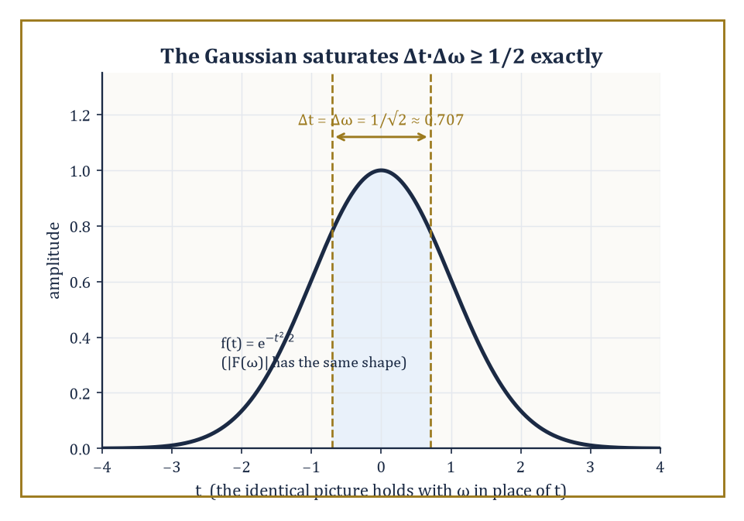
Figure 40.2 — The Gaussian bump: the one shape for which time-spread and frequency-spread hit the Heisenberg floor with nothing left over.
STFT(t, ξ) = ∫ x(τ) g(τ − t) exp(−i2πξτ) dτ
The result is a genuine time-frequency portrait — a value for every combination of time t and frequency ξ — but its resolution is locked in by the width of the window g, chosen once, in advance, and applied uniformly to a signal that may have no intention of cooperating with a single fixed timescale.
Numeric example — resolution bought and sold. A rough but standard rule of thumb relates window duration to frequency resolution:
Δf ≈ 1/T Hz
Choose T = 0.01 s (10 milliseconds, good for catching a drum hit):
Δf ≈ 1/0.01 = 100 Hz
Anything closer together than 100 Hz blurs into one smear. Choose T = 0.1 s (100 milliseconds, good for hearing a violin’s pitch):
Δf ≈ 1/0.1 = 10 Hz
That’s ten times sharper in frequency. You cannot have both from the same window. Sharpen the clock, and the ear goes fuzzy; sharpen the ear, and the clock goes fuzzy. This is not an engineering shortcoming to be fixed by trying harder — it is the STFT’s founding bargain.
Try it now — What frequency resolution does a 50 ms window give? Answer →
That bargain is not an accident of poor design; it is forced by the Heisenberg uncertainty principle, imported wholesale from the Fourier analysis of earlier chapters.
For any function f in L²(ℝ) (normalized so it has a well-defined ‘center’ and ‘spread’ in both time and frequency), the product of its time-spread Δt and its frequency-spread Δω obeys:
Δt·Δω ≥ 1/2
with equality if and only if f is a Gaussian bump. A function cannot be made arbitrarily narrow in time and arbitrarily narrow in frequency simultaneously — squeeze one, and the other balloons.
The same limit, applied to the analysis window g, caps how sharp the STFT’s time-frequency picture can ever be.
Numeric example — the Gaussian saturates the bound exactly. Take the function f, defined by:
f(t) = exp(−t²/2)
Its energy is a standard Gaussian integral:
∫exp(−t²) dt = √π
Its time-spread is:
Δt² = ∫t²exp(−t²)dt / ∫exp(−t²)dt = (√π/2)/√π = 1/2
Δt = 1/√2 ≈ 0.707
Its Fourier transform, using the convention:
F(ω)=∫f(t)exp(−iωt)dt
works out to:
F(ω) = √(2π)·exp(−ω²/2)
|F(ω)|² = 2π·exp(−ω²)
Its frequency-spread is:
Δω² = ∫ω²exp(−ω²)dω / ∫exp(−ω²)dω = (√π/2)/√π = 1/2
Δω = 1/√2 ≈ 0.707
The product is:
Δt·Δω = (1/√2)(1/√2) = 1/2
That is the Heisenberg bound, met with no slack whatsoever. Nothing beats a Gaussian at this game; nothing ever will.
The energy of the STFT is displayed as a spectrogram — the workhorse image of every audio-analysis package, every birdsong study, every sound-editing app’s waveform view. It shows time along one axis, frequency along the other, and brightness for energy.
Its Achilles’ heel is the fixed resolution just derived: a short window resolves a transient (a click, a consonant, a drum hit) crisply in time but blurs closely spaced tones together; a long window resolves closely spaced tones crisply but smears any transient out over its whole duration, turning a sharp click into a fuzzy, ambiguous smudge.
Abstract example — one signal, two failures. Consider a signal built from two events: a 5-millisecond click at t = 0, and two pure tones at 440 Hz and 460 Hz sustained throughout.
Using the 10 ms window from the earlier example (Δf ≈ 100 Hz): the click is well-timed but the two tones, only 20 Hz apart, are utterly indistinguishable — both fall inside the same 100 Hz smear.
Using the 100 ms window (Δf ≈ 10 Hz): the tones now separate cleanly, since a 20 Hz gap comfortably clears a 10 Hz resolution — but the 5 ms click gets smeared across the entire 100 ms window, its precise timing destroyed.
No single fixed window serves both halves of this rather ordinary signal well.
It is worth being honest about why the STFT cannot simply use a shorter window everywhere and call it a day. Musical pitch is perceived on a logarithmic (multiplicative) scale — the gap between 220 Hz and 440 Hz sounds like the same interval, an octave, as the gap between 440 Hz and 880 Hz — while the STFT’s frequency resolution Δf ≈ 1/T is a fixed, additive quantity in Hz, the same size everywhere on the frequency axis.
A resolution fine enough to separate two close low notes is needlessly, wastefully fine when applied to two far-apart high notes, and a resolution coarse enough to be efficient at high notes is far too blunt to separate low ones.
Numeric example — one resolution, two very different jobs. Take the window from the earlier example, with:
T = 0.1 s, giving Δf ≈ 10 Hz
Down at the bottom of the piano, the notes A2 (110 Hz) and A♯2 (about 116.5 Hz) are a semitone apart — a gap of only 6.5 Hz, smaller than the window’s 10 Hz resolution, so the two notes blur together.
Up near the top of the piano, A6 (1760 Hz) and A♯6 (about 1864.7 Hz) are also a semitone apart, but that is now a gap of roughly 105 Hz — more than ten times the window’s resolution, comfortably separated with room to spare.
The same fixed window is simultaneously too coarse for the bass and needlessly over-precise for the treble; no single choice of T serves both octaves well, because the ear’s sense of ‘how far apart’ two notes are does not match the STFT’s flat, uniform notion of frequency distance.
Wavelets sidestep the impasse not by cheating the uncertainty principle — nobody cheats the uncertainty principle, tenure or no tenure — but by refusing to fix the window size at all. Instead the window scales with what it’s looking for: narrow (short in time, wide in frequency) when hunting fine detail, wide (long in time, narrow in frequency) when hunting slow trends.
Picture the time-frequency plane tiled not by identical fixed boxes, as the STFT insists, but by boxes that are tall and narrow at high frequencies and short and wide at low frequencies — each box still obeying Heisenberg’s minimum area, but no longer forced to be the same shape everywhere. That single change of habit is the entire content of the next section.
Keep only this · Section 40.2: Time-Frequency Analysis and the Uncertainty Principle
The idea. No window can be sharp in both time and frequency: shortening it in time widens it in frequency, by a fixed trade.
Core.
Δf ≈ 1/T
σₜ σ_ω ≥ ½ (equality for the Gaussian)
Typical mistake. Thinking more computation beats the uncertainty principle. It is a property of the signal’s representation, not of the algorithm.
Minimal example. T = 10 ms gives Δf ≈ 100 Hz; T = 100 ms gives Δf ≈ 10 Hz.
Practice. Easy to challenge; full worked answers, with the usual mistake, are in Answers to the Practice Sets at the back.
Easy — How long a window is needed to separate tones at 440 Hz and 460 Hz? Answer →
Medium — With that 50 ms window, how precisely can a 5 ms click be located in time? Answer →
Challenge — For f(t) = exp(−t²/2), the energy density |f|² = exp(−t²) has variance σₜ² = ½, and its Fourier transform is again a Gaussian with σ_ω² = ½. Show that the bound σₜσ_ω ≥ ½ is met with equality. Answer →

Section 40.3: The Continuous Wavelet Transform
A transform so redundant it could retire twice
A wavelet is a short wiggle that rises and falls back to nothing. Slide it along a signal and, at each position, measure how well the two match; then stretch the wavelet and do it again. Wide wavelets respond to slow trends, narrow ones to fine detail, and the result is a map showing which scales are active where. A sudden jump in the signal stands out, right at the moment it happens. Matching the simplest wavelet, a square up-and-down pulse two units wide, against a step from 0 to 1 gives a strong response, about 0.707 in size, exactly where the pulse straddles the jump, and nothing at all away from it.
The continuous wavelet transform (CWT) correlates a signal x with scaled and translated copies of a mother wavelet ψ:
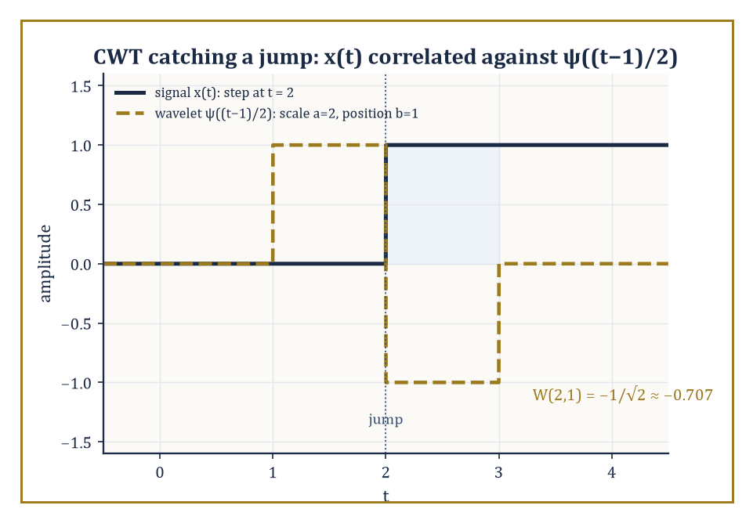
Figure 40.3 — The step signal and the one scaled, translated wavelet whose support straddles its jump — the pairing that produces W(2,1) ≈ −0.707.
W(a, b) = (1/√|a|) ∫ x(t) ψ*((t − b)/a) dt
Here a > 0 is the scale (large a stretches ψ, examining slow trends; small a compresses it, examining fine detail) and b is the translation (where along the signal we’re looking). Invertibility of the whole scheme rests on the admissibility condition:
C_ψ = ∫ |Ψ(ω)|²/|ω| dω < ∞
where Ψ is the Fourier transform of ψ. For this integral to converge near ω = 0, Ψ(0) must vanish — which, unwinding the definitions, means:
∫ψ(t) dt = 0
Every admissible wavelet has zero mean; that is the property we checked for the Haar wavelet in What Wavelets and Signal Analysis Are, and it is no coincidence.
Numeric example — a wavelet is blind to a constant. Zero mean has a sharp practical consequence: the CWT of any constant signal is identically zero. Take x(t) = 1 for all t, and the Haar mother wavelet at scale a = 2, translation b = 0.
The scaled wavelet ψ(t/2) equals +1 for t/2 ∈ [0, 0.5) — i.e. t ∈ [0, 1) — and −1 for t/2 ∈ [0.5, 1) — i.e. t ∈ [1, 2).
W(2, 0) = (1/√2) ∫₀² (1)·ψ(t/2) dt = (1/√2)[∫₀¹(1)(1)dt + ∫₁²(1)(−1)dt] = (1/√2)[1 − 1] = 0
A wavelet analysis cannot see a DC offset — it has, by construction, thrown that information away in exchange for sensitivity to change.
Try it now — Using the Haar wavelet, compute W(2, 0) for the ramp x(t) = t, with W(a, b) = (1/√a) ∫ x(t) ψ((t − b)/a) dt. Answer →
That same zero-mean property is what makes the CWT good at what a constant signal cannot show it: change. Correlating a wavelet against a signal at a given scale and location measures, roughly, how much that signal deviates from being locally constant at that scale and place.
Where the signal really is locally constant, the correlation vanishes (as just shown); where it isn’t — where there’s a jump, an edge, a transient — the correlation is large.
Numeric example — catching the jump. Let x(t) = 0 for t < 2 and x(t) = 1 for t ≥ 2 — a single step at t = 2 — and evaluate the Haar CWT at scale a = 2, translation b = 1.
The translated, scaled wavelet ψ((t−1)/2) equals +1 for (t−1)/2 ∈ [0, 0.5), i.e. t ∈ [1, 2), and −1 for (t−1)/2 ∈ [0.5, 1), i.e. t ∈ [2, 3).
W(2, 1) = (1/√2)∫₁³ x(t)ψ((t−1)/2) dt = (1/√2)[∫₁²(0)(1)dt + ∫₂³(1)(−1)dt] = (1/√2)[0 − 1] = −1/√2 ≈ −0.707
Compare against the zero response to a constant signal: the jump, sitting inside the wavelet’s support at just this scale and location, produces a non-zero reading. Move b away from 2, or choose a scale that doesn’t straddle the jump, and the response shrinks back toward zero.
Different choices of mother wavelet emphasize different features, in the same way that different microscope lenses emphasize different specimens.
The Morlet wavelet — a complex sinusoid tucked inside a Gaussian envelope — has excellent frequency localization and is the standard choice when you want to track how a dominant oscillation’s frequency drifts over time (birdsong, heartbeats, gravitational-wave chirps).
The Mexican hat wavelet (the negative second derivative of a Gaussian, so named for its cross-section) is real-valued, has no preferred oscillation frequency of its own, and is correspondingly better at flagging sharp local features — edges, blobs, sudden bumps — without worrying about their underlying periodicity.
The energy of the CWT across the whole (a, b) plane is displayed as a scalogram, the direct wavelet analogue of the STFT’s spectrogram, except that its ‘boxes’ now change shape with scale, as promised at the end of Time-Frequency Analysis and the Uncertainty Principle.
Abstract example — choosing the right lens. Suppose you are handed two signals: (i) a bat’s echolocation chirp, whose instantaneous frequency sweeps smoothly from 80 kHz down to 20 kHz over two milliseconds, and (ii) an ECG trace, whose main feature of interest is the sharp, narrow QRS spike marking each heartbeat.
For (i), a Morlet-based scalogram is the natural tool: its complex oscillatory structure tracks a sweeping frequency as a bright ridge moving through the time-scale plane.
For (ii), a Mexican-hat-based scalogram is the natural tool: its lack of internal oscillation means it responds to the spike itself, as a sharp, localized cone of energy, rather than getting entangled with whatever frequency content happens to sit inside the spike. Same transform, same machinery, deliberately different lens.
The CWT’s chief virtue — a continuous portrait over every scale and every location — is also, from a computational standpoint, an act of profligacy.
It is a highly redundant representation: a finite, discrete input signal gets mapped to a value at every (a, b) pair we care to sample, vastly more numbers than we started with. That redundancy buys robustness and a beautifully explicit reconstruction formula (the Calderón identity, which we will not chase down here), but it is not how anyone actually stores or transmits a signal.
The CWT is the analytic starting point, the proof that the idea works and is invertible; practical computation almost always passes to a discrete, non-redundant cousin — an orthonormal basis, built from a structure called a multiresolution analysis, which is where we head next.
Numeric example — counting the redundancy. Take a modest discrete signal of 8 samples. To build even a coarse CWT-style picture, sample, say, 5 scales at all 8 translations: that’s already 40 numbers describing an 8-number signal — a five-fold blow-up.
The orthonormal construction of Sections 40.4–40.6, by contrast, will turn those same 8 samples into exactly 8 coefficients: no more, no less, fully invertible, with not a single redundant number in sight.
The price of that efficiency is giving up the CWT’s continuous, oversampled comfort blanket — a fair trade, as we’re about to see.
Keep only this · Section 40.3: The Continuous Wavelet Transform
The idea. The CWT slides and stretches one wavelet across the signal and records how well it matches at every position and scale.
Core.
W(a, b) = (1/√a) ∫ x(t) ψ((t − b)/a) dt
∫ ψ = 0 ⇒ constants give W = 0
Typical mistake. Treating the CWT as a compact representation. It turns one signal into a whole surface of numbers: wonderful for looking, wasteful for storing.
Minimal example. x(t) = 1, Haar, a = 2, b = 0: W = (1/√2)(1 − 1) = 0.
Practice. Easy to challenge; full worked answers, with the usual mistake, are in Answers to the Practice Sets at the back.
Easy — Why is the CWT of x(t) = 7 identically zero for any admissible wavelet? Answer →
Medium — For the step x(t) = 0 (t < 2), 1 (t ≥ 2), compute the Haar W(1, 1.5). Answer →
Challenge — Show that the CWT of x(t) + c equals the CWT of x(t) for every constant c. Answer →

Section 40.4: Multiresolution Analysis
Nested boxes, all the way down to nothing and all the way up to everything
Before this section
What you need. Orthogonal projection onto a subspace and orthogonal complements from Linear Algebra (Volume 2); the Haar wavelet from What Wavelets and Signal Analysis Are.
Why it matters. Multiresolution is the idea that turns wavelets from a clever basis into an algorithm. Each rung of the ladder is a projection, and each detail space is the orthogonal complement you met in Volume 2.
Look at a photograph at low resolution, then add the detail needed for the next resolution, then the next. Each level contains everything in the coarser ones plus something extra, and in the limit you have the full picture. A multiresolution analysis is the mathematical form of that zooming. Its building block is a single bump. In the simplest case, the Haar system, the bump is a box of width 1, and that box is exactly two half-width boxes placed side by side. Coarse approximations are built from wide boxes, finer ones from narrower boxes, and the differences between successive levels are precisely what wavelets capture.
A multiresolution analysis (MRA) is the structural scaffold on which orthonormal wavelet bases are built, and it is worth sitting with its definition slowly, because everything in Orthonormal Wavelet Bases and The Discrete Wavelet Transform and Filter Banks is just this idea being cashed out.
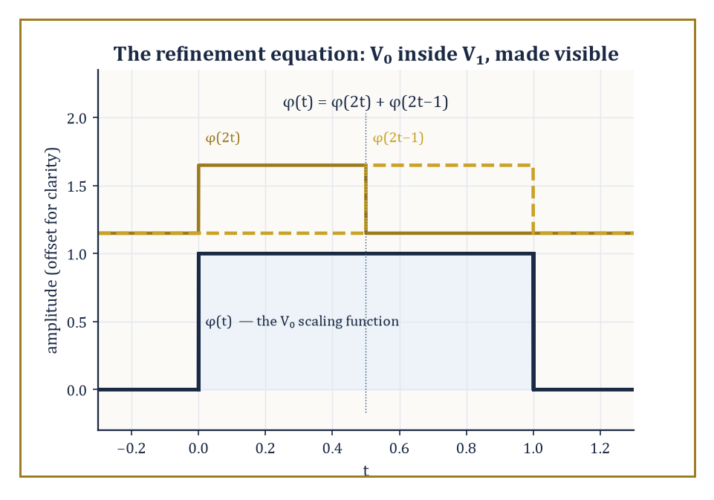
Figure 40.4 — The Haar refinement equation made literal: two half-width copies of φ, stacked side by side, reassemble the original box.
An MRA is a nested sequence of closed subspaces of L²(ℝ),
⋯ ⊂ V₋₁ ⊂ V₀ ⊂ V₁ ⊂ ⋯
such that: the union of all the Vⱼ is dense in L² (nothing is permanently out of reach as j → ∞); the intersection of all the Vⱼ is {0} (nothing survives as j → −∞ except the zero function); and each space is a dyadically rescaled copy of the next —
f(t) ∈ Vⱼ ⟺ f(2t) ∈ Vⱼ₊₁
— and the whole tower is generated by integer translates of a single function φ, the scaling function, whose translates {φ(t − k) : k ∈ ℤ} form an orthonormal basis of V₀.
The wavelet space Wⱼ is defined as the orthogonal complement of Vⱼ inside Vⱼ₊₁ — literally, the extra detail you gain going from resolution j to resolution j+1.
Abstract example — the Haar MRA made concrete. Let V₀ = the space of functions that are piecewise constant on each interval [k, k+1), k ∈ ℤ, and square-integrable. Its scaling function is φ = the indicator function of [0, 1), with {φ(t−k)} orthonormal (disjoint supports, each of unit length).
Let V₁ = functions piecewise constant on each half-integer interval [k/2, (k+1)/2). Since [0, 1) splits into two halves,
[0, 1) = [0, 0.5) ∪ [0.5, 1)
any function constant on [0,1) — such as φ itself — is automatically constant on each of its two halves, so V₀ ⊂ V₁, as required.
As j increases, the intervals halve again and again, resolution sharpens without limit, and in the limit any square-integrable function can be approximated arbitrarily well by piecewise-constant functions on ever-finer grids — which is precisely the density condition the definition demands.
Try it now — Let f be 3 on [0, ½), 5 on [½, 1) and 0 elsewhere. Is f in V₀ (Haar)? In V₁? Answer →
The two extreme conditions in the definition — union dense, intersection trivial — are not bureaucratic fine print; they are what stop the entire tower collapsing into something useless.
Density of the union guarantees that no square-integrable function is permanently out of reach: however wild or jagged a target function, fine enough resolution eventually approximates it as well as you like.
Triviality of the intersection guarantees the opposite failure mode is also ruled out: there is no non-zero function so featureless that it survives being viewed at arbitrarily coarse resolution forever — zoom out enough, and every genuine signal eventually blurs into indistinguishability from the zero function, exactly as intuition about ‘coarse resolution’ demands.
Abstract example — a function that would break the scaffold. Suppose, contrary to the axioms, some non-zero f survived in every Vⱼ as j → −∞ (violating trivial intersection).
Since each Vⱼ consists of functions constant on intervals of length 2⁻ʲ, which grow without bound as j → −∞, f would have to be constant on intervals of unbounded length — in the limit, constant on all of ℝ.
A non-zero constant function is not square-integrable (∫|c|² dt diverges for c ≠ 0 over an infinite domain), so no such f can exist in L²(ℝ) at all.
The trivial-intersection axiom is not an extra assumption bolted on for convenience; for L²(ℝ), it is forced, and checking why it’s forced is a good way to see that the MRA definition was engineered with no slack in it.
The relationship V₀ ⊂ V₁ is encoded algebraically by the refinement equation (also called the two-scale equation):
φ(t) = √2 Σₖ hₖ φ(2t − k)
This expresses the coarse scaling function as a specific combination of finer, shifted-and-compressed copies of itself. The coefficients hₖ are precisely the low-pass filter of the associated filter bank we will meet properly in The Discrete Wavelet Transform and Filter Banks; the wavelet ψ turns out to be built from the same coefficients, reordered and sign-flipped:
ψ(t) = √2 Σₖ gₖ φ(2t − k) with gₖ = (−1)ᵏ h₁₋ₖ (or an equivalent convention)
One equation, φ, quietly determines the entire infinite hierarchy of approximation spaces and their complementary detail spaces.
Numeric example — checking the Haar refinement equation by hand. For the Haar case, h₀ = h₁ = 1/√2, so the refinement equation reads:
φ(t) = √2·[(1/√2)φ(2t) + (1/√2)φ(2t−1)] = φ(2t) + φ(2t−1)
Verify it directly. For t ∈ [0, 0.5): 2t ∈ [0, 1), so φ(2t) = 1; 2t−1 ∈ [−1, 0), so φ(2t−1) = 0.
Sum = 1 = φ(t) ✓
For t ∈ [0.5, 1): 2t ∈ [1, 2), so φ(2t) = 0; 2t−1 ∈ [0, 1), so φ(2t−1) = 1.
Sum = 1 = φ(t) ✓
For t outside [0, 1), both terms vanish and so does φ(t). The identity holds exactly, for the entirely unglamorous reason that chopping the unit interval in half and gluing the halves back together gives you the unit interval back.
Once φ (and hence Vⱼ) is fixed, the theory does not leave the wavelet ψ (and hence Wⱼ) as a free choice — it is forced, up to the usual harmless ambiguities of sign and indexing.
This is the sense in which ‘MRA is the structural heart of orthonormal wavelet theory’: give a mathematician a valid nested sequence of approximation spaces satisfying the axioms above, and the wavelet basis falls out as a consequence, not as a separate act of invention.
Orthonormal Wavelet Bases shows what it takes to choose φ so that ψ is not just any old complementary function but one that is smooth and compactly supported — the two properties that took until the 1980s to reconcile.
Numeric example — the detail space really is orthogonal to the approximation space. The Haar wavelet is
ψ(t) = φ(2t) − φ(2t−1)
equal to +1 on [0, 0.5), −1 on [0.5, 1). Check the orthogonality integral, where φ is the indicator of [0,1):
∫φ(t)ψ(t) dt = ∫[0, 0.5] (1)(1) dt + ∫[0.5, 1] (1)(−1) dt = 0.5 − 0.5 = 0
The scaling function and the wavelet are orthogonal, as the definition Wⱼ = Vⱼ⁺¹ ⊖ Vⱼ demands — the ‘detail’ truly does contain nothing already captured by the ‘approximation’. It is a two-line integral, and it is the entire content of why decomposing a signal into approximation-plus-detail never double-counts information.
Keep only this · Section 40.4: Multiresolution Analysis
The idea. A multiresolution analysis is a ladder of approximation spaces, each finer than the last; what one rung adds to the previous one is spanned by wavelets.
Core.
⋯ ⊂ V₋₁ ⊂ V₀ ⊂ V₁ ⊂ ⋯, V₁ = V₀ ⊕ W₀
φ(t) = φ(2t) + φ(2t − 1) (Haar refinement)
Typical mistake. Forgetting that the detail space is orthogonal to the approximation space. V₁ = V₀ ⊕ W₀ is an orthogonal split, not just any split.
Minimal example. f = 3 on [0, ½), 5 on [½, 1): f = 4φ − ψ, with average 4 in V₀ and detail −ψ in W₀.
Practice. Easy to challenge; full worked answers, with the usual mistake, are in Answers to the Practice Sets at the back.
Easy — Write that f as average plus detail: f = cφ + dψ. Answer →
Medium — What is the orthogonal projection of that f onto V₀? Answer →
Challenge — Verify the Haar refinement equation φ(t) = φ(2t) + φ(2t − 1), and explain why it is the same statement as V₀ ⊂ V₁. Answer →

Section 40.5: Orthonormal Wavelet Bases
In which smoothness and compact support finally agree to share a function
In a good coordinate system the axes are perpendicular and of unit length, so that each coordinate can be read off without reference to the others. An orthonormal wavelet basis gives signals that kind of coordinate system, built entirely from stretched and shifted copies of one wavelet, each stretch twice as narrow as the one before. The Haar wavelet, a box that steps up and then down, achieves this but is jagged. For decades it was unclear whether a smooth wavelet could also be confined to a finite interval and still give perpendicular coordinates. Ingrid Daubechies showed in 1988 that it can, at the price of a wider support for every gain in smoothness.
An orthonormal wavelet basis is an orthonormal basis of L²(ℝ) consisting wholly of scaled and translated copies of a single mother wavelet ψ, indexed by scale j ∈ ℤ and position k ∈ ℤ:
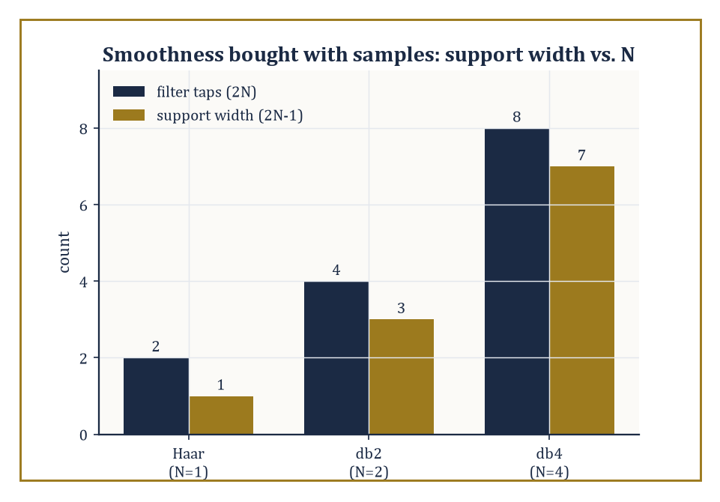
Figure 40.5 — Smoothness is not free: each extra tap in the Daubechies family buys a wider support, one sample at a time.
ψⱼ,ₖ(t) = 2^(j/2)ψ(2ʲt − k)
The Haar basis, built from the Haar wavelet of What Wavelets and Signal Analysis Are and Multiresolution Analysis, is the oldest and simplest example — it predates the word ‘wavelet’ by about seventy years, Alfréd Haar having written it down in 1909 for entirely different reasons and had no idea what he was starting.
The Daubechies family, constructed in the mid-1980s, is the workhorse of modern practice: compactly supported (each basis function is exactly zero outside a bounded interval, unlike a sinc function trailing off forever) and tunable smoothness, at the cost of losing the Haar wavelet’s endearing but limiting simplicity.
Numeric example — checking a basis element is unit length. Consider the basis element formed by scale j = 1, position k = 0:
ψ₁,₀(t) = 2^(1/2)·ψ(2t) = √2·ψ(2t)
Since ψ(2t) equals +1 for 2t ∈ [0, 0.5) — i.e. t ∈ [0, 0.25) — and −1 for 2t ∈ [0.5, 1) — i.e. t ∈ [0.25, 0.5) — we get ψ₁,₀(t) = √2 on [0, 0.25) and −√2 on [0.25, 0.5).
Check its squared norm:
∫[0, 0.25] (√2)² dt + ∫[0.25, 0.5] (−√2)² dt = 2(0.25) + 2(0.25) = 0.5 + 0.5 = 1
Norm exactly 1, as an orthonormal basis element must be — the 2^(j/2) scaling factor in front of ψⱼ,ₖ exists to compensate for the compression, keeping every basis element at unit length regardless of scale.
Try it now — Check that ψ₂,₁(t) = 2ψ(4t − 1) has norm 1. Answer →
Compact support deserves a moment’s separate attention, because it is what makes the whole family computable rather than merely elegant.
A wavelet with compact support is precisely zero outside some bounded interval, so computing a single wavelet coefficient only ever requires reading a bounded number of nearby signal samples — never the entire signal, however long.
A wavelet without compact support (a sinc function, say, trailing off forever) would in principle require every coefficient computation to touch every sample, which is a poor bargain for anything resembling real-time processing.
Numeric example — support width versus smoothness, a direct trade. The Haar wavelet (N = 1) has 2N = 2 filter taps and support width 1: it looks at exactly one adjacent pair of samples.
db2 (N = 2) has 2N = 4 taps and support width 3: computing one db2 wavelet coefficient reads 4 nearby samples instead of 2.
db4 (N = 4) has 2N = 8 taps and support width 7: 8 nearby samples per coefficient.
Smoothness and vanishing moments (Vanishing Moments, Approximation, and Compression) go up roughly in step with N, but so, linearly, does the number of neighboring samples each coefficient must consult — a completely explicit, arithmetic trade-off between how smoothly a wavelet behaves and how expensive it is to evaluate, with no hidden surprises.
Building smooth, compactly supported orthonormal wavelets — rather than the Haar basis’s discontinuous jumps — was a hard problem, and Ingrid Daubechies’s 1988 solution was rightly treated as a landmark.
The recipe is to design a finite low-pass filter (h₀, h₁, …, h_(2N−1)) satisfying the quadrature-mirror conditions — orthonormality of its integer shifts, plus the constant-reproduction condition:
Σhₖ = √2
— then iterate the refinement equation, starting from a crude initial guess:
φ(t) = √2 Σₖ hₖφ(2t−k)
Under the right conditions on the filter, this cascade algorithm converges to a genuine, well-defined scaling function φ, and the companion wavelet ψ falls out via the alternating-flip construction from Multiresolution Analysis.
Numeric example — the db2 (Daubechies-4) filter, checked by hand. The simplest non-Haar member of the family, db2, has four filter taps:
h₀ = (1+√3)/(4√2), h₁ = (3+√3)/(4√2), h₂ = (3−√3)/(4√2), h₃ = (1−√3)/(4√2)
With √3 ≈ 1.7321, these evaluate to (to 4 dp):
h₀ ≈ 0.4830, h₁ ≈ 0.8365, h₂ ≈ 0.2241, h₃ ≈ −0.1294
Check the constant-reproduction condition, Σhₖ = √2 ≈ 1.4142:
0.4830 + 0.8365 + 0.2241 − 0.1294 = 1.4142 ✓
Check the orthonormality (energy) condition, Σhₖ² = 1:
0.4830² + 0.8365² + 0.2241² + (−0.1294)² ≈ 0.2333 + 0.6998 + 0.0502 + 0.0167 = 1.0000 ✓
Four numbers, two exact identities, and a scaling function smoother than Haar’s step — that quiet arithmetic is the entire 1988 breakthrough, condensed to four decimal checks.
Abstract example — watching the cascade converge. Start the cascade for db2 with φ⁽⁰⁾ = the indicator of [0,1) (the crude Haar guess), and apply the refinement operator repeatedly:
φ⁽ⁿ⁺¹⁾(t) = √2 Σₖ hₖ φ⁽ⁿ⁾(2t−k)
φ⁽¹⁾ is already a jagged four-step approximation built from shifted, scaled copies of the indicator, weighted by h₀,…,h₃. φ⁽²⁾ refines each of those steps again, using the same four weights at half the scale.
There is no closed-form elementary formula for the limit φ — that is why the construction has to proceed by iteration rather than by writing down a tidy expression — but under the QMF conditions checked above, the sequence φ⁽ⁿ⁾ provably converges in L² to a continuous (in fact Hölder-continuous), compactly supported scaling function on [0, 3].
Smoothness earned by an infinite process, not by an explicit formula: an appropriately Sisyphean way for a mathematician to spend a decade.
The reward for going to all this trouble is Parseval’s identity: for an orthonormal basis, the total energy of the signal equals the total energy of its coefficients, exactly, with nothing lost or gained.
‖x‖² = Σⱼ,ₖ |⟨x, ψⱼ,ₖ⟩|²
This is what makes orthonormal bases the tool of choice whenever exact reconstruction and exact energy accounting matter — denoising thresholds (Applications: Denoising, Images, and Beyond), compression bit-budgets (Vanishing Moments, Approximation, and Compression), and numerical stability all lean on it.
Numeric example — Parseval, checked to the last integer. Take x = [1, 3, 5, 7], and compute one level of the (orthonormal) Haar transform, pairing (1,3) and (5,7):
a₀ = (1+3)/√2 = 4/√2 ≈ 2.8284, d₀ = (1−3)/√2 = −2/√2 ≈ −1.4142
a₁ = (5+7)/√2 = 12/√2 ≈ 8.4853, d₁ = (5−7)/√2 = −2/√2 ≈ −1.4142
Now compare the total signal energy against the total coefficient energy.
Signal energy: 1² + 3² + 5² + 7² = 1 + 9 + 25 + 49 = 84
Coefficient energy: a₀² + d₀² + a₁² + d₁² = 8 + 2 + 72 + 2 = 84
The two totals agree precisely — not approximately, exactly — because each pairwise Haar step is, geometrically, just a rotation of the plane by 45°, and rotations never change lengths. Not a single unit of energy went missing in the transform.
Keep only this · Section 40.5: Orthonormal Wavelet Bases
The idea. An orthonormal wavelet basis is a family ψⱼ,ₖ = 2^(j/2) ψ(2ʲt − k) of unit, mutually perpendicular functions; Daubechies wavelets trade support width for smoothness.
Core.
ψⱼ,ₖ(t) = 2^(j/2) ψ(2ʲt − k)
dbN: 2N taps, support width 2N − 1, N vanishing moments
Typical mistake. Assuming orthogonal wavelets can be symmetric and compactly supported at once. Apart from Haar they cannot; that is why JPEG 2000 uses biorthogonal ones.
Minimal example. x = [1, 3, 5, 7]: coefficient energy 8 + 2 + 72 + 2 = 84 = signal energy.
Practice. Easy to challenge; full worked answers, with the usual mistake, are in Answers to the Practice Sets at the back.
Easy — How many filter taps does db3 have, and how wide is its support? Answer →
Medium — Show that the Haar ψ₀,₀ and ψ₁,₀ are orthogonal. Answer →
Challenge — The db2 low-pass filter is h = (1 + √3, 3 + √3, 3 − √3, 1 − √3)/(4√2). Check that Σh = √2 and Σh² = 1. Answer →

Section 40.6: The Discrete Wavelet Transform and Filter Banks
How to have your wavelets and compute them too
Same structure, new language
A filter is a convolution, the operation of Fourier Transforms and the Laplace Transform in Volume 2: slide one list along another, multiply and add. The convolution theorem said filtering multiplies spectra, so a low-pass filter keeps slow wiggles and a high-pass filter keeps fast ones. A filter bank is two convolutions and a decimation; the DWT is that, repeated.
The discrete wavelet transform (DWT) is how the abstract orthonormal expansion of Orthonormal Wavelet Bases gets computed on a real, finite string of numbers.
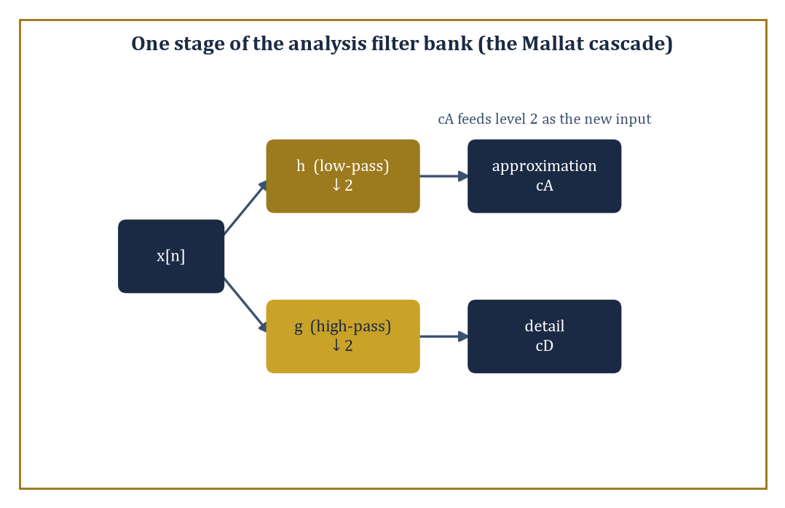
Figure 40.6 — One stage of the Mallat cascade: split, filter, downsample, repeat — the algorithm that turns the abstract wavelet basis into a linear-time computation.
Analysis proceeds by a cascade: at each stage, apply a low-pass filter h and a high-pass filter g to the current signal, then downsample each result by keeping only every second output sample.
The low-pass, downsampled output becomes the coarser approximation (feeding into the next stage); the high-pass, downsampled output is the detail at that scale (kept, untouched, as final output).
Synthesis reverses the process: upsample (insert zeros between samples) and apply the dual filters, then add the two results back together.
Numeric example — the filter-bank view matches the pairwise view exactly. Apply the Haar filter bank, h = [1/√2, 1/√2] and g = [1/√2, −1/√2], to x = [1, 3, 5, 7], convolving and keeping every second output (this is what ‘filter then downsample by 2’ does for a two-tap filter on non-overlapping pairs).
Low-pass, even-indexed outputs:
(1·1/√2 + 3·1/√2) = 4/√2 ≈ 2.8284
(5·1/√2 + 7·1/√2) = 12/√2 ≈ 8.4853
High-pass, even-indexed outputs:
(1·1/√2 − 3·1/√2) = −2/√2 ≈ −1.4142
(5·1/√2 − 7·1/√2) = −2/√2 ≈ −1.4142
These are a₀, a₁, d₀, d₁ from Section 40.5’s Parseval example — the filter-bank machinery and the pairwise average-and-difference machinery are, for Haar, the same computation wearing different clothes.
Try it now — Apply the Haar filter bank to the pair [2, 6]. Answer →
Perfect reconstruction — recovering the original signal from its coefficients — is equivalent to the analysis filters and synthesis filters forming a quadrature-mirror pair, the same QMF condition checked numerically for db2 in Orthonormal Wavelet Bases.
It is not automatic: filter banks that fail the condition lose information irretrievably on the way down.
When it holds, however, reconstruction is not merely possible but exact, to the last decimal (or, for integer-based schemes, to the last integer).
Numeric example — synthesis really does undo analysis. From a₀ ≈ 2.8284 and d₀ ≈ −1.4142 (the Haar analysis of the pair (1, 3)), synthesis recovers x₀ and x₁:
x₀ = (a₀ + d₀)/√2 and x₁ = (a₀ − d₀)/√2
x₀ = (2.8284 + (−1.4142))/1.4142 = 1.4142/1.4142 = 1.000
x₁ = (2.8284 − (−1.4142))/1.4142 = 4.2426/1.4142 = 3.000
Exactly (1, 3), recovered to three decimal places from two numbers that individually looked nothing like either original sample. No information was lost; it was only rearranged into a more useful shape.
Cascading the analysis stage across successive scales — feed the coarse output of level 1 into level 2 as input, and so on — is the Mallat algorithm (Stéphane Mallat, 1989), and it runs in time linear in the length of the signal, a fact worth pausing on, because ‘linear time and invertible and gives you an orthonormal basis’ is a combination most algorithms only dream of.
For finite-length signals, some care is needed at the two ends, where a filter of width w reaches past the available data; standard fixes are periodic extension (wrap around), symmetric extension (mirror the signal at the boundary), or specially constructed ‘wavelets on the interval’ that avoid the issue altogether.
Numeric example — why the cascade is linear time. Take a signal of N = 8 samples.
Level 1 processes all 8 samples (cost ∝ 8), producing 4 approximation and 4 detail coefficients; the detail coefficients are done, the 4 approximation coefficients move on. Level 2 processes those 4 (cost ∝ 4), producing 2 and 2. Level 3 processes those 2 (cost ∝ 2), producing 1 and 1, and the cascade stops.
Total cost ∝ 8 + 4 + 2 = 14
Compare against 2N = 16: the geometric series 8 + 4 + 2 + 1 + ⋯ sums to at most 2N = 16 for any starting length N, so the total work is always bounded by a small constant multiple of N — genuinely linear time, not merely ‘not exponential’.
Orthonormality is a convenient property, not a moral requirement, and relaxing it opens up design freedom that orthonormal filters cannot offer — most importantly, linear phase (symmetric filters, which avoid the visually unpleasant phase distortion that asymmetric filters introduce at edges).
The resulting biorthogonal wavelets use one filter pair for analysis and a different, but compatible, filter pair for synthesis.
The most famous biorthogonal pair in applied mathematics is the CDF 5/3 wavelet, the reversible, integer-to-integer transform used for lossless compression in JPEG 2000, computed via a simple two-step procedure called lifting.
Numeric example — the 5/3 lifting transform, by hand. Take x = [2, 4, 8, 10]. Split into even samples (2, 8) and odd samples (4, 10).
Predict step, using symmetric extension x[4] = x[2] = 8 at the boundary:
dₙ = x[2n+1] − ⌊(x[2n] + x[2n+2])/2⌋
d₀ = 4 − ⌊(2+8)/2⌋ = 4 − 5 = −1
d₁ = 10 − ⌊(8+8)/2⌋ = 10 − 8 = 2
Update step, using symmetric extension d₋₁ = d₀ = −1 at the boundary:
sₙ = x[2n] + ⌊(dₙ₋₁ + dₙ + 2)/4⌋
s₀ = 2 + ⌊(−1 + −1 + 2)/4⌋ = 2 + ⌊0/4⌋ = 2 + 0 = 2
s₁ = 8 + ⌊(−1 + 2 + 2)/4⌋ = 8 + ⌊3/4⌋ = 8 + 0 = 8
Result: low-pass s = [2, 8], high-pass (detail) d = [−1, 2].
Every number here is an integer, the whole procedure uses only addition, subtraction, and integer floor-division — no square roots, no rounding error, and, crucially, it is exactly reversible: run the two steps in reverse order with subtraction instead of addition and you recover [2, 4, 8, 10] to the last integer.
That reversibility is why JPEG 2000 can offer lossless compression alongside its lossy mode, using the same underlying transform.
Keep only this · Section 40.6: The Discrete Wavelet Transform and Filter Banks
The idea. The discrete wavelet transform is a filter bank: split into low-pass and high-pass halves, keep every second sample, repeat on the low half; it is exactly invertible and costs O(N).
Core.
analysis: a = (h ∗ x)↓2, d = (g ∗ x)↓2
cost: N + N/2 + N/4 + ⋯ < 2N
Typical mistake. Recursing on the detail half. The standard DWT splits only the low-pass output again; splitting both is a wavelet packet.
Minimal example. [1, 3, 5, 7] → a = (2.828, 8.485), d = (−1.414, −1.414).
Practice. Easy to challenge; full worked answers, with the usual mistake, are in Answers to the Practice Sets at the back.
Easy — From a = 8/√2 and d = −4/√2, recover the pair. Answer →
Medium — How many filter outputs does a full Haar DWT compute on N = 16 samples? Answer →
Challenge — Invert the 5/3 lifting result s = [2, 8], d = [−1, 2] by hand and recover [2, 4, 8, 10]. Answer →

Section 40.7: Vanishing Moments, Approximation, and Compression
How many kinds of polynomial a wavelet is willing to ignore
A wavelet coefficient measures how much a signal varies at a particular place and scale. If the signal is locally flat, a straight ramp or a gentle curve, a well-designed wavelet should report almost nothing there, saving its large coefficients for places where something happens, such as an edge. The number of polynomial degrees a wavelet ignores is its number of vanishing moments. The Haar wavelet ignores constants but not ramps: a ramp leaves small coefficients everywhere, while a genuine jump produces one six times larger than the rest. That is the key to compression, since smooth regions give tiny coefficients that can be discarded and only the edges need many bits.
A wavelet ψ has M vanishing moments if it is orthogonal to every polynomial of degree less than M — that is,
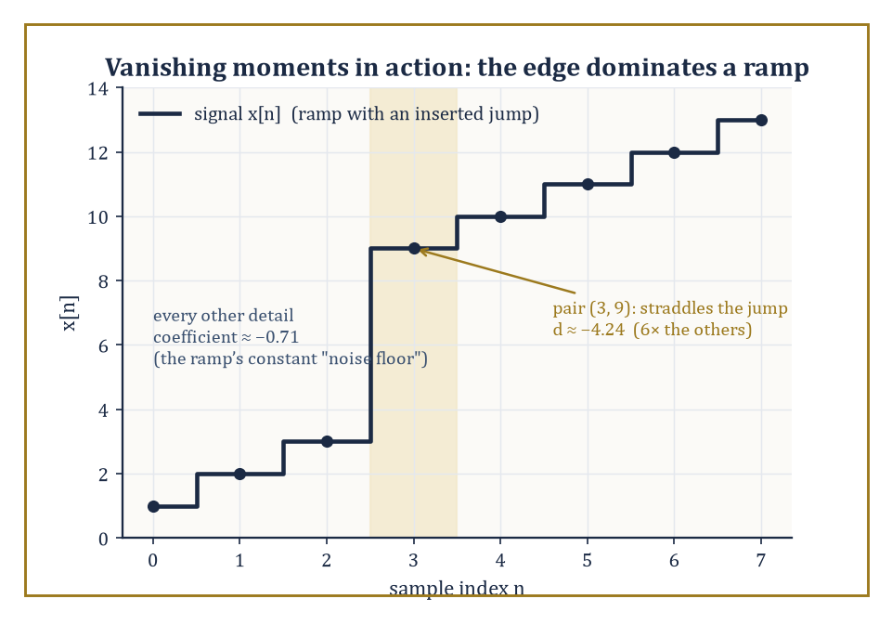
Figure 40.7 — A ramp Haar cannot fully ignore, and the one pair of samples where a genuine jump makes its detail coefficient six times the rest.
∫ tᵐ ψ(t) dt = 0 for m = 0, 1, …, M−1
We already checked the m = 0 case for the Haar wavelet back in What Wavelets and Signal Analysis Are (its mean is zero); vanishing moments generalize that idea to higher-degree polynomials, and M is the crucial design number that decides how good a wavelet is at ignoring smooth trends and reacting only to genuine irregularity. It is worth noticing what the condition does not say: it says nothing about ψ being small, or oscillatory, or any other qualitative property — only that its overlap with each low-degree polynomial, computed by this specific integral, comes out to precisely zero. Everything downstream in this section follows from that one narrow, checkable requirement.
Numeric example — Haar has exactly one vanishing moment, not two. Check the m = 1 moment for the Haar wavelet:
∫₀¹ t·ψ(t) dt = ∫[0, 0.5] t dt − ∫[0.5, 1] t dt = [t²/2]₀^0.5 − [t²/2]_0.5¹
= (0.125 − 0) − (0.5 − 0.125) = 0.125 − 0.375 = −0.25
Non-zero. So the Haar wavelet has M = 1 vanishing moment exactly — it kills constants (m=0) but not linear functions (m=1). This single computation explains a great deal of the Haar basis’s blocky, chunky character: it can be fooled by anything with a slope.
Try it now — Compute one Haar detail coefficient for the ramp pair (1, 2), and say what every pair of the ramp 1, 2, …, 8 gives. Answer →
The number of vanishing moments controls approximation order: the smoother the signal (more continuous derivatives it has), the faster its wavelet coefficients decay as the scale gets finer — but only up to what M permits.
A wavelet with M vanishing moments represents any polynomial of degree less than M with exactly zero coefficients at every scale, so it ‘wastes’ no coefficients describing perfectly smooth polynomial trends; all its coefficients are then free to describe genuine deviation from such trends. A wavelet with too few vanishing moments, by contrast, keeps registering non-zero coefficients even for signals that are locally very smooth, because ‘smooth’ for that signal means ‘linear’ or ‘quadratic’, and the wavelet isn’t blind enough to ignore it.
Numeric example — Haar cannot ignore a ramp. Take the quite smooth linear ramp x = [1, 2, 3, 4, 5, 6, 7, 8] and compute one level of the Haar detail coefficients:
pairs (1,2): d₀ = (1−2)/√2 ≈ −0.7071
(3,4): d₁ ≈ −0.7071
(5,6): d₂ ≈ −0.7071
(7,8): d₃ ≈ −0.7071
Every single detail coefficient is the same non-zero value, −0.7071 — the Haar wavelet, with only M = 1 vanishing moment, registers the ramp’s constant slope as ‘detail’ at every single position, even though there is nothing remotely irregular about a straight line. A wavelet with M = 2 vanishing moments (such as db2) is, by construction, orthogonal to linear functions too, and would return precisely zero for every one of these four coefficients.
This is the mechanism behind nonlinear approximation: rather than keeping the coefficients belonging to the coarsest scales (linear approximation), keep the largest coefficients wherever they occur (nonlinear approximation, so called because the choice of which coefficients to keep now depends on the signal, not just on a fixed rule).
For a piecewise-smooth signal — smooth stretches interrupted by a handful of genuine edges — this is spectacularly effective: the smooth stretches, wherever M is large enough to see through them, contribute small or zero coefficients that can be discarded almost for free; the edges contribute a small number of large coefficients, localized, that must be kept. Most of the signal’s true complexity is concentrated in a small fraction of the coefficients.
Numeric example — the edge dominates even a ramp Haar can’t fully tame. Take x = [1, 2, 3, 9, 10, 11, 12, 13] — a ramp with a jump inserted between positions 2 and 3. One level of Haar details:
pair (1,2): d₀ = −0.7071
pair (3,9): d₁ = (3−9)/√2 ≈ −4.2426
pair (10,11): d₂ = −0.7071
pair (12,13): d₃ = −0.7071
Three coefficients sit at the ‘ramp noise floor’ of about −0.71 (inherited from Section 40.7’s earlier example, since Haar can’t fully ignore a slope); one coefficient, d₁ ≈ −4.24, is six times larger, sitting at the genuine discontinuity. Keep only the largest coefficient and you have already captured the single most informative fact about this signal — that is nonlinear approximation working exactly as advertised, even with a wavelet whose vanishing-moment count is, frankly, a bit stingy.
The relationship between the smoothness of ψ, its number of vanishing moments M, and the decay rate of the resulting coefficients for smooth signals is the approximation-theoretic core of wavelet theory, and it is what ties Daubechies’s 1988 construction directly to compression performance decades later: choosing dbN roughly buys you N vanishing moments and on the order of 0.2N continuous derivatives — smoothness purchased in bulk, in exchange for a wider filter and hence a wider support.
Abstract example — db4 and the cubics. The db4 wavelet (N = 4, an eight-tap filter) has exactly M = 4 vanishing moments by construction:
∫tᵐψ(t)dt = 0 for m = 0, 1, 2, 3
Consequently, every polynomial of degree 0, 1, 2, or 3 — constants, lines, parabolas, cubics — produces precisely zero wavelet coefficients at every scale under a db4 analysis, structurally, without needing to check any particular numerical case. A signal that is cubic on some interval (imagine a short, smoothly curving stretch of a physical trajectory) is, to a db4 analysis, indistinguishable from silence on that interval — all its ‘information’, as far as db4 is concerned, lives at the points where the signal stops behaving like a cubic. This is why higher-order Daubechies wavelets are preferred for smoother data: more vanishing moments means more of the ordinary, unremarkable smoothness gets ignored for free, leaving the coefficient budget for what actually deserves attention.
Keep only this · Section 40.7: Vanishing Moments, Approximation, and Compression
The idea. A wavelet with M vanishing moments gives zero coefficients on polynomials of degree below M, so smooth stretches cost almost nothing and the large coefficients mark edges.
Core.
∫ tᵐ ψ(t) dt = 0 for m = 0, 1, …, M − 1
Haar: M = 1; dbN: M = N
Typical mistake. Thinking more vanishing moments is always better. Each extra moment widens the support, so edges spread over more coefficients.
Minimal example. Haar on a constant: all details 0. Haar on a ramp: all details −1/√2.
Practice. Easy to challenge; full worked answers, with the usual mistake, are in Answers to the Practice Sets at the back.
Easy — Show that the Haar wavelet has a zero 0th moment. Answer →
Medium — Compute the Haar details of [1, 4, 9, 16]. Answer →
Challenge — Prove that a wavelet with two vanishing moments gives zero coefficient ⟨x, ψ⟩ for every linear signal x(t) = α + βt (on its support). Answer →

Section 40.8: Applications: Denoising, Images, and Beyond
Where the theory finally gets its hands dirty
Wavelet denoising takes a noisy signal, transforms it, thresholds the coefficients, and inverts the transform — on the working assumption, justified by Vanishing Moments, Approximation, and Compression, that a clean signal’s energy concentrates into a few large coefficients while noise spreads its energy thinly and roughly evenly across all of them.
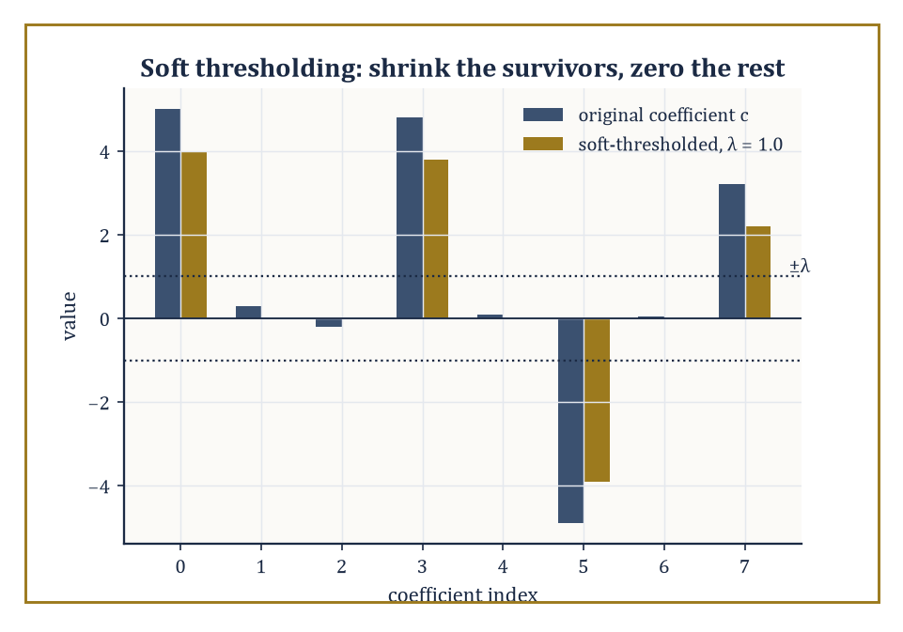
Figure 40.8 — Soft thresholding at λ = 1.0: the four small coefficients vanish, the four large ones survive, shrunk by λ.
Hard thresholding zeroes out any coefficient below a threshold λ and leaves the rest untouched; soft thresholding zeroes out the same coefficients but also shrinks every surviving coefficient toward zero by λ, which turns out to reduce the risk of the reconstructed signal developing ugly little artificial spikes at the threshold boundary.
The method, due substantially to Donoho and Johnstone in the early 1990s, remains a textbook benchmark against which fancier techniques are still measured.
Numeric example — hard versus soft, coefficient by coefficient. Take a coefficient vector c and a threshold λ:
c = [5.0, 0.3, −0.2, 4.8, 0.1, −4.9, 0.05, 3.2], λ = 1.0
Hard thresholding keeps a coefficient unchanged if |c| > λ, else sets it to zero:
hard(c) = [5.0, 0, 0, 4.8, 0, −4.9, 0, 3.2]
Soft thresholding shrinks surviving coefficients toward zero by λ, applied entrywise:
soft(c) = sign(c)·max(|c| − λ, 0) = [4.0, 0, 0, 3.8, 0, −3.9, 0, 2.2]
5.0 − 1.0 = 4.0; 4.8 − 1.0 = 3.8; 4.9 − 1.0 = 3.9 (sign preserved); 3.2 − 1.0 = 2.2
Every coefficient with |c| ≤ 1.0 is zeroed by both rules.
Four out of eight coefficients — the ones that look like noise — vanish under either rule; the four large ones survive, shrunk a little by soft thresholding or left untouched by hard thresholding.
Inverting the transform on either reduced set reconstructs a signal with most of the noise energy removed and essentially all of the genuine signal energy intact.
Try it now — Hard- and soft-threshold c = [2.5, −0.4, −3.0, 0.9] at λ = 1. Answer →
Choosing λ is not guesswork.
Donoho and Johnstone’s universal threshold is defined as follows, where σ is the noise’s standard deviation and n is the number of coefficients:
λ = σ√(2·log n)
This is derived from a precise fact about Gaussian noise: the largest of n independent standard-Gaussian samples is, with high probability, of order √(2 log n) — so any coefficient exceeding that, scaled by σ, is unlikely to be pure noise and is kept; anything smaller is what pure noise alone would be expected to produce, and is discarded.
Numeric example — computing a universal threshold by hand. Suppose a wavelet decomposition has n = 1024 coefficients and the estimated noise standard deviation is σ = 0.8.
log(1024) = log(2¹⁰) = 10·log 2 ≈ 10 × 0.6931 = 6.931
2·log n ≈ 13.863, √13.863 ≈ 3.723
The universal threshold is:
λ = σ√(2 log n) ≈ 0.8 × 3.723 ≈ 2.978
Any coefficient with magnitude below about 2.98 is treated as indistinguishable from noise and thresholded away; any coefficient above it is kept as probable signal.
Double the number of coefficients to n = 4096 and the threshold barely moves, because the threshold grows only like the square root of a logarithm:
log(4096) = 12·log 2 ≈ 8.318
λ ≈ 0.8×√16.636 ≈ 0.8×4.079 ≈ 3.263
Adding vastly more coefficients raises the bar only slightly, which is the mild, forgiving growth rate that makes the method practical at any signal length.
Image compression — most famously JPEG 2000, the successor to the DCT-based original JPEG — applies a two-dimensional DWT (separately along rows and then along columns, in the standard ‘separable’ construction), quantizes the resulting coefficients, and entropy-codes the quantized values.
The multiscale structure buys two practical bonuses beyond raw compression ratio: progressive transmission (send the coarse approximation first, refine with detail bands as more bandwidth becomes available — the picture ‘comes into focus’ rather than appearing line by line) and region-of-interest coding (spend extra bits on the coefficients covering a particular part of the image, and fewer elsewhere).
Closely related multiscale ideas turn up in audio coding, in numerical solvers for partial differential equations (wavelets adapt naturally to solutions with localized sharp features, such as shock fronts), and in the statistical analysis of turbulent flows, where energy does live at many scales simultaneously.
Numeric example — a single 2×2 pixel block, decomposed. Take the 2×2 pixel block P = [100 102; 98 150] (three similar values and one bright corner — a tiny stand-in for an edge).
Apply a one-level 2D Haar transform: first along rows, then along the resulting columns.
Row 0 = [100, 102]:
sum/√2 = 202/√2 ≈ 142.834, diff/√2 = −2/√2 ≈ −1.414
Row 1 = [98, 150]:
sum/√2 = 248/√2 ≈ 175.363, diff/√2 = −52/√2 ≈ −36.770
Now transform the column of row-sums [142.834, 175.363]:
combined sum/√2 = 318.197/√2 ≈ 225.00
This is the LL band — the coarse ‘thumbnail’ value.
diff/√2 = −32.529/√2 ≈ −23.00
This is the LH band, vertical detail.
Transform the column of row-diffs [−1.414, −36.770]:
sum/√2 = −38.184/√2 ≈ −27.00
This is the HL band, horizontal detail.
diff/√2 = 35.355/√2 ≈ 25.00
This is the HH band, diagonal detail.
One dominant number, LL ≈ 225.00 (proportional to the block’s average brightness — the eye’s main concern), and three much smaller detail numbers describing just how the corner pixel departs from its neighbors in each direction.
Quantize the detail bands aggressively — round HL, LH, HH to the nearest 10, say — and the block’s appearance barely changes, because almost all of its ‘story’ was already sitting in that one LL number.
In every application in this section, the underlying advantage is the same fact, restated in different clothing: a well-chosen wavelet basis concentrates the energy of the signal that interests you into a small number of coefficients, while spreading the energy of noise, or of visually irrelevant detail, thinly across a much larger number.
Thresholding, quantization, and progressive transmission are all, at heart, just different ways of exploiting that concentration.
Numeric example — the concentration, tallied. Extend the jump-signal computation of What Wavelets and Signal Analysis Are to 16 samples with two jumps, e.g. two flat plateaus of height 2 and height 6 stitched together with a third plateau of height 2, arranged so exactly two adjacent sample-pairs straddle a boundary.
Following precisely the mechanism verified in What Wavelets and Signal Analysis Are (constant pairs give zero detail; only a pair straddling a jump gives non-zero detail), a one-level Haar transform of this 16-sample signal produces 8 detail coefficients, of which 2 are non-zero (one at each jump) and 6 are exactly zero.
Two numbers out of eight carry all the information about where the signal changes; the other six are provably, exactly, zero — not ‘small’, zero.
That is what ‘concentrating energy into few coefficients’ means when you can count it on your fingers.
The same coarse-first order is how a computer draws a world too large to hold in full detail. A video game renders a distant mountain from a few hundred triangles and swaps in finer meshes as the player walks toward it; a map app shows a whole continent from one small tile and fetches sharper tiles only for the patch you zoom into. Graphics programmers call this level of detail.
Its oldest form for images is the mipmap: beside each texture the graphics card keeps copies at half the width, a quarter, an eighth, and so on, and in the simplest construction each pixel of a copy is the average of a 2×2 block of the copy above it. For the block in the numeric example above, that average is (100 + 102 + 98 + 150)/4 = 450/4 = 112.5, exactly half of the LL value 225. The Haar thumbnail and the mipmap pixel are the same number up to a fixed scale.
Where the two differ is in what they keep. A mipmap stores every level whole, so its storage is 1 + 1/4 + 1/16 + ⋯ times the original, a geometric series that sums to exactly 4/3: a third extra, paid for speed. The wavelet transform stores the coarsest thumbnail plus the detail bands, which together number exactly as many coefficients as there were pixels, and any finer level is rebuilt by adding its detail back. Level of detail and multiresolution analysis are one idea under two names: describe the coarse picture first, and spend effort on detail only where it is needed.
Where this returns
Coarse-first thinking returns in Preconditioning and Multigrid: multigrid solves a large linear system by smoothing on a fine grid and correcting on coarser ones, the same ladder of resolutions as a multiresolution analysis, now used to make a solver fast instead of a signal small.
Keep only this · Section 40.8: Applications: Denoising, Images, and Beyond
The idea. Denoise by transforming, killing the small coefficients (mostly noise), and transforming back; the same sparsity makes wavelet image compression work.
Core.
hard: c if |c| > λ, else 0; soft: sign(c)·max(|c| − λ, 0)
universal threshold: λ = σ √(2 ln n)
Typical mistake. Thresholding the coarsest approximation coefficients. They carry the signal’s overall level; denoising thresholds the details.
Minimal example. n = 1,024, σ = 0.8: λ = 0.8 √(2 ln 1024) ≈ 2.98.
Practice. Easy to challenge; full worked answers, with the usual mistake, are in Answers to the Practice Sets at the back.
Easy — Compute the universal threshold for n = 4,096 coefficients and σ = 0.5. Answer →
Medium — Apply one 2D Haar level (rows, then columns, each with 1/√2) to the block [100 100; 100 140]. Answer →
Challenge — Why does soft thresholding bias large coefficients, and when is that acceptable? Answer →

Section 40.9: Looking Ahead: From Classical Wavelets to Frames, Shearlets, and Learned Representations
The mother wavelet has grown up and left several very interesting descendants
We have now assembled the core of the subject: the time-frequency limits that make a fixed-window Fourier approach inadequate (Time-Frequency Analysis and the Uncertainty Principle), the continuous transform that first demonstrated the fix (The Continuous Wavelet Transform), the multiresolution structure that makes the fix systematic (Multiresolution Analysis), the orthonormal bases that make it exact and non-redundant (Orthonormal Wavelet Bases), the fast filter-bank algorithm that makes it computable in linear time (The Discrete Wavelet Transform and Filter Banks), the vanishing-moment theory that explains why it compresses so well (Vanishing Moments, Approximation, and Compression), and a tour of what happens when you point all this at real signals (Applications: Denoising, Images, and Beyond).
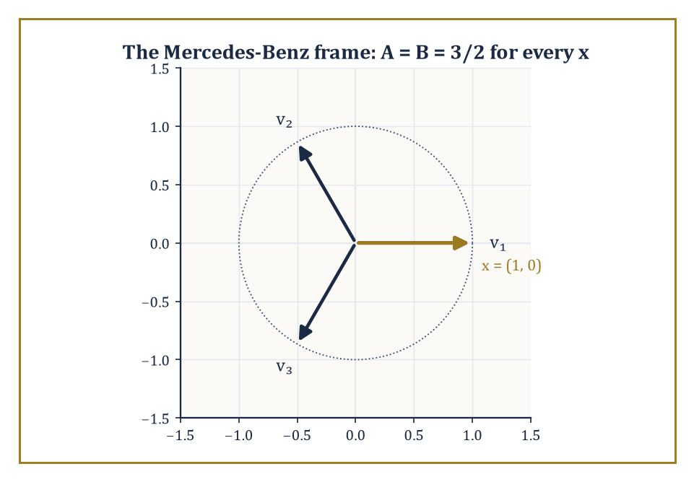
Figure 40.9 — The Mercedes-Benz frame: three vectors doing a two-dimensional job, with frame bounds A = B = 3/2 for every direction, x included.
What remains is to glance at where the idea keeps going.
The first extension relaxes orthonormality entirely, to a structure called a frame: a (possibly redundant) collection {eᵢ} such that the following holds for all x, for some fixed constants 0 < A ≤ B < ∞ called the frame bounds:
A‖x‖² ≤ Σᵢ |⟨x, eᵢ⟩|² ≤ B‖x‖²
When A = B, the frame is called tight, and it behaves almost like an orthonormal basis for the purposes of reconstruction — despite having more vectors than strictly necessary.
Redundancy of this kind buys robustness (losing one or two coefficients to transmission error or quantization noise no longer destroys information the way it would in a minimal orthonormal basis) at the cost of storing more numbers than the signal’s dimension strictly requires.
Numeric example — a tight frame with three vectors in a two-dimensional world. Take three unit vectors in ℝ² spaced 120° apart (the ‘Mercedes-Benz frame’).
v₁ = (1, 0), v₂ = (−0.5, √3/2) ≈ (−0.5, 0.866), v₃ = (−0.5, −√3/2) ≈ (−0.5, −0.866)
For x = (1, 0), compute the inner product with each of the three frame vectors.
⟨x, v₁⟩ = 1, ⟨x, v₂⟩ = −0.5, ⟨x, v₃⟩ = −0.5
Sum the squares of these inner products.
1² + (−0.5)² + (−0.5)² = 1 + 0.25 + 0.25 = 1.5
‖x‖² = 1² + 0² = 1
So the ratio is 1.5 — exactly 3/2.
Try x = (0, 1) instead.
⟨x, v₁⟩ = 0, ⟨x, v₂⟩ = 0.866, ⟨x, v₃⟩ = −0.866
sum of squares = 0 + 0.75 + 0.75 = 1.5
And ‖x‖² = 1, so the ratio is again exactly 3/2.
Three vectors describing a two-dimensional space, one vector more than an orthonormal basis would need, and yet the frame bounds A = B = 3/2 hold for every direction — a small, fully verifiable instance of the redundant-but-stable expansions that dominate modern frame theory.
Try it now — For the Mercedes-Benz frame and x = (0, 1), compute Σ⟨x, vₖ⟩². Answer →
The second extension addresses a genuine blind spot of separable wavelets: a two-dimensional wavelet basis, built by tensoring one-dimensional wavelets along rows and columns, is superb at isolated point-like singularities but comparatively wasteful at representing smooth curved edges, because it can only ‘zoom’ isotropically — the same amount in every direction.
Curvelets, shearlets, and contourlets fix this by scaling anisotropically: stretching the analyzing waveform more in one direction than another, so that a single atom can hug a curved edge over a much longer stretch before needing to be replaced by its neighbor.
Shearlets, in particular, achieve the needed directionality with a shearing matrix rather than a rotation, which keeps the underlying grid structure — and hence the fast algorithms — intact.
Numeric example — what a shear actually does to a square. Apply the shear matrix S = [1 1; 0 1] to the four corners of the unit square.
(0,0) ↦ (0·1+0·1, 0·0+0·1) = (0, 0)
(1,0) ↦ (1, 0)
(0,1) ↦ (0+1, 0+1) = (1, 1)
(1,1) ↦ (1+1, 1) = (2, 1)
The square has become a parallelogram elongated along the diagonal direction, its corners now at (0,0), (1,0), (2,1), (1,1) — same area (the shear matrix has determinant 1), but a very different shape, stretched precisely along one direction.
A shearlet built on this sheared support can lie flush against a diagonal edge over a much longer run than an isotropically scaled wavelet ever could, which is why directional systems outperform separable wavelets on images rich in curved contours.
The third extension is the increasingly porous border with machine learning: instead of hand-designing the filter coefficients hₖ to satisfy QMF conditions, learn them from data, subject to whatever constraints (orthogonality, sparsity, invariance) the application demands.
The scattering transform, an idea due to Mallat again, cascades fixed wavelet filters through alternating convolution and modulus (absolute-value) nonlinearities, producing representations that are provably stable to small deformations of the input — a property that ordinary trained neural networks have to learn from scratch, at considerable expense in data, but which a scattering network gets for free from the underlying wavelet mathematics.
Wavelet networks and learned filter banks sit somewhere between the two extremes, borrowing the multiscale skeleton and letting data fill in the details.
Abstract example — the first layer of a scattering transform. Take a toy signal with a single spike and a single Haar-type detail filter ψ at the finest scale.
x = [0, 0, 0, 5, 0, 0, 0, 0]
ψ = [1, −1]/√2
Convolving ψ against x near the spike and taking the modulus produces a small burst of activity concentrated at the two positions straddling the spike, made positive by the modulus, and zero everywhere else — this modulus-of-a-wavelet-coefficient is the first-layer scattering coefficient.
±5/√2 ≈ ±3.54
Average-pooling that burst over a short window produces a single number summarizing ‘there is high-frequency energy near here’, robust to the spike shifting slightly left or right within the pooling window — which is the local translation-invariance a scattering network is built to provide, using nothing more exotic than a wavelet filter, an absolute value, and an average.
The deeper lesson, running underneath every section in this chapter, is that the right basis — or the right frame — can make a stubborn signal simple, and that finding that basis is simultaneously a mathematical problem (does it exist? is it orthonormal? how many vanishing moments does it have?) and an engineering one (can we compute it in linear time? does it compress real photographs? does it fit in a chip small enough to put in a phone?).
Wavelets are the mathematics of multiscale signal representation, and the multiscale idea, once seen here, keeps reappearing — in hierarchical statistical models, in the analysis of data living on graphs and manifolds, and now in the architecture of learned representations themselves.
We arrived complaining that the Fourier transform, for all its brilliance, could not tell us when. We leave having built an entire apparatus — admissible mother wavelets, nested approximation spaces, quadrature-mirror filters, vanishing moments, lifting schemes — whose sole purpose is to answer exactly that question, and to do so with an algorithm that runs in time proportional to the length of the signal and loses not a single unit of energy along the way. Not every branch of mathematics gets to ship its central theorem inside a billion telephones within a decade of proving it. Wavelets did, and it is worth pausing on the stairwell to admire that, before the vertigo of the next flight sets in.
What remains open is not whether the idea works — that argument closed sometime around the release of JPEG 2000 — but how far the idea can be stretched: redundant frames that trade efficiency for robustness, shearlets that learn to bend around a curve rather than merely zoom in on a point, and scattering networks that borrow a wavelet’s provable stability and hand it to a learning algorithm as a head start rather than a homework assignment. The mother wavelet, having spent this chapter being scaled and translated in every direction we could think of, has evidently decided that motherhood suits her, and is not finished having descendants.
The next chapter abandons signals for strategies. Where wavelets found the basis that makes a stubborn function simple, game theory and decision mathematics go looking for the strategy that makes a stubborn opponent’s life difficult — a rather more adversarial kind of optimization, in which the other player, unlike Gaussian noise, is actively trying to outwit you back. Mind the discontinuity as you go up; some of what follows will, appropriately enough, arrive rather suddenly.
Keep only this · Section 40.9: Looking Ahead: From Classical Wavelets to Frames, Shearlets, and Learned Representations
The idea. Beyond orthonormal wavelets lie redundant frames, direction-sensitive shearlets, and learned representations, all keeping the place-and-scale idea.
Core.
tight frame: Σ ⟨x, vₖ⟩² = A ‖x‖²
Mercedes-Benz frame in ℝ²: A = 3/2
Typical mistake. Thinking redundancy is waste. Frames trade compactness for robustness: lose one coefficient and the signal can still be recovered.
Minimal example. x = (1, 0): 1 + 0.25 + 0.25 = 1.5.
Practice. Easy to challenge; full worked answers, with the usual mistake, are in Answers to the Practice Sets at the back.
Easy — Apply the shear S = [1 1; 0 1] to (0, 1) and (1, 1). Answer →
Medium — Check the frame identity for x = (1, 1). Answer →
Challenge — Prove that the Mercedes-Benz frame is tight with A = 3/2 for every x. Answer →
Chapter 40 recap · Wavelets & Signal Analysis
• A wavelet is a short zero-mean wiggle; shifted and scaled copies give a basis whose elements have both a place and a scale.
• Time and frequency cannot both be sharp: Δf ≈ 1/T, and σₜσ_ω ≥ ½, with equality for the Gaussian.
• The CWT correlates the signal with every shift and scale; it ignores constants and lights up at jumps, at the cost of huge redundancy.
• A multiresolution analysis nests approximation spaces V₀ ⊂ V₁ ⊂ ⋯; each step adds a detail space spanned by wavelets.
• The DWT is a filter bank: low-pass and high-pass, keep every second output, repeat on the low half. It costs O(N) and is exactly invertible; lifting does it in integers.
• Vanishing moments let a wavelet ignore polynomials, so smooth regions give tiny coefficients; thresholding them removes noise and compresses images.

Check Your Understanding — Chapter 40
Answers are in the Answer Key at the back of the book — have a go before you look.
1. [Explain] Why can’t a short-time Fourier transform give both sharp timing (good for catching a click) and sharp pitch resolution (good for separating close tones) from a single fixed window?
See the answer →
2. [Compute] Using the pairwise Haar transform (average a=(x₀+x₁)/√2, detail d=(x₀−x₁)/√2), what happens to the detail coefficients of the step signal [2,2,2,2,2,6,6,6], and why?
See the answer →
3. [Explain] In a multiresolution analysis, why must the intersection of all the nested spaces Vⱼ (as j → −∞) be just {0}?
See the answer →
4. [Explain] Why does the Haar wavelet fail to fully ignore a smooth linear ramp, and how would a wavelet like db2 behave differently?
See the answer →
5. [Compute] Apply one level of the pairwise Haar transform (a = (x₀+x₁)/√2, d = (x₀−x₁)/√2) to the constant signal [5, 5, 5, 5]. What are the detail coefficients, and what does that tell you about compressing smooth data?
See the answer →
6. [Compute] Transform the signal [8, 4, 2, 2] with one level of the Haar transform, and verify that energy is preserved.
See the answer →
7. [Explain] Image compression standards such as JPEG 2000 keep the largest wavelet coefficients and discard the rest. Why does that throw away detail rather than destroying the picture?
See the answer →
8. [Prove] Show that the single-level Haar transform preserves energy: a² + d² = x₀² + x₁².
See the answer →
9. [Explain] A wavelet with two vanishing moments produces zero detail coefficients on any linear ramp. Why is that a useful property for real signals?
See the answer →
10. [Challenge] Wavelets solve the time-frequency localization problem that Fourier analysis cannot. Why has the Fourier transform nevertheless not been displaced?
See the answer →

Problems — Chapter 40
The questions above test whether the ideas landed. These ask you to use them. Solutions are in Solutions to the Problems at the back. Work them before you look.
1. [Compute] The Haar function is 1 on [0, 1/2) and −1 on [1/2, 1). Show that its integral is 0.
2. [Compute] Two sample values, 3 and 4, already in an orthonormal coordinate system. What is their energy?
3. [Explain] A discrete wavelet transform of a signal of length 8, one level, produces an approximation of length 4 and a detail of length 4. Why is the total number of coefficients still 8?
4. [Concept] Adding one vanishing moment to a Daubechies wavelet lengthens its support. What does the extra vanishing moment buy for a smooth signal?

Math, Actually

Chapter 41

Game Theory & Decision Mathematics
Strategies, Equilibria, and the Art of Rational Choice in Conflict and Cooperation
The previous chapter left you taking a single signal apart wavelet by wavelet — a lone violin solo dissected wobble by wobble, coefficient by coefficient, with no other musician anywhere in the concert hall. That was, if you look back on it, a rather solitary way to spend a chapter. The signal sat there and let itself be decomposed. It did not object, negotiate, bluff, or attempt to anticipate which mother wavelet you were about to apply to it and adjust its frequency content accordingly out of spite. Reality, alas, is rarely so obliging once other minds get involved.
This chapter is about what happens the moment a second decision-maker walks into the section — one who also has preferences, also has options, and also, worse luck, is capable of reasoning about what you are likely to do. The mathematics of a single agent optimizing against a fixed, indifferent world is decision theory, and we will spend our first section getting that in order, because it is the one-player skeleton on which everything else hangs its coat. But the main event is game theory: several agents, whose outcomes depend jointly on everyone’s choices, each trying to out-think the others while knowing the others are trying to out-think them right back. It is optimization with the added indignity that the landscape you are climbing is also trying to guess where you’ll step.
A word of warning before we start, because this is one of the few corners of pure mathematics that escaped into the wild and now roams the opinion pages unsupervised. ‘Nash equilibrium’, ‘zero-sum’, and ‘dominant strategy’ get deployed at dinner parties and on cable news with a confidence wildly disproportionate to how carefully anyone involved has defined their terms. This is flattering, in its way — it is nice to be famous — but it also means the popular version of the subject is thinner and looser than the real one.
We are going to do the real one: games in normal and extensive form, Nash equilibria in pure and mixed strategies, sequential rationality, the folk theorems of repeated play, cooperative solutions to the bargaining problem, and a first pass at auctions and mechanism design, which is game theory practiced in reverse — designing the game so that self-interested play produces the outcome you wanted.
If optimization, several chapters back, taught us to choose the best action, this chapter teaches us to choose the best action when the very meaning of ‘best’ depends on what somebody else, who is thinking the same thought about you, decides to do. It is a small step in the sentence and a large step in the mathematics. Let’s reason about reasoning.
Before you begin — Chapter 41
By the end of this chapter you will be able to:
1. Compute expected utility, a certainty equivalent and a risk premium, and explain the Allais paradox.
2. Read a game in normal form and classify it as zero-sum or general-sum.
3. Find Nash equilibria by dominance, by best responses, and in mixed strategies by the indifference principle.
4. Solve extensive-form games by backward induction and tell credible threats from non-credible ones.
5. Find the discount factor that sustains cooperation in a repeated Prisoner’s Dilemma.
6. Compute a Shapley value, test a core allocation, and solve a Nash bargaining problem; explain why truthful bidding is dominant in a second-price auction.
Prerequisites. Expected value from Expectation, Variance, and Conditioning (or any first course in probability); maximizing a function from Differential (Volume 1); linear programming and duality from Optimization (Volume 3) for the zero-sum value.
Estimated study time. About 11 hours, exercises included.

Section 41.1: Decision Theory: Utility and Expected Utility
The one-player warm-up, in which the only opponent is arithmetic
Here is a choice you have made some version of. Somebody offers you a sum of money, guaranteed, or a coin flip that pays more if it comes down one way and less if it comes down the other. You do not need any theory to have an opinion about which you would take.
Arithmetic has an opinion too, and it is a simple one: work out what each option pays on average, and take the bigger number. Try it on a concrete offer. A guaranteed $25,000, or a fair coin flip paying $10,000 on heads and $40,000 on tails. The flip averages half of each, which is $25,000 exactly. Arithmetic therefore declares the two offers identical and has nothing further to say.
Almost nobody treats them as identical. Put that offer to a section of a hundred people and the great majority take the guaranteed money, and do not feel they are being irrational in doing so.
That changes what is worth asking. Not which option pays more on average, but whether the preference nearly everybody actually has can be given a number of its own, rather than waved away as nerves.
The obstacle is more stubborn than it looks, and it is worth sitting with. You cannot get the number by asking, because ‘I would take the sure thing’ is a sentence and not a quantity. Worse, you cannot get it by inventing one either: if you are free to attach any number you like to each outcome after seeing what somebody chose, you can fit every choice ever made and will have explained none of them. A theory that cannot fail is not doing any work.
What rescues it is a single restriction, imposed in advance. Let the number attached to an amount of money rise as the money rises — more is better, which nobody disputes — but let it rise more grudgingly the richer you already are. That one condition is enough, and it is enough because it can be violated.
Take the arithmetic before the notation. Suppose the number attached to an amount is its square root, which rises, and rises ever more slowly:
$10,000 scores 100
$40,000 scores 200
the coin flip scores half of each, 150
and 150 is the score of $22,500, since 150 × 150 = 22,500
So this person is indifferent between the gamble and a guaranteed $22,500 — and would hand over as much as $2,500 to have the uncertainty taken away, on an offer whose cash average is $25,000. That is not a rounding error. It is a tenth of the stake.
What none of those figures claim is that the gamble is worth less money. Its cash average is still $25,000, and no arithmetic has been overturned. The quantity that moved is not the money but the worth of the money to the person holding it, and keeping those two apart is the whole discipline of this section.
The number attached to an outcome is its utility; the average of those numbers across a gamble is expected utility; the guaranteed sum that matches it is the certainty equivalent; and the gap between that and the cash average is the risk premium. Each is defined properly below.
A decision problem under certainty — you know what each option delivers — is an optimization problem: list the options, evaluate them, pick the best. Nothing in this chapter’s title has entered the section yet; you are merely choosing among known quantities, the way you chose the cheapest of three identical kettles a great many chapters ago.
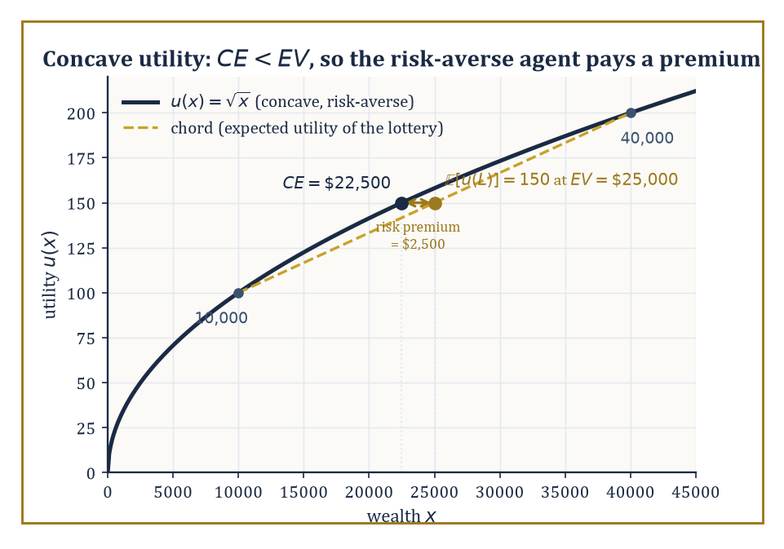
Figure 41.1 — A concave utility curve: the certainty equivalent falls short of the expected value, and that shortfall is the risk premium.
The interesting mathematics begins under risk, meaning you know the probabilities of the possible outcomes but not which one will occur, and it begins in earnest with a theorem that underwrites almost everything that follows: the von Neumann–Morgenstern (vNM) expected utility theorem.
The theorem starts from a handful of axioms about how a rational agent’s preferences over lotteries — gambles with known probabilities over prizes — ought to behave: completeness (you can always say which of two lotteries you prefer, or that you’re indifferent), transitivity (no cycles of preference), continuity (no lottery is infinitely better or worse than another, so small probability shifts produce small preference shifts), and independence (mixing two lotteries with a third, common one, in the same proportions, should not reverse your preference between them).
Von Neumann and Morgenstern proved that any preference relation satisfying these axioms can be represented by a utility function u on prizes such that lottery L is preferred to lottery M exactly when the expected utility of L exceeds that of M, where the expected utility is written:
𝔼[u(L)] = Σ p(x)·u(x)
This is a representation theorem, not a moral claim: it says rational preference of this specific kind is equivalent to maximizing an expectation, not that maximizing an expectation is the only sane way to live.
The utility function itself is pinned down only up to a positive affine transformation — you may rescale it as a·u + b for any a > 0 — because doubling every utility number and adding ten to each leaves every expected-utility comparison unchanged.
And crucially, the shape of u encodes attitude to risk: a concave u (curving downward, like a square root) means an agent who prefers a certain amount to a fair gamble of the same expected value — a risk-averse agent — while a convex u describes risk-seeking, and a straight line describes risk-neutrality, the rare soul who cares only about expected value and nothing about spread.
Numeric example — pricing a gamble with a concave utility. Suppose an agent’s utility for wealth x is given by:
u(x) = √x
This function is concave, hence risk-averse. Consider a lottery L offering a 50% chance of $10,000 and a 50% chance of $40,000. Its expected monetary value is:
EV = 0.5 × 10,000 + 0.5 × 40,000 = $25,000
But the agent doesn’t eat expected value; they eat expected utility:
𝔼[u(L)] = 0.5 × √10,000 + 0.5 × √40,000 = 0.5 × 100 + 0.5 × 200 = 50 + 100 = 150
Now ask: what certain amount CE (the ‘certainty equivalent’) would give this same utility? Solve u(CE) = 150:
√CE = 150, so CE = 150² = 22,500
The agent is indifferent between the gamble and a guaranteed $22,500 — they would happily pay up to:
$25,000 − $22,500 = $2,500
(the risk premium) just to make the uncertainty go away. Note this is not a small effect: a fair coin flip worth $25,000 on average is, to this agent, worth exactly the same as a check for $2,500 less. Concavity is expensive.
Try it now — With u(x) = √x, a lottery pays $0 or $100 with equal chances. Find its expected value, expected utility and certainty equivalent. Answer →
Risk, in the sense above, means the probabilities are known — you know it’s a fair coin. Uncertainty is the murkier cousin: you don’t even know the odds.
Subjective expected utility theory, due independently to Savage and to Anscombe and Aumann, extends the vNM framework by deriving both a utility function and a subjective probability distribution — the agent’s beliefs — from axioms on preferences over acts (functions from states of the world to outcomes) rather than over ready-made lotteries.
The upshot is the same expected-utility formula, except now the probabilities are not handed to you by nature but inferred from the agent’s own choices: you discover what someone believes by watching what they’re willing to bet on. This is elegant, and it is also the point at which real human behavior begins to misbehave.
The Allais paradox, devised by Maurice Allais in 1953, is the classic demonstration that people routinely violate the independence axiom even in problems designed to make the violation glaring. It works by presenting the same underlying trade-off twice, dressed differently, and showing that popular choices in the two dressings cannot both be expected-utility maximizing under any utility function whatsoever.
Numeric example — the Allais paradox, done in cold arithmetic. Situation 1 — choose between A: $1,000,000 for certain, or B: 10% chance of $5,000,000, 89% chance of $1,000,000, 1% chance of $0. Most people choose A; the 1% risk of walking away with nothing feels like a poor trade for a shot at more money you already, in some sense, have.
Situation 2 — choose between C: 11% chance of $1,000,000, 89% chance of $0, or D: 10% chance of $5,000,000, 90% chance of $0. Most people now choose D — with the 1,000,000 no longer ‘safe’ in either option, why not go for the bigger prize on roughly the same odds?
Normalize a utility function with u($0) = 0 and u($1,000,000) = 1, and let u($5,000,000) = k.
Preferring A to B means:
1 > 0.10k + 0.89(1) + 0.01(0)
which simplifies to:
0.11 > 0.10k
so:
k < 1.1
Preferring D to C means:
0.10k + 0.90(0) > 0.11(1) + 0.89(0)
which simplifies to:
0.10k > 0.11
so:
k > 1.1
The same number k is required to be both less than 1.1 and greater than 1.1 — a flat contradiction. No utility function reproduces the popular pair of choices; the independence axiom has been violated in the wild, by ordinary sensible people, not by anyone being stupid. That is precisely what makes it a paradox rather than a mistake.
The Ellsberg paradox, from Daniel Ellsberg in 1961 (yes, that Ellsberg, some years before the Pentagon Papers — a man clearly fond of releasing damning information), targets ambiguity rather than risk itself.
Offer a bet on drawing a red ball from an urn of 90 balls: 30 known red, and 60 that are black or yellow in an unknown split. People typically prefer betting on red (a known 1-in-3 chance) over betting on black (an ambiguous chance somewhere between 0 and 60-in-90) — ambiguity aversion.
But offered the complementary bet, on ‘red-or-yellow’ versus ‘black-or-yellow’, most of the same people now prefer betting on black-or-yellow, even though consistency under any fixed subjective probability for the black/yellow split would require the opposite ranking to hold throughout.
People, it turns out, don’t merely dislike bad odds; they dislike not knowing the odds at all, and no single subjective probability distribution captures that discomfort.
Prospect theory (Kahneman and Tversky) and various ambiguity-averse decision models were built afterwards to accommodate findings like these, replacing raw probabilities with distorted ‘decision weights’ and utility with gains-and-losses measured from a reference point rather than from absolute wealth — psychologically richer, mathematically messier, and a proper subject for a later chapter on its own.
Numeric example — the Ellsberg paradox, formalized. Formalize the two choices using a single subjective probability distribution over the urn’s contents: let r = 1/3 be the known, certain probability of drawing red, and let b and y be the agent’s subjective probabilities for black and yellow, whatever they happen to be, subject only to the constraint:
b + y = 2/3
(since exactly 60 of the 90 balls are black-or-yellow, even though the individual split is unknown). Preferring the bet on Red over the bet on Black means the agent’s subjective P(red) exceeds their subjective P(black):
1/3 > b, i.e. b < 1/3
Preferring the bet on ‘Black-or-Yellow’ over ‘Red-or-Yellow’ means P(black) + P(yellow) exceeds P(red) + P(yellow):
b + y > 1/3 + y
and since y appears identically on both sides it cancels straight out, leaving:
b > 1/3
The same number b is required to be simultaneously less than 1/3 and greater than 1/3 — the flat contradiction the Allais paradox produced a few paragraphs ago, and for the identical structural reason: no single subjective probability distribution, fed into the ordinary expected-utility formula, reproduces both popular preferences at once. The elegance of the argument is that y, the unknown quantity, never gets pinned down and never needs to be — it cancels out of the comparison entirely, which is just why the contradiction holds no matter what the agent actually believes about the black/yellow split.
None of this dents the theorem so much as it marks its boundary: expected utility remains the normative benchmark — what a coherent, axiom-respecting agent does — even where descriptive accounts of actual human choice must diverge from it.
And it is this one-player scaffolding, warts and paradoxes included, that game theory now bolts a second player onto: a player’s payoff in a game is a utility in this sense, and rational play means maximizing expected utility given beliefs about what the other players — who are doing the same calculation about you — are going to do.
Keep only this · Section 41.1: Decision Theory: Utility and Expected Utility
The idea. A rational decision maker ranks risky options by the average of their utilities, and the shape of the utility function encodes the attitude to risk.
Core.
EU(L) = Σ pᵢ u(xᵢ)
u(CE) = EU(L), risk premium = EV − CE
Typical mistake. Taking the utility of the expected value instead of the expected utility. For concave u, u(EV) > EU, and confusing them hides risk aversion.
Minimal example. u = √x, 50/50 on $10,000 and $40,000: EU = 150, CE = $22,500, risk premium $2,500.
Practice. Easy to challenge; full worked answers, with the usual mistake, are in Answers to the Practice Sets at the back.
Easy — With u(x) = x², find the certainty equivalent of a 50/50 lottery on $0 and $100. Is the agent risk-averse? Answer →
Medium — With u(x) = √x, find the risk premium of a 50/50 lottery on $400 and $1,600. Answer →
Challenge — Show that choosing A over B and D over C in the Allais paradox cannot both maximize expected utility for any u. (A: $1M certain. B: 10% $5M, 89% $1M, 1% $0. C: 11% $1M, 89% $0. D: 10% $5M, 90% $0.) Answer →

Section 41.2: Games in Normal Form
Writing down conflict as a spreadsheet
A game in normal form (also called strategic form) is specified by three ingredients: a finite set of players, a strategy set Sᵢ for each player i listing every action available to them, and a payoff function uᵢ, one per player, mapping every possible profile of strategies — one choice from each player, simultaneously — to a real-valued utility for that player.
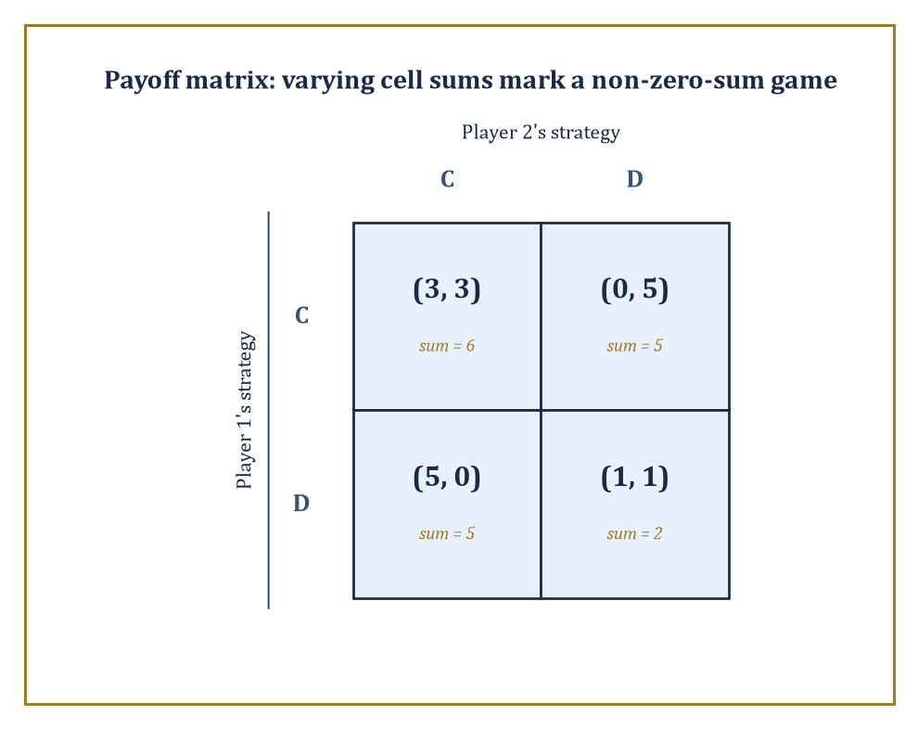
Figure 41.2 — The Prisoner’s Dilemma’s payoff matrix, cell sums included: a non-zero-sum game wears its varying sums on its sleeve.
For two players with finitely many strategies each, this is most naturally drawn as a payoff matrix: rows indexed by player 1’s strategies, columns by player 2’s, and each cell holding an ordered pair (u₁, u₂) of the payoffs both players receive if that row and that column are chosen together.
For three or more players the matrix becomes a tensor — a matrix with an extra dimension for each additional player — which is why textbook examples stop politely at two players and everyone else is left to imagine the three-dimensional spreadsheet.
Numeric example — reading a payoff matrix — the Prisoner’s Dilemma. Two suspects, interrogated separately, each choose to Cooperate (stay silent, i.e. cooperate with each other) or Defect (betray the other).
The classic payoff matrix, in years of freedom converted to utility points (higher is better), reads:
(Cooperate, Cooperate) → (3, 3); (Cooperate, Defect) → (0, 5); (Defect, Cooperate) → (5, 0); (Defect, Defect) → (1, 1)
Reading this is entirely mechanical once you know the convention: if player 1 plays Cooperate and player 2 plays Defect, look up the cell (Cooperate, Defect) and read off (0, 5) — player 1 gets 0, player 2 gets 5.
Notice the payoff sums across the four cells are 6, 5, 5, and 2 respectively — not constant.
That single observation is enough to classify the game, which is the next thing we need to do.
Try it now — In the Prisoner’s Dilemma table, what does player 2 receive at (Defect, Cooperate), and what is the payoff sum in that cell? Answer →
A zero-sum game is one in which the payoffs in every cell sum to the same constant (conventionally zero, by subtracting that constant from everyone) — one player’s gain is the other’s loss, and the game models pure, undiluted conflict: chess, tic-tac-toe, dividing a fixed pie with nothing left over.
A non-zero-sum (or general-sum) game, like the Prisoner’s Dilemma above, has payoff sums that vary across cells, meaning some outcomes are jointly better or worse than others — there is room for both conflict and cooperation to matter simultaneously, which is why the Prisoner’s Dilemma is philosophically far more interesting than a coin-matching contest: the players aren’t just fighting over a fixed pie, they’re deciding, without being able to talk about it, whether to bake a bigger one.
Numeric example — a genuinely zero-sum game — Matching Pennies. Two players each secretly show a coin as Heads or Tails.
Player 1 wins (+1) if the coins match; player 2 wins (+1) if they differ, and the loser in each case pays −1.
The payoff matrix:
(H, H) → (1, −1); (H, T) → (−1, 1); (T, H) → (−1, 1); (T, T) → (1, −1)
Check every cell:
1 + (−1) = 0
(−1) + 1 = 0
(−1) + 1 = 0
1 + (−1) = 0
Every single cell sums to exactly zero — this is a zero-sum game in the strictest sense, one player’s fortune is the other’s misfortune to the penny, and there is nothing here resembling the Prisoner’s Dilemma’s shared temptation to defect: there is no joint outcome either player would rather steer toward, only a pure contest of guessing.
Several classes of games carry extra structure worth naming because it buys tractability later.
A symmetric game is one where all players have the same strategy set and payoffs depend only on one’s own strategy and the multiset of others’ strategies, not on who specifically played what — Rock-Paper-Scissors is symmetric; a labor negotiation between a unique employer and a unique union is not.
A potential game (Monderer and Shapley) is one admitting a single real-valued potential function Φ over strategy profiles such that any player’s change in payoff from unilaterally switching strategies equals the resulting change in Φ — meaning every player, in effect, is secretly climbing the same shared hill, which guarantees a pure-strategy Nash equilibrium exists (at any local maximum of Φ) and that better-response dynamics converge to one.
A supermodular game is one where strategies are complements — if I raise my strategy, your best response weakly rises too — which also guarantees pure equilibria and gives them a lattice structure amenable to comparative-statics arguments.
All three properties are, in essence, promises that the game’s equilibria won’t be some pathological needle in a haystack, and a working game theorist checks for them the way a working analyst checks for convexity before reaching for calculus.
Abstract example — a potential game — congestion on two roads. Consider two commuters, each independently choosing Road A or Road B to get to work, where each road’s travel-time cost to a driver depends only on how many drivers (0, 1, or 2) use that road: a road with 1 driver costs that driver 1 (in time units), a road with 2 drivers costs each driver 3 (congestion), and payoffs are the negative of cost, since drivers want to minimize travel time, not maximize it.
Define the potential function:
Φ(profile) = −Σ, over each road, of the running total [cost paid by that road’s 1st driver, plus cost paid by its 2nd driver, ...]
This is the standard Rosenthal congestion-game potential, with a minus sign attached so it rises exactly when payoff rises, rather than when raw cost does.
If both drivers pick Road A: the road carries a ‘1st’ driver (cost 1) and a ‘2nd’ driver (cost 3), so:
Φ = −(1+3) + 0 = −4
If they split, one on each road: each road carries only a ‘1st’ driver (cost 1), so:
Φ = −1 + −1 = −2
Now check the potential-game property directly: starting from both-on-A (Φ = −4), suppose driver 2 switches to Road B.
Their actual payoff (negative cost) changes from −3 (on crowded A) to −1 (alone on B), a gain of +2.
The potential changes from −4 to −2, also a gain of +2 — the two changes agree precisely, as the definition promises.
And the practical payoff of the theory is that pure equilibria — here, one driver on each road, since abandoning it to join the other driver would trade a cost of 1 for a cost of 3 — always exist and can be found by locally optimizing Φ (the split outcome, Φ = −2, is a strict local maximum, beating both-on-one-road’s Φ = −4), rather than searching the whole strategy space for a fixed point.
One structural feature the normal form deliberately throws away is time: it records only which strategies were chosen, not the order in which anyone moved or what they knew at each stage.
That abstraction is often exactly what you want — a great many real interactions are simultaneous, or might as well be — but chess is not one of them, and neither is a used-car negotiation with an opening offer and a counter-offer.
The extensive form, several sections from now, puts the clock back on the wall.
Keep only this · Section 41.2: Games in Normal Form
The idea. A game in normal form is a table: players, the strategies of each, and a payoff for every combination; zero-sum games are those where one player’s gain is the other’s loss.
Core.
game = (players, strategy sets Sᵢ, payoffs uᵢ(s₁, …, sₙ))
zero-sum: u₁ + u₂ = 0 in every cell
Typical mistake. Calling a game zero-sum because one cell sums to zero. Every cell must have the same sum.
Minimal example. Matching Pennies: every cell is (1, −1) or (−1, 1), so it is zero-sum.
Practice. Easy to challenge; full worked answers, with the usual mistake, are in Answers to the Practice Sets at the back.
Easy — In Rock–Paper–Scissors with payoffs +1 for a win, −1 for a loss and 0 for a tie, what is the cell (Rock, Scissors), and is the game zero-sum? Answer →
Medium — A three-player game gives the players 2, 3 and 4 strategies. How many cells does its payoff table have, and how many numbers? Answer →
Challenge — Show that adding a constant k to every payoff of player 1 does not change any player’s best responses, so a constant-sum game can be studied as a zero-sum one. Answer →

Section 41.3: Dominance, Best Responses, and Nash Equilibrium
In which nobody wants to move first, second, or at all
Before this section
What you need. Reading a payoff table from Games in Normal Form.
Why it matters. Nash equilibrium is the solution concept for the rest of the chapter. Everything later — mixed strategies, subgame perfection, repeated games — either computes it or refines it.
A strategy is strictly dominated for player i if some other strategy of theirs yields a strictly higher payoff no matter what every other player does — dominance is a promise that holds against the entire field of possible opposition, not merely against what you happen to expect.
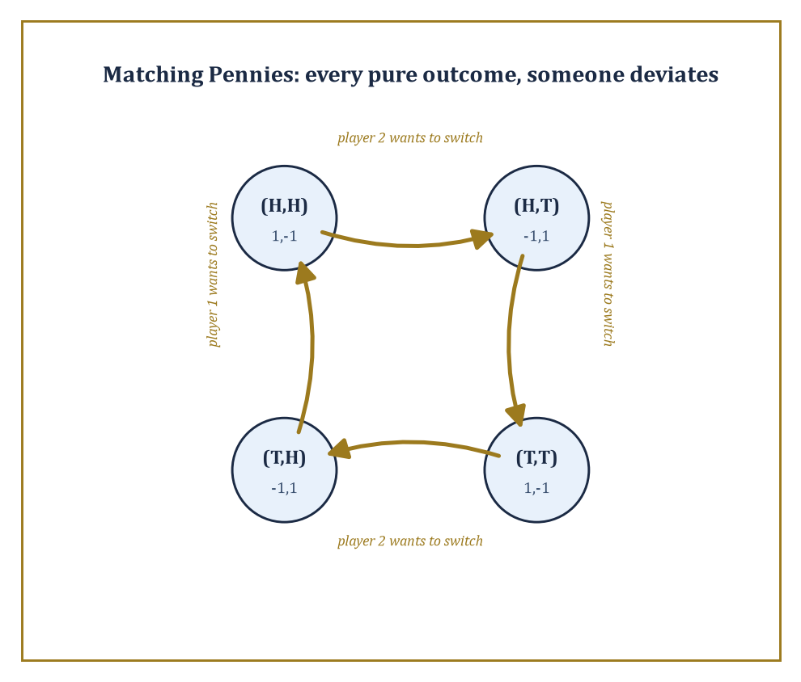
Figure 41.3 — Matching Pennies chased around its own outcomes: at every pure profile, somebody has a gold arrow pointing away from it.
A rational player, by definition, never plays a strictly dominated strategy, since some other option does better in literally every contingency; there is no story under which the dominated choice was the right call.
This licenses a solution procedure called iterative elimination of strictly dominated strategies (IESDS): delete any strictly dominated strategy from the game, recompute, and repeat, since removing an option from your opponent’s repertoire can create new dominance relations that weren’t there before.
Weak dominance — where the alternative is at least as good everywhere and strictly better somewhere — licenses a similar but more delicate procedure, delicate because, unlike the strict version, the order in which you eliminate weakly dominated strategies can change which equilibria survive; strict elimination, reassuringly, always arrives at the same reduced game no matter the order.
Numeric example — solving a game by iterated elimination. Player 1 chooses row U or D; player 2 chooses column L, M, or R. The payoffs (u₁, u₂) are as follows.
U-L = (4, 3), U-M = (5, 1), U-R = (6, 2); D-L = (2, 1), D-M = (8, 4), D-R = (3, 6)
Compare player 2’s columns M and R directly, holding player 1’s row fixed each time.
If player 1 plays U, M gives player 2 a payoff of 1 while R gives 2 — R is better; if player 1 plays D, M gives 4 while R gives 6 — R is better again.
Column R strictly dominates column M for player 2 in every contingency, so M is eliminated, leaving a 2×2 game.
U-L = (4,3), U-R = (6,2); D-L = (2,1), D-R = (3,6)
Now compare player 1’s rows: against L, U gives 4 versus D’s 2 — U better; against R, U gives 6 versus D’s 3 — U better again.
Row U strictly dominates row D, so D is eliminated, leaving player 1 committed to U and player 2 choosing only between L (payoff 3) and R (payoff 2). Player 2 picks L.
The game has been solved down to the single outcome (U, L), with payoffs (4, 3) — and, worth checking, this survivor is automatically a Nash equilibrium, since it survived elimination against every alternative at every stage.
Try it now — Check directly that (U, L) in the reduced game is a Nash equilibrium of the original 2 × 3 game. Answer →
A best response is a strategy for player i that maximizes i’s payoff given some fixed profile of strategies for everyone else.
A Nash equilibrium, the central solution concept of the entire subject, is a strategy profile in which every player’s strategy is simultaneously a best response to everyone else’s — no exceptions, no player left wishing they’d chosen differently once they see what happened.
This is what makes equilibrium self-enforcing rather than merely predicted: nobody needs to be forced, threatened, or morally persuaded to stay put, because unilateral deviation strictly does not pay.
It is worth dwelling on how modest this notion is — a Nash equilibrium says nothing about fairness, efficiency, or how the players got there; it says only that, once arrived at, no individual regrets their own choice given what everyone else did.
Two people can be jointly miserable in a perfectly good Nash equilibrium, as the Prisoner’s Dilemma is about to demonstrate.
Numeric example — finding the Nash equilibrium of the Prisoner’s Dilemma. Recall the payoffs.
(C,C) = (3,3), (C,D) = (0,5), (D,C) = (5,0), (D,D) = (1,1)
Compute player 1’s best response to each of player 2’s choices: if player 2 plays C, player 1 gets 3 from C and 5 from D — D is the best response; if player 2 plays D, player 1 gets 0 from C and 1 from D — D is again the best response.
Player 1’s best response is D regardless of what player 2 does; by the identical calculation (the game is symmetric) player 2’s best response is also D regardless.
The only profile in which both strategies are simultaneously best responses is (D, D), giving payoffs (1, 1) — a Nash equilibrium, and the unique one in pure strategies.
The bitter joke is that (C, C) gives both players 3, strictly better for everyone than the (1, 1) they’re actually stuck with; the equilibrium is self-enforcing but not remotely optimal, which is why this two-line game launched a thousand papers on cooperation, trust, and the difference between individual and collective rationality.
Existence, however, is not automatic.
A pure-strategy Nash equilibrium — one where each player commits deterministically to a single strategy — can fail to exist, and Matching Pennies, introduced last section, is the standard minimal counterexample: it has no stable deterministic outcome at all.
Numeric example — Matching Pennies has no pure Nash equilibrium. Recall the payoffs.
(H,H) = (1,−1), (H,T) = (−1,1), (T,H) = (−1,1), (T,T) = (1,−1)
Check all four candidate profiles exhaustively.
At (H,H): player 2 currently gets −1; switching to T moves the outcome to (H,T) = (−1, 1), improving player 2’s payoff to 1 — player 2 wants to deviate, so (H,H) is not an equilibrium.
At (H,T): player 1 currently gets −1; switching to T moves to (T,T) = (1,−1), improving player 1 to 1 — not an equilibrium.
At (T,H): player 1 currently gets −1; switching to H moves to (H,H) = (1,−1), improving player 1 — not an equilibrium.
At (T,T): player 2 currently gets −1; switching to H moves to (T,H) = (−1,1), improving player 2 — not an equilibrium.
Every one of the four possible deterministic outcomes leaves somebody itching to switch.
There is, quite literally, no way to stand still in this game — which is the intuition behind why it’s called Matching Pennies rather than Sitting-Still Pennies, and exactly the gap that mixed strategies, the subject of the next section, are built to fill.
Keep only this · Section 41.3: Dominance, Best Responses, and Nash Equilibrium
The idea. A Nash equilibrium is a profile in which every player’s strategy is a best response to the others’; dominance arguments can find it by elimination.
Core.
uᵢ(sᵢ, s₋ᵢ) ≥ uᵢ(sᵢ, s₋ᵢ*) for all sᵢ
strictly dominated strategies are never played in equilibrium
Typical mistake. Thinking a Nash equilibrium is the best outcome for everyone. In the Prisoner’s Dilemma the only equilibrium (D, D) is worse for both than (C, C).
Minimal example. Prisoner’s Dilemma: Defect strictly dominates (5 > 3, 1 > 0), so (D, D) is the unique Nash equilibrium.
Practice. Easy to challenge; full worked answers, with the usual mistake, are in Answers to the Practice Sets at the back.
Easy — Find the pure Nash equilibria of the coordination game (A, A) = (2, 2), (A, B) = (0, 0), (B, A) = (0, 0), (B, B) = (1, 1). Answer →
Medium — Verify that Defect strictly dominates Cooperate for player 1 in the Prisoner’s Dilemma. Answer →
Challenge — Prove that iterated elimination of strictly dominated strategies never removes a strategy used in a pure Nash equilibrium. Answer →

Section 41.4: Mixed Strategies and Existence of Equilibrium
Rational players learn to shrug convincingly
A mixed strategy for player i is a probability distribution over i’s pure strategies — instead of committing to Heads, the player commits to ‘Heads with probability p, Tails with probability 1 − p’, and then, crucially, randomizes, rather than merely picking whichever one they secretly prefer and calling it random.
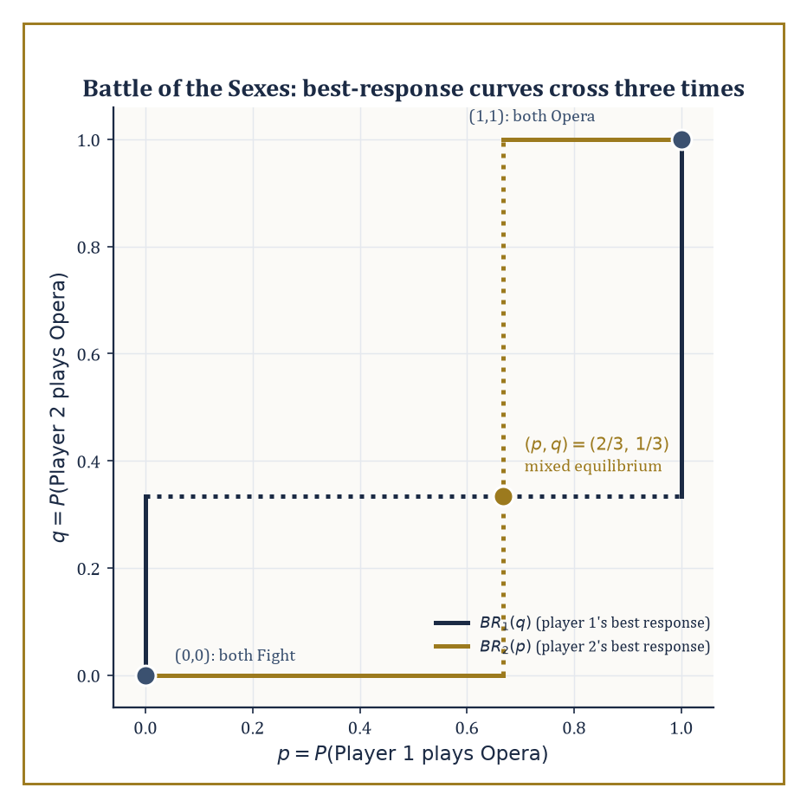
Figure 41.4 — Best-response curves for the Battle of the Sexes, crossing three times: two corners of agreement and one uneasy compromise in the middle.
Payoffs extend to mixed strategy profiles bilinearly: the expected payoff is the probability-weighted average over all combinations of pure strategies, one term per cell of the payoff matrix, weighted by the product of the probabilities that put the players there.
John Nash’s 1950 theorem is the existence result the whole apparatus has been building toward: every finite game — finitely many players, each with finitely many pure strategies — possesses at least one Nash equilibrium in mixed strategies, even when, as with Matching Pennies, no pure equilibrium exists at all.
The proof is not constructive in the useful sense; it applies a fixed-point theorem (Brouwer’s, or the more general Kakutani’s for the multi-player, correspondence-valued case) to the best-response correspondence, showing that some mixed profile must map to itself under ‘everybody best-responds to everybody else’. It guarantees an equilibrium exists; it does not tell you, free of charge, what it is.
Finding the equilibrium by hand relies on the indifference principle: if player i is willing to randomize between two pure strategies, both must yield i the same expected payoff against the other players’ mixture — otherwise i would strictly prefer one and would not be randomizing at all. Setting the two expected payoffs equal and solving is, in small games, entirely mechanical.
Numeric example — the mixed equilibrium of Matching Pennies. Let player 1 play H with probability p, T with probability 1 − p.
Player 2’s expected payoff from playing H outright: p·(−1) + (1−p)·(1) = 1 − 2p
Player 2’s expected payoff from playing T: p·(1) + (1−p)·(−1) = 2p − 1
For player 2 to be willing to randomize, these must be equal:
1 − 2p = 2p − 1
4p = 2, so p = 1/2
By the symmetric argument on player 1’s side, player 2 must also play H with probability q = 1/2. So the unique Nash equilibrium is p = q = 1/2 for both players — flip honestly.
The expected payoff to player 1 at this equilibrium, averaging over all four cells with weight 1/4 each, is:
1/4(1) + 1/4(−1) + 1/4(−1) + 1/4(1) = 0
A fair coin against a fair coin is worth nothing to anybody, which is reassuring, since the game was symmetric and zero-sum and any other answer would have been a sign something had gone wrong.
Try it now — In a Battle of the Sexes with (Opera, Opera) = (2, 1), (Fight, Fight) = (1, 2) and 0 elsewhere, what probability p of Opera must player 1 use to make player 2 indifferent? Answer →
Numeric example — mixed equilibrium in the Battle of the Sexes. Two players want to spend the evening together but disagree on where: player 1 prefers the Opera, player 2 prefers a Fight (a boxing match, in the traditional if slightly baffling telling). The payoffs are:
(Opera,Opera) = (2,1), (Opera,Fight) = (0,0), (Fight,Opera) = (0,0), (Fight,Fight) = (1,2)
There are two pure equilibria (both go to Opera, or both go to the Fight) but also a mixed one, worth finding for what it reveals. Let player 1 play Opera with probability p, Fight with 1−p; player 2 play Opera with probability q, Fight with 1−q.
Player 2’s indifference condition compares the expected payoff from each pure strategy.
Expected payoff from Opera: p·1 + (1−p)·0 = p
Expected payoff from Fight: p·0 + (1−p)·2 = 2 − 2p
Setting equal: p = 2 − 2p, so 3p = 2, p = 2/3
Player 1’s indifference condition works the same way.
Expected payoff from Opera: q·2 + (1−q)·0 = 2q
Expected payoff from Fight: q·0 + (1−q)·1 = 1 − q
Setting equal: 2q = 1 − q, so 3q = 1, q = 1/3
So player 1 (who prefers Opera) goes to Opera with probability 2/3, while player 2 (who prefers the Fight) goes to Opera with only probability 1/3 — each leans toward their own favorite, as you’d hope, while still leaving the other indifferent.
But check the payoffs this equilibrium delivers:
Player 1’s expected payoff: 2q = 2/3; player 2’s expected payoff: p = 2/3 (matching the Fight-branch value 2 − 2p = 2 − 4/3 = 2/3)
Both players get 2/3 — worse than the 1 or 2 either would get from successfully coordinating on either pure equilibrium. Mixing solves the existence problem; it does not solve the coordination problem, and the players pay a tangible price, in expectation, for not being able to ring each other up beforehand.
Two-player zero-sum games are the special case where the theory sharpens considerably: the equilibrium payoff is unique across all equilibria and is called the value of the game, and the equilibrium mixed strategies are the maximin strategy for the maximizing player (guaranteeing the best worst-case payoff) and the minimax strategy for the minimizing player.
This coincidence of maximin and minimax — von Neumann’s minimax theorem, which predates Nash by two decades and is really the zero-sum special case of the same fixed-point idea — means the value and the optimal mixed strategies can be computed by linear programming, no fixed-point machinery required, because the problem of finding your own best worst-case guarantee turns out to be the dual of your opponent’s identical problem.
Numeric example — computing the value of a zero-sum game. Player 1 (rows A, B) plays against Player 2 (columns C, D) in a zero-sum game with player 1’s payoff given below (player 2’s payoff is the negative of each):
A-C = 4, A-D = 1, B-C = 2, B-D = 3
First check for a pure saddle point.
Row minima: min(4,1) = 1 for row A, min(2,3) = 2 for row B, so maximin = max(1,2) = 2
Column maxima: max(4,2) = 4 for column C, max(1,3) = 3 for column D, so minimax = min(4,3) = 3
Since maximin (2) ≠ minimax (3), there is no pure saddle point, and mixed strategies are required. Let player 1 play A with probability p.
Player 2’s payoff from column C: 4p + 2(1−p) = 2p + 2
Player 2’s payoff from column D: 1p + 3(1−p) = 3 − 2p
Indifference requires these be equal:
2p + 2 = 3 − 2p, so 4p = 1, p = 1/4
Player 1 plays A a quarter of the time, B three-quarters.
Value at this point: 2(1/4) + 2 = 2.5 (check the other branch: 3 − 2(1/4) = 2.5, matches)
Now let player 2 play C with probability q.
Player 1’s payoff from A: 4q + 1(1−q) = 3q + 1
Player 1’s payoff from B: 2q + 3(1−q) = 3 − q
Indifference: 3q + 1 = 3 − q, so 4q = 2, q = 1/2
Value: 3(0.5) + 1 = 2.5, matching exactly
The game has value 2.5: player 1 can guarantee an expected payoff of at least 2.5 by mixing (1/4, 3/4), and player 2 can guarantee holding player 1 to at most 2.5 by mixing (1/2, 1/2), and neither can do any better against a competent opponent.
In general-sum games, this uniqueness collapses: multiple equilibria with different payoffs for the players can and do coexist, as the Battle of the Sexes just demonstrated with its two pure equilibria and one mixed one — three equilibria, three different outcomes, and the theory itself is silent on which one the players will actually reach.
Equilibrium selection — refinements, focal points, evolutionary or learning-based justifications for one equilibrium over another — remains a genuinely open conceptual problem, not merely a computational one.
And computation has its own bad news to deliver: finding a Nash equilibrium of a general finite game is PPAD-complete, a complexity class believed (though, tediously, not proven) to sit strictly between polynomial-time solvable problems and NP-complete ones — hard in a specific, well-understood, mathematically respectable way, rather than only hard because nobody’s been clever enough yet.
Special structure rescues tractability: zero-sum games reduce to linear programming, as above; potential games and congestion games reduce, essentially, to local search on the potential function. It is a running theme of applied mathematics that the general case is intractable and the useful special cases are the ones somebody eventually names after themselves.
Bridge: from games to optimization
For zero-sum games, finding an optimal mixed strategy is a linear program, and the two players’ problems are dual to each other, the duality of Optimization (Volume 3). That is why max over p of min over q equals min over q of max over p. General games have no such shortcut: Nash’s existence proof uses a fixed-point theorem from Topology (Volume 3), and computing equilibria can be hard.
Keep only this · Section 41.4: Mixed Strategies and Existence of Equilibrium
The idea. A mixed strategy randomizes over pure strategies; in a mixed equilibrium each player mixes so as to leave the opponent indifferent, and Nash proved such an equilibrium always exists in finite games.
Core.
indifference: every pure strategy used with positive probability earns the same expected payoff
zero-sum value: max over p of min over q = min over q of max over p
Typical mistake. Mixing to maximize your own expected payoff directly. In equilibrium your mix is chosen to neutralize the opponent, not to favor yourself.
Minimal example. Matching Pennies: p = q = ½, value 0.
Practice. Easy to challenge; full worked answers, with the usual mistake, are in Answers to the Practice Sets at the back.
Easy — Find player 1’s optimal mix and the value of the zero-sum game with payoffs to player 1: (A, C) = 2, (A, D) = −1, (B, C) = −1, (B, D) = 1. Answer →
Medium — In the same game, find player 2’s optimal mix q on C, and check that it gives the same value. Answer →
Challenge — Prove the indifference principle: in a mixed Nash equilibrium, every pure strategy a player uses with positive probability yields the same expected payoff. Answer →

Section 41.5: Extensive-Form Games and Sequential Rationality
Threats you would never carry out
An extensive-form game restores what the normal form threw away: order and information. It is drawn as a tree — a root node where the game begins, branches labeled by the actions available at each decision point, further nodes at the end of each branch, and payoffs sitting at the leaves, one number per player per leaf.
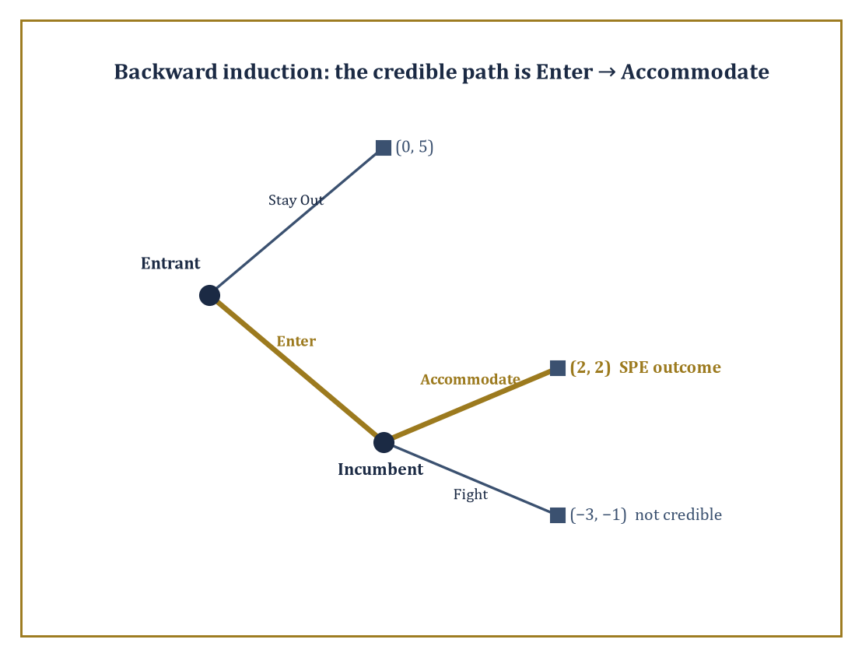
Figure 41.5 — The entry-deterrence tree, folded backward: the credible path runs Enter, then Accommodate, leaving Fight an empty threat.
Nodes are grouped into information sets: a set of nodes a player cannot tell apart when it is their turn to move, because they don’t yet know which one of them the game has reached.
A strategy in the extensive form is not merely ‘what I do’ but a complete contingency plan — an action specified at every information set where that player might ever be called on to move, including ones that, given how the game actually unfolds, are never reached. This is a stricter, more demanding object than a normal-form strategy, and it is just this extra structure that lets the theory distinguish threats a player would carry out from threats that are pure bluster.
When every information set is a single node — every player, at every point, knows where they are in the tree, which is called perfect information — the game can be solved by backward induction: work out the optimal action at each final decision node first (where the payoffs are immediately visible), fold those choices back into the payoffs one level up as if they were already fixed, and repeat toward the root.
The resulting equilibrium, playing optimally at every node including ones off the path taken, is called subgame-perfect (Selten), because it remains a Nash equilibrium not only of the whole game but of every subgame — every smaller tree hanging off any node — considered on its own.
Numeric example — backward induction in an entry-deterrence game. An Entrant first decides whether to Enter a market or Stay Out. If the Entrant Stays Out, the game ends with payoffs (Entrant, Incumbent):
(Entrant, Incumbent) = (0, 5)
If the Entrant Enters, the Incumbent then decides whether to Fight (a price war) or Accommodate (share the market), giving payoffs:
(Enter, Fight) = (−3, −1)
(Enter, Accommodate) = (2, 2)
Backward induction starts at the last decision, the Incumbent’s: comparing Fight (−1) against Accommodate (2), Accommodate is strictly better for the Incumbent, so a rational Incumbent, if the game ever reaches that node, accommodates.
Folding this back: the Entrant, anticipating that Entering leads to Accommodate rather than Fight, compares Stay Out (payoff 0) against Enter (which now effectively delivers 2, the Accommodate outcome), and Enter is strictly better.
The subgame-perfect equilibrium is (Enter, Accommodate), with payoffs:
(2, 2)
The Incumbent’s capacity to fight, however menacing it sounds beforehand, is simply not credible once the moment to actually pay its cost arrives, and a rational Entrant sees straight through it.
Try it now — In the entry game, change the Incumbent’s Fight payoff to 3 (Accommodate still gives 2). What is the subgame-perfect equilibrium? Answer →
This is worth contrasting directly with plain Nash equilibrium, because the extensive form exposes a gap that the normal form quietly papers over: a threat can be part of a perfectly good Nash equilibrium of the game’s normal form while being utterly incredible the moment you ask whether the threatener would carry it out.
Numeric example — a non-credible threat surviving as a Nash equilibrium. Consider the strategy profile where the Entrant Stays Out and the Incumbent’s strategy is ‘Fight if Entry occurs’ — i.e. the Incumbent commits, in advance, to a policy of fighting. Is this a Nash equilibrium of the normal form?
Check the Entrant’s best response to ‘Incumbent will Fight’: entering yields (−3), staying out yields 0, so Staying Out is indeed the Entrant’s best response — no incentive to deviate.
Check the Incumbent’s best response to ‘Entrant Stays Out’: whatever the Incumbent’s strategy says to do if entry occurred, that branch of the tree is never visited, so the Incumbent’s realized payoff is 5 regardless of whether their stated policy is Fight or Accommodate — they are indifferent, and ‘Fight’ is technically a best response (weakly, by not being strictly worse) to a threat that never gets tested.
So (Stay Out, Fight) is a bona fide Nash equilibrium of the normal form. But it fails to be subgame-perfect, because the Incumbent’s strategy prescribes Fight at the one node where it really matters — should entry occur — and there, as the previous example showed, Fight (−1) is strictly worse than Accommodate (2).
The threat is Nash-equilibrium-compatible precisely because it is never called upon; subgame perfection is the requirement that a strategy remain optimal even off the path played, and it is the tool that rules this equilibrium out as an empty bluff rather than a genuine deterrent.
Real information sets are rarely singletons — usually you move without knowing exactly which node you’re at, because an earlier player’s action was hidden from you. Under such imperfect information, backward induction as stated doesn’t directly apply (there’s no single ‘the’ payoff to work backward from at a multi-node information set), and the relevant refinements are sequential equilibrium (Kreps and Wilson) and perfect Bayesian equilibrium: each player’s strategy must be optimal given a system of beliefs — a probability distribution over which node in their current information set they’re at — and those beliefs must, wherever Bayes’ rule applies, be derived from the other players’ strategies rather than plucked from thin air.
The chief applications are signaling games, where an informed player (a job applicant who knows their own ability) takes a costly, visible action (getting a degree) partly to credibly reveal that information to an uninformed party (an employer who cannot directly observe ability); screening games, the mirror image, where the uninformed party designs a menu of options to induce the informed party to self-sort by type; and the broader reputation literature, where a long-run player’s history of past actions substitutes, however imperfectly, for information the short-run players who observe them can’t access directly.
Abstract example — the skeleton of a signaling game. A worker is privately either High-ability or Low-ability, each with prior probability 1/2 — the employer cannot see this directly.
The worker first chooses an education level (say, Degree or No Degree), which costs a High-ability worker less effort to obtain than a Low-ability one (the standard Spence single-crossing condition). The employer, observing only the education choice — not the underlying ability — then offers a wage, updating their belief about the worker’s type via Bayes’ rule based on which education level was chosen.
A separating equilibrium is one where High- and Low-ability workers choose different education levels, so the employer’s Bayesian belief becomes degenerate (certain) after observing the signal, and wages fully reveal ability even though ability itself was never directly observed — education here has no productive value whatsoever in the model; its entire function is to be a hard-to-fake billboard, credible only because it costs the two types differently.
A pooling equilibrium, by contrast, is one where both types choose the same education level, the employer’s belief stays at the 1/2-1/2 prior, and the signal conveys nothing at all — which of the two the game settles into depends on the specific cost and wage numbers chosen, but the qualitative machinery (beliefs updated by Bayes’ rule wherever possible, strategies optimal given those beliefs) is exactly what perfect Bayesian equilibrium was built to formalize.
Keep only this · Section 41.5: Extensive-Form Games and Sequential Rationality
The idea. Extensive-form games record who moves when and what they know; backward induction solves them from the end and removes threats that would never be carried out.
Core.
subgame-perfect equilibrium: Nash in every subgame
backward induction: solve the last moves first
Typical mistake. Accepting a Nash equilibrium that relies on a threat the player would not carry out. Subgame perfection rules those out.
Minimal example. Entry game: Accommodate (2) beats Fight (−1), so the Entrant enters: SPE (Enter, Accommodate), payoffs (2, 2).
Practice. Easy to challenge; full worked answers, with the usual mistake, are in Answers to the Practice Sets at the back.
Easy — How many subgames does the entry-deterrence game have? Answer →
Medium — Player 1 can Take (payoffs (1, 0)) or Pass. After Pass, player 2 can Take ((0, 2)) or Pass ((3, 1)). Solve by backward induction. Answer →
Challenge — Show that (Stay Out, Fight if entry) is a Nash equilibrium of the original entry game but not subgame perfect. Answer →

Section 41.6: Repeated Games and the Folk Theorems
Cooperation, purchased on an installment plan
A repeated game takes a single stage game — the Prisoner’s Dilemma will do nicely, since it has been sitting there being tragic for three sections now — and plays it over and over, either infinitely often or for a long but finite number of rounds, with the crucial twist that a strategy in the repeated game may condition its action in round t on the entire history of play in rounds 1 through t−1.
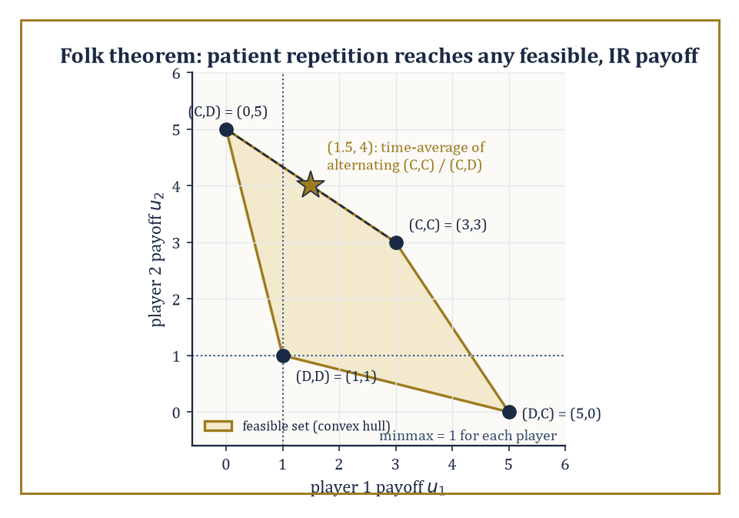
Figure 41.6 — The feasible payoff set of the repeated Prisoner’s Dilemma, with a patient pair reaching (1.5, 4) by alternating outcomes no single round could offer.
This extra memory is what makes repeated games interesting: an outcome that is not a Nash equilibrium of the one-shot stage game — mutual cooperation in the Prisoner’s Dilemma, for instance — can become sustainable as an equilibrium of the repeated game, enforced by the credible threat of future punishment for deviation.
Future payoffs are discounted by a factor δ ∈ (0,1) per period (δ close to 1 means the players are patient, weighting the future almost as heavily as the present; δ close to 0 means they barely care what happens tomorrow), and how patient the players are turns out to be the knob that determines how much cooperation is achievable.
The folk theorems — so called because their essential content was informally ‘known in the folklore’ among game theorists well before anyone bothered to write down a careful proof — characterize which payoff vectors can arise as equilibrium outcomes of the infinitely repeated game.
The rough statement: for sufficiently patient players (δ close enough to 1), essentially any feasible payoff vector (one achievable by some combination, including time-averaging or randomizing over, the stage game’s outcomes) that is also individually rational (giving each player at least their minmax payoff — the most a player can be held down to by the others, if that player then plays their own best response) can be supported as a subgame-perfect equilibrium outcome of the repeated game.
This is a strikingly permissive result — it says the set of sustainable outcomes is enormous, not that any particular one is inevitable — and the mechanism that makes it work is the trigger strategy: cooperate as long as everyone else has cooperated so far; the instant anyone deviates, switch to permanent (or temporary, in gentler variants) punishment.
Numeric example — how patient must you be to cooperate forever?. Take the Prisoner’s Dilemma payoffs, and consider the grim trigger strategy: both players cooperate every round until either defects, at which point both defect forever after (the harshest available punishment, since (D,D) gives each player their minmax payoff of 1 — neither can be pushed below 1, since defecting is always available as a fallback).
(C,C) = (3,3), (C,D) = (0,5), (D,C) = (5,0), (D,D) = (1,1)
Is mutual cooperation, sustained by this threat, a subgame-perfect equilibrium for a given discount factor δ? Compare the value of cooperating forever against the value of deviating once — grabbing 5 this round by defecting while the opponent still cooperates — and then suffering the punishment payoff of 1 every round after.
3 + 3δ + 3δ² + ... = 3/(1−δ)
5 + δ·1 + δ²·1 + ... = 5 + δ/(1−δ)
Cooperation is sustainable exactly when the first is at least the second:
3/(1−δ) ≥ 5 + δ/(1−δ)
Multiply both sides by (1−δ), which is positive:
3 ≥ 5(1−δ) + δ = 5 − 5δ + δ = 5 − 4δ
Rearranging:
4δ ≥ 2
δ ≥ 1/2
Cooperation, backed by the threat of eternal mutual defection, is a subgame-perfect equilibrium precisely when the players discount the future by no more than a factor of 1/2 per round — put plainly, when they value next round’s payoff at least half as much as this round’s. Below that threshold, the one-off temptation of grabbing 5 instead of 3 outweighs any amount of future punishment, patient posturing notwithstanding, and defection wins.
Try it now — With δ = 0.6, compare the grim-trigger values 3/(1 − δ) and 5 + δ/(1 − δ). Answer →
Grim trigger is the blunt instrument of the family — a single slip and the relationship never recovers, which is both maximally deterrent and maximally unforgiving, since it also punishes honest mistakes as harshly as calculated betrayal.
Tit-for-tat — cooperate first, then mirror whatever the opponent did last round — is gentler, self-correcting after a single mutual slip, and famously did rather well in Robert Axelrod’s repeated-tournament experiments because it is ‘nice’ (never defects first), ‘retaliatory’ (punishes defection immediately), and ‘forgiving’ (returns to cooperation the instant the opponent does).
Real applications complicate the clean theory in three ways worth flagging: discounting captures impatience, as above; imperfect monitoring — where players observe only a noisy signal of what others actually did, rather than the action itself — forces punishment to sometimes trigger by mistake, and the theory of repeated games with imperfect monitoring is largely about designing strategies robust to that noise; and finite horizons, where the game is known to end at a fixed round T, unravel cooperation entirely by backward induction in the pure Prisoner’s Dilemma case (nobody cooperates in round T, since there’s no future to protect; anticipating that, nobody cooperates in T−1 either, and so on back to round 1) — a sharp reminder that it is the shadow of an uncertain, sufficiently long future, not repetition for its own sake, that is doing the actual work of sustaining cooperation.
Numeric example — the folk theorem’s feasible payoff set, made concrete. The four stage-game outcomes of the Prisoner’s Dilemma give payoff pairs (3,3), (0,5), (5,0), (1,1); the feasible set is (roughly) the convex hull of these points, since patient players can approximate any point in that hull by alternating or randomizing among the pure outcomes over time and averaging the results.
Each player’s minmax payoff is 1 (achieved when the opponent defects and the player best-responds by defecting too), so the individually rational region is every feasible pair with both coordinates at least 1.
Take the target payoff (1.5, 4): is it in this region? It lies on the segment between (3,3) and (0,5) — specifically, alternate cooperation-cooperation and cooperation-defection every other round: half the rounds give (3,3), half give (0,5), and the long-run time-average is:
((3+0)/2, (3+5)/2) = (1.5, 4)
Both coordinates, 1.5 and 4, exceed the individually-rational floor of 1, so by the folk theorem this payoff pair is achievable as a subgame-perfect equilibrium outcome for δ close enough to 1, using an appropriately constructed punishment scheme (any deviation from the prescribed alternation collapses play to the mutual-defection payoff of (1,1) forever, the same disciplining device as before).
Notice how far outside the four original stage-game outcomes this lands: patient repetition doesn’t just make (3,3) achievable, it opens up an entire continuum of payoff splits nobody could reach in a single round of the underlying game at all.
Repeated games are, in this sense, the formal backbone of every long-run relationship economics or biology cares to model — supplier and buyer, employer and employee, two firms tacitly colluding on price, or two organisms locked in an evolutionary arms race — anywhere cooperation that looks individually irrational in a single encounter becomes rational once the encounter is understood to recur, and where reputation, memory, and the shadow of the future do the enforcement work that no external referee is available to provide.
Keep only this · Section 41.6: Repeated Games and the Folk Theorems
The idea. Repeating a game lets future punishment enforce present cooperation; the folk theorems say patient players can sustain any feasible payoffs above their minmax levels.
Core.
grim trigger in the PD: 3/(1 − δ) ≥ 5 + δ/(1 − δ) ⇔ δ ≥ ½
a + aδ + aδ² + ⋯ = a/(1 − δ)
Typical mistake. Expecting cooperation in a finitely repeated Prisoner’s Dilemma with a known last round. Backward induction unravels it from the end.
Minimal example. 3 ≥ 5 − 4δ gives δ ≥ ½.
Practice. Easy to challenge; full worked answers, with the usual mistake, are in Answers to the Practice Sets at the back.
Easy — If the temptation payoff is 6 instead of 5 (other payoffs unchanged), what δ is needed for grim trigger? Answer →
Medium — What is the present value of receiving 3 every round forever at δ = 0.9? Answer →
Challenge — Is the payoff pair (2, 2) feasible and individually rational in the repeated Prisoner’s Dilemma? How can it be produced? Answer →

Section 41.7: Cooperative Games and Bargaining
Splitting the pie without pretending it wasn’t a fight to bake it
Everything so far has been non-cooperative game theory: players choose strategies individually, and any cooperation that emerges must be self-enforcing, arising from the incentive structure itself rather than from an outside authority.
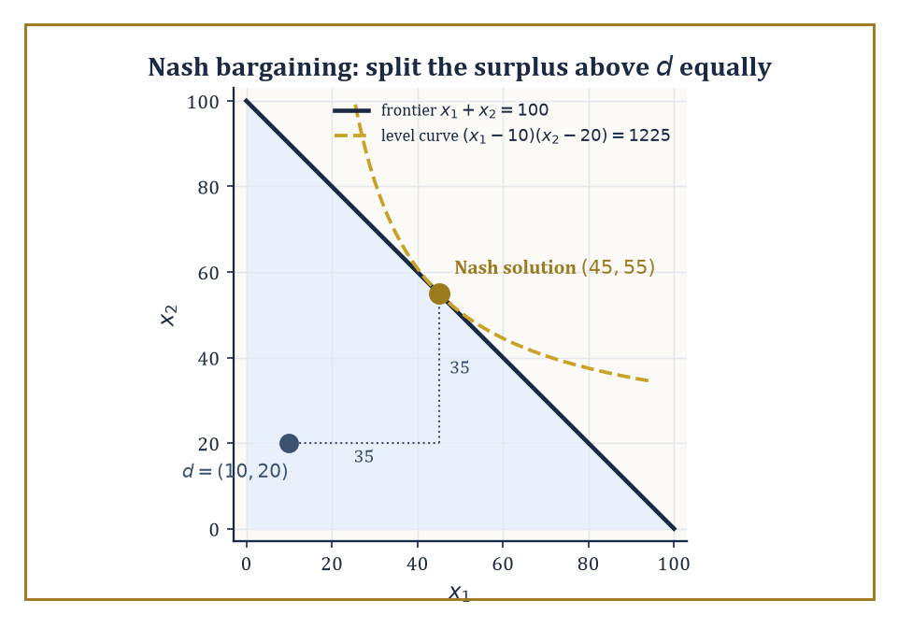
Figure 41.7 — The Nash bargaining solution: the highest reachable product-of-gains curve, tangent to the frontier at a fifty-fifty split of the surplus above disagreement.
Cooperative game theory takes a different starting point: it assumes coalitions can form and make binding agreements, and asks how the value those coalitions jointly create ought to be divided.
The basic object is the characteristic function v, which assigns to every possible coalition S of players (every subset of the full player set N, including the empty coalition and the grand coalition N itself) a single number v(S) — the total value that coalition can guarantee itself, regardless of what the players outside S do.
The question the theory then asks is not ‘what will happen?’ but ‘what division of v(N) — the value of everyone cooperating together — is stable, or fair, or both, according to some explicit set of axioms?’
Three solution concepts dominate the landscape, each formalizing a different notion of a ‘good’ division.
The core is the set of allocations (x₁, ..., xₙ) summing to v(N) such that no coalition S can do better by breaking away and splitting v(S) among just its own members.
Σ[i∈S] xᵢ ≥ v(S), for every coalition S
An allocation in the core is stable in the strongest sense: absolutely no subgroup has both the incentive and the capacity to defect.
The Shapley value (Lloyd Shapley, 1953) instead asks a fairness question, defining each player’s share as their average marginal contribution to the coalition, computed over every possible order in which the grand coalition could be assembled one player at a time — a single number for each player, always summing to v(N), and uniquely characterized by a small set of fairness axioms (symmetry, efficiency, additivity, and a null-player condition).
The nucleolus, a third and more computationally intricate concept, picks out the allocation that lexicographically minimizes the worst-case dissatisfaction (the largest shortfall v(S) − Σ[i∈S] xᵢ, over all coalitions S) — it exists and is unique even in games where the core is empty, which the core-based approach, by construction, cannot promise.
Numeric example — the Shapley value of the glove game. Players 1 and 2 each own a left-hand glove; player 3 owns a right-hand glove. A matched pair (one left, one right) sells for $10; unmatched gloves are worthless, and only one pair can ever be sold no matter how many spare gloves are lying around.
The characteristic function assigns 0 to any coalition without player 3, or with player 3 alone, since no pair can form.
v(∅) = v({1}) = v({2}) = v({3}) = v({1,2}) = 0
Any coalition containing player 3 and at least one left-glove owner can sell exactly one pair, for $10.
v({1,3}) = v({2,3}) = v({1,2,3}) = 10
Compute the Shapley value by averaging marginal contributions over all 3! = 6 orderings in which the grand coalition could be built up one player at a time.
Order (1,2,3): player 1 joins ∅, then player 2 joins {1}, then player 3 joins {1,2}.
v({1}) − v(∅) = 0
v({1,2}) − v({1}) = 0
v({1,2,3}) − v({1,2}) = 10 − 0 = 10
This ordering assigns contributions of 0, 0, and 10 to players 1, 2, and 3 respectively.
Order (1,3,2): player 1 joins first, contributing nothing; then player 3 joins {1}; then player 2 joins {1,3}.
v({1}) − v(∅) = 0
v({1,3}) − v({1}) = 10
v({1,2,3}) − v({1,3}) = 10 − 10 = 0
Order (2,1,3) is symmetric to the first, giving 0, 0, 10 to players 2, 1, 3 respectively.
Order (2,3,1): player 2 joins first, contributing 0; player 3 joining {2} contributes 10; player 1 joining {2,3} contributes 0.
v({2}) − v(∅) = 0
v({2,3}) − v({2}) = 10
v({1,2,3}) − v({2,3}) = 10 − 10 = 0
Order (3,1,2): player 3 joins ∅, contributing 0; player 1 joining {3} contributes 10; player 2 joining {1,3} contributes 0.
v({3}) − v(∅) = 0
v({1,3}) − v({3}) = 10
v({1,2,3}) − v({1,3}) = 10 − 10 = 0
Order (3,2,1) is symmetric, giving player 3 a contribution of 0, player 2 a contribution of 10, player 1 a contribution of 0.
Summing each player’s contributions across all six orderings and dividing by 6 gives the Shapley value. Player 1 gets:
(0+0+0+0+10+0)/6 = 10/6 = 5/3 ≈ 1.67
Player 2 gets, by the same symmetric calculation, the identical figure:
5/3 ≈ 1.67
Player 3 gets:
(10+10+10+10+0+0)/6 = 40/6 = 20/3 ≈ 6.67
Check the total:
5/3 + 5/3 + 20/3 = 30/3 = 10 = v(N)
As it must. Player 3, the sole owner of the scarce right glove, walks away with four times either left-glove owner’s share — a clean illustration of how scarcity, not effort or ownership count, drives the Shapley division.
Try it now — Two players: one owns a left glove, the other a right glove, and a pair sells for $10. What is each player’s Shapley value? Answer →
Numeric example — the core of the same game, and why it disagrees with Shapley. Is the Shapley allocation (5/3, 5/3, 20/3) in the core? Check the coalition {1,3}: its members receive, between them:
5/3 + 20/3 = 25/3 ≈ 8.33
But v({1,3}) = 10 — the coalition {1,3} could break away, sell their own pair, and split $10 among just the two of them, strictly better than the 8.33 the Shapley value gives them jointly. The Shapley allocation is not in the core of this game.
So what is? The core requires the total to equal v(N), together with the following coalition constraints (the {1,2} constraint, x₁+x₂ ≥ 0, is automatic since payoffs are non-negative).
x₁ + x₂ + x₃ = 10
x₁ + x₃ ≥ 10
x₂ + x₃ ≥ 10
From x₁+x₃ ≥ 10 and the total being exactly 10, we get x₂ ≤ 0, and since x₂ ≥ v({2}) = 0 also holds, x₂ = 0 exactly.
The identical argument on x₂+x₃ ≥ 10 forces x₁ = 0. That leaves x₃ = 10.
The core of this game is the single point (0, 0, 10) — the scarce player takes everything, and any allocation giving either left-glove owner so much as a cent leaves the coalition {the other left-glove owner, player 3} with an incentive to defect and undercut them.
This divergence is entirely typical, not a mistake in either concept: the Shapley value always exists and always treats symmetric players symmetrically (both left-glove owners here get equal shares, matching the fact that they are interchangeable), while the core can be a single razor’s-edge point, empty altogether in other games, or a large region — it answers ‘what’s stable’, not ‘what’s fair’, and the two questions, as this example shows starkly, need not have the same answer.
Bargaining theory narrows the cooperative question to the cleanest possible case: two (or more) parties dividing a surplus, with a specified disagreement point — what each gets if talks collapse wholly.
The Nash bargaining solution (a different, earlier contribution of John Nash’s, not to be confused with the equilibrium concept bearing his name) is the unique division satisfying four axioms — Pareto optimality (no surplus left needlessly on the table), symmetry (identical bargaining power if the underlying problem is symmetric), invariance to affine rescaling of utilities, and independence of irrelevant alternatives (shrinking the set of available deals, without removing the eventual agreement itself, shouldn’t change what’s agreed).
It turns out to be the division that maximizes the product of the two parties’ gains over their disagreement point, subject to feasibility:
(x₁ − d₁)(x₂ − d₂)
Strategic models of alternating-offer bargaining (Rubinstein, 1982) — where players take turns proposing splits, each round discounted, with the threat of talks dragging on forever looming over both — independently justify this same solution as the limit of subgame-perfect equilibrium outcomes as the time between offers shrinks to zero, which is a satisfying place for the axiomatic and the strategic to meet.
Numeric example — the Nash bargaining solution. Two parties bargain over a $100 pie, with disagreement payoffs d₁ = $10 and d₂ = $20 — what each party could secure by walking away (perhaps by suing, or by taking their business elsewhere).
The Nash solution maximizes the following product subject to feasibility:
(x₁ − 10)(x₂ − 20), subject to x₁ + x₂ = 100
Substitute x₁ = 100 − x₂ to reduce this to a single-variable maximization:
f(x₂) = (90 − x₂)(x₂ − 20) = −x₂² + 110x₂ − 1800
Differentiate and set to zero:
f′(x₂) = −2x₂ + 110 = 0
x₂ = 55, so x₁ = 100 − 55 = 45
(The second derivative is −2, confirming a maximum, not a minimum.) So the Nash bargaining solution is x₁ = $45, x₂ = $55.
There’s a shortcut worth noting for next time: the solution always splits the surplus above the disagreement point equally — here the surplus is:
100 − 10 − 20 = 70, split as 35 each
x₁ = 10 + 35 = 45, x₂ = 20 + 35 = 55
Matching exactly. Both parties end up better off than their disagreement payoffs (45 > 10, 55 > 20, satisfying individual rationality) despite party 2’s better fallback position translating directly into a larger absolute share — a formal version of the folk wisdom that your bargaining power is just as strong as your best alternative to agreement, no stronger.
The Nash program, finally, is less a theorem than a research agenda: it holds that every cooperative solution concept ought to be realizable — reconstructible, payoff for payoff — as the equilibrium outcome of some suitably designed non-cooperative game, so that binding agreements and unenforceable enlightened self-interest turn out, on sufficiently careful inspection, to be two descriptions of the same underlying incentive structure rather than two different phenomena.
The Rubinstein bargaining result above, recovering the axiomatically-defined Nash solution as the limit of an explicit non-cooperative negotiation protocol, is the program’s flagship success story.
Keep only this · Section 41.7: Cooperative Games and Bargaining
The idea. Cooperative game theory asks how a jointly earned surplus should be split; the Shapley value averages marginal contributions, the core lists splits no coalition can beat, and Nash bargaining splits the gains over the walk-away points.
Core.
Shapley: φᵢ = average over orderings of v(Sᵢ ∪ {i}) − v(Sᵢ)
core: Σ_(i∈S) xᵢ ≥ v(S) for every coalition S
Nash bargaining: maximize (x₁ − d₁)(x₂ − d₂)
Typical mistake. Assuming the Shapley value is always in the core. In the three-player glove game it is not.
Minimal example. $100 pie, d₁ = 10, d₂ = 20: surplus 70 split equally, x = (45, 55).
Practice. Easy to challenge; full worked answers, with the usual mistake, are in Answers to the Practice Sets at the back.
Easy — Two parties split $100 with disagreement payoffs (0, 0). What is the Nash bargaining solution? Answer →
Medium — Repeat with d₁ = 30 and d₂ = 10. Answer →
Challenge — Show that the core of the three-player glove game (players 1 and 2 hold left gloves, player 3 a right glove, a pair is worth 10) is the single allocation (0, 0, 10). Answer →

Section 41.8: Auctions and Mechanism Design
Game theory practiced backwards, on purpose
An auction is a game in which bidders submit bids according to some publicly known rule, and that rule — together with the bids submitted — determines both who wins whatever is being sold and how much everyone pays.
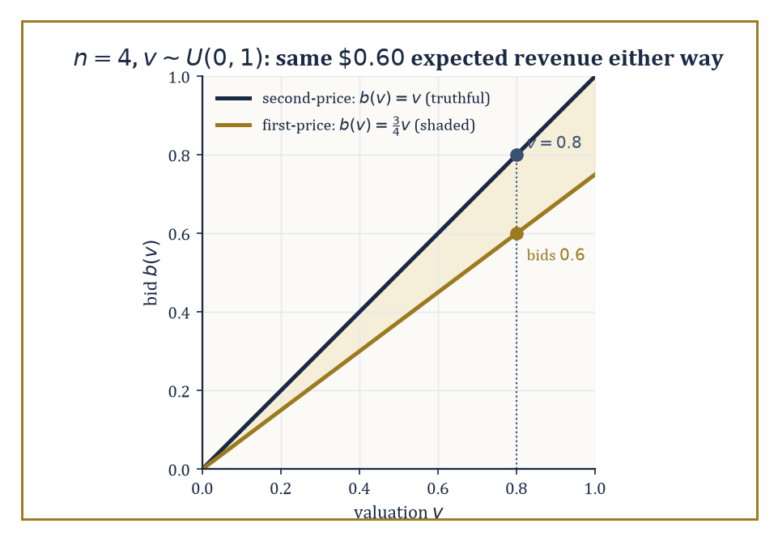
Figure 41.8 — First-price shading against second-price honesty for four uniform bidders: different lines, identical sixty-cent expected revenue.
Different rules define different games: in a first-price sealed-bid auction the highest bidder wins and pays their own bid; in a second-price sealed-bid auction (Vickrey, 1961) the highest bidder wins but pays only the second-highest bid; in an ascending (English) auction the price rises openly until only one bidder remains; in a descending (Dutch) auction the price falls from a high starting point until someone accepts.
The revenue equivalence theorem is the startling unifying fact underneath all of this variety: under standard assumptions — bidders’ valuations are independently and identically drawn from a common distribution, bidders are risk-neutral, and the object always goes to the highest-value bidder in equilibrium — a very wide class of auction formats, first-price and second-price included, yield the same expected revenue for the seller.
The formats look utterly different in procedure and feel; in expectation, they are financially indistinguishable.
The Vickrey second-price auction has a property that makes it a favorite teaching example and, increasingly, a favorite real-world mechanism (variants power a good deal of online advertising auction infrastructure): bidding one’s true valuation is a weakly dominant strategy.
That means it is a best response regardless of what anyone else bids, with no need to guess opponents’ behavior, model the distribution of their valuations, or engage in any strategic second-guessing whatsoever.
Numeric example — why truthful bidding dominates in a second-price auction. A bidder values the item at v = $10, and let b* denote the highest bid submitted by everyone else — unknown to this bidder in advance, but fixed for the purposes of the argument. Consider Case 1, where the highest rival bid falls short of this bidder’s value:
b* < 10
Bidding exactly v = 10 wins (ties broken however the rules specify) and pays b*, for a profit of:
10 − b* > 0
Bidding higher than 10 still wins, still pays b* (the price is set by the second-highest bid, not the winner’s own bid), so the profit is identical: no gain from overbidding. Bidding below b* loses the auction, earning 0 — strictly worse whenever 10 − b* > 0.
Now consider Case 2, the reverse situation:
b* > 10
Bidding v = 10 loses, earning 0. Bidding anything between 10 and b* still loses. Bidding above b* wins but pays b*, giving a profit of:
10 − b* < 0
which is strictly worse than the 0 from losing. Bidding v = 10 is therefore never worse, and sometimes strictly better, than any other bid, for every possible value of b* — what ‘weakly dominant’ means.
The elegant consequence: this bidder never needs to think about what anyone else is likely to bid at all. The strategic problem evaporates, replaced by pure honesty, which is not a phrase auction theory gets to use very often.
Try it now — In a second-price auction the bids are 7, 10 and 4. Who wins, and what do they pay? If the winner’s value is 10, what is their profit? Answer →
First-price auctions offer no such free lunch: since the winner pays their own bid rather than the second-highest, bidding one’s true value guarantees zero profit whenever you win (you’d have paid what the item is worth to you), so rational bidders shade their bids downward, trading a lower chance of winning against a larger profit conditional on winning.
The equilibrium amount of shading depends on the number of competing bidders and the distribution their values are drawn from — more bidders means fiercer competition means less room to shade.
Numeric example — revenue equivalence, checked with actual numbers. Take n = 4 bidders, each with a valuation drawn independently from a Uniform(0,1) distribution. A classical result gives the symmetric equilibrium bidding function in the first-price auction as:
b(v) = ((n−1)/n)·v
Here that is:
b(v) = (3/4)v
so a bidder valuing the item at 0.8 optimally bids 0.6, shading down by a quarter. To compare expected revenue across formats, recall a fact about order statistics of n iid Uniform(0,1) draws: the expected value of the k-th smallest of n draws is
k/(n+1)
The largest of 4 draws (k = 4) has expectation:
4/5 = 0.8
and the second-largest (k = 3) has expectation:
3/5 = 0.6
In the second-price auction, truthful bidding (from the earlier dominance argument) means the seller’s revenue equals the second-highest valuation, so expected revenue is exactly:
3/5 = 0.6
In the first-price auction, the winner is whoever has the highest valuation, and they pay:
b(vₘₐₓ) = (3/4)·vₘₐₓ
so expected revenue is:
(3/4)·𝔼[vₘₐₓ] = (3/4)·(4/5) = 3/5 = 0.6
— identical, to the exact fraction, to the second-price figure. Two auctions that look, run, and feel completely different — one truthful and transparent, one requiring careful strategic shading — hand the seller the same $0.60 in expectation, out of a maximum possible $1.00. Revenue equivalence, confirmed in cold arithmetic rather than merely asserted.
Mechanism design inverts the entire question the rest of this chapter has been asking. Instead of starting from a fixed game and working out what equilibrium play looks like, it starts from a desired social outcome — the item should go to whoever values it most, say, or a public good should be built exactly when its total benefit exceeds its cost — and asks what game (what mechanism: what messages players may send, and what allocation and payment rule turns those messages into an outcome) will make self-interested equilibrium behavior produce that outcome.
The revelation principle is the tool that makes this search tractable: it states that for any mechanism and any equilibrium of it, there exists an equivalent direct mechanism — one where players simply report their private information (their true valuation, say) directly — in which truthful reporting is itself an equilibrium and produces the same outcomes.
This collapses an unbounded search over conceivable game forms down to a search over truthful direct mechanisms alone, subject to two basic constraints: incentive compatibility (no player can gain by lying about their private information) and individual rationality (no player is made worse off by participating than by staying out entirely).
The Vickrey auction, not coincidentally, is the simplest possible illustration of a direct, incentive-compatible, individually rational mechanism, since ‘report your value’ and ‘bid your value’ are, for that particular design, one and the same instruction.
Abstract example — the revelation principle in miniature. Suppose some indirect mechanism — a complicated multi-round bidding procedure, say — has an equilibrium in which a bidder with true value v strategically submits some transformed bid β(v) rather than v itself, and this produces outcome (allocation, payment) pair O(β(v)) for that bidder.
Define a new, direct mechanism: ask each bidder to report a value directly, and when a bidder reports r, run them through the transformation β and then through the original outcome rule, i.e. give them O(β(r)) exactly as the indirect mechanism would have.
In this constructed direct mechanism, reporting truthfully (r = v) delivers precisely the outcome O(β(v)) that the bidder was already getting by playing their equilibrium strategy β(v) in the original indirect game — and since β(v) was optimal there, r = v is optimal here, because the two mechanisms are, by construction, delivering identical outcomes for identical true values.
Nothing about the bidder’s incentives has changed; only the label on what they’re asked to submit has.
This is the entire content of the revelation principle: it is a change of variables, not a discovery about strategic behavior, but it is a change of variables that turns an intractable search over all possible mechanisms into a tractable search over the comparatively small, well-behaved space of truthful ones.
Auctions and mechanism design are, fittingly, the point where this chapter’s mathematics turns from description to engineering: rather than merely predicting how self-interested agents will behave in a given game, the theory tells you how to build the game itself so that the behavior it predicts is the behavior you actually wanted all along.
Spectrum auctions, matching markets for school places and kidney exchanges, and the ad-auction infrastructure quietly running behind a great many web pages are this theory, deployed.
Keep only this · Section 41.8: Auctions and Mechanism Design
The idea. An auction is a game whose rules decide who wins and who pays; mechanism design chooses the rules so that the equilibrium produces the outcome you want, often by making truth-telling optimal.
Core.
second price: bidding your value is weakly dominant
revenue equivalence: standard auctions with i.i.d. values earn the same expected revenue
Typical mistake. Shading a bid in a second-price auction. Your bid only decides whether you win, never what you pay, so shading can only lose you auctions you wanted.
Minimal example. Value 10, rival bid 8: bid 10, win, pay 8, profit 2. Bid 7: lose, profit 0.
Practice. Easy to challenge; full worked answers, with the usual mistake, are in Answers to the Practice Sets at the back.
Easy — In a first-price auction with n bidders and values uniform on [0, 1], the equilibrium bid is b(v) = ((n − 1)/n)v. What does a bidder with v = 0.8 bid when n = 4? Answer →
Medium — With 4 bidders and values uniform on [0, 1], the expected second-highest value is (n − 1)/(n + 1). What is the expected revenue of a second-price auction? Answer →
Challenge — Prove that in a second-price auction, bidding above your value v can never help and can hurt. Answer →

Section 41.9: Looking Ahead: From Classical Game Theory to Evolutionary, Algorithmic, and Behavioral Extensions
The series continues, and so, alarmingly, does everyone else’s reasoning about it
We have, over eight sections, assembled the classical core of the subject: utility and expected utility as the one-player foundation; games in normal and extensive form as the two languages for describing strategic situations, one abstracting time away and one restoring it; dominance and best response as the basic solution tools; Nash equilibrium, in pure and mixed strategies, as the central self-enforcing solution concept, guaranteed to exist by Nash’s theorem even where pure equilibria fail outright; subgame perfection as the refinement that separates credible strategies from empty threats; the folk theorems as the account of how repetition and patience manufacture cooperation that a single encounter could never sustain; cooperative solutions — the core, the Shapley value, Nash bargaining — as the mathematics of dividing jointly created value; and mechanism design as game theory reversed, engineering the rules so that self-interest does the designer’s work.
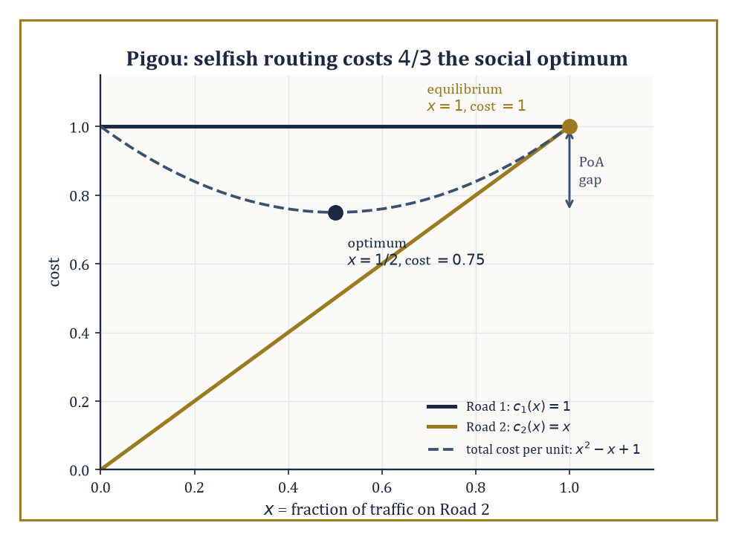
Figure 41.9 — Pigou’s two roads: selfish routing settles at cost 1 where a planner could have had 0.75 — the price of anarchy, drawn as a gap.
It is, by any reasonable standard, already a formidable toolkit.
It is also, this final section exists to insist, very much not the end of the story.
Evolutionary game theory (Maynard Smith and Price, 1973) drops the assumption that players are calculating, forward-looking reasoners at all, and replaces it with populations of agents playing fixed strategies, whose relative numbers change over time according to how well each strategy currently performs — strategies that do well multiply, strategies that do badly die out, no cognition required anywhere in the model.
The central solution concept is the evolutionarily stable strategy (ESS): a strategy that, once it dominates a population, cannot be successfully invaded by any rare mutant strategy, because the mutant does no better against the resident population than residents already do against each other.
Remarkably, this biological, non-rational notion of stability turns out to coincide, in the relevant technical sense, with a refinement of Nash equilibrium — evolution, with no reasoning involved anywhere, discovers the same equilibria that careful strategic calculation does, which either says something profound about the universality of the mathematics or something faintly deflating about how much credit strategic reasoning deserves, depending on your mood that afternoon.
Numeric example — the evolutionarily stable strategy in Hawk-Dove. In the classic Hawk-Dove game, individuals compete for a resource worth V; Hawks always fight, Doves always retreat. Two Hawks meeting split the cost of a fight C evenly, each netting (V − C)/2; a Hawk meeting a Dove takes the whole resource (V) while the Dove gets 0; two Doves meeting share peacefully, each getting V/2.
Take the following values (fighting is expensive relative to the prize — a biologically realistic regime):
V = 2, C = 6
If Hawks are rare in a population and cost of conflict is high, an all-Dove population is unstable (a Hawk mutant does very well against passive Doves), but an all-Hawk population is also unstable, since C > V here means fighting is a net loss on average against other Hawks.
The mixed ESS is the Hawk-frequency p* at which a Hawk and a Dove earn the same expected payoff against the population, so neither strategy can invade the other.
A Hawk’s expected payoff against a population playing Hawk with probability p is:
p·(V−C)/2 + (1−p)·V
A Dove’s expected payoff is:
p·0 + (1−p)·V/2
Setting these equal:
p(V−C)/2 + (1−p)V = (1−p)V/2
Substitute V = 2, C = 6:
p(−4)/2 + 2(1−p) = (1−p)(1)
−2p + 2 − 2p = 1 − p
−4p + 2 = 1 − p
−3p = −1
p = 1/3
This matches the well-known closed form exactly:
p* = V/C = 2/6 = 1/3
At this mixture — a population that is one-third Hawk, two-thirds Dove (or, equivalently, every individual playing Hawk with probability 1/3) — no mutant strategy, Hawk or Dove or anything in between, can achieve a higher average payoff, and the population sits in a stable evolutionary equilibrium that no individual organism ever had to reason its way into.
Try it now — In Hawk–Dove with V = 2 and C = 6, what is the evolutionarily stable Hawk frequency p* = V/C? Answer →
Algorithmic game theory asks the computer-science question that classical theory tends to wave past: how hard is it, computationally, to find these equilibria, and what happens to overall system efficiency when everyone plays selfishly rather than being centrally coordinated?
We have already met the first strand — PPAD-completeness of general Nash equilibrium computation, back in the mixed-strategy section.
The second strand asks about the price of anarchy: the ratio between the worst-case total welfare under selfish equilibrium play and the welfare achievable under a centrally-imposed social optimum, and it turns out this price can be substantial even in strikingly simple settings.
Numeric example — the price of anarchy in Pigou’s traffic example. One unit of traffic must travel from A to B via one of two roads. Road 1 has a constant travel cost of 1 regardless of how much traffic uses it; Road 2 has a cost equal to the fraction x of total traffic using it:
c₂(x) = x
Selfish drivers each choose whichever road is currently cheaper. At equilibrium, traffic keeps piling onto Road 2 until its cost rises to match Road 1’s, since
c₂(0) = 0 < c₁ = 1
This happens at x = 1, i.e. all traffic uses Road 2 (any driver peeling off to Road 1 would incur cost 1, identical to staying, so nobody has incentive to move first, and any earlier point with x < 1 still has c₂(x) = x < 1 pulling more traffic in).
Total cost at equilibrium:
1 unit of traffic × cost 1 each = 1
Now find the social optimum: a planner chooses the split x on Road 2 (and 1−x on Road 1) to minimize total cost:
x·c₂(x) + (1−x)·c₁ = x² + (1−x) = x² − x + 1
Differentiate:
d/dx(x² − x + 1) = 2x − 1 = 0
x = 1/2
(and the second derivative, 2, confirms a minimum). Total cost at the optimum:
(1/2)² + (1 − 1/2) = 0.25 + 0.5 = 0.75
The price of anarchy is the ratio of selfish cost to optimal cost:
1 / 0.75 = 4/3 ≈ 1.33
Selfish routing makes everyone worse off by a full third compared to what a benevolent traffic planner could achieve, purely because Road 2’s cheap early capacity lures in more traffic than is collectively sensible, and no individual driver, choosing selfishly, has any reason to hold back. This is the mathematical seed of Braess’s paradox, in which adding an additional road to a network can, astonishingly, make every driver’s commute longer — a possibility that sounds like nonsense until you’ve sat with this calculation.
Behavioral game theory folds the descriptive lessons of decision theory’s paradoxes — Allais, Ellsberg, and their many relatives — back into strategic settings, replacing perfect best-response with models like quantal response equilibrium (players best-respond only probabilistically, with better responses more likely but not certain, capturing the reality that people err), level-k reasoning (players reason only a finite number of steps deep — ‘I think you think I think...’ stopping after k iterations rather than reaching a fully self-consistent equilibrium), and explicit fairness or inequity-aversion preferences (players’ utilities depend not just on their own payoff but on how it compares to others’, which alone explains a great deal of experimentally observed behavior in bargaining and public-goods games that pure self-interest cannot).
Beyond these three extensions, the theory continues to grow outward into mean-field games (Lasry and Lions), which handle populations so large that no single player’s action meaningfully affects any other individually, only through the aggregate distribution of behavior — a different mathematical regime, closer to a partial differential equation than to a payoff matrix — and continuous-time stochastic games, where the state of the world evolves randomly between decision points and strategies must account for both the other players and the uncertainty of the environment itself.
The deeper lesson of the whole chapter, stripped of its many payoff matrices, is this: rational choice in the presence of other rational choosers is not a mushy, case-by-case affair to be settled by intuition or negotiation seminars — it has genuine mathematical structure, precise solution concepts, known existence guarantees, known computational limits, and known failure modes, and that same body of mathematics turns out to be just what’s needed to design the institutions — auctions, voting rules, matching markets, traffic networks — within which future choices will be made.
Game theory is the mathematics of strategic interaction: not merely a description of conflict and cooperation after the fact, but, in its mechanism-design guise, a set of tools for engineering better versions of both.
We arrived at this chapter already able to optimize; we leave it able to optimize while somebody else optimizes back at us, which is a genuinely different and considerably more paranoid skill. Utility and expected utility gave us the one-player scaffolding; Nash equilibrium, in its pure, mixed, and sequential varieties, gave us the self-enforcing notion of a stable outcome; repeated play and cooperative solutions gave us cooperation without a referee; and mechanism design gave us the closing trick of building the game itself around the outcome we wanted. If you take only one habit of mind up the stairwell from here, let it be this: before asking what you should do, ask what everyone else, doing the same arithmetic about you, is rationally going to do first.
Notice, too, how much of this chapter leaned on probability without ever stopping to justify it — mixed strategies are probability distributions, expected utility is an expectation, the folk theorems traffic in discounted sums, ESS computations balance expected payoffs against a resident population. We borrowed the machinery and paid none of the intellectual rent. The next chapter collects the debt properly: Statistics & Probability builds the theory of chance and inference from first principles — the very apparatus this chapter spent nine sections cheerfully assuming was already in the room.
It is, in its way, a fitting sequel. Game theory asks what a rational agent should do when the world includes other rational agents; probability and statistics ask what a rational agent should believe, and how confidently, when the world refuses to hold still and tell you the truth. Between the two, not much of decision-making under any form of uncertainty is left unaddressed. The series continues. We have learned to reason about reasoning; next, we learn to reason about not knowing.
Where this returns
Minimax returns in Minimax Optimization and GANs, where two networks play a zero-sum game and gradient steps can circle the equilibrium instead of reaching it. Mechanism design’s idea — choose the rules so that self-interest gives the outcome you want — is the same idea as feedback in State Feedback, Pole Placement, and Observers: change the system so that its natural behavior is the behavior you need.
Keep only this · Section 41.9: Looking Ahead: From Classical Game Theory to Evolutionary, Algorithmic, and Behavioral Extensions
The idea. Game theory extends to evolving populations, to algorithms that must compute equilibria, and to real people who are not fully rational.
Core.
Hawk–Dove ESS: p* = V/C (when C > V)
price of anarchy = cost at equilibrium / optimal cost
Typical mistake. Thinking an evolutionarily stable strategy requires rational players. ESS is about which strategies survive selection, with no reasoning at all.
Minimal example. Pigou’s network: equilibrium cost 1, optimum 3/4, price of anarchy 4/3.
Practice. Easy to challenge; full worked answers, with the usual mistake, are in Answers to the Practice Sets at the back.
Easy — Find the ESS for V = 4 and C = 8. Answer →
Medium — In Pigou’s example (road 1 costs 1, road 2 costs x when a fraction x uses it), find the optimum split and its total cost. Answer →
Challenge — Show that if C ≤ V, all-Hawk is an evolutionarily stable strategy in Hawk–Dove. Answer →
Chapter 41 recap · Game Theory & Decision Mathematics
• A rational agent with utility u ranks lotteries by expected utility; concave u means risk aversion, measured by the gap between expected value and certainty equivalent.
• A normal-form game lists players, strategies and payoffs; zero-sum games are pure conflict.
• Nash equilibrium: no player gains by deviating alone. Dominance and best responses find pure equilibria; mixed equilibria make the opponent indifferent.
• Extensive form adds order: backward induction gives subgame-perfect equilibria and removes non-credible threats.
• Repetition makes cooperation self-enforcing if players are patient enough: δ ≥ ½ for the standard Prisoner’s Dilemma.
• Cooperative games split a surplus (Shapley value, core, Nash bargaining); mechanism design chooses the rules so that truth-telling pays.

Check Your Understanding — Chapter 41
Answers are in the Answer Key at the back of the book — have a go before you look.
1. [Model] In Section 41.1’s worked example, an agent with utility u(x)=√x faces a 50/50 gamble between $10,000 and $40,000 (expected value $25,000). Why does this agent value the gamble at only $22,500, and what does that gap represent?
See the answer →
2. [Compute] In the Battle of the Sexes (Mixed Strategies and Existence of Equilibrium), the mixed Nash equilibrium has player 1 choosing Opera with probability 2/3 and player 2 choosing Opera with probability 1/3, yet both players end up with expected payoff 2/3 — worse than either pure equilibrium (2,1) or (1,2). Why doesn’t mixing give the players a better outcome?
See the answer →
3. [Explain] In the entry-deterrence game of Extensive-Form Games and Sequential Rationality, the strategy profile (Entrant Stays Out, Incumbent Fights-if-entered) is a Nash equilibrium of the normal form. Why does it fail to be subgame-perfect?
See the answer →
4. [Model] Using the repeated Prisoner’s Dilemma payoffs (C,C)=(3,3), (C,D)=(0,5), (D,C)=(5,0), (D,D)=(1,1), how patient (in terms of discount factor δ) must the players be for grim-trigger cooperation to be a subgame-perfect equilibrium?
See the answer →
5. [Model] Two firms simultaneously choose High or Low price. Payoffs (firm 1, firm 2): (High,High) = (3,3); (High,Low) = (0,5); (Low,High) = (5,0); (Low,Low) = (1,1). Find each firm’s dominant strategy and the Nash equilibrium, and say what is uncomfortable about it.
See the answer →
6. [Explain] Why is a Nash equilibrium not required to be Pareto efficient, and why is that not a defect in the definition?
See the answer →
7. [Model] In a sealed-bid second-price (Vickrey) auction you value an item at $100. The highest competing bid will be $80. What do you pay if you bid $100, if you bid $90, and if you bid $70 — and what does the pattern show?
See the answer →
8. [Prove] Show that in a mixed-strategy Nash equilibrium, every pure strategy played with positive probability yields the same expected payoff to that player.
See the answer →
9. [Explain] In the Battle of the Sexes, each player’s equilibrium mixing probability is chosen to make the *opponent* indifferent, not themselves. Why does the logic run that way round?
See the answer →
10. [Challenge] Laboratory subjects cooperate in one-shot Prisoner’s Dilemmas far more often than the theory predicts. Does that falsify the model?
See the answer →

Problems — Chapter 41
The questions above test whether the ideas landed. These ask you to use them. Solutions are in Solutions to the Problems at the back. Work them before you look.
1. [Compute] Matching pennies: each player shows heads or tails. If they match, player 1 wins 1 from player 2; if they differ, player 2 wins 1 from player 1. Show there is no pure-strategy Nash equilibrium.
2. [Compute] In that same game, both players randomize with probability 1/2. Show that neither gains by switching to a pure strategy.
3. [Explain] A dominant strategy gives a higher payoff no matter what the opponent does. Why does its presence collapse the search for a Nash equilibrium?
4. [Model] Two bidders, values drawn independently from the uniform distribution on [0, 1], in a second-price auction. You value the object at 3/4. What do you bid, and why is that bid not an attempt to guess the other bid?

Math, Actually

Chapter 42

Statistics & Probability
Randomness, Inference, and the Art of Learning from Data
The previous chapter left us in the company of game theorists, who build magnificent structures on a foundation of two convenient fictions: that the players are rational, and that they already know the probabilities of everything that might happen to them. It is a wonderful piece of scaffolding, and we leaned on it happily for an entire chapter. But somebody, eventually, has to build the probabilities those payoff matrices were resting on, and somebody else has to go out into the world, collect a horribly small and horribly noisy pile of data, and try to reconstruct which of those probabilities is actually true. That is this chapter’s job. Game theory assumed the numbers; we now supply them, and then, with slightly less confidence, estimate them from evidence.
Probability and statistics are really one subject wearing two coats. Probability starts from a fully specified chance mechanism — a fair die, a biased coin, a population with a known distribution of heights — and computes what is likely to happen. Statistics runs the film backwards: it starts from what did happen, a stubborn little dataset sitting on a hard drive, and tries to infer what chance mechanism could plausibly have produced it. Every statistical method is only as good as the probability theory used to evaluate it, and every serious probability calculation eventually has to answer to data. Neither coat fits well without the other.
This chapter builds the machinery of both from the ground up: random variables, expectation, conditioning, the great limit theorems that make large samples behave predictably, and then the statistical apparatus built on top of them — likelihood, estimation, hypothesis testing, regression, and a first, honest look at the Bayesian alternative to all of it. We keep things applied in spirit — real numbers, real computations, no measure-theoretic throat-clearing beyond what is strictly needed — while being honest about where the rigor is presently hiding, since Chapter 43 is where we go back and do probability properly, with σ-algebras and all the trimmings, once you’ve seen why anyone would bother.
A confession, before we start: statistics is the branch of mathematics where elegance most visibly collides with compromise. The estimator you want does not exist; the test you want has no power; the model you fitted is, strictly speaking, wrong, because all models are, strictly speaking, wrong. Good statistical practice is not the pursuit of the perfect procedure — it is the art of choosing a procedure that keeps working when your assumptions turn out to be only approximately true, which is the only kind of assumption the universe ever grants you. With that cheerful disclaimer lodged, let us quantify some uncertainty.
Before you begin — Chapter 42
By the end of this chapter you will be able to:
1. Set up a finite probability space and compute probabilities of events, including sums of dice.
2. Compute means, variances and conditional probabilities, and use Bayes’ rule.
3. Use the law of large numbers and the central limit theorem to approximate probabilities for sums and averages.
4. Find maximum-likelihood estimates and the Cramér–Rao bound for simple models.
5. Build a confidence interval, run a z-test, and compute the power of a test.
6. Fit a least-squares line by hand and update a Beta prior with binomial data.
Prerequisites. Counting from Counting Carefully (Volume 2); integrals from Integral (Volume 1); the σ-algebra and the integral from Measure Theory (Volume 3), used lightly here and fully in Probability Theory (Advanced).
Estimated study time. About 13 hours, exercises included.

Section 42.1: Probability Spaces and Random Variables
In which chance acquires a filing system
Chapter 42: intuition and computation. The measure-theoretic formulation of probability spaces and random variables is in Probability Measures and Random Variables Revisited.
Roll a die and ask for the chance of a four. You answered before you finished reading the sentence, and you answered by counting: one face out of six that would do, six faces in all, so one in six. That procedure was taught to you early and it has never once let you down.
Now throw a dart at a dartboard and ask for the chance that it lands exactly on the center point — not near it, on it. Counting gives an answer straight away: one point out of infinitely many, which is zero. The trouble is that the same argument gives zero for every other point on the board as well, and the dart lands somewhere. However many zeros you gather up, they do not amount to one.
So the thing to settle is not the one you expected. Not how many outcomes are favorable, but which collections of outcomes it is legitimate to attach a probability to at all.
The natural wish is to attach one to every collection, and it is worth understanding why that wish cannot be granted. For the die it can: there are six outcomes, so there are sixty-four collections of them, and you could write a probability beside each of the sixty-four by hand in an afternoon. For the dartboard the same program does not merely get tedious. It can be proved that no assignment covering every collection of points can behave the way probability has to behave.
The escape is to stop insisting. Say in advance which collections you are willing to be asked about, demand only that this family be closed under the handful of operations you genuinely need, and answer questions about those. Everything outside the family is not assigned a small probability; it is not assigned one at all.
The die makes every piece of that visible, and the arithmetic stays small enough to check in your head:
six outcomes so 2⁶ = 64 collections of them
P(the whole thing) = 6/6 = 1
P(the roll is even) = 3/6 = 1/2
P(the roll exceeds 4) = 2/6 = 1/3
Every one of those lines leans on something the dartboard does not offer: a finite list of outcomes, short enough that counting them is a sensible thing to do. Nothing in the column survives the move to the board, which is the reason the machinery below looks heavier than a die seems to warrant. It is not built for the die.
The three pieces — the outcomes, the family of collections you will answer about, and the assignment itself — are what the rest of this section names and pins down.
A probability space is nothing more exotic than a measure space whose total mass has been rationed to exactly one — a budget of certainty that every possible outcome must share. Formally it is a triple (Ω, ℱ, P): Ω is the sample space, the set of everything that could conceivably happen; ℱ is a collection of subsets of Ω called events, chosen so that the usual set operations (complement, countable union, countable intersection) never take you outside the collection; and P is a measure on ℱ satisfying the following normalization.
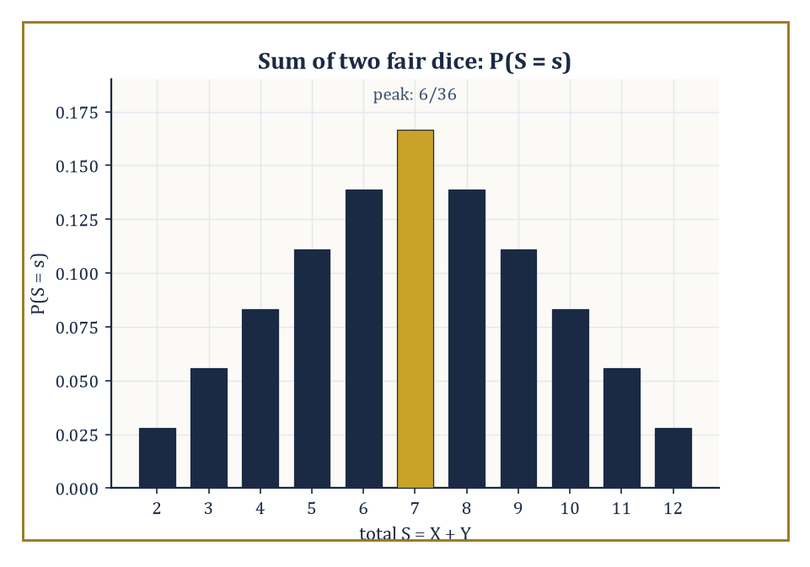
Figure 42.1 — The probability mass function of the sum of two fair dice — a tent pitched squarely on 7, as thirty-six equally likely outcomes demand.
P(Ω) = 1
An event’s probability is its measure. This is the entire metaphysical commitment of the subject: uncertainty is mass, and mass of one unit is spread across all the ways the world might turn out.
Numeric example — a single fair die. Let Ω = {1, 2, 3, 4, 5, 6}, one outcome per face. Take ℱ to be every subset of Ω (sixty-four of them, including the empty set and Ω itself — with a finite Ω you never need to be fussy about which sets are ‘measurable’). Define the probability of each subset A as follows.
P(A) = |A|/6
Check the budget.
P(Ω) = 6/6 = 1
as required. The event ‘the roll is even’ is A = {2, 4, 6}, which has probability:
P(A) = 3/6 = 1/2
The event ‘the roll exceeds 4’ is B = {5, 6}, which has probability:
P(B) = 2/6 = 1/3
Nothing here is deep, but it is worth seeing the formalism close its jaws on something this simple before we ask it to bite into anything harder.
Try it now — For one fair die, what is P(the roll is prime)? Answer →
A random variable is not, despite the name, random or a variable in any sense a first-year algebra course would recognize — it is a measurable function X: Ω → ℝ, a rule that reads off a number from each outcome. Measurability just means that for every real number x, the following set is an event in ℱ.
{ω : X(ω) ≤ x} ∈ ℱ
so that we are always permitted to ask for the probability that X falls below some threshold. The distribution of X is the push-forward of P along X: a new measure on ℝ that records how the original mass of one lands once you view it through X’s eyes. If X takes finitely or countably many values, the distribution is described by a probability mass function; if it takes a continuum of values smoothly, by a density. The cumulative distribution function is defined as follows.
F(x) = P(X ≤ x)
This is the universal translator that describes discrete, continuous, and even hybrid distributions in one formula, which is why it is the object probabilists reach for first and abandon last.
Numeric example — the sum of two dice. Roll two fair dice and let S = X + Y, the total. There are 36 equally likely ordered outcomes, each with probability 1/36. Counting the ways to make each total gives the probability mass function.
P(S=2)=1/36, P(S=3)=2/36, P(S=4)=3/36, P(S=5)=4/36, P(S=6)=5/36, P(S=7)=6/36, P(S=8)=5/36, P(S=9)=4/36, P(S=10)=3/36, P(S=11)=2/36, P(S=12)=1/36
This is a little tent shape peaking at 7, and the skeptical reader is invited to check that these eleven numbers sum to 36/36 = 1. The cumulative distribution function at 7 is:
F(7) = P(S≤7) = (1+2+3+4+5+6)/36 = 21/36 = 7/12 ≈ 0.583
This means that in slightly under three rolls out of five, two dice will total 7 or less. Compare a continuous cousin: if U is uniform on [0,1], its density and CDF on that interval are simple.
f(u) = 1, F(u) = u
so that:
P(0.2 < U ≤ 0.7) = F(0.7) − F(0.2) = 0.5
exactly — no counting required, because the mass is spread evenly rather than lumped at integers.
When several random variables live on the same sample space, their joint distribution is a measure on the product space of their possible values — a full account of how they behave together, not merely separately. From the joint distribution you can always recover each variable’s marginal distribution (its behavior ignoring the others, obtained by summing or integrating the joint over the variables you don’t care about) and its conditional distributions (its behavior once you’ve been told the value of the others). Independence is the special case in which conditioning teaches you nothing: the joint measure factors as a product of the marginals.
P(X∈A, Y∈B) = P(X∈A)·P(Y∈B) for all events A and B
It is the mathematical way of saying that two pieces of information have nothing to do with each other, a state of affairs statisticians spend a suspicious amount of energy both assuming and then testing for.
Numeric example — checking independence directly. In the two-dice setup, let X be the first die and Y the second. Their joint distribution assigns probability 1/36 to each pair (i,j) with i,j ∈ {1,...,6}. The marginal of X is found by summing over all six values of Y for a fixed X=3.
P(X=3) = 6/36 = 1/6
and likewise P(Y=5) = 1/6. The joint probability is:
P(X=3, Y=5) = 1/36
and indeed the product rule holds precisely.
(1/6)×(1/6) = 1/36
confirming what physical common sense already told you: one die has no idea what the other one is doing. Contrast this with S = X+Y and X itself.
P(X=3, S=7) = P(X=3, Y=4) = 1/36
P(X=3)·P(S=7) = (1/6)(6/36) = 1/36
as well here — no contradiction yet, and checking a second case finds another exact match.
P(X=6,S=7)=1/36 against P(X=6)P(S=7)=(1/6)(1/6)=1/36
a quirk of the value 7 specifically (every X-value pairs with exactly one Y to make S=7, so X is, unusually, independent of the single event ‘S=7’). The dependence is not hiding, though: try P(X=1,S=2) against P(X=1)P(S=2).
P(X=1,S=2)=1/36 vs. P(X=1)P(S=2)=(1/6)(1/36)=1/216
wildly unequal, so X and S are dependent overall, exactly as it should be, since S is built out of X.
Keep only this · Section 42.1: Probability Spaces and Random Variables
The idea. Probability is measure with total mass one: a sample space, a σ-algebra of events you may ask about, and a probability for each event.
Core.
(Ω, ℱ, P), P(Ω) = 1, P(⋃ Aᵢ) = Σ P(Aᵢ) for disjoint Aᵢ
distribution of X: P(X ∈ B) = P(X⁻¹(B))
Typical mistake. Assigning probability by counting when outcomes are not equally likely. Counting works for a fair die, not for a dartboard or a loaded coin.
Minimal example. Two dice: 36 equally likely pairs, P(sum = 7) = 6/36 = 1/6.
Practice. Easy to challenge; full worked answers, with the usual mistake, are in Answers to the Practice Sets at the back.
Easy — Two fair dice: what is P(sum = 7)? Answer →
Medium — Two fair dice: what is P(sum ≥ 10)? Answer →
Challenge — On a die, let ℱ = {∅, {1, 2}, {3, 4, 5, 6}, Ω}. Show that ℱ is a σ-algebra, and that X = 1 if the roll is even, 0 otherwise, is not a random variable with respect to ℱ. Answer →

Section 42.2: Expectation, Variance, and Conditioning
Averages, spreads, and the art of updating your beliefs when someone tells you something
Chapter 42: intuition and computation. Conditioning on a σ-algebra, not just on an event, is in Conditional Expectation.
Begin with something you can already do. Five test scores, 6, 7, 7, 8 and 9: add them and divide by five, and the average is 37/5 = 7.4. You have been finding averages like that since school, and the recipe never changes: total, then share out.
Now ask for the average roll of a fair die. The recipe has nothing to add up. The die has not been rolled yet, and the question is not about any particular list of rolls. It is about the die itself, about every roll it might ever produce. A list of a hundred rolls gives one answer, and the next hundred give a slightly different one.
So change the question. Not ‘what is the average of these numbers’, but ‘what average does this random thing carry, before anything has happened’?
The difficulty is that the honest list is infinitely long. You would have to roll for ever, and you cannot add up a list that never ends.
The way round it is to stop listing rolls and list chances instead. Over a long run each face turns up about one time in six, so its share of the total is about one sixth. Weight each value by its probability and add:
(1 + 2 + 3 + 4 + 5 + 6) × 1/6 = 21/6 = 3.5
Notice something the answer never does: it never turns up. No roll of a die is 3.5. The average is a balance point for the whole distribution, not a value you should expect to see. The weighting also handles unfair dice, which plain averaging of faces cannot. Load a die so that a six comes up half the time and each other face one time in ten, and the weighted sum is (1 + 2 + 3 + 4 + 5)/10 + 6/2 = 1.5 + 3 = 4.5.
Spread can be measured the same way. For the fair die, the squared distances of the six faces from 3.5 are 6.25, 2.25, 0.25, 0.25, 2.25 and 6.25. Each has probability 1/6, so their weighted average is 17.5/6 = 35/12.
The weighted average is the expectation, E[X], and the weighted average squared distance from it is the variance. Nothing more alarming is going on. The formal version replaces the sum by an integral, so that it works for a dart landing anywhere on a board as well as for a die, and the first worked example below gets 3.5 and 35/12 again by a different route.
Expectation is integration against the probability measure.
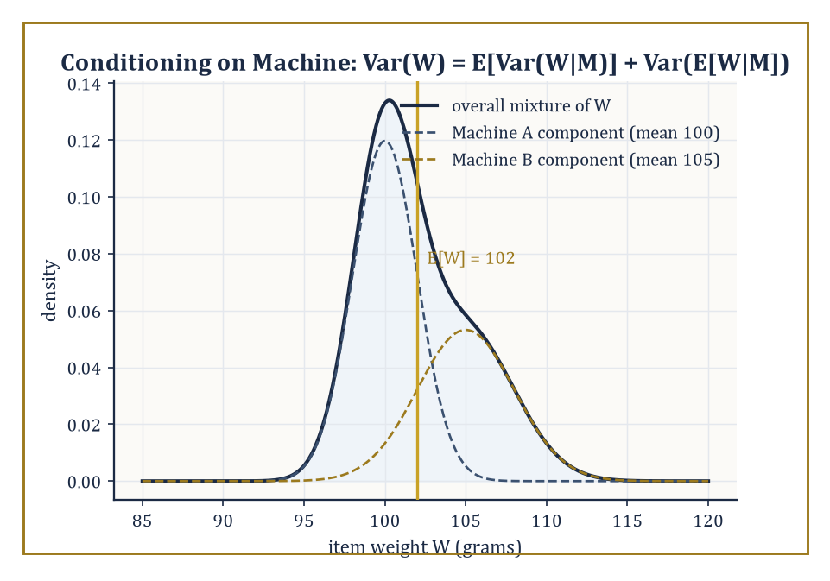
Figure 42.2 — The two machine-conditional weight distributions blend into the overall mixture — the law of total variance is this picture, quantified.
E[X] = ∫ X dP
which for a discrete variable collapses to the familiar sum.
E[X] = Σ x·P(X=x)
It inherits linearity from the Lebesgue integral for free and without needing independence.
E[X+Y] = E[X] + E[Y]
always, whether or not X and Y have ever heard of each other, which surprises almost everyone the first time they see it proved. Positivity and the monotone and dominated convergence theorems likewise transfer over unchanged; expectation is Lebesgue integration wearing a probabilist’s hat. Variance measures how far a variable typically strays from its own average.
Var(X) = E[(X−E[X])²]
and covariance measures the extent to which two variables stray together rather than independently.
Cov(X,Y) = E[(X−E[X])(Y−E[Y])]
Numeric example — mean and variance of a die. For a fair die, the mean is:
E[X] = (1+2+3+4+5+6)/6 = 21/6 = 3.5
To get the variance, first compute E[X²].
E[X²] = (1²+2²+3²+4²+5²+6²)/6 = (1+4+9+16+25+36)/6 = 91/6 ≈ 15.1667
Then:
Var(X) = E[X²] − (E[X])² = 91/6 − 3.5² = 15.1667 − 12.25 = 2.9167
i.e. precisely 35/12. Now use linearity, which cost us nothing: for S = X+Y, the sum of two independent dice:
E[S] = E[X]+E[Y] = 3.5+3.5 = 7
the peak of the tent shape from the previous section, reassuringly. Because X and Y are independent, variances also add — a fact linearity alone does not give you; you need Cov(X,Y)=0 as well — so:
Var(S) = Var(X)+Var(Y) = 35/12+35/12 = 35/6 ≈ 5.833
Try it now — For a fair die X, find E[2X + 1] and Var(2X + 1), using E[X] = 3.5 and Var(X) = 35/12. Answer →
Conditional expectation is the single most important construction in this section, and arguably in the entire subject. Given a σ-algebra 𝒢 (informally, a record of ‘what you currently know’), E[X∣𝒢] is the 𝒢-measurable random variable that best approximates X in the least-squares sense — literally the orthogonal projection of X onto the subspace of 𝒢-measurable functions inside L². It is a random variable, not a number, because your best guess at X generally depends on which piece of the sample space you’ve landed in. The law of total expectation says that averaging your conditional best-guesses over all the ways 𝒢 could have turned out recovers the unconditional average.
E[X] = E[E[X∣𝒢]]
no information is lost or gained by conditioning and then un-conditioning. The law of total variance splits the total spread of X into an ‘average within-group spread’ term and a ‘spread of the group averages’ term.
Var(X) = E[Var(X∣𝒢)] + Var(E[X∣𝒢])
and is one of the most useful two-line theorems a working statistician owns.
Numeric example — a factory with two machines. A factory’s Machine A produces 60% of its output with a 2% defect rate; Machine B produces the remaining 40% with a 5% defect rate. Let D be the indicator that a randomly chosen item is defective, and let M record which machine made it — this M is exactly the ‘σ-algebra’ of the previous paragraph, dressed in overalls. The law of total expectation gives the overall defect probability.
E[D] = E[E[D∣M]] = P(M=A)·0.02 + P(M=B)·0.05 = 0.6×0.02 + 0.4×0.05 = 0.012 + 0.020 = 0.032
a 3.2% defect rate overall — and E[D∣M] is literally the step function taking the value 0.02 on every item from Machine A and 0.05 on every item from Machine B, which is the L²-projection description: it is the simplest possible function that still respects what you know (the machine) while discarding everything you don’t (which specific item). Now extend to a continuous quantity, item weight W in grams: given Machine A, W has mean 100 and variance 4; given Machine B, mean 105 and variance 9. The law of total variance gives:
Var(W) = E[Var(W∣M)] + Var(E[W∣M])
The first term is:
E[Var(W∣M)] = 0.6×4 + 0.4×9 = 2.4+3.6 = 6.0
For the second term, E[W∣M] equals 100 with probability 0.6 and 105 with probability 0.4, so:
E[E[W∣M]] = 0.6×100+0.4×105 = 60+42 = 102
and:
Var(E[W∣M]) = 0.6×100² + 0.4×105² − 102² = 6000 + 4410 − 10404 = 6.0
Total:
Var(W) = 6.0 + 6.0 = 12.0
a suspiciously tidy number, included here purely because it is more satisfying to check arithmetic that comes out clean.
Generating functions repackage a whole distribution as a single function chosen so that a difficult operation on random variables — convolution, the way the distribution of a sum is built from the distributions of the parts — becomes easy multiplication of functions. The probability generating function of a variable X taking non-negative integer values is:
G(s) = E[s^X]
the characteristic function does the same job for arbitrary real-valued variables and always exists, which is its chief virtue over the more fragile moment generating function.
φ(t) = E[exp(itX)]
If X and Y are independent, the generating function of X+Y is:
G_(X+Y)(s) = G_X(s)·G_Y(s)
the messy sum-over-all-ways-to-make-a-total calculation from the two-dice example becomes ordinary polynomial multiplication.
Worked example — recovering the dice-sum probabilities by multiplication. A single fair die has probability generating function:
G(s) = (s+s²+s³+s⁴+s⁵+s⁶)/6 = s(1+s+s²+s³+s⁴+s⁵)/6
For two independent dice, the PGF of the sum S is:
G(s)² = s²(1+s+s²+s³+s⁴+s⁵)²/36
Expand (1+s+s²+s³+s⁴+s⁵)² just far enough to check one coefficient: the s⁵ term (which, multiplied by the leading s², gives the coefficient of s⁷ in G(s)², matching P(S=7)) arises from pairs of exponents (0,5),(1,4),(2,3),(3,2),(4,1),(5,0) in the product — six pairs, each contributing coefficient 1×1, so the s⁵ coefficient is 6. Hence the s⁷ coefficient of G(s)² is:
6/36 = 1/6
matching P(S=7) = 6/36 computed by brute-force counting in Probability Spaces and Random Variables. The generating function did not know it was rolling dice; it multiplied two polynomials and produced the right answer anyway, which is either reassuring or slightly eerie, depending on how much sleep you’ve had.
Keep only this · Section 42.2: Expectation, Variance, and Conditioning
The idea. Expectation is a probability-weighted average, variance is the average squared distance from it, and conditioning recomputes both once you are told something.
Core.
E[X] = Σ x P(X = x), Var(X) = E[X²] − (E[X])²
P(A | B) = P(A ∩ B)/P(B), P(A | B) = P(B | A) P(A)/P(B)
Typical mistake. Confusing P(A | B) with P(B | A). The chance a defective item came from Machine B is not the defect rate of Machine B.
Minimal example. Fair die: E = 3.5, E[X²] = 91/6, Var = 91/6 − 49/4 = 35/12.
Practice. Easy to challenge; full worked answers, with the usual mistake, are in Answers to the Practice Sets at the back.
Easy — Machine A makes 60% of output with 2% defects, Machine B 40% with 5% defects. What fraction of all output is defective? Answer →
Medium — Given that an item is defective, what is the probability it came from Machine A? Answer →
Challenge — Prove Var(X) = E[X²] − (E[X])² and check it on a fair die. Answer →

Section 42.3: Independence and Classical Limit Theorems
Why averaging things makes chaos behave, eventually, mostly
Chapter 42: intuition and computation. Independence of σ-algebras and infinite product spaces are in Independence, Product Spaces, and Kolmogorov’s Extension; the strong law with a proof is in Convergence Theorems and the Strong Law.
Independence extends naturally from events to whole σ-algebras: two σ-algebras 𝒢 and ℋ are independent if every event in 𝒢 is independent of every event in ℋ, and a sequence of random variables is independent if the σ-algebras they generate are jointly independent.
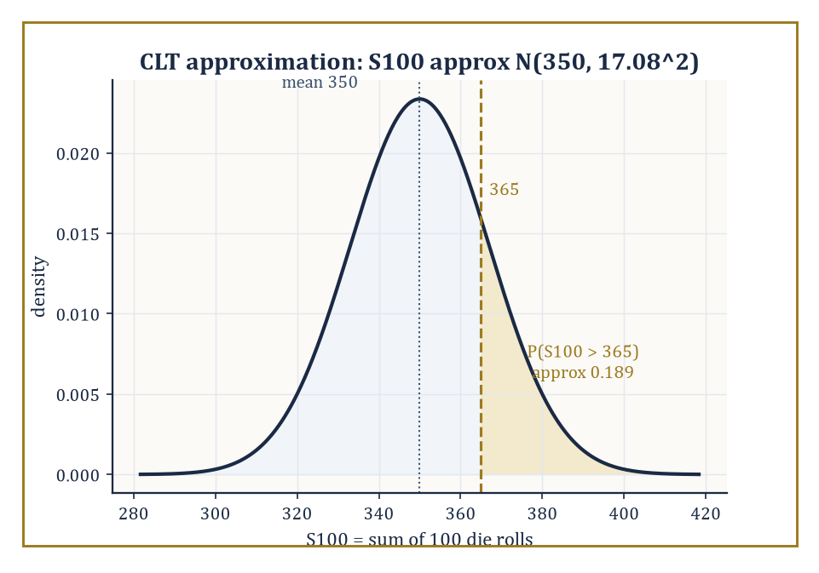
Figure 42.3 — The CLT’s Gaussian stand-in for the sum of 100 dice, with the tail P(S100 > 365) shaded in gold.
A sequence that is both independent and identically distributed — i.i.d., the two most-abused initials in the subject — is the setting for the two theorems that make classical statistics possible at all. The law of large numbers (LLN) says that the sample average of n i.i.d. variables with finite mean μ converges to μ as n grows — informally, that random noise averages itself away.
The central limit theorem (CLT) says something sharper and stranger: rescale the deviation of that average from μ by √n and, regardless of the shape of the original distribution — lumpy, skewed, bimodal, whatever — the rescaled deviation converges in distribution to a Gaussian. Chaos, viewed through the correct rescaling, turns out to have a fixed, universal shape.
Numeric example — the law of large numbers as shrinking variance. For the fair die, Var(X) = 35/12 ≈ 2.9167 (Expectation, Variance, and Conditioning). The sample mean of n independent rolls has the following variance, since averaging n independent copies divides the variance by n — a direct consequence of Var(X+Y)=Var(X)+Var(Y) for independent variables, plus the scaling rule Var(cX)=c²Var(X).
Var(X̄ₙ) = Var(X)/n
At n=10:
Var(X̄₁₀) = 2.9167/10 = 0.2917, standard deviation ≈ 0.540
a typical run of ten rolls might plausibly average anywhere from about 3.0 to 4.0. At n=1000:
Var(X̄₁₀₀₀) = 2.9167/1000 = 0.0029, standard deviation ≈ 0.054
now the average is essentially pinned to 3.5 ± 0.11 or so. This is the LLN made visible without needing to roll a thousand dice: the theoretical spread of the sample mean shrinks like 1/√n, squeezing the average toward the true mean of 3.5 as n grows, as advertised, and entirely mechanically.
Try it now — What are the variance and standard deviation of the average of 100 fair-die rolls? Answer →
Numeric example — the CLT approximating a dice-sum tail probability. Let S₁₀₀ be the sum of 100 independent fair-die rolls. By linearity:
E[S₁₀₀] = 100×3.5 = 350
and by independence:
Var(S₁₀₀) = 100×(35/12) = 291.67, standard deviation = √291.67 ≈ 17.08
The exact distribution of S₁₀₀ is a nightmare of a sum over an enormous number of dice-outcome combinations; the CLT lets us skip it wholly by approximating:
S₁₀₀ ≈ N(350, 17.08²)
To estimate P(S₁₀₀ > 365), standardize:
z = (365−350)/17.08 = 15/17.08 ≈ 0.88
and read off the standard normal tail Φ(0.88) ≈ 0.8106, giving:
P(S₁₀₀ > 365) ≈ 1 − 0.8106 = 0.1894
or about 19%. The honest reader should note this is an approximation — the true sum is discrete and bounded between 100 and 600 — but for n this large the approximation is excellent, which is the CLT’s promise and precisely why it underwrites so much of classical statistics: sums and averages of almost anything look Gaussian once you have enough of them.
There is more than one way for a sequence of random variables to ‘converge’, and the differences matter. Convergence in probability means that for every ε>0, the following holds.
P(|Xₙ−X|>ε) → 0
the variable is eventually almost certainly close to its limit, though it may occasionally misbehave. Almost-sure convergence is stronger: it says that, with probability one, the entire sequence of outcomes (not just the probability of a single deviation) settles down and stays close to the limit forever after some point. Convergence in distribution is weaker still — only the distributions need to converge, not the variables themselves, which may not even live on a comparable sample space.
The implications run as follows, and none of the reverse implications hold in general — a fact best appreciated through a genuine counterexample rather than taken on faith.
a.s. ⇒ in probability ⇒ in distribution
Abstract example — convergence in probability without almost-sure convergence. Let U be uniform on [0,1]. Enumerate the sequence of intervals I₁=[0,1], I₂=[0,½], I₃=[½,1], I₄=[0,⅓], I₅=[⅓,⅔], I₆=[⅔,1], and so on: at ‘level k’ the interval [0,1] is chopped into 2ᵏ equal pieces, and the pieces are listed in order, one after another — the classic ‘typewriter sequence’. Define Xₙ = 1 if U falls in the n-th interval on this list, and 0 otherwise.
Since the n-th interval at level k has length 1/2ᵏ, and level k is reached once n exceeds roughly 2ᵏ, we get the following.
P(Xₙ=1) = 1/2ᵏ → 0 as n→∞
so Xₙ → 0 in probability: the chance of a false alarm shrinks to nothing. But almost-sure convergence fails completely: because every level’s intervals tile the whole of [0,1], every single point U=u lies in exactly one interval at each level k, meaning Xₙ(u)=1 for infinitely many n, no matter which u you picked. So for every outcome, the sequence Xₙ(u) equals 1 infinitely often and never settles down — it does not converge to 0, or to anything, at any single point. Convergence in probability tolerates this kind of persistent, shrinking, but never-vanishing misbehavior; almost-sure convergence does not.
Two workhorse theorems let us transfer limiting behavior through further computation without redoing the analysis from scratch. The continuous mapping theorem says that if Xₙ converges (in any of the above senses) to X, and g is a continuous function, then g(Xₙ) converges to g(X) in the same sense — limits pass through continuous transformations for free.
Slutsky’s theorem handles the common situation where you have one sequence converging in distribution and a second converging in probability to a constant: if Xₙ→ᵈ X and Yₙ→ᵖ c, then the following both hold.
Xₙ+Yₙ →ᵈ X+c and Xₙ·Yₙ →ᵈ cX
This innocuous-looking pair of results is what justifies, among other things, replacing an unknown standard deviation by its sample estimate inside a test statistic and still trusting the resulting distribution — the very trick that makes the t-statistic of Hypothesis Testing legitimate.
Abstract example — why Slutsky legitimizes the t-statistic. Suppose the following holds by the CLT, where σ is the true (unknown) standard deviation.
√n(X̄ₙ−μ)/σ →ᵈ N(0,1)
In practice we don’t know σ, so we substitute the sample standard deviation Sₙ, which by the law of large numbers satisfies the following — a consistency fact, not a distributional one, since it converges to a constant.
Sₙ →ᵖ σ
Write the statistic as a product of two brackets.
√n(X̄ₙ−μ)/Sₙ = [√n(X̄ₙ−μ)/σ] × [σ/Sₙ]
The first bracket converges in distribution to N(0,1); the second converges in probability to the constant 1 (since Sₙ→ᵖσ). Slutsky’s theorem then licenses multiplying these together and concludes the following as well.
√n(X̄ₙ−μ)/Sₙ →ᵈ N(0,1)
the swap of the true σ for the estimated Sₙ costs nothing in the limit. This one abstract move, entirely mechanical once you trust the theorem, is what allows every introductory-statistics t-test to pretend it knows the population standard deviation when it manifestly does not.
Keep only this · Section 42.3: Independence and Classical Limit Theorems
The idea. Averages of many independent copies settle at the mean (law of large numbers), and their fluctuations around it are approximately normal with width σ/√n (central limit theorem).
Core.
Var(X̄ₙ) = σ²/n
(X̄ₙ − μ)/(σ/√n) → N(0, 1) in distribution
Typical mistake. Expecting the sum of rolls to get closer to its mean. The average does; the sum’s spread grows like √n.
Minimal example. 100 rolls: the sum has mean 350 and SD √(100 × 35/12) ≈ 17.1.
Practice. Easy to challenge; full worked answers, with the usual mistake, are in Answers to the Practice Sets at the back.
Easy — Use Chebyshev to bound P(|X̄ − 3.5| ≥ 0.5) for 100 rolls. Answer →
Medium — Use the CLT to estimate P(S₁₀₀ ≥ 380) for the sum of 100 die rolls. Answer →
Challenge — In the moving-interval (“typewriter”) sequence Xₙ = indicator of Iₙ on [0, 1], show that P(Xₙ ≠ 0) → 0 but that Xₙ(ω) = 1 for infinitely many n, for every ω. Answer →

Section 42.4: Parametric Models and Likelihood
Turning the model around and asking which parameter it likes best
A parametric model is a family of distributions {P_θ : θ ∈ Θ} indexed by a finite-dimensional parameter θ, ranging over some parameter space Θ — a Bernoulli(p) model indexed by p ∈ [0,1], say, or a Normal(μ,σ²) model indexed by (μ,σ²) ∈ ℝ×(0,∞).
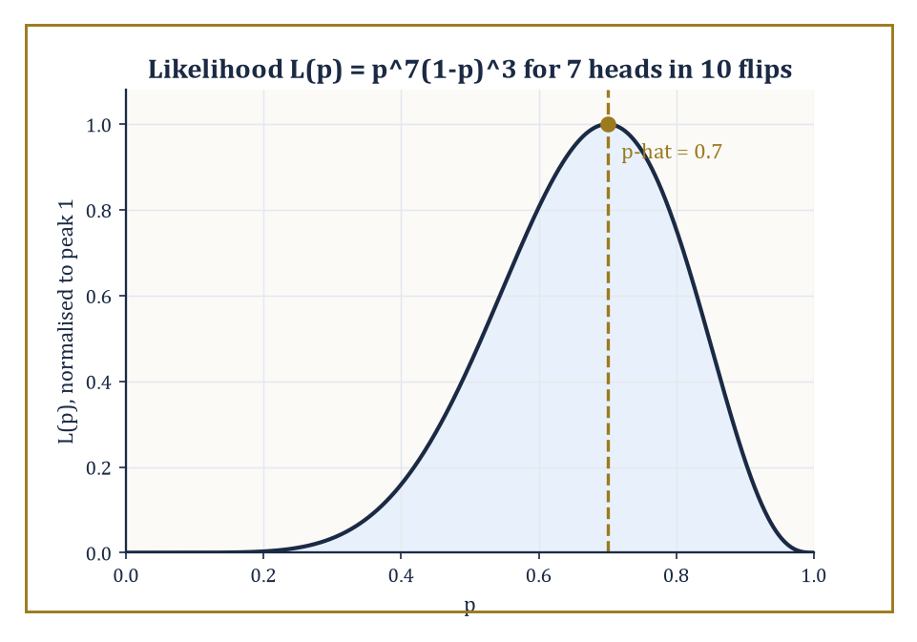
Figure 42.4 — The likelihood curve for 7 heads in 10 flips, peaking obediently at p-hat = 0.7.
The likelihood function performs a small act of conceptual jujitsu: it takes the same density or mass function f(x;θ) used to compute probabilities of data given a parameter, and, once the data x are fixed at their observed values, reinterprets it as a function of θ instead.
L(θ) = f(x;θ)
The maximum-likelihood estimator (MLE), θ̂, is whichever value of θ makes the observed data look as probable as possible.
Under mild regularity conditions the MLE is consistent (it converges to the true θ as sample size grows), asymptotically normal (its sampling distribution becomes Gaussian for large samples, courtesy of the CLT machinery of the previous section), and asymptotically efficient (no competing consistent estimator can beat its large-sample variance).
Numeric example — MLE for a coin. Flip a coin 10 times and observe 7 heads. Modeling each flip as Bernoulli(p), the likelihood of this data is the following (seven factors of p for the heads, three of (1−p) for the tails; the binomial coefficient C(10,7) is a constant that doesn’t affect where the maximum sits, so it’s usually dropped).
L(p) = p⁷(1−p)³
It’s easier to maximize the log-likelihood.
ℓ(p) = 7 ln p + 3 ln(1−p)
Differentiating and setting to zero:
ℓ′(p) = 7/p − 3/(1−p) = 0
so 7(1−p) = 3p, giving 7 − 7p = 3p, hence 7 = 10p, so:
p̂ = 0.7
the sample proportion of heads, as the theory predicts for a Bernoulli model.
Try it now — A coin gives 12 heads in 20 flips. What is the maximum-likelihood estimate of p? Answer →
The Fisher information I(θ) measures how sharply the log-likelihood curves near the true parameter — a sharp, narrow peak means the data pin θ down tightly; a broad, flat peak means the data are nearly indifferent to θ. Formally, it is the expected curvature of the log-likelihood.
I(θ) = E[−∂²/∂θ² ln f(X;θ)]
The Cramér–Rao bound then states that no unbiased estimator of θ can have variance smaller than the following.
Var(θ̂) ≥ 1/I(θ)
The information sets a hard floor under how precisely you are ever allowed to know the parameter, however cleverly you build your estimator. An estimator that actually achieves this chapter is called efficient.
Numeric example — the Cramér–Rao bound for the coin. For a single Bernoulli(p) observation, one can show the Fisher information is 1/(p(1−p)); for n independent flips it is:
Iₙ(p) = n/(p(1−p))
With n=10 and p=0.7:
p(1−p) = 0.7×0.3 = 0.21, I₁₀(0.7) = 10/0.21 ≈ 47.62
The Cramér–Rao bound is then:
Var(p̂) ≥ 1/I₁₀(0.7) = 0.21/10 = 0.021
Compare this to the actual variance of the sample proportion, a standard fact about Bernoulli trials.
Var(p̂) = p(1−p)/n = 0.21/10 = 0.021
the two numbers coincide exactly. The sample proportion doesn’t just satisfy the Cramér–Rao bound; it sits on it, meaning it wastes not one drop of the information the data contain. Few estimators in this life are so honestly efficient; treasure this one while you can.
Exponential families are the distributions whose density can be written in the following form, for some functions h, η, T, A.
f(x;θ) = h(x)·exp(η(θ)·T(x) − A(θ))
A rather forbidding formula that buys a remarkably clean payoff: the log-likelihood is linear in the statistic T(x), meaning that however large your sample, all the information relevant to estimating θ compresses losslessly into the single (or finite-dimensional) quantity T(x), called a sufficient statistic.
The Bernoulli, Poisson, exponential, normal, and gamma families are all exponential families, which is why maximum-likelihood estimation for them so often reduces to computing one simple summary of the data — a sample mean, a sample proportion, a sum — rather than requiring the entire dataset to be retained.
Numeric example — sufficiency and MLE for a Poisson model. Suppose five independent counts are observed from a Poisson(λ) model: x = (2, 4, 3, 5, 1). The Poisson family is exponential with sufficient statistic T(x) = Σxᵢ, so the entire dataset compresses to a single number.
Σxᵢ = 2+4+3+5+1 = 15
The log-likelihood, with n=5, is:
ℓ(λ) = Σ(−λ + xᵢ ln λ − ln xᵢ!) = −nλ + (Σxᵢ) ln λ + constant
Setting ℓ′(λ) = −n + (Σxᵢ)/λ = 0 gives:
λ̂ = (Σxᵢ)/n = 15/5 = 3
the sample mean, just as sufficiency predicted — the individual values 2, 4, 3, 5, 1 were never needed beyond their sum. The Fisher information for a single Poisson observation is 1/λ, so for n=5 at λ=3:
I₅(3) = 5/3 ≈ 1.667
giving a Cramér–Rao bound of:
1/I₅(3) = 3/5 = 0.6
And since Var(Xᵢ)=λ for a Poisson variable, the true variance of the sample mean is:
Var(λ̂) = λ/n = 3/5 = 0.6
the bound is met again. Two for two: both the Bernoulli and Poisson MLEs turn out to be efficient, though the reader should be warned this happy coincidence is a feature of exponential families specifically, not a universal law of the mathematical universe.
That phrase ‘under mild regularity conditions’ has been doing a great deal of quiet work throughout this section, and it is worth showing what happens when the conditions are withdrawn. Regularity essentially demands that the support of the model — the set of x-values that have positive probability — does not itself depend on θ, so that the likelihood is smooth in θ everywhere it matters.
When the support does depend on the parameter, both the Cramér–Rao bound and the usual √n-rate asymptotic normality can fail outright, and the MLE can behave in a completely different, and often better, way.
Numeric example — a non-regular model, Uniform(0,θ). Let X₁,…,Xₙ be i.i.d. Uniform(0,θ), so the density is f(x;θ)=1/θ for 0≤x≤θ and 0 otherwise — the support [0,θ] depends on θ itself, immediately breaking the regularity assumption.
The likelihood is L(θ)=1/θⁿ for θ ≥ max(x₁,…,xₙ), and 0 for any smaller θ, since a smaller θ would make some observed xᵢ impossible. Because 1/θⁿ is decreasing in θ, the likelihood is maximized by taking θ as small as the data will allow, giving the MLE:
θ̂ = max(X₁,…,Xₙ)
Take a concrete sample of n=5 draws from a true θ=10: x = (3.1, 7.8, 9.6, 2.4, 6.0). The MLE is:
θ̂ = max(x) = 9.6
a perfectly sensible-looking estimate, but a biased one: one can show that:
E[max(X₁,…,Xₙ)] = (n/(n+1))θ
so here:
E[θ̂] = (5/6)×10 ≈ 8.333, bias = 8.333−10 = −1.667
Worse (or rather, more interestingly) for the asymptotics: because the maximum of n uniforms converges to θ at rate n rather than the usual √n, the estimator’s error shrinks far faster than regularity theory promises, and its limiting distribution is exponential, not Gaussian. The MLE recipe still hands you an answer here — it refuses to obey the standard-issue asymptotic normality and Cramér–Rao machinery this section otherwise leans on so heavily, a useful reminder to check the fine print before trusting a general theorem.
Bridge: from optimization to model selection
Maximum likelihood is an optimization problem: find the θ that maximizes log L(θ). Everything Optimization (Volume 3) taught about first-order conditions and convexity applies. Model selection, in Linear Models and Regression and Validation, Falsification, and Model Selection, adds one more question the optimizer cannot answer: a model with more parameters always fits at least as well, so how much better must it fit to earn them? AIC answers by charging two units of −2 log L per parameter.
Keep only this · Section 42.4: Parametric Models and Likelihood
The idea. Likelihood treats the data as fixed and the parameter as variable; the maximum-likelihood estimate is the parameter value that makes the observed data most probable.
Core.
L(θ) = Π f(xᵢ; θ), θ̂ = argmax log L(θ)
Cramér–Rao: Var(θ̂) ≥ 1/I(θ), I(p) = n/(p(1 − p)) for n coin flips
Typical mistake. Reading the likelihood as the probability that θ is true. It is the probability of the data given θ, not of θ given the data.
Minimal example. 7 heads in 10: p̂ = 0.7.
Practice. Easy to challenge; full worked answers, with the usual mistake, are in Answers to the Practice Sets at the back.
Easy — Three Poisson counts are 3, 1 and 2. What is the MLE of λ? Answer →
Medium — For n = 100 flips with p = 0.5, what is the Cramér–Rao lower bound on the standard deviation of an unbiased estimator of p? Answer →
Challenge — For Uniform(0, θ) with data 2.1, 4.7 and 3.3, find the MLE, and explain why it is biased. Answer →

Section 42.5: Estimation and Confidence Intervals
How wrong you’re willing to admit you might be, quantified
An opinion poll that reports 52 per cent support, plus or minus 3, is doing two jobs: giving a best guess and admitting how wrong it might be. Estimation theory makes both jobs precise. A good estimate should aim at the right target on average, should not wobble too much from one sample to the next, and should improve as the sample grows. The confidence interval packages the uncertainty. A 95 per cent interval comes from a procedure that captures the true value in 95 of every 100 samples, which is a statement about the method rather than a promise about any one interval, a distinction that trips up even professional researchers.
A point estimator is judged by three related quantities. Its bias measures systematic error — does it aim at the right target on average?
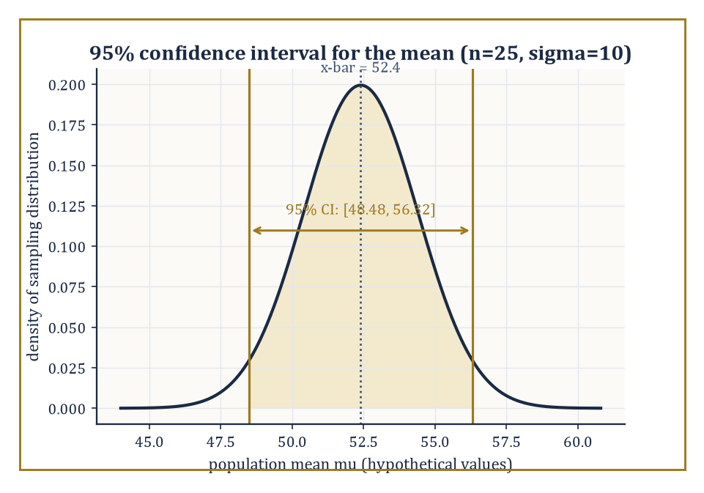
Figure 42.5 — The sampling distribution behind a 95% confidence interval — a statement about the manufacturing process, not about this one interval.
Bias(θ̂) = E[θ̂] − θ
Its variance measures how much it wobbles from sample to sample around wherever it is aiming. And its mean squared error combines both into a single number, via a short algebraic identity worth memorizing.
MSE(θ̂) = E[(θ̂−θ)²] = Var(θ̂) + Bias(θ̂)²
An estimator can trade a little bias for a large reduction in variance and come out ahead on MSE, which is the philosophical justification behind an enormous amount of modern regularized statistics and machine learning.
Numeric example — the bias of the maximum-likelihood variance estimator. Given n i.i.d. observations with true variance σ², the maximum-likelihood estimator of variance is:
S²_MLE = (1/n)Σ(Xᵢ−X̄)²
which has expectation — a standard, if slightly fiddly, calculation traceable to the fact that X̄ itself is estimated from the same data, using up one degree of freedom.
E[S²_MLE] = ((n−1)/n)σ²
Take n=5 and suppose the true variance is σ²=16. Then:
E[S²_MLE] = (4/5)×16 = 12.8, bias = 12.8 − 16 = −3.2
the MLE systematically underestimates the variance by 3.2 on average, for this sample size. This is why the ‘unbiased’ sample variance divides by n−1 rather than n — it corrects this deficit, at the cost of being (very slightly) less efficient in mean-squared-error terms for some models. Nobody said this subject would stop making you choose between two imperfect options.
Try it now — With n = 5 observations of true variance σ² = 10, what is the expected value of the maximum-likelihood variance estimator (dividing by n)? Answer →
Bias and variance are only the ingredients; how they get combined into a verdict depends on a loss function chosen up front, and different loss functions can crown different estimators as ‘best’.
Squared-error loss is minimized in expectation by the mean, and its associated risk is exactly the MSE already discussed.
(θ̂−θ)²
Absolute-error loss is instead minimized by the median, which cares only about which side of the truth an estimate falls on, not by how far — a property that makes median-based estimators far more forgiving of the occasional wild outlier.
|θ̂−θ|
Numeric example — mean versus median under an outlier. Consider the small dataset {1, 2, 2, 3, 50} — four ordinary-looking measurements and one that looks like a typo or a genuine rare event. The sample mean is:
(1+2+2+3+50)/5 = 58/5 = 11.6
dragged far from where four of the five points sit, because squared-error loss punishes the single large deviation so heavily that the estimator is forced to chase it.
(50−11.6)² = 1474.56
The sample median, sorting to (1,2,2,3,50) and taking the middle value, is 2 — untouched by the outlier’s exact magnitude, since absolute-error loss only ‘sees’ that 50 is on the high side, not how astronomically high. Neither estimator is objectively correct; which one is ‘best’ depends entirely on whether the loss function governing the decision penalizes large errors quadratically (squared-error, favoring the mean) or merely linearly (absolute-error, favoring the median) — a choice statistics cannot make for you, only illuminate the consequences of.
An interval estimator attaches an honest admission of uncertainty to a point estimate. A 95% confidence interval is constructed by a procedure that, applied to repeated independent samples, would contain the true (fixed, non-random) parameter in 95% of those repetitions — a statement about the reliability of the procedure across hypothetical repeated sampling, not a probability statement about the one interval you happen to be holding, however much everyone (including, on a bad day, the author) is tempted to say the latter.
For many exponential-family models exact intervals are available in closed form; more generally, one leans on the CLT-driven asymptotic normality of the MLE from Parametric Models and Likelihood to build an approximate interval, where SE is the estimated standard error and z is a quantile of the standard normal (1.96 for 95% coverage, since Φ(1.96)≈0.975 leaves 2.5% in each tail).
θ̂ ± z·SE(θ̂)
Numeric example — a confidence interval for a mean. Suppose a sample of n=25 measurements has sample mean X̄=52.4, and the population standard deviation is known to be σ=10 (a slightly artificial but pedagogically forgivable assumption). The standard error of the mean is:
SE = σ/√n = 10/5 = 2
A 95% confidence interval is:
X̄ ± 1.96×SE = 52.4 ± 1.96×2 = 52.4 ± 3.92 = [48.48, 56.32]
The correct reading: if this sampling-and-interval-building procedure were repeated many times on fresh samples of size 25, about 95% of the resulting intervals would contain the true population mean. This particular interval either contains the true mean or it does not — the 95% describes the manufacturing process, not this one unit off the line.
When the sampling distribution of an estimator has no clean closed form — which, in the untidy world outside textbook exponential families, is most of the time — the bootstrap offers a computational escape hatch. It approximates the sampling distribution of a statistic by resampling the observed data with replacement, recomputing the statistic on each resample, and using the spread of those recomputed values as a stand-in for the true (unknown) sampling variability.
It costs computation rather than mathematical cleverness, which is why it only became routine once computers became cheap.
Numeric example — bootstrap resampling by hand. Take the tiny dataset {2, 5, 9}, with sample mean:
(2+5+9)/3 = 16/3 ≈ 5.333
A bootstrap resample draws 3 values from {2,5,9} with replacement — so any value may appear zero, one, two, or three times. A few illustrative resamples, drawn to show the mechanics rather than a full simulation, give the following means.
{2,2,9}: (2+2+9)/3 = 13/3 ≈ 4.333
{5,5,5}: mean = 5
{9,9,2}: (9+9+2)/3 = 20/3 ≈ 6.667
and {2,5,9} itself (the original sample, which is one of the 27 equally likely ordered resamples for n=3) recovers the original mean 16/3. Collecting many such resample means — in practice, thousands of them, generated by a computer rather than a patient human — builds up an approximate distribution for the sample mean, from which a bootstrap confidence interval can be read off directly, without ever invoking the CLT or assuming a particular parametric family. The price is that you need a machine and a few thousand repetitions rather than a formula; the reward is that the method barely cares what the underlying distribution is.
Keep only this · Section 42.5: Estimation and Confidence Intervals
The idea. An estimator aims at a parameter; a confidence interval reports a range produced by a procedure that captures the true value a stated fraction of the time.
Core.
95% CI for a mean with known σ: X̄ ± 1.96 σ/√n
S² = (1/(n − 1)) Σ (Xᵢ − X̄)² is unbiased
Typical mistake. Saying the true mean lies in a computed 95% interval with probability 0.95. The 95% describes the procedure, not this interval.
Minimal example. n = 100, X̄ = 52.4, σ = 10: SE = 1, CI = [50.44, 54.36].
Practice. Easy to challenge; full worked answers, with the usual mistake, are in Answers to the Practice Sets at the back.
Easy — Compute that 95% interval: n = 100, X̄ = 52.4, σ = 10. Answer →
Medium — How large must n be for a 95% interval of half-width 1 when σ = 10? Answer →
Challenge — Prove that E[Σ (Xᵢ − X̄)²] = (n − 1)σ² for i.i.d. Xᵢ with variance σ². Answer →

Section 42.6: Hypothesis Testing
Formalized skepticism, with a strict word limit on how wrong you’re allowed to be
A hypothesis test adjudicates between a null hypothesis H₀ (the skeptical default, usually ‘nothing interesting is going on’) and an alternative H₁, using the observed data as evidence.
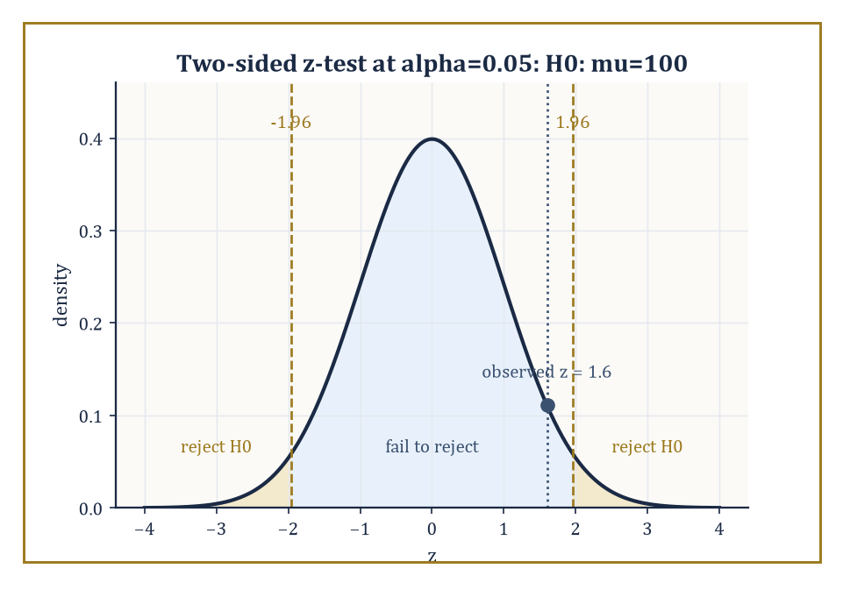
Figure 42.6 — The two-sided z-test’s rejection regions, with the observed z = 1.6 landing safely — if narrowly — inside ‘fail to reject’.
The Neyman–Pearson framework fixes in advance the probability of a Type I error — rejecting H₀ when it is in fact true — at some small level α, called the size of the test (conventionally 0.05, a number chosen by historical accident and defended ever since by force of habit), and then, among all tests with that size, seeks the one with maximal power: the highest probability of correctly rejecting H₀ when the alternative is in fact true.
For composite hypotheses — where H₀ or H₁ specify a whole range of parameter values rather than one exact value — the likelihood-ratio test, which rejects when the likelihood under the best-fitting null parameter is much smaller than under the best-fitting unrestricted parameter, is the generic, essentially always-sensible choice under regularity conditions.
Numeric example — a z-test for a mean. Test H₀: μ=100 against H₁: μ≠100, with known population standard deviation σ=15 and a sample of n=36 giving X̄=104. The test statistic is:
z = (X̄−μ₀)/(σ/√n) = (104−100)/(15/6) = 4/2.5 = 1.6
At significance level α=0.05, the two-sided rejection region is |z|>1.96; since 1.6<1.96, we fail to reject H₀ — the data are not surprising enough under the null to overturn it. The p-value quantifies precisely how unsurprising.
p = 2×P(Z>1.6) = 2×(1−Φ(1.6)) = 2×(1−0.9452) = 2×0.0548 = 0.1096
Since 0.1096 > 0.05, the conclusion matches the rejection-region approach, as it always must — the p-value and the fixed-α test are two descriptions of the same comparison.
Try it now — Test H₀: μ = 100 (σ = 15, n = 36) at α = 0.05 two-sided, if X̄ = 106. Answer →
The p-value is the probability, computed under the null hypothesis, of observing data at least as extreme as what was actually seen.
It is not the probability that the null hypothesis is true, it is not the probability that the result is ‘due to chance’ in some vague philosophical sense, and it does not measure the size or importance of an effect — three misreadings so common and so persistent that entire journal editorial policies have been rewritten to fight them, with only partial success. It is a statement about the data, conditional on the null, full stop.
Power, meanwhile, is the mirror-image quantity: the probability of correctly rejecting H₀ when a specific alternative is true, and it depends on the sample size, the significance level, and how far the true parameter sits from the null value.
Numeric example — computing power against a specific alternative. Continue the previous test (H₀: μ=100, σ=15, n=36, α=0.05, two-sided, so SE=2.5), whose rejection region is the following.
X̄ > 100+1.96×2.5 = 104.9 or X̄ < 100−1.96×2.5 = 95.1
Suppose the true mean is μ=108 — how often would this test catch it? Under the true μ=108, X̄ ~ N(108, 2.5²). The probability of landing in the upper rejection region is:
P(X̄>104.9) = P(Z > (104.9−108)/2.5) = P(Z > −1.24) = Φ(1.24) ≈ 0.8925
using the symmetry Φ(−z)=1−Φ(z). The probability of landing in the lower rejection region, P(X̄<95.1), is astronomically small under a true mean of 108 (over five standard deviations away) and safely ignored. So the power against the alternative μ=108 is approximately 0.8925 — this test would correctly flag the shift about 89% of the time, and miss it, embarrassingly, the other 11%.
Run enough tests and some will reject purely by chance, however true every null hypothesis really is — this is the multiple-testing problem, and ignoring it is one of the most common ways good data becomes a bad paper.
The Bonferroni correction is the crude but reliable fix: to keep the overall (family-wise) probability of at least one false rejection at or below α across m independent tests, run each individual test at level α/m instead of α; the union bound guarantees the total error stays controlled.
The false-discovery-rate approach is a subtler, less conservative alternative, controlling the expected proportion of false rejections among all rejections rather than the probability of any false rejection at all — appropriate when you expect to make some discoveries and can tolerate a controlled fraction of them being wrong, which describes most of genomics and a distressing amount of the social sciences.
Numeric example — the cost of not correcting for multiple tests. Suppose 20 independent hypothesis tests are each run at the nominal level α=0.05, and every single null hypothesis happens to be true (nothing real is going on anywhere). The probability that at least one test rejects anyway is:
1 − (0.95)²⁰
Computing (0.95)²⁰ by repeated squaring:
(0.95)²=0.9025, (0.95)⁴=0.9025²≈0.8145, (0.95)⁸≈0.8145²≈0.6634, (0.95)¹⁶≈0.6634²≈0.4401, (0.95)²⁰=(0.95)¹⁶×(0.95)⁴≈0.4401×0.8145≈0.3585
So the family-wise error rate is approximately:
1−0.3585=0.6415
a 64% chance of at least one spurious ‘significant’ result out of twenty tests on pure noise, despite each individual test looking perfectly respectable at the 5% level. Applying the Bonferroni correction, each test is instead run at α/20 = 0.0025; the union bound then guarantees the family-wise error rate is at most:
20×0.0025=0.05
restoring the 5% guarantee for the collection as a whole, at the cost of making each individual test considerably harder to pass.
Every test considered so far has fixed its sample size n in advance and looked at the data exactly once.
Sequential analysis instead lets the sample size itself be a random, data-driven quantity: after each new observation, a running likelihood ratio is compared against two thresholds, and sampling stops the moment the evidence is decisive enough in either direction — often letting a clear-cut case be settled with far fewer observations than a fixed-n design would have required, which matters enormously when each additional observation is expensive, slow, or (in a clinical trial) ethically fraught.
Numeric example — Wald’s sequential probability ratio test. Test H₀: p=0.5 against H₁: p=0.7 for a stream of coin flips, at Type I error α=0.05 and Type II error β=0.05. Wald’s sequential probability ratio test (SPRT) tracks the cumulative likelihood ratio and stops as soon as it leaves the interval (B, A).
Λₙ = L₁(x₁,…,xₙ)/L₀(x₁,…,xₙ), A = (1−β)/α, B = β/(1−α)
Here:
A = 0.95/0.05 = 19, B = 0.05/0.95 ≈ 0.0526
if Λₙ climbs to 19 or beyond, stop and reject H₀ (the data are 19 times more consistent with p=0.7 than p=0.5); if Λₙ falls to 0.0526 or below, stop and fail to reject H₀; otherwise, flip again. Each observed head multiplies Λₙ by 0.7/0.5=1.4, and each tail multiplies it by 0.3/0.5=0.6. Starting from Λ₀=1, four heads in a row would give:
Λ₄=1.4⁴≈3.84
not yet decisive — while seven heads in a row give:
Λ₇=1.4⁷≈10.54
still short of 19, and eight heads give:
Λ₈≈14.76
still short; a ninth head pushes it to:
Λ₉≈20.66
crossing 19 and triggering a stop-and-reject after just nine observations, something a fixed-sample z-test of comparable error rates would typically need several times as many flips to achieve, precisely because the sequential design keeps spending observations only for as long as the evidence remains ambiguous.
Keep only this · Section 42.6: Hypothesis Testing
The idea. A hypothesis test asks whether the data would be surprising if nothing interesting were going on, with a preset ceiling α on false alarms.
Core.
z = (X̄ − μ₀)/(σ/√n)
p-value = P(as extreme as observed | H₀)
P(at least one false positive in m tests) = 1 − (1 − α)ᵐ
Typical mistake. Reading a p-value as the probability that H₀ is true. It is computed assuming H₀ is true.
Minimal example. X̄ = 104: z = 1.6, p ≈ 0.11, do not reject at 0.05.
Practice. Easy to challenge; full worked answers, with the usual mistake, are in Answers to the Practice Sets at the back.
Easy — What is the two-sided p-value for z = 1.6? Answer →
Medium — Ten independent tests at α = 0.05 with all nulls true: what is the chance of at least one false positive, and what Bonferroni level fixes it? Answer →
Challenge — For the test above (α = 0.05, SE = 2.5), compute the power against μ = 105. Answer →

Section 42.7: Linear Models and Regression
Drawing the straight line that data least objects to
Five measurements: at x = 1, 2, 3, 4 and 5 the readings are y = 2.1, 3.9, 6.2, 7.8 and 10.1. Plotted, they lie almost on a straight line, and a line can be drawn through any two points. The trouble is that different pairs give different lines. Through the first and last points the line is y = 0.1 + 2x. Through the second and fourth it is y = 1.95x. Neither pair has a better claim than any other.
So ask a different question: not which line goes through the points, since none does, but which line misses them least. The miss at each point is the residual, the reading minus the line’s value there. Adding up the residuals does not work, because misses above and below the line cancel each other. Square them first, then add:
y = 1.95x: total 0.2675
y = 0.1 + 2x: total 0.14
y = 2x: total 0.11
y = 0.05 + 1.99x: total 0.107
Notice the last two rows. The data were made by taking y = 2x and adding a little noise, yet the line with the smallest total, 0.107, is not y = 2x. It fits these five readings slightly better than the rule that produced them, because it has bent itself, by a hair, toward this particular noise.
Choosing the line with the smallest sum of squared residuals is ordinary least squares. The first worked example below finds y = 0.05 + 1.99x with a short formula instead of a search, and the rest of the section asks how far that line can be trusted.
The linear model expresses a response Y as a linear function of covariates plus noise.
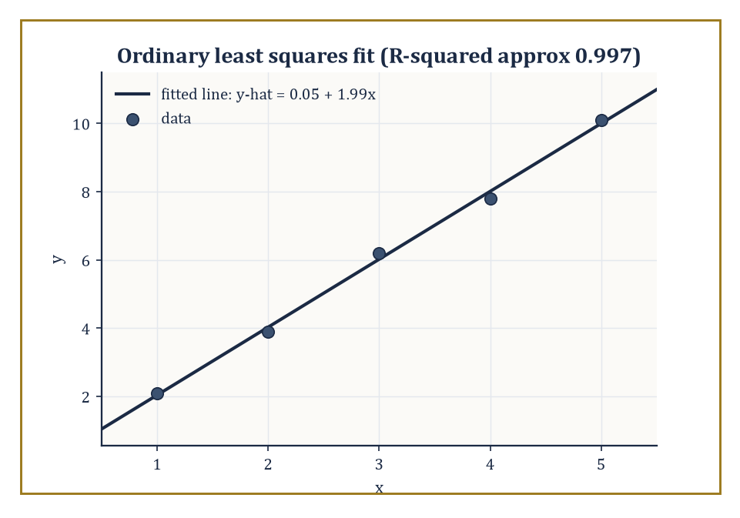
Figure 42.7 — The hand-fitted line y-hat = 0.05 + 1.99x against its five data points, with residuals drawn in as short gold verticals.
Y = Xβ + ε
where X is a matrix of predictors, β the vector of coefficients to be estimated, and ε random error, conventionally assumed to have mean zero. Ordinary least squares (OLS) chooses β̂ to minimize the sum of squared residuals.
Σ(yᵢ−ŷᵢ)²
Geometrically, this is the orthogonal projection of the response vector onto the column space spanned by the covariates. When the errors are Gaussian, OLS coincides with the maximum-likelihood estimator of Parametric Models and Likelihood; even without Gaussian errors, the Gauss–Markov theorem guarantees OLS is the best linear unbiased estimator (BLUE) — the minimum-variance choice among all linear, unbiased estimators — provided only that the errors have mean zero, constant variance, and are uncorrelated.
Numeric example — fitting a line by hand. Data: x = (1,2,3,4,5), y = (2.1, 3.9, 6.2, 7.8, 10.1). The means are x̄=3 and ȳ=30.1/5=6.02. The deviations from the mean are as follows.
(x−x̄) = (−2,−1,0,1,2); (y−ȳ) = (−3.92,−2.12,0.18,1.78,4.08)
The slope is b = Σ(x−x̄)(y−ȳ) / Σ(x−x̄)²: the numerator and denominator work out to the following.
numerator = (−2)(−3.92)+(−1)(−2.12)+0(0.18)+1(1.78)+2(4.08) = 7.84+2.12+0+1.78+8.16 = 19.9
denominator = 4+1+0+1+4 = 10
giving:
b = 19.9/10 = 1.99
The intercept is:
a = ȳ − b·x̄ = 6.02 − 1.99×3 = 6.02−5.97 = 0.05
So the fitted line is:
ŷ = 0.05 + 1.99x
very close to the tidy relationship y=2x with a little noise stirred in, which is exactly how this dataset was cooked up.
Try it now — Using the fitted line ŷ = 0.05 + 1.99x from the five measurements, predict y at x = 6, and give the residual at x = 3. Answer →
The total variability in the response splits cleanly into a part explained by the model and a part left over as residual, a decomposition called the partition of sums of squares.
SST = SSR + SSE
where SST is the total variation, SSR is the variation explained by the regression, and SSE is the leftover, unexplained residual variation.
SST = Σ(yᵢ−ȳ)², SSR = Σ(ŷᵢ−ȳ)², SSE = Σ(yᵢ−ŷᵢ)²
The ratio R² = SSR/SST reports the proportion of variability the model accounts for, running from 0 (useless) to 1 (perfect fit, and therefore slightly suspicious). The t-test on an individual coefficient and the F-test on the whole model are both, at bottom, comparisons of explained to unexplained variation, calibrated against the appropriate reference distribution.
Numeric example — sums of squares, R², and a t-test on the slope. Continuing the fit above, the predicted values are ŷ = (2.04, 4.03, 6.02, 8.01, 10.00), giving residuals (0.06, −0.13, 0.18, −0.21, 0.10), which sum to zero as they must.
SSE = 0.06²+0.13²+0.18²+0.21²+0.10² = 0.0036+0.0169+0.0324+0.0441+0.0100 = 0.107
SST = 3.92²+2.12²+0.18²+1.78²+4.08² = 15.3664+4.4944+0.0324+3.1684+16.6464 = 39.708
So:
SSR = 39.708−0.107 = 39.601, R² = 39.601/39.708 ≈ 0.9973
the line explains 99.7% of the variation in y, which is what near-perfect linear data with a small amount of noise looks like. For the t-test on the slope: the residual mean square is MSE = SSE/(n−2) (n−2=3 degrees of freedom, since two parameters — slope and intercept — were estimated from 5 points).
MSE = 0.107/3 ≈ 0.03567
The standard error of the slope is:
SE(b) = √(MSE/Sxx) = √(0.03567/10) = √0.003567 ≈ 0.0597
and the t-statistic is:
t = b/SE(b) = 1.99/0.0597 ≈ 33.3
enormously larger than the critical value of about 3.18 (3 degrees of freedom, α=0.05, two-sided), so the slope is overwhelmingly statistically significant. It would be alarming if it weren’t, given the data was practically shouting y≈2x.
Generalized linear models (GLMs) free the framework from the assumption that the response is Gaussian and additive. A link function g relates the linear predictor η=Xβ to the mean response.
g(E[Y]) = η
and a variance function specifies how the response’s variance depends on its mean — logistic regression (binary response, logit link) and Poisson regression (count response, log link) are the two most common examples encountered outside the safety of continuous, symmetric data.
Beyond the fit itself, responsible practice examines the residuals for patterns the model missed, checks for individual points exerting outsized influence on the fitted coefficients, and uses model-selection criteria such as AIC (which penalizes added complexity against improved fit) or cross-validation (which directly tests predictive performance on held-out data) to choose among competing specifications rather than trusting R² alone, which increases automatically with every added predictor whether or not that predictor means anything.
Numeric example — the logistic link in action. In a logistic regression predicting the probability p of some binary outcome from a covariate x, suppose the fitted coefficients are β₀=−2 and β₁=0.05. The linear predictor at x=40 is:
η = β₀+β₁x = −2+0.05×40 = −2+2 = 0
The logit link inverts as p = 1/(1+exp(−η)); at η=0:
p = 1/(1+e⁰) = 1/(1+1) = 1/2 = 0.5
So a covariate value of x=40 is the point at which the model predicts a 50–50 outcome — the link function’s whole job is performed here in one line: it took an unbounded linear predictor (which could stray to −∞ or +∞ as x varies) and squeezed it, via the logistic curve, into the open interval (0, 1), safely inside the range [0, 1] that a probability is required to occupy.
Numeric example — AIC prefers the model that earns its extra parameter. Using the AIC formula (dropping an additive constant common to every model being compared, since only differences matter):
AIC ≈ n·ln(SSE/n) + 2k
compare the fitted line from above (k=2 parameters: slope and intercept, SSE=0.107, n=5) against a null model that predicts the sample mean ȳ=6.02 for every point regardless of x (k=1 parameter, so its SSE is SST=39.708, since a constant-mean model explains nothing). For the fitted line:
n·ln(SSE/n) = 5·ln(0.107/5) = 5·ln(0.0214) ≈ 5×(−3.844) = −19.22, AIC ≈ −19.22 + 4 = −15.22
For the null model:
5·ln(39.708/5) = 5·ln(7.9416) ≈ 5×2.072 = 10.36, AIC ≈ 10.36 + 2 = 12.36
Lower AIC is preferred, and −15.22 is dramatically lower than 12.36 — AIC agrees emphatically with the R²≈0.997 finding from before that x is doing real explanatory work, while also being the more principled comparison, since it is the sort of criterion that would correctly refuse to reward a third, fourth, or fifth predictor added purely to shave a few more decimal places off SSE without improving genuine predictive power.
Keep only this · Section 42.7: Linear Models and Regression
The idea. Least squares chooses the line that minimizes the sum of squared vertical misses; its slope is Sₓᵧ/Sₓₓ and it always passes through (x̄, ȳ).
Core.
b = Σ(xᵢ − x̄)(yᵢ − ȳ)/Σ(xᵢ − x̄)², a = ȳ − b x̄
logistic: p = 1/(1 + exp(−(β₀ + β₁x)))
Typical mistake. Extrapolating far beyond the data. The line is fitted on 1 ≤ x ≤ 5; at x = 50 it is a guess with no support.
Minimal example. Sₓᵧ = 19.9, Sₓₓ = 10: b = 1.99, a = 6.02 − 1.99 × 3 = 0.05.
Practice. Easy to challenge; full worked answers, with the usual mistake, are in Answers to the Practice Sets at the back.
Easy — Recompute Sₓᵧ for the data x = 1, …, 5, y = 2.1, 3.9, 6.2, 7.8, 10.1. Answer →
Medium — With β₀ = −2 and β₁ = 0.05, what probabilities does the logistic model give at x = 40 and x = 60? Answer →
Challenge — Prove that the least-squares line passes through (x̄, ȳ). Answer →

Section 42.8: Bayesian Inference
Treating the unknown parameter as one more random variable, and being honest about it
The Bayesian approach makes a philosophical move the frequentist framework of the previous sections refuses to make: it treats the unknown parameter θ itself as a random variable, equipped with a prior distribution π(θ) that encodes what you believed before seeing any data.
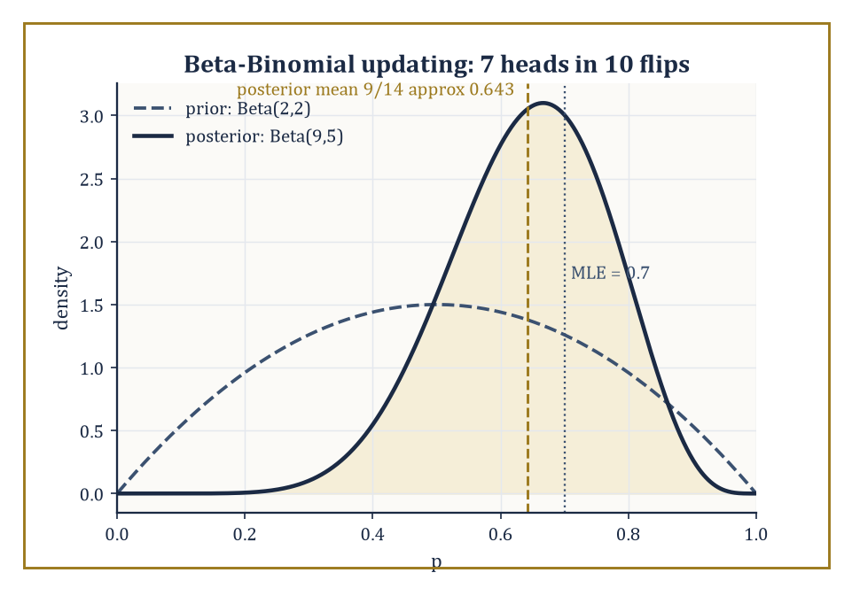
Figure 42.8 — The flat Beta(2,2) prior sharpens into the Beta(9,5) posterior once 7 heads out of 10 flips are taken into account — the MLE sits a little to its right, still slightly unshrunk.
Bayes’ theorem then converts this prior, together with the likelihood of the observed data, into a posterior distribution.
π(θ∣x) ∝ L(θ)·π(θ)
This is the complete, updated description of your uncertainty about θ once the evidence has been taken into account. Everything downstream — point estimates (the posterior mean, median, or mode), and credible intervals (ranges containing, say, 95% of the posterior probability) — is read directly off this one object, with none of the repeated-sampling gymnastics that confidence intervals require.
Numeric example — Beta-Binomial conjugacy. Return to the coin from Parametric Models and Likelihood: 7 heads out of 10 flips. Suppose the prior belief about p is Beta(2,2) — a symmetric prior centered at 0.5, mildly favoring middling values of p over extreme ones. The Beta distribution is conjugate to the Binomial likelihood, meaning the posterior is again a Beta distribution, with parameters simply updated by adding the observed successes and failures.
posterior = Beta(2+7, 2+3) = Beta(9,5)
The posterior mean is:
9/(9+5) = 9/14 ≈ 0.643
noticeably pulled down from the raw MLE of 0.7 toward the prior’s center of 0.5, a phenomenon called shrinkage, and the price (or the benefit, depending on your priors about priors) of bringing prior belief to bear at all. The posterior mode, for a Beta(a,b) with a,b>1, is (a−1)/(a+b−2):
(9−1)/(9+5−2) = 8/12 ≈ 0.667
For a credible interval, use the Beta variance formula.
Var = ab/[(a+b)²(a+b+1)] = (9×5)/(14²×15) = 45/2940 ≈ 0.0153
giving a standard deviation of about 0.124; a normal approximation to the posterior then gives an approximate 95% credible interval:
0.643 ± 1.96×0.124 ≈ [0.400, 0.885]
an interval that, unlike its frequentist cousin, really does mean ‘there is a 95% probability the true p lies in here, given the prior and the data’, because in the Bayesian framework p genuinely is being treated as random.
Try it now — With a uniform Beta(1, 1) prior and 7 heads in 10 flips, what is the posterior, and its mean? Answer →
Conjugate priors, of which the Beta-Binomial pair is the most famous, yield posteriors in closed form and make Bayesian arithmetic as clean as the exponential-family likelihood arithmetic of Parametric Models and Likelihood — indeed the two facts are the same fact, since conjugacy is the exponential-family sufficiency structure applied to the prior as well as the likelihood.
Outside these tidy special cases, the posterior generally has no closed form, and one resorts to numerical integration for low-dimensional problems, Markov chain Monte Carlo (MCMC) — which builds a random walk whose long-run behavior reproduces the posterior without ever writing its formula down — for higher-dimensional ones, or variational approximation, which trades some accuracy for enormous speed by fitting the closest tractable distribution to the true posterior.
Hierarchical models extend the whole apparatus to problems with natural grouping structure — many related but not identical experiments — by placing a prior not on a single parameter but on a shared distribution from which each group’s parameter is drawn, letting information flow between groups automatically.
Numeric example — hierarchical shrinkage across two coins. Suppose two coins are each flipped 10 times: Coin A gives 8 heads (raw MLE 0.8), Coin B gives 3 heads (raw MLE 0.3). Taken in isolation, these look like two very different coins. A hierarchical (or shared-prior) Bayesian treats both as drawn from a common family of ‘coins like these’, represented by a shared Beta(3,3) prior (centered at 0.5, expressing mild skepticism that any single coin is wildly biased).
Coin A posterior = Beta(3+8, 3+2) = Beta(11,5), mean = 11/16 = 0.6875
Coin B posterior = Beta(3+3, 3+7) = Beta(6,10), mean = 6/16 = 0.375
Notice what happened: Coin A’s estimate was pulled down from 0.8 to 0.6875, and Coin B’s was pulled up from 0.3 to 0.375 — both nudged toward the shared center of 0.5, and both nudged by the same proportion (37.5%) of their original distance from that center, because that proportion depends only on the strength of the shared prior relative to the (here, equal) amount of data behind each coin, not on how far off-center the raw estimate happened to be.
0.375×(0.5−0.8) = −0.1125, 0.375×(0.5−0.3) = +0.075
matching both shifts exactly. This is the essence of empirical-Bayes and hierarchical reasoning: individually noisy estimates borrow strength from each other via the shared prior, typically improving overall accuracy even though no individual coin’s true bias is known with certainty.
Estimation and Confidence Intervals showed that the choice of loss function determines which point estimate is ‘best’ among frequentist candidates; the Bayesian posterior makes that same choice explicit and almost mechanical, because once you have a full distribution over θ rather than just a point guess, the optimal action under any given loss function is whichever summary of the posterior minimizes expected loss under that posterior.
Numeric example — different Bayes estimators from one posterior. Return to the Beta(9,5) posterior from earlier in this section. Under squared-error loss, the Bayes estimator is the posterior mean.
9/14 ≈ 0.643
Under absolute-error loss, it is the posterior median (not computed in closed form for the Beta in general, but numerically close to 0.649 for Beta(9,5) — slightly above the mean here, since the distribution has a modest left skew). Under 0–1 loss (rewarding an exact hit and penalizing any miss equally, however small), the Bayes estimator is the posterior mode.
(9−1)/(9+5−2) = 8/12 ≈ 0.667
Three different, defensible summaries of the same evidence — 0.643, roughly 0.649, and 0.667 — disagreeing by a few hundredths, purely because they are answering three subtly different questions about what ‘best’ means. The frequentist mean-versus-median tension from Estimation and Confidence Intervals has not been resolved by going Bayesian; it has simply been relocated to a single, honestly displayed posterior distribution instead of two separate, competing estimators.
The Bayesian machinery supplies a fully coherent calculus of uncertainty — every quantity of interest, from a single parameter to a prediction for tomorrow’s data, is another distribution to be computed from the posterior — and it slots naturally into decision theory, since a posterior distribution over states of the world is exactly the input a rational decision-maker needs to minimize expected loss.
Whether one is a Bayesian by temperament or a frequentist by training (or, like most working statisticians, both depending on the day and the deadline), the two frameworks agree on an enormous amount in the large-sample limit — the CLT and its cousins from Independence and Classical Limit Theorems ensure that with enough data, the choice of prior fades and posterior and confidence intervals converge to much the same numbers, which is either a deeply reassuring unification or a sign that both camps have been arguing about the same mountain from different, equally steep sides.
Numeric example — the prior fading with more data. Return once more to the Beta(2,2) prior on the coin, but suppose the same 70% heads rate is now observed over n=1000 flips instead of 10, i.e. 700 heads and 300 tails. The posterior is:
Beta(2+700, 2+300) = Beta(702,302), mean = 702/1004 ≈ 0.6992
a shift of only 0.7−0.6992 = 0.0008 from the raw MLE, compared with the shift of 0.7−0.643 = 0.057 seen back at n=10: the same prior, applied to fifty times more data, now moves the estimate by roughly one-seventieth as much. The posterior standard deviation is:
√(702×302/(1004²×1005)) ≈ 0.01447
giving a 95% credible interval:
0.6992 ± 1.96×0.01447 ≈ [0.671, 0.727]
Compare the frequentist 95% confidence interval built from the MLE alone.
SE = √(0.7×0.3/1000) ≈ 0.01449, 0.7 ± 1.96×0.01449 ≈ [0.672, 0.728]
the two intervals, built from philosophically opposite starting points, now sit almost on top of each other. This is the CLT-driven convergence promised above, made visible: with 10 flips the prior was doing real work; with 1000 it has been outvoted by the data without a fight.
Keep only this · Section 42.8: Bayesian Inference
The idea. Bayesian inference treats the unknown parameter as random, starts from a prior and updates it with the likelihood into a posterior.
Core.
posterior ∝ likelihood × prior
Beta(a, b) prior + k heads in n → Beta(a + k, b + n − k)
Typical mistake. Thinking the prior must be “objective” to be legitimate. It must be stated; with enough data its influence fades either way.
Minimal example. Beta(2, 2) + 7 heads, 3 tails → Beta(9, 5), mean 9/14 ≈ 0.643.
Practice. Easy to challenge; full worked answers, with the usual mistake, are in Answers to the Practice Sets at the back.
Easy — Find the posterior mode of Beta(9, 5). Answer →
Medium — Beta(2, 2) prior, 700 heads in 1,000 flips: posterior mean? Answer →
Challenge — Show that the Beta family is conjugate to the binomial likelihood. Answer →

Section 42.9: Looking Ahead: From Classical Statistics to Modern Inference and Probability Theory
In which the practical toolkit sends the bill forward for the foundations it never paid for
Chapter 42: intuition and computation. Martingales and Markov processes in full are in Martingales in Discrete Time and Markov Processes and Generators.
We now hold the core toolkit of classical probability and statistics: random variables and their distributions, expectation and conditioning, the law of large numbers and the central limit theorem, likelihood and the maximum-likelihood estimator, point and interval estimation, hypothesis testing, linear regression, and a first honest look at the Bayesian alternative. Every one of these tools was built to answer one question in two directions — given a chance mechanism, what will the data look like; given the data, what was the chance mechanism — and every worked example in this chapter was, in the end, one small demonstration of that same back-and-forth.
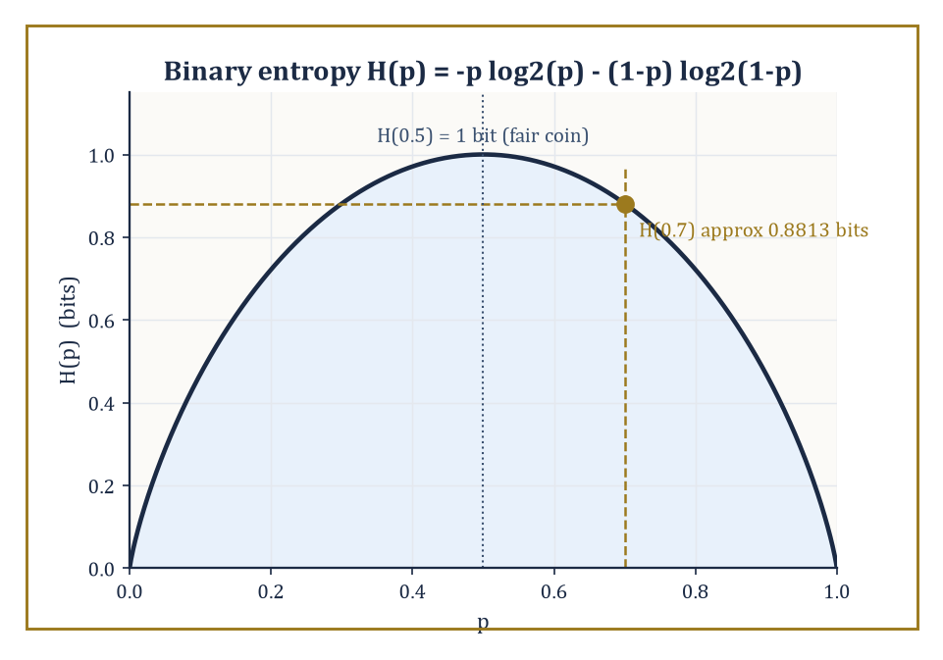
Figure 42.9 — The binary entropy curve, with the chapter’s recurring 70%-biased coin marked at just under 0.9 bits of genuine surprise per flip.
These tools open directly onto the next chapter’s measure-theoretic probability, where the informal ‘total mass of one’ of Probability Spaces and Random Variables gets its full Lebesgue-integral treatment, conditional expectation is properly constructed as a Radon–Nikodym derivative rather than gestured at as a projection, and stochastic processes — sequences and continuous-time families of random variables evolving together, martingales prominent among them — take center stage.
They also open onto modern high-dimensional statistics (where the number of parameters can rival or exceed the number of observations, breaking many classical guarantees), nonparametric methods (which estimate whole functions rather than finite parameter vectors), causal inference (which asks not merely what is correlated but what would happen under intervention), and the statistical foundations quietly underneath most of machine learning, which is, when the marketing is peeled away, mostly very large parametric and nonparametric models fitted by maximum likelihood or its close relatives.
Numeric example — a first taste of a stochastic process. Everything in this chapter treated each observation as independent of the others, or at most conditionally related through a fixed grouping variable like ‘which machine’ or ‘which coin’. A Markov chain, the simplest dynamic stochastic process and a fixture of Chapter 43, instead lets today’s state directly determine tomorrow’s probabilities. Take a two-state weather chain with states {Sunny, Rainy} and the following transition probabilities.
P(Sunny→Sunny)=0.9, P(Sunny→Rainy)=0.1, P(Rainy→Sunny)=0.5, P(Rainy→Rainy)=0.5
The long-run, or stationary, distribution (π_S, π_R) is the one that reproduces itself after one more step.
π_S = 0.9π_S + 0.5π_R, π_R = 0.1π_S + 0.5π_R, π_S+π_R=1
The first equation rearranges to 0.1π_S = 0.5π_R, so π_S = 5π_R; substituting into π_S+π_R=1 gives:
5π_R+π_R=6π_R=1, so π_R=1/6, π_S=5/6
In the long run, regardless of today’s weather, this chain spends five-sixths of its days sunny and one-sixth rainy — a clean, computable limit reached by solving two linear equations, and a small preview of how this chapter’s expectation, conditioning, and limiting arguments extend, with a little more machinery, to systems that unfold through time rather than sitting still.
Try it now — A two-state chain has P = [0.9 0.1; 0.5 0.5]. Starting in state 1, what is the probability of being in state 1 after two steps? Answer →
Computational statistics — the bootstrap of Estimation and Confidence Intervals, the MCMC of Bayesian Inference, and their many descendants — has made previously intractable calculations routine, trading mathematical cleverness for raw computation in a bargain that would have seemed almost like cheating to earlier generations of statisticians armed with nothing but tables and patience.
And the same probabilistic vocabulary built here resurfaces, essentially unchanged in spirit, in information theory’s account of how much a message or a dataset can possibly tell you.
Numeric example — a glimpse forward into information theory. The entropy of a Bernoulli(p) distribution measures in bits how much genuine uncertainty remains in a single flip of a coin with bias p — the same quantity, not coincidentally, that governs how compactly a long sequence of such flips can be encoded.
H(p) = −p log₂p − (1−p) log₂(1−p)
For the coin from Parametric Models and Likelihood and Bayesian Inference, with p=0.7:
log₂(0.7) = ln(0.7)/ln(2) ≈ (−0.3567)/0.6931 ≈ −0.5146, log₂(0.3) = ln(0.3)/ln(2) ≈ (−1.2040)/0.6931 ≈ −1.7370
So:
H(0.7) = −0.7×(−0.5146) − 0.3×(−1.7370) = 0.3602 + 0.5211 = 0.8813 bits
noticeably less than the full 1 bit of a fair coin, because a coin known to favor heads 70% of the time carries a little less genuine surprise per flip than one that is perfectly balanced. The same p=0.7 that maximized our likelihood in Parametric Models and Likelihood and anchored our posterior in Bayesian Inference reappears here as the input to an entirely different calculation, in an entirely different chapter of mathematics, which is as good an illustration as any that probability is not a subject with borders — it is closer to a common currency the rest of mathematics keeps finding reasons to spend.
The deeper lesson of this chapter, if it must be compressed into a single sentence, is that uncertainty is not a confession of mathematical failure but an object with its own precise, learnable structure — one that data can reduce in principled, quantifiable ways, and whose reduction is what all of estimation, testing, and Bayesian updating are for. It is not a small thing to have built a mathematics of not-quite-knowing.
The next chapter climbs back down into the foundations we borrowed from without properly repaying — measure-theoretic probability, stochastic processes, and the machinery that lets ‘random variable’ mean something rigorous even when time itself becomes a continuous parameter. Consider this chapter the practitioner’s tour; the one above is where the plumbing gets inspected. The series continues, and it is, as ever, considerably longer than it looks from here.
We came up from a chapter of game theorists who assumed their probabilities and went straight to computing equilibria; we leave having built those probabilities from the ground up, and having learned, at some length, how to recover them honestly from data that never cooperates quite as fully as one would like. Random variables, expectation, the limit theorems, likelihood, estimation, testing, regression, and the Bayesian posterior — nine sections, one continuous argument: uncertainty can be measured, data can shrink it, and the mathematics that describes how much and how reliably is neither a bolt-on to the rest of the series nor a mere practical afterthought, but one of its load-bearing walls.
It has also, if the author may say so without too much immodesty, been a chapter where practically nothing needed to be taken on faith — every claim came with a number attached, checked twice, because a statistics book that gets its own arithmetic wrong has no business lecturing anyone about the perils of unchecked inference.
Ahead lies Chapter 43, where probability theory sheds its applied clothing and puts on the full measure-theoretic uniform: σ-algebras taken seriously, conditional expectation built rather than merely described, and stochastic processes unfolding through continuous time. Everything learned here survives the transition intact — it simply gets a rigorous foundation poured underneath it. Onward, as always in this series.
Keep only this · Section 42.9: Looking Ahead: From Classical Statistics to Modern Inference and Probability Theory
The idea. Classical statistics assumed independent observations and polite sample spaces; stochastic processes and measure-theoretic probability, in Chapter 43, pay that bill.
Core.
Markov chain: P(next = j | now = i) = Pᵢⱼ, n steps = Pⁿ
stationary π: πP = π
Typical mistake. Assuming dependence ruins every limit theorem. Markov chains have their own law of large numbers, governed by the stationary distribution.
Minimal example. P = [0.9 0.1; 0.5 0.5]: π = (5/6, 1/6).
Practice. Easy to challenge; full worked answers, with the usual mistake, are in Answers to the Practice Sets at the back.
Easy — What is the entropy of a fair coin flip, in bits? Answer →
Medium — Compute P² for P = [0.9 0.1; 0.5 0.5]. Answer →
Challenge — Find the stationary distribution of P = [0.9 0.1; 0.5 0.5] and check it against P². Answer →
Chapter 42 recap · Statistics & Probability
• A probability space is (Ω, ℱ, P) with P(Ω) = 1; a random variable is a measurable function, and its distribution is what calculations use.
• Expectation is a weighted average; variance measures spread; conditioning updates probabilities, and Bayes’ rule turns P(B | A) into P(A | B).
• Averages of independent copies settle down (law of large numbers) and fluctuate like a normal curve of width σ/√n (central limit theorem).
• Likelihood turns a model around: the MLE is the parameter that makes the data most probable; Fisher information bounds how precise any unbiased estimator can be.
• Confidence intervals and tests quantify how wrong an estimate may be; power and multiple testing are the two places tests most often mislead.
• Regression fits the line the data least object to; Bayesian inference updates a prior into a posterior, and with much data the prior fades.

Check Your Understanding — Chapter 42
Answers are in the Answer Key at the back of the book — have a go before you look.
1. [Explain] Why does E[X+Y] = E[X] + E[Y] hold for the sum of two random variables even when X and Y are dependent?
See the answer →
2. [Compute] Using the central limit theorem, estimate the probability that the sum of 100 independent fair-die rolls exceeds 365.
See the answer →
3. [Explain] Why does the maximum-likelihood estimator for a Uniform(0,θ) model fail to obey the usual asymptotic-normality and Cramér–Rao guarantees that the coin-flip and Poisson MLEs satisfied?
See the answer →
4. [Compute] If 20 independent hypothesis tests are each run at the nominal α=0.05 level and every null hypothesis is true, what is the chance at least one test rejects anyway, and how does the Bonferroni correction fix this?
See the answer →
5. [Model] A factory measures 64 components and finds a mean length of 50.0 mm with sample standard deviation 8.0 mm. Give a 95% confidence interval for the true mean.
See the answer →
6. [Explain] A 95% confidence interval is often read as “there is a 95% probability the true mean lies in this interval”. Why is that not what it says?
See the answer →
7. [Model] An A/B test shows 50 conversions from 1,000 users on version A and 65 from 1,000 on version B. Is the difference statistically significant at the 5% level?
See the answer →
8. [Prove] Show that Var(X) = E[X²] − (E[X])².
See the answer →
9. [Explain] The tallest fathers tend to have sons shorter than themselves, and the shortest fathers sons taller. Why is this not evidence of any force pulling heights toward average?
See the answer →
10. [Challenge] A p-value of 0.03 is routinely reported as “a 3% chance the result is due to chance”. What has gone wrong, and why does the error survive so well?
See the answer →

Problems — Chapter 42
The questions above test whether the ideas landed. These ask you to use them. Solutions are in Solutions to the Problems at the back. Work them before you look.
1. [Model] The numbers 2, 4, and 6. Compute the mean, and the population variance, dividing the sum of squared deviations by 3.
2. [Compute] One fair coin and one two-headed coin. You pick a coin at random and flip heads. What is the probability you picked the two-headed coin?
3. [Explain] A random variable has mean 0 and variance 1. Chebyshev says P(|X| ≥ 2) ≤ 1/4. Why is this a ceiling and not a typical value?
4. [Compute] A sample of size 4 has sample mean 10. You add a fifth observation equal to 10. What happens to the sample mean?

Math, Actually

Chapter 43

Probability Theory (Advanced)
Same Probability, Deeper Machinery: Measure, Martingales, and Randomness at the Foundations
The previous chapter taught you to compute with randomness: distributions, densities, the central limit theorem wheeled out like a reliable but slightly overworked family car. That was probability as most of the world meets it, and it is not wrong, merely provisional — built on a sample space that is politely assumed to behave, on random variables that are politely assumed to have nice densities, and on limit theorems whose proofs, if you look closely, tend to wave their hands at the moment things get interesting. This chapter removes the politeness. We rebuild probability from the measure theory laid down many chapters back, and in exchange for the extra rigor we get a theory that works on any measurable space whatsoever, handles continuous time without flinching, and turns a dozen classical theorems that used to require separate, ad-hoc proofs into corollaries of one idea.
That one idea, roughly, is information. A σ-algebra is not only bureaucratic apparatus for deciding which sets are measurable; once you have a probability measure sitting on top of it, a σ-algebra is what you know. Conditional expectation given that σ-algebra is your best possible guess given what you know. A martingale is a process whose best guess about tomorrow, given everything you know today, is today’s value — a fair game, formalized until it squeaks. Once these three notions are in place, filtrations track the flow of information through time, stopping times encode decisions that cannot see the future, and a startling number of classical results — the strong law, the central limit theorem, the existence of Brownian motion — turn out to be the same theorem wearing different coats.
We will build the core of this machinery in nine sections: probability measures and random variables done properly, independence and the construction of infinite product spaces, conditional expectation, discrete-time martingales, the great convergence theorems, Brownian motion, continuous-time martingales, Markov processes and their generators, and finally a look at what lies just beyond — stochastic calculus, stochastic PDEs, and ergodic theory, none of which we will attempt to close-read, all of which will look considerably less alarming once you have this chapter behind you.
A small confession before we begin: advanced probability is the subject in which the phrase ‘almost surely’ does most of the moral labor without being asked, in which null sets are cheerfully ignored, and in which the underlying sample space — supposedly the whole point of the enterprise — is very often never mentioned again once we have proven it exists. This is not evasion; it is the price admission to a theory that can handle continuous time, infinite dimensions, and the mild vertigo of a stopping time that cannot see next Tuesday. Let’s build on measure, and then let it run.
Same probability, deeper machinery
This chapter does not reteach Chapter 42. It takes the same probability and supplies the machinery needed for infinitely many variables, continuous time and limits of whole distributions. Use the map below to find the version you need.
• Probability spaces, random variables — intuition and computation: Probability Spaces and Random Variables; measure-theoretic formulation: Probability Measures and Random Variables Revisited.
• Independence — Independence and Classical Limit Theorems; Independence, Product Spaces, and Kolmogorov’s Extension.
• Conditioning — Expectation, Variance, and Conditioning; Conditional Expectation.
• Limit theorems — Independence and Classical Limit Theorems; Convergence Theorems and the Strong Law.
• Processes — Looking Ahead: From Classical Statistics to Modern Inference and Probability Theory; Martingales in Discrete Time to Markov Processes and Generators.
Before you begin — Chapter 43
By the end of this chapter you will be able to:
1. Build a random variable with a given distribution from a uniform one, and decide whether a family of measures is tight.
2. Tell pairwise from mutual independence, and check the consistency conditions behind Kolmogorov’s extension theorem.
3. Compute a conditional expectation given a σ-algebra and use the tower property.
4. Verify the martingale property, apply optional stopping correctly, and compute gambler’s-ruin probabilities.
5. Use the strong law and the martingale convergence theorem, including Pólya’s urn.
6. Compute with Brownian motion (increments, covariances, reflection principle) and with the generator of a Markov process.
Prerequisites. All of Statistics & Probability; the σ-algebra, Lebesgue integral and dominated convergence from Measure Theory (Volume 3); the heat equation from Partial Differential Equations (Volume 3) for Brownian motion.
Estimated study time. About 15 hours, exercises included. This is the most demanding chapter of the volume; take it one section per sitting.

Section 43.1: Probability Measures and Random Variables Revisited
In which coin flips turn out to have been a special case all along
Chapter 43: measure-theoretic formulation. Intuition and computation for this material: Probability Spaces and Random Variables.
You have met a random number between zero and one. A spinner, a shuffled deck cut at a random depth, the function on a pocket calculator that produces a decimal nobody can predict. Whatever produces it, the useful property is that no part of the interval is favored: a result in the first tenth is exactly as likely as one in the last.
Now try to use it for something it was not built for. You want a waiting time — how long until the next bus, how long until a machine fails. That quantity does not behave like the spinner at all. Short waits are commoner than long ones, and there is no longest wait to put at the end of the ruler; it runs on without limit. Nothing you can do by counting favorable cases will manufacture it, because there is nothing to count.
The question is therefore one of construction rather than description. Not what is the probability of this or that event, but whether an awkward random quantity can be built out of the plainest one there is.
Here is where it becomes uncomfortable. Stretching the interval [0, 1] out to cover every waiting time from zero to infinity is not the hard part; plenty of functions do that. The hard part is that almost every one of them gets the odds wrong. Stretch carelessly and you will make long waits far too likely, or far too rare, and the spinner underneath gives you no indication whatever of which stretch is the honest one.
The way through is to run the question backwards. Do not pick a stretch and then examine what it did to the odds. Decide the odds you want first, write them down, and let them tell you which stretch you are obliged to use.
Do it once, with numbers, and the trick stops looking like one. Take the spinner result ω and hand back the waiting time X = −ln ω. Asking for the chance that the wait comes in at or below t is then asking which spinner results produce such a wait, and that turns out to be the stretch of the interval from e⁻ᵗ up to 1 — whose length is all the answer you need:
P(wait ≤ t) = 1 − e⁻ᵗ
t = 1 gives 1 − 0.3679 = 0.6321
t = 2 gives 1 − 0.1353 = 0.8647
t = 0 gives 0, as it must
Now look at what that derivation never once used. It never used the word random, and it never counted anything. Every step was the length of an interval. The randomness was carried entirely by the spinner underneath, and the work was done by measurement.
That is the whole reorganization this chapter performs. Probability becomes measurement with a total budget of one; a random variable becomes an ordinary function sitting on top of it; and the coin flips and dice of earlier chapters turn out to be the special case where the measurement happens to sit in lumps rather than spread out. The formal statement follows.
You already have the definitions from Probability Spaces and Random Variables, and this chapter uses them unchanged. A probability space (Ω, F, P) is a measure space with P(Ω) = 1. A random variable is a measurable function X: Ω → ℝ, so that “X is at most t” is always an event. The distribution of X is the push-forward μ_X(B) = P(X⁻¹(B)), one definition covering mass functions and densities alike. What changes in this chapter is not the definitions but how hard we lean on them: Ω becomes large, time becomes continuous, and limits are taken of whole measures.
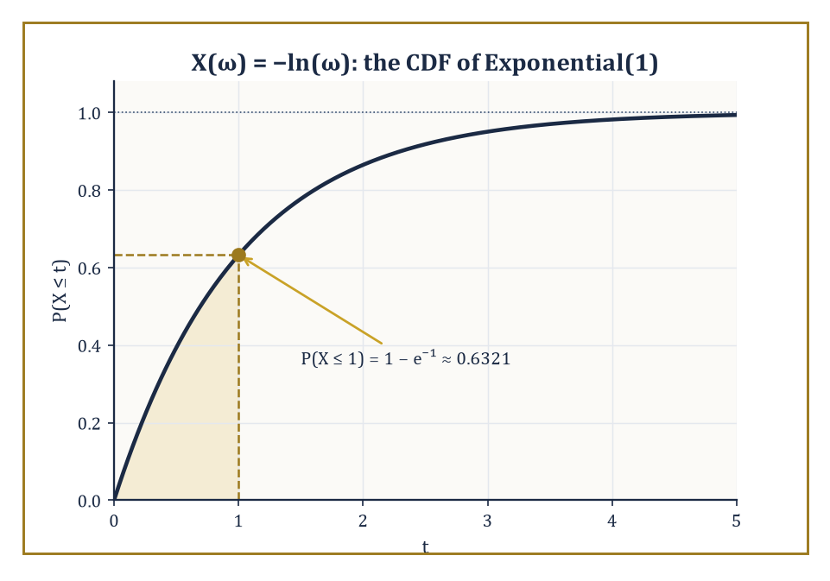
Figure 43.1 — The CDF of X(ω) = −ln(ω): a probability space this humble, and it already knows how to be exponential.
Numeric example — building an exponential random variable from a uniform one. Take Ω = [0, 1], F the Borel sets, and P Lebesgue measure — the uniform distribution on the unit interval, the humblest probability space there is. Define X as follows.
X(ω) = −ln(ω)
We compute the distribution of X directly from the definition, with no appeal to any pre-packaged ‘exponential density’ formula. For t ≥ 0, consider the event {ω : X(ω) ≤ t}, which unwinds by a chain of equivalent descriptions.
{ω : X(ω) ≤ t} = {ω : −ln ω ≤ t} = {ω : ln ω ≥ −t} = {ω : ω ≥ e⁻ᵗ}
This last set is the interval [e⁻ᵗ, 1]. Since P is Lebesgue measure, its length is the answer.
P(X ≤ t) = 1 − e⁻ᵗ
Two sanity checks confirm this is right. At t = 0 the formula gives the following.
P(X ≤ 0) = 0
This must be true since ω ∈ (0, 1] forces −ln ω ≥ 0, so X can never be negative; and as t → ∞ the formula tends to 1, as any honest cumulative distribution function must.
Plugging in a concrete value:
P(X ≤ 1) = 1 − e⁻¹ ≈ 1 − 0.3679 = 0.6321
We have just derived, from first principles, that X is Exponential(1) distributed — and in doing so reconstructed the inverse-transform method that every random-number generator on your computer uses to turn a uniform sample into an exponential one.
Try it now — For X(ω) = −ln ω on ([0, 1], Lebesgue), compute P(X ≤ 2) and P(X > 3). Answer →
When the underlying space is not just ℝ but a metric space, the natural σ-algebra is the Borel σ-algebra generated by the open sets, and once a probability measure P is fixed it is common (and harmless) to complete F by throwing in every subset of every P-null set, so that ‘measurable’ and ‘negligible’ interact politely.
The theory becomes especially well-behaved when the state space is Polish — complete, separable, and metrizable — which is the standing assumption for essentially everything from here to the end of the chapter.
On Polish spaces one gets two regularity properties that classical probability rarely needed to name but that become indispensable once we start taking limits of entire probability measures rather than limits of numbers: tightness, which says a family of measures does not let its mass leak off to infinity, and weak convergence, where μₙ ⇒ μ means the following.
∫ f dμₙ → ∫ f dμ for every bounded continuous f
Prokhorov’s theorem says a family of measures is relatively compact for weak convergence exactly when it is tight, and the portmanteau theorem gives half a dozen equivalent ways to check weak convergence (via open sets, closed sets, or sets whose boundary the limit measure ignores). These are the tools that will let us talk sensibly, several sections from now, about a sequence of random walks converging to Brownian motion.
Abstract example — tight versus non-tight families of measures. Consider two families of Gaussian measures on ℝ. First, take the family with mean zero and shrinking variance.
μₙ = N(0, 1/n)
Given ε > 0, choose the following radius.
M = 1/√ε
By Chebyshev’s inequality, for every n ≥ 1, the following bound holds, since the variance 1/n never exceeds 1.
P(|X| > M) ≤ Var(X)/M² ≤ 1/M² = ε
So the compact interval [−M, M] captures at least 1 − ε of the mass of every μₙ simultaneously: the family is tight, and indeed the Gaussians converge weakly as follows, collapsing onto the origin.
μₙ ⇒ δ₀
Here δ₀ is the point mass at zero. Now consider the second family — fixed variance, but a mean marching off to infinity.
νₙ = N(n, 1)
For any fixed compact set K = [−M, M], the following holds, because the entire bell curve is sailing past M and never coming back.
νₙ(K) → 0 as n → ∞
No single compact set can trap uniform mass 1 − ε from every νₙ, so the family is not tight — and correspondingly there is no weak limit on ℝ at all; the mass has escaped.
This is the whole content of tightness in one illustrative pair: shrinking variance keeps a family corralled, a runaway mean lets it escape — and a growing variance with a fixed mean would escape too, by the same mechanism, spread rather than shift.
Prokhorov’s theorem is the abstract guarantee built to catch every version of this escape at once: a family is relatively compact for weak convergence when no such leak, however it happens, is occurring.
Keep only this · Section 43.1: Probability Measures and Random Variables Revisited
The idea. A random variable is a measurable function on a probability space; its distribution is the push-forward of P, and any distribution can be built from a uniform one.
Core.
P(X ≤ t) = P({ω : X(ω) ≤ t})
X = −ln ω on ([0, 1], Lebesgue): X ~ Exponential(1)
tight: for each ε a compact K with μₙ(K) ≥ 1 − ε for all n
Typical mistake. Thinking weak convergence needs densities to converge. N(0, 1/n) converges weakly to the point mass δ₀, which has no density.
Minimal example. P(X ≤ 1) = 1 − e⁻¹ ≈ 0.6321.
Practice. Easy to challenge; full worked answers, with the usual mistake, are in Answers to the Practice Sets at the back.
Easy — On ([0, 1], Lebesgue), let X(ω) = ω². Find P(X ≤ ¼). Answer →
Medium — Let X(ω) = −2 ln ω. Find P(X ≤ t) and name the distribution. Answer →
Challenge — Show that the family N(0, n), n = 1, 2, …, is not tight. Answer →

Section 43.2: Independence, Product Spaces, and Kolmogorov’s Extension
How to build infinitely many coins without flipping a single one
Chapter 43: measure-theoretic formulation. Intuition and computation: Independence and Classical Limit Theorems.
Two fair coin tosses are independent: the chance of two heads is a half times a half, a quarter, because neither toss knows anything about the other. Probability needs that idea for whole families of events, and it hides a trap. Three events can be independent in every pair and still fail to be independent all together, as two coin tosses and the event that they agree demonstrate. The section also settles a question that sounds philosophical but is practical: does an infinite sequence of independent coin tosses actually exist as a mathematical object? Kolmogorov’s extension theorem says yes, and builds it from nothing more than the probabilities of finite stretches.
Two sub-σ-algebras G₁, G₂ ⊆ F are independent if the following product property holds for every A₁ ∈ G₁ and A₂ ∈ G₂, and finitely many σ-algebras are independent if the product property holds for every choice of one set from each.
P(A₁ ∩ A₂) = P(A₁)P(A₂)
Random variables are independent when the σ-algebras they generate are independent, which unpacks to the familiar statement that their joint distribution is the product of their marginal distributions.
It is worth stating plainly, because it trips up even careful people: independence of every pair in a collection — pairwise independence — does not imply independence of the entire collection.
Genuine (mutual) independence is a strictly stronger, and strictly more useful, condition; it is the hypothesis under which the classical limit theorems of the next few sections actually hold.
Numeric example — pairwise independence is not enough. Let X and Y be independent fair coin flips, each taking values 0 or 1 with probability 1/2, and let Z = X XOR Y (so Z = 1 exactly when X and Y differ). First check pairwise independence of X and Z.
P(X=1, Z=1) = P(X=1, Y=0) = 1/4
P(X=1)P(Z=1) = (1/2)(1/2) = 1/4
They match, and by symmetry Y and Z are pairwise independent too, alongside the given independence of X and Y. So every pair in {X, Y, Z} is independent. But check the triple: the event {X=1, Y=1, Z=1} is impossible, because if X = Y = 1 then Z = X XOR Y = 0, not 1; hence
P(X=1, Y=1, Z=1) = 0
Yet the product of the marginals is
P(X=1)P(Y=1)P(Z=1) = (1/2)(1/2)(1/2) = 1/8 ≠ 0
The three variables are pairwise independent but not mutually independent — a standard cautionary tale, and the reason every serious statement of independence in this chapter insists on the full product property for every finite subcollection, not merely for pairs.
Try it now — With X, Y independent fair bits and Z = X XOR Y, compute P(X = 1, Y = 1, Z = 1) and compare it with the product of the three marginals. Answer →
None of this is useful unless infinite collections of independent random variables exist as honest measurable functions on some probability space, rather than as a comforting story about flipping a coin forever.
The Kolmogorov extension theorem supplies them: given, for every n, a probability measure on ℝⁿ, such that the family is consistent (the measure on ℝⁿ, marginalized down to ℝᵐ for m < n, agrees with the given measure on ℝᵐ), there exists a single probability measure on the infinite product space ℝ^∞ whose finite-dimensional marginals are the given ones.
This is how one rigorously builds an infinite sequence of i.i.d. random variables with any prescribed common distribution, and — far more importantly for what follows — it is how one builds a stochastic process from nothing but a consistent specification of its finite-dimensional distributions, which is exactly the strategy we will use to construct Brownian motion in Brownian Motion.
The Ionescu–Tulcea theorem is the companion result for processes specified not by fixed finite-dimensional laws but by a consistent chain of transition kernels, and it is the existence theorem behind Markov chains with arbitrarily prescribed transition probabilities.
Abstract example — checking consistency for a Gaussian random walk. Suppose we want to build an infinite sequence (X₁, X₂, X₃, …) by declaring that, for every n, the vector (X₁, …, Xₙ) is multivariate Gaussian with mean zero and covariance given by the following.
Cov(Xᵢ, Xⱼ) = min(i, j)
This is not an arbitrary choice: it is the covariance structure of the partial sums Sᵢ = ξ₁ + ⋯ + ξᵢ of independent, mean-zero, unit-variance increments, since for i ≤ j:
Cov(Sᵢ, Sⱼ) = Cov(Sᵢ, Sᵢ + (Sⱼ − Sᵢ)) = Var(Sᵢ) + Cov(Sᵢ, Sⱼ − Sᵢ) = i + 0 = i = min(i, j)
The cross term vanishes by independence of Sᵢ and the later increment. To apply Kolmogorov’s theorem we must check consistency: does marginalizing the 5-dimensional law down to its first 3 coordinates recover the 3-dimensional law we specified directly?
Since any subvector of a multivariate Gaussian is again Gaussian, with covariance given by the corresponding submatrix, the marginal of (X₁, X₂, X₃) taken from the 5-dimensional specification has covariance the 3×3 submatrix [min(i,j)]ᵢ,ⱼ≤3 — the 3-dimensional law we specified.
Consistency holds automatically, for every n and every choice of subset, and Kolmogorov’s theorem hands us a single probability space carrying the entire infinite sequence at once. We have just constructed, rigorously and without simulating a single step, the discrete-time random walk sampled at every integer time — the exact skeleton on which Brownian motion will later be draped.
Independence, seen this way, is probability’s precise model of ‘learning nothing’: knowing the value of one variable leaves your belief about the others completely unmoved.
And the extension theorems are what let us stop worrying, once and for all, whether ‘infinitely many independent trials’ is secretly nonsense dressed up in probabilistic language. It is not. Kolmogorov checked, and the receipt is the theorem bearing his name.
Keep only this · Section 43.2: Independence, Product Spaces, and Kolmogorov’s Extension
The idea. Independence is a property of σ-algebras, and mutual independence is stronger than pairwise; Kolmogorov’s extension builds a whole process from consistent finite-dimensional distributions.
Core.
mutual: P(A₁ ∩ ⋯ ∩ Aₖ) = Π P(Aᵢ) for every finite subfamily
consistency: each finite law is the marginal of every larger one
Typical mistake. Treating pairwise independence as enough for products of three or more. It is not, as XOR shows.
Minimal example. Random walk with N(0, 1) steps: Cov(Xᵢ, Xⱼ) = min(i, j) for the partial sums, consistent in every dimension.
Practice. Easy to challenge; full worked answers, with the usual mistake, are in Answers to the Practice Sets at the back.
Easy — In the XOR example, check that X and Z are independent. Answer →
Medium — For the Gaussian random walk, write the covariance matrix of (X₁, X₂, X₃) and check that deleting X₃ gives the covariance matrix of (X₁, X₂). Answer →
Challenge — Explain why consistency is necessary for Kolmogorov’s theorem: what would go wrong if the specified law of X₁ alone were N(0, 1) but the law of (X₁, X₂) had X₁ ~ N(0, 2)? Answer →

Section 43.3: Conditional Expectation
The best guess you can make, formalized until it hurts
Chapter 43: measure-theoretic formulation. Intuition and computation: conditional probability and expectation in Expectation, Variance, and Conditioning.
Your best guess of tomorrow’s temperature changes as information arrives: the forecast this morning, the clouds this afternoon, the wind tonight. Conditional expectation is the mathematics of that best guess. Given whatever information is currently available, it is the prediction that is right on average and that uses that information and nothing more. For a point chosen at random in a disk, learning its horizontal position narrows it down to a single vertical chord, and the best guess of its height is then the middle of that chord. When the information is a single event, the definition reduces to familiar conditional probability; this section extends it to information of any kind.
Let G be a sub-σ-algebra of F, thought of as ‘the information currently available’ — some events are decidable from G, others are not yet.
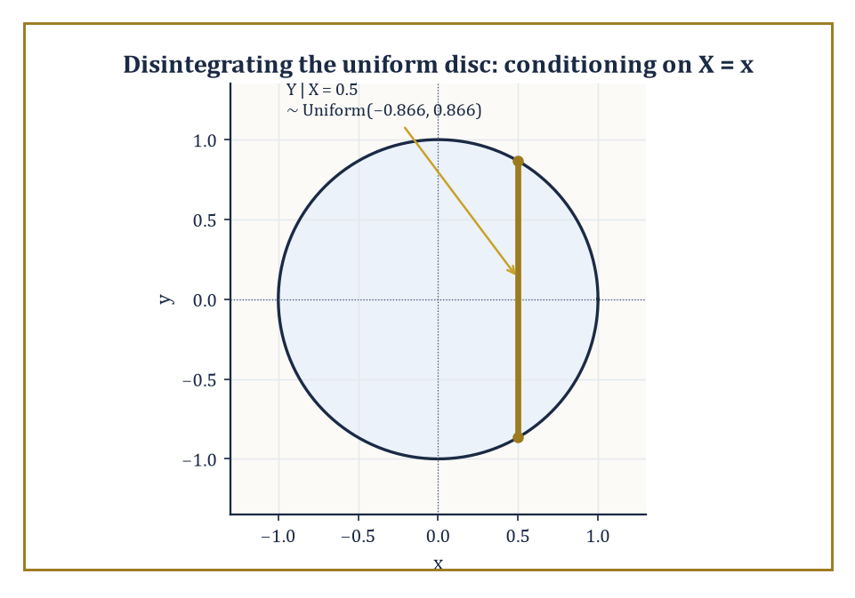
Figure 43.2 — Conditioning on X = x slices the disk into a single vertical chord, uniform along its own length and nothing more.
The conditional expectation E[X | G] is defined as the (essentially unique) G-measurable random variable Y satisfying, for every A ∈ G, the relation:
∫[A] Y dP = ∫[A] X dP
Existence follows from the Radon–Nikodym theorem applied to the signed measure A ↦ ∫[A] X dP restricted to G.
Read the defining property carefully: it says Y agrees with X on average over every G-measurable event, while being forced to be constant on the ‘atoms’ of G — it is the best approximation to X that can be computed using only the information in G.
When X has a finite second moment, this coincides with the orthogonal projection of X onto the closed subspace L²(G) of the Hilbert space L²(F, P), which is the cleanest possible way to think about it: conditional expectation is projection, full stop.
It is linear, positive, preserves constants, and satisfies the following identity (take A = Ω):
E[E[X|G]] = E[X]
It also satisfies the tower property, valid whenever G₂ ⊆ G₁ — more information can always be thrown away, never conjured:
E[E[X|G₁] | G₂] = E[X|G₂]
and Jensen’s inequality, for convex φ:
φ(E[X|G]) ≤ E[φ(X)|G]
Conditional probability P(A|G) is the special case:
X = 1_A
Numeric example — conditioning on one die out of two. Roll two independent fair dice and let X be their sum, with G = σ(D₁) — the information consisting of the first die’s value alone:
X = D₁ + D₂
Since D₂ is independent of D₁, with expected value:
E[D₂] = 3.5
we claim:
E[X | G] = D₁ + 3.5
Verify this directly on the event A = {D₁ = 3} ∈ G, where X = 3 + D₂. Averaging over the six equally likely values of D₂ gives an average value of X on A equal to:
3 + 3.5 = 6.5
The claimed conditional expectation D₁ + 3.5 also equals, on A:
3 + 3.5 = 6.5
The two sides of the defining integral equation agree, and the same check works for every value D₁ can take, so the formula holds.
Now confirm the tower property: E[E[X|G]] should equal E[X]. The left side is:
E[D₁ + 3.5] = 3.5 + 3.5 = 7
The right side, the expected sum of two dice, is famously also 7.
The two-dice example is small enough to check by hand and general enough to show just what conditional expectation does: it replaces the unknown D₂ by its unconditional average, while leaving the known quantity D₁ untouched.
Try it now — Two dice, X = D₁ + D₂. Find E[X | D₁] as a formula, and its value when D₁ = 4. Answer →
For Polish state spaces, one can go further and construct a regular conditional distribution: for (almost) every value x, an honest probability measure describing ‘the law of Y given X = x’, not merely an equivalence class of functions defined up to null sets.
This is the rigorous version of disintegration — slicing a joint measure into a family of conditional measures glued together by the marginal law of X — and it is what allows statements like ‘conditional on X = x, Y is distributed as…’ (the daily bread of Bayesian statistics, back in the previous chapter) to be honest mathematics rather than convenient shorthand.
It is also the technical backbone of the Markov property we meet in Markov Processes and Generators, where the future given the present is a regular conditional distribution.
Abstract example — disintegrating the uniform measure on a disk. Let (X, Y) be uniformly distributed on the unit disk {x² + y² ≤ 1} ⊂ ℝ², with the following joint density on the disk:
f(x,y) = 1/π
The marginal density of X is obtained by integrating out y over the vertical chord at height x, for x ∈ (−1, 1):
f_X(x) = ∫[−√(1−x²), √(1−x²)] (1/π) dy = 2√(1−x²)/π
The conditional density of Y given X = x, for y ∈ (−√(1−x²), √(1−x²)), is then:
f(y|x) = f(x,y)/f_X(x) = (1/π) / (2√(1−x²)/π) = 1/(2√(1−x²))
This is the uniform density on that interval, since its value times the interval’s length 2√(1−x²) equals 1, confirming it is a genuine probability density for every fixed x.
So the regular conditional distribution of Y given X = x is:
Uniform(−√(1−x²), √(1−x²))
Geometrically, the conditional law at each x is ‘uniform along the vertical slice of the disk at that x’, and integrating these honest slice-measures against the marginal law of X reconstructs the original uniform measure on the whole disk exactly.
Conditional expectation, in this picture, is nothing more mysterious than averaging over one particular slice.
This operator is the single load-bearing wall of the entire chapter. Martingales are defined by it, the Markov property is a special case of it, and the theory of filtering and estimation is built entirely out of it, relabeled and reintroduced under a fresh name every few chapters — so it is worth having the two pictures (best-guess-given-information, and orthogonal projection) both firmly in hand before we go any further.
Keep only this · Section 43.3: Conditional Expectation
The idea. E[X | G] is the best guess of X using only the information in G: it is G-measurable and has the same averages as X on every event of G.
Core.
E[E[X | G]] = E[X] (tower)
E[X | G] minimizes E[(X − Y)²] over G-measurable Y
Typical mistake. Treating E[X | G] as a number. It is a random variable that depends on what G reveals.
Minimal example. E[D₁ + D₂ | D₁] = D₁ + 3.5.
Practice. Easy to challenge; full worked answers, with the usual mistake, are in Answers to the Practice Sets at the back.
Easy — Check the tower property for E[X | D₁] = D₁ + 3.5. Answer →
Medium — Find E[D₁ | X = 4]. Answer →
Challenge — Compare the mean squared errors of the guesses D₁ + 3.5 and 7 for X. Answer →

Section 43.4: Martingales in Discrete Time
Fair games, formalized, with no house edge permitted
Before this section
What you need. Conditional expectation given a σ-algebra, from Conditional Expectation.
Why it matters. Martingales are the main tool of the rest of the chapter. Brownian motion, stochastic calculus and much of mathematical finance are built on the one equation E[Xₙ₊₁ | Fₙ] = Xₙ.
Toss a fair coin for £1 a time: heads you win a pound, tails you lose one. Suppose the first two tosses were heads, so you are £2 up. The next toss leaves you at £3 or at £1, each with chance 1/2, and the average of those is (3 + 1)/2 = 2. On average, tomorrow is worth exactly what today is. That is what ‘fair’ means, and you can check it at any point in the game.
Now here is a famous way to beat a fair game. Bet £1. If you lose, bet £2. If you lose again, bet £4, and keep doubling until the first win. Whenever the win comes, it pays back every earlier loss plus £1. Win at once: +1. Lose then win: −1 + 2 = +1. Lose, lose, win: −1 − 2 + 4 = +1. Every round of the system ends £1 up. A pile of fair bets appears to have produced a sure profit.
So the question is not whether each bet is fair, which it is, but whether a gambler who chooses when to stop can turn fair bets into an advantage.
The trouble is that the system looks airtight. Every ending in that list is a profit, and the chance that the winning toss never comes is zero. It is worth taking that seriously before it is taken apart.
Take it apart by giving the gambler a limit. Say the bank allows five bets at most, so the stakes run 1, 2, 4, 8, 16:
win on bet 1, 2, 3, 4 or 5 (chance 31/32): +£1
lose all five (chance 1/32): −£(1 + 2 + 4 + 8 + 16) = −£31
average result: (31/32) × 1 − (1/32) × 31 = 0
Exactly zero. Allow ten bets instead and the rare loss grows to £1,023 at chance 1/1,024, and the average is still exactly zero. Notice what it never does: at no limit, however generous, does the average become positive. The profit only appears in a game with no limit on time and no limit on money, and in that game the losses before the win can grow larger than any amount you name.
A game in which, given everything known so far, the average of the next value equals the current value is a martingale; oddly enough, the doubling system above was called ‘the martingale’ long before mathematicians borrowed the word. ‘Everything known so far’ is made precise by a filtration. ‘Choosing when to stop’ is a stopping time, and the optional stopping theorem near the end of this section says when stopping cannot help you. The trap example there, a walk stopped the first time it reaches +1, is the same trap in its simplest form: a fair game, a stopping rule willing to wait as long as it takes, and an apparently certain gain of 1.
A filtration (Fₙ)_(n≥0) is an increasing sequence of σ-algebras,
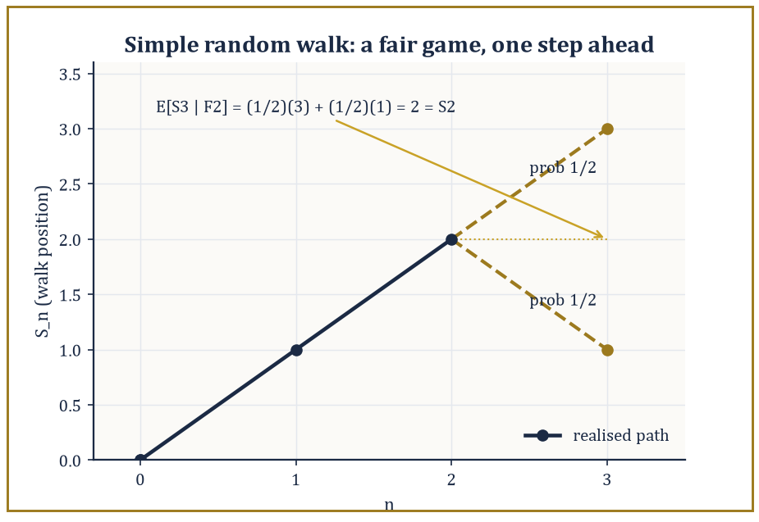
Figure 43.3 — Two equally likely futures from S₂ = 2, and the honest average of them is precisely S₂ — no edge, house or otherwise.
F₀ ⊆ F₁ ⊆ F₂ ⊆ …
representing information accumulating over time: Fₙ is everything knowable by time n. A process (Xₙ) is adapted to the filtration if Xₙ is Fₙ-measurable for every n — you are not allowed to know the future.
The process is a martingale if it is adapted, integrable, and satisfies:
E[Xₙ₊₁ | Fₙ] = Xₙ
almost surely: your best guess of tomorrow’s value, given everything you know today, is today’s value. This is the formal content of ‘fair game’ — no systematic drift in either direction.
A submartingale satisfies:
E[Xₙ₊₁|Fₙ] ≥ Xₙ
(a favorable game, or at least one that never actively cheats you), and a supermartingale satisfies the reverse inequality (a casino, essentially, dressed in stochastic-process clothing).
Numeric example — the simple random walk is a martingale. Let ξ₁, ξ₂, … be i.i.d. with P(ξᵢ = 1) = P(ξᵢ = −1) = 1/2, let S₀ = 0, Sₙ = ξ₁ + ⋯ + ξₙ, and Fₙ = σ(ξ₁, …, ξₙ).
Then, using that Sₙ is Fₙ-measurable and ξₙ₊₁ is independent of Fₙ:
E[Sₙ₊₁ | Fₙ] = E[Sₙ + ξₙ₊₁ | Fₙ] = Sₙ + E[ξₙ₊₁ | Fₙ] = Sₙ + E[ξₙ₊₁] = Sₙ + 0 = Sₙ
Concretely, suppose the first two steps were (ξ₁, ξ₂) = (+1, +1), so S₂ = 2.
Given this history, S₃ is either 3 (if ξ₃ = +1, probability 1/2) or 1 (if ξ₃ = −1, probability 1/2), so:
E[S₃ | F₂] = (1/2)(3) + (1/2)(1) = 2 = S₂
This holds exactly, as the martingale property demands.
Try it now — For the simple random walk, compute E[S₅ | S₄ = 2] and E[S₄² − 4 | S₃ = 1]. Answer →
A stopping time τ is a random time such that {τ = n} ∈ Fₙ for every n: the decision to stop by time n may use only information available by time n, never a peek ahead.
The optional stopping theorem states that, under suitable integrability conditions (τ bounded, or the stopped process uniformly integrable, are the standard sufficient hypotheses):
E[X_τ] = E[X₀]
The fair-game property survives being evaluated at a well-behaved random time, not merely a fixed one.
Doob’s maximal inequality bounds the running maximum of a non-negative submartingale:
P(max[k≤n] Xₖ ≥ λ) ≤ E[Xₙ]/λ
And the upcrossing inequality, which controls how many times a martingale can cross back and forth over an interval, is the engine behind the almost-sure convergence theorem of the next section.
Numeric example — optional stopping, applied correctly and applied incorrectly. First, the trap. Let τ be the first time the simple random walk from S₀ = 0 hits the level +1. Since the walk is recurrent, τ is finite almost surely, and S_τ = 1 always, so:
E[S_τ] = 1
But:
E[S₀] = 0
And 1 ≠ 0, so the optional stopping theorem has failed here. It fails because its hypotheses fail — one can show:
E[τ] = ∞
And the stopped martingale is not uniformly integrable, even though it converges (trivially) almost surely. A finite stopping time is not enough; the theorem needs genuine integrability control.
Now the legitimate case: gambler’s ruin with two absorbing barriers, −a and b (integers a, b > 0), and τ = the first time the walk hits either barrier. Here τ has finite expectation and the walk is bounded between −a and b before stopping, so optional stopping applies cleanly:
E[S_τ] = 0
Writing p = P(hit b before −a), this expectation expands as:
E[S_τ] = b·p + (−a)·(1−p) = 0
Which rearranges to:
p = a/(a+b)
Taking a = 2, b = 3 (ruin at −2, win at 3, starting at 0):
p = 2/5 = 0.4
Check directly:
bp − a(1−p) = 3(0.4) − 2(0.6) = 1.2 − 1.2 = 0
As required.
Numeric example — Doob’s maximal inequality, applied to the random walk. Since Sₙ is a martingale, Sₙ² is a submartingale (Jensen’s inequality applied to the convex function x², using the martingale property of Sₙ). Doob’s maximal inequality for a non-negative submartingale gives:
P(max[k≤n] Sₖ² ≥ λ) ≤ E[Sₙ²]/λ
Take n = 9: since Var(Sₙ) = n for the simple random walk (each of the nine independent ±1 steps contributes variance 1):
E[S₉²] = 9
Choosing λ = 36 (i.e. asking about the event max[k≤9] Sₖ² ≥ 36, equivalently max[k≤9] |Sₖ| ≥ 6) gives:
P(max[k≤9] |Sₖ| ≥ 6) ≤ 9/36 = 0.25
This is a genuine, non-trivial bound obtained without knowing the exact distribution of the running maximum at all — a single moment computation on the endpoint S₉ controls the entire path’s excursions, which is precisely the point of maximal inequalities: they trade exact distributional knowledge for a cheap, universally applicable bound.
Martingales unify, without fanfare, a surprising range of classical probability: sums of independent random variables (of which the random walk above is the simplest instance), branching processes, optimal stopping problems (when should you sell the stock, stop the search, accept the offer?), and the online-updating algorithms — stochastic gradient descent, reinforcement learning value estimates — that are, when you look closely, martingale-difference sequences with a modern job title.
Numeric example — the martingale hiding inside a branching process. Consider a Galton–Watson branching process: Z₀ = 1 individual, and each individual independently produces a random number of offspring according to a fixed distribution with mean m, the generations Zₙ evolving accordingly. Take the offspring distribution to be 0 with probability 1/2 and 4 with probability 1/2, so:
m = (1/2)(0) + (1/2)(4) = 2
The normalized population size Wₙ = Zₙ/mⁿ is always a martingale, regardless of the offspring distribution’s details. Here is the n = 0 to n = 1 step checked by hand: Z₁ is 0 (probability 1/2, if the single ancestor has no offspring) or 4 (probability 1/2), so W₁ = Z₁/2 is 0 or 2, each with probability 1/2.
E[W₁] = (1/2)(0) + (1/2)(2) = 1 = W₀
This confirms the martingale property for this first step. Since Wₙ ≥ 0, it is automatically a supermartingale-turned-honest-martingale bounded below, and the martingale convergence theorem of the next section guarantees Wₙ converges almost surely — the rigorous starting point for the classical theory of branching-process extinction probabilities, where the fate of an entire family tree is read off from the limiting behavior of a single martingale.
The next section shows why this unification is not merely aesthetic: the strong law of large numbers and the central limit theorem, once proved by separate and rather laborious arguments, both fall out of the martingale convergence theorem almost for free.
Keep only this · Section 43.4: Martingales in Discrete Time
The idea. A martingale is a fair game: given the past, the expected next value is the current value; optional stopping keeps that fairness at a random time, under conditions.
Core.
E[Xₙ₊₁ | Fₙ] = Xₙ
gambler’s ruin from 0, stop at +a or −b: P(hit +a first) = b/(a + b), E[τ] = ab
Typical mistake. Applying optional stopping to an unbounded stopping time. The walk stopped at +1 has S_τ = 1 always, yet E[S₀] = 0.
Minimal example. Sₙ simple random walk: martingale. Sₙ² − n: martingale.
Practice. Easy to challenge; full worked answers, with the usual mistake, are in Answers to the Practice Sets at the back.
Easy — Starting at 0, what is the probability that the walk hits +2 before −3, and the expected time to exit? Answer →
Medium — Show that Sₙ² − n is a martingale. Answer →
Challenge — In a branching process with mean offspring μ = 1.5, use the martingale Zₙ/μⁿ to find E[Z₄] from Z₀ = 1. Answer →

Section 43.5: Convergence Theorems and the Strong Law
In which averages finally stop wobbling, almost surely
Chapter 43: measure-theoretic formulation. Intuition and computation: the weak law and the CLT in Independence and Classical Limit Theorems.
Toss a fair coin again and again and keep track of the fraction of heads. It wanders at first, but it settles down, and with probability one it settles on exactly one half. That is the strong law of large numbers, and this section proves it alongside a more general result about fair games. A fair game is one in which, given everything so far, your expected fortune tomorrow equals your fortune today. If such a game cannot drift off to infinity, it must eventually stop wobbling and converge. Pólya’s urn shows how: draw a ball, return it with another of the same color, and the proportion of red settles down, though to a different value on every run.
The martingale convergence theorem is the payoff of the upcrossing inequality mentioned in the last section: if (Xₙ) is a martingale that is L¹-bounded, meaning
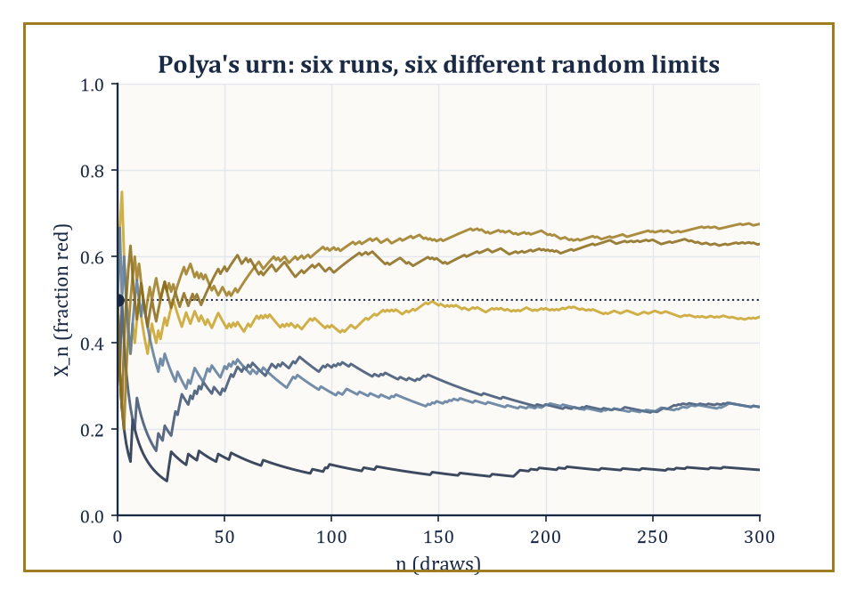
Figure 43.4 — Six runs of Pólya’s urn, six different destinies — each one a martingale that stopped wobbling and committed.
supₙ E|Xₙ| < ∞
then X_n converges almost surely to an integrable limit X_∞.
The intuition behind the proof is worth keeping, even without the details: if a martingale kept crossing back and forth over some interval [a, b] infinitely often, it would have to accumulate an unbounded amount of expected ‘wasted motion’ — up past b, back down past a, up again — which the L¹ bound forbids.
So for every rational interval, the number of crossings must eventually stay finite, which forces the sequence to settle down on one side or the other for every such interval simultaneously, which forces convergence.
Numeric example — Pólya’s urn and its random limit. Start an urn with 1 red ball and 1 blue ball. At each step, draw a ball uniformly at random, then return it to the urn along with one additional ball of the same color. Let Xₙ be the fraction of red balls after n draws, so
X₀ = 1/2
Compute one step by hand: from the 2-ball urn, drawing red (probability 1/2) produces an urn with 2 red, 1 blue, so
X₁ = 2/3
drawing blue (probability 1/2) produces 1 red, 2 blue, so
X₁ = 1/3
Check the martingale property:
E[X₁ | F₀] = (1/2)(2/3) + (1/2)(1/3) = (1/2)(1) = 1/2 = X₀
exactly as required — the urn ‘knows’ the future draw is unbiased by the past composition in the right way. Since X_n is always trapped in [0, 1], it is automatically L¹-bounded, so the martingale convergence theorem guarantees X_n → X_∞ almost surely for some random limit X_∞.
The classical (and rather charming) further fact — not proved here, but worth knowing as the punchline — is that X_∞ is Uniform(0, 1) distributed: the urn’s eventual color proportion is itself a uniformly random number, generated entirely by its own history.
Try it now — Pólya’s urn starts with 1 red and 1 blue. What is P(first draw red), and P(second red | first red)? Answer →
The strong law of large numbers holds for i.i.d. integrable Xᵢ with mean μ:
(1/n)Σᵢ₌₁ⁿ Xᵢ → μ almost surely
This is now recoverable as an instance of this general machinery, either by building a suitable reverse martingale from the partial sums, or by the classical two-step route: Kolmogorov’s three-series theorem, which reduces almost-sure convergence of a series of independent (not necessarily identical) terms to the convergence of three auxiliary numerical series built from truncated means, variances, and tail probabilities; followed by Kronecker’s lemma, a purely deterministic fact converting convergence of a series Σaₙ/n into convergence of the Cesàro-type average (1/n)Σaₙ to zero.
Almost-sure convergence alone does not hand you convergence of expectations — dominated convergence needs an actual dominating function — so one further ingredient, uniform integrability, is what upgrades almost-sure (or in-probability) convergence to convergence in L¹: it is the ‘just enough domination, on average, uniformly across the sequence’ condition.
Numeric example — the strong law’s fluctuations, in numbers. Let Xᵢ be i.i.d. Bernoulli(0.3), so
Var(Xᵢ) = 0.3 × 0.7 = 0.21
The strong law says
(1/n)ΣXᵢ → 0.3 almost surely
but it says nothing about the rate — for that we need the standard deviation of the average, σ/√n.
At n = 10,
σ/√n = √(0.21/10) = √0.021 ≈ 0.145
two standard deviations is about 0.29, so a run of just 10 flips could easily land anywhere from roughly 0 to 6 successes (a sample fraction of 0 to 0.6) without contradicting anything.
At n = 1000,
σ/√n = √(0.21/1000) = √0.00021 ≈ 0.0145
ten times smaller, so the sample average is now typically pinned to within about ±0.03 of the true value 0.3.
This is the strong law’s convergence made visible: the fluctuation shrinks like 1/√n, so no fixed finite sample ever proves the limit, but every larger sample squeezes the plausible range tighter around it — the qualitative picture ‘almost surely’ is promising to deliver in the limit, unannounced.
The central limit theorem admits at least three different proofs, each illuminating a different part of the theory: via characteristic functions and Lévy’s continuity theorem (convergence of characteristic functions implies weak convergence of laws); via Lindeberg’s replacement method, which swaps the summands for independent Gaussians one at a time while controlling the damage using a third-moment condition; and via a martingale central limit theorem for triangular arrays of martingale differences satisfying a conditional Lindeberg condition, which is what lets the CLT extend far beyond the i.i.d. case — to Markov chains, to regression residuals, to any process whose increments are ‘unpredictable given the past’ in the martingale sense even if they are not literally independent or identical.
The Berry–Esseen theorem makes the rate of convergence in the classical CLT completely explicit:
supₓ |P((Sₙ − nμ)/(σ√n) ≤ x) − Φ(x)| ≤ Cρ/(σ³√n)
where ρ = E|X₁ − μ|³ and C is an absolute constant (the best known value, due to Shevtsova, is C ≈ 0.4748).
Numeric example — an explicit Berry–Esseen bound. Continue with Xᵢ i.i.d. Bernoulli(0.3), so
μ = 0.3, σ² = 0.21, σ = √0.21 ≈ 0.45826
and
ρ = E|X − 0.3|³ = 0.3 × (0.7)³ + 0.7 × (0.3)³ = 0.3 × 0.343 + 0.7 × 0.027 = 0.1029 + 0.0189 = 0.1218
Since σ² = 0.21 exactly,
σ³ = σ² × σ = 0.21 × 0.45826 ≈ 0.09623
At n = 100, √n = 10, so the denominator is
σ³√n ≈ 0.9623
and the numerator is
Cρ ≈ 0.4748 × 0.1218 ≈ 0.05783
The bound is therefore about
0.05783 / 0.9623 ≈ 0.0601
for a sample of 100 Bernoulli(0.3) trials, the standardized sum’s cumulative distribution function is guaranteed to be within about 0.06 of the standard normal CDF, uniformly over every threshold — a fully explicit, non-asymptotic guarantee, in contrast to the bare central limit theorem, which only promises the gap vanishes eventually without saying how fast.
Seen from here, the classical limit theorems of elementary probability — once proved by separate and often quite delicate ad hoc arguments — are the martingale convergence theorem, applied to cleverly chosen martingales, wearing their nineteenth- and twentieth-century names.
Keep only this · Section 43.5: Convergence Theorems and the Strong Law
The idea. The strong law says averages converge with probability one; martingale convergence says bounded fair games settle down, possibly at a random limit.
Core.
X̄ₙ → μ almost surely (i.i.d., E|X| < ∞)
L¹-bounded martingales converge a.s.
Typical mistake. Assuming every martingale limit is a constant. Pólya’s urn’s red fraction converges, and its limit is uniformly distributed on [0, 1].
Minimal example. Bernoulli(0.3): the fraction of successes converges to 0.3 almost surely.
Practice. Easy to challenge; full worked answers, with the usual mistake, are in Answers to the Practice Sets at the back.
Easy — For Bernoulli(0.3), what is the standard deviation of X̄ at n = 10,000? Answer →
Medium — In Pólya’s urn, find the probability that the first two draws are both red. Answer →
Challenge — Show that the red fraction in Pólya’s urn is a martingale. Answer →

Section 43.6: Brownian Motion
The drunkard’s walk, taken to the continuous limit, and still no soberer for it
Robert Brown, looking through a microscope in 1827, saw tiny particles from pollen grains jostling endlessly in water, kicked about by molecules far too small to see. The mathematical version of that motion is a path that moves continuously but changes direction at every instant, each stretch of it independent of the past, with its spread growing in proportion to elapsed time: after four seconds the typical distance from the start is twice what it was after one. It is the limit of a random walk with ever smaller and faster steps. The path is continuous everywhere yet differentiable nowhere, and it underlies models of diffusion, stock prices and electronic noise.
A standard Brownian motion (or Wiener process) (Bₜ)_(t≥0) is a stochastic process with B₀ = 0, independent increments (Bₜ − Bₛ is independent of the past for t > s), and continuous sample paths almost surely. Its increments are Gaussian:
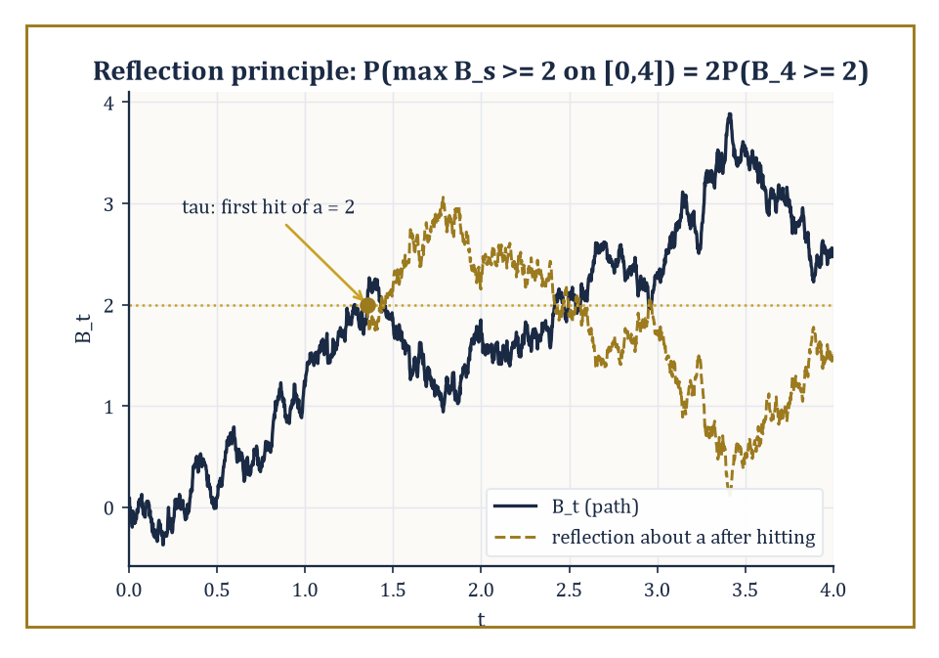
Figure 43.5 — Reflect the path about the level it first touches, and the maximum’s whole distribution falls out for free.
Bₜ − Bₛ ~ N(0, t − s)
That such a process exists at all is not obvious — a naive construction from the prescribed finite-dimensional (Gaussian) distributions via Kolmogorov’s extension theorem gives a process, but says nothing about whether its paths can be chosen continuous. Kolmogorov’s continuity criterion closes this gap: if a moment bound of the following form holds for some p, C, α > 0, then a continuous modification of the process exists.
E|Bₜ − Bₛ|ᵖ ≤ C|t − s|¹⁺ᵅ
For Brownian motion’s Gaussian increments this moment bound is easy to check directly. An equally illuminating existence route is Donsker’s invariance principle, which builds Brownian motion as the limit, as n → ∞, of a suitably rescaled simple random walk.
Numeric example — Donsker scaling, checked at one point. Let Sₖ be the simple random walk with i.i.d. ±1 steps, and define the rescaled process
Wₙ(t) = S_⌊nt⌋/√n, for t ∈ [0, 1]
Take n = 100 and t = 0.25, so ⌊nt⌋ = 25. Since each step has variance 1 and the steps are independent,
Var(S₂₅) = 25
so
Var(W₁₀₀(0.25)) = Var(S₂₅)/100 = 25/100 = 0.25
which matches, exactly,
Var(B_(0.25)) = 0.25
for standard Brownian motion. In general,
Var(Wₙ(t)) = ⌊nt⌋/n → t as n → ∞
for every fixed t, which is the numerical heart of Donsker’s theorem: the rescaled random walk’s variance converges pointwise to Brownian motion’s, and (with considerably more work) so do all its finite-dimensional distributions and its path behavior.
Try it now — For standard Brownian motion, compute P(B₄ > 2) and, by the reflection principle, P(max over s ≤ 4 of Bₛ ≥ 2). Answer →
Brownian motion’s quadratic variation is one of its most consequential features: for a partition of [0, t] with mesh going to zero, the sum of squared increments converges (in probability, and in L²) to t itself.
Σ(B_(tᵢ₊₁) − B_(tᵢ))² → t
Compare this to any smooth function, whose quadratic variation over any interval is zero — Brownian paths, despite being continuous, are almost surely nowhere differentiable and have infinite total variation on every interval, a fact that scandalized nineteenth-century analysts and merely irritates first-year probabilists now.
Numeric example — quadratic variation, checked in expectation. Partition [0, 1] into n equal pieces, each of length 1/n. Each increment B_(i/n) − B_((i−1)/n) has variance 1/n, since Brownian increments over an interval of length h have variance h. There are n such increments, so:
E[Σᵢ₌₁ⁿ (B_(i/n) − B_((i−1)/n))²] = n × (1/n) = 1
precisely, for every single n — not only in the limit. This is a much weaker statement than the true quadratic-variation theorem (which shows the sum itself, not merely its expectation, converges to 1 as the partition refines), but it already shows why the answer has to be t = 1 and not, say, 0: the expected value of the sum of squared increments is pinned to 1 at every level of partition refinement, so whatever the limit turns out to be, it cannot be anything other than 1. Refining the partition (larger n) does not change this expectation at all — it only shrinks the fluctuation of the sum around it, which is the extra ingredient (a variance computation, then Chebyshev) needed to upgrade ‘correct on average’ to ‘converges in probability’.
The strong Markov property says that Brownian motion, restarted at a stopping time, is again a Brownian motion independent of everything that came before — a fact used constantly, for instance in the reflection principle, obtained by reflecting the path about a level a after the first time it is hit (which, by the strong Markov property, is a legitimate fresh Brownian motion to reflect):
P(max[s≤t] Bₛ ≥ a) = 2P(Bₜ ≥ a), for a > 0
A tidy corollary worth remembering is that the running maximum has the same distribution as |Bₜ| itself:
Mₜ = max[s≤t] Bₛ has the same distribution as |Bₜ|
Reflection turns ‘the maximum exceeded a’ into ‘the endpoint, possibly reflected, exceeded a’, and the two events have exactly matching probability for every a. The law of the iterated logarithm pins down the almost-sure envelope of oscillation with remarkable precision:
limsup[t→∞] Bₜ/√(2t ln ln t) = 1 almost surely
This is a growth rate slower than any fixed power of t, but faster than any fixed multiple of √t, sitting in the narrow gap between the two with an exactness that still looks like a magic trick on first meeting it.
Numeric example — the reflection principle, in numbers. Take t = 4 and a = 2. Since B₄ ~ N(0, 4), standardize:
Z = B₄/2 ~ N(0, 1)
so
P(B₄ ≥ 2) = P(Z ≥ 1) = 1 − Φ(1) ≈ 1 − 0.8413 = 0.1587
By the reflection principle:
P(max[s≤4] Bₛ ≥ 2) = 2 × 0.1587 = 0.3174
This must exceed P(B₄ ≥ 2) alone — reaching level 2 at some point during [0,4] is strictly easier than being at or above 2 at time 4 — and indeed 0.3174 > 0.1587, as required; it must also stay below 1, which it comfortably does.
Brownian motion is simultaneously a martingale (Martingales in Discrete Time) and a Markov process (Markov Processes and Generators) with continuous paths — the meeting point of every idea this chapter has built so far.
It is the object from which essentially every continuous-time process of real interest is constructed, by time-change, by conditioning, or by the stochastic integration that lies just past this chapter’s summit, in the neighborhood usually called stochastic calculus.
Same structure, new language
The density of Bₜ is the heat kernel exp(−x²/(2t))/√(2πt), and it solves u_t = ½u_xx, the heat equation of Partial Differential Equations (Volume 3) with diffusion constant ½. The ink drop that spread in Volume 3 and the random walker here are one object seen twice: the PDE describes the crowd, Brownian motion one member of it.
Keep only this · Section 43.6: Brownian Motion
The idea. Brownian motion is the continuous limit of a random walk: continuous paths, independent normal increments with variance equal to elapsed time.
Core.
B₀ = 0, Bₜ − Bₛ ~ N(0, t − s) independent of the past
Cov(Bₛ, Bₜ) = min(s, t), quadratic variation over [0, t] = t
Typical mistake. Treating Brownian paths like smooth curves. They are continuous but nowhere differentiable, with infinite length on every interval.
Minimal example. Var(B₃ − B₁) = 2.
Practice. Easy to challenge; full worked answers, with the usual mistake, are in Answers to the Practice Sets at the back.
Easy — Find Var(B₃ − B₁). Answer →
Medium — Find Cov(B₂, B₅). Answer →
Challenge — Show that the sum of squared increments over n equal pieces of [0, 1] has mean 1 and variance 2/n. Answer →

Section 43.7: Continuous-Time Martingales and Stopping Times
Doob’s theory, now with an uncountable index set (apologies in advance)
Moving from discrete to continuous time introduces a genuine technical hazard: with uncountably many time points, naive definitions can silently break.
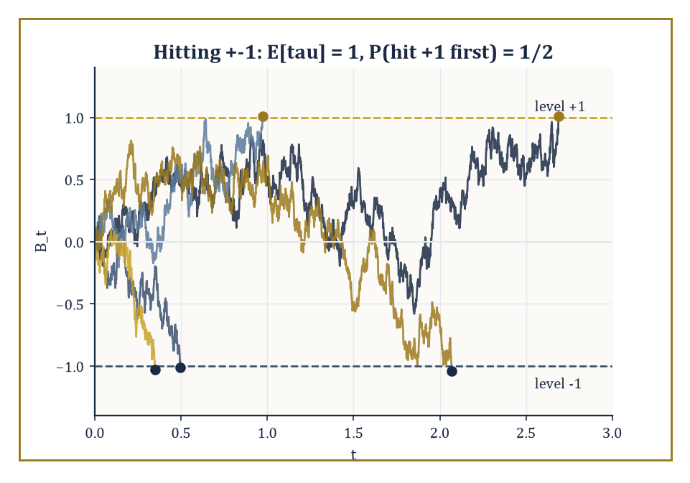
Figure 43.6 — Five paths, two barriers, and a coin flip’s worth of suspense about which one gets hit first.
The standard fix is to require the filtration (Fₜ)_(t≥0) to satisfy the ‘usual conditions’ — right-continuity, meaning information cannot jump discontinuously into existence, plus completeness with respect to null sets. Right-continuity is the requirement that:
Fₜ = ∩_(s>t) Fₛ
Under mild conditions a submartingale has a càdlàg version (right-continuous with left limits — the French acronym has simply stuck in English usage), which is the standard choice of representative path.
An optional time is the continuous-time analogue of a stopping time:
{τ ≤ t} ∈ Fₜ for every t
The optional sampling theorem extends Doob’s discrete result: for a right-continuous martingale with the right integrability (bounded τ, or a uniformly integrable stopped process, are the usual sufficient conditions),
E[X_τ] = E[X₀]
Doob’s maximal inequality likewise extends:
P(sup[s≤t] |Xₛ| ≥ λ) ≤ E|Xₜ|/λ
Numeric example — hitting probabilities via optional sampling. Let τ be the first time standard Brownian motion, started at 0, hits either level +1 or level −1. This τ is a legitimate case for optional sampling, unlike the cautionary example in Martingales in Discrete Time: it is a classical fact that E[τ] = 1 (in general, for symmetric barriers at ±a, E[τ] = a²), so the integrability hypothesis genuinely holds, and B is bounded by 1 throughout [0, τ].
Optional sampling therefore applies directly:
E[B_τ] = E[B₀] = 0
Writing p = P(hit +1 first), B_τ equals +1 with probability p and −1 with probability 1 − p, so:
E[B_τ] = p(1) + (1−p)(−1) = 2p − 1 = 0
giving:
p = 1/2
This is the continuous-time mirror of the discrete gambler’s-ruin computation from Martingales in Discrete Time with a = b = 1, which also gave:
p = a/(a+b) = 1/2
— the discrete and continuous theories agreeing precisely, as any sensible theory built on the same intuitions ought to.
Try it now — Brownian motion from 0 stops at the first hit of +1 or −2. What is the probability of hitting +1 first, and the expected stopping time? Answer →
Quadratic variation ⟨X⟩_t, already met for Brownian motion in the last section (where ⟨B⟩_t = t), is defined in general as the increasing process making the following a local martingale:
Xₜ² − ⟨X⟩_t
‘Local martingale’ relaxes the martingale property to hold only up to a localizing sequence of stopping times — an accommodation needed because several important continuous-time processes are fair games only in this weaker, local sense: their true martingale property can fail globally purely because an integrability condition blows up, even though every finite piece of the path looks perfectly fair.
A semimartingale is a local martingale plus a finite-variation process, and semimartingales are the class of integrators against which the Itô stochastic integral — the subject waiting just past this chapter’s horizon — can be defined.
The Doob–Meyer decomposition writes any (sufficiently regular) submartingale uniquely as:
Xₜ = Mₜ + Aₜ
with Mₜ a local martingale and Aₜ a predictable increasing process: the continuous-time way of saying ‘fair game plus a systematic, foreseeable upward drift’.
Abstract example — the Doob–Meyer decomposition of a Poisson process. Let Nₜ be a Poisson process of rate λ — a counting process whose increments Nₜ − Nₛ (t > s) are Poisson(λ(t−s)) and independent of the past. It is a submartingale:
E[Nₜ | Fₛ] = Nₛ + λ(t − s) ≥ Nₛ
Its Doob–Meyer decomposition is:
Nₜ = Mₜ + λt
where Mₜ := Nₜ − λt is the compensated Poisson process. Verify Mₜ is a genuine martingale:
E[Mₜ | Fₛ] = E[Nₜ − Nₛ | Fₛ] + Nₛ − λt = λ(t−s) + Nₛ − λt = Nₛ − λs = Mₛ
the martingale property. Here the increasing process Aₜ = λt is even deterministic, hence trivially predictable — the simplest possible instance of Doob–Meyer, and the maneuver queueing theorists and actuaries use to convert a raw arrival count into a fair-game process suitable for martingale-based estimation and central limit arguments.
Numeric example — Doob’s continuous-time maximal inequality, and how loose it is. Doob’s L² maximal inequality states:
E[(sup[s≤t] |Xₛ|)²] ≤ 4 E[Xₜ²]
for a martingale X. Apply it to standard Brownian motion at t = 9:
E[B₉²] = 9
(Brownian Motion), so the inequality gives:
E[(sup[s≤9] |Bₛ|)²] ≤ 4 × 9 = 36
But for Brownian motion the running maximum Mₜ = max[s≤t] Bₛ has the same distribution as |Bₜ| (the reflection-principle corollary from Brownian Motion), so:
E[Mₜ²] = E[Bₜ²] = t
exactly — meaning the true value at t = 9 is:
E[M₉²] = 9
not 36. Doob’s inequality, in this instance, is correct but loose by a factor of 4, which is entirely typical: maximal inequalities are prized for holding in complete generality, for every martingale whatsoever, and that generality is paid for in tightness.
When you have extra structure — as Brownian motion’s reflection principle supplies here — you can usually do much better than the universal bound, but the universal bound is what you reach for first, on a process about which you know nothing else.
This continuous-time apparatus — right-continuous filtrations, optional times, quadratic variation, local martingales, Doob–Meyer — is not an end in itself.
It is the load-bearing scaffolding on which the stochastic calculus of the next mathematical neighborhood is built, and a first taste of that calculus is where this chapter’s final section is headed.
Keep only this · Section 43.7: Continuous-Time Martingales and Stopping Times
The idea. Continuous-time martingales need right-continuous paths and filtrations so that stopping times are well defined; with that care, Doob’s theorems carry over.
Core.
exit of (−b, a) from 0: P(+a first) = b/(a + b), E[τ] = ab
Nₜ − λt is a martingale for a Poisson process of rate λ
Typical mistake. Assuming a first-hitting time is automatically a stopping time. Without regular paths and a suitable filtration it need not be.
Minimal example. Exit of (−1, 1): P(+1 first) = ½, E[τ] = 1.
Practice. Easy to challenge; full worked answers, with the usual mistake, are in Answers to the Practice Sets at the back.
Easy — Find P(hit +3 before −1) for Brownian motion from 0. Answer →
Medium — Find the expected exit time of (−1, 3). Answer →
Challenge — For a Poisson process of rate λ = 2, use the martingale Nₜ − λt to find E[N₃], and give Var(N₃). Answer →

Section 43.8: Markov Processes and Generators
Amnesia as an organizing principle
A board game played with dice has a useful kind of forgetfulness: where you go next depends only on the square you are on now, not on how you got there. Processes with this property are called Markov processes, and they model queues, chemical reactions, the spread of infections and the wandering of web surfers between pages. In continuous time the whole behavior is summarized by the rates at which the process jumps from each state to each other. A machine that breaks down and is repaired at the same rate, switching each way at rate q, forgets which state it started in at rate 2q and settles into spending half its time in each.
A stochastic process (Xₜ) is Markov if its future depends on its past only through its present value, for every s, t ≥ 0 and every event A:
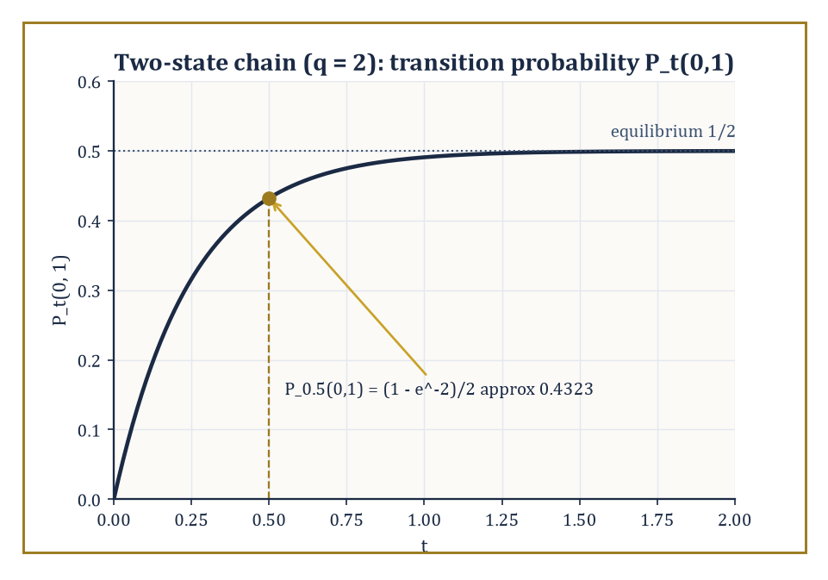
Figure 43.7 — The two-state chain forgets which state it started in at rate 2q, settling into its equilibrium coin flip.
P(Xₜ₊ₛ ∈ A | Fₜ) = P(Xₜ₊ₛ ∈ A | Xₜ) almost surely
The transition semigroup (Pₜ)_(t≥0) encodes the law of the future given the present:
Pₜ(x, A) = P(Xₜ ∈ A | X₀ = x)
The semigroup property — the Chapman–Kolmogorov equation —
Pₜ₊ₛ = Pₜ Pₛ
is the statement that going partway and then the rest of the way gives the same distribution as going straight there.
The infinitesimal generator L is defined on a suitable domain of functions f by
Lf = lim[t→0] (Pₜ f − f)/t
it captures the instantaneous drift and diffusion of the process.
Kolmogorov’s backward equation describes how expectations evolve, with u(t,x) = Eₓ[f(Xₜ)]:
∂_t u = Lu
The forward (Fokker–Planck) equation describes how the probability mass itself evolves, for the transition density p:
∂_t p = L*p
The same physics, viewed from two ends of the same telescope.
Numeric example — a two-state continuous-time Markov chain. Consider a chain on states {0, 1} that jumps from 0 to 1 at rate q and from 1 to 0 at rate q (a symmetric telegraph-type process), with generator matrix
L = [−q q; q −q]
Diagonalizing L: the vector (1,1) is an eigenvector with eigenvalue 0, and (1,−1) is an eigenvector with eigenvalue −2q. Exponentiating gives the standard closed form
Pₜ(0,1) = (1 − exp(−2qt))/2
Take q = 2 and t = 0.5, so
2qt = 2 × 2 × 0.5 = 2
and e⁻² ≈ 0.1353:
Pₜ(0,1) = (1 − 0.1353)/2 = 0.8647/2 ≈ 0.4324
Two sanity checks confirm the formula: as t → 0,
2qt → 0 and Pₜ(0,1) → (1−1)/2 = 0
correctly saying there is no time to jump; as t → ∞,
Pₜ(0,1) → (1−0)/2 = 0.5
correctly converging to the symmetric chain’s equilibrium of spending half its time in each state.
Try it now — For the symmetric two-state chain with rate q = 2, P(Xₜ = 0 | X₀ = 0) = ½ + ½e^(−2qt). Evaluate it at t = 0.25. Answer →
Numeric example — Chapman–Kolmogorov, checked directly. The semigroup property should hold for the two-state chain above with q = 2:
Pₜ₊ₛ = Pₜ Pₛ
Split t = 0.5 as t = 0.3 + 0.2 and check both routes agree. Direct, this was computed earlier:
P_(0.5)(0,1) = (1 − e⁻²)/2 ≈ 0.4324
Via the split, first compute the two intermediate transition probabilities:
P_(0.3)(0,1) = (1 − exp(−1.2))/2 ≈ (1 − 0.3012)/2 ≈ 0.3494, so P_(0.3)(0,0) ≈ 0.6506
P_(0.2)(0,1) = (1 − exp(−0.8))/2 ≈ (1 − 0.4493)/2 ≈ 0.2753, so P_(0.2)(1,1) = P_(0.2)(0,0) ≈ 0.7247 by the chain’s symmetry
Chapman–Kolmogorov says:
P_(0.5)(0,1) = P_(0.3)(0,0) P_(0.2)(0,1) + P_(0.3)(0,1) P_(0.2)(1,1)
Substituting the numbers:
0.6506 × 0.2753 + 0.3494 × 0.7247 ≈ 0.1791 + 0.2532 ≈ 0.4323
This matches the direct computation of 0.4324 up to rounding. The semigroup property is not a formal abstraction here; it is an ordinary law-of-total-probability statement (condition on where the chain is at the intermediate time 0.3), and the matrix exponential formula for Pₜ is the bookkeeping device that makes it automatic for every split of every t.
Diffusion processes are Markov processes with continuous paths whose generators are second-order differential operators — literally the advection–diffusion operator of classical physics, now interpreted probabilistically, with b the drift and σ² the diffusion coefficient. In one dimension:
Lf(x) = ½σ²(x) f″(x) + b(x) f′(x)
Brownian motion is the case b = 0, σ = 1, giving
L = ½ d²/dx²
Geometric Brownian motion, the standard Black–Scholes model of a stock price, has generator
Lf(x) = ½σ²x² f″(x) + μx f′(x)
The Ornstein–Uhlenbeck process, the standard model of mean reversion (interest rates, physical systems relaxing to equilibrium), has generator
Lf(x) = ½σ² f″(x) − θx f′(x)
with the term −θx pulling the process back toward zero at rate θ. Jump processes — the Poisson process, and more generally Lévy processes, defined by stationary independent increments, of which Brownian motion and the Poisson process are the two purest examples — extend the Markov class beyond continuous paths entirely. Notice that all three named diffusions above are, at bottom, the same generator ½σ²f″ with a different drift term bolted on — a small, respectable menagerie built from one recycled idea, which is rather how most of applied mathematics gets done.
Abstract example — the Ornstein–Uhlenbeck generator explains its own mean reversion. Take the Ornstein–Uhlenbeck generator
Lf(x) = ½σ² f″(x) − θx f′(x)
and test it on the simple function f(x) = x, so that f′(x) = 1 and f″(x) = 0:
Lf(x) = ½σ²(0) − θx(1) = −θx = −θf(x)
The identity function is an eigenfunction of L with eigenvalue −θ. This single computation is the generator-level explanation for exponential mean reversion: solving the backward equation ∂_t u = Lu with initial condition u(0,x) = f(x) = x, and using that f is an eigenfunction, gives
u(t,x) = eᴸᵗf(x) = e⁻ᶿᵗf(x) = e⁻ᶿᵗx
that is,
Eₓ[Xₜ] = e⁻ᶿᵗx
the mean decaying exponentially back to zero at rate θ, exactly the ‘spring pulling toward zero’ intuition one draws for this process, now derived rather than merely asserted.
The Markov property is the probabilistic expression of memorylessness, and it is the organizing principle behind an enormous swathe of applied probability — queueing theory, population genetics, mathematical finance, statistical mechanics — precisely because ‘forget everything except where you are right now’ is, remarkably often, close enough to true to be worth building an entire theory on.
Where this returns
A generator is to a Markov process what the right-hand side f(x) of ẋ = f(x) is to a flow in Flows, Maps, and Phase Portraits: the instantaneous rule from which the whole evolution follows. Uncertainty quantification in Uncertainty Quantification pushes random inputs through such evolutions numerically.
Keep only this · Section 43.8: Markov Processes and Generators
The idea. A Markov process forgets its past; its generator, the instantaneous rate of change of expectations, determines everything, and the transition probabilities form a semigroup.
Core.
Pₜ₊ₛ = PₜPₛ (Chapman–Kolmogorov)
two-state, rate q: Q = [−q q; q −q]
OU: Lf = −θx f′ + (σ²/2) f″
Typical mistake. Thinking the generator’s rows should sum to 1. They sum to 0; it is the transition matrices Pₜ whose rows sum to 1.
Minimal example. q = 2, t = 0.25: P₀₀ ≈ 0.684.
Practice. Easy to challenge; full worked answers, with the usual mistake, are in Answers to the Practice Sets at the back.
Easy — Write the generator for the two-state chain with q = 2 and check its row sums. Answer →
Medium — Check Chapman–Kolmogorov: P₀₀(0.5) from the formula and from P₀₀(0.25)² + P₀₁(0.25)P₁₀(0.25). Answer →
Challenge — Apply the OU generator to f(x) = x and deduce E[Xₜ | X₀ = x]. Answer →

Section 43.9: Looking Ahead: From Advanced Probability to Stochastic Calculus, SPDEs, and Ergodic Theory
Onward, upward, and increasingly stochastic
We have now assembled the core of advanced probability: measure-theoretic foundations for probability spaces and random variables; independence and the extension theorems that let infinite collections of them exist; conditional expectation as the operator underlying everything else; martingales in discrete time and the convergence theorems built from them; Brownian motion as the canonical continuous-time process; the continuous-time martingale theory of quadratic variation, local martingales, and Doob–Meyer; and Markov processes with their generators.
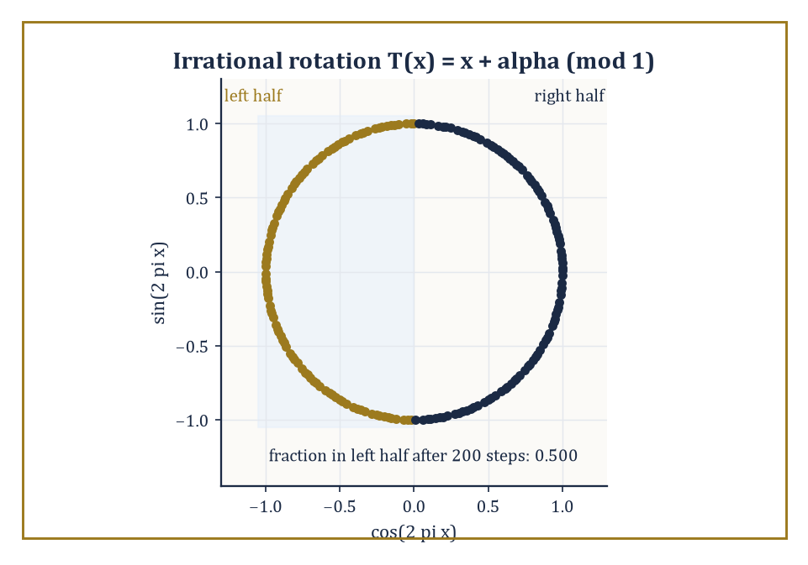
Figure 43.8 — Two hundred steps of an irrational rotation, and the orbit has already split the circle down the middle.
Each of these pieces was, in its own section, a destination; together, they are also a staging ground.
The most immediate neighborhood beyond this chapter is stochastic calculus: the Itô integral, which makes sense of ‘integrating against’ a martingale of unbounded variation like Brownian motion, and Itô’s formula, the corrected chain rule that accounts for the fact that Brownian motion’s quadratic variation is not zero. Where ordinary calculus says
df(Bₜ) = f′(Bₜ) dBₜ
Itô’s formula adds a second term,
df(Bₜ) = f′(Bₜ) dBₜ + ½f″(Bₜ) dt
a correction that is, in effect, the tax levied for differentiating a function of a path that is continuous but nowhere smooth.
Numeric example — Itô’s formula recovers a fact we already knew. Take f(x) = x², so f′(x) = 2x and f″(x) = 2. Itô’s formula gives
d(Bₜ²) = 2Bₜ dBₜ + ½(2) dt = 2Bₜ dBₜ + dt
The term 2Bₜ dBₜ is (the differential of) an Itô integral, which is itself a martingale started at 0, so its expectation is 0 for every t; taking expectations of both sides therefore gives
d E[Bₜ²] = dt
and integrating from 0 with E[B₀²] = 0 gives
E[Bₜ²] = t
This matches Var(Bₜ) = t exactly, a fact we already established directly from the definition of Brownian motion back in Brownian Motion — two entirely different routes, the defining Gaussian property and the machinery of Itô’s formula, landing on the identical answer. That agreement is not a coincidence to be shrugged off; it is the kind of cross-check that makes stochastic calculus trustworthy rather than merely clever, and it is the first genuine computation in a toolkit the next mathematical neighborhood will use constantly.
Try it now — Use Itô’s formula for f(x) = x² to find E[Bₜ²]. Answer →
Past stochastic calculus lie stochastic partial differential equations, where the noise driving the equation is itself an infinite-dimensional (space-time) object; the general theory of stochastic processes, which sharpens the distinction between predictable information (‘can see it coming one instant ahead’) and only optional information (‘knows it the moment it happens’), a distinction this chapter’s Doob–Meyer decomposition already leaned on without quite naming it; and ergodic theory, whose Birkhoff almost-everywhere convergence theorem for measure-preserving transformations is the deterministic-dynamics cousin of the strong law of large numbers from Convergence Theorems and the Strong Law — time averages along a single trajectory converging to space averages, the same phenomenon this chapter proved for independent randomness, now proved for deterministic systems with just enough mixing to behave, statistically, as if they were random.
Abstract example — Birkhoff’s theorem for an irrational rotation. Let T : [0,1) → [0,1) be rotation by an irrational angle α,
T(x) = x + α (mod 1)
which preserves Lebesgue measure (rotating the circle does not distort lengths) and is ergodic because α is irrational (a rational rotation would instead break the circle into finitely many invariant arcs, and ergodicity — the deterministic analogue of ‘no non-trivial invariant information’, echoing the independence discussion of Independence, Product Spaces, and Kolmogorov’s Extension — would fail). Take f to be the indicator function of the interval [0, 0.5). Birkhoff’s theorem guarantees that for almost every starting point x₀, the time average converges to the space average:
(1/n)Σₖ₌₀ⁿ⁻¹ f(Tᵏx₀) → ∫₀¹ f dx = 0.5
the Lebesgue measure of the interval. Concretely: this says that the orbit x₀, x₀+α, x₀+2α, … (mod 1) visits the left half of the circle exactly half the time in the long run, for almost every starting point — the equidistribution of irrational rotations, which number theorists knew and proved by other means well before ergodic theory existed, now recovered as a single instance of the same time-average-equals-space-average phenomenon that gave us the strong law of large numbers for coin flips. Deterministic dynamics and independent randomness, in the end, obey the identical limit law.
Applications of this whole apparatus range from mathematical finance and signal filtering to statistical physics and the probabilistic analysis of algorithms — anywhere a system evolves under genuine uncertainty and someone, eventually, needs a guarantee sharper than a shrug.
The deeper lesson of this chapter is not any single theorem but the shift in vocabulary: once probability is built on measure theory, information, fairness, and continuous-time evolution stop being metaphors and become precise mathematical objects, with a coherent theory connecting them.
Advanced probability, in the end, is the measure-theoretic theory of randomness and information — and having built it, we are now equipped to let it run.
We have spent this chapter turning informal certainties into provable ones, at the cost of a prose style in which ‘almost surely’ quietly carries most of the moral weight and the sample space itself, once its existence is secured, is rarely spoken of again. That trade — rigor for a certain deliberate austerity — is the going rate for a theory that can handle continuous time and infinite dimensions without blinking, and it is, on the entire, a fair exchange; certainly fairer than most martingales one meets in practice.
The next chapter moves, sideways perhaps, into computational geometry: convex hulls, Voronoi diagrams, triangulations, the combinatorics of points and lines in the plane and beyond — a subject that looks, on first approach, like the driest and most deterministic corner of the entire series. It will not stay that way for long. The fastest known algorithms for building convex hulls and Delaunay triangulations are randomized, and their expected-running-time analyses lean on the independence, conditional expectation, and martingale bookkeeping this chapter just built — so the randomness we have spent nine sections taming will turn out to be, a chapter from now, someone else’s favorite algorithmic trick.
The series continues. We have learned to build probability on measure, and to let it run — and, mercifully, it appears to know where it is going even when we, its architects, occasionally do not.
Keep only this · Section 43.9: Looking Ahead: From Advanced Probability to Stochastic Calculus, SPDEs, and Ergodic Theory
The idea. Stochastic calculus adds a second-order correction to the chain rule; ergodic theory says time averages equal space averages for suitable systems.
Core.
Itô: df(Bₜ) = f′(Bₜ) dBₜ + ½ f″(Bₜ) dt
Birkhoff: (1/n) Σ g(Tᵏx) → ∫ g (ergodic T)
Typical mistake. Dropping the ½ f″ dt term. It is there because (dBₜ)² = dt, not 0.
Minimal example. Irrational rotation: the fraction of time spent in [0, ½) tends to ½.
Practice. Easy to challenge; full worked answers, with the usual mistake, are in Answers to the Practice Sets at the back.
Easy — For the irrational rotation of [0, 1), what is the long-run fraction of time spent in [0, 0.3)? Answer →
Medium — Use Itô’s formula on f(x) = x³. Answer →
Challenge — Show that Mₜ = exp(Bₜ − t/2) has E[Mₜ] = 1. Answer →
Chapter 43 recap · Probability Theory (Advanced)
• Nothing about probability changes here except the machinery: the definitions of Chapter 42, used on large Ω and in continuous time.
• Independence is a property of σ-algebras; pairwise is weaker than mutual. Kolmogorov’s theorem builds a process from consistent finite-dimensional laws.
• E[X | G] is the best guess of X from the information G; the tower property says averaging a guess gives the plain average.
• Martingales are fair games: E[Xₙ₊₁ | Fₙ] = Xₙ. Optional stopping holds only under conditions, and its failures are instructive.
• Convergence theorems: the strong law, martingale convergence (Pólya’s urn has a random limit), Berry–Esseen rates.
• Brownian motion is the continuum random walk: independent N(0, t − s) increments, quadratic variation t. Markov processes are run by their generators.

Check Your Understanding — Chapter 43
Answers are in the Answer Key at the back of the book — have a go before you look.
1. [Compute] Working on the probability space Ω=[0,1] with Lebesgue measure, define X(ω) = −ln ω. What is P(X ≤ 1), and what distribution have you just constructed?
See the answer →
2. [Concept] Give an example showing that pairwise independence of a collection of random variables does not imply their mutual independence.
See the answer →
3. [Explain] For the simple random walk S_n starting at S₀=0, let τ be the first time it hits +1. Since the walk is recurrent, S_τ = 1 always, so E[S_τ] = 1, yet E[S₀] = 0. Why doesn’t this contradict the optional stopping theorem?
See the answer →
4. [Compute] Using the reflection principle, compute P(max[s≤4] Bₛ ≥ 2) for standard Brownian motion, and briefly explain why the reflection principle applies.
See the answer →
5. [Model] A gambler starts with £10 and bets £1 at a time on a fair coin, stopping at £0 or £20. What is the probability of reaching £20, and how does the answer change if the target is £100 instead?
See the answer →
6. [Explain] Why is the conditional expectation E[X | G] a random variable rather than a number, when the ordinary expectation E[X] is just a number?
See the answer →
7. [Prove] Show the tower property: E[E[X | G]] = E[X].
See the answer →
8. [Explain] A Brownian path is continuous, yet its quadratic variation over [0, t] is exactly t rather than zero. Why does that difference matter so much?
See the answer →
9. [Compute] For standard Brownian motion, compute P(B₁ > 0) and P(B₁ > 1).
See the answer →
10. [Challenge] A martingale has constant expected value, so “you cannot beat a fair game”. Yet the doubling strategy wins with probability one. What resolves the contradiction?
See the answer →

Problems — Chapter 43
The questions above test whether the ideas landed. These ask you to use them. Solutions are in Solutions to the Problems at the back. Work them before you look.
1. [Compute] A fair coin, three independent flips. Probability of exactly two heads.
2. [Compute] A fair coin again. Probability that the first head arrives on the third flip.
3. [Concept] The strong law says the sample average converges almost surely to the mean. What is the measure of the set of sequences where it does not?
4. [Compute] Events A and B, with P(B) = 1/2, P(A ∩ B) = 1/6. Compute P(A | B).

Math, Actually

Chapter 44

Computational Geometry
Algorithms, Data Structures, and the Art of Computing with Shapes
The previous chapter closed with a promise, tossed off almost as an afterthought at the end of a discussion of martingale convergence: that the machinery just built there — independence, conditional expectation, the whole disciplined apparatus for reasoning rigorously about randomness — would turn out, one chapter later, to be somebody else’s favorite algorithmic trick. That somebody is this chapter. The trick is this: the fastest convex hull algorithm known to humanity works by throwing the input points in at random and hoping, and the hoping is not naïve optimism, it is a theorem, with an expected-running-time proof that leans directly on the conditional-expectation bookkeeping we spent nine sections assembling.
Computational geometry, encountered cold, looks like the most bloodlessly deterministic subject in the entire series — points, lines, polygons, a Euclidean world with the straightedge and compass replaced by a machine that does not appreciate elegance and must be told, with tedious precision, just what to do. It does not stay that way for long, and we shall watch the randomness sneak back in by Convex Hulls.
Classical geometry, the kind Euclid practiced and the kind several early chapters of this series revisited, reasons about individual configurations: this triangle, that circle, prove the claim once and for all with a diagram and a chain of deductions. Computational geometry asks a different question, and it is a question Euclid never had to face because he never had ten million points to process before lunch.
Given a finite set of points, segments, or polygons — as input, on a computer, with no diagram to squint at — how quickly, and how reliably, can an algorithm compute their convex hull, their pairwise intersections, a triangulation, a nearest-neighbor structure, a decomposition into cells? The objects are the same ones geometry has always studied. The demand for a procedure that terminates in a predictable and provably small number of steps, on inputs of a size no human draftsman would attempt, is new, and it is the demand this entire chapter exists to satisfy.
The plan of the chapter: Convex Hulls builds the convex hull, the first nontrivial computation in the subject and the building block for most of what follows. Line-Segment Intersection and Arrangements sweeps a line across the plane to find every crossing among a bundle of segments, and introduces the arrangement those segments cut the plane into. Polygon Triangulation and Art Galleries cuts simple polygons into triangles and asks how few security guards a nervous museum director can get away with hiring. Voronoi Diagrams and Delaunay Triangulations studies the two most beautiful structures in the subject — Voronoi diagrams and Delaunay triangulations — which turn out to be the same structure viewed from two directions. Geometric Searching and Range Queries builds data structures that answer geometric questions about a fixed point set without re-examining every point each time. Arrangements of Lines and Hyperplanes studies what happens when the segments of Line-Segment Intersection and Arrangements are extended into full lines, an innocuous-sounding change that multiplies the complexity of the picture by roughly a factor of n. Robustness, Degeneracies, and Exact Computation confronts the fact that computers do arithmetic in floating point, and floating point does not know what convexity is, which turns out to matter enormously. Looking Ahead: From Classical CG to Motion Planning, Meshing, and High-Dimensional Geometry looks ahead toward motion planning, mesh generation, computational topology, and geometry in more dimensions than any of us can comfortably picture.
If Euclidean geometry taught us the properties of shapes, computational geometry teaches us to compute those properties at scale, under a clock, without cheating. Let’s compute with shapes.
Before you begin — Chapter 44
By the end of this chapter you will be able to:
1. Compute polygon areas with the shoelace formula and decide left or right turns with the orientation test.
2. Find a planar convex hull by hand and explain the Ω(n log n) lower bound.
3. Test whether two segments cross, and count the vertices, edges and faces of a line arrangement.
4. Triangulate a simple polygon and apply the art gallery bound ⌊n/3⌋.
5. Find Voronoi vertices as circumcenters and use the empty-circle test for Delaunay triangulations.
6. Explain why floating-point orientation tests fail near degeneracy and how exact or filtered arithmetic fixes them.
Prerequisites. Coordinates and distance from Coordinate Systems (Volume 1); determinants from Linear Algebra (Volume 2); the idea of an algorithm’s cost from Numerical Methods (Volume 3).
Estimated study time. About 10 hours, exercises included. Squared paper helps.

Section 44.1: What Computational Geometry Is
In Which Euclid Meets a Compiler and Is Not Amused
Draw a shape on squared paper and you can find its area by counting squares. Everybody has done this, and for a shape whose corners land on the grid lines it works perfectly well.
Give the same shape to a machine and the method evaporates. A machine has no squared paper and no eyes. What it has is a list: four pairs of numbers, the corners in the order you walk round them, and nothing else. It cannot glance at the figure to see whether the shape is fat or thin, or whether a corner pokes inward. Euclid assumed a draftsman with a straight edge and the ability to look; every one of those assumptions has been withdrawn.
What has to be answered, then, is narrower than it first sounds. Not what is the area of this shape, but what is the area computed from a list of numbers alone, with no picture consulted at any point.
The obvious route runs into something worth noticing. Chop the shape into triangles, find each triangle, add them up. But to chop it you must know which cuts stay inside the shape, and deciding whether a proposed cut stays inside a polygon is itself a geometry problem of exactly the kind you were trying to solve. You are required to do the geometry before you are permitted to begin the geometry.
The escape is to give up on cutting the shape up at all. Walk once round the boundary. Let every edge contribute a small signed quantity, chosen so that the contributions from the parts hanging outside cancel against the parts hanging inside. Then add them, having looked at nothing but consecutive pairs of numbers.
Take the quadrilateral with corners (0, 0), (4, 0), (5, 3) and (1, 4), and for each consecutive pair form the first corner’s x times the second’s y, less the second’s x times the first’s y:
(0, 0) and (4, 0) 0·0 − 4·0 = 0
(4, 0) and (5, 3) 4·3 − 5·0 = 12
(5, 3) and (1, 4) 5·4 − 1·3 = 17
(1, 4) and (0, 0) 1·0 − 0·4 = 0
total 29, and the area is half of it: 14.5
Two things that arithmetic never did are worth as much as the answer. It never looked at the shape, so it neither knows nor cares whether the quadrilateral is convex. And it never checked that the corners were given in the order you walk them: hand the same four points over in the order (0, 0), (5, 3), (4, 0), (1, 4) and the identical procedure returns 2, with no complaint and no warning. The method is blind, which is what makes it fast and what makes it dangerous.
That combination — a geometric answer extracted from a list, and a correctness that depends on conditions the arithmetic cannot see — is the subject of this chapter.
Computational geometry is the study of algorithms and data structures for solving geometric problems on finite, explicitly given input.
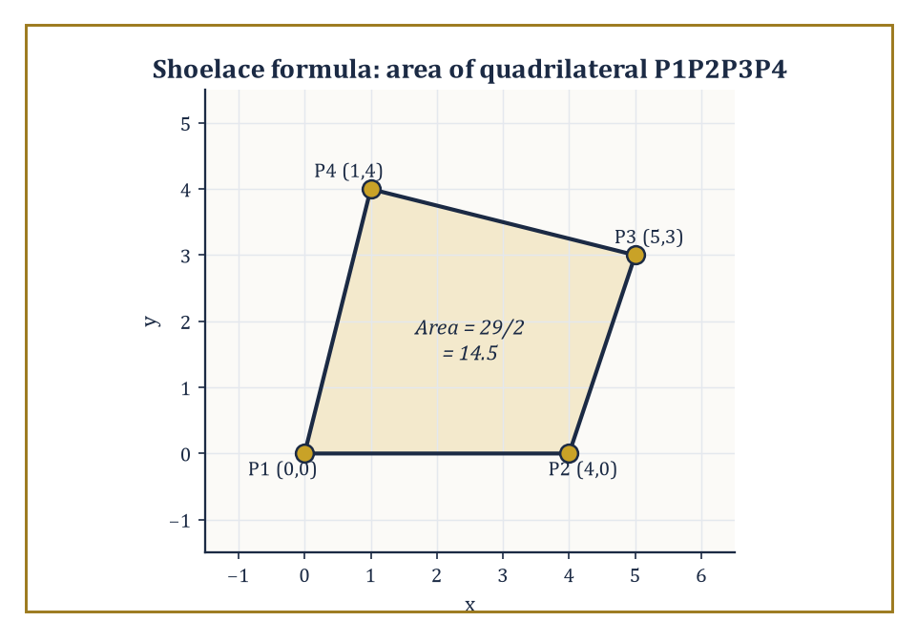
Figure 44.1 — The shoelace formula turns four pairs of coordinates into the exact area 14.5, no protractor required.
The inputs are typically finite sets of points, line segments, or polygons, living in the plane or in some higher-dimensional space; the outputs are either combinatorial structures — a convex hull, a triangulation, a partition of the plane into cells — or numeric quantities computed from the input, such as an area, a distance, or a count of intersections.
What makes the subject distinctively computational, rather than merely another branch of geometry, is that every claim must come with a bound on how long it takes to compute and how much space it takes to store, stated as a function of the input size n and, crucially, of the ambient dimension d.
A theorem in classical geometry says a fact is true. A theorem in computational geometry says a fact is true, and here is a machine that discovers it in at most c·n log n steps, and here is a proof that no machine can do it faster.
Numeric example — the shoelace formula. The most basic move in the entire subject is turning a list of coordinates into a number, and the area of a simple polygon is the cleanest instance. Take the quadrilateral with vertices, listed counterclockwise, P1=(0,0), P2=(4,0), P3=(5,3), P4=(1,4).
The shoelace formula computes twice the signed area as a sum over consecutive pairs, with the list wrapping around:
Σ(xᵢyᵢ₊₁ − xᵢ₊₁yᵢ)
(P1,P2): 0·0 − 4·0 = 0
(P2,P3): 4·3 − 5·0 = 12
(P3,P4): 5·4 − 1·3 = 20 − 3 = 17
(P4,P1): 1·0 − 0·4 = 0
Summing gives:
0 + 12 + 17 + 0 = 29
and the area is half the absolute value:
29/2 = 14.5 square units
No diagram was drawn, no protractor was consulted; four pairs of numbers went in, one number came out, and it is exact and correct for any simple polygon, however many vertices it has and however irregular its shape. That is the entire spirit of the subject in miniature: geometric meaning, reduced to arithmetic that a machine can execute a billion times a second without ever once feeling the pull of visual intuition.
Try it now — Use the shoelace formula on the triangle (0, 0), (4, 0), (0, 3). Answer →
Almost every algorithm in this chapter is built, ultimately, out of one microscopic decision, repeated enormously many times: given three points P, Q, R, does the path P→Q→R turn left, turn right, or go straight? This is the orientation test, and it is computed without a single trigonometric function, using only the sign of a 2×2 determinant:
orient(P,Q,R) = (Qₓ−Pₓ)(R_y−P_y) − (Q_y−P_y)(Rₓ−Pₓ)
A positive value means the turn is counterclockwise (R lies to the left of the directed line P→Q); negative means clockwise (R to the right); zero means the three points are collinear.
It costs two subtractions and two multiplications and a subtraction — no square roots, no angles, no ambiguity about which quadrant anything is in — which is precisely why it can be evaluated billions of times inside a hull or intersection algorithm without ruining the running time, and why, in Robustness, Degeneracies, and Exact Computation, it turns out to be the single predicate whose sign floating-point arithmetic is most likely to get catastrophically wrong.
Numeric example — the orientation test. Take P=(1,1), Q=(4,2), R=(2,5). Compute:
orient(P,Q,R) = (4−1)(5−1) − (2−1)(2−1) = (3)(4) − (1)(1) = 12 − 1 = 11
The result is positive, so the path P→Q→R turns left (counterclockwise) — and indeed, sketching it mentally, the first leg moves mostly rightward and slightly up, while the second leg swings sharply up and back to the left, which is what a left turn looks like.
Now test P′=(0,0), Q′=(4,0), R′=(2,−3):
orient = (4−0)(−3−0) − (0−0)(2−0) = (4)(−3) − 0 = −12
Negative, a right turn — R′ sits below the line through P′ and Q′, consistent with a clockwise bend. This one formula, and the sign of its output, is doing all the geometric work; everything else in this chapter is bookkeeping around it.
The field is a marriage of two older habits of mind.
Combinatorial geometry contributes the study of the discrete structure of geometric configurations: how many vertices can a convex hull have, how many cells can an arrangement of lines create, how does that count grow with n and with d.
Algorithm design contributes the toolkit for exploiting that structure efficiently: divide-and-conquer (solve two halves, merge), the sweep line (process the plane one coordinate at a time, as if dragging a ruler across it), randomized incremental construction (add the input in a random order and let the expected cost work out small), and range searching (organize data so that a query only touches the part of it that matters).
Every section from here on is an application of one or two of these paradigms to one geometric problem, and the dependence on dimension d is the theme that recurs most stubbornly: an algorithm that is embarrassingly fast in the plane can become embarrassingly slow, or combinatorially explosive, the moment d climbs past three or four — a phenomenon with its own name, the curse of dimensionality, that will follow us all the way to Looking Ahead: From Classical CG to Motion Planning, Meshing, and High-Dimensional Geometry.
Numeric example — the curse of dimensionality in round numbers. To put a number on the phrase before meeting its formal source in Convex Hulls: an algorithm whose cost scales as n^⌊d/2⌋ — the bound convex hull complexity turns out to obey — costs, for a modest n=100 points:
d=2: 100¹ = 100 operations
d=4: 100² = 10,000 operations
d=6: 100³ = 1,000,000 operations
d=10: 100⁵ = 10,000,000,000 operations
Four small, entirely reasonable-looking increases to the dimension — from 2 up to 10 — turn a computation done on the back of an envelope into one needing ten billion steps, and not one single point was added to the input the whole time.
That is the curse of dimensionality reduced to a table: not that high-dimensional geometry is impossible, but that the exponent in its running-time bounds is the dimension itself, or half of it, and exponents are considerably less forgiving than the constants everybody spends their afternoons optimizing instead.
One further confession, inherited from the source material and worth stating in cold numbers before we go any further: in this subject, the gap between O(n²) and O(n log n) is not an aesthetic preference for theorists with time on their hands, it is the difference between a program that finishes and a program that does not.
Applications drive the choice of which geometric problems get studied — computer graphics, geographic information systems, robotics, computer-aided design, mesh generation for numerical simulation — and the theory’s job is to supply both the fastest known algorithm and a matching lower bound proving nobody will ever do better, so that engineers can stop looking for a speedup that provably does not exist.
Numeric example — why the exponent matters. Take n = 1,000,000 points, a modest dataset by modern standards (a city’s worth of GPS pings, say).
An O(n²) algorithm performs roughly n² elementary operations:
n² = 10¹² elementary operations
An O(n log n) algorithm performs roughly n·log₂n operations; since log₂(10⁶) ≈ 19.93, that is about:
10⁶ × 19.93 ≈ 1.99×10⁷ operations — call it 2×10⁷
The ratio between the two is:
10¹²/(2×10⁷) = 5×10⁴, a factor of fifty thousand
On a processor doing a generous one billion elementary operations per second, the O(n log n) algorithm finishes in about 0.02 seconds — you would not have time to glance away from the screen.
The O(n²) algorithm needs about:
10¹²/10⁹ = 1,000 seconds
That is the better part of seventeen minutes, for the same input. Scale n up by a further factor of ten, to ten million points, and the O(n log n) algorithm is still comfortably under a second, while the O(n²) algorithm now needs on the order of a full day.
This is why the subject cares, with an intensity that can look excessive from the outside, about whether an algorithm’s exponent is 1, or 1 with a logarithm attached, or 2.
Keep only this · Section 44.1: What Computational Geometry Is
The idea. Computational geometry turns geometric questions into exact arithmetic on coordinates, built from a few primitive tests such as signed area and orientation.
Core.
2 × area = |Σ (xᵢyᵢ₊₁ − xᵢ₊₁yᵢ)|
orient(P, Q, R) = (Qₓ − Pₓ)(R_y − P_y) − (Q_y − P_y)(Rₓ − Pₓ)
Typical mistake. Using angles and trigonometry to decide turns. The orientation determinant needs no angles, only two multiplications and a subtraction.
Minimal example. P = (1, 1), Q = (4, 2), R = (2, 5): orient = 11 > 0, a left turn.
Practice. Easy to challenge; full worked answers, with the usual mistake, are in Answers to the Practice Sets at the back.
Easy — Compute orient((0, 0), (1, 1), (2, 2)). Answer →
Medium — Apply the shoelace formula to the square (0, 0), (0, 2), (2, 2), (2, 0), listed in that order. What does the sign tell you? Answer →
Challenge — Show that orient(P, Q, R) equals twice the signed area of triangle PQR. Answer →

Section 44.2: Convex Hulls
The Shrink-Wrap Theorem
You have seen this before
Convexity is the property that made optimization tractable in Optimization (Volume 3): a local minimum of a convex function is global. Here the same property makes geometry tractable: a point is a hull vertex exactly when some line separates it from the rest, which is a linear program in disguise.
The convex hull of a finite set of points is the smallest convex set containing them all — imagine stretching a rubber band around a scattering of nails hammered into a board and letting it snap tight; the shape it settles into is the hull.
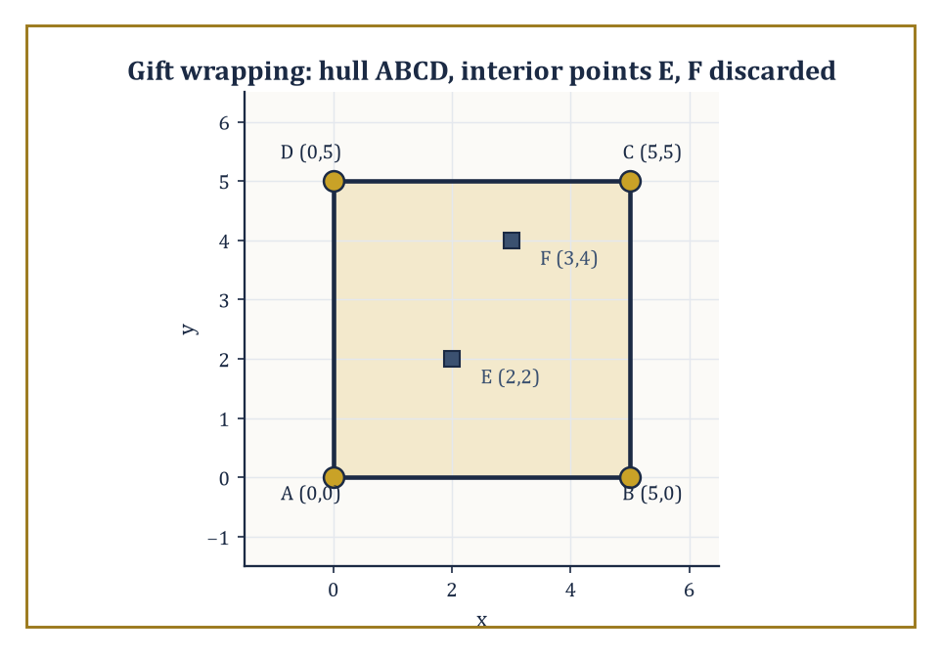
Figure 44.2 — Gift wrapping finds the square ABCD and correctly ignores the interior points E and F, which never win a single left-of-everything test.
In the plane, the hull is always a convex polygon, and its vertices are always a subset of the original points (the rubber band only ever touches the outermost nails; the ones in the middle are irrelevant to it, however many of them there are).
Three classical algorithms compute the planar hull: gift wrapping (Jarvis march), which walks around the outside picking the next most extreme point at each step and costs O(nh) for a hull with h vertices; Graham scan, which sorts the points by angle around a fixed pivot and then sweeps, discarding any point that would create a right turn; and Andrew’s monotone chain, which sorts by x-coordinate and builds the upper and lower chains of the hull independently. The last two run in O(n log n) time.
All three lean on the orientation test from What Computational Geometry Is for every decision about which points to keep.
Numeric example — gift wrapping by hand. Take the six points A(0,0), B(5,0), C(5,5), D(0,5), E(2,2), F(3,4).
Gift wrapping starts at a point guaranteed to be on the hull — here the lowest point, A — and repeatedly finds the next hull vertex by testing, via the orientation test, whether every other point lies to the left of the current candidate edge. From A, try candidate edge A→B: for each remaining point r, check orient(A,B,r).
r=C=(5,5): orient = (5−0)(5−0) − (0−0)(5−0) = 25 − 0 = 25 > 0, left
r=D=(0,5): orient = (5)(5) − (0)(0) = 25 > 0, left
r=E=(2,2): orient = (5)(2) − (0)(2) = 10 > 0, left
r=F=(3,4): orient = (5)(4) − (0)(3) = 20 > 0, left
Every remaining point lies to the left of A→B, so B is confirmed as the next hull vertex — no other candidate edge from A could have this property, since any edge with a point to its right is disqualified.
Repeating the same test from B finds C next, then D, then back to A, closing the hull as the square A→B→C→D. The interior points E and F never once win the left-of-everything test, and are correctly discarded — the algorithm has, without ever computing an area or drawing a picture, identified the four extreme points and ignored the two that contribute nothing to the shape.
Try it now — For A(0,0), B(5,0), C(5,5), D(0,5), E(2,2), F(3,4), which points are hull vertices? Answer →
That O(n log n) is not merely the best anyone has managed; it is provably optimal, and the proof is a small piece of intellectual jujitsu: the hull problem can be made to sort.
Given any n real numbers, place the point (xᵢ, xᵢ²) for each one on the parabola y = x². Because the parabola is strictly convex, every one of these points lies on the convex hull — none is ever interior to the others — and the hull’s vertices occur in exactly the same left-to-right order as the sorted xᵢ values.
So an algorithm that computed convex hulls faster than O(n log n) would sort faster than O(n log n) too, by disguising the numbers as points on a parabola; since comparison-based sorting has a proven Ω(n log n) lower bound, convex hull computation inherits the same chapter.
It is a rare and satisfying situation in which a geometric problem and a purely combinatorial one turn out to be, computationally, the very same problem wearing different coats.
Worked example — hiding a sorting problem inside a hull. Take the five numbers 3, 1, 4, 2, 5 and lift each onto the parabola y = x²:
(3,9), (1,1), (4,16), (2,4), (5,25)
Because y = x² is convex, all five points already sit in convex position — none is inside the hull of the others — so the convex hull is the entire set, and its boundary, traced from left to right, visits the points in order of increasing x-coordinate:
(1,1), (2,4), (3,9), (4,16), (5,25)
Read off the x-coordinates in that order — 1, 2, 3, 4, 5 — and the original list has been sorted, entirely as a side effect of computing a convex hull.
Any hull algorithm faster than O(n log n) could therefore be repurposed as a sorting algorithm faster than O(n log n), which the Ω(n log n) comparison-sorting lower bound forbids; hence no hull algorithm can be faster than O(n log n) either. This is the whole lower-bound argument, run on five numbers instead of an abstract n, and it generalizes without changing a single idea.
Move to three dimensions and the hull becomes a convex polyhedron; the two-dimensional algorithms do not generalize gracefully, but randomized incremental construction (add the points one at a time in random order, updating the hull as each new point either lies inside the current hull, in which case ignore it, or outside, in which case patch the hull to include it) achieves optimal O(n log n) expected time.
Timothy Chan’s algorithm achieves the same bound deterministically, in the worst case, with no randomness required at all — a small triumph, since derandomizing a randomized algorithm without losing its speed is usually much harder than it sounds.
In three dimensions the hull’s combinatorial complexity (its number of vertices, edges, and faces) is always O(n), by Euler’s formula for polyhedra.
The surprise arrives in higher dimensions, where the hull of n points in general position in ℝᵈ can have as many as Θ(n^⌊d/2⌋) faces — a bound that is quadratic already at d=4 and grows without any comfortable limit as d increases, a first hint of the curse of dimensionality that will recur through the rest of this chapter.
Numeric example — Sanity check — Euler’s formula in three dimensions. Take the simplest possible 3-D hull, a tetrahedron: 4 vertices, 6 edges, 4 faces. Euler’s formula for a convex polyhedron states:
V − E + F = 2
4 − 6 + 4 = 2 — correct
Now take a triangular bipyramid formed by gluing two tetrahedra together on a shared face: it has 5 vertices, 9 edges, 6 (triangular) faces.
5 − 9 + 6 = 2 — correct again
Both examples confirm the general fact underlying the O(n) bound on 3-D hull complexity: for any convex polyhedron, the edge and face counts are pinned to the vertex count by a single linear relation, so however many vertices the hull has, its total combinatorial size stays proportional to that number — no quadratic blow-up is possible in three dimensions, however the points are arranged.
It is this comfortable linear relationship that fails once the ambient dimension climbs to four and beyond.
Convex hulls are the first nontrivial computation in the subject, and very far from the last time we shall use one: hull computations sit inside collision-detection routines in physics engines, inside the first step of many triangulation and mesh-generation algorithms, and — as the arrangement of Arrangements of Lines and Hyperplanes will reveal — inside the very lower-bound arguments the field uses to prove itself optimal elsewhere.
Treat the hull, from here on, as a building block rather than a destination.
Keep only this · Section 44.2: Convex Hulls
The idea. The convex hull is the smallest convex set containing the points; in the plane it can be computed in O(n log n) time, which is optimal because a hull algorithm can be used to sort.
Core.
gift wrapping: O(nh); Graham scan, monotone chain: O(n log n)
3-D polytopes: V − E + F = 2
Typical mistake. Believing gift wrapping is always fast. It costs O(nh), and h can be as large as n.
Minimal example. Lift 3, 1, 4, 2, 5 to (x, x²): every lifted point is on the hull, and walking the hull lists them in sorted order.
Practice. Easy to challenge; full worked answers, with the usual mistake, are in Answers to the Practice Sets at the back.
Easy — Find the hull of (0, 0), (4, 0), (2, 1), (2, 4). Answer →
Medium — Check Euler’s formula for the cube. Answer →
Challenge — Explain why no comparison-based planar hull algorithm can beat Ω(n log n). Answer →

Section 44.3: Line-Segment Intersection and Arrangements
Where Everybody Crosses Everybody, Politely
Given n line segments in the plane, how quickly can every pair of crossings among them be found and reported? A naive approach checks all C(n,2) pairs, costing O(n²) time regardless of how few intersections actually occur — wasteful when the segments barely cross at all, and precisely the kind of quadratic blowup What Computational Geometry Is warned against.
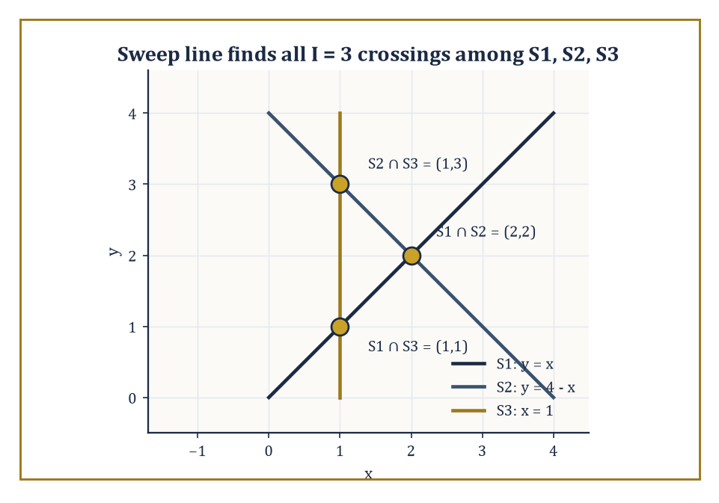
Figure 44.3 — Three segments, three crossings — the I = 3 a sweep line would report, and no more.
The Bentley–Ottmann sweep-line algorithm does better: it drags an imaginary vertical line across the plane from left to right, pausing at a sequence of events (segment endpoints, and intersection points as they are discovered), and maintains a status structure recording the top-to-bottom order of the segments currently crossed by the sweep line.
Two segments can only intersect if they become adjacent in this order at some point during the sweep, which lets the algorithm find every crossing in O(n log n + I) time, where I is the number of intersection points reported — the running time adapts to how cluttered the picture is, rather than pessimistically assuming the worst.
Numeric example — three segments, three crossings. Take three segments: S1 from (0,0) to (4,4) (the line y = x); S2 from (0,4) to (4,0) (the line y = 4 − x); S3 the vertical segment from (1,0) to (1,4) (the line x = 1).
Compute S1 ∩ S2 by writing both as points-plus-parameter, for t, s ∈ [0,1]:
S1(t) = (4t, 4t), S2(s) = (4s, 4 − 4s)
Setting the x-coordinates equal gives:
4t = 4s, so t = s
Setting the y-coordinates equal gives:
4t = 4 − 4s = 4 − 4t, so 8t = 4, t = 0.5
Substituting back, the intersection point is:
(4·0.5, 4·0.5) = (2, 2)
and t = s = 0.5 both lie in [0,1], so the crossing is genuinely on both segments (not merely on their infinite extensions). A quick check of the other two pairs confirms the pattern: S1 meets S3 (x=1 on y=x) at (1,1); S2 meets S3 (x=1 on y=4−x) at (1,3). So I = 3 for this instance.
A sweep line moving left to right would process, in order of x-coordinate, the left endpoints of S1 and S2 (both at x=0), then the crossing S1∩S3 and S2∩S3 at x=1 (with S3 itself starting there too), then the crossing S1∩S2 at x=2, then the remaining right endpoints at x=4 — six endpoint events and three intersection events, nine events total, each handled in O(log n) time to update the status structure.
A naive method here would test all C(3,2) = 3 pairs of segments directly, which for an instance this tiny is cheaper than running an event queue with nine entries in it — nobody sane deploys a sweep line to intersect three segments, and this example is not a demonstration of speed but a demonstration of mechanism.
The saving the sweep line is actually built for is asymptotic: with n segments and I crossings, sweeping costs O((n+I)log n) against a naive method’s C(n,2), which grows like n²/2, and it is only once n climbs into the thousands, exactly as in the O(n²) versus O(n log n) comparison of What Computational Geometry Is, that the sweep’s per-event overhead stops being the dominant cost and its refusal to examine irrelevant pairs starts to pay for itself.
Try it now — Use orientation tests to decide whether the segments (0,0)–(2,2) and (0,2)–(2,0) cross. Answer →
The same sweep, run to completion rather than only to report crossings, produces the arrangement of the segments: the subdivision of the plane into vertices (segment endpoints and crossings), edges (the pieces of segments between consecutive vertices), and faces (the regions the segments cut the plane into), each face bounded by a constant number of edges.
Arrangements generalize readily from segments to full lines or curves, and Arrangements of Lines and Hyperplanes is devoted to the case of full lines, where the complexity explodes in an instructive way.
The key structural fact used throughout the subject is the zone theorem: the total complexity — counted in edges — of all the faces that a single additional curve passes through, as it crosses an existing arrangement of n lines or segments, is only O(n), even though the arrangement as a whole can have complexity Θ(n²).
A curve threading its way through a crowded arrangement only ever disturbs a linear-sized neighborhood of its own path.
Abstract example — counting faces in an arrangement. An arrangement of n lines in general position (no two parallel, no three meeting at a point) has C(n,2) vertices, and divides the plane into exactly 1 + n + C(n,2) faces — a formula worth checking on small cases before trusting it on large ones.
For n=2, two crossing lines have C(2,2)=1 vertex:
1 + 2 + 1 = 4 faces
The familiar four quadrants an X-shape cuts the plane into. Correct.
For n=3 lines in general position (forming a small triangle in the middle), C(3,2)=3 vertices:
1 + 3 + 3 = 7 faces
The central triangle, three regions adjacent to its edges, and three unbounded regions beyond its corners, seven in total. Correct, and a pleasant thing to verify by sketching three lines on paper and counting.
The face count grows as Θ(n²) — for n=20 lines it is already:
1 + 20 + 190 = 211 faces
Yet the zone theorem says that if a twenty-first line is added to this arrangement of 20, it crosses each of the 20 existing lines at most once (general position again), so it is cut into at most 21 pieces by those crossings, and each piece lies in a single face of the original arrangement — meaning the new line passes through at most 21 faces, not 211.
This gap between the linear cost of touching an arrangement and the quadratic cost of the entire arrangement is precisely why algorithms that build an n-line arrangement by inserting the lines one at a time can do so in optimal O(n²) total time: each of the n insertions costs only O(n), and n insertions at O(n) apiece sum to O(n²), matching the size of the final answer with no wasted work.
Keep only this · Section 44.3: Line-Segment Intersection and Arrangements
The idea. Sweep a line across the plane and only ever test neighbors for crossings; arrangements of lines have exactly countable vertices, edges and faces.
Core.
Bentley–Ottmann: O((n + k) log n) for n segments, k crossings
n lines in general position: V = C(n, 2), E = n², F = 1 + n + C(n, 2)
Typical mistake. Thinking a sweep is always better than checking all pairs. With k near n², it is not.
Minimal example. Three lines in general position: 3 vertices, 9 edges, 7 faces.
Practice. Easy to challenge; full worked answers, with the usual mistake, are in Answers to the Practice Sets at the back.
Easy — How many pairs does the naive method test for 10 segments? Answer →
Medium — Count V, E, F for 4 lines in general position and check V − E + F = 1. Answer →
Challenge — For n = 1,000 segments with k = 10 crossings, compare (n + k) log₂ n with the naive pair count. Answer →

Section 44.4: Polygon Triangulation and Art Galleries
Cutting Up Sections, Guarding Museums
Every simple polygon with n vertices — simple meaning its boundary does not cross itself, however wildly it wanders — can be cut into triangles using only diagonals that lie entirely inside the polygon, and any such triangulation always uses exactly n − 3 diagonals and produces exactly n − 2 triangles, regardless of the polygon’s shape or how the diagonals are chosen.
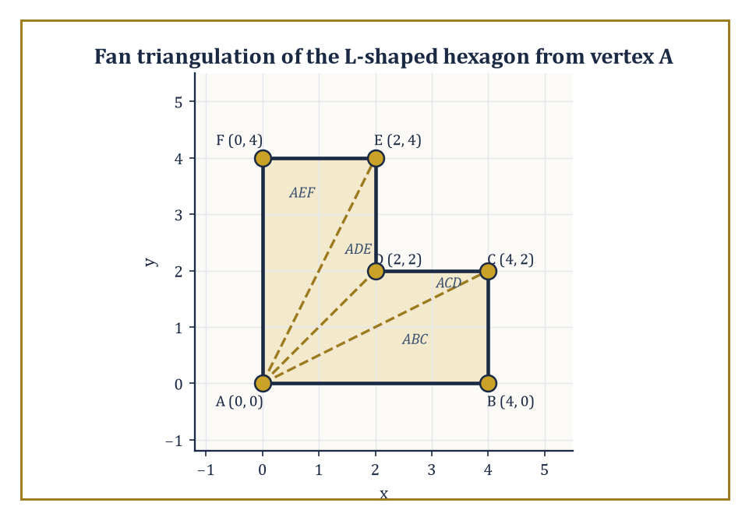
Figure 44.4 — Fanning three diagonals out from vertex A cuts the L-shaped hexagon into exactly n−2 = 4 triangles, areas summing to the whole.
Bernard Chazelle’s algorithm computes such a triangulation in O(n) time, linear, after a linear-time partition of the polygon into simpler pieces — a landmark result, and one of the more technically demanding optimal algorithms in the field.
Polygons that happen to be monotone (meaning every vertical line crosses the boundary at most twice, so the polygon has a well-defined top chain and bottom chain) are far easier: a simple stack-based sweep triangulates a monotone polygon in O(n) time using nothing more sophisticated than the orientation test from What Computational Geometry Is, and turning an arbitrary simple polygon into a handful of monotone pieces first is the standard route to a triangulation in practice, even when Chazelle’s fully linear method is overkill.
Numeric example — triangulating an L-shaped hexagon. Take the L-shaped hexagon with vertices, in order, A(0,0), B(4,0), C(4,2), D(2,2), E(2,4), F(0,4) — the union of a wide rectangle [0,4]×[0,2] and a tall rectangle [0,2]×[2,4] sharing an edge, with a reflex (inward-pointing) vertex at D.
With n=6, any triangulation must use n−2=4 triangles and n−3=3 diagonals.
Fan the triangulation out from vertex A, using diagonals A–C, A–D, and A–E; checking each diagonal stays inside the polygon (A–C runs wholly within the wide rectangle; A–D runs along y=x from (0,0) to (2,2), staying inside the wide rectangle the entire way; A–E runs from (0,0) to (2,4), staying inside the wide rectangle for the first half and the tall rectangle for the second) confirms all three are legal. This produces triangles ABC, ACD, ADE, AEF.
As a check on the whole construction, compute each triangle’s area by the shoelace formula and confirm they sum to the polygon’s true area. The shoelace area of a triangle (P,Q,R) is:
½|Pₓ(Q_y−R_y) + Qₓ(R_y−P_y) + Rₓ(P_y−Q_y)|
Triangle ABC = A(0,0),B(4,0),C(4,2): ½|0(0−2)+4(2−0)+4(0−0)| = ½|0+8+0| = 4
Triangle ACD = A(0,0),C(4,2),D(2,2): ½|0(2−2)+4(2−0)+2(0−2)| = ½|0+8−4| = 2
Triangle ADE = A(0,0),D(2,2),E(2,4): ½|0(2−4)+2(4−0)+2(0−2)| = ½|0+8−4| = 2
Triangle AEF = A(0,0),E(2,4),F(0,4): ½|0(4−4)+2(4−0)+0(0−4)| = ½|0+8+0| = 4
Summing:
4 + 2 + 2 + 4 = 12
Independently, the polygon’s own area is the sum of the two rectangles:
(4×2) + (2×2) = 8 + 4 = 12
The two totals agree exactly, confirming both that the triangulation is valid and that no arithmetic slipped along the way.
Try it now — How many triangles and diagonals does any triangulation of a hexagon have? Answer →
The art-gallery theorem, due to Václav Chvátal, asks a question a security consultant might ask: how many stationary guards, each with an unlimited 360° field of view, are always sufficient to see every point inside an arbitrary simple polygon with n walls, and how many are sometimes necessary?
The answer is a clean ⌊n/3⌋: that many guards always suffice for any simple polygon, and there exist polygons — comb-shaped ones, with deep narrow prongs — for which ⌊n/3⌋ guards are also necessary, so the bound cannot be improved in general.
The proof that ⌊n/3⌋ always suffices runs through triangulation: triangulate the polygon, three-color the vertices of the resulting triangulation so that every triangle has one vertex of each color (always possible, by an inductive argument on the triangulation’s dual tree), and place a guard at every vertex of whichever color class is smallest — since the three color classes partition the n vertices, the smallest is at most ⌊n/3⌋ vertices, and because every triangle has a vertex of that color, every triangle (and hence the whole polygon) is seen by some guard standing on one of its own corners.
Abstract example — a comb polygon needs its guards. To see that ⌊n/3⌋ is sometimes necessary and not merely a lazy upper bound, picture a comb with k prongs: a long rectangular base with k narrow, deep triangular teeth sawn into one long side, each tooth separated from its neighbors by a deep narrow notch.
Such a polygon can be built with exactly:
n = 3k vertices
Three vertices per prong, roughly speaking: the tip and the two notch-corners flanking it. The crucial feature is that the interior of each notch can only be seen from very close to the tip of its own prong; no single guard, wherever placed, can see into two different notches at once, because the deep narrow walls of the intervening teeth block the line of sight between them.
Guarding all k notches therefore requires at least k separate guards, one per prong, and:
k = n/3
Matching the ⌊n/3⌋ upper bound and showing it is tight. This is the standard reason computational geometers reach for a comb whenever they need to prove a guarding bound cannot be beaten: it is the geometric equivalent of a worst-case adversary, purpose-built to make every guard as short-sighted as the theorem allows.
The computational problem of finding the true minimum number of guards for a given polygon — rather than the worst-case bound over all polygons — is NP-hard in general, though efficient exact and approximation algorithms exist for restricted classes such as monotone or orthogonal (rectilinear) polygons.
Keep only this · Section 44.4: Polygon Triangulation and Art Galleries
The idea. Every simple polygon can be cut into n − 2 triangles by diagonals; three-coloring that triangulation shows ⌊n/3⌋ guards suffice to see the whole gallery.
Core.
triangles = n − 2, diagonals = n − 3
art gallery: ⌊n/3⌋ guards always suffice, sometimes needed
Typical mistake. Assuming one guard per triangle is required. Each guard at a vertex sees every triangle touching that vertex.
Minimal example. L-shaped hexagon: 4 triangles; ⌊6/3⌋ = 2 guards suffice (one at the inner corner D(2, 2) already sees it all).
Practice. Easy to challenge; full worked answers, with the usual mistake, are in Answers to the Practice Sets at the back.
Easy — How many guards suffice for any 12-vertex gallery? Answer →
Medium — What is the interior angle sum of a hexagon, checked through a triangulation? Answer →
Challenge — Prove that every triangulation of a simple n-gon by diagonals has n − 2 triangles. Answer →

Section 44.5: Voronoi Diagrams and Delaunay Triangulations
Everybody Gets Their Own Postcode
Before this section
What you need. Perpendicular bisectors and circumcircles from Euclidean Geometry (Volume 1); the orientation test from What Computational Geometry Is.
Why it matters. Voronoi diagrams and Delaunay triangulations are the most widely used structures in the chapter: nearest-neighbor search, mesh generation for the finite elements of Adaptive Finite Elements and Multilevel Methods, and interpolation of scattered data.
Given a finite set of sites in the plane, the Voronoi diagram partitions the plane into cells, one per site, where the cell belonging to site s consists of every point closer to s than to any other site — the mathematical formalization of catchment areas, postcodes, and the territory a mobile-phone mast covers.
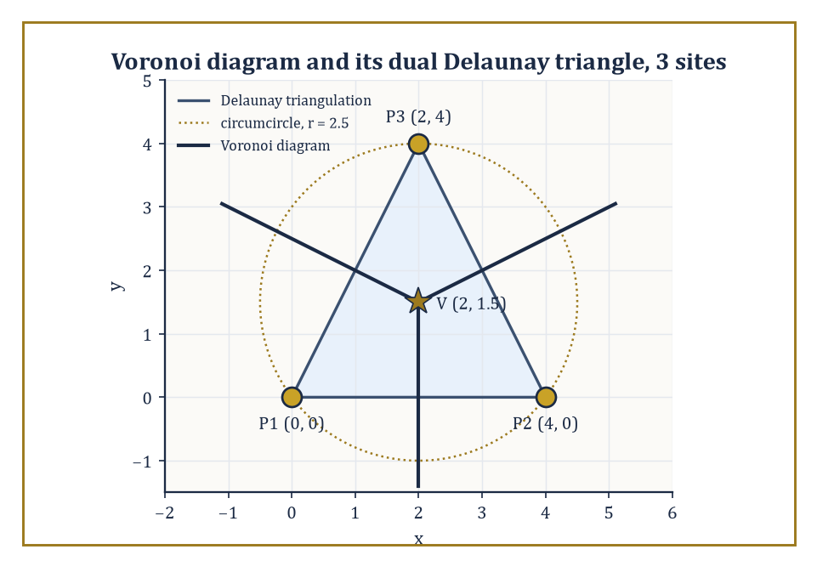
Figure 44.5 — The same three points, viewed two ways: Voronoi cells meeting at V, and the Delaunay triangle they are dual to, both governed by the circumcircle of radius 2.5.
Each cell is a convex polygon (possibly unbounded, for sites on the outer edge of the set), bounded by segments of the perpendicular bisectors between pairs of sites, and the whole diagram has only O(n) total complexity and can be built in O(n log n) time by a sweep or by randomized incremental construction, despite there being, in principle, O(n²) pairs of sites whose bisectors might have contributed an edge — most bisectors, it turns out, never make it into the final diagram at all, because some closer site always renders them irrelevant.
Numeric example — the Voronoi vertex of three sites. Take three sites P1=(0,0), P2=(4,0), P3=(2,4). Their three Voronoi cells meet at the circumcenter of the triangle P1P2P3 — the unique point equidistant from all three.
The perpendicular bisector of P1P2 passes through the midpoint (2,0) and, since P1P2 is horizontal, is the vertical line:
x = 2
The perpendicular bisector of P1P3 passes through the midpoint (1,2); since P1P3 has direction (2,4) and hence slope 2, the bisector has slope −1/2, giving the line:
y − 2 = −½(x − 1)
Substituting x=2 from the first bisector:
y − 2 = −½(2−1) = −0.5, so y = 1.5
The two bisectors meet at (2, 1.5). Check this point is indeed equidistant from all three sites:
distance to P1 = √(2²+1.5²) = √(4+2.25) = √6.25 = 2.5
distance to P2 = √((2−4)²+1.5²) = √(4+2.25) = 2.5
distance to P3 = √((2−2)²+(1.5−4)²) = √(0+6.25) = 2.5
All three distances equal 2.5 exactly, confirming (2,1.5) is the common Voronoi vertex where the three cells meet — a disk of radius 2.5 centered there passes through all three sites and contains no other site (there are no others), which is the empty-circle property that characterizes Delaunay triangulations.
Joining the three sites directly, P1–P2, P2–P3, P3–P1, gives the Delaunay triangulation dual to this diagram: an edge appears in the Delaunay triangulation when the two sites’ Voronoi cells share a boundary edge, and here all three pairs do, meeting at the single vertex just computed.
Try it now — Find the Voronoi vertex of the sites (0, 0), (6, 0) and (0, 8), and its distance to each site. Answer →
Among all the possible triangulations of a given point set, the Delaunay triangulation is distinguished by an elegant optimality property: it maximizes the minimum angle appearing anywhere in the triangulation, over all possible ways of choosing the diagonals.
This is not a cosmetic preference — triangles with very small angles (slivers) cause numerical instability in the finite-element and finite-difference methods that triangulations are so often built to feed, so a triangulation that provably avoids slivers wherever the point set allows it is a mesh generator’s favorite structure, and it is why the Delaunay triangulation, rather than some arbitrary alternative, is the default choice throughout computational science.
Numeric example — an edge flip, and the angle that improves. Take the convex quadrilateral A(0,0), B(2,0), C(2,2), D(0,2.5), and consider its two possible triangulations, split by either diagonal AC or diagonal BD.
Diagonal AC gives triangles ABC and ACD. Triangle ABC is right-angled at B (legs AB=2, BC=2), giving angles:
90°, 45°, 45°
Triangle ACD, with AC=√8≈2.828, AD=2.5, CD=√(2²+0.5²)=√4.25≈2.062, has angle at A precisely 45° (since AC lies at 45° to the x-axis and AD lies along the y-axis, at 90°, a 45° difference); its three angles are:
angle A ≈ 45°, angle C ≈ 59°, angle D ≈ 76° (summing to 180°)
The minimum angle across this triangulation is 45°.
Diagonal BD instead gives triangles ABD and BCD. Triangle ABD is right-angled at A (legs AB=2, AD=2.5), giving:
angle A = 90°, angle B = arctan(2.5/2) ≈ 51.3°, angle D ≈ 38.7°
Triangle BCD, with BC=2, BD=√(2²+2.5²)=√10.25≈3.202, CD≈2.062, works out via the dot-product form of the cosine rule to:
angle C ≈ 104.0°, angle B ≈ 38.7°, angle D ≈ 37.3° (summing to 180°)
The minimum angle across this triangulation is 37.3°.
Comparing the two: the AC-diagonal triangulation has minimum angle 45°, the BD-diagonal triangulation has minimum angle only 37.3°. Since 45° > 37.3°, the AC diagonal is the Delaunay choice — exactly the diagonal that the empty-circle test would also select, since it avoids creating the thinner, more sliver-prone triangles that the BD diagonal produces.
Flipping from the worse diagonal to the better one, whenever a local test like this one detects an improvement, is the local operation that incremental Delaunay algorithms repeat until no more flips help.
Beyond meshing, the Voronoi diagram is the natural data structure for nearest-neighbor queries (find which site a query point falls closest to — just locate which cell it lands in), for facility-location problems (where should a new depot go to be as far as possible from every existing depot’s territory — look at the diagram’s vertices, which are the locally most-distant points from their nearest sites), and for the classical post-office problem this whole line of research is sometimes named after: given a set of post offices, which one is closest to an arbitrary address?
Once the diagram is built, each such query is answered by a single O(log n) point-location step, the subject of Geometric Searching and Range Queries.
Keep only this · Section 44.5: Voronoi Diagrams and Delaunay Triangulations
The idea. The Voronoi diagram gives each site the region closer to it than to any other; its dual, the Delaunay triangulation, has empty circumcircles and the best smallest angle.
Core.
Voronoi vertex = circumcenter of three sites
Delaunay: no site inside any triangle’s circumcircle
planar: triangles = 2n − 2 − h, edges = 3n − 3 − h
Typical mistake. Thinking the Voronoi cell of a site is a polygon around its nearest neighbors only. Cells of hull sites are unbounded.
Minimal example. Sites (0, 0), (4, 0): the Voronoi edge between them lies on the bisector x = 2.
Practice. Easy to challenge; full worked answers, with the usual mistake, are in Answers to the Practice Sets at the back.
Easy — Write the perpendicular bisector of (0, 0) and (0, 6). Answer →
Medium — Is (1, 1) inside the circumcircle of (0, 0), (6, 0), (0, 8)? What does that say about the triangle if (1, 1) is also a site? Answer →
Challenge — A Delaunay triangulation has n = 10 sites, 4 of them on the convex hull. How many triangles and edges does it have? Answer →

Section 44.6: Geometric Searching and Range Queries
Finding a Needle Without Reading the Whole Haystack
Point location asks: given a planar subdivision fixed in advance — the faces of a Voronoi diagram, say, or of any arrangement — and given a query point that arrives afterwards, which face contains it?
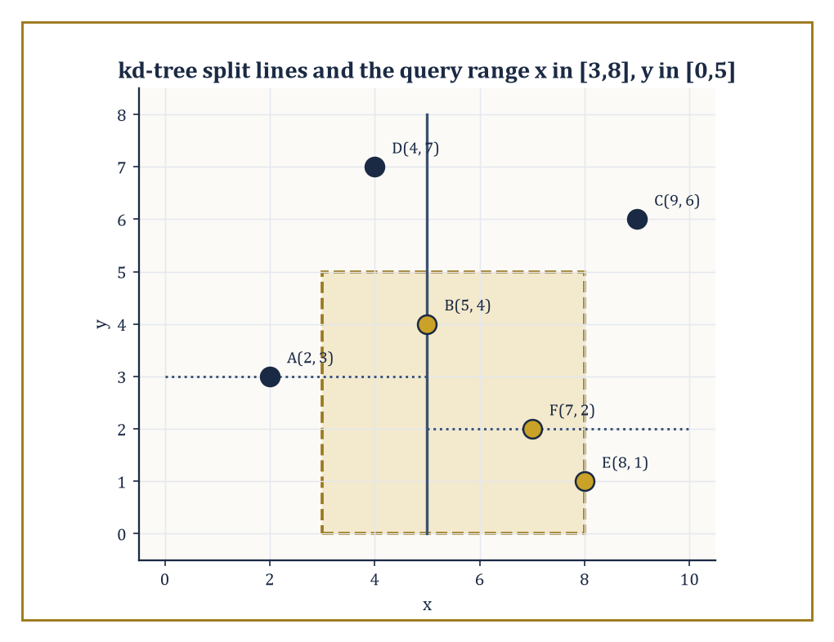
Figure 44.6 — The kd-tree’s alternating split lines let the query rectangle skip straight to B, E, and F without ever touching A, C, or D.
Preprocessing the subdivision into a trapezoidal map (extend a vertical segment upward and downward from every vertex until it hits another edge, cutting every face into trapezoids) and a corresponding search structure (a directed acyclic graph whose internal nodes each test the query point against a single x-coordinate or a single edge) allows any subsequent query to be answered in O(log n) expected time, using only O(n) space, built by randomized incremental construction in O(n log n) expected time — one query touches only a handful of trapezoids, however large n is, because each internal test halves (in expectation) the remaining candidates.
Numeric example — locating a point among Voronoi cells. Reuse the three sites from Section 44.5’s Voronoi example: P1=(0,0), P2=(4,0), P3=(2,4), whose bisectors were x=2 (separating P1 from P2), y=−½x+2.5 (separating P1 from P3), and y=½x+0.5 (separating P2 from P3), meeting at the Voronoi vertex (2,1.5). Locate the query point Q=(1,1) without computing a single distance.
Test 1: compare Q against the P1/P2 bisector x=2.
Qₓ = 1 < 2, so Q sits on P1’s side
Test 2: compare Q against the P1/P3 bisector; at x=1 the bisector sits at:
y = −½(1)+2.5 = 2
And Q_y=1<2, so Q again sits on P1’s side (P1 itself, at y=0, also lies below this line). Two tests, both pointing to P1, and the search structure can stop — no need to consult the P2/P3 bisector at all, since P1’s cell has already been identified.
Check the answer the slow way, by direct distance:
d(Q,P1) = √(1+1) = √2 ≈ 1.414
d(Q,P2) = √(9+1) = √10 ≈ 3.162
d(Q,P3) = √(1+9) = √10 ≈ 3.162
P1 is indeed nearest. Two comparisons settled a question that three distance computations (each requiring a square root) would otherwise have answered — and with log₂3≈1.58, two is the ⌈log₂ n⌉ the O(log n) bound promises for three cells, a saving that stays at O(log n) however many sites are added, rather than growing with n the way a distance-by-distance scan would.
Try it now — Which Voronoi cell of P1(0, 0), P2(4, 0), P3(2, 4) contains the query point (3, 1)? Answer →
Range searching asks a related but distinct question: given a fixed set of n points, preprocessed once, report (or merely count) all the points lying inside an arbitrary query rectangle, half-plane, or simplex, presented later.
A kd-tree answers axis-aligned rectangle queries by recursively splitting the point set with alternating vertical and horizontal lines (split by x-coordinate at the root, by y-coordinate at depth one, back to x at depth two, and so on), using O(n) space and O(n log n) preprocessing time, at the cost of O(√n + k) query time for reporting k points — slower per query than a range tree, which achieves O(log n + k) query time at the price of O(n log n) space instead of O(n); partition trees offer yet another point on this space–time trade-off curve, and lower bounds derived from partition theorems in combinatorial geometry prove that no data structure can do better on every axis of the trade-off simultaneously — you may pick your poison, but you may not avoid poison altogether.
Numeric example — building and querying a kd-tree. Take six points A(2,3), B(5,4), C(9,6), D(4,7), E(8,1), F(7,2). Build a kd-tree by splitting on x at the root: sorted by x, the points are A(2), D(4), B(5), F(7), E(8), C(9), and the median is B(5,4), which becomes the root with a vertical split at x=5.
The remaining points split into {A,D} (x<5) and {F,E,C} (x≥5). Within {A,D}, split on y: A(2,3) becomes the node (y=3 split), with D(4,7) as its child (y=7 ≥ 3).
Within {F,E,C}, split on y: sorted by y, E(1), F(2), C(6), so the median F(7,2) becomes the node, with E(8,1) as its left child (y=1<2) and C(9,6) as its right child (y=6≥2). The tree: root B, left child A (with right grandchild D), right child F (with children E and C).
Now query the rectangle x∈[3,8], y∈[0,5]. Ground truth by direct inspection: A(x=2) fails the x-test, excluded. B(5,4): both coordinates pass, included. C(9,6): x fails, excluded. D(4,7): y fails, excluded. E(8,1): both pass, included. F(7,2): both pass, included. So the true answer is {B, E, F}.
Tracing the tree: at root B, the x-range [3,8] straddles the split at 5, so both children must be explored; B itself is tested and passes (report B).
In the left subtree (region x<5), the query range [3,8] overlaps [−∞,5), so it must be explored; A itself fails the x-test (2∉[3,8]), and its only child D fails the y-test (7∉[0,5]) — nothing reported from this side.
In the right subtree (region x≥5), the query overlaps, so explore; F itself passes both tests (report F); F’s left child E, in the region x≥5, y<2, overlaps the query and is explored — E passes both tests (report E); F’s right child C, in the region x≥5, y≥2, also overlaps and must be explored, but C itself fails the x-test (9∉[3,8]) and has no children.
Total reported: {B, F, E} — matching the ground truth, and obtained by examining every node of a six-point tree rather than the full brute-force scan, a saving that becomes dramatic once n runs into the millions rather than six.
The common thread linking point location and range searching is that both trade preprocessing time and storage, paid once, for query time paid repeatedly — the right trade to make whenever a fixed dataset will be queried far more often than it is built, which describes the overwhelming majority of interactive geometric applications, from a map application locating your tap on the correct building to a physics engine deciding, sixty times a second, which objects are close enough to warrant a full collision check.
Keep only this · Section 44.6: Geometric Searching and Range Queries
The idea. Preprocess a subdivision or a point set once, so that later queries — which face, which points in a box — cost logarithmic time plus output.
Core.
point location: O(log n) query after O(n log n) preprocessing
kd-tree in 2-D: O(√n + k) per range query
Typical mistake. Rebuilding the structure for every query. The whole point is to pay once and query many times.
Minimal example. A balanced kd-tree on 1,024 points has depth log₂ 1024 = 10.
Practice. Easy to challenge; full worked answers, with the usual mistake, are in Answers to the Practice Sets at the back.
Easy — What is the depth of a balanced kd-tree on 4,096 points? Answer →
Medium — Which of A(2,3), B(5,4), C(9,6), D(4,7), E(8,1), F(7,2) lie in the box [3, 8] × [1, 6]? Answer →
Challenge — Explain the √n in the 2-D kd-tree query bound. Answer →

Section 44.7: Arrangements of Lines and Hyperplanes
The Plane, Thoroughly Gridlocked
Extend the segments of Line-Segment Intersection and Arrangements into full, infinite lines, and the picture changes character sharply: an arrangement of n lines in the plane, in general position, has C(n,2) vertices, n² edges, and 1 + n + C(n,2) faces — all Θ(n²), and all computable in optimal O(n²) time by incremental construction, adding the lines one at a time and updating the arrangement’s affected zone at each step (the O(n) zone-theorem cost from Line-Segment Intersection and Arrangements, paid once per line, n times over).
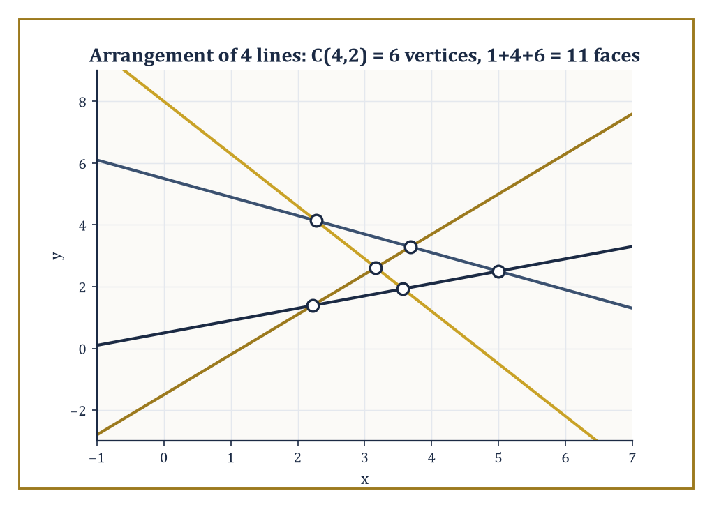
Figure 44.7 — Four lines in general position produce C(4,2) = 6 vertices and 1+4+6 = 11 faces, the Θ(n²) arithmetic made visible.
Higher-dimensional arrangements of n hyperplanes in ℝᵈ have complexity Θ(nᵈ) — a still hungrier exponent than the Θ(n^⌊d/2⌋) that bounded convex hull complexity back in Convex Hulls, and for a related, not coincidental, reason: a hyperplane arrangement’s vertices are simply all the ways of choosing d of the n hyperplanes to intersect, C(n,d) of them, which already grows like nᵈ before a single edge or face is counted, and it is exactly the same combinatorial counting — how many subsets of the input can simultaneously determine a feature of the output — that drives the hull’s Θ(n^⌊d/2⌋) bound as well.
The two exponents differ, but the mechanism generating both is the same one, and the point-line duality below makes the kinship precise rather than merely rhetorical.
Numeric example — point-line duality preserves incidence. The standard point-line duality sends a point (a,b) to the line y = ax − b, and a line y = mx + c to the point (m, −c); applying the transform twice recovers the original object (dual of the dual is the identity), which is why the map is called a duality rather than only a trick.
It also preserves incidence: a point lies on a line if and only if the dual point lies on the dual line. Check this concretely. Take point P=(2,3) and line ℓ: y=4x−5. Does P lie on ℓ? Substitute x=2:
4(2)−5 = 8−5 = 3
This matches P’s y-coordinate, so yes, P lies on ℓ. The dual of P=(2,3) is the line y=2x−3. The dual of ℓ (with m=4, c=−5) is the point:
(4, −(−5)) = (4,5)
Now check whether the dual point (4,5) lies on the dual line y=2x−3: substitute x=4:
2(4)−3 = 8−3 = 5
This matches the dual point’s y-coordinate precisely. The incidence has been faithfully preserved across the transform, in both directions, on real numbers, with nothing hand-waved.
This is more than a curiosity: it means any theorem about points lying on lines (or below them, since the transform also respects above/below relations with a consistent sign convention) automatically yields a theorem about lines passing through points, by dualizing every statement — a two-for-one deal that combinatorial geometers exploit constantly, and it is the formal underpinning of the claim that hull complexity in high dimensions and arrangement complexity in high dimensions are, at bottom, the same phenomenon.
Try it now — Under the duality (a, b) ↦ y = ax − b and y = mx + c ↦ (m, −c), take the point (2, 3) and the line y = x + 1. Check that incidence is preserved. Answer →
Because the full Θ(n²) arrangement is expensive to build and store whenever only part of it is actually needed, the subject singles out substructures of lower complexity that suffice for many applications: the zone of a curve (the faces it passes through, O(n) total complexity, as established in Line-Segment Intersection and Arrangements), the k-level (the set of edges with exactly k lines of the arrangement passing below them, whose worst-case complexity is a long-standing open problem, currently bounded only slightly below the trivial O(n²)), and the envelope (the boundary of the region above, or below, all n lines simultaneously, closely related to the k=0 level and computable via the same divide-and-conquer machinery used for convex hulls).
Incremental algorithms and topological sweeps — sweeps that follow the combinatorial structure of the arrangement rather than a literal geometric coordinate — compute these substructures without ever materializing the full arrangement, which is the saving that makes many downstream algorithms, motion planning among them (a preview of Looking Ahead: From Classical CG to Motion Planning, Meshing, and High-Dimensional Geometry), practical at all.
Abstract example — the zone theorem, elementarily. Here is the zone theorem’s core mechanism, provable in three lines without any heavy machinery. Suppose an arrangement of n lines, in general position, already exists, and one further line ℓ is added.
Because the configuration is in general position, ℓ is not parallel to any of the n existing lines, so it crosses each of them precisely once, at n distinct points along its own length.
Those n crossing points divide ℓ itself into at most n+1 pieces (n interior segments plus two unbounded rays, or however the count falls depending on where ℓ’s own crossings land — but never more than n+1 pieces total).
Each of these pieces, lying strictly between two consecutive crossings, cannot cross any line of the arrangement partway through, so it must lie entirely within a single face of the existing arrangement.
Since ℓ has at most n+1 pieces, it can visit at most n+1 distinct faces — a linear bound, obtained with nothing more than a counting argument, even though the arrangement those n+1 faces sit inside can itself have as many as 1+n+C(n,2) faces in total, a quantity that is quadratic in n rather than linear.
For n=20, the arrangement has 211 faces (as computed in Line-Segment Intersection and Arrangements), yet any single new line added to it can touch at most 21 of them — a concrete illustration of how much smaller a curve’s own footprint is than the arrangement it passes through.
Keep only this · Section 44.7: Arrangements of Lines and Hyperplanes
The idea. Point–line duality turns questions about points into questions about lines, and arrangements of lines have tightly countable structure, captured by the zone theorem.
Core.
F(n) = 1 + n + C(n, 2)
zone of a line in an arrangement of n lines: O(n)
Typical mistake. Counting faces as 2ⁿ, as if each line independently halved every region. A line meets only the faces it actually crosses.
Minimal example. Adding a fifth line to 4 lines in general position crosses 4 lines, passes through 5 faces and splits each in two.
Practice. Easy to challenge; full worked answers, with the usual mistake, are in Answers to the Practice Sets at the back.
Easy — How many faces do 5 lines in general position make? Answer →
Medium — A new line is added to an arrangement of 5 lines in general position. How many faces does it pass through, and how many new faces appear? Answer →
Challenge — Prove F(n) = 1 + n + C(n, 2) by induction. Answer →

Section 44.8: Robustness, Degeneracies, and Exact Computation
When the Computer’s Idea of a Straight Line Disagrees With Reality’s
Every algorithm in this chapter has been described as though arithmetic were exact — as though the orientation test’s sign, or the circumcenter’s coordinates, were computed with infinite precision and no rounding whatsoever.
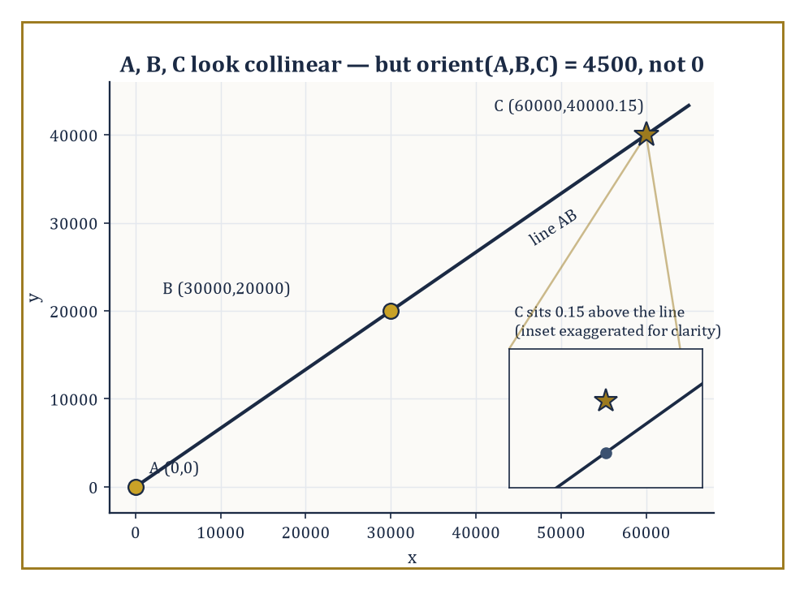
Figure 44.8 — A, B, and C look perfectly collinear at this scale — the inset reveals the 0.15 that catastrophic cancellation rounds away.
Real computers, running floating-point arithmetic, offer no such guarantee, and the gap between the two is not a minor footnote: it is capable of making a convex hull algorithm output a polygon that is not, in fact, convex, or making a Delaunay triangulation contain an edge that should not be there, because the orientation test or the in-circle test returned the wrong sign on points that were close to the boundary case.
The field’s response is exact geometric computation: evaluate the predicates — orientation, in-circle, and their relatives — with just enough precision, dynamically, to guarantee the sign returned is correct, using filtered arithmetic (try fast floating point first, and only fall back to slow, exact arbitrary-precision arithmetic when the floating-point result is too close to zero to trust) and adaptive precision (increase the working precision only as far as the specific inputs require, rather than paying the cost of full exactness on every single evaluation).
Numeric example — catastrophic cancellation in the orientation test. To see the failure mode concretely, without needing real IEEE double-precision hardware to demonstrate it, work with a deliberately coarse toy arithmetic that keeps only 3 significant figures per multiplication — a stand-in for the same phenomenon that afflicts real floating point, just triggered here with smaller numbers for legibility.
Take A=(0,0), B=(30000,20000), C=(60000, 40000.15) — C sits just 0.15 above the point (60000,40000), which lies on the line through A and B (since B has slope 20000/30000 = 2/3, and 40000/60000 = 2/3 also).
The exact orientation test is:
orient(A,B,C) = (Bₓ)(C_y) − (B_y)(Cₓ) = 30000×40000.15 − 20000×60000 = 1,200,004,500 − 1,200,000,000 = 4,500
A small but definitely positive number, correctly signaling that C sits very slightly to the left of the line AB (counterclockwise turn).
Now recompute using the toy 3-significant-figure arithmetic: 30000×40000.15 rounds to 3 sig figs as 1,200,000,000 (the true value 1,200,004,500 rounds down, since the fourth significant figure is the first to be dropped), and 20000×60000 = 1,200,000,000 already. The rounded orientation value is:
1,200,000,000 − 1,200,000,000 = 0
The coarse computation reports the three points as collinear, when the true answer is a small but definite positive number.
This is catastrophic cancellation: two large, nearly equal numbers were subtracted, and the small but meaningful difference between them was swallowed entirely by the rounding error in computing the large numbers themselves.
Real IEEE double precision carries about fifteen to sixteen significant decimal digits rather than three, so it takes correspondingly larger or more closely-spaced coordinates to trigger the same failure — but the mechanism is identical, and it is exactly the mechanism that exact geometric computation is built to defeat, by detecting when a floating-point result is too close to the cancellation danger zone to be trusted and falling back to arbitrary-precision arithmetic only then.
Try it now — Compute orient((0, 0), (1, 1), (2, 2.0000001)) exactly, and say why a rounding error of 10⁻⁶ in the products would be fatal. Answer →
A second, distinct hazard is degeneracy: configurations that are combinatorially ambiguous even under perfectly exact arithmetic, such as four points lying on a common circle (so the in-circle test used by Delaunay triangulation returns precisely zero, and it is unclear which of two triangulations to prefer) or three lines meeting at exactly one common point (so an arrangement algorithm cannot decide whether to treat it as one triple-intersection vertex or three separate crossings).
Symbolic perturbation, and its most famous instance, Simulation of Simplicity (Edelsbrunner and Mücke), resolve these by replacing every input coordinate with a formal symbol perturbed by an infinitesimal amount, in a fixed and consistent order — small enough, conceptually, to be smaller than any actual real number, yet large enough to break every tie — so that the algorithm always sees a generic, non-degenerate configuration, and the perturbation is chosen so that as it shrinks to zero the answer converges consistently to a single well-defined combinatorial structure, decided once and for all rather than by whichever way the rounding happens to fall on a given run.
Abstract example — perturbing away a three-line degeneracy. Take three lines, all passing through the origin — a textbook degenerate concurrency:
ℓ1: x=0, ℓ2: y=0, ℓ3: x+y=0
Perturb each by an infinitesimal ε, using a fixed convention that assigns line i the perturbation εⁱ:
ℓ1′: x=ε, ℓ2′: y=ε², ℓ3′: x+y=ε³
Find the three pairwise intersections of the perturbed lines.
ℓ1′∩ℓ2′: x=ε, y=ε², giving the point (ε, ε²)
For ℓ1′∩ℓ3′: x=ε, so y = ε³−ε, giving:
ℓ1′∩ℓ3′ = (ε, ε³−ε)
Since ε is infinitesimal, ε³ is negligible next to ε, so this point behaves, to leading order, like (ε, −ε).
For ℓ2′∩ℓ3′: y=ε², so x = ε³−ε², giving:
ℓ2′∩ℓ3′ = (ε³−ε², ε²)
Since ε³ is negligible next to ε², this behaves, to leading order, like (−ε², ε²).
As ε shrinks toward zero, all three intersection points converge to the origin, recovering the original degenerate picture in the limit — but for any fixed, however tiny, positive ε, the three points (ε,ε²), (ε,−ε), and (−ε²,ε²) are genuinely distinct, forming a small, well-defined triangle rather than a single ambiguous vertex.
Because the perturbation order ε³ ≪ ε² ≪ ε was fixed once, in advance — ε itself infinitesimal but still the largest of the three, since raising a number already less than 1 to a higher power only shrinks it further — every algorithm applying the same convention to the same degenerate input arrives at the same triangle, the same combinatorial structure, every single time — the ambiguity has not been avoided by luck, it has been resolved by a deterministic rule agreed in advance, which is what Simulation of Simplicity provides.
Controlled perturbation offers a randomized alternative to this fully symbolic approach — perturb the actual input coordinates by a small random amount, run ordinary floating-point arithmetic, and use probabilistic bounds to guarantee the resulting combinatorial structure is correct with high probability — trading the deterministic guarantee of the symbolic method for the considerably lower implementation cost of not needing arbitrary-precision arithmetic at all.
Robustness is, in the end, the difference between an algorithm that is correct in the algebraic decision-tree model — the idealized world every complexity bound in this chapter has been stated in — and a program that is correct on the actual floating-point hardware it will be compiled and run on.
A great many published, peer-reviewed, theoretically optimal geometric algorithms have shipped in production code that occasionally crashes, loops forever, or silently produces nonsense on real data, purely because this last, unglamorous step was skipped.
It is not an exaggeration to say that robustness engineering is where a sizable fraction of the actual professional labor in computational geometry goes, however little of it makes it into the textbooks — including, one must admit with the appropriate degree of sheepishness, this one until just now.
Where this returns
Catastrophic cancellation is the same failure that limits finite-difference derivatives and that preconditioning fights in Iterative Methods for Linear Systems: subtracting nearly equal numbers destroys significant digits. Numerical analysis measures it with condition numbers; computational geometry sidesteps it with exact predicates.
Keep only this · Section 44.8: Robustness, Degeneracies, and Exact Computation
The idea. Geometric algorithms are only as correct as their predicates; exact arithmetic, floating-point filters and symbolic perturbation make the signs trustworthy and the degenerate cases disappear.
Core.
filter: accept the floating-point sign when |value| > error bound, else recompute exactly
symbolic perturbation: break ties by a fixed infinitesimal order
Typical mistake. Fixing robustness with an epsilon tolerance. “Treat |x| < ε as zero” makes the predicates inconsistent with each other and can loop forever.
Minimal example. With 3 significant figures, orient = 4,500 rounds to 0: a near-collinear triple reported as collinear.
Practice. Easy to challenge; full worked answers, with the usual mistake, are in Answers to the Practice Sets at the back.
Easy — Compute orient((0, 0), (1/3, 1/3), (2/3, 2/3)) in exact fractions. Answer →
Medium — Perturb the three lines y = x, y = −x, y = 0 (all through the origin) by moving the third to y = ε. Find the three pairwise intersections. Answer →
Challenge — Why does a floating-point filter make exact arithmetic affordable? Answer →

Section 44.9: Looking Ahead: From Classical CG to Motion Planning, Meshing, and High-Dimensional Geometry
The View From the End of This Chapter
We have now acquired the core of computational geometry: convex hulls (Convex Hulls), line-segment intersection and arrangements (Line-Segment Intersection and Arrangements), polygon triangulation and the art-gallery theorem (Polygon Triangulation and Art Galleries), Voronoi diagrams and Delaunay triangulations (Voronoi Diagrams and Delaunay Triangulations), geometric searching and range queries (Geometric Searching and Range Queries), arrangements of lines and hyperplanes (Arrangements of Lines and Hyperplanes), and the practical machinery of robustness, degeneracy handling, and exact computation that keeps all of the above honest on real hardware (Robustness, Degeneracies, and Exact Computation).
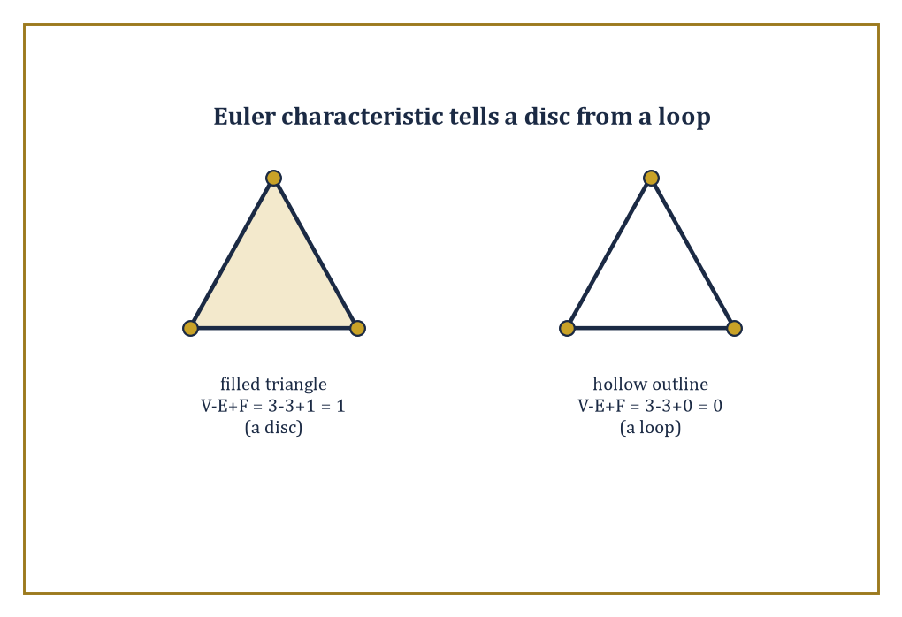
Figure 44.9 — Same vertex and edge count, different fate: a filled triangle has χ = 1 like a disk, its hollow outline χ = 0 like a loop.
Every subsequent tool in the field either combines these directly or generalizes one of them to a setting classical computational geometry was not originally built for.
Motion planning takes a robot with some number of independently movable joints and asks how it can get from a start configuration to a goal configuration without any part of it colliding with an obstacle, at any moment along the way.
The natural setting is the configuration space: not the physical room the robot sits in, but an abstract space in which each point represents one complete configuration of every joint simultaneously, and the robot’s motion becomes a single point tracing a continuous path through that space, which must avoid a region — the union of all configurations that cause a collision — computed, at bottom, using arrangement and intersection algorithms like those of Line-Segment Intersection and Arrangements and Arrangements of Lines and Hyperplanes.
Sampling-based planners (build a roadmap by scattering random configuration-space points and connecting the nearby ones that have a collision-free straight path between them, an unmistakable cousin of the randomized incremental constructions of Convex Hulls and Voronoi Diagrams and Delaunay Triangulations) now dominate practical robotics, because computing the collision region exactly, for a robot with many joints, runs straight into the Θ(nᵈ) high-dimensional blow-up first met with convex hulls back in Convex Hulls.
Abstract example — configuration space grows with every joint. A single point-robot moving freely in a two-dimensional room with polygonal obstacles has a configuration space that is the room itself, minus the obstacles — two-dimensional, and the arrangement and triangulation tools of this chapter apply directly and without modification.
Now replace the point-robot with a rigid car-like robot that also has an orientation θ, free to point any direction as it moves: a single configuration is now a triple (x, y, θ), and the configuration space is three-dimensional even though the physical room the robot drives around in is still flat and two-dimensional — an obstacle that was a single polygon in the physical room becomes, in configuration space, a more complicated three-dimensional region, swept out by all the orientations at which the car-shaped robot would collide with that obstacle at each position.
Add a second robot arm with two independently rotating joints, and the configuration space climbs to two more dimensions on top of whatever the base already contributed.
This is the mechanism, entirely elementary once stated, by which motion-planning problems that look almost identical to the flat polygonal picture of Line-Segment Intersection and Arrangements and Polygon Triangulation and Art Galleries become, without any fanfare, five- or six- or twenty-dimensional arrangement problems, and it is just why the Θ(nᵈ) complexity bound from Convex Hulls is not an abstract curiosity to a robotics engineer but the reason their exact planner has been running since Tuesday.
Try it now — A filled square is cut into two triangles by a diagonal. Compute V − E + F. Answer →
Mesh generation refines the triangulations of Polygon Triangulation and Art Galleries and Voronoi Diagrams and Delaunay Triangulations for use in numerical simulation: Delaunay refinement inserts additional points, chosen carefully, until every triangle in the mesh meets a prescribed quality bound (no angle too small, no triangle too large relative to its neighbors), while advancing-front methods grow a mesh inward from the boundary of a region, one layer of well-shaped elements at a time.
Computational topology asks coarser questions that triangulation and Voronoi machinery turn out to answer well: persistent homology tracks how the connectivity of a shape built from noisy data — how many connected pieces it has, how many loops, how many enclosed voids — changes as a scale parameter is varied, and Morse theory organizes a shape by the critical points of a function defined on it, in a discretized, algorithmic form direct descended from the continuous Morse theory of earlier, more analytic chapters.
Numeric example — a first taste of the Euler characteristic. The Euler characteristic, already used to check hull complexity in Convex Hulls, is also computational topology’s simplest invariant, and it distinguishes shapes that triangulation alone cannot tell apart by vertex count:
χ = V − E + F
Take a filled triangle: V=3 vertices, E=3 edges, and F=1 (counting the solid triangular face itself).
χ = 3 − 3 + 1 = 1
This matches the Euler characteristic of a topological disk — any shape that can be continuously squashed down to a single point has χ=1.
Now take only the triangle’s boundary, the hollow outline with no interior face filled in: V=3, E=3, F=0 (there is no 2-dimensional face to count, only the loop).
χ = 3 − 3 + 0 = 0
This matches the Euler characteristic of a circle — a loop, unlike a disk, cannot be squashed to a point without tearing it, and χ=0 is topology’s way of recording that difference using nothing but a vertex count, an edge count, and a face count, the same three quantities Section 44.2’s polyhedra were built from.
Persistent homology, several chapters of mathematical machinery beyond this one’s remit, generalizes this idea — count holes of every dimension, not just this one crude alternating sum — and does so robustly enough to apply to noisy real-world data rather than only to clean triangulated shapes.
High-dimensional geometric algorithms confront the curse of dimensionality directly rather than working around it: approximate nearest-neighbor search abandons the promise of finding the exact closest point (impossibly expensive once d grows large) in exchange for a point provably within a small factor of the true nearest, found in time that no longer explodes with dimension.
Dimension reduction techniques, such as the Johnson–Lindenstrauss lemma, prove that n points in an arbitrarily high-dimensional space can be projected down into a space of dimension only O(log n) while distorting all pairwise distances by at most a small controlled factor — a startling fact, since it says the relevant dimension of a geometric problem is often not the number of coordinates the data happens to arrive in, but something closer to the logarithm of how many points there are.
Numeric example — Johnson–Lindenstrauss in round numbers. Take n=1,000,000 points living in some enormous ambient space, d=10,000 coordinates, however they arrived there. A commonly cited sufficient form of the Johnson–Lindenstrauss bound says a target dimension of about:
k ≈ (8/ε²)·ln n
suffices to preserve every pairwise distance to within a factor of (1±ε). Fix a modest distortion tolerance ε=0.5:
ln(1,000,000) = 6·ln10 ≈ 6×2.3026 = 13.82
k ≈ (8/0.25)×13.82 = 32×13.82 ≈ 442
Round up, and about 450 dimensions suffice — a reduction from ten thousand coordinates down to a few hundred, at a distance-distortion cost of only 50%.
Notice what did not appear anywhere in that calculation: d. Had the ambient space been 10,000,000-dimensional instead of 10,000-dimensional, k would not have moved by a single unit, because the bound depends only on n and ε, never on d.
This is the startling part of the lemma made concrete: it is the number of points, not the number of coordinates describing them, that decides how far the data can be compressed.
The same circle of ideas, applied to smooth rather than combinatorial shapes, reappears in discrete differential geometry and throughout the modern analysis of geometric data more broadly.
The deeper lesson of this chapter is that geometry, once discretized and combinatorialized — reduced to finite point sets, orientation tests, and cell counts — becomes an algorithmic subject with its own complexity landscape, its own optimal algorithms, and its own matching lower bounds, every bit as rigorous as the classical geometry it grew out of, and considerably more useful to anyone who needs an answer before the heat death of the universe.
Computational geometry is the algorithmic theory of shape. We have learned to compute with shapes.
It is worth pausing, before the chapter turns, on how remarkably calm the objects of this chapter have been throughout. A convex hull, once computed, sits there, being convex, with no further opinions on the matter. A Voronoi diagram tiles the plane and stops. A Delaunay triangulation maximizes its minimum angle once, permanently, and does not need to be reminded to keep doing so. Even the arrangement of Arrangements of Lines and Hyperplanes, for all its Θ(n²) exuberance, is a static picture the moment the last line has been added. This is not a criticism — it is precisely what allows the subject’s algorithms to be provably optimal, since a target that holds still is enormously easier to hit than one that keeps moving.
That stillness, though, was purchased at a cost we spent all of Robustness, Degeneracies, and Exact Computation confessing to: real machines compute with floating-point arithmetic, not the exact real numbers the theory pretends is available, and the gap between the two is not a rounding error to be politely ignored but an active adversary that has, in practice, turned theoretically optimal algorithms into programs that crash. Robustness earns its keep as the least glamorous and most indispensable section in the chapter — the discipline of taking a beautiful, provably correct algorithm and making sure it survives contact with a computer that has never heard of convexity and does not much care.
The series continues, and its next chapter trades our static shapes for objects that will not hold still no matter how firmly asked: dynamical systems, evolving under differential equations, that someone or something must actively steer. Control theory awaits, with feedback loops standing in for the diagonals and bisectors of this chapter, and stability replacing convexity as the property everyone is desperately trying to guarantee. We have learned to compute with shapes; the series is about to ask us to keep them moving in the right direction instead.
Keep only this · Section 44.9: Looking Ahead: From Classical CG to Motion Planning, Meshing, and High-Dimensional Geometry
The idea. Beyond the plane, the same tools meet motion planning in high-dimensional configuration spaces, mesh generation, computational topology and dimension reduction.
Core.
χ = V − E + F: disk 1, circle 0
Johnson–Lindenstrauss: k ≈ (8/ε²) ln n, independent of d
Typical mistake. Thinking dimension reduction depends on the original dimension d. The JL target dimension depends only on n and ε.
Minimal example. n = 10⁶, ε = 0.5: k ≈ 32 × 13.82 ≈ 442.
Practice. Easy to challenge; full worked answers, with the usual mistake, are in Answers to the Practice Sets at the back.
Easy — With ε = 0.5, what JL dimension does n = 1,000 need? Answer →
Medium — With n = 10⁶ and ε = 0.25, what is k? Answer →
Challenge — Show that subdividing a triangle of a triangulated disk by an interior point leaves χ unchanged. Answer →
Chapter 44 recap · Computational Geometry
• The shoelace formula turns coordinates into area; the orientation test, one 2 × 2 determinant, decides every left-or-right question in the chapter.
• Convex hulls take O(n log n) time in the plane, and no comparison-based method can do better, because hulls can sort.
• Sweep lines find all k crossings among n segments in O((n + k) log n); n lines in general position make C(n, 2) vertices, n² edges and 1 + n + C(n, 2) faces.
• Every simple n-gon splits into n − 2 triangles; ⌊n/3⌋ guards always suffice and are sometimes needed.
• Voronoi cells and Delaunay triangles are duals; Delaunay triangles have empty circumcircles and maximize the smallest angle.
• Exact predicates, filters and symbolic perturbation make the algorithms correct on real machines.

Check Your Understanding — Chapter 44
Answers are in the Answer Key at the back of the book — have a go before you look.
1. [Explain] Why must every convex hull algorithm take at least O(n log n) time, no matter how cleverly it is written?
See the answer →
2. [Explain] Polygon Triangulation and Art Galleries proves ⌊n/3⌋ guards always suffice to watch a simple polygon with n walls. How does the proof place the guards?
See the answer →
3. [Compute] What property does the circumcircle of a Delaunay triangle satisfy, and how was it confirmed for the sites P1=(0,0), P2=(4,0), P3=(2,4)?
See the answer →
4. [Explain] What is catastrophic cancellation, and why is the orientation test especially vulnerable to it?
See the answer →
5. [Compute] Use the orientation determinant to decide whether the points P₁ = (0,0), P₂ = (4,0), P₃ = (2,4) are listed clockwise or counterclockwise.
See the answer →
6. [Explain] The convex hull of n points has at most n vertices. When does it have far fewer, and why is that the normal case?
See the answer →
7. [Compute] What is the maximum possible number of pairwise intersection points among 10 line segments, and what does that imply about the best case for a sweep-line algorithm?
See the answer →
8. [Prove] Show that every triangulation of a simple polygon with n vertices uses exactly n − 2 triangles.
See the answer →
9. [Explain] Why is the Voronoi diagram the dual of the Delaunay triangulation, rather than merely related to it?
See the answer →
10. [Challenge] In computational geometry, exact arithmetic for predicates often matters more than shaving a log factor off the running time. Why is that priority the right way round?
See the answer →

Problems — Chapter 44
The questions above test whether the ideas landed. These ask you to use them. Solutions are in Solutions to the Problems at the back. Work them before you look.
1. [Compute] Shoelace formula for the triangle (0, 0), (4, 0), (0, 3). Compute the area, and check it against base times height over 2.
2. [Concept] Three points, not collinear. What is their convex hull, and how many edges does it have?
3. [Compute] Segments AB from (0, 0) to (1, 1) and CD from (0, 1) to (1, 0). Do they intersect? Use the fact that the endpoints of each must lie on opposite sides of the line through the other.
4. [Concept] A range tree answers rectangle queries faster than a kd-tree, and it uses more memory. What did the extra memory buy?

Math, Actually

Chapter 45

Control Theory
Feedback, Stability, and the Art of Making Systems Behave
The previous chapter left us surrounded by static shapes: convex hulls wrapped snugly around point clouds, Voronoi cells tiling the plane with geometric indifference, Delaunay triangulations sitting there being optimal and not going anywhere in particular. It was, if we are honest, a rather calm neighborhood of the series. This chapter is not calm. Here the objects move, drift, oscillate, and occasionally blow up in finite time if left entirely to their own devices — and, this being the point of the whole enterprise, someone or something is expected to stop them doing that. Welcome to control theory: the branch of mathematics devoted to the modest ambition of making the universe behave.
A dynamical system, recall from several chapters back, evolves according to a differential or difference equation: give it a starting point and the rules of motion, and it will dutifully trace out a trajectory whether or not you approve of where it is going. Control theory asks a sharper question: can we choose an input — a rudder angle, a voltage, a drug dose, an interest rate — so that the trajectory does what we actually want? Stays near a setpoint. Tracks a moving target. Shrugs off the wind, the sensor noise, the well-meaning colleague leaning on the accelerator.
That input can be a fixed function of time, decided in advance and never revisited (open-loop), or it can watch the system’s actual behavior and correct on the fly (closed-loop, or feedback). Feedback is the idea this entire chapter is built around, so it is worth saying now what makes it remarkable: a feedback loop can turn a system that is uncertain, disturbed, or outright unstable into one that behaves reliably — without the controller ever needing to know exactly what is wrong. It only needs to notice that something is wrong, and push back.
The mathematical scaffolding should feel familiar, since we assembled most of it many chapters ago: ordinary differential equations for the dynamics, linear algebra for the state-space bookkeeping, and complex analysis for the frequency-domain half of the subject, where stability becomes a question about where certain functions are impolite enough to have poles. What is new is the purpose to which all this machinery is put. Where an earlier chapter asked what a system does, control theory asks what we can make it do, and how much we are allowed to cheat.
A confession, before we begin: control theory is unusually candid about the gap between the linear theory one teaches — complete, elegant, almost suspiciously well-behaved — and the nonlinear world one has to engineer, which is none of those things. The linear methods work far more often than the underlying mathematics has any strict right to promise. Knowing when to trust that luck, and when the linearization is a flattering lie rather than a faithful portrait, is most of what separates a control engineer from someone who has merely read a book about control engineering. We shall try, over the next nine sections, to become the former.
If differential equations taught us how systems evolve, control theory teaches us how to make them evolve as we would like. Let’s close the loop.
Running example · One pendulum, five views
A single system runs through this chapter and the next two: the pendulum of length L = 1 m under gravity g = 9.8 m/s², θ̈ + (g/L) sin θ = u. Watch it change role.
• The equation: a second-order ODE, the subject of Chapter 26 (Volume 3).
• A controlled system: the input u and the state (θ, θ̇), here in Chapter 45.
• A dynamical system: phase portraits, equilibria and energy, in Dynamical Systems & Chaos.
• A physical system: Lagrangian and Hamiltonian mechanics, in Mathematical Physics.
• A numerical problem: whose integrator keeps the energy, in Structure-Preserving and Geometric Integration.
Look for the purple boxes marked “Running example”.
Before you begin — Chapter 45
By the end of this chapter you will be able to:
1. Explain what feedback buys over open-loop control, with a steady-state error calculation.
2. Write a physical system, such as the pendulum, in state-space form and linearize it.
3. Test controllability and observability with rank conditions.
4. Certify stability with a Lyapunov function, a Lyapunov equation, or the small-gain theorem.
5. Place poles by state feedback, design an observer, and compute a scalar LQR gain.
6. Read a Bode plot, compute stability margins, and find a critical gain by Routh–Hurwitz.
Prerequisites. Linear ordinary differential equations and the matrix exponential from Chapter 26 (Volume 3); eigenvalues from Linear Algebra (Volume 2); the Laplace transform from Chapter 18 (Volume 2).
Estimated study time. About 11 hours, exercises included.

Section 45.1: What Control Theory Is
Or: the thermostat as a philosophical statement
You have used a thermostat. You set it to twenty degrees and walk away. You do not tell it that it is freezing outside, that six people have arrived, or that somebody has propped the back door open. It holds twenty degrees regardless, and you have never once thought this remarkable.
Now put it beside the thing in the spare room: an electric heater with a dial numbered one to six. Set the dial to four and it delivers a fixed quantity of heat, faithfully, for ever. On a mild evening the section bakes. On a cold one it never warms up. Same setting, different outcome — and that is not the heater’s fault. The dial knows about the heater and nothing whatever about the section.
So the question has to be asked differently. Not ‘how much heat should I put in?’, but ‘what rule should choose the heat, when I cannot see what is stealing it?’
That looks circular, and the circle is worth standing inside for a moment. To work out the right fixed setting you would have to know the disturbance — the weather, the guests, the open door. But the disturbance is the one thing you cannot measure; if you could, you would not have wanted a thermostat in the first place. You appear to need the answer before you are allowed to compute it.
There is a way out, and its whole cleverness is that it sidesteps the question rather than answering it. Do not measure the disturbance. Measure its effect. You cannot see the propped door, but you can see that the section is two degrees colder than you asked for, and two degrees of error is a number you can act on without ever learning what caused it.
Before any notation, some numbers, on the smallest plant that will hold still. Let x be the quantity we care about, measured as the gap between where it is and where we want it — so x = 0 is success, and any other value is the error. Let u be our control and d a disturbance we cannot observe, with x settling wherever ẋ = −x + u + d comes to rest. Take d = 1. With no control at all the quantity settles at x = 1, carrying the disturbance’s full mark. Now let the control push back in proportion to the error, u = −kx, and the resting point becomes 1/(1 + k):
k = 0 → x = 1
k = 1 → x = 1/2 = 0.5
k = 4 → x = 1/5 = 0.2
k = 9 → x = 1/10 = 0.1
k = 99 → x = 1/100 = 0.01
Look down that column and something is missing: it never reaches zero. Wind the gain up and the resting point falls to a half of the disturbance, then a fifth, then a tenth, then a hundredth — and not one of those is none of it. Proportional feedback shrinks an error it cannot see; it does not abolish it. On this one-line plant you could keep winding k up and watch the remainder shrink as far as you cared to. Real plants are less obliging: they lag, they carry dynamics of their own, and past a certain gain the feedback begins to fight itself. Stability is where stability is made precise.
That is feedback, and it is the entire philosophical content of the thermostat: a rule that looks at the gap between what was wanted and what is happening, and acts on the gap rather than on any theory of the world. The rest of this chapter — state, controllability, optimality, robustness — is the machinery for doing that to systems more complicated than a cold room.
Control theory studies how to influence the behavior of a dynamical system — called the plant, in a nod to the process-control factories where much of this language was coined, though today’s plant is as likely to be a satellite, an insulin pump, or a national power grid. The influence comes through an input, and the three goals worth naming up front are stability (the system doesn’t fly apart), performance (it tracks what you asked it to track, and shrugs off disturbances it wasn’t asked to tolerate), and robustness (it keeps doing both even though your model of the plant is, to some degree, a polite fiction). Almost everything in this chapter is an elaboration of those three words.
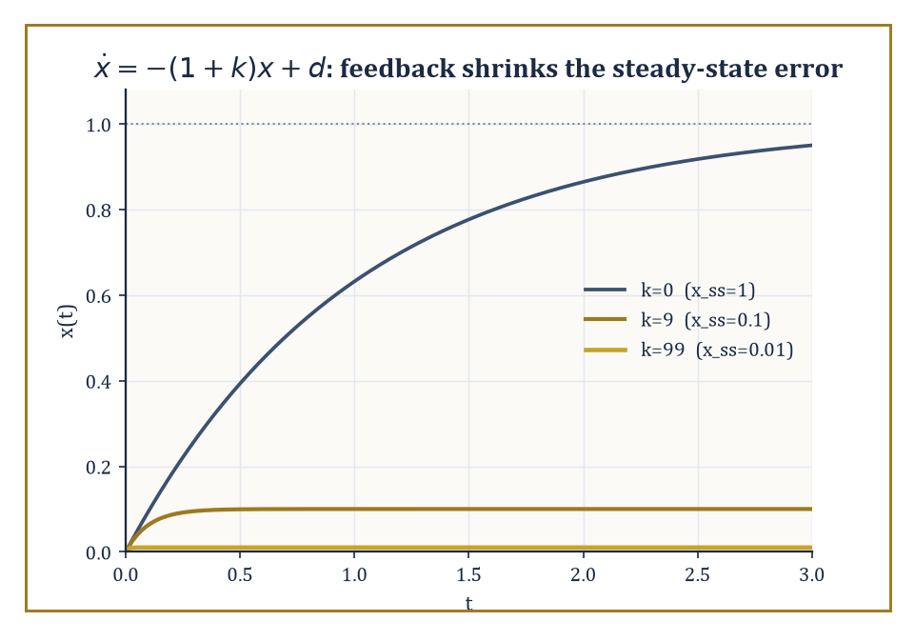
Figure 45.1 — The same disturbance, the same plant, three gains: feedback buys accuracy without ever measuring what it’s correcting for.
Numeric example — what feedback actually buys you. Take the simplest plant imaginable: a scalar system ẋ = −x + u + d, where x is the quantity we care about, u is our control input, and d is a constant disturbance we did not ask for and cannot measure — say d = 1.
With no control at all (u = 0), the system settles to a steady state where ẋ = 0, i.e. −x + d = 0, giving
xₛₛ = d = 1
The disturbance leaves its full mark. Now apply proportional feedback: u = −k·x, pushing back harder the further x drifts from zero. The closed-loop equation becomes
ẋ = −x − kx + d = −(1+k)x + d
with steady state
xₛₛ = d/(1+k)
Set k = 0 (no feedback) and you recover xₛₛ = 1, as before. Set k = 9 and xₛₛ = 1/10 = 0.1 — the disturbance’s effect has been cut by a factor of ten using nothing but a measurement of x and a dial. Set k = 99 and xₛₛ = 0.01. Nothing about the disturbance changed; we never even measured it. The controller simply refused, ten times a second if need be, to let x sit anywhere but very close to zero. That is the entire miracle of feedback, in one line of algebra: it buys accuracy by spending correction, and it does so without needing to know what it’s correcting for.
Try it now — In ẋ = −x + u + d with d = 2, find the steady state with no control and with u = −4x. Answer →
The open-loop/closed-loop distinction is worth dwelling on because it is a difference in kind, not just in cleverness. An open-loop input is a piano roll: composed in advance, played back regardless of whether the piano is in tune. A closed-loop input is a driver: watching the road, the speedometer, the errant cyclist, and adjusting continuously.
The first working feedback controller most historians point to is James Watt’s centrifugal governor of 1788 — a pair of spinning weights on a steam engine that flew outward as the engine sped up, and via simple linkage throttled the steam valve in response. Nobody involved knew a differential equation from a bread recipe; the mathematics of why it worked (and why, tuned wrong, it could oscillate itself to pieces) had to wait for James Clerk Maxwell in 1868, arguably the first paper in the modern theory of stability of feedback systems.
Abstract example — feedback older than the mathematics. Biology got there first, of course. The human pupillary reflex is a textbook closed loop: photoreceptors in the retina sense light intensity, signal the brain, and the iris sphincter muscle contracts or relaxes to change pupil diameter — which changes the light hitting the retina, closing the loop.
Too much light narrows the pupil, which reduces the light, which stops the narrowing: negative feedback, self-limiting, no central planner required. The controller here is a few milliseconds of neural circuitry; the plant is an optical aperture; the disturbance is whatever the sun is doing. It is, structurally, identical to Watt’s governor and to the thermostat on your wall, and it evolved roughly four hundred million years before anyone wrote
ẋ = Ax + Bu
The field then fans out along several independent axes, and it helps to see them laid out before we start filling in each one. Linear versus nonlinear: whether the plant’s response to input is proportional and superimposable, or whether it does something more interesting (and harder). Time-domain versus frequency-domain: whether we reason about trajectories x(t) directly, or about how the system responds to oscillations of each frequency ω — the same plant, interrogated in two different languages, neither of which it is under any obligation to answer in.
And a further split by design philosophy — optimal control (find the provably best input by some cost measure), robust control (find an input that survives the worst plausible model error), adaptive control (find an input that learns the model error as it goes), and geometric control (understand what’s reachable at all, using the tools of differential geometry). Applications range from aerospace guidance and chemical-process control to robotic manipulation, power-grid frequency regulation, and — as the pupil already showed us — the oldest control systems of all, running quietly inside every living thing.
Strip away the applications and the mathematical core is single and sharp: the analysis and design of feedback maps that turn an open-loop plant — uncertain, possibly unstable, doing whatever differential equations do when left alone — into a closed-loop system with properties we specified. The next eight sections build that core in order: a language for describing plants precisely (state-space models), a pair of structural questions about what such a description can and cannot do (controllability and observability), a rigorous notion of good behavior (stability), the two main levers for enforcing it (state feedback and observers), a way to do all this optimally rather than merely adequately (LQR and the maximum principle), an older and still-thriving parallel language (frequency-domain methods), and finally an honest look at what happens once we admit the plant was never quite linear to begin with (nonlinear and robust control).
Keep only this · Section 45.1: What Control Theory Is
The idea. Control theory designs inputs that make a system behave as wanted; feedback, which reacts to measurements, corrects disturbances that no plan anticipated.
Core.
closed loop: ẋ = −(1 + k)x + d
xₛₛ = d/(1 + k)
Typical mistake. Thinking feedback must measure the disturbance. It measures only the output, and that is enough.
Minimal example. d = 1, k = 99: xₛₛ = 0.01.
Practice. Easy to challenge; full worked answers, with the usual mistake, are in Answers to the Practice Sets at the back.
Easy — With d = 1, how large must k be for xₛₛ ≤ 0.05? Answer →
Medium — With k = 9, the closed loop decays at rate 1 + k = 10. How long until an initial error falls to 1% of its size? Answer →
Challenge — An engineer expects d = 1 and applies the open-loop input u = −1. The true disturbance is d = 1.5. Compare the open-loop steady state with that of the feedback u = −9x. Answer →

Section 45.2: Linear State-Space Models
In which the state of the system is finally given somewhere to live
Two carts sit side by side on a frictionless track, both at the 0 mark. One is at rest. The other is rolling at 2 meters per second. Ask where each will be in two seconds, and knowing that they start at the same place is no help: the first will still be at 0, the second at 4. To predict a cart you need two numbers, where it is and how fast it is going. With those two numbers and the force you plan to apply, you need nothing else.
Those two numbers are the cart’s state, and the rules for updating them are simple. For a cart of mass 1, position changes at the rate given by velocity, and velocity changes at the rate given by the force. Push the rolling cart with a steady force of 1 and you can step the rules forward by hand, a small time h at a time:
new position = position + h × velocity
new velocity = velocity + h × force
Here is where the pushed cart is after 1 second, worked out with smaller and smaller steps:
h = 0.5: 2.25 meters
h = 0.25: 2.375 meters
h = 0.1: 2.45 meters
h = 0.01: 2.495 meters
The answers climb toward 2.5 meters and never reach it. Each step uses the velocity at the start of the step, and while the cart is speeding up that velocity is always a little too small. The exact answer, from x = x₀ + v₀t + ½at², is 0 + 2 + ½ = 2.5 meters. Reaching it needs the steps to become infinitely small.
This section takes that limit once and for all. Collect the state into a vector x, the push into an input u, and the update rules into a matrix A and a vector B, and the rules become ẋ = Ax + Bu. Its exact solution, built from the matrix exponential, appears below. The first worked example there is these same two carts: the coasting one, and the pushed one, which reaches exactly 2.5 meters at t = 1.
A linear time-invariant (LTI) system is written
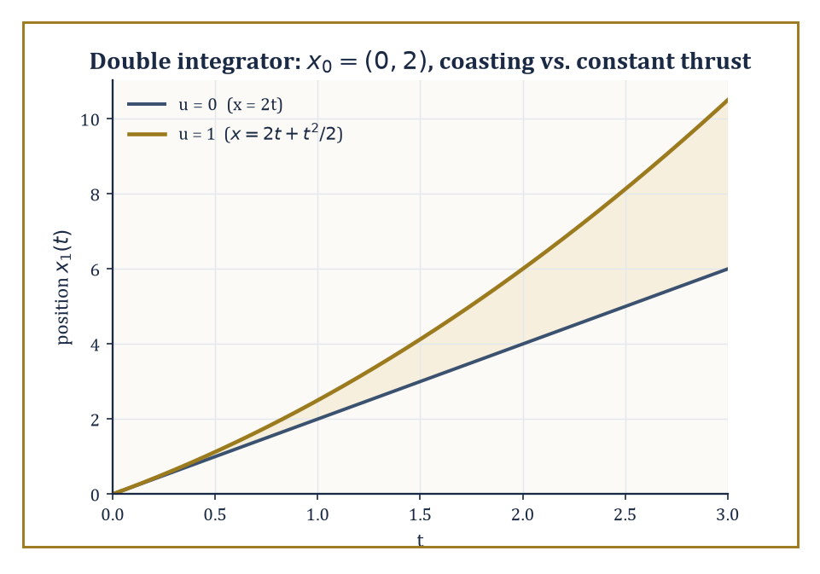
Figure 45.2 — The matrix exponential reproducing first-year kinematics, unannounced: coasting versus constant thrust from the same starting velocity.
ẋ = Ax + Bu, y = Cx + Du
Here x is the state vector — a snapshot, at each instant, of everything you need to know about the system to predict its future given the future inputs; u is the input (what we get to choose); y is the output (what we get to measure, which is often less than the whole state); and A, B, C, D are constant matrices doing four distinct jobs.
A encodes the internal dynamics — how the state evolves on its own, with no input. B encodes actuation — how the input pushes on the state. C encodes sensing — which combinations of the state we can see. D encodes direct feedthrough — the rare case where the input leaks straight into the output without passing through the state at all (most physical systems have D = 0, since instantaneous influence without any dynamics in between is usually a modeling shortcut rather than physics).
The exact solution, for constant A, is
x(t) = eᴬᵗ x(0) + ∫₀ᵗ eᴬ⁽ᵗ⁻ˢ⁾ B u(s) ds
the matrix-exponential analogue of the scalar formula you met chapters ago for ẋ = ax + u, now correctly accounting for the fact that A’s various components can rotate into and feed off one another.
Numeric example — the double integrator, solved exactly. Let x₁ be position and x₂ be velocity of a unit mass under a force u (Newton’s second law, F = ma with a = 1):
ẋ₁ = x₂, ẋ₂ = u
In matrix form, A = [0 1; 0 0], B = [0; 1]. Notice
A² = [0 1; 0 0]·[0 1; 0 0] = [0 0; 0 0]
A is nilpotent, so the matrix exponential series eᴬᵗ = I + At + (At)²/2! + ⋯ truncates after two terms:
eᴬᵗ = [1 t; 0 1]
With no force (u = 0) and initial condition x(0) = [0; 2] (starting position 0, starting velocity 2):
x(t) = eᴬᵗx(0) = [1 t; 0 1]·[0; 2] = [2t; 2]
Position grows linearly at the constant velocity, as Newton would insist. Now switch on a constant unit force u(s) = 1 for s ≥ 0. The forced term is ∫₀ᵗ eᴬ⁽ᵗ⁻ˢ⁾B·1 ds. Compute
eᴬ⁽ᵗ⁻ˢ⁾B = [1 (t−s); 0 1]·[0; 1] = [t−s; 1]
then integrate componentwise:
∫₀ᵗ(t−s)ds = t²/2 and ∫₀ᵗ1ds = t
So the forced contribution is [t²/2; t], and the total solution is
x(t) = [2t + t²/2; 2 + t]
That is precisely x = x₀ + v₀t + ½at² and v = v₀ + at with x₀=0, v₀=2, a=1 — the matrix exponential has, correctly and automatically, reproduced first-year kinematics.
Try it now — For the double integrator ẋ₁ = x₂, ẋ₂ = u with u = 0, x₁(0) = 1 and x₂(0) = 3, find x₁(2). Answer →
The transfer function
G(s) = C(sI−A)⁻¹B + D
is the same system described from outside: an input-output map that hides the internal state entirely, obtained by Laplace-transforming the state equations. Two systems with wildly different state-space descriptions can have identical transfer functions, because the transfer function only sees the part of the state that is both reachable from the input and visible at the output — a preview of the controllability and observability distinction the next section makes precise.
A realization is any state-space model (A,B,C,D) reproducing a given G(s); realizations are never unique, but a minimal realization — one that is both controllable and observable, in the sense the next section defines — has the smallest possible state dimension, and is unique up to a change of coordinates (a similarity transform x → Tx).
Abstract example — two realizations, one transfer function. Realization 1 (minimal): A = −1, B = 1, C = 1, D = 0, a scalar system. Its transfer function is
C(s−A)⁻¹B = 1·(s+1)⁻¹·1 = 1/(s+1)
Realization 2 (non-minimal): A = [−1 0; 0 −2], B = [1; 0], C = [1 0], D = 0 — a two-dimensional system with an extra decaying mode at −2. Its transfer function is
C(sI−A)⁻¹B = [1 0]·diag(1/(s+1), 1/(s+2))·[1; 0] = 1/(s+1) + 0 = 1/(s+1)
Identical to Realization 1, despite carrying an entire extra state. The −2 mode contributes nothing to the input-output behavior because B’s second entry is zero — the input never reaches it — so it decays away in total obscurity, present in the equations but invisible from outside. We shall meet this exact mode again in the next section, where it will get the recognition (or lack thereof) it deserves.
Why does the linear case get such complete treatment while the general nonlinear case remains, several sections from now, a collection of special techniques rather than one theory? Partly because linear systems are the ones for which the tools of linear algebra apply without approximation. But mostly because linear models are the natural first approximation to nonlinear ones: near an equilibrium, a nonlinear system ẋ = f(x,u) behaves, to leading order, like the linear system
ẋ = Ax + Bu, with A = ∂f/∂x, B = ∂f/∂u
evaluated at that equilibrium — the Jacobian linearization. Everything built in this chapter’s early sections is therefore not merely a toy theory for toy systems; it is the local theory that governs every nonlinear plant near wherever we’ve chosen to balance it.
Numeric example — linearizing a pendulum. A pendulum of length L = 1 m obeys
θ̈ + (g/L)sinθ = u, g ≈ 9.8 m/s²
Writing x₁ = θ, x₂ = θ̇, this is
ẋ₁ = x₂, ẋ₂ = −(g/L)sinx₁ + u
manifestly nonlinear, thanks to sinx₁. Near the downward equilibrium x₁ = 0, sinx₁ ≈ x₁ for small angles, giving the linearized model
ẋ₁ = x₂, ẋ₂ = −9.8x₁ + u, i.e. A = [0 1; −9.8 0], B = [0; 1]
This is the linear pendulum equation from the chapter on ordinary differential equations, recovered here as the A-matrix of a control problem — and every pole-placement or LQR calculation later in this chapter that uses a system ‘like a spring’ is secretly reasoning about a system exactly like this one, valid as long as θ stays small enough that sinθ ≈ θ hasn’t started lying to us.
You have seen this before
The matrix A = [0 1; −9.8 0] is the linear pendulum of Chapter 26 (Volume 3) rewritten as a first-order system. Its eigenvalues ±3.13i give the period 2π/3.13 ≈ 2.007 s; the same number returns in What Mathematical Physics Is, where the small-angle substitution is put on trial.
Keep only this · Section 45.2: Linear State-Space Models
The idea. A state-space model gives the system’s memory a vector to live in: ẋ = Ax + Bu, y = Cx + Du, solved by the matrix exponential and summarized by the transfer function C(sI − A)⁻¹B + D.
Core.
x(t) = eᴬᵗx(0) + ∫₀ᵗ eᴬ⁽ᵗ⁻τ⁾Bu(τ) dτ
G(s) = C(sI − A)⁻¹B + D
Typical mistake. Treating the transfer function as the whole system. Different realizations, some hiding modes, share one transfer function.
Minimal example. Pendulum, L = 1 m: A = [0 1; −9.8 0], B = [0; 1].
Practice. Easy to challenge; full worked answers, with the usual mistake, are in Answers to the Practice Sets at the back.
Easy — Write A for the linearized pendulum of length L = 2 m (g = 9.8 m/s²). Answer →
Medium — Find the eigenvalues of A = [0 1; −9.8 0] and the period they predict. Answer →
Challenge — Compute the transfer function of the double integrator with C = [1 0], D = 0. Answer →

Section 45.3: Controllability and Observability
Can you get there from here, and can you tell where ‘there’ was
A system is controllable if, for any two states, there exists a control input that drives the system from the first to the second in finite time. This is a purely structural question — it says nothing about how large the input needs to be, how long it takes, or how sensible the resulting trajectory looks, only whether it is possible at all.
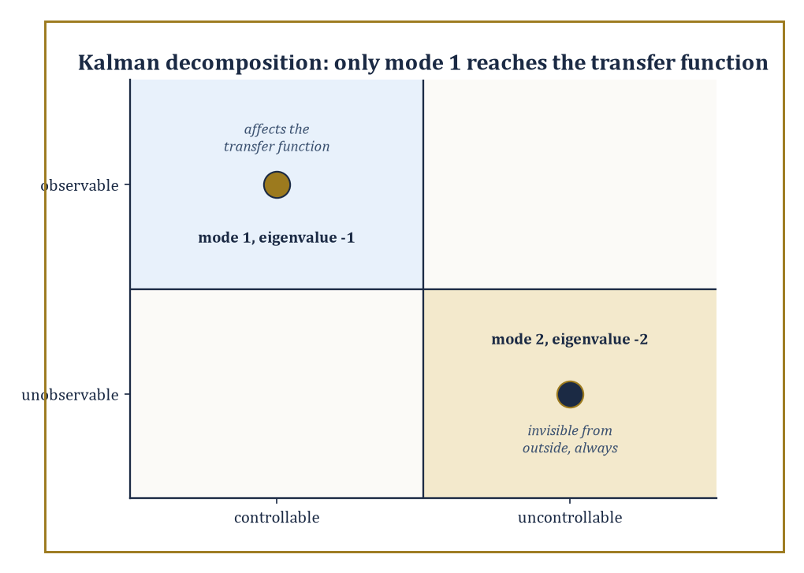
Figure 45.3 — Only the controllable-and-observable quadrant ever shows up outside the equations; the other three modes keep their secrets.
Kalman’s rank test turns this into linear algebra: form the controllability matrix
𝒞 = [B AB A²B ⋯ Aⁿ⁻¹B]
(n being the state dimension); the system is controllable if and only if 𝒞 has full rank n. The intuition is that B tells you which directions the input can push immediately, AB tells you which directions it can push one differentiation later (by first pushing, then letting the dynamics carry that push somewhere new), and so on — if these directions together span the whole state space, nowhere is permanently out of reach.
Numeric example — the double integrator is controllable. Return to A = [0 1; 0 0], B = [0; 1] from the previous section (force controlling a mass’s position and velocity). Compute
AB = [0 1; 0 0]·[0; 1] = [1; 0]
The controllability matrix is 𝒞 = [B AB] = [0 1; 1 0] (first column [0;1], second column [1;0]). Its determinant is
det(𝒞) = 0·0 − 1·1 = −1 ≠ 0
so 𝒞 has full rank 2: the system is controllable. This matches physical common sense — a force applied to a free mass can, given enough time, steer it to any position with any velocity you like.
Contrast this with the realization from the previous section, A = diag(−1,−2), B = [1; 0]: there,
AB = diag(−1,−2)·[1;0] = [−1; 0]
giving 𝒞 = [1 −1; 0 0] — a matrix whose second row is entirely zero, hence rank 1, not full rank. That system is not controllable: the input, having zero effect on the second state’s equation, can never reach it. This is the mode that vanished from the transfer function two sections ago; that was not a coincidence, and the next paragraph explains why.
Try it now — Is the linearized pendulum A = [0 1; −9.8 0], B = [0; 1] controllable? Answer →
Dual to controllability is observability: the ability to reconstruct the full internal state from a history of inputs and outputs, even though the output y = Cx + Du may reveal only a partial, blurred combination of the state at each instant. The observability matrix stacks
𝒪 = [C; CA; CA²; ⋯; CAⁿ⁻¹]
(each block a row, or several rows, of the output map applied after successive rounds of dynamics); the system is observable exactly when 𝒪 has full rank n. The intuition mirrors controllability precisely, with time reversed: C tells you what you can see right now, CA tells you what you can infer about the state one time-derivative back by watching how the visible part changes, and so on.
Numeric example — position alone reveals velocity. Take the same double integrator, but suppose we can only measure position, not velocity: y = x₁, i.e. C = [1 0]. Then
CA = [1 0]·[0 1; 0 0] = [0 1]
The observability matrix is 𝒪 = [1 0; 0 1] = the identity matrix, of full rank 2. So the system is observable: watching position alone over time is enough, in principle, to reconstruct velocity as well — which is just what differentiating a position sensor’s reading does, and what an observer (built in State Feedback, Pole Placement, and Observers) will do far more gracefully than raw differentiation ever could.
Kalman’s decomposition puts these two structural facts together: any linear system splits (via a suitable change of coordinates) into up to four subsystems — controllable-and-observable, controllable-but-unobservable, uncontrollable-but-observable, and uncontrollable-and-unobservable. Only the first piece, controllable and observable, affects the transfer function and hence the input-output behavior that anyone outside the system can ever detect; the other three pieces are, from the outside, undetectable ghosts, however dramatic their internal dynamics.
Abstract example — the ghost mode, formally introduced. In the realization A = diag(−1,−2), B = [1;0], C = [1 0] from the previous two sections, mode 1 (eigenvalue −1) has B’s first entry nonzero (controllable) and C’s first entry nonzero (observable): it is the controllable-and-observable part, and it alone survives into the transfer function 1/(s+1).
Mode 2 (eigenvalue −2) has both entries zero: uncontrollable, because the input never reaches it, and unobservable, because the output never sees it. It sits in Kalman’s fourth, most thoroughly ignored quadrant — the uncontrollable-and-unobservable part — decaying away at its own pace, affected by nothing we do and noticed by no one watching. If one wanted an unkind analogy for the state of mode 2 in the university sense, one need not look terribly far.
These tests extend, with real effort, beyond the linear time-invariant case. For linear time-varying systems the controllability and observability matrices become time-dependent Gramians rather than fixed-rank tests. For nonlinear systems the questions become differential-geometric: controllability is governed by the Lie brackets of the vector fields that describe how each control direction pushes the state (an idea we shall put to concrete use, and considerable delight, when Nonlinear and Robust Control parallel-parks a car), and observability by the codistribution generated by successive Lie derivatives of the output map. The rank conditions of this section are, in that sense, the linear shadow of a much richer geometric story — but they are also, happily, the version an engineer reaches for first, because most plants near their operating point are well approximated by the linear systems this section has been testing.
It is tempting, having just watched two clean rank conditions settle two clean questions, to assume controllability and observability are permanent properties of a physical device — that a car either is or isn’t steerable, full stop. They are properties of the model at a particular operating point, and can change as that point changes: a system linearized near one equilibrium may be perfectly controllable, while the same physical device linearized near a different equilibrium develops a direction the input genuinely cannot reach (a control surface that goes aerodynamically limp at a certain angle of attack is the classic aerospace nightmare version of this).
The rank tests of this section, in other words, are not once-and-for-all facts about a machine; they are facts about a linear approximation, valid exactly where that approximation is valid, and worth re-checking whenever the operating point moves far enough for the Jacobian from Linear State-Space Models to have changed its mind.
Keep only this · Section 45.3: Controllability and Observability
The idea. Controllability asks whether the input can steer every state; observability asks whether the output reveals every state. Both are rank conditions.
Core.
controllable ⇔ rank [B AB ⋯ Aⁿ⁻¹B] = n
observable ⇔ rank [C; CA; ⋯; CAⁿ⁻¹] = n
Typical mistake. Thinking an unstable system cannot be controllable. Controllability is about reach, not about stability.
Minimal example. A = diag(−1, −2), B = [1; 0]: the second mode is never touched.
Practice. Easy to challenge; full worked answers, with the usual mistake, are in Answers to the Practice Sets at the back.
Easy — Test A = diag(−1, −2), B = [1; 0] for controllability. Answer →
Medium — Is the linearized pendulum observable from velocity alone, C = [0 1]? Answer →
Challenge — Show that the double integrator is not observable from velocity, C = [0 1], and explain physically. Answer →

Section 45.4: Stability: Lyapunov and Input-Output
Not falling over, mathematically speaking
Lyapunov’s second method certifies stability of an equilibrium without ever solving the differential equation — a considerable relief, since most nonlinear equations refuse to be solved in closed form at all. The idea: find a scalar function V(x), positive everywhere except at the equilibrium (V(0)=0, V(x)>0 otherwise), that acts as a generalized energy. If V̇(x), the rate of change of V along the system’s own trajectories, is negative everywhere except at the equilibrium, then V is strictly decreasing along every trajectory, is bounded below by zero, and therefore the state must be converging toward the one place where V bottoms out. No formula for x(t) is needed; only a single well-chosen function and some careful differentiation.
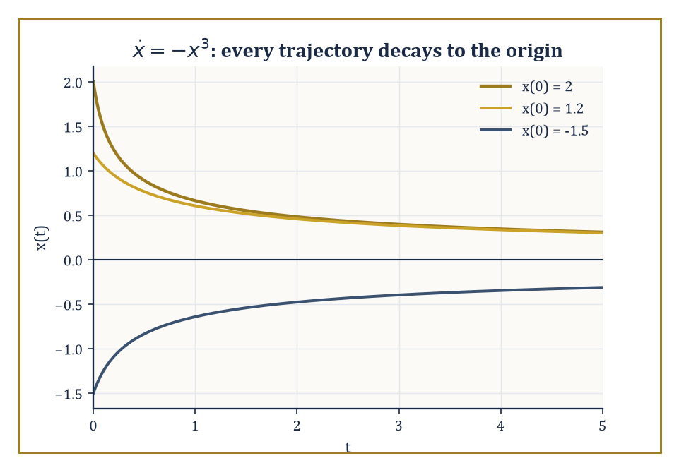
Figure 45.4 — No formula for x(t) was needed to prove this convergence — only that V=x²/2 keeps going downhill.
Numeric example — a nonlinear system stabilized by inspection. Consider the scalar nonlinear system ẋ = −x³. Try the natural energy-like candidate V(x) = x²/2, positive for all x ≠ 0. Then
V̇ = (dV/dx)·ẋ = x·(−x³) = −x⁴
This is negative for every x ≠ 0 and zero only at x = 0. Lyapunov’s theorem therefore certifies that the origin is (globally) asymptotically stable — every trajectory, wherever it starts, decays to zero — despite the fact that we never wrote down x(t) explicitly (it happens to be x(t) = x₀/√(1+2x₀²t), but Lyapunov’s method didn’t need to know that, and for most nonlinear systems no such formula exists at all).
Try it now — Use V(x) = x²/2 to decide the stability of ẋ = −x⁵. Answer →
For linear systems ẋ = Ax, this machinery collapses to a single matrix equation. Try the quadratic candidate V(x) = xᵀPx for a symmetric positive-definite matrix P; its derivative along trajectories is
V̇ = xᵀ(AᵀP + PA)x
Choosing any symmetric positive-definite Q and solving the Lyapunov equation
AᵀP + PA = −Q
for P then guarantees V̇ = −xᵀQx < 0 automatically. The remarkable fact, due to Lyapunov, is the converse too: A is stable (all eigenvalues in the open left half-plane) if and only if this equation has a positive-definite solution P for every positive-definite Q — turning a question about eigenvalues into a question about solving one linear matrix equation, which is often easier in high dimensions.
Numeric example — solving the Lyapunov equation directly. Scalar case first: A = −2, Q = 1. The Lyapunov equation Aᵀ P + PA = −Q becomes
(−2)P + P(−2) = −4P = −1, so P = 1/4 > 0
confirming, via a route that never mentions eigenvalues, that ẋ = −2x is stable (which we already knew, since −2 < 0, but the method scales to cases where ‘already knowing’ is not an option).
Now a 2×2 case: A = diag(−1,−2), Q = I. Try P diagonal, P = diag(p₁,p₂); for diagonal matrices,
AᵀP + PA = diag(−2p₁, −4p₂)
Setting this equal to −I = diag(−1,−1) gives p₁ = 1/2 and p₂ = 1/4, both positive, so P = diag(0.5, 0.25) is positive-definite and certifies stability — again correctly, since A’s eigenvalues −1 and −2 are both negative.
Lyapunov stability concerns behavior near an equilibrium; input-output (or BIBO, bounded-input-bounded-output) stability concerns the system as a black box, asking only that bounded inputs never produce unbounded outputs. For LTI systems this is equivalent to the impulse response g(t) being absolutely integrable,
∫[0, ∞]|g(t)|dt < ∞
which in turn is equivalent to every pole of the transfer function lying strictly in the open left half-plane — the same condition as Lyapunov stability of A, seen from the frequency-domain side of the house, which is reassuring, since it would be alarming if the two main notions of stability in this section disagreed with each other.
Numeric example — a stable pole and an unstable one. G(s) = 1/(s+3) has impulse response g(t) = e⁻³ᵗ for t ≥ 0. Then
∫[0, ∞] e⁻³ᵗdt = [−(1/3)e⁻³ᵗ]₀^∞ = 0 − (−1/3) = 1/3
finite — utterly integrable, so BIBO stable, and indeed its single pole s = −3 sits in the open left half-plane. Compare G(s) = 1/(s−1), impulse response eᵗ, for which ∫[0, ∞] eᵗdt diverges: not BIBO stable, and its pole s = 1 sits in the right half-plane, where the theorem said trouble would be.
Neither Lyapunov’s method nor the transfer-function pole test says anything, on its own, about what happens when stable systems are wired together — and almost nothing useful is ever built from a single isolated system. The small-gain theorem fills the gap: if two systems are interconnected in a feedback loop and each has an input-output gain (formally, an induced L₂ norm) of γ₁ and γ₂ respectively, the closed loop is guaranteed stable whenever
γ₁γ₂ < 1
regardless of the internal details of either system, linear or not. Passivity theorems offer a related, energy-based sufficient condition for stability of interconnections, particularly suited to physical systems that cannot manufacture energy from nothing.
Numeric example — small-gain in one line. Two subsystems in a feedback loop have gains γ₁ = 0.5 and γ₂ = 1.5. Their product is
γ₁γ₂ = 0.75 < 1
so the small-gain theorem certifies stability of the interconnection — a guarantee obtained without ever examining either subsystem’s internal equations, linear, nonlinear, or otherwise, which is the theorem’s appeal when the internals are unknown or too unpleasant to inspect.
Stability is deliberately treated first among the design requirements, because it is a precondition rather than a preference: a controller that stabilizes badly is a starting point for improvement, while a controller that fails to stabilize at all has nothing further worth discussing. Performance — how quickly, how accurately, how gracefully the system behaves — and robustness — how much of that performance survives contact with a plant that isn’t quite the one on paper — are the subjects of the next several sections, and both presuppose that this section’s business has already been settled.
Running example · The pendulum’s energy is a Lyapunov function
For the pendulum with friction feedback u = −cθ̇, the mechanical energy V = ½θ̇² + 9.8(1 − cos θ) satisfies V̇ = −cθ̇² ≤ 0 (Challenge exercise above). The same function returns three times: as the textbook Lyapunov function in Lyapunov Stability and Invariant Sets, where LaSalle’s principle upgrades V̇ ≤ 0 to convergence; as the Hamiltonian H = p²/2 + 9.8(1 − cos θ) in Lagrangian and Hamiltonian Mechanics; and as the quantity a good integrator must not let drift in Structure-Preserving and Geometric Integration.
Keep only this · Section 45.4: Stability: Lyapunov and Input-Output
The idea. Stability can be certified without solving the equation: find an energy-like V that never increases. For linear systems, solve AᵀP + PA = −Q; for interconnections, check γ₁γ₂ < 1.
Core.
V̇ = ∇V · f ≤ 0
AᵀP + PA = −Q, P ≻ 0 ⇔ A stable
small gain: γ₁γ₂ < 1
Typical mistake. Reading a failed Lyapunov candidate as proof of instability. A bad V proves nothing; try another.
Minimal example. A = −3, Q = 1: −6P = −1, so P = 1/6 > 0.
Practice. Easy to challenge; full worked answers, with the usual mistake, are in Answers to the Practice Sets at the back.
Easy — Two loop gains are γ₁ = 2 and γ₂ = 0.6. What does the small-gain theorem say? Answer →
Medium — Solve AᵀP + PA = −I for A = diag(−1, −4). Answer →
Challenge — For the pendulum ẋ₁ = x₂, ẋ₂ = −9.8 sin x₁ + u with friction feedback u = −cx₂ (c > 0), show that V = ½x₂² + 9.8(1 − cos x₁) never increases. Answer →

Section 45.5: State Feedback, Pole Placement, and Observers
Moving the poles, and guessing what you cannot see
If a system is controllable, the pole-placement theorem guarantees something remarkably strong: state feedback of the form u = −Kx can move the closed-loop poles — the eigenvalues of A − BK, which govern the closed-loop system’s transient behavior and stability — to any locations we like (subject only to complex poles coming in conjugate pairs, since the physical system has to stay real-valued). For a single-input system, the gain K achieving a desired set of poles is unique, and Ackermann’s formula computes it directly from the controllability matrix and the desired characteristic polynomial; for multi-input systems, modern ‘place’ algorithms do the same job numerically, with extra freedom to choose the K that is best-conditioned or otherwise best-behaved among the many that work.
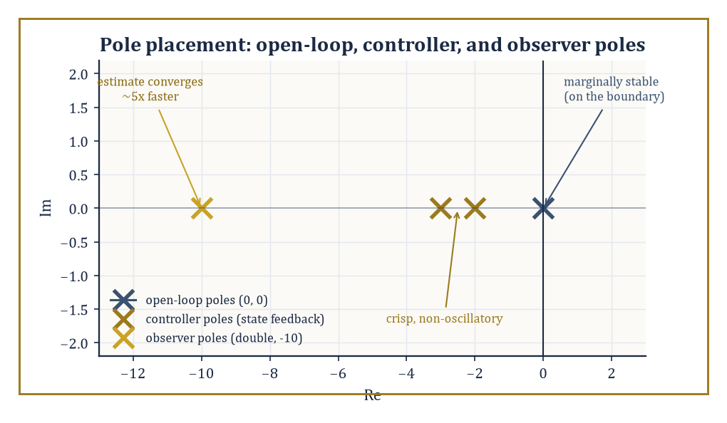
Figure 45.5 — Two poles marginally stable at the origin get relocated by feedback, while the observer poles are placed well to their left so the estimate never lags behind.
Numeric example — placing the poles of the double integrator. Take our recurring double integrator, A = [0 1; 0 0], B = [0; 1], and feedback u = −Kx with K = [k₁ k₂]. Then BK = [0;1]·[k₁ k₂] = [0 0; k₁ k₂], and the closed-loop matrix is A − BK = [0 1; −k₁ −k₂]. Its characteristic polynomial is
det(λI − (A−BK)) = det([λ −1; k₁ λ+k₂]) = λ(λ+k₂) + k₁ = λ² + k₂λ + k₁
Suppose we want closed-loop poles at −2 and −3 (both stable, giving a reasonably crisp, non-oscillatory response). The desired polynomial is
(λ+2)(λ+3) = λ² + 5λ + 6
Matching coefficients: k₂ = 5, k₁ = 6, so K = [6 5]. Check: trace(A−BK) = 0 + (−5) = −5, which should equal the sum of the poles, −2 + (−3) = −5 — correct. And det(A−BK) = 0·(−5) − 1·(−6) = 6, which should equal the product of the poles, (−2)(−3) = 6 — correct. A single line of feedback, u = −6x₁ − 5x₂, has converted a system with two poles sitting right on the stability boundary (the open-loop double integrator has both poles at the origin — marginally stable at best) into one with two comfortably stable, well-separated poles.
Try it now — Place both closed-loop poles of the double integrator at −1 with u = −Kx. Answer →
Pole placement assumes the full state x is available for feedback, which is often wishful thinking — many systems can only be measured through a handful of sensors, not read off in full. When the state is not directly measured, an observer reconstructs an estimate x̂ from the input and the actual output, using a copy of the plant’s own dynamics plus a correction term driven by the prediction error:
x̂̇ = Ax̂ + Bu + L(y − Cx̂)
The observer gain L is chosen — again by a pole-placement calculation, this time on the error dynamics — to make the estimation error e = x − x̂ decay quickly. The classical version for deterministic systems is the Luenberger observer; its stochastic cousin, tuned to minimize estimation error variance in the presence of measurement and process noise, is the Kalman filter.
Numeric example — an observer for the same system. Suppose we can only measure position, y = x₁, so C = [1 0], and we want the estimation error to decay fast — say, both observer poles at −10 (faster than the controller poles at −2, −3, on the sound principle that a guess should converge well before the control law starts trusting it). Set L = [l₁; l₂]. Then LC = [l₁; l₂]·[1 0] = [l₁ 0; l₂ 0], and A − LC = [−l₁ 1; −l₂ 0]. Its characteristic polynomial is
det(λI−(A−LC)) = det([λ+l₁ −1; l₂ λ]) = λ(λ+l₁) + l₂ = λ² + l₁λ + l₂
The desired polynomial for a double pole at −10 is
(λ+10)² = λ² + 20λ + 100
giving l₁ = 20, l₂ = 100. Check: trace(A−LC) = −20 = −10 + −10, and det(A−LC) = l₂ = 100 = (−10)(−10) — both correct. This observer reconstructs both position and velocity from position measurements alone, converging roughly five times faster than the controller designed around it needs it to.
The separation principle is the elegant theorem that makes this two-step design legitimate rather than merely convenient: for a controllable and observable linear system, the feedback gain K and the observer gain L may be designed entirely independently, using the plant model alone, and the resulting combined closed-loop system (controller acting on the estimate x̂, observer fed by the actual output y) has closed-loop eigenvalues exactly equal to the union of the two sets designed separately —
eigenvalues(A−BK) ∪ eigenvalues(A−LC)
There is no cross-term, no interaction to worry about, no coupled higher-order eigenvalue problem to solve by hand.
Abstract example — the separation principle cashed out. Combining the two designs above: the full closed-loop system — controller plus observer, four states in total (two plant states, two estimation-error states) — has closed-loop poles precisely
{−2, −3} ∪ {−10, −10} = {−2, −3, −10, −10}
Nobody needed to write down, let alone diagonalize, the resulting 4×4 matrix; two clean 2×2 pole-placement calculations, done in isolation and without reference to each other, are provably sufficient. It is one of the few moments in this chapter where the mathematics hands the engineer a genuine, no-strings-attached shortcut — a rare enough event in this line of work to be worth pausing to enjoy.
It is worth being precise about what static output feedback — control laws of the form u = −Ky using only the measured output y directly, with no observer in between — can and cannot do: it is, in general, not powerful enough to place closed-loop poles arbitrarily, even for systems that are fully controllable and observable, because y typically carries less information than x. Dynamic output feedback — precisely the observer-plus-state-feedback architecture just built — recovers the full pole-placement power of state feedback for any controllable and observable system, at the modest cost of doubling the state dimension (the observer’s estimation error is itself a dynamical system riding along). State feedback and observers, used together via the separation principle, are the two basic components from which the great majority of modern linear controllers are actually built.
Running example · Balancing the pendulum upright
Upright, the pendulum is unstable: with φ = θ − π, linearization gives φ̈ = 9.8φ + u, with eigenvalues ±3.13. It is controllable, so pole placement works: K = [13.8 4] puts both poles at −2, since s² + 4s + (13.8 − 9.8) = (s + 2)². The same upright position is a saddle point in the phase portrait of Linearization and Local Structure.
Keep only this · Section 45.5: State Feedback, Pole Placement, and Observers
The idea. If the system is controllable, state feedback u = −Kx puts the closed-loop poles anywhere; if it is observable, an observer estimates the state; the two designs combine without interfering.
Core.
closed loop: eig(A − BK)
observer: eig(A − LC)
separation: controller poles ∪ observer poles
Typical mistake. Placing observer poles slower than controller poles. The estimate must converge before the controller can trust it.
Minimal example. Double integrator, poles at −3, −3: K = [9 6].
Practice. Easy to challenge; full worked answers, with the usual mistake, are in Answers to the Practice Sets at the back.
Easy — Place both poles of the double integrator at −3. Answer →
Medium — The upright pendulum linearizes to φ̈ = 9.8φ + u, A = [0 1; 9.8 0], B = [0; 1]. Find K placing the poles at −1 and −3. Answer →
Challenge — Design an observer for the double integrator with C = [1 0] and both observer poles at −5. Answer →

Section 45.6: Optimal Control: LQR and the Maximum Principle
Doing it not just well, but provably as well as possible
Balancing a broom upright on your palm, you constantly trade two costs: letting the broom lean too far and moving your hand too much. Optimal control turns that trade-off into mathematics. You state, in a single number, how much you dislike errors and how much you dislike effort, and the theory delivers the control law that minimizes the total over all time. For a linear system with quadratic costs, the linear-quadratic regulator, the answer is remarkably simple: feed back the current state, multiplied by a gain matrix found by solving one matrix equation. Applied to a system that would otherwise run away exponentially, it produces exponential decay back to rest.
Pole placement asks for a specific closed-loop behavior; optimal control asks for the best closed-loop behavior, according to a stated cost. The linear-quadratic regulator (LQR) minimizes
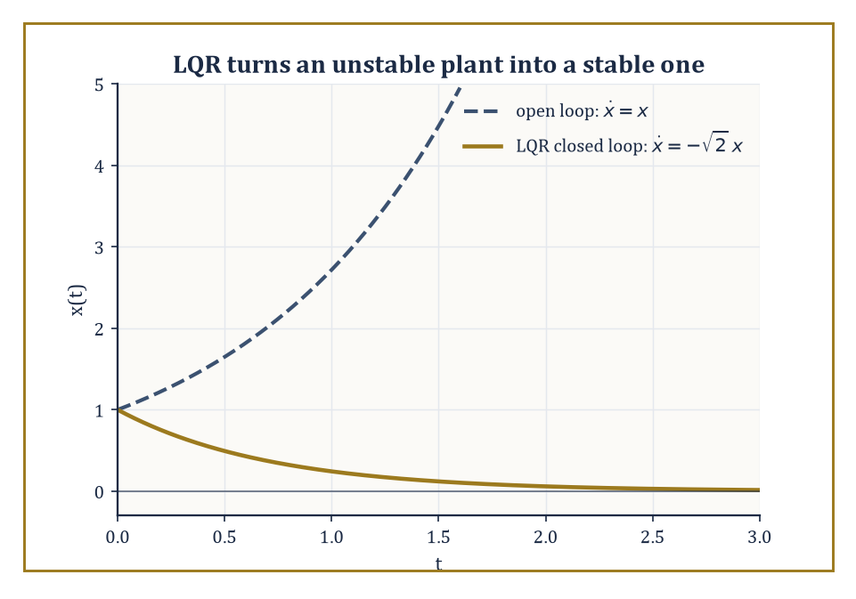
Figure 45.6 — Same plant, same starting point, one Riccati equation later: exponential blow-up becomes exponential decay.
J = ∫[0, ∞] (xᵀQx + uᵀRu) dt
for a linear system ẋ = Ax + Bu, where Q ≥ 0 penalizes deviation of the state from zero and R > 0 penalizes control effort — a formalization of the entirely reasonable desire to get the job done without either wandering off or slamming the actuators.
The remarkable result, and the reason LQR remains a default choice decades after its discovery, is that the optimal control is linear state feedback,
u = −Kx, K = R⁻¹BᵀP
where P is the unique positive-definite solution of the algebraic Riccati equation (ARE):
AᵀP + PA − PBR⁻¹BᵀP + Q = 0
The optimization problem, infinite-dimensional in principle (a whole function u(t) to choose), collapses to solving one matrix quadratic equation.
Numeric example — LQR stabilizes an unstable plant. Take a scalar system ẋ = ax + bu with a = 1 (unstable — without control, x(t) = x(0)eᵗ grows without bound) and b = 1, with equal weighting Q = 1, R = 1. The scalar Riccati equation is 2aP − (b²/R)P² + Q = 0, i.e.
2P − P² + 1 = 0, or P² − 2P − 1 = 0
The quadratic formula gives
P = [2 ± √(4+4)]/2 = 1 ± √2
taking the positive root (required for P > 0), P = 1 + √2 ≈ 2.4142. The gain is
K = R⁻¹bP = 1·1·(1+√2) = 1+√2 ≈ 2.4142
The closed-loop system is
ẋ = (a−bK)x = (1 − (1+√2))x = −√2·x ≈ −1.4142x
asymptotically stable, with decay rate √2, despite starting from a plant that was unstable on its own. Notice the closed-loop pole −√2 is exactly −√(a² + b²Q/R) = −√(1+1) = −√2, the general scalar-LQR closed-loop pole formula; LQR has done more than merely stabilize, it has done so while explicitly balancing the cost of state deviation against the cost of the control effort spent correcting it.
Try it now — Find the LQR gain for ẋ = u (a = 0, b = 1) with Q = R = 1. Answer →
The version above is the infinite-horizon LQR, appropriate when the control runs indefinitely; a finite-horizon version instead solves a Riccati differential equation backward from a terminal condition, and under standard conditions (controllability, observability of √Q) its solution converges to the algebraic Riccati equation’s solution as the horizon lengthens — reassuring evidence that the two formulations agree when they overlap.
Pairing LQR’s optimal state feedback with the Kalman filter — the optimal observer for systems disturbed by Gaussian process and measurement noise — gives the LQG (linear-quadratic-Gaussian) design methodology, and the separation principle from the previous section extends here too: the two problems may be solved independently and combined, with the Kalman filter gain solving a Riccati equation that is structurally the dual of the LQR one, with (A,B,Q,R) replaced by (Aᵀ,Cᵀ, process noise covariance, measurement noise covariance).
Abstract example — the LQR/Kalman duality. LQR takes (A,B,Q,R) and produces a state-feedback gain K minimizing a cost on future state and control. The Kalman filter takes the transposed, role-swapped data (Aᵀ,Cᵀ,Qₙₒᵢₛₑ,Rₙₒᵢₛₑ) — where C now plays the part B played, and the noise covariances play the part the cost weights played — and produces an observer gain Lᵀ minimizing estimation-error variance. Solve one Riccati equation, relabel the symbols, and you have solved the other: control and estimation, so often taught as separate subjects, turn out to be the same piece of mathematics wearing two different sets of matrix labels — arguably the single most elegant fact in this entire chapter.
LQR presupposes a linear system and a quadratic cost; for nonlinear dynamics or more general costs, the Pontryagin maximum principle (PMP) supplies necessary conditions that any optimal trajectory must satisfy, without requiring the problem to be solved in closed form. Define the Hamiltonian
H(x,u,p) = L(x,u) + pᵀf(x,u)
where L is the running cost, f is the dynamics ẋ = f(x,u), and p(t) is an adjoint (costate) variable — a Lagrange multiplier that evolves in time, satisfying ṗ = −∂H/∂x. The principle states that an optimal control u*(t) minimizes (or maximizes, by sign convention) the Hamiltonian pointwise over admissible controls at each instant. This is a direct generalization of the Euler–Lagrange equations from the calculus of variations, extended to handle explicit control inputs and constraints on them — the costate p is, in effect, the shadow price of the state constraint ẋ = f(x,u), just as a Lagrange multiplier is the shadow price of an ordinary constrained optimum.
Numeric example — minimum-energy control via the maximum principle. Minimize
J = ∫₀¹ ½u² dt subject to ẋ = u, x(0) = 0, x(1) = 1
— steer a point from 0 to 1 in one unit of time, spending as little control energy as possible. The Hamiltonian (minimization convention) is H = ½u² + pu. Minimizing over u: ∂H/∂u = u + p = 0, so u*(t) = −p(t). The costate equation is ṗ = −∂H/∂x = 0 (H does not depend on x here), so p(t) is constant, p(t) ≡ p₀, and hence u(t) is constant too, u(t) ≡ u₀ = −p₀. Then x(t) = ∫₀ᵗ u₀ ds = u₀t, and the boundary condition x(1) = 1 forces u₀ = 1. So the optimal control is
u(t) = 1 for all t ∈ [0,1], giving x(t) = t
check: x(0)=0, x(1)=1, both satisfied. The minimum cost is J = ∫₀¹ ½(1)²dt = 1/2. The maximum principle has told us, correctly and with no wasted effort, that the cheapest way to cover a fixed displacement in a fixed time is to push at a constant, steady rate — the instinct any sensible driver already has, now derived from first principles rather than habit.
LQR and the maximum principle are best understood as complementary rather than competing: LQR is a design method, handing back an explicit, implementable feedback law whenever the problem happens to be linear-quadratic; the maximum principle is a set of necessary conditions, characterizing what any optimal trajectory must look like for a far wider class of nonlinear problems, at the cost of usually requiring a two-point boundary-value problem (in x and p together) to be solved numerically rather than in closed form. Between them, they supply both the everyday workhorse and the theoretical ceiling against which every other design method in this chapter is, implicitly, being measured.
Same structure, new language
The maximum principle is the calculus of variations of Chapter 28 (Volume 3) with the dynamics ẋ = f(x, u) as a constraint, and its costate p is a Lagrange multiplier, the shadow price of Optimization (Volume 3). Its Hamiltonian is the same construction that turns Lagrangian into Hamiltonian mechanics in Lagrangian and Hamiltonian Mechanics.
Keep only this · Section 45.6: Optimal Control: LQR and the Maximum Principle
The idea. LQR chooses the feedback minimizing ∫(Qx² + Ru²) dt, found from a Riccati equation; the maximum principle extends optimal control to nonlinear problems through a Hamiltonian.
Core.
2aP − (b²/R)P² + Q = 0, K = bP/R
closed-loop pole −√(a² + b²Q/R)
Typical mistake. Thinking a larger Q always helps. It buys speed with control effort, which saturates real actuators.
Minimal example. a = 1, b = 1, Q = R = 1: K = 1 + √2, pole −√2.
Practice. Easy to challenge; full worked answers, with the usual mistake, are in Answers to the Practice Sets at the back.
Easy — Find the closed-loop pole for a = 2, b = 1, Q = R = 1. Answer →
Medium — With a = 0, b = 1, R = 1, compare Q = 1 and Q = 4. Answer →
Challenge — For an unstable plant a > 0 with b = 1, what happens to the LQR pole as R → ∞, and why is that sensible? Answer →

Section 45.7: Frequency-Domain Methods
The same story, told in Hertz
Classical control design largely ignores the state altogether and works directly with the transfer function G(s), read off along the imaginary axis s = jω to see how the system responds to sinusoids of each frequency ω. A Bode plot displays the magnitude |G(jω)| (usually in decibels, 20log₁₀|G(jω)|) and the phase ∠G(jω) as functions of ω, on logarithmic frequency axes; a Nyquist plot traces G(jω) as a curve in the complex plane as ω sweeps from −∞ to ∞; a root-locus diagram tracks how the closed-loop poles migrate as a single gain is varied. None of these require ever forming a state-space model, which is their appeal to an engineer handed only a measured frequency response and no equations at all.
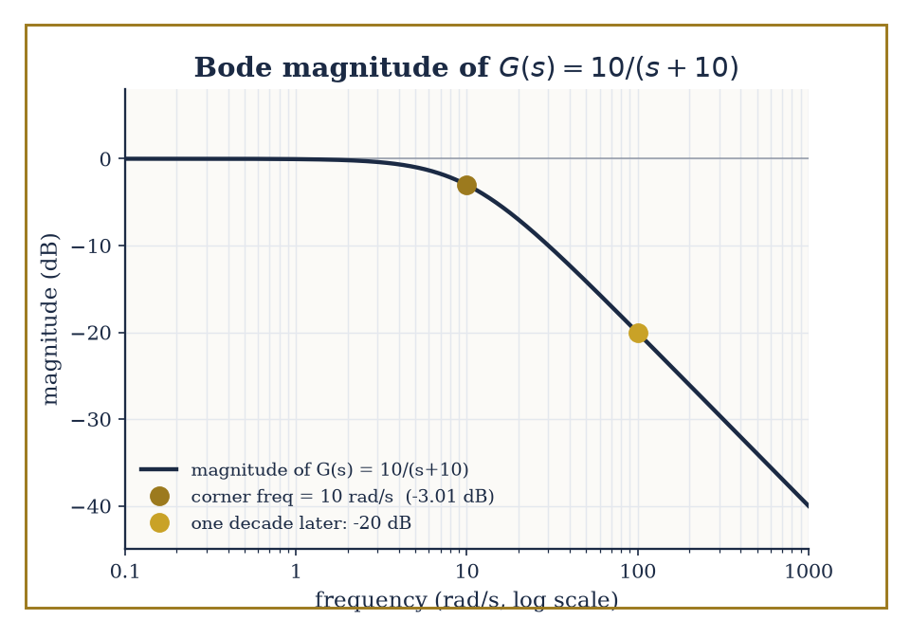
Figure 45.7 — The corner frequency, the −3 dB point, and the −20 dB/decade roll-off, all readable off the same curve without sketching a single asymptote.
Numeric example — reading a Bode plot by hand. Take the first-order system G(s) = 10/(s+10), a simple low-pass filter with a pole at s = −10. Its magnitude at real frequency ω is
|G(jω)| = 10/√(ω²+100)
At ω = 0: |G| = 10/10 = 1, i.e. 20log₁₀(1) = 0 dB — full gain at DC. At ω = 10 (the ‘corner frequency’, where ω equals the pole magnitude):
|G| = 10/√(100+100) = 10/√200 ≈ 0.7071, 20log₁₀(0.7071) ≈ −3.01 dB
the famous ’−3 dB point’. The phase there is
∠G(j10) = −arctan(10/10) = −arctan(1) = −45°
halfway to the eventual −90° a first-order lag approaches at high frequency. At ω = 100, one decade above the corner:
|G| = 10/√(10000+100) = 10/√10100 ≈ 10/100.499 ≈ 0.0995, 20log₁₀(0.0995) ≈ −20.04 dB
a drop of almost exactly 20 dB from the corner, confirming the standard −20 dB/decade roll-off rate of a single pole past its corner frequency, without needing to sketch a single asymptote.
Try it now — For G(s) = 5/(s + 5), find |G(j5)| in dB and the phase at ω = 5. Answer →
Stability margins quantify how close a nominally stable closed loop sits to instability, using nothing but the open-loop frequency response L(jω) (open loop = plant times controller, before the loop is closed). The phase margin is 180° plus the phase of L(jω) at the frequency where |L(jω)| first crosses 0 dB (unity gain); the gain margin is how many decibels of extra gain could be added before |L(jω)| reaches 0 dB at the frequency where the phase first crosses −180°. Rules of thumb (phase margin ≥ 45°, gain margin ≥ 6 dB or so) are the classical engineer’s proxy for the more rigorous — but harder to build intuition for — robustness guarantees of later, modern methods.
Numeric example — margins from two numbers. Suppose the open loop crosses 0 dB at some frequency ω_c where the measured phase is −130°. Phase margin =
180° − 130° = 50°
comfortably above the 45° rule of thumb. Suppose separately that at the frequency where the phase crosses −180°, the measured gain is −8 dB. The gain margin is 8 dB, meaning the loop gain could be multiplied by
10^(8/20) = 10^0.4 ≈ 2.512
before the system reaches the brink of instability — a healthy safety factor of roughly 2.5×, obtained from two single-number readings off a Bode plot and no further calculation.
The Nyquist stability criterion goes further than a margin: it decides closed-loop stability outright from the open-loop frequency response, by counting how many times the Nyquist plot of L(jω) encircles the critical point −1. Precisely, the number of clockwise encirclements N equals Z − P, where P is the number of open-loop unstable poles and Z the number of closed-loop unstable poles; for an open-loop stable system (P=0), the closed loop is stable exactly when the plot does not encircle −1 at all. This is the frequency-domain machinery that ultimately explains why the gain and phase margins of the previous example mean anything — they measure, in two convenient numbers, how far the Nyquist plot sits from the one point it is forbidden to touch.
Numeric example — a critical gain, found by Routh–Hurwitz. Take the classic triple-pole plant L(s) = K/[(s+1)(s+2)(s+3)], stable in open loop (P = 0), with gain K > 0 to be chosen. The closed-loop characteristic equation is (s+1)(s+2)(s+3) + K = 0. Expanding:
(s+1)(s+2) = s²+3s+2
(s²+3s+2)(s+3) = s³ + 3s² + 3s² + 9s + 2s + 6 = s³ + 6s² + 11s + 6
So the closed-loop characteristic polynomial is s³ + 6s² + 11s + (6+K). Build the Routh array: row s³ holds coefficients 1 and 11; row s² holds 6 and (6+K); row s¹ holds (6·11 − 1·(6+K))/6 = (60−K)/6; row s⁰ holds (6+K). Stability requires every entry in the first column — 1, 6, (60−K)/6, (6+K) — to be positive, which requires K < 60 and K > −6.
For physically sensible K > 0, the closed loop is stable for 0 < K < 60, marginally stable (a pair of poles on the imaginary axis, sustained oscillation) at K = 60, and unstable beyond. This K = 60 is the same number the Nyquist plot would show swallowing the −1 point as K increases past it, and — as the next example shows — it is not merely a number we compute and discard.
Proportional-integral-derivative (PID) control remains the overwhelming industrial default, not because it is theoretically optimal but because it is cheap, transparent, and tunable by operators who have never seen a Riccati equation and never need to. The Ziegler–Nichols ultimate-gain method is the classical tuning recipe: increase a purely proportional gain until the closed loop first sustains steady oscillation, record that critical gain K_u and the oscillation period T_u, then set Kp = 0.6K_u, integral time Tᵢ = T_u/2 (giving integral gain Kᵢ = Kp/Tᵢ), and derivative time T_d = T_u/8 (giving derivative gain K_d = Kp·T_d).
Numeric example — Ziegler–Nichols tuning, continuing the plant above. The triple-pole plant just analyzed sustains oscillation exactly at Kᵤ = 60 — the K where the Routh test found a marginally stable pole pair, the same critical gain a Nyquist plot would flag as touching −1. Suppose the resulting sustained oscillation is measured to have period Tᵤ = 2 s. Ziegler–Nichols then prescribes
Kp = 0.6×60 = 36
Tᵢ = 2/2 = 1 s (so Kᵢ = 36/1 = 36)
T_d = 2/8 = 0.25 s (so K_d = 36×0.25 = 9)
A full PID controller, three numbers, obtained from a plant we never needed to model beyond finding the single gain at which it starts to sing.
Modern frequency-domain design extends this classical toolkit to systems with many inputs and outputs, and to uncertainty that isn’t just ‘the gain might be a bit off’ but structured — different actuators, sensors, or subsystems each with their own, possibly correlated, error bars. H∞ loop shaping designs a controller minimizing the worst-case gain, over all frequencies, from disturbance to error — the H∞ norm
‖T‖∞ = sup[ω] σ̄(T(jω))
the peak of the largest singular value of the closed-loop transfer function, generalizing the scalar peak |T(jω)| to the multivariable case. μ-synthesis refines this further to account explicitly for the structure of the uncertainty, rather than treating it as an undifferentiated blob. For all their machinery, both methods are answering the question a Bode plot was already asking — how big can the response get, and at what frequency — just for systems too large and too uncertain for a hand sketch to settle.
Keep only this · Section 45.7: Frequency-Domain Methods
The idea. Frequency-domain design reads stability and robustness from the open-loop frequency response: Bode plots, margins, Nyquist encirclements, and the Routh–Hurwitz test for the closed loop.
Core.
phase margin = 180° + ∠L(jω_c)
Nyquist: N = Z − P
Ziegler–Nichols: K_p = 0.6Kᵤ, Tᵢ = Tᵤ/2, T_d = Tᵤ/8
Typical mistake. Reading the phase margin as the phase itself. It is the distance of the phase from −180°.
Minimal example. Crossover phase −130°: phase margin 50°.
Practice. Easy to challenge; full worked answers, with the usual mistake, are in Answers to the Practice Sets at the back.
Easy — The open loop crosses 0 dB where its phase is −150°. What is the phase margin, and is it comfortable? Answer →
Medium — A gain margin is 12 dB. By what factor can the loop gain grow before instability? Answer →
Challenge — For L(s) = K/(s + 1)³, find the critical gain and oscillation frequency, then the Ziegler–Nichols PID settings. Answer →

Section 45.8: Nonlinear and Robust Control
When the straight line stops being a kindness
Before this section
What you need. Lyapunov functions from Stability: Lyapunov and Input-Output and pole placement from State Feedback, Pole Placement, and Observers.
Why it matters. Every earlier technique leaned on linearity. Real plants, the pendulum at large angles among them, are nonlinear and imperfectly known.
Every technique so far has, at some point, leaned on linearity — superposition, eigenvalues, transfer functions, quadratic Lyapunov functions solved by a matrix equation. Real plants are rarely so obliging over their full operating range, and nonlinear control supplies a toolkit for the cases where the straight-line approximation from Linear State-Space Models has been stretched past its useful life. Feedback linearization is the most direct idea: if the nonlinearity enters the dynamics in a way we can identify and algebraically cancel using the very input we’re free to choose, we can manufacture linear closed-loop behavior from a nonlinear plant, rather than merely approximating one.
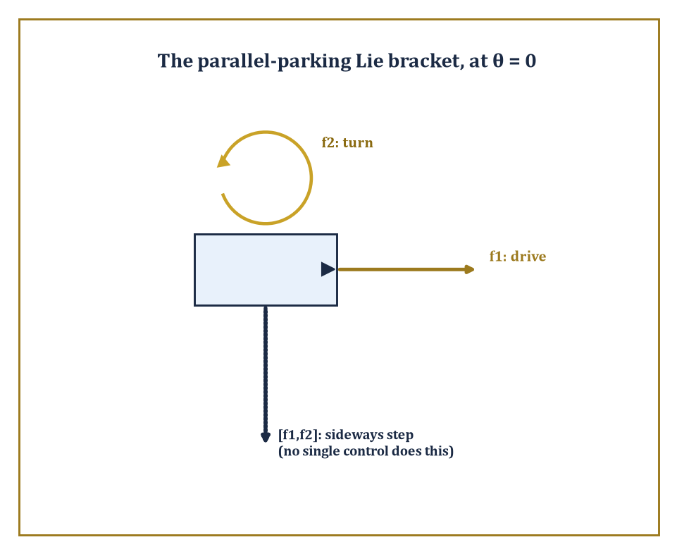
Figure 45.8 — Neither drive nor turn moves the car sideways; their Lie bracket does — every parallel-parking driver implements this arrow by hand.
Numeric example — canceling a cubic nonlinearity. Take ẋ = −x + x³ + u — stable for small x thanks to the −x term, but the x³ term threatens to dominate and destabilize for larger x. Choose u = −x³ + v, canceling the troublesome term: the closed loop becomes
ẋ = −x + x³ + (−x³ + v) = −x + v
now perfectly linear in the new input v, regardless of how large x gets. Design v as ordinary linear feedback, v = −4x (so the effective gain, combined with the existing −x, gives decay rate 5):
ẋ = −x − 4x = −5x, x(t) = x(0)e⁻⁵ᵗ
Starting from x(0) = 2, at t = 0.2:
x(0.2) = 2e⁻¹ = 2 × 0.367879 ≈ 0.7358
The cubic term has been surgically removed from the closed-loop dynamics, not only tolerated for being small; this is a nonlinear technique, valid for all x, not just x near an equilibrium.
Try it now — Cancel the nonlinearity in ẋ = x² + u and make the closed loop decay at rate 3. Answer →
Sliding mode control trades the elegance of exact cancellation for outright robustness to disturbances we cannot cancel because we don’t know their exact size — only a bound on it. Choose a sliding surface s(x) = 0 (here, for simplicity, just s = x) and a discontinuous control law that switches sign depending on which side of the surface the state currently sits, with a switching gain large enough to overpower the worst-case disturbance. The state is driven onto the surface in finite time and, once there, held on it despite the disturbance — at the cost of chattering, rapid switching near the surface, which is the well-known practical nuisance of the method.
Numeric example — robustness against a bounded disturbance. Take ẋ = f(x) + u + d(t), where d(t) is an unknown disturbance satisfying only |d(t)| ≤ D = 3 (bound known, exact value not). Choose u = −f(x) − K·sign(x) with K = 5 > D. The sliding variable is s = x, and
ṡ = ẋ = f(x) + u + d = −K·sign(s) + d
Using the Lyapunov function V = s²/2:
V̇ = s·ṡ = s(−K·sign(s) + d) = −K|s| + sd ≤ −K|s| + |s|·D = −(K−D)|s| = −(5−3)|s| = −2|s|
Since V̇ ≤ −2|s| < 0 whenever s ≠ 0, regardless of the disturbance’s exact behavior (only its bound D=3 was ever used), the state reaches s = 0 in finite time and stays there — a robustness guarantee obtained without ever needing to know, or estimate, what d(t) was doing.
Some questions of controllability cannot even be asked in linear language, because the system’s controls only ever push in a handful of instantaneous directions, and yet the full state space turns out to be reachable anyway — a phenomenon linear algebra alone cannot explain, but Lie brackets can. The Lie bracket [f₁,f₂] of two vector fields (control directions) measures the net motion produced by wiggling first along f₁, then f₂, then back along f₁, then back along f₂ — a motion in a new direction, unavailable from f₁ or f₂ alone, that emerges purely from the order in which the two motions fail to commute.
Abstract example — the parallel-parking Lie bracket. The kinematic car (unicycle model) has state (x,y,θ) — position and heading — and two controls: drive forward, f₁ = (cosθ, sinθ, 0), or turn in place, f₂ = (0,0,1). Neither control alone moves the car sideways. Computing the Lie bracket [f₁,f₂] = Df₂·f₁ − Df₁·f₂: since f₂ is constant, Df₂ = 0; the Jacobian of f₁ with respect to (x,y,θ) is Df₁ = [0 0 −sinθ; 0 0 cosθ; 0 0 0], so Df₁·f₂ = Df₁·(0,0,1)ᵀ = (−sinθ, cosθ, 0)ᵀ, giving
[f₁,f₂] = −(−sinθ,cosθ,0)ᵀ = (sinθ, −cosθ, 0)ᵀ
At θ = 0 (car facing along the x-axis), this bracket direction is (0, −1, 0) — pure sideways motion, in the y-direction, perpendicular to the heading. No single control produces this motion, but alternating drive-turn-reverse-turn, in the pattern the bracket encodes, produces a net sideways step over one full cycle. This is, quite literally, the mathematics of parallel parking: the car cannot move sideways directly, but the Lie bracket of its two available motions can, and every driver who has ever inched a car into a tight space has been implementing this bracket by hand, entirely without noticing.
Robust control accepts, as a starting premise, that the model is wrong by some amount, and designs for the worst case that amount allows. H∞ control chooses the controller minimizing the worst-case closed-loop gain from disturbance to error across all frequencies (the same H∞ norm introduced in the previous section, now used as a direct design objective rather than a passive measurement); μ-synthesis extends this to structured uncertainty, where different parts of the model are wrong in different, possibly correlated ways, rather than treating all uncertainty as one undifferentiated blob. Adaptive control takes a different tack again: rather than designing once for the worst case, it estimates the unknown parameters online and adjusts the controller as better information arrives — appropriate when the uncertainty is parametric (a mass, a friction coefficient, a gain, unknown but constant) rather than an arbitrary disturbance.
Abstract example — an adaptive law verified by Lyapunov, not by solving the trajectory. Consider ẋ = θ*x + u, with true parameter θ* unknown and constant, and control u = −kx − αx, where α is an online estimate of θ* and k > 0 is a fixed, known robustifying gain. Writing the estimation error φ = α − θ*, the closed loop is
ẋ = θ*x + u = θ*x − kx − αx = −kx + (θ*−α)x = −kx − φx
Choose the adaptive update law α̇ = γx² for some fixed γ > 0 (note φ̇ = α̇, since θ* is constant). Try the Lyapunov function V = x²/2 + φ²/(2γ):
V̇ = xẋ + φφ̇/γ = x(−kx−φx) + φ(γx²)/γ = −kx² − φx² + φx² = −kx²
With, say, k = 2, this gives V̇ = −2x² ≤ 0 for every value of the unknown θ*, every value of γ > 0, and every trajectory of α — a stability guarantee established without ever solving the coupled nonlinear equations for x(t) and α(t) explicitly, which in general cannot be done in closed form. This is the defining move of Lyapunov-based adaptive control: choose the update law specifically so that the awkward cross-term in V̇ cancels, and let the sign of what remains do all the remaining work.
Nonlinear and robust methods do not replace the linear theory built in Sections 45.2 through 45.6; they extend its reach into territory where a single linearization, a single fixed model, or a single worst-case-free assumption would fail without warning. The goals — stability, performance, robustness — are unchanged from Section 45.1’s opening sentence. Only the honesty required to pursue them has increased.
Keep only this · Section 45.8: Nonlinear and Robust Control
The idea. When linearization is not enough: cancel nonlinearities exactly, dominate bounded disturbances with sliding modes, reach new directions through Lie brackets, and adapt to unknown parameters with a Lyapunov-certified update law.
Core.
feedback linearization: u = −(nonlinearity) + v
sliding mode: V̇ ≤ −(K − D)|s|
Typical mistake. Trusting exact cancellation with an inexact model. The leftover term is the model error, and it must be checked.
Minimal example. D = 2, K = 5: V̇ ≤ −3|s|.
Practice. Easy to challenge; full worked answers, with the usual mistake, are in Answers to the Practice Sets at the back.
Easy — A disturbance satisfies |d| ≤ 2 and the sliding gain is K = 5. What bound does V = s²/2 give? Answer →
Medium — Feedback-linearize the pendulum θ̈ = −9.8 sin θ + u so that the closed loop has both poles at −2. Answer →
Challenge — The controller of the previous exercise assumed g = 9.8, but the true value is 10. Is the loop still stable near θ = 0? Answer →

Section 45.9: Looking Ahead: From Classical Control to Hybrid, Networked, and Learning-Based Control
From the loop to the network, the switch, and the machine that learns
We have now assembled the core of control theory: linear state-space models as the common language, controllability and observability as the structural prerequisites for design, Lyapunov and input-output stability as the non-negotiable first requirement, state feedback and observers as the two basic levers (united by the separation principle), LQR and the Pontryagin maximum principle as the optimal versions of those levers, frequency-domain methods as an older and still-thriving parallel dialect, and the beginnings of nonlinear and robust control for when the linear dialect starts to strain. Every later development in the field builds directly on this list, rather than replacing any part of it.
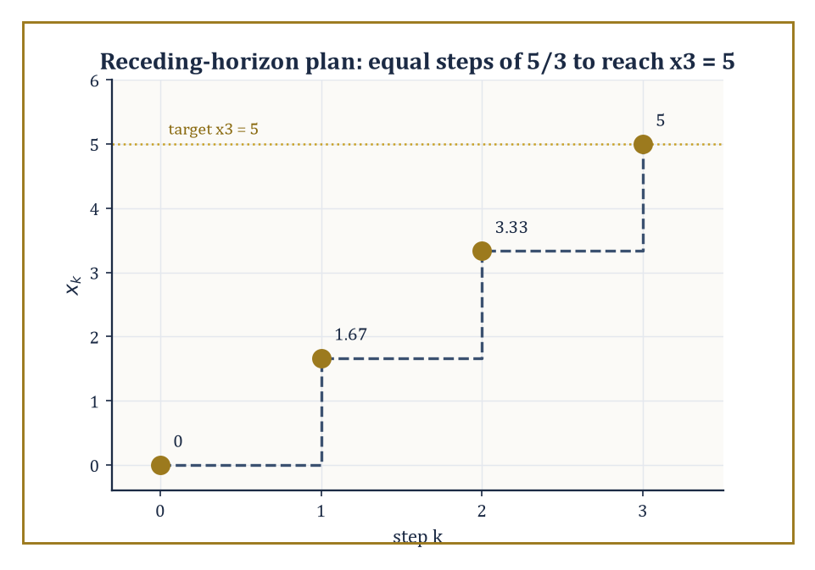
Figure 45.9 — A one-shot optimal plan would apply all three moves; MPC applies only the first, then re-solves from wherever reality put it.
Hybrid systems combine continuous dynamics with discrete switches — a thermostat that is a linear heat-transfer equation almost everywhere, except at the instants it flips the furnace on or off; a bouncing ball, whose height obeys ordinary Newtonian free-fall except at the instant of impact, when velocity is reset (with a coefficient of restitution) rather than merely continuous. Networked control confronts the fact that, outside the classroom, sensors and actuators rarely sit in the same box as the controller: communication delays, dropped packets, and — increasingly — the coordination of many controllers and many plants at once (a fleet of drones, a smart grid) as a genuinely multi-agent problem, rather than one loop closed in isolation.
Model-predictive control (MPC) takes the finite-horizon optimal control idea from Optimal Control and runs it on a rolling basis: at each time step, solve a finite-horizon optimal control problem (explicitly incorporating constraints on state and input that LQR’s unconstrained framework cannot handle directly) from the currently measured state, apply only the first control move of the resulting plan, then measure the actual resulting state and re-solve the whole problem from scratch. The controller never trusts its own multi-step plan beyond the very next instant — a philosophy summarized, not unfairly, as never fully believing a forecast beyond the next step, and re-checking constantly.
Numeric example — a receding-horizon plan, and its first move. Take a discrete-time integrator xₖ₊₁ = xₖ + uₖ, starting at x₀ = 0, with the goal of reaching x₃ = 5 after three steps while minimizing the control energy Σₖ₌₀² uₖ². This is the discrete cousin of Section 45.6’s minimum-energy problem, and the same logic applies: minimizing a sum of squares subject to a fixed total (here u₀+u₁+u₂ = 5, from the constraint x₃−x₀=5) is minimized, by symmetry (or a one-line Lagrange-multiplier argument), by splitting the total evenly,
u₀ = u₁ = u₂ = 5/3 ≈ 1.667
A one-shot optimal controller would apply all three moves in sequence. An MPC controller applies only the first, u₀ ≈ 1.667, then measures the actual x₁ (which may differ from the planned 1.667, if reality disagreed with the model), and re-solves the two-step problem from whatever x₁ turned out to be — repeating the same minimum-energy logic on a shrinking, continually re-grounded horizon, rather than trusting a three-step plan made before anything had actually happened yet.
Try it now — For xₖ₊₁ = xₖ + uₖ from x₀ = 0, plan three equal moves that reach x₃ = 6. Which one does MPC apply? Answer →
Learning-based control replaces some or all of the model itself with data: system identification learns A, B (or their nonlinear generalizations) from observed trajectories rather than first-principles physics; reinforcement learning for continuous control learns a feedback policy directly by trial, reward, and correction, without ever writing down an explicit model at all — a strategy control theorists view with a mixture of professional interest and a certain territorial unease, since it frequently works rather well on problems the classical theory finds awkward, while offering markedly weaker stability guarantees than a hand-derived Lyapunov certificate. The two communities are, at the time of writing, still negotiating how much of each other’s furniture to borrow.
The negotiation is not merely academic turf-guarding: it is a genuine trade-off, and this chapter has equipped us to state it precisely. An LQR controller from Optimal Control comes with a certificate — the Riccati equation’s solution is a Lyapunov function, in the sense of Stability, and its existence proves stability, not merely observes it in simulation. A learned policy, however capable it looks in a million training episodes, comes with no such certificate by default; it has been tested, not proved.
The most promising current work in learning-based control is, tellingly, work that tries to have both — learning a policy or a model from data, then handing the result back to the Lyapunov and small-gain machinery built in Stability to certify it after the fact, rather than trusting the training curve alone. The classical theory, in other words, is not being replaced so much as relocated: from the design phase to the verification phase, still doing the same job of separating behavior that is guaranteed from behavior that merely happened to work on the examples tried so far.
What is easy to lose, amid switches, networks, and learned policies, is how far the same underlying mathematical ideas travel. A robot arm’s joint controllers are pole-placement and observer design from Sections 45.2 through 45.5, wearing overalls. A power grid’s frequency regulation is a large-scale, networked instance of exactly the stability and disturbance-rejection questions Stability asked of a scalar toy system. And the pupillary reflex from What Control Theory Is — negative feedback, self-limiting, no central planner — is structurally the same object as the thermostat, the cruise control, and the Kalman filter humming quietly inside a modern aircraft’s autopilot: the same loop, closed, over and over, at every scale biology and engineering have found a use for it.
The deeper lesson of this chapter is that feedback is a universal mechanism for converting uncertainty and instability into reliable behavior — and that the mathematics required to use it correctly, rather than merely hopefully, is both elegant and, in any system anyone depends on, indispensable. Control theory is the mathematics of steering dynamical systems. We have learned to close the loop.
Stand back and look at what this chapter handed us: a way to describe a moving system precisely (state space), two structural questions about what such a description can and cannot do (controllability, observability), a rigorous meaning for ‘behaving’ (Lyapunov and input-output stability), two levers for enforcing it (state feedback and observers, married by the separation principle), a way to do all of this not just adequately but provably optimally (LQR and the maximum principle), a parallel and still-thriving frequency-domain dialect for saying much the same things in Hertz, and a first, honest look at what happens once the plant stops being linear or the model stops being trustworthy. Every one of those pieces reduces, in the end, to the same single idea from What Control Theory Is: measure what is happening, and push back.
It is worth sitting with how strange that idea is, mathematically speaking. Nothing in this chapter required the controller to know the disturbance, or to have correctly identified every parameter of the plant, or to have anticipated the specific way things would go wrong. Feedback does not need to be right about the future; it only needs to notice, continuously, that the present has drifted from where it should be, and correct. That a mechanism this modest can stabilize an inverted pendulum, land a rocket booster on a barge, or keep a pupil the right size in changing light, is either a minor miracle or an extremely good argument that the universe rewards persistence over prescience. Possibly both.
Every system in this chapter, however, was a system we were allowed to touch — a plant with a B matrix, an input channel, a standing invitation to intervene. The next chapter withdraws that invitation entirely. Dynamical Systems and Chaos asks what these same differential equations do when left completely alone: unforced, unfed, un-Kalman-filtered, with nobody minding the loop. Stability spent considerable effort teaching us to recognize and enforce stability; the next chapter goes looking, quite deliberately, for equations that provably refuse it — trajectories that never settle to an equilibrium, never repeat, and depend so sensitively on their starting point that two initial conditions indistinguishable to twenty decimal places diverge into entirely different futures. It is, in a sense, this chapter’s mirror image: control theory is the art of making a system predictable; chaos theory studies what a system does when nobody has bothered, or nobody is able, to make it behave.
The series continues. We have learned to close the loop; next, we find out what happens when we don’t.
Keep only this · Section 45.9: Looking Ahead: From Classical Control to Hybrid, Networked, and Learning-Based Control
The idea. Modern control extends the classical loop to switched, networked and learning-based systems; the same ideas — feedback, Lyapunov certificates, optimal costs — carry across.
Core.
MPC: plan over a horizon, apply the first move, re-plan
learned models still need a stability certificate
Typical mistake. Thinking learning-based control makes certificates unnecessary. A learned policy with no stability guarantee is a hope, not a design.
Minimal example. Target 5 in three steps: each planned move 5/3.
Practice. Easy to challenge; full worked answers, with the usual mistake, are in Answers to the Practice Sets at the back.
Easy — In the Try it now plan, a gust leaves x₁ = 1.5 instead of 2. Re-plan the remaining two equal moves to reach x₃ = 6. Answer →
Medium — A discrete plant xₖ₊₁ = 1.2xₖ + uₖ uses uₖ = −0.5xₖ. Is the closed loop stable? Answer →
Challenge — A network drops packets. When a packet arrives, xₖ₊₁ = 0.5xₖ; when it is lost, xₖ₊₁ = 2xₖ. What fraction p of packets must arrive for the state to decay on average? Answer →
Chapter 45 recap · Control Theory
• Feedback measures the output and pushes back; it shrinks the effect of disturbances it never measures.
• A linear state-space model ẋ = Ax + Bu, y = Cx + Du is the common language; nonlinear systems such as the pendulum are linearized about an equilibrium.
• Controllability and observability are rank tests on [B AB ⋯] and [C; CA; ⋯].
• Lyapunov functions certify stability without solving the equation; BIBO stability and the small-gain theorem treat systems as black boxes.
• Pole placement, observers and the separation principle give a complete linear design; LQR chooses the gain that balances state error against control effort.
• Bode plots, margins, Nyquist and Routh–Hurwitz decide stability from the open loop; nonlinear, robust and adaptive methods extend the reach.

Check Your Understanding — Chapter 45
Answers are in the Answer Key at the back of the book — have a go before you look.
1. [Explain] In the scalar example ẋ = −x + u + d with disturbance d = 1, why does proportional feedback u = −kx reduce the steady-state error even though the controller never measures d?
See the answer →
2. [Compute] Is the system A = diag(−1,−2), B = [1;0] controllable? Show the calculation.
See the answer →
3. [Explain] What does the separation principle guarantee about designing a state-feedback gain K and an observer gain L, and why is it useful?
See the answer →
4. [Concept] Neither driving forward nor turning in place alone moves a car sideways, yet parallel parking achieves sideways motion. What mathematical object explains this, and what does it give for a car facing along the x-axis?
See the answer →
5. [Model] A cruise controller for the plant ẋ = −x + u uses proportional feedback u = k(r − x) with reference speed r = 100 km/h. Find the steady-state speed for k = 9, and say what happens as k grows.
See the answer →
6. [Explain] Why does adding an integral term to a controller eliminate the steady-state error that proportional action alone cannot?
See the answer →
7. [Compute] Determine whether ẋ = Ax is asymptotically stable for A = [0 1; −2 −3].
See the answer →
8. [Prove] Show that if every eigenvalue of A has strictly negative real part, then ẋ = Ax is asymptotically stable.
See the answer →
9. [Explain] A system can be perfectly controllable and yet impossible to control well in practice if it is not observable. Why does observability matter when the control law acts on the state?
See the answer →
10. [Challenge] If more feedback gain reduces steady-state error, why do engineers not simply use very large gains?
See the answer →

Problems — Chapter 45
The questions above test whether the ideas landed. These ask you to use them. Solutions are in Solutions to the Problems at the back. Work them before you look.
1. [Compute] The plant ẋ = −x + u + 2, with feedback u = −3x. Find the steady state, and say whether it is stable.
2. [Concept] In that calculation the disturbance was the constant 2, and the feedback never measured it. What did the feedback measure instead?
3. [Compute] Open loop, u = 0, same plant, disturbance 2. What is the steady state now? Compare it with 1/2.
4. [Explain] Why does a larger gain shrink the steady-state error and, past a point, make a real system ring?

Math, Actually

Chapter 46

Dynamical Systems & Chaos
Flows, Maps, Attractors, and the Art of Long-Term Behavior
Control theory left us with the comforting idea that if you observe a system well enough and design the right feedback, you can force it to do roughly what you want — steer it, stabilize it, apologize to it if necessary. Dynamical systems now asks the ruder question underneath: left entirely to itself, with no engineer fiddling with the dials, what does a system do? The answer, we shall see, ranges from ‘settles down and has a nice little rest at an equilibrium’ to ‘wanders forever through an infinitely detailed cloud of its own making, never once repeating itself, while remaining quite, insultingly deterministic.’
This is the chapter in which the word ‘chaos’ finally earns its formal mathematics rather than its Hollywood soundtrack. We will define it properly — no butterflies required, though one insists on making a cameo — and discover that chaos is not the absence of law but an excess of it: a rule so faithfully obeyed, iterated so relentlessly, that its outputs become as unpredictable in practice as a coin toss, while remaining as fixed in principle as 2 + 2 = 4.
The tools are geometric: phase space, trajectories, linearization near equilibria, Poincaré maps that turn continuous flows into countable clicks, Lyapunov functions that behave like an ever-so-slightly disapproving energy, and eventually strange attractors, whose geometry is so intricate that ‘dimension’ itself has to be redefined to keep up with them. None of it requires more machinery than we already possess from earlier chapters — differential equations, linear algebra, a smattering of topology — but the way these tools combine produces some of the most startling pictures in all of mathematics, and a fair amount of quiet despair for anyone who was hoping long-term forecasting would eventually get easier.
Ahead lies Mathematical Physics, where these same flows turn out to be the equations of motion of the universe itself, and where the question ‘does this system behave predictably’ becomes rather more pressing than an academic curiosity. But first, let us learn to distrust our intuition about ‘simple rule, simple outcome’ — because it is about to be thoroughly, gleefully demolished.
Running example · The pendulum, now as a dynamical system
In Control Theory the pendulum was a plant to steer. Here the input is switched off and the question becomes: what does it do on its own, from every starting state at once? Look for the purple boxes.
Before you begin — Chapter 46
By the end of this chapter you will be able to:
1. Iterate maps and read phase portraits of flows, including the pendulum’s.
2. Find equilibria, linearize, and classify them as nodes, spirals, saddles or centers.
3. Locate limit cycles and compute their stability through a Poincaré map.
4. Certify stability with Lyapunov functions and finish the argument with LaSalle’s principle.
5. Follow the logistic map from fixed points through period doubling to chaos, and compute Lyapunov exponents.
6. Recognize saddle-node, pitchfork and transcritical bifurcations from their normal forms.
Prerequisites. Ordinary differential equations from Chapter 26 (Volume 3); eigenvalues from Linear Algebra (Volume 2); Lyapunov functions from Stability: Lyapunov and Input-Output help but are not required.
Estimated study time. About 11 hours, exercises included.

Section 46.1: What Dynamical Systems Actually Are
In which a state learns to move, and immediately regrets it
Start with a number and a rule for getting the next one. Halve what you have and add one. Beginning at zero you get one; halving that and adding one gives one and a half; and you could sit and do this all afternoon without meeting anything difficult.
Now ask where it ends up. That is a different kind of question, and stepping cannot answer it. You can take a hundred steps and have a hundred numbers, none of which is the destination, and no amount of further stepping will ever be a proof, because there is always another step you have not taken.
The useful question is therefore about the far end rather than the next move. Not what comes after this value, but where the whole sequence is going, settled without walking there.
The awkwardness is that the early numbers are not evidence. A sequence can sit almost still for fifty steps and then move; it can circle back on itself; it can wander off. Nothing you can read off the beginning of the list is entitled to settle what happens at the end of it, and this is a chapter where that caution earns its keep.
What gets you out is a change of target. Stop chasing the sequence and ask instead what a resting place would have to look like. If the values do come to rest somewhere, then applying the rule at that spot must hand back the same spot — otherwise it would move, and it would not be resting.
Both halves of that are small enough to do by hand. The walking:
0 1 1.5 1.75 1.875 1.9375
and the resting place, which never requires a single step: if x is unmoved by the rule then x = 0.5x + 1, so half of x is 1, so x is 2.
Set the two beside each other and notice the thing the left-hand list withholds. Not one of its entries is 2. The sequence closes on 2 and never arrives, so stepping could not have produced the answer however long you continued — while one line of algebra, which never visited any of those values, produced it exactly.
The set of places the system could be is its phase space, the trail it traces is an orbit, and a spot the rule leaves untouched is a fixed point. Whether an orbit actually goes to a given fixed point is a separate question, and a harder one, which Lyapunov Stability and Invariant Sets takes up.
A dynamical system consists of two ingredients: a phase space — the set of every state the system could conceivably be in — and a rule for how a state changes as time passes. If time flows continuously, the rule is a differential equation, and the resulting motion is called a flow.
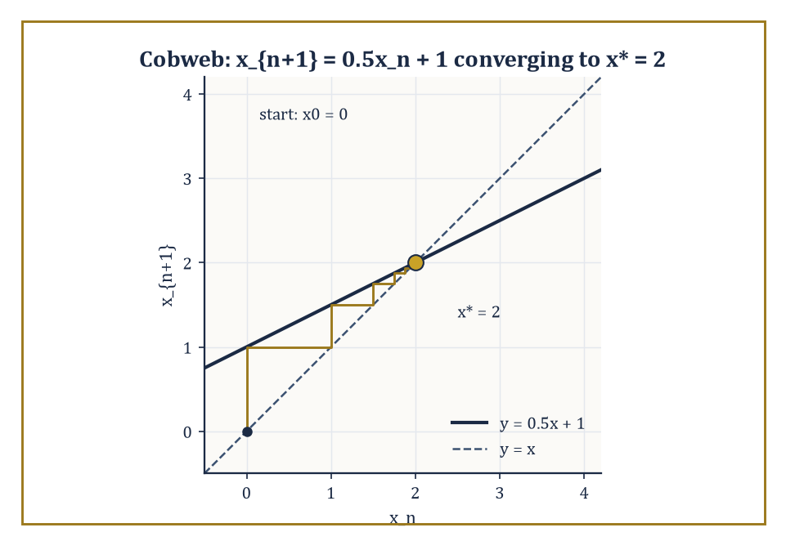
Figure 46.1 — A cobweb diagram for xₙ₊₁ = 0.5xₙ + 1, spiraling obediently into the fixed point x* = 2.
ẋ = f(x)
If time ticks in discrete steps (year one, year two, year three, with nothing in between), the rule is an iterated map.
xₙ₊₁ = f(xₙ)
Either way, the trajectory (or orbit) of a starting point x₀ is the full sequence of states it passes through as time runs forward — the curve traced by a flow, or the list of iterates produced by a map. Everything in this chapter is really one question dressed up in different clothes: given the rule, and given enough time, where does the state end up?
Numeric example — iterating a map by hand. Take the discrete rule xₙ₊₁ = 0.5xₙ + 1, starting from x₀ = 0. Compute the orbit:
x₁ = 0.5(0) + 1 = 1
x₂ = 0.5(1) + 1 = 1.5
x₃ = 0.5(1.5) + 1 = 1.75
x₄ = 0.5(1.75) + 1 = 1.875
x₅ = 1.9375
The values are creeping toward a number that satisfies x = 0.5x + 1, i.e. 0.5x = 1, i.e. x* = 2 — an equilibrium (or fixed point): a state the rule maps to itself. The orbit never quite arrives, but it gets there in the limit. This is dynamical systems in miniature: a rule, an orbit, and a long-term destination.
Try it now — Iterate xₙ₊₁ = 0.5xₙ + 2 from x₀ = 0 for three steps. Where is it heading? Answer →
Not every orbit settles at a single point. The principal types of recurrent long-term behavior are: equilibria (states that never move), periodic orbits (states that return to where they started after a fixed time or fixed number of steps), invariant tori (motion that combines two or more independent, generally incommensurate frequencies, so the state wanders over a doughnut-shaped surface without ever repeating), and — the star of this chapter — chaotic attractors, where the orbit is confined to a bounded region forever but never settles, never repeats, and depends with terrifying sensitivity on where it started.
Numeric example — periodic versus quasi-periodic on a circle. Consider the circle map xₙ₊₁ = xₙ + α (mod 1), which nudges a point around a circle of circumference 1 by a fixed amount α each step. With α = 1/3:
x₀ = 0, x₁ = 1/3, x₂ = 2/3, x₃ = 1 mod 1 = 0
The orbit is periodic with period 3, revisiting {0, 1/3, 2/3} forever. Now take α irrational, say α = √2 − 1 ≈ 0.41421. The orbit
xₙ = n α (mod 1)
never returns to 0, because n α = integer would force α to be rational — a contradiction. Instead the orbit is quasi-periodic: it fills the circle densely without ever repeating a point, a fact known since Weyl’s equidistribution theorem. Same map, same formula; whether α is a fraction or an irrational decides the entire character of the long-term behavior, which ought to be a small early warning about how much rides on the fine print.
A dynamical system is called structurally stable if its qualitative phase portrait — which regions flow where, how many equilibria there are and of what type — survives small perturbations of the rule f itself (not just small perturbations of the starting point). A bifurcation is precisely a parameter value at which this fails: an infinitesimal nudge to the rule changes the picture qualitatively, not just quantitatively. We will spend an entire section on this later (Bifurcations), but it is worth meeting the idea now, since it explains why dynamical systems is a subject about families of rules, not single rules in isolation.
Numeric example — a bifurcation you can watch happen. Take the linear map xₙ₊₁ = a xₙ with starting point x₀ = 1, for two nearby values of the parameter a. At a = 0.9:
x₁ = 0.9, x₂ = 0.81, x₃ = 0.729, x₄ = 0.6561
— decaying steadily to the equilibrium 0. At a = 1.1:
x₁ = 1.1, x₂ = 1.21, x₃ = 1.331, x₄ = 1.4641
— growing without bound. Nothing violent happens to the formula as a crosses 1; the coefficient just ticks past a threshold. But the qualitative fate of every orbit flips from ‘converges’ to ‘diverges’. That crossing, at a = 1, is a bifurcation — the simplest possible one, and the ancestor of every richer bifurcation we will meet later.
One more piece of vocabulary earns its place immediately, because it recurs at every later stage of this chapter: two dynamical systems are topologically conjugate if there exists a homeomorphism h (a continuous, continuously invertible change of coordinates) carrying every orbit of one system exactly onto an orbit of the other, respecting the direction of time. Conjugate systems are, for every qualitative purpose, the same dynamical system dressed in different coordinates — the precise notion of sameness that structural stability is defending, and the exact relationship the Hartman–Grobman theorem asserts between a nonlinear flow and its linearization near a hyperbolic equilibrium (Linearization and Local Structure).
Numeric example — two very different-looking maps, secretly the same. The logistic map at r = 4, xₙ₊₁ = 4xₙ(1 − xₙ), and the doubling map θₙ₊₁ = 2θₙ (mod 1) look nothing alike, yet are conjugate via h(θ) = sin²(πθ). To check:
h(2θ) = sin²(2πθ) = [2 sin(πθ)cos(πθ)]² = 4 sin²(πθ) cos²(πθ) = 4 sin²(πθ)(1 − sin²(πθ)) = 4h(θ)(1 − h(θ))
— the logistic formula applied to h(θ). So doubling θ and then applying h gives the same result as applying h and then applying the logistic map: the diagram commutes. Numerically, take θ₀ = 0.1:
h(θ₀) = sin²(18°) = (0.309017)² ≈ 0.095492
Doubling first:
θ₁ = 0.2, h(θ₁) = sin²(36°) = (0.587785)² ≈ 0.345492
Logistic first:
x₁ = 4(0.095492)(1 − 0.095492) = 4(0.095492)(0.904508) ≈ 0.345493
The two routes agree (to rounding error) — confirming that the wild, fractal-looking logistic map at r = 4 is, underneath a smooth change of coordinates, nothing but the doubling map from What Dynamical Systems Actually Are in disguise, binary-digit shift and all.
Keep only this · Section 46.1: What Dynamical Systems Actually Are
The idea. A dynamical system is a state space with a rule of evolution; the questions are long-term ones — fixed points, cycles, sensitivity, and how the picture changes with parameters.
Core.
map: xₙ₊₁ = f(xₙ)
flow: ẋ = f(x)
fixed point: f(x) = x
Typical mistake. Looking for a formula for xₙ. Dynamical systems usually answer qualitative questions instead.
Minimal example. Circle map with α = 1/4: every orbit has period 4.
Practice. Easy to challenge; full worked answers, with the usual mistake, are in Answers to the Practice Sets at the back.
Easy — Find the fixed point of xₙ₊₁ = 0.8xₙ + 1 and say whether orbits approach it. Answer →
Medium — For the circle map xₙ₊₁ = xₙ + 3/8 (mod 1) from x₀ = 0, find the period. Answer →
Challenge — Show that x = sin²(πθ) turns the doubling map θ ↦ 2θ (mod 1) into the logistic map x ↦ 4x(1 − x). Answer →

Section 46.2: Flows, Maps, and Phase Portraits
Portraiture without a sitter
A swinging pendulum is fully described at any instant by two numbers, its angle and its speed. Plot those two numbers as a point and, as time passes, the point traces a curve; draw the curves for every possible starting condition and you have a phase portrait, a single picture of everything the system can ever do. Closed loops mean repeating motion, points where curves converge mean rest, and curves that run off to infinity mean escape. For a mass on a spring, conservation of energy alone forces every curve to be a closed loop of fixed size, a circle in suitable units, with no equation solved. The rule that carries points along these curves is called a flow.
Formally, a flow is a family of maps φₜ : M → M, one for each time t ∈ ℝ, satisfying φ₀ = identity and the group law:
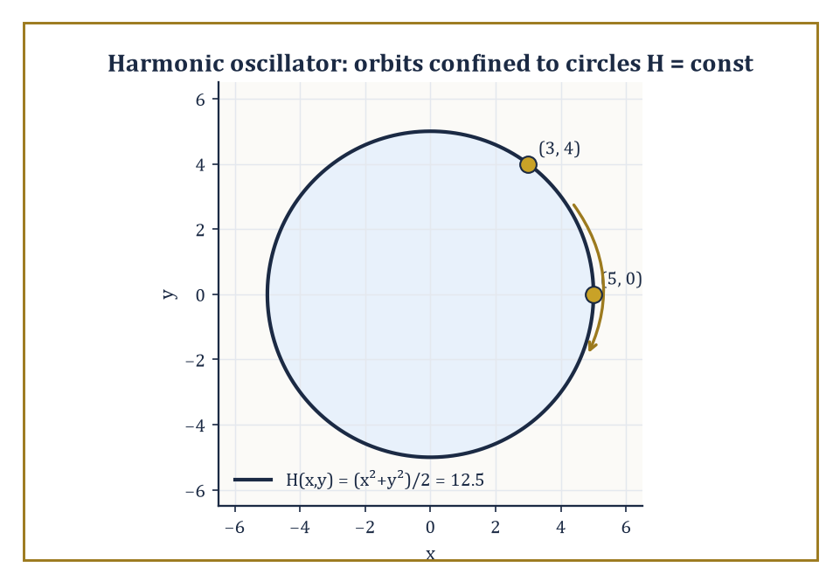
Figure 46.2 — The harmonic oscillator’s orbits, pinned by conservation of H to circles of constant radius — no differential equation required.
φₜ(φₛ(x)) = φₜ₊ₛ(x)
Flowing for s time units and then t more is the same as flowing for s + t all at once. A flow is generated by a vector field f via the differential equation:
ẋ = f(x)
Here φₜ(x₀) is the solution starting at x₀, evaluated at time t. A discrete dynamical system dispenses with the group law’s continuity and just iterates a single map f : M → M directly.
The phase portrait is the picture you get by drawing enough orbits to see the whole qualitative structure — which regions spiral in, which flow past, where the equilibria and periodic orbits sit. It is the cartography of the rule’s long-term behavior, and like all cartography it involves a certain amount of tasteful omission.
Numeric example — checking the group law by hand. The flow of ẋ = x on ℝ is given by the explicit solution:
φₜ(x₀) = x₀ eᵗ
Take x₀ = 2, and check φₜ(φₛ(x₀)) = φₜ₊ₛ(x₀) for s = t = 1. First route: flow by 1, then flow by 1 again.
φ₁(2) = 2e ≈ 5.4366
φ₁(2e) = 2e · e = 2e² ≈ 14.7781
Second route: flow by 2 directly.
φ₂(2) = 2e² ≈ 14.7781
The two routes agree exactly, as the group law demands — flowing for one unit twice is indistinguishable from flowing for two units once, which is a statement about time itself being additive, not a coincidence of this particular equation.
Try it now — For the flow φₜ(x) = xeᵗ of ẋ = x, check φ₁(φ₂(3)) = φ₃(3). Answer →
Existence, uniqueness, and continuous dependence on initial conditions for ẋ = f(x) follow from the standard ODE theorems already met in an earlier chapter, provided f is Lipschitz continuous.
But local existence — a solution defined for a little while near t = 0 — is not the same as completeness, which is global existence for all time. Some perfectly smooth, perfectly well-behaved vector fields generate solutions that reach infinity in finite time, at which point the flow simply has nothing left to say.
Numeric example — a smooth equation with no future. Take ẋ = x², x(0) = 1 — about as innocent-looking an equation as one could write. Separating variables gives:
dx/x² = dt
Integrating:
−1/x = t + C
At t = 0, x = 1 gives C = −1, so:
−1/x = t − 1, i.e. x(t) = 1/(1 − t)
This solution is quite well defined and smooth for t < 1 — but as t → 1⁻, x(t) → +∞. The trajectory reaches infinity at the finite time t = 1 and the solution ceases to exist afterward, despite f(x) = x² being Lipschitz on every bounded set and about as tame-looking a formula as you could ask for. Completeness is not automatic; growth conditions (typically, f growing no faster than linearly at infinity) are needed to rule this out.
Continuous dependence on initial conditions is the standard guarantee, valid whenever f is Lipschitz with constant L, that two solutions starting a distance δ apart stay within δe^(L|t|) of one another for as long as both remain defined — a precise, quantitative version of ‘a small change at the start produces a small change later.’
Read casually this sounds entirely reassuring; read carefully, the sting is already visible. The very same exponential bound that guarantees closeness over any fixed finite stretch of time also permits — indeed, in the worst case, predicts — arbitrarily large separation over long stretches of time.
This is not a flaw in the theorem; it is the crack through which sensitive dependence and chaos will later climb.
Numeric example — a rigorous bound that still allows enormous drift. For ẋ = x (so L = 1, the Lipschitz constant is the coefficient), take two starting points x₀ = 1 and x₀′ = 1.01, a gap of δ = 0.01. The explicit solutions are:
x(t) = eᵗ and x′(t) = 1.01eᵗ
So their gap at time t is exactly:
gap(t) = 0.01eᵗ
This matches the general bound δeᴸᵗ with equality, since the system is linear and the bound is tight here. At t = 0 the gap is a modest 0.01.
gap(5) = 0.01 × e⁵ ≈ 0.01 × 148.41 ≈ 1.484
That is a roughly 148-fold amplification of a tiny initial discrepancy, achieved by a flow that is perfectly smooth, perfectly deterministic, and in full compliance with the continuous-dependence theorem the entire time. Continuity of dependence was never a promise that errors stay small forever; it was only ever a promise about how fast, and by what factor, they are allowed to grow.
Conserved quantities and Lyapunov functions constrain the possible phase portrait dramatically. A conserved quantity is a function H(x) that stays constant along every trajectory:
Ḣ = 0
This means the entire flow is confined to move along the level sets of H — the portrait is foliated by these invariant surfaces before you have solved a single equation of motion. This is often the fastest route to understanding global behavior: find the conserved quantity, and the geometry does the rest.
Numeric example — energy conservation confines the orbit to a circle. For the harmonic oscillator ẋ = y, ẏ = −x, try the candidate conserved quantity:
H(x, y) = (x² + y²)/2
Differentiating along trajectories:
Ḣ = x ẋ + y ẏ = x·y + y·(−x) = xy − xy = 0
So H is conserved, and every orbit lies on a circle x² + y² = constant. Concretely: starting at (x, y) = (3, 4):
H = (9 + 16)/2 = 12.5, so √(x²+y²) = 5
That radius holds for the whole orbit thereafter. Checking a later point on the same trajectory, say (5, 0):
H = (25 + 0)/2 = 12.5, and √(25+0) = 5
Both match precisely, confirming the same radius. The orbit never needed to be solved explicitly (though it is easy enough: (x(t), y(t)) = (5 cos t, 5 sin t) up to a phase) — the conservation law alone pinned it to a circle.
Running example · The pendulum’s phase portrait
For ẋ = y, ẏ = −9.8 sin x the energy E = ½y² + 9.8(1 − cos x) is constant along every orbit, so the phase portrait is the set of level curves of E. The bottom rest states (2kπ, 0) are centers; the upright ones ((2k + 1)π, 0) are saddles, the same instability that pole placement removed in State Feedback, Pole Placement, and Observers. The level E = 19.6 is the separatrix: inside it the pendulum swings, outside it spins.
Next: friction turns the centers into stable spirals (Medium exercise in Linearization and Local Structure), and the energy becomes a Lyapunov function in Lyapunov Stability and Invariant Sets.
Keep only this · Section 46.2: Flows, Maps, and Phase Portraits
The idea. A flow is the whole family of time-t solution maps; it obeys φₛ ∘ φₜ = φₛ₊ₜ. Existence may fail in finite time, and conserved quantities confine orbits to curves.
Core.
φ₀ = id, φₛ ∘ φₜ = φₛ₊ₜ
Gronwall: |x(t) − x′(t)| ≤ |x₀ − x₀′|exp(Lt)
Typical mistake. Assuming smooth equations have solutions for all time. ẋ = x² blows up.
Minimal example. Harmonic oscillator: x² + y² is constant, so orbits are circles.
Practice. Easy to challenge; full worked answers, with the usual mistake, are in Answers to the Practice Sets at the back.
Easy — Solve ẋ = x², x(0) = 2, and find the blow-up time. Answer →
Medium — For ẋ = x, two starts differ by 0.01. When does the Gronwall bound let their separation reach 1? Answer →
Challenge — For the pendulum ẋ = y, ẏ = −9.8 sin x, show that E = ½y² + 9.8(1 − cos x) is conserved, and find the energy that separates swinging from spinning. Answer →

Section 46.3: Linearization and Local Structure
Zooming in until the curve looks straight, then hoping it stays that way
Zoom in far enough on a smooth curve and it looks like a straight line; zoom in on a smooth landscape and it looks like a tilted plane. The same idea applies to motion near a point of rest. Close to an equilibrium, a complicated nonlinear system behaves almost exactly like a much simpler linear one, and linear systems can be solved completely. If the linear version spirals inward, the real system does too; if it shows a saddle, with motion drawn in along one direction and flung out along another, so does the real system. The approximation can fail only in borderline cases, and this section identifies those cases precisely.
Near an equilibrium x₀ (where f(x₀) = 0), the nonlinear flow ẋ = f(x) is approximated by its linearization,
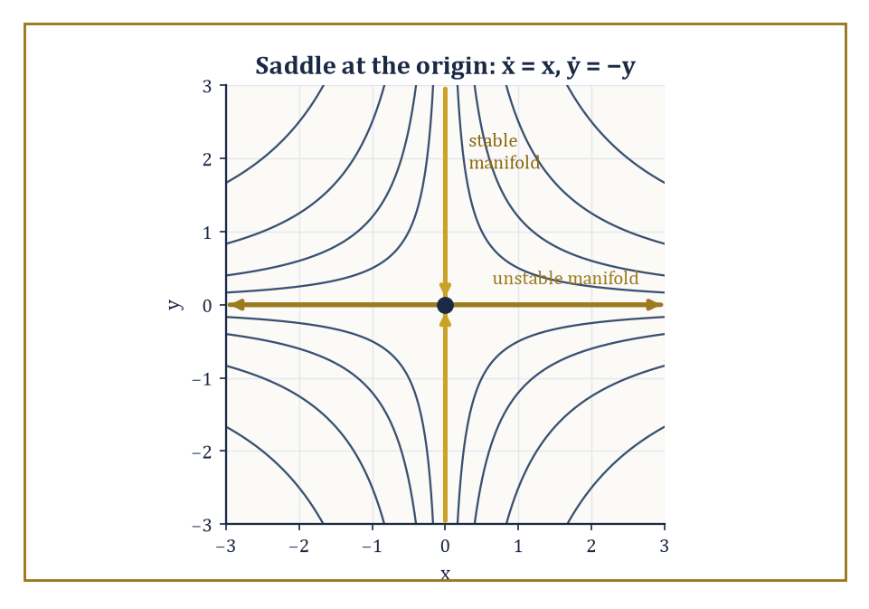
Figure 46.3 — The saddle ẋ = x, ẏ = −y made literal: hyperbolas of constant xy, with the two axes standing in as the stable and unstable manifolds.
ẋ = Df(x₀)(x − x₀)
where Df(x₀) is the Jacobian matrix of partial derivatives evaluated at the equilibrium. An equilibrium is called hyperbolic if no eigenvalue of Df(x₀) has zero real part — none of them sit exactly on the knife-edge between growth and decay.
The Hartman–Grobman theorem then guarantees that near a hyperbolic equilibrium, the true nonlinear flow is topologically conjugate to its linearization: there is a continuous, continuously invertible change of coordinates turning one into the other, so the qualitative local picture (sink, source, saddle) is entirely decided by the linear algebra, and the nonlinear terms only distort the picture, never its topology.
Numeric example — linearizing a nonlinear system. Take the system:
ẋ = −x + y², ẏ = −2y
At the origin, f(0,0) = (0,0), confirming it is an equilibrium. The Jacobian is
Df(x,y) = [−1 2y; 0 −2]
so
Df(0,0) = [−1 0; 0 −2]
which is already diagonal with eigenvalues −1 and −2 — both real and negative, neither zero, so the origin is hyperbolic (a stable node, or ‘sink’). Check the approximation at a nearby point (0.1, 0.1): the true vector field gives
f(0.1, 0.1) = (−0.1 + 0.01, −0.2) = (−0.09, −0.2)
The linear approximation gives
Df(0,0)·(0.1, 0.1) = (−0.1, −0.2)
The two agree to within 0.01 in the x-component (the discrepancy is wholly the quadratic y² term, which is second-order small near the origin) and in the y-component. Both point inward toward the origin, confirming the local picture the eigenvalues predicted.
Try it now — Classify the pendulum’s upright equilibrium (π, 0) for ẋ = y, ẏ = −9.8 sin x. Answer →
Real eigenvalues give straight-line approach or departure along the eigendirections, as in the sink just examined.
A complex-conjugate pair of eigenvalues a ± bi (with b ≠ 0) gives a qualitatively different picture: trajectories wind around the equilibrium infinitely often as they approach it (if a < 0) or flee it (if a > 0), tracing logarithmic spirals rather than straight paths.
Hyperbolicity only demands a nonzero real part and has nothing to say about the imaginary part, so Hartman–Grobman applies here precisely as before: a stable spiral is still topologically conjugate to its linearization, spiral and all.
Numeric example — a stable spiral, verified by its own radius. Take the system:
ẋ = −x − y, ẏ = x − y
The Jacobian is constant, [−1 −1; 1 −1], with characteristic equation
(−1 − λ)² + 1 = 0
that is,
(λ + 1)² = −1
giving
λ = −1 ± i
a complex-conjugate pair with negative real part −1: a stable spiral. This can be confirmed without ever solving for x(t) and y(t) explicitly, by tracking r² = x² + y² instead:
d(r²)/dt = 2xẋ + 2yẏ = 2x(−x−y) + 2y(x−y) = −2x² − 2xy + 2xy − 2y² = −2x² − 2y² = −2r²
This is a clean exponential decay equation for r² alone, with solution
r²(t) = r²(0)e⁻²ᵗ
and the rate, 2, is exactly twice the real part of the eigenvalues (2 × 1 = 2), as the general theory predicts. Numerically: start at (x₀,y₀) = (1,0), so r²(0) = 1. At t = 1:
r²(1) = e⁻² ≈ 0.1353
so
r(1) ≈ 0.368
the trajectory has spiraled from radius 1 down to about a third of that in one time unit, while simultaneously rotating (the imaginary part ±1 sets the angular speed), the spiral behavior the complex eigenvalues foretold.
At a hyperbolic equilibrium, the tangent space splits into a stable subspace (eigenvalues with negative real part, along which nearby solutions are drawn in) and an unstable subspace (positive real part, along which they are flung out).
The corresponding curved objects in the full nonlinear system — the stable and unstable manifolds — are invariant surfaces tangent to these subspaces at the equilibrium.
When an eigenvalue does sit on the boundary (zero real part), its direction is called a center direction, and the linear theory falls silent: whether that direction is attracting, repelling, or neither depends on the nonlinear terms, which is what center-manifold reduction and normal-form theory are built to sort out.
Abstract example — a saddle, made completely explicit. Consider the system:
ẋ = x, ẏ = −y
The origin is an equilibrium; the Jacobian is already [1 0; 0 −1], with eigenvalues +1 (unstable direction, the x-axis) and −1 (stable direction, the y-axis) — a hyperbolic saddle. The system solves precisely:
x(t) = x₀eᵗ, y(t) = y₀e⁻ᵗ
Multiplying,
x(t)y(t) = x₀y₀ eᵗ e⁻ᵗ = x₀y₀
a constant for each orbit — so every orbit lies on a hyperbola xy = constant, except the two axes themselves, which are the stable manifold (x₀ = 0, so y decays to 0 while x stays 0) and the unstable manifold (y₀ = 0, so x grows while y stays 0). The abstract classification (stable manifold = span of negative-eigenvalue eigenvectors) here becomes two literal, drawable lines.
Exactly the same machinery governs fixed points of discrete maps, with one change of vocabulary: instead of asking whether eigenvalues have negative or positive real part, one asks whether they lie inside or outside the unit circle in the complex plane.
An eigenvalue of magnitude less than 1 means perturbations shrink with each iteration (stable); greater than 1, they grow (unstable); exactly 1 is the non-hyperbolic borderline where center-manifold and normal-form techniques again take over.
Numeric example — inside versus outside the unit circle. Compare two linear maps near their fixed point at 0. First,
xₙ₊₁ = 2xₙ
with derivative (eigenvalue) 2, outside the unit circle. Starting at x₀ = 0.01:
x₁ = 0.02, x₂ = 0.04, x₃ = 0.08
doubling each step, repelled from 0. Second,
xₙ₊₁ = 0.5xₙ
with eigenvalue 0.5, inside the unit circle. Starting at x₀ = 1:
x₁ = 0.5, x₂ = 0.25, x₃ = 0.125
converging geometrically to 0. The magnitude of the single eigenvalue — 2 in one case, 0.5 in the other — fully decides the fate of every nearby orbit, mirroring the flow case where it was the sign of the real part rather than the size relative to 1.
Keep only this · Section 46.3: Linearization and Local Structure
The idea. Near an equilibrium whose linearization has no eigenvalues on the imaginary axis, the flow looks like the linear flow ẋ = Jx (Hartman–Grobman); the eigenvalues classify it.
Core.
J = Df(x*)
hyperbolic: no eigenvalue with zero real part
maps: stable when all |λ| < 1
Typical mistake. Trusting a center found by linearization. Purely imaginary eigenvalues are not hyperbolic; the nonlinear terms decide.
Minimal example. A = diag(−1, −3): a stable node.
Practice. Easy to challenge; full worked answers, with the usual mistake, are in Answers to the Practice Sets at the back.
Easy — Classify the origin of ẋ = −x, ẏ = −3y. Answer →
Medium — Classify the downward rest state of the damped pendulum ẋ = y, ẏ = −9.8 sin x − 0.5y. Answer →
Challenge — The undamped pendulum’s linearization at (0, 0) has eigenvalues ±3.13i. Why does Hartman–Grobman say nothing here, and what settles the question? Answer →

Section 46.4: Periodic Orbits and Poincaré Maps
Turning an eternal loop into a single, judgeable click
Before this section
What you need. Polar coordinates and the phase portraits of Flows, Maps, and Phase Portraits; fixed points of maps from Linearization and Local Structure.
Why it matters. Heartbeats, predator–prey cycles and oscillating circuits are periodic orbits, and the Poincaré map turns their stability into a fixed-point question.
Many systems settle into a rhythm: a heartbeat, a dripping tap, the rise and fall of predators and prey. To decide whether such a rhythm is stable, Henri Poincaré had a clever idea. Instead of following the whole loop, place a checkpoint across it and record only where the system crosses it each time round. A continuous motion becomes a sequence of points, and the question becomes simple: do nearby crossings move closer to the loop’s own crossing, or further away? For the classic example in this section, a cycle at radius 1, trajectories starting inside and outside both spiral onto the cycle, and their crossings close in on it every time round.
A periodic orbit is a trajectory γ(t) satisfying the periodicity condition below, for some minimal period T > 0 — the state returns to a previous value and then repeats forever.
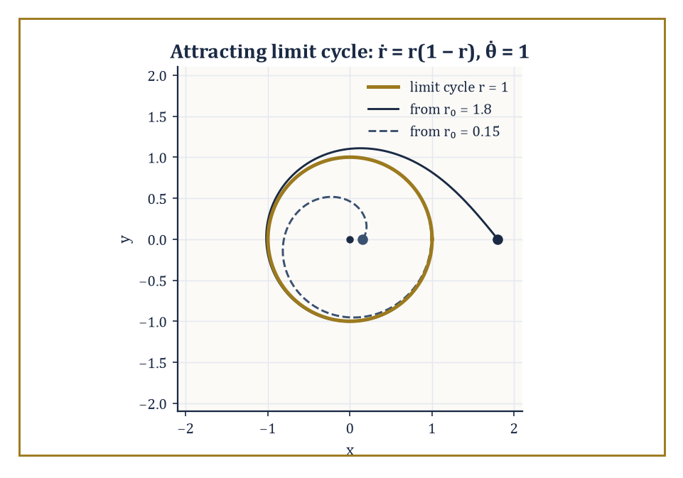
Figure 46.4 — The attracting limit cycle r = 1, with trajectories spiraling onto it from both outside and inside — just as its negative Floquet multiplier promises.
γ(t + T) = γ(t) for all t
To study its stability, pick a section Σ transverse to the orbit (a small surface the orbit crosses, rather than runs along) and follow the flow starting from a nearby point on Σ until it first returns to Σ. This defines the Poincaré return map P : Σ → Σ, and the periodic orbit itself corresponds to a fixed point of P.
Crucially, this converts a question about a continuous-time loop into a question about a discrete-time fixed point — the linearization toolkit from Linearization and Local Structure applies, and the eigenvalues of DP at the fixed point (called Floquet multipliers) decide stability: inside the unit circle means the periodic orbit attracts nearby trajectories, outside means it repels them.
Numeric example — a limit cycle and its exact Floquet multiplier. Consider the planar system written in polar coordinates:
ṙ = r(1 − r), θ̇ = 1
Since θ increases at a constant unit rate, the point sweeps around the origin at constant angular speed regardless of r; since ṙ = 0 at r = 1, the unit circle is a periodic orbit of period T = 2π.
To find its stability, linearize the r-equation about r = 1: writing u = r − 1, consider the function g(r) = r(1 − r), whose derivative is:
g′(r) = 1 − 2r
Evaluating at the fixed point:
g′(1) = −1
This gives u̇ ≈ −u near the orbit, hence:
u(t) ≈ u(0)e⁻ᵗ
Over one full period T = 2π, a perturbation shrinks by the exact factor:
exp(−2π) ≈ 0.001867
this is the Floquet multiplier, and its magnitude is far below 1, so the orbit is strongly stable.
Concretely: start at r₀ = 1.1, so u₀ = 0.1. After one full loop:
u(2π) ≈ 0.1 × 0.001867 ≈ 0.0001867
i.e. r ≈ 1.000187 — a trajectory that started 10% off the cycle is within 0.02% of it after a single revolution. That is what ‘attracting periodic orbit’ looks like in numbers.
Try it now — Find the limit cycle of ṙ = r(4 − r²), θ̇ = 1 and decide its stability. Answer →
The Poincaré–Bendixson theorem is the reason chaos cannot occur in continuous flows confined to the plane: if a trajectory stays forever inside a compact trapping region containing no equilibria, its long-term (ω-limit) behavior must be a periodic orbit — nothing more exotic is available.
The intuitive reason is topological: a planar trajectory cannot cross itself (that would violate uniqueness of solutions), so it behaves like a single car stuck on a one-lane road with no exits — it can only settle at a point or loop around. Add a third dimension, however, and trajectories gain room to pass ‘over’ or ‘under’ each other without literally crossing, and the theorem’s guarantee evaporates — which is why every strange attractor in this chapter lives in three dimensions or more.
Abstract example — Poincaré–Bendixson caught in the act. Return to the system:
ṙ = r(1 − r), θ̇ = 1
Take the annulus 0.5 ≤ r ≤ 1.5 as the trapping region: since θ̇ = 1 is never zero, there are no equilibria anywhere in the annulus (an equilibrium would need both ṙ = 0 and θ̇ = 0 simultaneously).
By Poincaré–Bendixson, every trajectory entering this annulus must have a periodic orbit as its long-term fate — and we already found it by direct calculation: the unit circle r = 1. The theorem, in this case, could have told us a periodic orbit existed even before we solved anything; the explicit solution merely confirmed which one.
Floquet theory generalizes the eigenvalue calculation above to the case of a periodic orbit in any number of dimensions, where the linearization along the orbit is a matrix A(t) that is itself periodic rather than constant:
A(t+T) = A(t)
The fundamental solution of this linear time-varying system, evaluated over one full period, is called the monodromy matrix; its eigenvalues are exactly the Floquet multipliers, generalizing the single number computed above to a full spectrum.
Abstract example — a monodromy matrix computed by hand. Take the constant matrix:
A = [0 1; −1 0]
This is the generator of pure rotation, formally periodic with any period since it never changes. Its flow is eᴬᵗ, a rotation by angle t; at t = 2π this is a full rotation, so the fundamental matrix over one period is:
Φ(2π) = exp(A·2π) = the identity matrix
The monodromy matrix is therefore I, with both Floquet multipliers equal to 1 — neither attracting nor repelling, but neutral.
This matches the earlier finding (Flows, Maps, and Phase Portraits) for the pure-rotation system:
ẋ = y, ẏ = −x
whose orbits are an entire continuum of concentric circles, each one as stable (or unstable) as its neighbors: a whole family of periodic orbits sharing the same neutral multiplier, rather than one isolated orbit standing out from the crowd.
Keep only this · Section 46.4: Periodic Orbits and Poincaré Maps
The idea. Periodic orbits are studied through the Poincaré map on a transversal section: a fixed point of the map is a cycle of the flow, and its multiplier decides stability.
Core.
Floquet multiplier = exp(g′(r*)T)
Poincaré–Bendixson: bounded planar orbits without equilibria approach a cycle
Typical mistake. Expecting chaos in a planar autonomous system. Poincaré–Bendixson rules it out.
Minimal example. ṙ = −r, θ̇ = 1: return map r ↦ exp(−2π)r ≈ 0.0019r.
Practice. Easy to challenge; full worked answers, with the usual mistake, are in Answers to the Practice Sets at the back.
Easy — For ṙ = −r, θ̇ = 1, find the Poincaré map on the positive x-axis. Answer →
Medium — For ṙ = r(1 − r)(2 − r), θ̇ = 1, find the cycles and their stability. Answer →
Challenge — Use Poincaré–Bendixson to prove that ṙ = r(4 − r²), θ̇ = 1 has a periodic orbit in 1 ≤ r ≤ 3, without solving it. Answer →

Section 46.5: Lyapunov Stability and Invariant Sets
Proving convergence without ever solving the equation
You have seen this before
Lyapunov functions appeared in Stability: Lyapunov and Input-Output, and before that in Systems, Stability, and Lyapunov Functions (Volume 3), where LaSalle’s principle rescued the damped pendulum. In Chapter 45 the engineer chooses the feedback so that some V decreases. Here the system is given, and V is a tool for finding out what it does. The pendulum’s energy serves both purposes; see the running-example box at the end of this section.
A marble in a bowl comes to rest at the bottom, and you can be sure of that without solving any equation of motion: friction only ever drains its energy, and the energy is lowest at the bottom. Lyapunov’s method generalizes that argument. Find any quantity that is smallest at the equilibrium and never increases as the system evolves, and you have proved the equilibrium stable without knowing a single trajectory. The quantity need not be physical energy; any function with those two properties will do, and finding one is something of an art. The method can also mark out a region of starting points guaranteed to settle, even when the full region is unknown.
Lyapunov’s direct method proves stability without ever solving the differential equation, by exhibiting an auxiliary function V(x) — positive everywhere except at the equilibrium, where V = 0 — that never increases along trajectories.
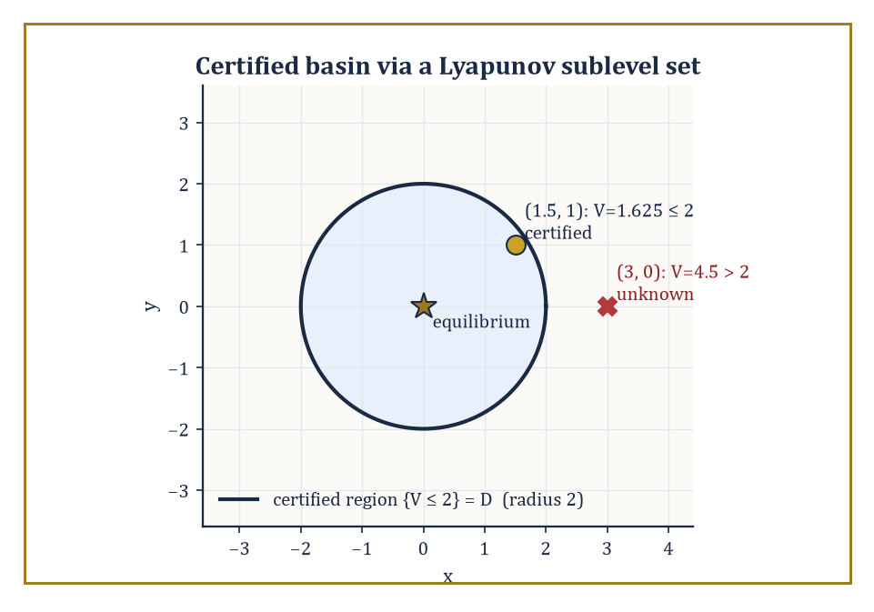
Figure 46.5 — A Lyapunov sublevel set certifying a chunk of the true basin of attraction — one point provably converges, its neighbor is merely unproven.
V̇ = ∇V · f ≤ 0
Think of V as a generalized energy: if it can only fall or stay level, the state can never wander arbitrarily far from where V is small, which is the definition of stability. If V̇ is strictly negative away from the equilibrium, the state is squeezed all the way down to it — asymptotic stability.
Numeric example — an energy function that only ever falls. Take the damped oscillator ẋ = y, ẏ = −x − y, and try V(x, y) = (x² + y²)/2.
V̇ = x ẋ + y ẏ = x·y + y·(−x − y) = xy − xy − y² = −y²
This is always ≤ 0 — confirming stability immediately, without solving anything. But notice V̇ is exactly 0 whenever y = 0, even if x ≠ 0, so this test alone does not yet prove the state is pulled all the way to the origin.
at (x, y) = (1, 0): V = 0.5, V̇ = 0
But ẏ = −1 − 0 = −1 ≠ 0, so y is immediately about to become nonzero, and V̇ will immediately become strictly negative again.
at (x, y) = (2, 1): V = 2.5, V̇ = −1² = −1
A genuine decrease. The energy is not monotonically decreasing at every single instant along every direction, but it never increases, which is already enough to certify stability.
Try it now — Use V = (x² + y²)/2 for ẋ = −x, ẏ = −2y. Answer →
LaSalle’s invariance principle finishes the job Lyapunov’s method left open: when V̇ ≤ 0 but is not strictly negative everywhere, trajectories are guaranteed to converge not to the whole equilibrium set but to the largest invariant subset contained inside {V̇ = 0} — the set of points where equality holds and that the dynamics cannot escape from once entered.
Numeric example — LaSalle closes the gap. Continuing the damped oscillator above, {V̇ = 0} is the entire x-axis (y = 0). Is the x-axis itself invariant — can a trajectory stay on it forever?
on y = 0: ẋ = 0, ẏ = −x − 0 = −x
ẋ = 0 is fine — x is momentarily frozen — but ẏ = −x is nonzero whenever x ≠ 0. So any point on the x-axis other than the origin immediately leaves it. The largest invariant subset of {V̇ = 0} is therefore the single point (0, 0). By LaSalle’s principle, every trajectory converges to the origin — full asymptotic stability, recovered even though the raw Lyapunov derivative was only ever ≤ 0 rather than < 0.
An attracting set is a closed invariant set A with a neighborhood U such that every trajectory starting in U converges to A; the basin of attraction is the union of all such neighborhoods — every initial condition that eventually ends up at A, however circuitous the route. An attractor, more precisely, is an attracting set that cannot be split into smaller closed invariant pieces each independently attracting a full neighborhood on its own — it is, so to speak, attracting as one indivisible unit. The global structure of a dynamical system is then the partition of the entire phase space into basins, and the attractors sitting at the bottom of each one.
Numeric example — two attractors and the knife-edge between their basins. Take the bistable system ẋ = x − x³. Its equilibria solve:
x − x³ = x(1 − x²) = 0, giving x = 0, +1, −1
The derivative is f′(x) = 1 − 3x².
at x = 0: f′ = 1 > 0 (unstable); at x = ±1: f′ = 1 − 3 = −2 < 0 (stable)
So there are two attractors, {+1} and {−1}, each a single stable equilibrium. Their basins are (0, ∞) and (−∞, 0) respectively, separated by the unstable equilibrium at x = 0, whose own ‘basin’ is the single point 0 — a set of measure zero, meaning a randomly chosen starting point will, with probability one, end up at +1 or −1 and never balance forever on the ridge between them.
checking numerically: at x₀ = 0.1, f(0.1) = 0.1 − 0.001 = 0.099 > 0
So x increases — heading toward +1, exactly as the basin (0, ∞) predicts.
A Lyapunov function rarely certifies stability across the whole of phase space in one go; more often V̇ < 0 can only be verified within some bounded region D surrounding the equilibrium, since the argument that produced it — a Taylor expansion, an inequality that only held for moderate values — quietly stopped being valid further out. In that common case, the largest sublevel set {x : V(x) ≤ c} that still fits entirely inside D gives an explicit, computable underestimate of the true basin of attraction: a region the analyst can certify by arithmetic, even without knowing the real basin’s exact — and usually far more generous — shape.
Numeric example — certifying a basin you can compute. Suppose, for some system with equilibrium at the origin, the energy-like function V(x, y) = (x² + y²)/2 can only be shown to satisfy V̇ < 0 within the disk x² + y² < 4 (beyond that radius the nonlinear terms are no longer dominated, and the sign of V̇ is simply unknown). The largest sublevel set of V fitting inside that disk is found by matching radii: {V ≤ c} is the disk of radius √(2c), so setting:
√(2c) = 2 gives c = 2
The certified region is therefore {(x,y) : x² + y² ≤ 4} — which happens to coincide with D here.
at (1.5, 1): V = (2.25 + 1)/2 = 1.625 ≤ 2
So this point is certified to converge to the origin.
at (3, 0): V = 9/2 = 4.5 > 2
This point lies outside the certified region — it may well still converge (the true basin is very often larger than any sublevel-set estimate), but the Lyapunov argument, applied honestly, is silent about it. Knowing the boundary of what one has proved, as opposed to what is merely probably true, is most of the discipline in applied stability theory.
Running example · Friction drains the pendulum’s energy
With friction, V = ½y² + 9.8(1 − cos x) satisfies V̇ = −cy² (Challenge exercise above), and LaSalle’s principle gives convergence to the bottom. The same energy, without friction, is conserved: it is the Hamiltonian of Lagrangian and Hamiltonian Mechanics, and keeping it from drifting is the test of a good integrator in Structure-Preserving and Geometric Integration.
Keep only this · Section 46.5: Lyapunov Stability and Invariant Sets
The idea. A function that never increases along trajectories certifies stability; LaSalle’s principle turns V̇ ≤ 0 into convergence, and sublevel sets of V certify part of the basin of attraction.
Core.
V̇ = ∇V · f ≤ 0
LaSalle: limit sets lie in the largest invariant subset of {V̇ = 0}
Typical mistake. Treating a sublevel-set estimate as the whole basin. Points outside it may still converge; the method is silent.
Minimal example. ẋ = x − x³: attractors ±1, separated by 0.
Practice. Easy to challenge; full worked answers, with the usual mistake, are in Answers to the Practice Sets at the back.
Easy — For ẋ = x − x³ starting at x₀ = −0.5, which attractor wins? Answer →
Medium — V = (x² + y²)/2 satisfies V̇ < 0 only inside x² + y² < 9. Which sublevel set is certified, and is (2, 2) inside it? Answer →
Challenge — For the damped pendulum ẋ = y, ẏ = −9.8 sin x − cy (c > 0) with energy V = ½y² + 9.8(1 − cos x), show that trajectories near the bottom converge to it. Answer →

Section 46.6: Chaos in One-Dimensional Maps
Where a single multiplication table learns to misbehave
A population that breeds in yearly generations can be modeled with a single rule: next year’s size is this year’s, multiplied by a growth factor and scaled down as the population nears the limit its environment can support. With a modest growth factor of 2.8, any starting population settles at about 64 per cent of that limit, overshooting and undershooting on the way. Raise the growth factor and the settled value splits into a two-year cycle, then four, then eight, and beyond about 3.57 the behavior becomes chaotic: entirely deterministic, yet so sensitive to the starting value that long-term prediction is impossible. All of that comes from one line of arithmetic.
The logistic map is, astonishingly, complicated enough to contain the entire mechanism of chaos, despite being a single quadratic formula with one parameter r.
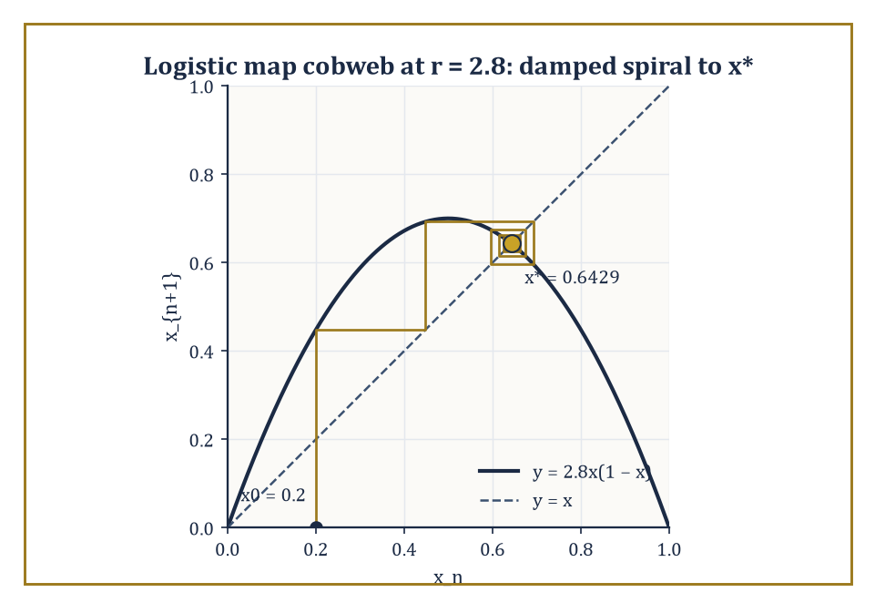
Figure 46.6 — The logistic map at r = 2.8, cobwebbing its way in a damped spiral toward x* ≈ 0.6429 — the alternating convergence a negative derivative always produces.
xₙ₊₁ = r xₙ(1 − xₙ)
For small r, every orbit converges to a fixed point. As r increases, that fixed point loses stability and is replaced by a stable period-2 orbit, then period 4, period 8, and so on — a period-doubling cascade — culminating, beyond a critical value, in a regime with sensitive dependence on initial conditions, densely many periodic orbits of every period, and a positive Lyapunov exponent (defined properly in Strange Attractors and Lyapunov Exponents).
The tent map, a simpler piecewise-linear cousin, exhibits the same phenomena with arithmetic simple enough to do by hand, which is why it is the textbook’s favorite training wheel.
Numeric example — converging to a fixed point at r = 2.8. For the logistic map with r = 2.8, the nonzero fixed point solves for x*.
x* = 2.8x*(1 − x*)
Solving gives x* explicitly.
x* = 1 − 1/2.8 = 0.642857
Its derivative is f′(x) = r(1 − 2x), which simplifies at the fixed point to the following.
f′(x*) = 2 − r = 2 − 2.8 = −0.8
This value is comfortably inside the unit circle, so x* is stable. Iterating from x₀ = 0.2 gives the sequence of values below.
x₁ = 2.8(0.2)(0.8) = 0.448
x₂ = 2.8(0.448)(0.552) ≈ 0.6924
x₃ = 2.8(0.6924)(0.3076) ≈ 0.5963
x₄ = 2.8(0.5963)(0.4037) ≈ 0.6740
x₅ ≈ 0.6152
x₆ ≈ 0.6628
The values oscillate back and forth while creeping toward x* ≈ 0.6429 — the damped, alternating convergence a negative derivative of magnitude 0.8 predicts.
Try it now — For the logistic map with r = 2.5, find the non-zero fixed point and its stability. Answer →
Increase r past 3 and the fixed point’s derivative crosses −1, the threshold beyond which even the smallest oscillation is amplified rather than damped: the fixed point ejects a stable period-2 orbit in its place. Further increases repeat the trick — period 2 destabilizes into period 4, then 8, then 16 — with the bifurcations accumulating at r∞ ≈ 3.569946, beyond which lies a tangled zone of chaos interrupted by narrow periodic windows.
Remarkably, the ratio of successive parameter gaps between bifurcations tends to a universal constant, δ ≈ 4.6692 (Feigenbaum’s constant), that reappears in an enormous range of unrelated one-parameter families of maps sharing only a single smooth quadratic-like maximum — a piece of order lurking directly inside the onset of disorder.
Numeric example — catching the exact bifurcation point. At r = 3, the fixed point formula gives x* explicitly.
x* = 1 − 1/3 = 2/3
Its derivative is the following.
f′(x*) = 2 − r = 2 − 3 = −1
This sits on the boundary between stability and instability, confirming by direct hand calculation that r = 3 is the threshold at which the period-1 fixed point hands off to a period-2 orbit. No numerical search was needed; the formula 2 − r = −1 pins the transition down to the decimal.
Sharkovskii’s theorem orders all the positive integers into a single, strange total order — 3, then 5, 7, 9, ... (all odd numbers beyond 1), then 2·3, 2·5, 2·7, ..., then 4·3, 4·5, ..., then higher and higher powers of 2 times odd numbers, and only at the very end, 2ⁿ, ..., 8, 4, 2, 1 — such that if a continuous map of an interval has a periodic orbit of period p, it is guaranteed to have periodic orbits of every period q that comes later than p in this order.
Since 3 sits right at the front, the existence of a period-3 orbit forces periodic orbits of every possible period simultaneously — the celebrated ‘period three implies chaos’ theorem of Li and Yorke, which further guarantees uncountably many aperiodic orbits alongside them.
Abstract example — the period-3 window forces everything else. In the logistic map’s bifurcation diagram, a visually striking period-3 window opens near r ≈ 3.83, in the middle of the otherwise chaotic region beyond r∞.
By Sharkovskii’s theorem, the mere presence of that period-3 orbit at r ≈ 3.83 forces the coexistence of periodic orbits of every other period — 1, 2, 4, 5, 6, 7, and so on, all present at once inside the same map — together with uncountably many orbits that never repeat at all.
A single observed period-3 cycle is, in this precise sense, a certificate of total combinatorial chaos, without needing to hunt down any of the other periods individually.
Symbolic dynamics makes this combinatorial richness explicit by conjugating a chaotic map to the shift map on sequences of symbols: record, at each iterate, which region of the interval the point currently occupies (say, symbol 0 for the left half, symbol 1 for the right), and the resulting infinite sequence of symbols evolves under iteration the way the shift map evolves an infinite sequence — by deleting the first symbol and moving everything else one place to the left.
The doubling map, and the logistic map at r = 4 (related to it by a smooth change of variables), are the cleanest possible illustrations, since their symbolic itinerary is literally the binary expansion of the starting point.
Numeric example — the shift map made completely literal. The doubling map on [0, 1) is exactly the shift map on binary digits.
θₙ₊₁ = 2θₙ (mod 1)
Take θ₀ = 5/8, whose binary expansion is 0.101 (since 1/2 + 1/8 = 0.625).
θ₀ = 5/8 = 0.625
Iterating gives the following steps.
θ₁ = 2(0.625) mod 1 = 1.25 mod 1 = 0.25
This is 0.01 in binary — the digits of 0.101 with the leading 1 deleted and everything shifted left.
θ₂ = 2(0.25) = 0.5
That’s binary 0.1 — again the leading digit of 0.01 dropped.
θ₃ = 2(0.5) mod 1 = 0
Binary 0.000... — the last digit dropped, leaving nothing.
5/8 → 1/4 → 1/2 → 0 → 0 → ...
The whole orbit is nothing but the binary digits of the starting point being read off and discarded one at a time. A rational starting point like 5/8 has a finite (or eventually repeating) binary expansion and so gives an eventually periodic orbit; an irrational starting point has a binary expansion that never repeats, and its orbit under the doubling map is correspondingly non-repeating and, in the technical sense of this section, chaotic.
Same structure, new language
The logistic map is the discrete-time version of the logistic growth model: Discrete and Continuous Models shows the difference equation tracking the smooth curve for small r and overshooting into oscillation and chaos for larger r, the cascade of this section seen by a modeler.
Keep only this · Section 46.6: Chaos in One-Dimensional Maps
The idea. The logistic map xₙ₊₁ = rxₙ(1 − xₙ) passes from a stable fixed point through a cascade of period doublings to chaos; chaos means sensitive dependence, dense periodic orbits and topological mixing.
Core.
x* = 1 − 1/r, f′(x*) = 2 − r
period 3 implies every period (Sharkovskii)
Typical mistake. Equating chaos with randomness. The logistic map is fully deterministic.
Minimal example. r = 3.2: fixed point 0.6875 is unstable (|f′| = 1.2).
Practice. Easy to challenge; full worked answers, with the usual mistake, are in Answers to the Practice Sets at the back.
Easy — At r = 3.2, find x* and decide its stability. Answer →
Medium — At r = 3.2, the period-2 points are (r + 1 ± √((r − 3)(r + 1)))/(2r). Compute them and check one step. Answer →
Challenge — For the doubling map, find the orbits of 1/3 and 1/7 and explain their periods with binary expansions. Answer →

Section 46.7: Strange Attractors and Lyapunov Exponents
Measuring how fast the universe forgets your starting guess
A strange attractor is an attracting invariant set that is neither a finite collection of equilibria nor a periodic orbit (nor a finite union of tori) — it is a new kind of long-term destination, typically possessing a fractal, non-integer geometry and exhibiting sensitive dependence on initial conditions within it.
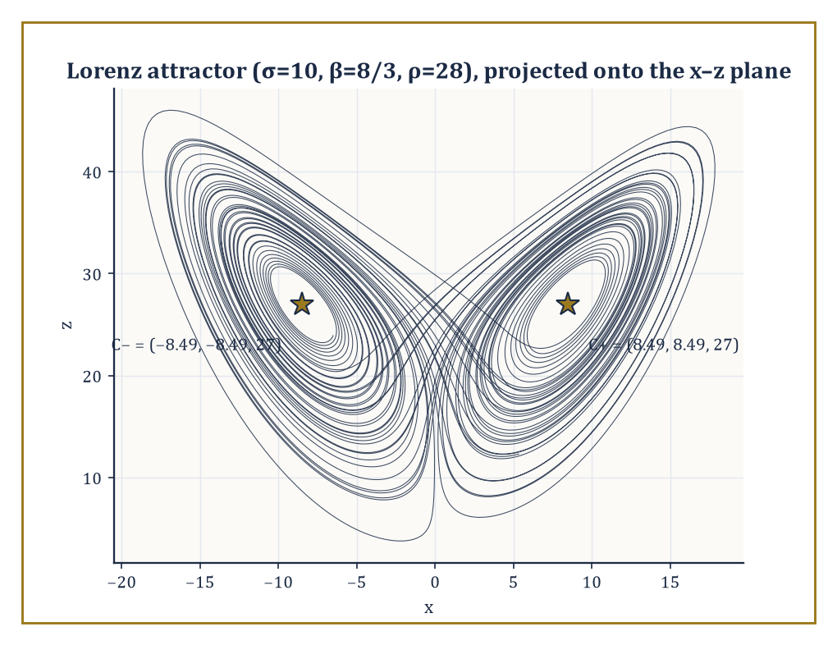
Figure 46.7 — The Lorenz attractor at the classic parameters, winding forever around its two ghost equilibria without ever once repeating a loop.
The Lorenz attractor, born from a drastically simplified three-variable model of atmospheric convection, and the Hénon attractor, its two-dimensional discrete-map cousin, are the two classic exhibits — objects one can stare at for years and never see repeat a single loop.
Abstract example — locating the Lorenz equilibria. The Lorenz system is given by the following equations, with the classic parameters σ = 10, β = 8/3, ρ = 28.
ẋ = σ(y − x)
ẏ = x(ρ − z) − y
ż = xy − βz
Setting all derivatives to zero, the first equation gives:
σ(y − x) = 0 gives y = x
Substituting y = x into the second equation gives:
x(ρ − z) − y = 0 with y = x gives x(ρ − z − 1) = 0
So either x = 0 or z = ρ − 1 = 27. Substituting y = x into the third equation gives:
xy − βz = 0 with y = x gives x² = βz
Taking the nonzero branch z = 27:
x² = β(27) = (8/3)(27) = 72
x = ±√72 = ±6√2 ≈ ±8.485
This gives two symmetric equilibria C± = (±8.485, ±8.485, 27) alongside the origin.
At ρ = 28, both C± have already turned unstable (through a subcritical bifurcation), and it is around this pair of ghost equilibria that the famous butterfly-shaped attractor winds, switching between the two wings in a pattern that never repeats despite the equations themselves containing not one grain of randomness.
Try it now — Find the non-zero Lorenz equilibria for σ = 10, β = 8/3, ρ = 10. Answer →
The Lyapunov exponent measures the average exponential rate at which two initially close trajectories separate: for a small perturbation δx(0) evolved under the linearized (variational) flow,
λ = lim[t→∞] (1/t) ln(|δx(t)| / |δx(0)|)
A positive largest exponent, λ₁ > 0, is the precise quantitative signature of chaos: it means nearby states, no matter how close, are pulled apart exponentially fast, so that any uncertainty in the initial measurement — however tiny — grows to swamp the whole system within a predictable ‘horizon time’ of roughly 1/λ₁, after which the two trajectories are, for practical purposes, unrelated strangers.
Numeric example — a computable Lyapunov exponent. The doubling map θ ↦ 2θ (mod 1) has derivative exactly 2 at every point (away from the measure-zero set of boundary points).
So after n iterations a small initial perturbation δθ₀ has grown, by the chain rule, to:
2ⁿ δθ₀
The Lyapunov exponent is therefore:
λ = lim[n→∞] (1/n) ln(2ⁿ) = ln 2 ≈ 0.6931
This is a positive number computed precisely, no approximation required.
This gives a concrete predictability horizon: losing one decimal digit of accuracy takes about the following number of iterations.
ln 10 / ln 2 ≈ 3.32
Concretely, perturb θ₀ = 0.5 by δ = 10⁻⁶.
After 20 iterations the perturbation has grown by a factor of:
2²⁰ = 1,048,576
So the two orbits — which started closer together than a millionth of the interval — now differ by roughly:
10⁻⁶ × 1,048,576 ≈ 1.05
That is, they are completely decorrelated, anywhere on the unit interval relative to each other. That is sensitive dependence, stated as an arithmetic fact rather than a meteorological metaphor.
For an n-dimensional flow there is a full spectrum of exponents λ₁ ≥ λ₂ ≥ ... ≥ λₙ, one for each independent direction, and the Kaplan–Yorke conjecture converts this spectrum into an estimate of the attractor’s fractal (Lyapunov) dimension:
D_KY = k + (λ₁ + ... + λₖ)/|λₖ₊₁|
Here k is the largest number of leading exponents whose sum is still non-negative.
This sidesteps the famously painful business of literally trying to count boxes over a fractal shape, replacing it with an ordinary sum of numbers already computed for other reasons.
Numeric example — the fractal dimension of the Lorenz attractor. At the classic Lorenz parameters, the numerically established Lyapunov spectrum is approximately λ₁ ≈ 0.906, λ₂ ≈ 0 (the flow direction along any non-equilibrium trajectory always contributes exactly one zero exponent), and λ₃ ≈ −14.57.
As a sanity check, the sum of all three exponents should equal the average divergence of the vector field, which for the Lorenz system is the constant:
−(σ + 1 + β) = −(10 + 1 + 8/3) ≈ −13.667
Indeed:
0.906 + 0 − 14.57 = −13.664
This matches closely.
Taking k = 2 (since λ₁ + λ₂ ≈ 0.906 ≥ 0, but adding λ₃ would make the running sum negative):
D_KY = 2 + (0.906 + 0)/14.57 ≈ 2 + 0.0622 ≈ 2.062
This is the widely quoted fractal dimension of the Lorenz attractor — a set with ‘more structure than a surface but nowhere near the bulk of a solid,’ which is the kind of object the word ‘strange’ was coined to describe, and the kind of number (‘two point oh-six dimensions’) that makes geometry teachers reach for the sherry.
Keep only this · Section 46.7: Strange Attractors and Lyapunov Exponents
The idea. Strange attractors are bounded, attracting and fractal; the largest Lyapunov exponent measures how fast nearby trajectories separate, and the spectrum estimates the fractal dimension.
Core.
λ = lim (1/n) Σ ln|f′(xₖ)|
Kaplan–Yorke: D = j + (λ₁ + ⋯ + λⱼ)/|λⱼ₊₁|
Typical mistake. Reading a positive Lyapunov exponent off one short simulation. It is a long-time average.
Minimal example. Doubling map: λ = ln 2 ≈ 0.693.
Practice. Easy to challenge; full worked answers, with the usual mistake, are in Answers to the Practice Sets at the back.
Easy — Compute the Lyapunov exponent of the tripling map θ ↦ 3θ (mod 1). Answer →
Medium — A system has Lyapunov spectrum (0.5, 0, −2.5). Find its Kaplan–Yorke dimension. Answer →
Challenge — With λ = 0.906, how long until an initial error of 10⁻¹⁰ grows to order 1? What does that say about forecasting? Answer →

Section 46.8: Bifurcations
The calculus of a phase portrait changing its mind
A bifurcation is a qualitative change in the phase portrait as a parameter is varied — not just a shift in where an equilibrium sits, but a change in how many equilibria there are, or what type they are.
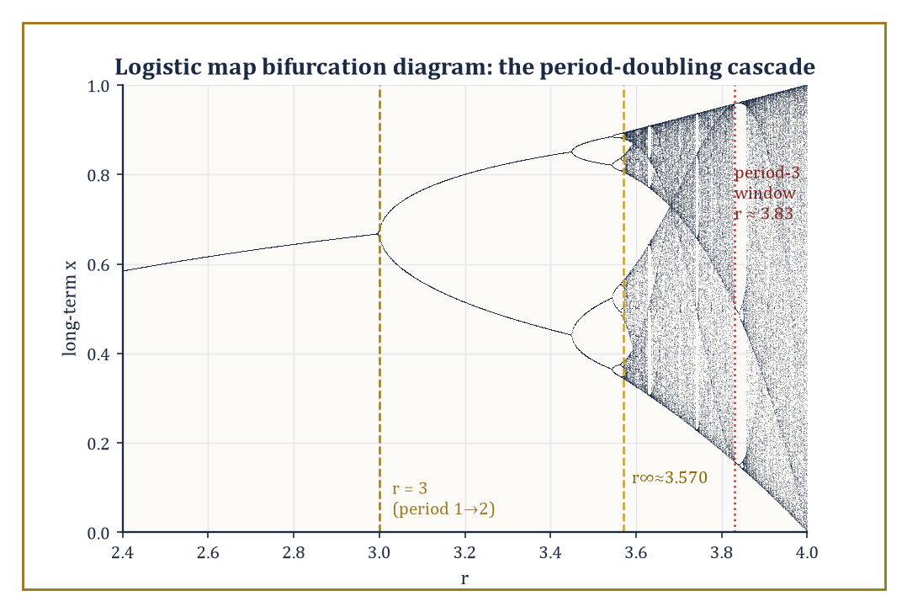
Figure 46.8 — The single most reproduced picture in nonlinear dynamics: the logistic map’s period-doubling cascade, accumulating at r∞ and thinning briefly at the period-3 window.
The codimension-one local bifurcations of equilibria (meaning: generic, requiring only one parameter to tune) come in four standard flavors: saddle-node (a pair of equilibria, one stable and one unstable, collide and annihilate each other, or are born together from nothing), transcritical (two equilibria pass through one another, trading stability as they cross), pitchfork (occurring in systems with a symmetry, where one equilibrium splits into three), and Hopf (an equilibrium loses stability by ejecting a small periodic orbit, as a complex-conjugate pair of eigenvalues crosses the imaginary axis).
Numeric example — a saddle-node bifurcation, equilibria appearing and vanishing. Take the canonical normal form:
ẋ = μ + x²
For μ < 0, equilibria solve
x² = −μ
x = ±√(−μ)
At μ = −1, this gives
x = ±1
The derivative is
f′(x) = 2x
so at each equilibrium:
f′(+1) = 2 > 0 (unstable)
f′(−1) = −2 < 0 (stable)
— one stable, one unstable equilibrium, as promised.
At μ = 0, the two equilibria have merged into a single non-hyperbolic point at x = 0, since
f′(0) = 0
At μ = +1, the equation
ẋ = 1 + x²
is strictly positive for every real x, so there is no equilibrium anywhere — the pair has collided and annihilated completely, and the flow sweeps every point rightward, forever. Watching μ go from −1 to 0 to +1 is watching two equilibria approach, merge, and vanish, in three lines of arithmetic.
Try it now — For ẋ = μ − x² with μ = 4, find the equilibria and their stability. Answer →
The pitchfork bifurcation is the symmetric cousin, appearing when the governing equation is odd in x (unchanged, up to sign, under x ↦ −x) — the same symmetry that produced the two-attractor bistable example back in Lyapunov Stability and Invariant Sets, now with the splitting parameter made explicit.
Numeric example — a pitchfork opening as the parameter grows. Take the normal form:
ẋ = μx − x³
The equilibria are x = 0 always, together with
x² = μ, so x = ±√μ, whenever μ > 0
The derivative is
f′(x) = μ − 3x²
so at the origin:
f′(0) = μ
meaning the origin is stable for μ < 0 and unstable for μ > 0.
At μ = 4, the two new equilibria sit at x = ±2, and
f′(±2) = 4 − 3(4) = 4 − 12 = −8 < 0
confirming both are stable. So as μ crosses 0, the single stable equilibrium at the origin turns unstable and simultaneously spawns two new stable equilibria straddling it symmetrically — exactly the μ = 1 case of this same family (equilibria 0 and ±1) already examined as a bistable system in Lyapunov Stability and Invariant Sets, now recognizable as one snapshot of a whole bifurcating family rather than an isolated curiosity.
Global bifurcations involve the collision of invariant sets that are not confined to a single neighborhood, and so cannot be seen by linearizing at any one equilibrium.
A homoclinic tangency occurs when a trajectory leaving a saddle equilibrium loops around and returns to that very same saddle; as a parameter varies, such loops can develop tangencies that, on crossing, create or destroy entire chaotic invariant sets (horseshoes) in one stroke.
A blue-sky catastrophe is the equally dramatic case where a periodic orbit’s period stretches to infinity as it collides with a homoclinic loop, and the orbit itself disappears — from the perspective of anyone watching only a bounded region, apparently into empty air.
Bifurcation diagrams — the parameter plotted horizontally, the long-term values (equilibria, periodic points, or chaotic bands) plotted vertically for each parameter value — compress an entire family’s worth of qualitative behavior into a single image, and are the field’s principal computational and expository tool.
Abstract example — one picture, the entire cascade. The logistic map’s bifurcation diagram (r along the horizontal axis from 0 to 4, the long-term iterates plotted vertically for each r) is precisely the period-doubling cascade of Chaos in One-Dimensional Maps rendered as a single image: a single stable branch splits into two at r = 3, splits again at the next threshold, then again, the splittings accumulating at r∞ ≈ 3.569946, after which the picture dissolves into a chaotic haze.
This chaotic haze is interrupted by clean, narrow periodic windows, the period-3 window near r ≈ 3.83 chief among them, visible as a sudden thinning of the haze into three sharp branches before it thickens back into chaos.
It is, at once, a bifurcation diagram, a portable chaos detector, and very probably the single most reproduced picture in the whole of nonlinear dynamics — which is either a great compliment to the logistic map or a damning indictment of how few pictures the rest of us have bothered to draw.
Where this returns
The transcritical bifurcation is the turning point of the capstone case study in The Capstone Case Study, in Ten Steps: a harvested population survives while the harvest rate stays below its growth rate, and the two equilibria exchange stability exactly when they are equal.
Keep only this · Section 46.8: Bifurcations
The idea. A bifurcation is a parameter value where the phase portrait changes qualitatively; normal forms give the simplest equation for each kind.
Core.
saddle-node: ẋ = μ − x²
transcritical: ẋ = μx − x²
pitchfork: ẋ = μx − x³
Typical mistake. Thinking bifurcations happen only at instabilities. Equilibria can also be born or destroyed, as in the saddle-node.
Minimal example. ẋ = μ − x² with μ = −1: no equilibria.
Practice. Easy to challenge; full worked answers, with the usual mistake, are in Answers to the Practice Sets at the back.
Easy — How many equilibria does ẋ = μ − x² have for μ = −1, 0 and 1? Answer →
Medium — For ẋ = μx − x³ with μ = 4, find the equilibria and classify them. Answer →
Challenge — For the transcritical form ẋ = μx − x², show that the equilibria exchange stability at μ = 0. Answer →

Section 46.9: Looking Ahead: From Classical Dynamics to Ergodic Theory, Hyperbolicity, and Applications
Packing for the rest of the journey
We have now acquired the working core of dynamical systems and chaos: flows and maps as the two grammars of time evolution, linearization and the Hartman–Grobman theorem for the local picture near an equilibrium, Poincaré maps and Floquet multipliers for periodic orbits, Lyapunov’s method and LaSalle’s principle for certifying long-term convergence, one-dimensional maps as the cleanest laboratory for chaos itself, strange attractors and Lyapunov exponents as its geometric and quantitative signatures, and bifurcation theory as the calculus of how all of the above can change discontinuously as a parameter is tuned.
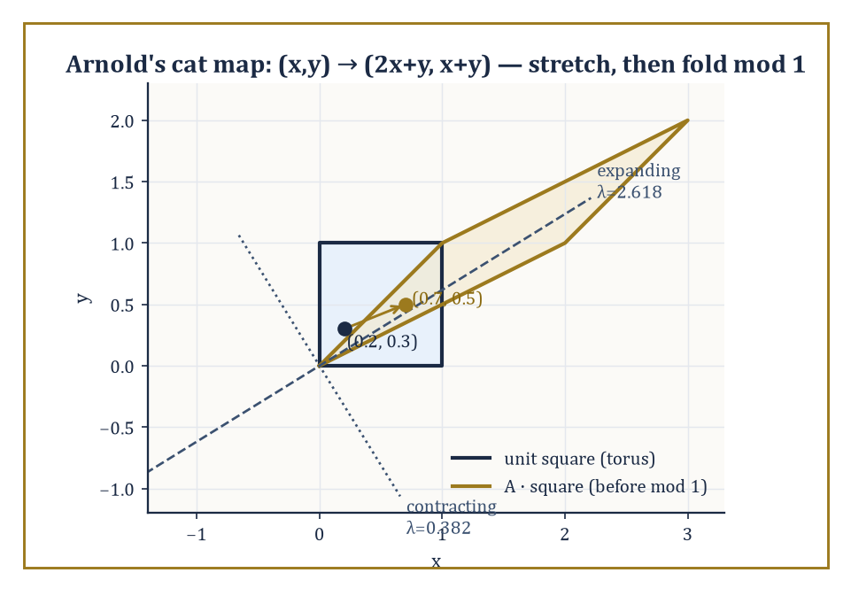
Figure 46.9 — Arnold’s cat map stretching the unit square along its expanding eigendirection before the mod-1 fold sends it back onto the torus — hyperbolicity at every single point, taken completely literally.
That is a respectable amount of luggage for one chapter, and rather more than most of us manage to pack for two weeks abroad.
These tools open directly onto hyperbolic theory, which asks what happens when the local hyperbolicity of Linearization and Local Structure (stable and unstable directions, no lingering center directions) holds not just at isolated equilibria but at every single point of the phase space simultaneously — a condition called being Anosov, or, in a slightly relaxed form allowing periodic orbits and equilibria too, Axiom A.
Such systems are the best-behaved chaotic systems known: provably structurally stable (their qualitative picture survives perturbation, unlike the fragile bifurcation points of Bifurcations) despite being chaotic everywhere at once.
Numeric example — Arnold’s cat map, hyperbolic at every point simultaneously. Consider the map on the unit torus,
(x, y) ↦ (2x + y, x + y) (mod 1)
with matrix
A = [2 1; 1 1]
Its determinant is
2(1) − 1(1) = 1
(so the map preserves area exactly), and its trace is
2 + 1 = 3
giving the characteristic equation
λ² − 3λ + 1 = 0
with roots
λ = (3 ± √5)/2 ≈ 2.618 and 0.382
— one eigenvalue expanding, one contracting, their product exactly 1 as the determinant demands. Because the matrix is constant, these same two eigenvalues govern the map at every single point of the torus: this is Anosov hyperbolicity taken fully literally.
Watching a point move: starting at (0.2, 0.3), one iteration gives
(2(0.2)+0.3, 0.2+0.3) = (0.7, 0.5)
a second iteration gives
(2(0.7)+0.5, 0.7+0.5) mod 1 = (1.9, 1.2) mod 1 = (0.9, 0.2)
The ‘mod 1’ wraparound folds the torus back onto itself at every step, and it is this folding — combined with the underlying stretching by a factor of 2.618 — that produces genuine chaos out of a map that is, underneath the wraparound, entirely linear.
Try it now — Apply Arnold’s cat map (x, y) ↦ (2x + y, x + y) mod 1 to (0.1, 0.2). Answer →
Ergodic theory, meanwhile, gives up on tracking individual orbits altogether and instead asks statistical questions: is there an invariant probability measure μ on phase space — one left completely unchanged by the dynamics — with respect to which one can speak of the ‘typical’ long-term behavior of almost every orbit?
Birkhoff’s ergodic theorem is the payoff: for such a measure, the time average of a quantity along almost every individual trajectory equals its space average against μ, converting an impossibly complicated infinite orbit into a single computable number.
Entropy then quantifies how fast the system generates new, unpredictable information with each step — a statistical cousin of the Lyapunov exponent from Strange Attractors and Lyapunov Exponents, viewed through the lens of probability rather than geometry.
Numeric example — checking measure invariance directly. The doubling map
θ ↦ 2θ (mod 1)
preserves ordinary Lebesgue measure — length, in other words — which can be checked directly rather than taken on faith.
Take the interval [0, 0.3); its preimage under the doubling map consists of every θ mapping into it, namely θ ∈ [0, 0.15) (which doubles, without wraparound, straight into [0, 0.3)) together with θ ∈ [0.5, 0.65) (which doubles to [1, 1.3), and mod 1 lands back in [0, 0.3)).
The total length of the preimage is
0.15 + 0.15 = 0.3
matching the length of the original interval [0, 0.3) — confirming, by one concrete computation, that the map neither inflates nor deflates length on average, which is just what ‘Lebesgue measure is invariant’ means in practice.
From here the subject fans out in every direction: the thermodynamic formalism recasts ergodic theory in the language of statistical mechanics; physics contributes turbulence and celestial mechanics (the three-body problem that started much of this field in the first place); biology contributes population dynamics and neuroscience; engineering contributes vibration analysis and climate modeling; and delay equations, partial differential equations, and other infinite-dimensional systems extend the entire framework to phase spaces that are no longer merely high-dimensional but properly infinite.
The deeper lesson of this chapter is not that the universe is secretly random — it manifestly is not, not in any of the systems we have examined — but that simple deterministic rules, iterated patiently enough, can generate behavior so intricate that it is, for every practical purpose, indistinguishable from randomness, while still admitting a precise geometric and statistical description for anyone willing to do the bookkeeping.
So: deterministic rules can produce unpredictable futures, and we now know precisely what that sentence is allowed to mean. Not ‘anything could happen’ — the trajectory is still pinned down exactly, for all time, by its starting point and the rule — but ‘no finite amount of measurement precision will let you say what happens next, past a horizon set by a number (the Lyapunov exponent) you can, with sufficient patience, actually compute.’ It is one of the tidier ironies available in mathematics: total lawfulness and total unpredictability turn out to be entirely compatible, and the proof fits in a phase portrait.
There is, inevitably, a small existential moral lurking underneath the fractals: most systems worth caring about — the weather, an ecosystem, an economy, several of the author’s own attempts at long-term planning — sit somewhere on this spectrum between ‘boringly predictable’ and ‘chaotically unknowable,’ and the mathematics developed here is the toolkit for finding out which. It will not make the forecast come true. It will, at least, tell you honestly how far ahead you are allowed to trust yourself, which is more than most forecasting can promise.
Ahead lies Mathematical Physics, and the flows we have spent this chapter drawing as abstract arrows in an abstract phase space are about to be revealed as nothing less than the equations of motion of the physical world itself — planets, pendulums, fields, and the occasional genuinely cosmic-scale strange attractor. The geometry stays the same; only the stakes go up.
The series continues.
Keep only this · Section 46.9: Looking Ahead: From Classical Dynamics to Ergodic Theory, Hyperbolicity, and Applications
The idea. Beyond the classical core lie ergodic theory (time averages equal space averages), hyperbolic dynamics, and applications in which the long-run statistics are the answer.
Core.
cat map eigenvalues (3 ± √5)/2
invariance: μ(f⁻¹(A)) = μ(A)
Typical mistake. Thinking chaos destroys all predictability. Long-run statistics can be perfectly predictable.
Minimal example. Cat map: det = 1, so area is preserved.
Practice. Easy to challenge; full worked answers, with the usual mistake, are in Answers to the Practice Sets at the back.
Easy — What is the Lyapunov exponent of the cat map? Answer →
Medium — For the doubling map, compute the preimage of [0, 1/4) and its length. Answer →
Challenge — Explain why an area-preserving map such as the cat map cannot have an attractor with a basin of positive area. Answer →
Chapter 46 recap · Dynamical Systems & Chaos
• A dynamical system is a rule for time evolution: a map xₙ₊₁ = f(xₙ) or a flow ẋ = f(x). Its phase portrait shows every trajectory at once.
• Near a hyperbolic equilibrium the flow looks like its linearization (Hartman–Grobman); eigenvalues classify nodes, spirals and saddles.
• Periodic orbits are studied through Poincaré maps; in the plane, Poincaré–Bendixson rules out chaos.
• Lyapunov functions certify stability, LaSalle’s principle finishes the job when V̇ ≤ 0, and sublevel sets estimate basins.
• The logistic map passes from fixed points through period doubling to chaos; Lyapunov exponents measure sensitive dependence.
• Bifurcations — saddle-node, pitchfork, transcritical, Hopf — are where the qualitative picture changes.

Check Your Understanding — Chapter 46
Answers are in the Answer Key at the back of the book — have a go before you look.
1. [Explain] In the circle map xₙ₊₁ = xₙ + α (mod 1), why does the orbit come back to repeat itself when α = 1/3, but never repeat at all when α = √2 − 1?
See the answer →
2. [Explain] For the damped oscillator ẋ = y, ẏ = −x − y with V = (x²+y²)/2, the Lyapunov derivative works out to V̇ = −y², which is only ≤ 0 (it hits zero whenever y = 0). How does LaSalle’s invariance principle still prove the origin is fully asymptotically stable?
See the answer →
3. [Compute] Using the logistic map’s fixed-point derivative formula f′(x*) = 2 − r, at what value of r does the fixed point lose stability, and what replaces it?
See the answer →
4. [Compute] The doubling map θ ↦ 2θ (mod 1) has derivative exactly 2 everywhere, giving Lyapunov exponent λ = ln 2 ≈ 0.693. How many iterations does it take to lose one decimal digit of precision, and what does a positive Lyapunov exponent mean in practice?
See the answer →
5. [Compute] For the logistic map xₙ₊₁ = r xₙ(1 − xₙ) with r = 2.5, find the non-zero fixed point and determine whether it is stable.
See the answer →
6. [Explain] A chaotic system is completely deterministic, yet its output passes many tests for randomness. Why is chaos not the same as randomness?
See the answer →
7. [Compute] A weather model has a Lyapunov time such that errors double roughly every 2 days. If the initial state is known to one part in a million, roughly how long before the error becomes order one?
See the answer →
8. [Prove] Show that the logistic map’s period-2 orbit is born precisely at r = 3.
See the answer →
9. [Explain] A strange attractor is bounded, never repeats, and never intersects itself. How can a trajectory do all three at once?
See the answer →
10. [Challenge] Is chaos a property of the physical system, or a statement about the limits of our knowledge of it?
See the answer →

Problems — Chapter 46
The questions above test whether the ideas landed. These ask you to use them. Solutions are in Solutions to the Problems at the back. Work them before you look.
1. [Compute] The logistic map f(x) = r x (1 − x). The fixed point in (0, 1) is x* = 1 − 1/r. Show that f′(x*) = 2 − r, and evaluate it at r = 3.
2. [Compute] Same map, r = 2. Find x* and f′(x*).
3. [Explain] A positive Lyapunov exponent means a small error in the initial condition is multiplied, on average, by more than 1 at each step. Why does that make a long forecast useless even when the equation is exact?
4. [Compute] An error of 10⁻⁶ doubles at every step. After how many steps has it grown to about 10⁻³?

Math, Actually

Chapter 47

Mathematical Physics
From Classical Mechanics to Quantum Theory, and the Art of Modeling the Physical World
The last chapter left the series in a slightly undignified state: watching a system with no randomness whatsoever — no dice, no noise, nothing but a differential equation and an honest initial condition — generate behavior so sensitive to its own starting point that predicting it became, for practical purposes, as hopeless as reading tea leaves. Lorenz’s attractor, the Lyapunov exponents totting up how fast your ignorance compounds, the whole cheerful business of chaos: it was a masterclass in humility, administered by mathematics to anyone who ever thought ‘deterministic’ was a synonym for ‘predictable’.
This chapter turns that humility to a rather different use. If dynamical systems taught us what can go wrong once you’ve written down an equation of motion, mathematical physics is the discipline that had the nerve to write the equation down in the first place — to look at the actual universe (planets wheeling about the sun, electrons refusing to have a definite position, spacetime bending under the weight of stars) and assert, calmly, that it obeys laws precise enough to state as mathematics and rich enough to reward the effort of solving them. It is not experimental physics, which measures; it is not pure mathematics, which is under no obligation to describe anything real. It is the bridge between the two, built out of the analytic, geometric, algebraic, and probabilistic machinery assembled in every chapter before this one.
The route runs from the variational principles of classical mechanics, through the intrinsic geometry of phase space, through continuum theories of matter and the four deceptively short equations that govern electricity and magnetism, out into the four-dimensional geometry of relativity — special first, then the considerably more demanding general theory — and finally down into the operator-theoretic strangeness of quantum mechanics, where tools built for spectral theory turn out to have been, all along, a theory of measurement.
A small confession, worth stating plainly before we begin: mathematical physics is the one subject in the series where the line between ‘mathematics motivated by physics’ and ‘physics expressed as mathematics’ is deliberately, permanently smudged. The same symplectic manifold is a phase space to a physicist and a geometric object to a mathematician; the same self-adjoint operator is an observable to one and a spectral problem to the other. Nobody here is trying to resolve the ambiguity. The ambiguity is the point.
Once the laws of nature are written down, somebody eventually wants to use them — to find the trajectory that costs least fuel, the shape that costs least material, the decision that costs least regret. That is a problem for the next chapter, which turns from describing the world to improving our choices within it. But that is optimization’s job, not physics’s. Ours, for now, is simply to write the laws of nature in mathematical form, and to mean it.
Running example · The pendulum as a physical system
The pendulum was a plant in Control Theory and a phase portrait in Dynamical Systems & Chaos. Here it becomes physics: where its equation comes from, why its energy is conserved, and what the small-angle approximation costs. The first worked example of the chapter puts that approximation on trial.
Before you begin — Chapter 47
By the end of this chapter you will be able to:
1. Derive equations of motion from a Lagrangian and pass to Hamilton’s equations.
2. Explain why Hamiltonian flows preserve phase-space area and what integrability means.
3. Follow characteristics to a shock and apply the Rankine–Hugoniot condition.
4. Compute with Maxwell’s equations, Lorentz factors and spacetime intervals.
5. Use the Schwarzschild radius and spherical geodesics to see curvature at work.
6. Compute energy levels and commutators in elementary quantum mechanics.
Prerequisites. Calculus of variations from Chapter 28 (Volume 3); differential forms and manifolds from Chapter 34 (Volume 3); Hilbert spaces and the spectral theorem from Chapter 35 (Volume 3); complex numbers from Complex Analysis (Volume 2).
Estimated study time. About 12 hours, exercises included.

Section 47.1: What Mathematical Physics Is
Or: the discipline that refuses to pick a side
Hang a weight on a string and let it swing. You have met this object in a playground and probably in a clock, and you already know one true thing about it: a longer string swings more slowly. That is physics, and it took no mathematics to acquire.
Now write the law down properly and watch the mathematics decline to cooperate. Newton gives an equation relating the angle to its own acceleration, with the sine of the angle in it, and that equation has no solution in any of the functions you have met in forty-six chapters. Not a hard solution. None. The physics was straightforward and the mathematics has stopped dead.
So the matter to settle is not the one the physics raised. Not what does the pendulum do, but what do you do when an equation is entirely correct and entirely useless.
There is an obvious move, and it costs more than it looks. For small swings the sine of the angle is close to the angle itself, so replace one with the other and the equation becomes solvable at once. But the solvable equation is not the pendulum. It is a different system that resembles it, and you have quietly taken on a second question nobody asked: how far wrong is the substitute, and at what angle does it stop being trustworthy?
The discipline of this chapter is to refuse to leave that second question unanswered. Make the approximation — physicists are right to make it — and then do the mathematics that says when it is safe.
The substitution first, in numbers. Comparing an angle in radians with its own sine:
0.1 rad sine 0.0998 wrong by 0.2%
0.3 rad sine 0.2955 wrong by 1.5%
1.0 rad sine 0.8415 wrong by 19%
For a swing of a few degrees the substitution is beyond reproach; for a swing of nearly sixty it is a fiction. And on a one-meter string under ordinary gravity the tamed equation hands back a period of about 2.007 seconds, which is close enough to two that pendulum clocks were built around the coincidence.
What that table does not tell you is the thing you actually wanted. It reports how far sine has been mis-stated, not how far the period has been mis-stated, and those are separate quantities — an error in the equation and an error in its answer need not be the same size at all. Getting from the first to the second is real work, and it is the work this chapter exists to do.
Mathematical physics is the discipline that formulates physical laws in precise mathematical language and then extracts their consequences by mathematical reasoning — not by squinting at an apparatus, and not by intuition alone, but by proof, or at least by argument sufficiently careful to deserve the name.
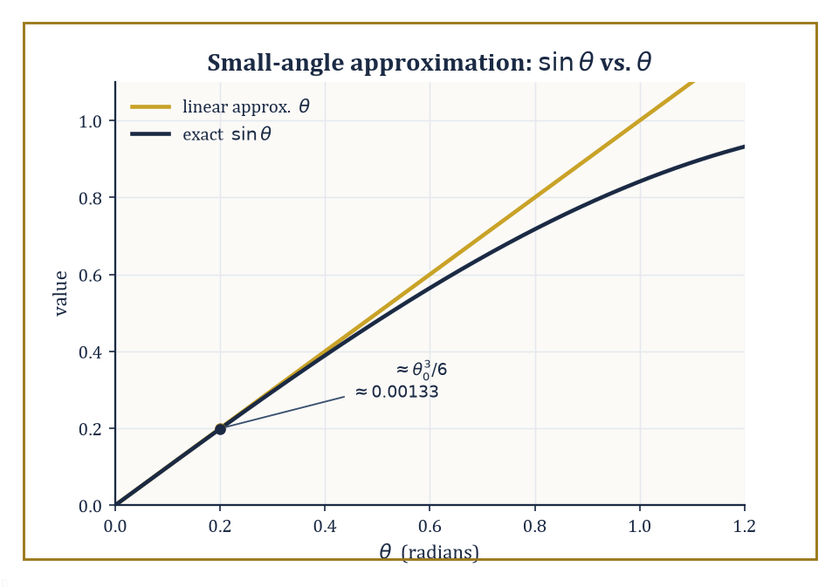
Figure 47.1 — The bold simplification (θ) and the honest function (sin θ), with Taylor’s theorem keeping score of exactly how far apart they are.
It is neither pure mathematics, which cares not a jot whether its objects correspond to anything you could drop on your foot, nor experimental physics, which cares about little else.
It occupies the increasingly crowded middle ground: the belief, which is either wildly optimistic or the only sane position available, that the universe runs on rules simple enough to write down and precise enough to compute with.
The subject spans a startling range of rigor. At one end sits the fully proved: the spectral theorem for self-adjoint operators, the classification of Lie groups underlying gauge symmetry, the existence and uniqueness theory for well-behaved wave equations.
At the other end sits the pragmatically rigorous — formal calculations, performed by physicists with an excellent nose for which manipulations are safe, that produce correct and testable predictions long before a mathematician manages to justify them fully.
The existence and smoothness of solutions to the Navier–Stokes equations in three dimensions remains open — one of the seven Clay Millennium Prize Problems, and arguably the only one you could, in principle, disprove by watching a kettle boil in a sufficiently pathological way. The mathematical foundations of quantum field theory are, at the time of writing, still incomplete, which has not stopped that theory from predicting the electron’s magnetic moment to ten significant figures.
Both styles have a place in this chapter; the formal calculation and the existence proof are not rivals so much as colleagues who occasionally turn up to the same seminar in rather different degrees of dress.
Numeric example — A pragmatic approximation, made rigorous. Consider a simple pendulum of length L = 1 meter, swinging under gravity g = 9.8 m/s². Its exact equation of motion is:
θ’’ + (g/L) sin θ = 0
a perfectly respectable nonlinear ODE with no closed-form solution in elementary functions (its solutions are elliptic integrals, which is mathematics’s polite way of saying ‘go away’).
The physicist’s instinct, for small swings, is to replace sin θ by θ, giving the linear equation:
θ’’ + (g/L) θ = 0
with angular frequency:
ω = √(g/L) = √9.8 ≈ 3.1305 rad/s
and period:
T = 2π/ω ≈ 2.007 seconds
Is this legitimate? Taylor’s theorem says yes, and tells you how legitimate. Since:
sin θ = θ − θ³/6 + O(θ⁵)
the error introduced at amplitude θ₀ = 0.2 radians (about 11.5°) is θ₀ − sin θ₀, which is approximately:
θ₀³/6 = (0.2)³/6 = 0.008/6 ≈ 0.00133 radians
a relative error of about θ₀²/6 ≈ 0.0067, roughly two-thirds of one percent.
Direct computation confirms it:
sin(0.2) = 0.19867, and 0.2 − 0.19867 = 0.00133
just as promised. That is the whole method of ‘pragmatic’ mathematical physics in miniature: make the bold simplification first, because it’s the equation you can solve, then let a rigorous remainder estimate tell you, afterwards, how much you were allowed to get away with.
Try it now — Use T = 2π√(L/g) with g = 9.8 m/s² for a pendulum of length 0.25 m. Answer →
Every earlier chapter of this series supplied a tool; mathematical physics is where the tools finally get used in anger.
Real and complex analysis furnish the differential equations. Differential geometry furnishes the curved spaces on which those equations live.
Functional analysis — Hilbert spaces, spectral theory, operator theory — furnishes almost the entire apparatus of quantum mechanics, largely unchanged from its pure-mathematical form. Group theory furnishes the symmetries that Noether’s theorem converts into conservation laws.
None of these connections is superficial; each is load-bearing, in the sense that removing it collapses the chapter built on top of it.
Abstract example — Where the machinery comes from. Take one thread and follow it end to end. An earlier chapter on functional analysis proved the spectral theorem: every self-adjoint operator A on a Hilbert space H admits a spectral decomposition:
A = ∫ λ dE(λ)
where E is a projection-valued measure supported on the real spectrum of A. At the time it was proved, this was a statement purely about operators — abstract, elegant, and to all appearances physics-free.
Quantum Mechanics of this chapter will hand you the postulates of quantum mechanics, and the very first one reads: every physical observable is represented by a self-adjoint operator, and the possible outcomes of measuring it are exactly the points of that operator’s spectrum.
The spectral theorem, proved with no physical intention whatsoever, turns out to be the precise mathematical reason measured quantities in quantum mechanics come out real, and why repeated measurement of the same quantity on the same state is statistically well-defined.
Nobody designed it that way. It was waiting.
There is a famous phrase for this state of affairs, coined by the physicist Eugene Wigner in 1960: ‘the unreasonable effectiveness of mathematics in the natural sciences.’ Wigner’s puzzle was why mathematical structures developed with no thought of physical application — complex numbers, matrix algebra, non-Euclidean geometry — turn out again and again to be the right language for a physical theory decades or centuries later.
Mathematical physics does not resolve Wigner’s puzzle so much as live inside it permanently, treating the coincidence as a working method rather than a mystery to be settled before proceeding.
Abstract example — A structure invented for algebra, later needed for physics. Complex numbers were introduced in the sixteenth century solely to make Cardano’s formula for solving cubic equations work in cases where it produced square roots of negative numbers even though the final answer was a perfectly ordinary real number — a piece of algebraic bookkeeping that mathematicians of the time treated with open suspicion (Descartes coined the term ‘imaginary’ as an insult, and it stuck).
Three centuries later, Schrödinger’s equation has an i sitting in it that cannot be removed by any change of variables:
iħ ∂ψ/∂t = Ĥψ
Quantum mechanics is not merely convenient to write with complex numbers, it is false without them, since a real-valued wavefunction cannot reproduce the interference and probability-conservation properties actually observed in experiment.
A tool built to tidy up cubic equations turned out, entirely unrequested, to be load-bearing for the whole of quantum theory.
With the philosophical throat-clearing out of the way, we can begin building. The natural starting point — the one every physicist meets first and never quite gets over — is the variational principle: the striking claim that a particle moving from A to B chooses, among all conceivable paths, the one that makes a certain integral stationary.
That is the subject of the next section.
Keep only this · Section 47.1: What Mathematical Physics Is
The idea. Mathematical physics studies the mathematics that physical laws require — and the surprising way mathematics invented for other reasons turns out to fit.
Core.
small angles: sin θ ≈ θ, T = 2π√(L/g)
error of the substitution: sin θ − θ ≈ −θ³/6
Typical mistake. Treating a solvable approximation as the original equation. The error must be estimated, not assumed away.
Minimal example. L = 1 m: T ≈ 2.007 s.
Practice. Easy to challenge; full worked answers, with the usual mistake, are in Answers to the Practice Sets at the back.
Easy — By how much does the period change if the length is quadrupled? Answer →
Medium — For an amplitude of 60° (1.047 rad), the first correction to the period is T ≈ T₀(1 + θ₀²/16). Estimate T for L = 1 m. Answer →
Challenge — Compare the relative error of replacing sin θ by θ at θ = 0.1 rad and θ = 1 rad. Answer →

Section 47.2: Lagrangian and Hamiltonian Mechanics
Two ways of being right about the same ball
You have seen this before
The Euler–Lagrange equation is the one derived in Chapter 28 (Volume 3), Calculus of Variations, for any functional ∫L(q, q̇, t) dt; Hamilton’s principle is its application to mechanics. This section does not rederive it; it uses it.
Throw a ball straight up so that it comes back to your hand 2 seconds later. Newton’s way to find its path is to name the force, gravity, and solve. With g = 10 m/s², the ball must leave your hand at 10 meters per second, and its height after t seconds is 10t − 5t² meters: up to 5 meters at t = 1, back down to 0 at t = 2.
Here is a different way to ask the question, one that never mentions force. The ball is in your hand at t = 0 and back in it at t = 2. Imagine all the paths it might take in between: an arch rising 3 meters, or 7, or no rise at all. Give each path a score. At every instant, take the kinetic energy and subtract the potential energy, and add the result up over the 2 seconds. For a 1-kilogram ball on a parabolic arch that peaks at a meters, the score works out to (4a² − 40a)/3:
peak 0 m (the ball never moves): score 0
peak 3 m: score −28
peak 4 m: score −32
peak 5 m: score −33.3
peak 6 m: score −32
peak 7 m: score −28
The lowest score belongs to the 5-meter arch, which is the path Newton’s law gives. Look at the scores on either side of it: 4 meters and 6 meters tie, and so do 3 meters and 7. The true path sits at the bottom of the valley, where a small change to the path makes almost no change to the score.
That is the principle of this section. The score is the action, and kinetic minus potential energy is the Lagrangian. Nature takes the path whose action does not change, to first order, when the path is nudged. Here that path is a minimum, but the section explains why ‘stationary’ is the more honest word. The rule that singles out such a path is the Euler–Lagrange equation, and the first worked example below uses it to recover the motion of a spring, again without ever writing down a force.
Classical mechanics, in its Newtonian form, tells you to write down forces and solve:
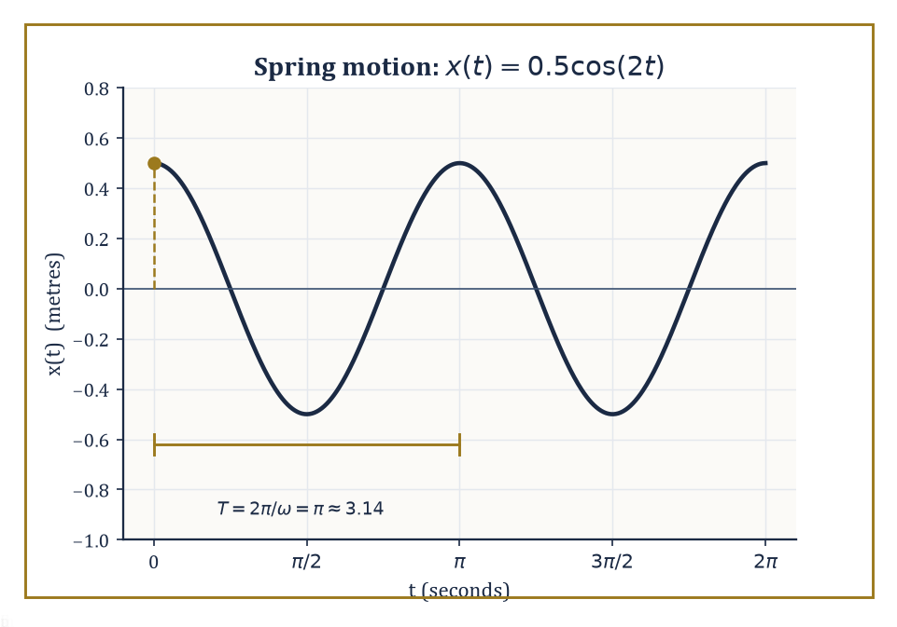
Figure 47.2 — The mass-on-a-spring’s motion, x(t) = 0.5 cos(2t), recovered from the Euler–Lagrange equation without ever mentioning a force.
F = ma
The Lagrangian formulation asks a stranger question: among all the paths a system could conceivably take from its state at time t₁ to its state at time t₂, which one does it take?
The answer, due to Euler, Lagrange, and (in its full generality) Hamilton, is that nature chooses the path making the action stationary:
S = ∫[t₁,t₂] L(q, q̇, t) dt
Here L = T − V is the Lagrangian — kinetic energy minus potential energy, expressed in generalized coordinates q and generalized velocities q̇. ‘Stationary’ does not mean ‘minimal’, despite the traditional name ‘principle of least action’; saddle points are allowed, and in several standard examples the true path is a saddle, not a minimum, of the action.
Applying the calculus of variations (built in an earlier chapter) to this stationarity condition produces the Euler–Lagrange equations, one for each coordinate:
d/dt(∂L/∂q̇) − ∂L/∂q = 0
These are equivalent to Newton’s equations of motion — but written in a form that survives a change of coordinates unscathed, incorporates constraints gracefully, and generalizes without modification to fields, relativity, and quantum theory in ways F = ma never could.
Numeric example — The Lagrangian of a spring. Take a mass m = 2 kg on a spring of stiffness k = 8 N/m, sliding on a frictionless line, with position x.
Kinetic energy is T = ½mẋ² and potential energy is V = ½kx², so the Lagrangian is, after substituting the numbers:
L = ½mẋ² − ½kx² = ẋ² − 4x²
Compute the two pieces of the Euler–Lagrange equation. First:
∂L/∂ẋ = mẋ = 2ẋ, so d/dt(∂L/∂ẋ) = 2ẍ
And second:
∂L/∂x = −kx = −8x
The equation d/dt(∂L/∂ẋ) − ∂L/∂x = 0 then gives:
2ẍ − (−8x) = 0, i.e. 2ẍ + 8x = 0, i.e. ẍ = −4x
That is Newton’s second law for a spring, F = −kx = ma, recovered without ever writing down a force.
Solving ẍ = −4x with initial conditions x(0) = 0.5 m and ẋ(0) = 0 gives angular frequency:
ω = √(k/m) = √4 = 2 rad/s
and solution:
x(t) = 0.5 cos(2t)
Check the solution by differentiating twice:
x′(t) = −1·sin(2t), so x″(t) = −2cos(2t)
and comparing against −4x(t):
−4x(t) = −4(0.5cos 2t) = −2cos(2t)
They agree, confirming the solution.
Try it now — Write the Lagrangian of a unit mass on a spring of stiffness 4 and derive its equation of motion. Answer →
The Lagrangian lives on velocity space; the Hamiltonian formulation moves house to phase space, coordinatized by positions q and momenta p, where the momentum conjugate to q is defined as:
p = ∂L/∂q̇
The transition — replacing q̇ by p as the independent variable — is a Legendre transform, the same operation that turns a convex function’s graph into the graph of its dual, familiar from thermodynamics and convex analysis.
The Hamiltonian itself is, re-expressed entirely in q and p:
H(q,p) = pq̇ − L
For the ordinary mechanical systems met in this section it works out to be the total energy, T + V, written in momentum rather than velocity.
The payoff is Hamilton’s equations — a first-order system, twice the dimension of the Lagrangian’s second-order one:
q̇ = ∂H/∂p and ṗ = −∂H/∂q
These are strikingly symmetric, and, as the next section will show, the natural flow of a geometric structure on phase space in its own right.
Numeric example — The same spring, in phase space. Continuing the spring above, the conjugate momentum is:
p = ∂L/∂ẋ = mẋ = 2ẋ, so ẋ = p/2
The Legendre transform then gives:
H = pẋ − L = p(p/2) − [½(2)(p/2)² − 4x²] = p²/2 − p²/4 + 4x² = p²/4 + 4x²
In general form this is H = p²/(2m) + ½kx², which for m = 2, k = 8 gives p²/4 + 4x², as computed.
Check that Hamilton’s equations reproduce the same motion. First:
q̇ = ∂H/∂p = p/2
matching ẋ = p/2 above. Second:
ṗ = −∂H/∂q = −8x
while p = 2ẋ means ṗ = 2ẍ, giving:
2ẍ = −8x, i.e. ẍ = −4x
the identical equation of motion, arrived at from the opposite direction.
Now track the energy. At t = 0: x = 0.5, ẋ = 0, so p = 0, and:
H(0) = 0²/4 + 4(0.5)² = 1 joule
At t = π/4 (a quarter period later), x(π/4) = 0.5cos(π/2) = 0, and p(π/4) = 2ẋ(π/4) = 2(−1·sin(π/2)) = −2, so:
H(π/4) = (−2)²/4 + 4(0)² = 1 joule
The energy agrees at both instants, as it must, since H has no explicit time dependence and Hamilton’s equations guarantee dH/dt = 0 along any trajectory.
Phase space carries an algebraic structure beyond simply being a space of pairs (q,p): the Poisson bracket, defined for functions f and g on phase space as:
{f,g} = ∂f/∂q · ∂g/∂p − ∂f/∂p · ∂g/∂q
Hamilton’s equations can be rewritten compactly using this bracket:
q̇ = {q,H} and ṗ = {p,H}
More generally, the time evolution of any observable f along the flow is ḟ = {f,H}.
Canonical transformations are exactly the changes of coordinates on phase space that preserve every Poisson bracket — the symmetries of the Hamiltonian formalism, in the same sense isometries are the symmetries of a metric space.
This bracket is not decorative: it is the classical shadow of the commutator that governs quantum mechanics, and the resemblance is not a coincidence, as Quantum Mechanics will make embarrassingly explicit.
Abstract example — The fundamental bracket. Compute {x,p} directly from the definition, treating x and p as the two functions on phase space:
{x,p} = ∂x/∂x · ∂p/∂p − ∂x/∂p · ∂p/∂x = (1)(1) − (0)(0) = 1
This single number, {x,p} = 1, is the entire algebraic content of classical mechanics’ phase space — every other bracket among polynomials in q and p can be built from it using bilinearity, antisymmetry, and the Leibniz rule.
Remember it for when it resurfaces in Quantum Mechanics, dressed up as the commutation relation:
[x̂,p̂] = iħ
The classical bracket, multiplied by iħ, becomes the quantum one. This procedure, taking Poisson brackets to (1/iħ) times commutators, is literally called ‘canonical quantization’, and it is close to the most direct bridge between classical and quantum mechanics that exists.
Lagrangian and Hamiltonian mechanics are equivalent whenever the Lagrangian is regular — meaning the map from velocities to momenta is invertible, so the Legendre transform doesn’t get stuck.
Between them they are the foundation of essentially everything downstream: the geometric structure of phase space (next section), the field theories obtained by promoting q to a field (two sections from now), and the entire operator formalism of quantum theory, which is best understood as what happens when you take the Poisson bracket seriously as an algebra and represent it on a Hilbert space instead of a phase space.
Running example · The pendulum from a single principle
With m = ℓ = 1 the Lagrangian L = ½θ̇² + 9.8 cos θ gives θ̈ = −9.8 sin θ (Medium exercise above), the equation that Linear State-Space Models linearized. The momentum is p = θ̇ and the Hamiltonian H = p²/2 + 9.8(1 − cos θ), up to a constant, is the energy whose level curves drew the phase portrait in Flows, Maps, and Phase Portraits and which served as a Lyapunov function in Stability: Lyapunov and Input-Output and Lyapunov Stability and Invariant Sets.
Last stage: Structure-Preserving and Geometric Integration asks which numerical method keeps H from drifting.
Keep only this · Section 47.2: Lagrangian and Hamiltonian Mechanics
The idea. Mechanics can be rebuilt from one principle: the true motion makes the action ∫L dt stationary. Legendre-transforming L gives the Hamiltonian, and Hamilton’s equations turn motion into a flow on phase space.
Core.
d/dt(∂L/∂q̇) = ∂L/∂q
p = ∂L/∂q̇, H = pq̇ − L
q̇ = ∂H/∂p, ṗ = −∂H/∂q
Typical mistake. Assuming H is always the energy. It is when the constraints do not depend on time and the kinetic energy is quadratic in velocities.
Minimal example. Spring, m = 2, k = 8: ẍ = −4x.
Practice. Easy to challenge; full worked answers, with the usual mistake, are in Answers to the Practice Sets at the back.
Easy — For the pendulum L = ½mℓ²θ̇² + mgℓ cos θ, find the conjugate momentum. Answer →
Medium — Derive the pendulum’s equation of motion from L = ½mℓ²θ̇² + mgℓ cos θ. Answer →
Challenge — Show from Hamilton’s equations that dH/dt = 0 when H does not depend on t. Answer →

Section 47.3: Symplectic Geometry and Integrable Systems
The geometry nobody told you phase space had
Phase space is not merely a set of pairs (q,p); it carries a geometric structure, and once you see it, Hamilton’s equations stop looking like an arbitrary recipe and start looking inevitable.
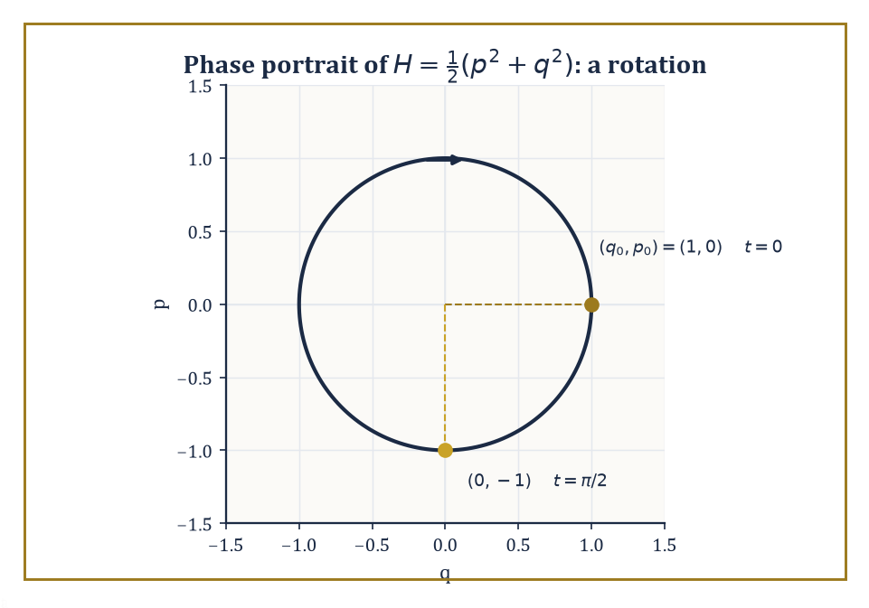
Figure 47.3 — The oscillator’s phase-space flow is a rotation: a quarter turn carries (1,0) to (0,−1), and Liouville’s theorem is det R(t)=1 in disguise.
The structure is a symplectic form: a differential 2-form ω that is closed (dω = 0) and non-degenerate (ω(v,·) = 0 forces v = 0). On the standard phase space ℝ²ⁿ with coordinates (q¹,...,qⁿ,p₁,...,pₙ), the canonical symplectic form is:
ω = Σᵢ dpᵢ ∧ dqᵢ
Given a Hamiltonian function H, the Hamiltonian vector field X_H is defined by:
ι_(X_H)ω = dH
In words: plug X_H into the first slot of ω and you get the differential of H out — and the integral curves of X_H are, when unwound in coordinates, the solutions of Hamilton’s equations.
Symplectic geometry is what phase space looks like once you stop thinking of it as a mere coordinate system and start thinking of it as the intrinsic object classical mechanics lives on.
Numeric example — The flow of the oscillator is a rotation. Take the simplest possible Hamiltonian, a unit-mass, unit-frequency oscillator:
H(q,p) = ½(p² + q²)
Hamilton’s equations are:
q̇ = ∂H/∂p = p and ṗ = −∂H/∂q = −q
giving the general solution:
q(t) = q₀cos t + p₀sin t and p(t) = −q₀sin t + p₀cos t
Direct differentiation confirms q̇ = −q₀sin t + p₀cos t = p(t) and ṗ = −q₀cos t − p₀sin t = −q(t), so both equations hold. This flow is the linear map (q₀,p₀) ↦ (q(t),p(t)) given by the rotation matrix:
R(t) = [cos t sin t; −sin t cos t]
Take t = π/2 and starting point (q₀,p₀) = (1,0):
q(π/2) = cos(π/2)·1 + sin(π/2)·0 = 0, and p(π/2) = −sin(π/2)·1 + cos(π/2)·0 = −1
So (1,0) is carried to (0,−1), a quarter-turn clockwise, as a rotation should behave.
Now check whether the flow preserves the symplectic form — equivalently, area, in this two-dimensional case. The Jacobian of the flow at any time is R(t) itself, and:
det R(t) = cos²t + sin²t = 1
for every t. This is Liouville’s theorem in miniature: Hamiltonian flows always preserve symplectic volume, no matter how complicated H gets, and this two-line calculation is the whole reason a gas of a million billion billion classical particles cannot, whatever else it does, spontaneously shrink the volume it occupies in phase space.
Try it now — The flow of H = (p² + q²)/2 rotates phase space. What is the area of the image of the unit disk after time t? Answer →
Most Hamiltonian systems cannot be solved in closed form — this is the generic situation, and the reason the previous chapter needed an entire theory of chaos to handle it. A special class, the completely integrable systems, can be solved.
A system with n degrees of freedom is fully integrable if it possesses n independent conserved quantities (including H itself) that Poisson-commute with each other:
{Fᵢ,Fⱼ} = 0 for all i,j
The Liouville–Arnold theorem then guarantees that, under mild compactness and non-degeneracy hypotheses, the common level sets of the Fᵢ are n-dimensional tori, and the motion on each torus is a straight-line, quasi-periodic flow when expressed in the right coordinates: the action-angle variables (I,θ), in which the angles θᵢ wind around the torus at constant rates and the actions Iᵢ — essentially the area enclosed by one cycle of the motion — are the conserved labels picking out which torus you’re on.
Integrable systems are the solvable models of classical mechanics — the harmonic oscillator, the Kepler problem, the free rigid body — and everything the previous chapter called ‘chaos’ is what happens when you perturb an integrable system just enough that KAM theory’s guarantee of surviving tori starts to fail.
Worked example — Two independent clocks, and the tori they trace out. Take two decoupled unit-mass oscillators with frequencies ω₁ = 1 and ω₂ = 2, total Hamiltonian H = H₁ + H₂ where Hᵢ = ½(pᵢ² + ωᵢ²qᵢ²).
Each Hᵢ is separately conserved (they Poisson-commute trivially, since they depend on disjoint coordinates), so this is a wholly integrable system with two degrees of freedom. For a single such oscillator, the standard action-angle computation gives:
Iᵢ = Eᵢ/ωᵢ
where Eᵢ is the energy stored in that oscillator. Suppose the first oscillator carries E₁ = 3 joules and the second E₂ = 8 joules. Then:
I₁ = E₁/ω₁ = 3/1 = 3, and I₂ = E₂/ω₂ = 8/2 = 4
The invariant torus for this motion is the set {I₁ = 3, I₂ = 4} — a genuine two-dimensional torus sitting inside the four-dimensional phase space (q₁,p₁,q₂,p₂). The motion on it is:
θ₁(t) = θ₁(0) + t and θ₂(t) = θ₂(0) + 2t
Two independent clocks, one running twice as fast as the other. Because ω₁/ω₂ = 1/2 is rational here, the combined motion actually closes up (after time 2π); for a generic, irrational frequency ratio it would wind around the torus forever without ever repeating — quasi-periodic in the strict sense.
KAM theory (Kolmogorov–Arnold–Moser) answers the natural next question: what happens to these invariant tori when the Hamiltonian is perturbed slightly,
H = H₀ + εH₁
away from perfect integrability?
The naive expectation — that a small perturbation produces a small, controllable change in the motion — turns out to be catastrophically wrong for many individual tori, because of the small-divisor problem: perturbation theory produces correction terms with denominators like (m·ω) for integer vectors m, and when the unperturbed torus’s frequency ratios are close to rational, these denominators come arbitrarily close to zero, blowing the correction up.
KAM theory’s remarkable rescue is that tori whose frequency ratios are sufficiently irrational — in a precise Diophantine sense, badly approximable by rationals — survive small perturbations largely intact, merely deformed, while tori with rational or near-rational frequency ratios are generically destroyed, dissolving into the chaotic layers explored in the previous chapter.
‘Most’ tori, in a measure-theoretic sense, survive for small enough ε; the destroyed ones are exactly where chaos gets its foothold.
Numeric example — The small divisor, made concrete. Fix ω₁ = 1 and compare two choices of ω₂: a value deliberately chosen close to the rational 3/2, namely ω₂ = 1.4995, and the golden ratio:
ω₂ = φ = (1+√5)/2 ≈ 1.618034
famous among number theorists as the real number hardest to approximate well by rationals. Perturbation theory for the resonance associated with the integer vector m = (3,−2) needs the quantity m·ω = 3ω₁ − 2ω₂ sitting in a denominator.
For the near-resonant frequency:
m·ω = 3(1) − 2(1.4995) = 3 − 2.999 = 0.001
a denominator of one-thousandth, so any correction term of the form (something)/(m·ω) gets amplified a thousandfold, and the perturbation series is in real danger of diverging.
For the golden ratio:
m·ω = 3(1) − 2(1.618034) = 3 − 3.236068 = −0.236068
more than two hundred times larger in magnitude, even though φ is irrational and 1.4995 is not.
This is the small-divisor problem in miniature: it is not irrationality alone that protects a torus, but how badly the frequency ratio resists approximation by rationals — and the golden ratio, whose continued fraction [1;1,1,1,...] converges more slowly than that of any other number, is essentially the best-protected frequency ratio there is, which is why it turns up disproportionately often in KAM-theoretic examples.
This is where the previous chapter’s chaos and this chapter’s order meet: an integrable system’s tori are the scaffolding, and KAM theory tells you how many of them survive a small perturbation of H before the scaffolding collapses into the strange attractors and sensitive dependence explored two chapters ago.
Continuum physics, next, generalizes all of this from finitely many degrees of freedom to infinitely many — from a handful of (q,p) pairs to a field defined at every point of space.
Keep only this · Section 47.3: Symplectic Geometry and Integrable Systems
The idea. Hamiltonian flows preserve the symplectic form, hence phase-space volume; integrable systems move quasi-periodically on invariant tori, and KAM theory says which tori survive small perturbations.
Core.
Liouville: volume preserved
integrable: n conserved quantities in involution
KAM: tori with badly approximable frequency ratios survive
Typical mistake. Thinking volume preservation forbids chaos. Area-preserving maps can be chaotic, as the cat map is.
Minimal example. ω₁ = 1, ω₂ = 2: closed orbits, period 2π.
Practice. Easy to challenge; full worked answers, with the usual mistake, are in Answers to the Practice Sets at the back.
Easy — Two decoupled oscillators have ω₁ = 1 and ω₂ = 3/2. Is the motion periodic, and with what period? Answer →
Medium — Is the motion with ω₁ = 1, ω₂ = √2 periodic? Answer →
Challenge — Explain why the pendulum is an integrable system, and what its invariant tori are. Answer →

Section 47.4: Continuum Mechanics and Classical Field Theories
Matter, smoothed out for your convenience
Before this section
What you need. The method of characteristics from Partial Differential Equations (Volume 3); weak solutions and Sobolev spaces from Functional Analysis (Volume 3).
Why it matters. Fluids, elastic solids and fields are described by PDEs, and shocks show why smooth solutions are not always enough.
Continuum mechanics treats matter not as a swarm of point particles but as a continuous medium — a simplification that is technically false at the atomic scale and enormously useful at every scale a bridge engineer or a meteorologist cares about.
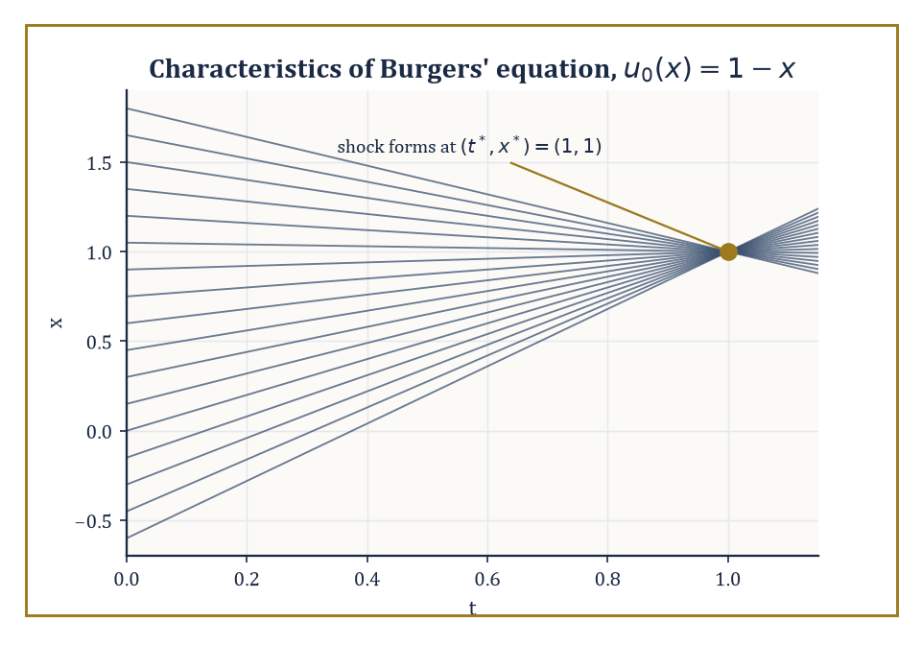
Figure 47.4 — Every characteristic of u₀(x)=1−x, however far apart it started, arrives at the same instant — which is what a shock is.
The governing equations come from three balance laws — conservation of mass, momentum, and energy — applied to an arbitrary chunk of material, combined with a constitutive relation encoding what the material is actually made of (how stress relates to strain, or to rate of strain).
For an inviscid fluid this produces the Euler equations; adding viscosity produces the Navier–Stokes equations; applied to a deformable solid instead of a fluid, the same balance-law logic produces the equations of elasticity.
When these equations are nonlinear and hyperbolic — which the compressible Euler equations emphatically are — smooth initial data can develop genuine discontinuities in finite time: shock waves, the mathematical signature of a sonic boom or a traffic jam forming out of nothing but smoothly varying density.
Numeric example — Watching a shock form, one equation at a time. The simplest nonlinear hyperbolic equation that still shows shock formation is Burgers’ equation:
uₜ + u·uₓ = 0
a drastically simplified stand-in for momentum balance in the Euler equations, sharing their essential nonlinear pathology. Its solutions are constant along characteristic lines: if a point x₀ carries initial value u₀(x₀), u stays equal to u₀(x₀) forever along the line x(t) = x₀ + u₀(x₀)·t.
Take initial condition u₀(x) = 1 − x, a straight line sloping downward. The characteristic starting at x₀ is:
x(t) = x₀ + (1 − x₀)t
Take two nearby starting points, x₀ and x₀ + ε. They collide when:
x₀ + (1−x₀)t = (x₀+ε) + (1−x₀−ε)t
Expanding the right side gives x₀ + ε + (1−x₀)t − εt; setting the two sides equal:
(1−x₀)t = ε + (1−x₀)t − εt, which simplifies to 0 = ε − εt, i.e. t = 1
independent of both x₀ and ε. Every pair of characteristics collides at exactly the same instant, t* = 1. Substituting t = 1 into the characteristic formula gives:
x(1) = x₀ + (1−x₀)(1) = 1
again independent of x₀: every characteristic line, wherever it started, passes through the single point (t,x) = (1,1). At that instant the smooth solution must be replaced by a discontinuous one governed by a jump (Rankine–Hugoniot) condition — a shock forms.
(This particular initial condition is unusually tidy: a linear velocity profile makes every characteristic collide at one shared point, chosen here because the arithmetic comes out precisely, not because real shocks are typically this obliging.)
Try it now — For Burgers’ equation uₜ + uuₓ = 0 with u(x, 0) = −x, find when characteristics cross. Answer →
Once a shock has formed, the classical, differentiable notion of ‘solving the PDE’ breaks down, and the equation must be reinterpreted in a weak sense: an integral identity, tested against smooth functions, that no longer requires u itself to be differentiable across the discontinuity.
Weak solutions are not unique, however — infinitely many discontinuous functions can satisfy the weak formulation of Burgers’ equation with the same initial data, and only one of them is physically correct.
Selecting the right one requires an extra admissibility condition, the entropy condition (so named by analogy with the second law of thermodynamics, which likewise picks out the physically realized direction among mathematically permitted ones): characteristics must run into a shock from both sides, never emerge from one.
This is the same logic, transplanted into pure analysis, that rules out a traffic jam spontaneously un-forming itself for no reason.
Numeric example — A shock that is allowed, and one that isn’t. Consider the Riemann problem for Burgers’ equation: a single jump at x = 0 at time zero, with u(x,0) = u_L for x < 0 and u(x,0) = u_R for x > 0.
The Rankine–Hugoniot condition fixes the speed of any propagating discontinuity, with flux f(u) = ½u²:
s = [f(u_L) − f(u_R)]/(u_L − u_R), which simplifies to s = (u_L + u_R)/2
Take u_L = 2, u_R = 0: the shock speed is:
s = (2+0)/2 = 1
Check the entropy condition, u_L > s > u_R:
2 > 1 > 0
This holds, so this jump is admissible — characteristics carrying value 2 travel at speed 2 and catch the shock from the left, characteristics carrying value 0 sit still and get caught by the shock from the right, and both families feed into the discontinuity, as required.
Now swap the states: u_L = 0, u_R = 2. The same formula gives the same-looking jump, speed:
s = (0+2)/2 = 1
but the entropy condition u_L > s now reads 0 > 1, which is false. This discontinuity satisfies the jump condition but is not the physically correct solution, because no characteristics run into it — the left state’s characteristics (speed 0) and the right state’s (speed 2) both move away from x = 0 as t increases.
The genuine solution here has no shock at all: it is the continuous rarefaction fan:
u(x,t) = x/t for 0 ≤ x/t ≤ 2
smoothly interpolating between the two states as the initial jump fans out rather than propagating.
Classical field theories generalize continuum mechanics one step further: instead of a displacement field defined on a lump of matter, a field φ(x,t) is defined at every point of spacetime itself, and the Lagrangian becomes a Lagrangian density ℒ(φ, ∂φ), integrated over spacetime to give the action:
S = ∫ ℒ d⁴x
Extremizing S with respect to variations of φ produces the Euler–Lagrange equation for fields:
∂ℒ/∂φ − ∂_μ(∂ℒ/∂(∂_μφ)) = 0
This is the direct field-theoretic descendant of the particle Euler–Lagrange equation from Lagrangian and Hamiltonian Mechanics, with the time derivative now joined by the spatial ones.
Scalar fields, the electromagnetic field, and (much higher up the scale of difficulty) Yang–Mills gauge fields are all continuum theories of just this shape, differing only in what φ is and what ℒ looks like.
Abstract example — A symmetry, enforcing a conservation law without being asked. Noether’s theorem states that every continuous symmetry of the action corresponds to a conserved quantity. Take the simplest instance: a free particle with Lagrangian L = ½mẋ², and the symmetry x → x + ε for constant infinitesimal ε — translating the whole trajectory sideways changes nothing about L, since L doesn’t depend on x at all, only on ẋ.
Noether’s construction gives the conserved quantity as:
Q = (∂L/∂ẋ)·(δx/δε)
and since δx/δε = 1 here:
Q = ∂L/∂ẋ = mẋ = p
the ordinary linear momentum.
Check directly that Q is conserved along the actual motion: for a free particle the Euler–Lagrange equation reads:
d/dt(mẋ) − 0 = 0
so mẋ is constant in time — Q, precisely conserved.
Translation symmetry of space, run through Noether’s machine, produces conservation of momentum; the same argument applied to time-translation symmetry produces conservation of energy, and to rotational symmetry produces conservation of angular momentum. Three of Newtonian mechanics’ oldest conservation laws turn out to be one theorem, applied three times.
Electromagnetism, the next section, is the best-known and most consequential example of this field-theoretic pattern: a Lagrangian density, an Euler–Lagrange equation, and — because the theory has an enormous symmetry group — a correspondingly enormous supply of conserved and geometrically meaningful structure.
Keep only this · Section 47.4: Continuum Mechanics and Classical Field Theories
The idea. Continuum mechanics turns conservation laws into PDEs; nonlinear ones form shocks, which need weak solutions, the Rankine–Hugoniot condition and an entropy condition. Noether’s theorem links symmetries to conserved quantities.
Core.
Burgers: shock speed s = (u_L + u_R)/2
entropy: a shock needs u_L > u_R
Noether: symmetry ⇒ conservation law
Typical mistake. Accepting every discontinuous weak solution. Without an entropy condition weak solutions are not unique.
Minimal example. u_L = 2, u_R = 0: a shock moving at speed 1.
Practice. Easy to challenge; full worked answers, with the usual mistake, are in Answers to the Practice Sets at the back.
Easy — Find the shock speed for Burgers’ equation with u_L = 3, u_R = 1. Answer →
Medium — For u_L = 1, u_R = 3, is a jump allowed? Answer →
Challenge — The pendulum’s Lagrangian does not depend on t. What does Noether’s theorem give, and where have you met that quantity in this volume? Answer →

Section 47.5: Electromagnetism and Maxwell’s Equations
Four equations, one universe, rather too much notation
Every radio broadcast, every electric motor and every ray of light is governed by four equations, first gathered into a complete theory by James Clerk Maxwell in the 1860s. Two say what electric and magnetic fields can look like at any instant: electric field lines start and end on charges, while magnetic field lines never start or end at all. The other two say how the fields change: a changing magnetic field drives an electric one, which is how generators work, and a current or a changing electric field drives a magnetic one. Combine the two dynamical laws in empty space and they predict waves traveling at about 300,000 kilometers per second, the speed of light.
Maxwell’s equations are four statements — two structural, two dynamical — that between them determine the entire classical behavior of electric and magnetic fields. In vector-calculus notation, they read:
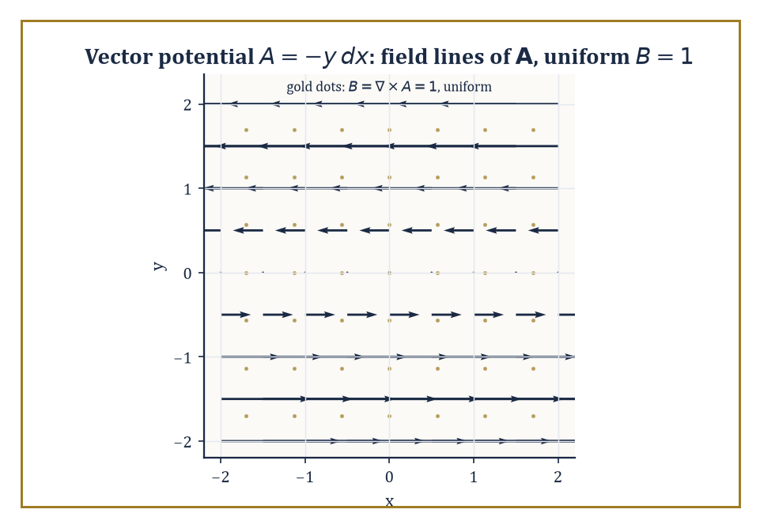
Figure 47.5 — The vector potential A = −y dx, drawn as arrows, generates a perfectly uniform magnetic field — the only thing anyone could measure.
∇·E = ρ/ε₀ (Gauss’s law)
∇·B = 0 (no magnetic monopoles)
∇×E = −∂B/∂t (Faraday’s law)
∇×B = μ₀J + μ₀ε₀∂E/∂t (the Ampère–Maxwell law, with Maxwell’s own crucial addition of the displacement current term)
In vacuum, with no charges or currents, taking the curl of Faraday’s law and substituting the Ampère–Maxwell law produces a wave equation for E (and symmetrically for B):
∂²E/∂t² = c²∇²E, where c = 1/√(ε₀μ₀)
Maxwell noticed, in 1861, that this quantity — built entirely out of two constants measured in static electricity and magnetism experiments, with no reference to light whatsoever — came out equal to the known speed of light, and correctly concluded that light itself is an electromagnetic wave.
It remains one of the most startling unifications in the history of science, and it happened by pure calculation, before a single new experiment was performed.
Numeric example — Deriving the speed of light from two unrelated constants. The vacuum permittivity is ε₀ ≈ 8.854×10⁻¹² F/m and the vacuum permeability is μ₀ ≈ 1.2566×10⁻⁶ N/A² (equal to 4π×10⁻⁷ in the older SI convention). Multiply them:
ε₀μ₀ ≈ 8.854×10⁻¹² × 1.2566×10⁻⁶ ≈ 11.127×10⁻¹⁸ = 1.1127×10⁻¹⁷ (units of s²/m²)
Take the square root:
√(1.1127×10⁻¹⁷) = √(11.127×10⁻¹⁸) = √11.127 × 10⁻⁹ ≈ 3.336×10⁻⁹ s/m
Invert:
c = 1/(3.336×10⁻⁹) ≈ 2.998×10⁸ m/s
This matches the measured speed of light, 299,792,458 m/s, to the precision of the constants used — and neither ε₀ nor μ₀ was measured by anyone looking at light.
Two wholly electrostatic and magnetostatic experiments, multiplied and square-rooted, hand you the speed of light. This is the calculation that told Maxwell, and tells every student since, that light is electromagnetism.
Try it now — A plane wave in vacuum has E = 300 V/m. Find the magnetic field B. Answer →
Rewritten in the language of differential forms (built in an earlier chapter), the whole theory collapses to two lines and becomes manifestly coordinate-free. The electric and magnetic fields combine into a single field-strength 2-form F on spacetime.
The two source-free equations (no monopoles, Faraday’s law) become:
dF = 0
meaning F is closed. The two equations with sources become:
d★F = J
relating the Hodge dual of F to the current 3-form J.
Because dF = 0 and spacetime (locally, or globally if it is topologically simple) has no interesting closed-but-not-exact 2-forms, F = dA for some 1-form A, the vector potential.
But A is not unique: replacing A by A + dχ for any function χ leaves F unchanged, since d(dχ) = 0 always (the exterior derivative squared vanishes — this is the differential-forms reason ‘curl of a gradient is zero’).
This freedom to shift A without changing any physically measurable field is gauge freedom, the prototype of every gauge symmetry in modern physics, up to and including the Standard Model.
Abstract example — Changing the potential without changing the physics. Work in the plane, with coordinates x,y, and take the 1-form A = −y dx. Compute its exterior derivative:
dA = d(−y)∧dx = −dy∧dx = dx∧dy (using dy∧dx = −dx∧dy)
So F = dA = dx∧dy, corresponding to a uniform magnetic field:
B = ∂A_y/∂x − ∂A_x/∂y = 0 − (−1) = 1
in suitable units. Now perform a gauge transformation with χ = xy:
dχ = y dx + x dy
The new potential is:
A′ = A + dχ = (−y dx) + (y dx + x dy) = x dy
a completely different-looking expression, with A′ₓ = 0 and A′_y = x instead of A_x = −y and A_y = 0. Compute the field it produces:
B′ = ∂A′_y/∂x − ∂A′ₓ/∂y = ∂(x)/∂x − 0 = 1
The same magnetic field as before, despite the potential having changed fully. Equivalently:
dA′ = d(x dy) = dx∧dy = dA
the same F, confirmed directly. This is gauge invariance in its smallest possible example: the potential is a bookkeeping device with genuine freedom in it; the field is the only thing anyone can measure.
The electromagnetic field also carries its own energy and momentum, encoded in a stress-energy tensor built from F, with energy density:
u = ½ε₀E² + B²/(2μ₀)
and energy flux given by the Poynting vector:
S = E×B/μ₀
This is the mechanism by which sunlight, having traveled 150 million kilometers through the vacuum carrying no matter whatsoever, nonetheless arrives carrying enough energy to warm a face.
Numeric example — The energy hiding in an electric field. For a plane electromagnetic wave in vacuum, B = E/c at every instant, so the magnetic contribution to the energy density can be rewritten entirely in terms of E:
B²/(2μ₀) = E²/(2μ₀c²)
and since c² = 1/(ε₀μ₀), this equals ε₀E²/2 — the same as the electric contribution.
The two halves are equal, so the total energy density simplifies to:
u = ½ε₀E² + ½ε₀E² = ε₀E²
Take E = 300 V/m, a typical peak field strength for bright midday sunlight. Then:
u = ε₀E² = 8.854×10⁻¹² × (300)² = 8.854×10⁻¹² × 90,000 = 7.969×10⁻⁷ J/m³
a very small number per cubic meter, which is exactly why it takes an enormous cross-sectional area (such as the disk of the Earth, or a large solar panel) sweeping through this energy density at the speed of light to add up to a noticeable warming effect.
Electromagnetism was also the first classical theory to insist, quietly but unavoidably, that Newtonian absolute time could not be right — because the wave equation predicts that light travels at a fixed speed c regardless of the observer’s motion, and reconciling that with Newtonian kinematics is impossible.
Sorting out the consequences is the next section’s entire job.
Keep only this · Section 47.5: Electromagnetism and Maxwell’s Equations
The idea. Maxwell’s equations unify electricity and magnetism; in the language of differential forms they become dF = 0 and d⋆F = J, and they predict waves at the speed c = 1/√(ε₀μ₀).
Core.
c = 1/√(ε₀μ₀)
F = dA, so dF = 0
gauge: A ↦ A + df leaves F unchanged
Typical mistake. Thinking the potential A is physical in itself. Only F = dA is fixed; A is defined up to a gauge.
Minimal example. A = −y dx: dA = dx ∧ dy.
Practice. Easy to challenge; full worked answers, with the usual mistake, are in Answers to the Practice Sets at the back.
Easy — Compute the electric energy density ε₀E²/2 for E = 300 V/m. Answer →
Medium — Show that A = x dy and A′ = −y dx give the same field F. Answer →
Challenge — Why does F = dA force the magnetic part of Maxwell’s equations, ∇·B = 0, automatically? Answer →

Section 47.6: Special Relativity and Minkowski Space
Time loses its absoluteness and nobody gets a refund
Special relativity begins by taking Maxwell’s inconvenient prediction — that light travels at the same speed c for every inertial observer — completely at face value, and working out what geometry makes that consistent.
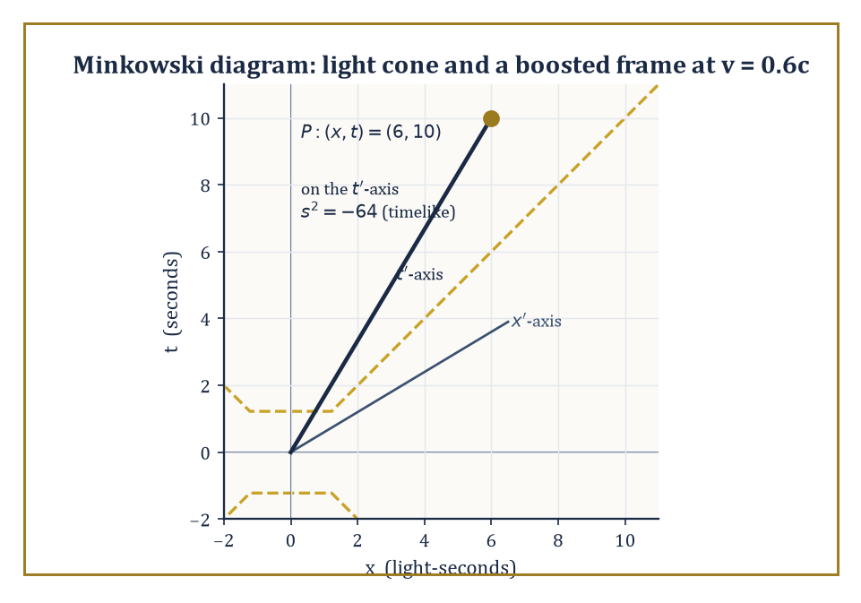
Figure 47.6 — Event P sits on the boosted observer’s own t′-axis; the light cone and the interval s²=−64 look the same to everyone, which is the whole point.
The answer is Minkowski spacetime: ℝ⁴, with coordinates (t,x,y,z), equipped not with the ordinary Euclidean distance but with the Minkowski metric:
ds² = −c²dt² + dx² + dy² + dz²
(signature (−,+,+,+); some authors use the opposite sign convention, and mathematical physicists have never quite forgiven each other for it.)
The crucial novelty is that ds² can be negative, zero, or positive, and each case means something physically distinct: a timelike interval (ds² < 0) connects events that could be cause and effect; a null interval (ds² = 0) connects events joinable only by light; a spacelike interval (ds² > 0) connects events too far apart in space, relative to the time between them, for any signal to travel between them at all.
Newtonian absolute simultaneity — the idea that ‘at the same time’ means the same thing to every observer — simply does not survive; it is replaced by this causal structure, which every observer agrees on even though they disagree about almost everything else.
Numeric example — A clock and a ruler, both misbehaving at 0.6c. Take an observer moving at v = 0.6c relative to you. The Lorentz factor is:
γ = 1/√(1 − v²/c²) = 1/√(1 − 0.36) = 1/√0.64 = 1/0.8 = 1.25
Time dilation: if the moving observer’s own clock ticks off a proper time Δτ = 1 second between two events on their worldline, you measure the time between those same two events as:
Δt = γΔτ = 1.25 × 1 = 1.25 seconds
their clock, from your point of view, runs slow.
Length contraction: if the moving observer carries a ruler measuring L₀ = 10 meters in their own rest frame, you measure its length as:
L = L₀/γ = 10/1.25 = 8 meters
Nothing physical has happened to the ruler; different observers disagree about simultaneity, and ‘the length of a moving object’ secretly means ‘the distance between its two ends measured at the same time in my frame’ — and ‘the same time in my frame’ is not the same set of events as ‘the same time in their frame’.
Try it now — Compute the Lorentz factor at v = 0.8c. Answer →
The transformations relating the coordinates used by two inertial observers in relative motion are the Lorentz transformations — the linear maps preserving the Minkowski metric, forming the Lorentz group O(3,1); adding spacetime translations gives the full Poincaré group, the complete symmetry group of special relativity.
Physical quantities that were separate three-dimensional vectors and scalars in Newtonian physics get bundled into four-vectors and tensors that transform properly under this group: energy and three-momentum combine into a single energy-momentum four-vector; the electric and magnetic fields combine, as seen in the previous section, into the single field-strength tensor F.
Maxwell’s equations, written in four-dimensional form, turn out to have been secretly Lorentz-invariant the entire time — special relativity was hiding inside electromagnetism since 1865, waiting for 1905.
Numeric example — The spacetime interval, computed by two disagreeing observers. Work in units where c = 1 (time measured in the same units as distance, e.g. light-seconds), with the same relative velocity as above, v = 0.6, γ = 1.25. Take an event with coordinates (t,x) = (10, 6) in your frame — 10 seconds and 6 light-seconds from the origin.
The Minkowski interval in your frame is:
s² = −t² + x² = −(10)² + (6)² = −100 + 36 = −64
timelike since it’s negative (check: x/t = 0.6 < 1, consistent with a sub-light-speed signal).
Now transform to the moving observer’s coordinates using x′ = γ(x − vt) and t′ = γ(t − vx):
x′ = 1.25×(6 − 0.6×10) = 1.25×(6 − 6) = 0
t′ = 1.25×(10 − 0.6×6) = 1.25×(10 − 3.6) = 1.25×6.4 = 8
Compute the interval again in the moving observer’s own coordinates:
s′² = −t′² + x′² = −(8)² + 0² = −64 + 0 = −64
the same number as before, despite t and x individually changing completely (10 became 8; 6 became 0).
This is what it means for the metric to be invariant: individual coordinates are observer-dependent opinions, but the interval ds² is a fact every observer computes identically, and it is the closest thing special relativity has to an absolute quantity.
Special relativity also forces a reconsideration of energy and momentum themselves. The energy of a particle of rest mass m moving with momentum p satisfies the relativistic energy-momentum relation:
E² = (pc)² + (mc²)²
which reduces to the familiar Newtonian approximation at low speeds (a binomial expansion left as a pleasant exercise):
E ≈ mc² + p²/(2m)
and collapses to the single most quoted equation in physics, when the particle is at rest and p = 0:
E = mc²
Numeric example — The energy locked in an electron at rest. Take an electron, rest mass m = 9.109×10⁻³¹ kg, and compute its rest energy using E = mc² with c = 2.998×10⁸ m/s. First:
c² = (2.998×10⁸)² ≈ 8.988×10¹⁶ m²/s²
Then:
E = mc² = 9.109×10⁻³¹ × 8.988×10¹⁶ ≈ 8.187×10⁻¹⁴ joules
(multiplying the leading digits, 9.109 × 8.988 ≈ 81.87, gives E ≈ 81.87×10⁻¹⁵ = 8.187×10⁻¹⁴ joules).
Converting to the units particle physicists actually use — dividing by 1.602×10⁻¹³ joules per MeV:
E ≈ 8.187×10⁻¹⁴ / 1.602×10⁻¹³ ≈ 0.5111 MeV
This is the electron’s rest energy, a number that appears constantly in particle physics (it sets, for instance, the minimum photon energy needed for electron-positron pair production, 2×0.511 = 1.022 MeV) and is recovered here from nothing but the electron’s mass and the speed of light, with no reference to any experiment beyond those two measurements.
Special relativity handles inertial observers moving at constant velocity relative to each other; it says nothing about acceleration, and nothing at all about gravity.
Extending the theory to cover both turns out to require abandoning flat Minkowski spacetime altogether and letting the geometry itself become dynamical — which is the escalation the next section makes.
Keep only this · Section 47.6: Special Relativity and Minkowski Space
The idea. Special relativity is the geometry of Minkowski space: lengths and times depend on the observer, but the interval s² = c²t² − x² does not.
Core.
γ = 1/√(1 − v²/c²)
s² = c²Δt² − Δx² − Δy² − Δz²
E = mc² (at rest)
Typical mistake. Adding velocities by ordinary addition at high speed. Relativistic composition never exceeds c.
Minimal example. v = 0.6c: γ = 1.25.
Practice. Easy to challenge; full worked answers, with the usual mistake, are in Answers to the Practice Sets at the back.
Easy — A clock moving at 0.8c ticks for 10 s of its own time. How long is that in your frame? Answer →
Medium — With c = 1, an event is at t = 5, x = 3 from the origin. Compute the interval and the proper time. Answer →
Challenge — Compose two velocities of 0.5c with (u + v)/(1 + uv/c²). Answer →

Section 47.7: General Relativity and Curved Spacetime
Gravity is what happens when geometry won’t behave
General relativity’s central claim is audacious even by the standards of this chapter: gravity is not a force at all, but a manifestation of the curvature of spacetime itself. Matter and energy tell spacetime how to curve; curved spacetime tells matter how to move.
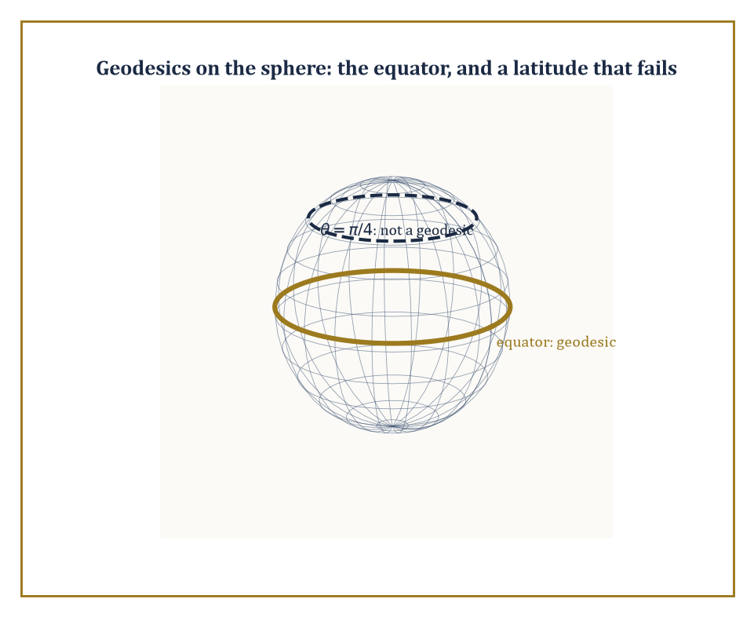
Figure 47.7 — On the sphere, the equator solves the geodesic equation and a random latitude circle does not — curvature’s opinion on what counts as ‘straight’.
Specifically, free particles (subject to no force except gravity) move along geodesics, the curved-space generalization of straight lines, satisfying:
d²xᵘ/dτ² + Γᵘ_(αβ)(dxᵅ/dτ)(dxᵝ/dτ) = 0
where the Christoffel symbols Γᵘ_(αβ) encode how the metric — and hence the notion of ‘straight’ — varies from point to point.
The precise relationship between curvature and matter is the Einstein field equation:
Gᵘᵛ = 8πG/c⁴ · Tᵘᵛ
equating the Einstein tensor Gᵘᵛ (a specific contraction of the Riemann curvature tensor, built from second derivatives of the metric) to the stress-energy tensor Tᵘᵛ, which encodes the density and flow of energy, momentum, and stress.
Spacetime is now a Lorentzian manifold — the metric g varies from point to point, and flat Minkowski space from the previous section is recovered only in the total absence of matter and energy.
Abstract example — Geodesics on a sphere, as a warm-up. Before tackling the four-dimensional Schwarzschild geometry, it helps to see curvature bend a geodesic in a space simple enough to visualize completely: the ordinary 2-sphere, with metric:
ds² = dθ² + sin²θ dφ² (θ = colatitude, φ = longitude)
Its nonzero Christoffel symbols are:
Γᶿᵩᵩ = −sinθcosθ and Γᵠ_(θφ) = Γᵠ_(φθ) = cotθ
The geodesic equations become:
θ’’ − sinθcosθ (φ′)² = 0 and φ’’ + 2cotθ θ′φ′ = 0
Try the equator, θ(t) ≡ π/2 constant, and check whether it is a valid solution. Since θ is constant, θ′ = 0 and θ’’ = 0.
The first equation becomes:
0 − sin(π/2)cos(π/2)(φ′)² = 0 − (1)(0)(φ′)² = 0
satisfied automatically for any φ′, since cos(π/2) = 0.
The second equation becomes:
φ’’ + 2cot(π/2)·0·φ′ = φ’’
and since cot(π/2) = 0 this reduces to φ’’ = 0, so φ′ is constant and φ(t) = φ(0) + ωt for some constant ω.
Both geodesic equations are satisfied: the equator, traversed at constant angular speed, is a genuine geodesic — a great circle, exactly the ‘straight line’ intuition demands on a sphere. The same machinery, applied to the considerably more complicated Schwarzschild metric instead of the round sphere, is what produces the actual orbits of planets and photons around a gravitating mass.
Try it now — Find the Schwarzschild radius of the Earth, M = 5.972 × 10²⁴ kg. Answer →
Schwarzschild found, within weeks of Einstein publishing the field equations in 1915, the exact solution describing the spacetime geometry outside a static, spherically symmetric mass.
It predicts three things Newtonian gravity gets subtly wrong: an extra precession of planetary orbits (famously resolving a long-standing discrepancy in Mercury’s orbit), the bending of starlight passing near the sun (confirmed in the 1919 eclipse expedition that made Einstein famous overnight), and — pushed to its extreme, where the metric develops a genuine singularity in its causal structure rather than just a coordinate artifact — black holes.
Cosmological solutions of the same field equations, the Friedmann–Lemaître family, describe a spacetime that is homogeneous and isotropic but whose overall scale expands or contracts with time, and form the mathematical backbone of the expanding-universe picture.
Numeric example — How compact does the Sun have to get?. The Schwarzschild radius of a mass M is:
rₛ = 2GM/c²
the radius within which the escape velocity from the mass would, in a Newtonian-flavored but essentially correct heuristic, exceed the speed of light.
Take the Sun: M = 1.989×10³⁰ kg, G = 6.674×10⁻¹¹ m³ kg⁻¹ s⁻², c = 2.998×10⁸ m/s. Compute 2GM:
2GM = 2 × 6.674×10⁻¹¹ × 1.989×10³⁰ ≈ 2 × 13.275×10¹⁹ = 26.55×10¹⁹ = 2.655×10²⁰
Compute c²:
c² = (2.998×10⁸)² ≈ 8.988×10¹⁶
Divide:
rₛ = 2.655×10²⁰ / 8.988×10¹⁶ ≈ 0.2954×10⁴ = 2954 m ≈ 2.95 km
The Sun, whose actual radius is about 696,000 km, would need to be compressed into a sphere less than 3 kilometers across before it stopped being merely a very hot ball of plasma and became a black hole.
It cannot do this on its own — stellar collapse to a black hole requires a mass considerably larger than the Sun’s, since smaller stars are rescued from this fate by electron or neutron degeneracy pressure — but the number itself is a clean, checkable consequence of a formula with no free parameters, worth confirming by hand exactly once in a mathematical physicist’s life.
The perihelion precession mentioned above is not just a qualitative prediction; general relativity supplies an explicit formula for it:
Δφ = 6πGM/(c²a(1−e²)) radians per orbit
where a is the orbit’s semi-major axis and e its eccentricity — a formula with no adjustable parameters, depending only on the central mass and the shape of the orbit.
Numeric example — Mercury’s orbit, precessing as much as it should. Mercury has semi-major axis a = 5.79×10¹⁰ m and eccentricity e = 0.2056, orbiting the Sun (M = 1.989×10³⁰ kg). Using G = 6.674×10⁻¹¹ and c = 2.998×10⁸ m/s:
GM = 6.674×10⁻¹¹ × 1.989×10³⁰ ≈ 1.3275×10²⁰ m³/s²
so:
6πGM = 18.850 × 1.3275×10²⁰ ≈ 2.502×10²¹
Next:
e² = 0.2056² ≈ 0.04227, so 1 − e² ≈ 0.95773
and:
a(1−e²) ≈ 5.79×10¹⁰ × 0.95773 ≈ 5.544×10¹⁰ m
Then:
c²·a(1−e²) ≈ 8.988×10¹⁶ × 5.544×10¹⁰ ≈ 4.983×10²⁷
Dividing:
Δφ ≈ 2.502×10²¹ / 4.983×10²⁷ ≈ 5.021×10⁻⁷ radians per orbit
Converting to arcseconds (1 radian = 206,265 arcsec):
Δφ ≈ 5.021×10⁻⁷ × 206,265 ≈ 0.1036 arcsec per orbit
Mercury completes an orbit every 87.969 days ≈ 0.2408 years, so in a century it completes about 100/0.2408 ≈ 415.2 orbits, giving a total precession of about:
0.1036 × 415.2 ≈ 43.0 arcseconds per century
the exact figure, long unexplained by Newtonian gravity alone, that convinced astronomers in 1915 that Einstein’s theory, and not some undiscovered planet named Vulcan, was the correct explanation for Mercury’s stubbornly anomalous orbit.
General relativity is where mathematical physics and differential geometry become, for long stretches, the same subject wearing different hats.
What it does not touch — deliberately, and for very good reason — is the atomic and subatomic scale, where classical fields and classical geodesics give way entirely to a different kind of mathematics. That is where this chapter now, at last, must go.
Keep only this · Section 47.7: General Relativity and Curved Spacetime
The idea. General relativity makes gravity the curvature of spacetime: free bodies follow geodesics, and Einstein’s equations tie curvature to energy and momentum.
Core.
r_s = 2GM/c²
free fall = geodesic
spherical triangle: angle sum − π = area/R²
Typical mistake. Picturing curvature as bending in an extra dimension. It is measured from inside, by angles and geodesics.
Minimal example. Sun: r_s ≈ 2.95 km.
Practice. Easy to challenge; full worked answers, with the usual mistake, are in Answers to the Practice Sets at the back.
Easy — A black hole has ten solar masses. What is its Schwarzschild radius? Answer →
Medium — Two points on the equator differ in longitude by 90°. How long is the geodesic between them on a sphere of radius 6,371 km? Answer →
Challenge — A geodesic triangle on a sphere has three right angles. Find its area from the angle excess. Answer →

Section 47.8: Quantum Mechanics: Operators, Spectra, and States
The universe, now with uncertainty built in
Why this abstraction exists
Hilbert spaces, self-adjoint operators and the spectral theorem were built in Functional Analysis (Volume 3) as pure structure. Quantum mechanics needs exactly that structure: an infinite-dimensional space of states, real spectra for measurements, and the spectral theorem to decompose them.
Quantum mechanics performs, on the classical framework built over the last seven sections, one of the strangest substitutions in the history of physics: phase space is replaced by a Hilbert space H of states (a complex vector space with an inner product, complete in the norm it induces — the object built in an earlier chapter on functional analysis), and observables — position, momentum, energy, spin — are replaced by self-adjoint operators on H.
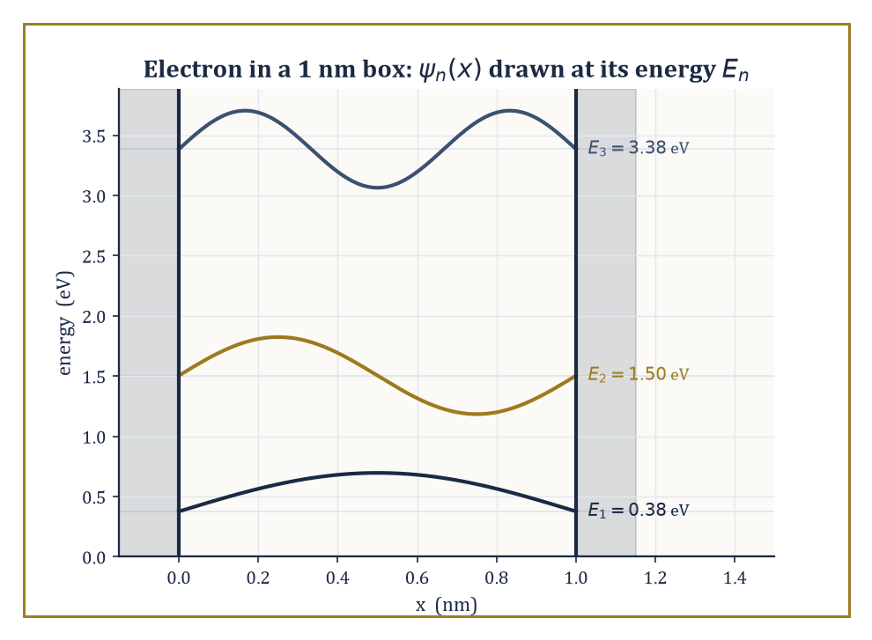
Figure 47.8 — An electron in a 1 nm box, confined to three discrete energies instead of a continuum — quantization made visible, not just asserted.
A measurement of an observable A can only yield a value in A’s spectrum, and the Born rule gives the probability of each outcome in terms of the state vector’s overlap with A’s eigenspaces.
Time evolution is governed by the Schrödinger equation:
iħ ∂ψ/∂t = Ĥψ
where Ĥ is the Hamiltonian operator — the direct quantum descendant of the classical Hamiltonian function from Lagrangian and Hamiltonian Mechanics, now acting on states rather than being evaluated on points of phase space.
Numeric example — An electron confined to a one-nanometer box. The simplest quantum system is a particle confined to an infinite square well (a ‘particle in a box’) of width L, where the Schrödinger equation forces the wavefunction to vanish at both walls. Solving it gives discrete, quantized energy levels:
Eₙ = n²π²ħ²/(2mL²), n = 1, 2, 3, ...
already a striking departure from classical mechanics, where a confined particle can have any energy at all.
Take an electron (m = 9.109×10⁻³¹ kg) confined to a box of width L = 1 nanometer = 1×10⁻⁹ m, roughly the scale of a small molecule. With ħ = 1.0546×10⁻³⁴ J·s, compute the ground-state energy E₁ = π²ħ²/(2mL²). The numerator is:
ħ² = (1.0546×10⁻³⁴)² ≈ 1.1122×10⁻⁶⁸; multiplying by π² ≈ 9.8696 gives π²ħ² ≈ 1.0977×10⁻⁶⁷
The denominator is:
2mL² = 2 × 9.109×10⁻³¹ × (1×10⁻⁹)² = 2 × 9.109×10⁻³¹ × 1×10⁻¹⁸ ≈ 1.8218×10⁻⁴⁸
Divide:
E₁ ≈ 1.0977×10⁻⁶⁷ / 1.8218×10⁻⁴⁸ ≈ 6.026×10⁻²⁰ joules
Converting to electron-volts (divide by 1.602×10⁻¹⁹ J/eV) gives:
E₁ ≈ 0.376 eV
comparable to typical chemical bond energies, which is just why quantum confinement effects of this kind matter for real molecules and nanostructures.
The second level scales as n² and comes out at E₂ = 4E₁ ≈ 1.50 eV, the third at E₃ = 9E₁ ≈ 3.39 eV: the spacing between levels grows, rather than staying constant as it would for a classical oscillator, itself a diagnostic fingerprint distinguishing a ‘box’ potential from a harmonic one in real spectroscopy.
Try it now — For a particle in a box, Eₙ = n²h²/(8mL²). What is E₂/E₁? Answer →
Most operators of physical interest — position and momentum chief among them — are unbounded, which introduces genuine technical difficulty: they cannot be defined on the whole Hilbert space, only on a dense domain, and ‘self-adjoint’ becomes a considerably more delicate condition than ‘symmetric’.
The reward for getting this right is Stone’s theorem: every strongly continuous one-parameter group of unitary operators U(t) (such as the time evolution generated by the Schrödinger equation) arises as:
U(t) = exp(−iĤt/ħ)
for a unique self-adjoint Ĥ, and conversely.
Uncertainty principles — the fact that position and momentum cannot both be measured with unlimited precision on the same state — follow directly from the non-commutativity of the corresponding operators, via a short Cauchy–Schwarz argument that turns ‘these two operators don’t commute’ into ‘the product of their measurement uncertainties has a hard lower bound.’
Abstract example — Deriving the fundamental commutator. Represent position as multiplication by x and momentum as the differential operator p̂ = −iħ d/dx, acting on differentiable wavefunctions ψ(x). Compute the commutator [x̂,p̂]ψ = x̂p̂ψ − p̂x̂ψ directly, for a general ψ.
First term:
x̂p̂ψ = x·(−iħψ′) = −iħxψ′
Second term, by the product rule:
p̂x̂ψ = −iħ d/dx(xψ) = −iħ(ψ + xψ′)
Subtract:
[x̂,p̂]ψ = −iħxψ′ − [−iħ(ψ + xψ′)] = −iħxψ′ + iħψ + iħxψ′ = iħψ
The xψ′ terms cancel exactly, leaving [x̂,p̂] = iħ as an operator identity, holding for every ψ in the domain.
This is the classical Poisson bracket {x,p} = 1, computed in Lagrangian and Hamiltonian Mechanics, multiplied by iħ — canonical quantization, promised two sections ago, delivered explicitly.
Every classical Poisson bracket of observables becomes, on passing to quantum mechanics, (1/iħ) times the corresponding operator commutator, and the entire uncertainty-principle machinery of quantum theory is downstream of this one non-vanishing bracket refusing to be zero.
The general form of the uncertainty relation, for any two observables A and B, is:
ΔA·ΔB ≥ ½|⟨[Â,B̂]⟩|
the spread in one measurement times the spread in the other is bounded below by half the expectation value of their commutator.
Substituting the result just derived, [x̂,p̂] = iħ, gives the specific and famous case, Heisenberg’s uncertainty principle:
Δx·Δp ≥ ħ/2
This is not a statement about the clumsiness of measuring instruments, but a hard mathematical consequence of position and momentum being represented by non-commuting operators on the same Hilbert space.
Abstract example — A state that saturates the bound precisely. The inequality Δx·Δp ≥ ħ/2 is achieved with equality only for Gaussian wavepackets. Take:
ψ(x) = (2πσ²)^(−1/4) exp(−x²/(4σ²))
for some width parameter σ > 0, normalized so that ∫|ψ|²dx = 1 and centered so ⟨x⟩ = 0.
Since |ψ(x)|² is a normal distribution with variance σ², the position spread is Δx = σ, directly by inspection.
The Fourier transform of a Gaussian is again a Gaussian, and the standard calculation for the free Schrödinger equation shows the momentum-space wavefunction has variance in wavenumber k equal to 1/(4σ²), so the momentum spread is:
Δp = ħ·Δk = ħ/(2σ)
Multiplying the two:
Δx·Δp = σ · ħ/(2σ) = ħ/2
the lower bound, with no slack whatsoever.
Any other shape of wavepacket (a top-hat, an exponential, or the particle-in-a-box ground state from the earlier example in this section) gives a strictly larger product; the Gaussian is the uncertainty principle’s unique ‘best case’, which is part of why Gaussian wavepackets are the standard starting point for building coherent states and semiclassical approximations throughout quantum theory.
That is the mathematical skeleton of nonrelativistic quantum mechanics: a Hilbert space, a spectral theorem doing quiet, essential work, and a commutator inherited from classical phase space.
What it does not yet do is fit together with special relativity, or say anything about particles being created and destroyed — problems that belong to quantum field theory, and to the final section of this chapter, which looks ahead rather than solving anything new.
Keep only this · Section 47.8: Quantum Mechanics: Operators, Spectra, and States
The idea. Quantum mechanics represents states as vectors in a Hilbert space and observables as self-adjoint operators; spectra are the possible measurement outcomes, and non-commuting operators cannot be sharp together.
Core.
[x̂, p̂] = iħ
Δx·Δp ≥ ħ/2
Eₙ = n²h²/(8mL²)
Typical mistake. Reading uncertainty as measurement clumsiness. It is a property of the state, forced by the commutator.
Minimal example. Box: E₃/E₁ = 9.
Practice. Easy to challenge; full worked answers, with the usual mistake, are in Answers to the Practice Sets at the back.
Easy — In the box, what energy does a photon carry when the particle drops from n = 2 to n = 1, in units of E₁? Answer →
Medium — Compute [x̂², p̂] using [x̂, p̂] = iħ. Answer →
Challenge — An electron is localized to Δx = 1.0 × 10⁻¹⁰ m. What is the least possible Δp, and which state achieves it? Answer →

Section 47.9: Looking Ahead: From Classical Mathematical Physics to Quantum Field Theory and Beyond
Or: everything above was the easy part
We have, over eight sections, assembled the mathematical core of classical and early-quantum physics: the variational principles of Lagrangian and Hamiltonian mechanics; the symplectic geometry that makes phase space more than just a set of coordinates; the continuum theories of matter and the field-theoretic pattern — Lagrangian density, Euler–Lagrange equations, Noether currents — recurring everywhere from elasticity to electromagnetism; the geometry of electromagnetism itself and its forced marriage with relativity; the curved-spacetime formulation of gravity; and the operator-theoretic reformulation of mechanics that is quantum theory.
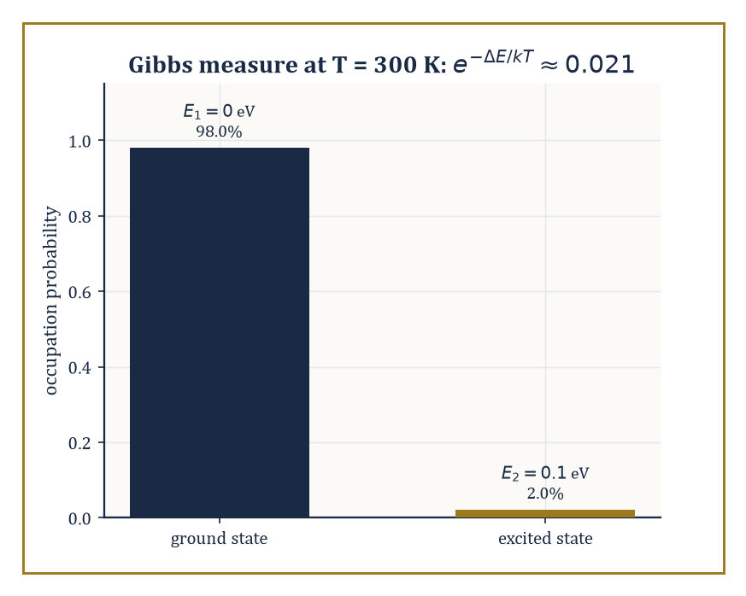
Figure 47.9 — At room temperature, a 0.1 eV energy gap is almost never bridged: the Gibbs measure leaves the excited state occupied about 2% of the time.
It is, by any reasonable standard, an enormous amount of physics — and it is also, by the standards of what remains, only the classical half of the subject.
The immediately next step, quantum field theory, is the synthesis this chapter’s structure has been pointing toward the entire time, unannounced: take the field-theoretic pattern from Continuum Mechanics and Classical Field Theories, apply the canonical quantization procedure from Quantum Mechanics (Poisson brackets become commutators) not to a handful of particle coordinates but to a field defined at every point of space, and the result is a theory in which particles themselves become quantized excitations of an underlying field, capable of being created and destroyed.
Beyond QFT lie statistical mechanics and the still largely unrigorous mathematics of phase transitions, the infinite-dimensional dynamical systems governing fluid turbulence and kinetic theory (a direct descendant of the previous chapter’s dynamical systems, now with a Hilbert space of degrees of freedom instead of a handful), and the geometric and topological methods — bundles, characteristic classes, moduli spaces — appearing throughout modern gauge theory and string theory.
Abstract example — From two oscillators to a field, in one paragraph of algebra. Recall the two decoupled oscillators of Symplectic Geometry and Integrable Systems, with Hamiltonian H = H₁ + H₂, each Hᵢ = ½(pᵢ² + ωᵢ²qᵢ²).
Quantum field theory is, at a first and illuminating approximation, this idea run to its logical extreme: a free field can be decomposed, by Fourier analysis, into infinitely many independent normal modes, indexed by wavenumber k instead of by i = 1,2, each behaving as its own independent harmonic oscillator with frequency ωₖ determined by the field’s equation of motion.
Canonically quantizing each mode separately — promoting each classical (qₖ,pₖ) pair to operators with:
[q̂ₖ,p̂ₖ] = iħ
exactly as in Section 47.8’s worked example — turns each mode into a quantum harmonic oscillator, whose energy levels are equally spaced multiples of ħωₖ above a ground state.
Those equally spaced energy quanta are, by definition, what a physicist calls ‘particles’: the n-th excited level of the mode with wavenumber k is interpreted as n particles, each of momentum ħk, present in the field. A field theory’s vacuum state is the state with every mode in its ground level; a single particle is one mode nudged up by exactly one quantum.
Nothing about this required inventing new mathematics — it is the harmonic oscillator of Lagrangian and Hamiltonian Mechanics and the Poisson-bracket-to-commutator dictionary of Quantum Mechanics, applied to infinitely many degrees of freedom at once, with all the analytic difficulty of ‘infinitely many’ swept, not entirely honestly, under a rug that a few of mathematics’s hardest open problems are still trying to lift.
Try it now — Two levels differ by ΔE = 0.05 eV at T = 300 K (kT ≈ 0.02585 eV). Find the Gibbs ratio of populations. Answer →
Statistical mechanics deserves a specific mention here, since it is the point where mathematical physics rejoins the probability theory built many chapters before this one.
A macroscopic system’s equilibrium behavior is recovered by averaging a Hamiltonian flow, of the kind built in Lagrangian and Hamiltonian Mechanics and Symplectic Geometry and Integrable Systems, over an enormous number of degrees of freedom, using the ergodic hypothesis to trade time-averages for phase-space averages weighted by the Gibbs measure exp(−H/kT).
Phase transitions — water freezing, a magnet losing its magnetism as it is heated past a critical temperature — correspond to genuine mathematical singularities in the resulting partition function, and understanding which singularities are possible, and why, remains an active area straddling probability, analysis, and mathematical physics all at once.
Numeric example — The Gibbs measure, weighing two states. Take a system with just two available energy levels, E₁ = 0 and E₂ = 0.1 eV, in equilibrium at room temperature T ≈ 300 K, where Boltzmann’s constant is k ≈ 8.617×10⁻⁵ eV/K.
The Gibbs measure exp(−H/kT) says the relative probability of the two states is exp(−E₁/kT) : exp(−E₂/kT), so their ratio is exp(−(E₂−E₁)/kT). Compute kT first:
kT = 8.617×10⁻⁵ × 300 ≈ 0.02585 eV
Then:
(E₂−E₁)/kT = 0.1/0.02585 ≈ 3.868
so the ratio of populations is:
exp(−3.868) ≈ 0.0209
the excited state is occupied only about 2.1% as often as the ground state at room temperature.
This is the entire content of the Gibbs measure in miniature: it is not a mysterious weighting, it is one exponential, applied to whatever Hamiltonian the earlier sections of this chapter handed you, and it is why almost nothing is thermally excited at room temperature unless its energy gap is measured in a fraction of an electron-volt or less.
Which brings us honestly to the state of the art: several of the deepest unsolved problems in mathematics are, at bottom, problems of mathematical physics.
Whether solutions to the three-dimensional Navier–Stokes equations remain smooth for all time, or instead blow up in finite time, is unknown, and is one of the seven Clay Millennium Prize Problems.
Whether Yang–Mills theory — the gauge-field generalization of electromagnetism underlying the strong and weak nuclear forces — can be given a fully rigorous quantum construction with a ‘mass gap’ (a strictly positive lowest excitation energy, matching experimental reality) is another, and remains entirely open despite decades of extraordinarily successful physics built on the assumption that the answer is yes.
The rigorous, non-perturbative construction of interacting quantum field theories in four spacetime dimensions is, essentially, still missing.
None of this stops physicists from using these theories to predict experiments correctly to remarkable precision; it simply means the mathematics has not yet caught up with its own success, which is either an embarrassment or the single most exciting sentence in the whole series, depending on your temperament and how close you are to a grant deadline.
The deeper lesson of this entire chapter is a two-way one. The physical world, described with sufficient mathematical care, turns out to be a source of mathematical structures of startling depth — symplectic manifolds, spectral theory, gauge bundles, none of which were ‘invented’ so much as noticed, lying in wait inside careful descriptions of planets and electrons.
And those structures, once understood on their own mathematical terms, become in turn the language in which the world is redescribed, more precisely and more predictively than before. Neither direction is primary.
The blur promised at this chapter’s opening was not a rhetorical flourish; it is the actual mechanism by which physics and mathematics keep making each other better.
Mathematical physics is the mathematics of the laws of nature — a grander sentence than most sections in this series get to end on, and one earned honestly across nine sections of Lagrangians, curvature tensors, and one stubbornly non-vanishing commutator.
Having spent this chapter writing down laws, the series’ next chapter turns to a different question wholly: given the laws — or given any well-posed mathematical description of a system’s possibilities and their costs — how do you find the best one? Optimization, in its advanced form, is the mathematics of extracting the single most useful answer from an enormous space of candidates, and it will call, more than once, on the variational instincts this chapter spent nine sections building: after all, the Euler–Lagrange equation was itself found by extremizing something. The series continues.
Keep only this · Section 47.9: Looking Ahead: From Classical Mathematical Physics to Quantum Field Theory and Beyond
The idea. Beyond the classical core lie statistical mechanics, quantum field theory and the mathematics they demand — Gibbs measures, path integrals, gauge theory — some of it still without rigorous foundations.
Core.
Gibbs: P(E) ∝ exp(−E/kT)
Z = Σ exp(−βEᵢ), ⟨E⟩ = −∂ ln Z/∂β
Typical mistake. Thinking every successful physical theory is mathematically settled. Several are not.
Minimal example. ΔE = 0.1 eV, 300 K: ratio ≈ 0.021.
Practice. Easy to challenge; full worked answers, with the usual mistake, are in Answers to the Practice Sets at the back.
Easy — What happens to the Gibbs ratio as T → ∞? Answer →
Medium — With ratio 0.1445, find the probability of the ground state. Answer →
Challenge — Compute the mean energy ⟨E⟩ for the two-level system of the Try it now, with the ground level at 0. Answer →
Chapter 47 recap · Mathematical Physics
• Mathematical physics is a two-way trade: physics poses problems that need new mathematics, and mathematics built for its own reasons turns out to describe the world.
• Lagrangian mechanics turns the laws of motion into Euler–Lagrange equations; Hamiltonian mechanics writes them as a flow on phase space with Poisson brackets.
• Hamiltonian flows preserve the symplectic form and phase-space volume; integrable systems move on tori, and KAM theory says which tori survive perturbation.
• Continuum mechanics and field theories are PDEs; shocks need weak solutions, and Noether’s theorem links symmetries to conservation laws.
• Maxwell’s equations, written with differential forms, predict light; special relativity is the geometry of Minkowski space, and general relativity makes spacetime curved.
• Quantum mechanics replaces numbers by operators on a Hilbert space: observables are self-adjoint, spectra are measurement outcomes, and commutators give uncertainty.

Check Your Understanding — Chapter 47
Answers are in the Answer Key at the back of the book — have a go before you look.
1. [Model] A mass m = 2 kg sits on a spring of stiffness k = 8 N/m. Using the Lagrangian L = ẋ² − 4x², where the usual factor of 1/2 on the kinetic energy and on the potential energy is omitted because it scales both terms alike and leaves the Euler–Lagrange equation unchanged, derive the equation of motion via the Euler–Lagrange equation, and give the solution for x(0) = 0.5 m, ẋ(0) = 0.
See the answer →
2. [Explain] Why do KAM tori with near-rational frequency ratios get destroyed by a small perturbation while tori with badly-approximable irrational ratios (like the golden ratio) survive?
See the answer →
3. [Concept] Two vector potentials, A = −y dx and A′ = x dy, look completely different. Show they describe the same physics, and name the principle this illustrates.
See the answer →
4. [Explain] An electron is confined to a 1-nanometer box. Use the constants from this chapter’s numeric example: m = 9.109×10⁻³¹ kg, L = 1×10⁻⁹ m, and ħ = 1.0546×10⁻³⁴ J·s. Why can’t its energy be zero or arbitrary, as it could classically, and roughly what is its ground-state energy?
See the answer →
5. [Model] A simple pendulum has length 1.00 m. Using T = 2π√(L/g) with g = 9.81 m/s², find its period, and say what the answer would be on the Moon where g = 1.62 m/s².
See the answer →
6. [Explain] Noether’s theorem links continuous symmetries to conserved quantities. Why is that considered the deepest structural result in classical mechanics?
See the answer →
7. [Compute] Estimate Earth’s escape velocity from v = √(2gR), with g = 9.81 m/s² and R = 6.371 × 10⁶ m.
See the answer →
8. [Prove] Show that for a time-independent Hamiltonian H(q,p), the value of H is conserved along any trajectory.
See the answer →
9. [Explain] Special relativity takes the constancy of the speed of light in every inertial frame as a postulate. Why can it not simply be derived from Maxwell’s equations instead?
See the answer →
10. [Challenge] Quantum mechanics and general relativity are each extraordinarily well confirmed, yet a century of effort has not combined them. What makes the obstacle mathematical rather than merely technical?
See the answer →

Problems — Chapter 47
The questions above test whether the ideas landed. These ask you to use them. Solutions are in Solutions to the Problems at the back. Work them before you look.
1. [Model] A pendulum of length L in gravity g, small angle, so sin θ is replaced by θ. Write the period. Then set L = g and simplify.
2. [Concept] That replacement produces a different equation from the pendulum’s. What question does the approximation owe you, once it has been made?
3. [Compute] An infinite square well has energies Eₙ = n² E₁. What is E₂ / E₁, and what is E₃ / E₁?
4. [Concept] Two vector potentials that differ by the gradient of a function describe the same magnetic field. What is unchanged, and what is not worth treating as physical?

Math, Actually

Chapter 48

Optimization (Advanced)
Nonconvex Landscapes, Stochastic Methods, and the Art of Hard Optimization
The forty-eighth chapter opens with the particular judder that tells you the ground has shifted again, and not gently. Below, Chapter 47 has just finished persuading matter to obey the calculus of variations — geodesics, least action, a universe that files its paperwork in beautifully smooth Euler–Lagrange equations. Up here the geodesics have been repossessed. The single tidy valley you were confidently descending in Chapter 30 (Volume 3) — convex, smooth, one exit, no surprises — has been replaced overnight with something resembling the Alps after a difficult renovation: hundreds of valleys, several of them decoys, and an alarming number of saddle-shaped picnic spots where an unwary gradient can sit down, feel perfectly stable, and never leave.
This is advanced optimization, and its opening confession is an uncomfortable one for anybody who spent two chapters falling in love with convexity: most of the optimization problems the world hands you are not convex. Training a neural network is not convex. Recovering a signal from a handful of noisy measurements is not convex. Fitting a low-rank matrix to a pile of corrupted entries is not convex.
For decades this was treated as a death sentence — nonconvex meant, essentially, give up, or at best, relax the problem into a convex one and hope the relaxation isn’t lying to you. The modern discovery, still warm from the printer, is that a great many of these landscapes are secretly well-behaved: every local minimum turns out to be global, or every troublesome flat spot turns out to have an escape hatch if you know where to push. Finding that hidden good behavior, and building algorithms that exploit it, is the entire sport of this chapter.
None of this abandons the earlier machinery — quite the opposite. Gradient descent, Newton’s method, and the convergence proofs of Chapter 30 (Volume 3) remain the load-bearing walls; we are asking what happens to them when the ground is no longer flat, when the gradient you compute is a noisy estimate rather than the truth, and when the number of unknowns is so large that the sample size looks embarrassingly small by comparison. We will meet strict saddles and the perturbations that dodge them, stochastic gradient descent and the variance that both plagues and, cleverly tamed, powers it, the adaptive methods that run inside every deep-learning training loop whether or not anybody fully understands why, the minimax games that pit one gradient against another, and the complexity lower bounds that tell us, with some finality, when we have already found the best algorithm there is going to be.
A small confession before we begin: advanced optimization is the subject in which the optimistic theorems of convex optimization meet the pessimistic reality of nonconvexity — and quite often discover the pessimism was overstated. If convex optimization taught us what is tractable, this chapter teaches us what remains possible once tractability is no longer handed to us on a plate. Let’s climb the nonconvex landscape.
What you already know, and the assumption now removed
Chapter 30 (Volume 3), Optimization: Theory and Algorithms, built the convex theory. You already know:
• For a convex function every local minimum is global, and the KKT conditions are sufficient as well as necessary.
• Strong duality usually holds, so the dual problem certifies optimality.
• Gradient descent converges at known rates; Newton’s method converges quadratically near the minimum.
This chapter removes one assumption: convexity. The consequences, in order: spurious minima and saddles (The Landscape of Nonconvex Optimization, Critical Points, Saddles, and Landscape Geometry); noisy gradients from data (Stochastic Gradient Methods, Variance Reduction and Adaptive Methods); structure that rescues tractability (High-Dimensional and Structured Nonconvex Problems); games instead of minima (Minimax Optimization and GANs); what no method can beat (Complexity Lower Bounds and Optimal Rates); and learning, where the optimizer helps choose the model (Optimization for Statistical Learning).
Before you begin — Chapter 48
By the end of this chapter you will be able to:
1. Find and classify the critical points of nonconvex functions, including strict saddles.
2. Run stochastic gradient steps by hand and explain how batch size and step size control the noise.
3. Compute AdaGrad and Adam steps and explain why variance reduction works.
4. Describe the landscape of low-rank recovery and why symmetry creates saddles.
5. Analyze simultaneous gradient play and extragradient on a bilinear game.
6. Compare iteration complexities and connect implicit regularization to model selection.
Prerequisites. Convexity, gradient descent, Newton’s method and duality from Chapter 30 (Volume 3); the Hessian and its eigenvalues from Multi-Variable Calculus and Linear Algebra (Volume 2); expectation and variance from Expectation, Variance, and Conditioning.
Estimated study time. About 10 hours, exercises included.

Section 48.1: The Landscape of Nonconvex Optimization
In which the single valley becomes a mountain range, and some of the peaks are lying to you
You are somewhere on a hillside in fog and want the lowest point. There is a test available to you, and you have used it all your life: feel which way the ground falls, and walk that way. When every direction from where you stand goes up, stop. You are at the bottom.
On a landscape with one valley that test is not merely reasonable, it is correct, and Chapter 30 (Volume 3) is built on its being correct. Put a second valley in the landscape and nothing about the test changes — it still tells you that every direction goes up, it is still telling the truth, and you may now be standing in entirely the wrong place.
The question sharpens by one word. Not whether you are at a bottom, but whether you are at the bottom.
Sit with why that is hard, because the difficulty is not one that better equipment removes. Everything you can measure where you stand — the slope, the way the slope is turning, every derivative you care to compute — takes exactly the same values at the bottom of a shallow dip as at the bottom of the deepest trench on the map. The readings are not merely similar. They agree. What would separate the two is information about somewhere you are not, and no amount of care where you are standing will produce it.
There is no trick that repairs this, and it would be dishonest to promise one. What can be done is to go and look at every candidate, which is affordable when the candidates are few.
Take f(x) = x⁴ − x³ − 4x² + 4. Its slope vanishes at three places, and the local test at each reports as follows:
x = −1.0881 a bottom height 1.95
x = 0 a top height 4
x = 1.8381 a bottom height −4.31
Both bottoms pass an identical local examination: zero slope, ground curving upward in every direction. Standing at either one in fog, the instruments agree to the last decimal. The heights do not — one is more than six units above the other — and the only way that difference came to light was by computing both and comparing, which is to say by leaving.
A function that permits this is nonconvex, a bottom that is only locally lowest is a local minimum, and the distinction between those and the genuine article is what the rest of this chapter is organized around.
A function f is nonconvex when its graph refuses the one guarantee convexity gave us for free: that every local minimum is automatically global.
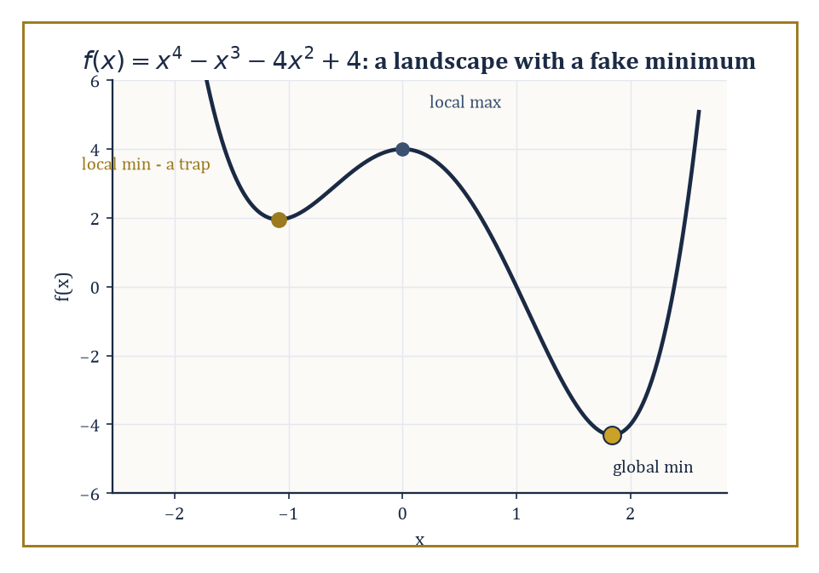
Figure 48.1 — The quartic f(x) = x⁴ − x³ − 4x² + 4, with its local-max decoy at x = 0 and its two local minima — only one of which is telling the truth.
Recall the vocabulary: a point x* is a local minimum if the following holds for all x in some neighborhood of x*,
f(x*) ≤ f(x)
and x* is a global minimum if that same inequality holds for every x in the whole domain, neighborhood or not.
Convex functions collapse this distinction: every local minimum is global, so a hillwalker who only ever walks downhill is guaranteed to end up at the best possible place.
Nonconvex functions un-collapse it, and with a vengeance: they can have arbitrarily many local minima, most of them mediocre, plus critical points that are neither minima nor maxima at all — saddle points, where the surface curves up in some directions and down in others, like the seat of a horse.
The task of nonconvex optimization is not merely to find a point where the gradient vanishes (that’s easy: sit still) but to find one that is good, in a landscape that offers no a priori assurance that ‘locally best’ means ‘best’.
Numeric example — a landscape with a fake minimum. Take f(x) = x⁴ − x³ − 4x² + 4, a quartic — so certainly nonconvex, since its second derivative changes sign. Its critical points satisfy
f′(x) = 4x³ − 3x² − 8x = 0
Factor out x:
x(4x² − 3x − 8) = 0
One root is x = 0. The other two solve the quadratic factor, and the quadratic formula gives
4x² − 3x − 8 = 0 ⟹ x = (3 ± √(9 + 128))/8 = (3 ± √137)/8
Since √137 ≈ 11.7047, the roots are x ≈ 1.8381 and x ≈ −1.0881. Classify them with the second derivative,
f″(x) = 12x² − 6x − 8
At x = 0:
f″(0) = −8 < 0
a local maximum, with f(0) = 4. At x ≈ −1.0881:
f″(−1.0881) ≈ 14.21 + 6.53 − 8 = 12.74 > 0
a local minimum; computing the value,
f(−1.0881) ≈ 1.954
At x ≈ 1.8381:
f″(1.8381) ≈ 40.54 − 11.03 − 8 = 21.51 > 0
also a local minimum; here
f(1.8381) ≈ −4.310
So the landscape has two local minima, at heights 1.954 and −4.310 — and only the second one is global. A hillwalker who starts near x = −1.088 and only ever walks downhill will confidently arrive at a point that is, in absolute terms, more than six units worse than the true bottom of the valley next door. This is the entire crisis of nonconvex optimization in miniature: local information certifies nothing about global quality.
Try it now — Find and classify the critical points of f(x) = x⁴ − 2x². Answer →
The crisis, however, is not universal. Certain nonconvex problems that show up constantly in statistics and machine learning — phase retrieval (recovering a signal from the magnitudes of its measurements, with the phase information thrown away), low-rank matrix recovery, and the training landscapes of many neural networks — turn out to possess what practitioners have taken to calling benign nonconvexity.
The technical content of ‘benign’ varies by problem, but two flavors recur constantly: either every local minimum is secretly global (so the crisis above cannot occur), or every non-minimal critical point is a strict saddle, meaning it has at least one direction of strictly negative curvature that a sufficiently curious algorithm can use to escape.
Both properties are studied under the heading of landscape analysis — quite literally cartography for functions, mapping which regions are safe, which critical points are traps, and whether the good points (the global minima) form a connected set that a continuous path of descent could realistically reach, or scattered islands separated by ridges no local method could cross.
Abstract example — topology taxes the landscape. Landscape geometry is not free to be arranged however we like; the shape of the domain constrains how many critical points a function must have. This is Morse theory’s contribution, and a compact instance makes it vivid.
Stand a torus (a doughnut) upright on a table and consider the height function h giving each point on its surface its vertical coordinate. Walking up from the bottom: there is one minimum (the lowest point, where the doughnut touches the table), then a saddle where the surface first curves both up and down as you pass the inner rim, then a second saddle at the inner rim on the opposite side, and finally one maximum at the top. That’s 1 minimum, 2 saddles, 1 maximum.
Morse theory insists these counts satisfy the following, where χ is the Euler characteristic of the surface, and for a torus χ = 0:
(#minima) − (#saddles) + (#maxima) = χ
Check:
1 − 2 + 1 = 0
It works. Compare a sphere (χ = 2, like a ball sitting on the table): its height function has exactly 1 minimum and 1 maximum and needs no saddle at all, since
1 − 0 + 1 = 2
The torus is topologically obliged to have a saddle; the sphere is not. This is why the standard warning that ‘the number of critical points can grow with dimension’ is not superstition — it is a theorem about the shape of the space the function lives on, long before any particular function is chosen.
The upshot, and the thesis of this entire chapter, is that nonconvex optimization is no longer a polite synonym for ‘we have no idea what to do here.’ It is a landscape, and landscapes can be surveyed.
The next section formalizes what a critical point looks like up close — first order, second order, and the crucial strict-saddle property that turns ‘the gradient vanished’ into ‘the gradient vanished, but here is the direction that lets you keep going.’
Keep only this · Section 48.1: The Landscape of Nonconvex Optimization
The idea. Nonconvex optimization gives up the guarantee that every local minimum is global; the landscape — minima, saddles, plateaus — becomes the object of study.
Core.
f′(x) = 0, f″(x) > 0 ⇒ local min
convex ⇒ every local min is global; nonconvex ⇒ no such guarantee
Typical mistake. Trusting that gradient descent finds the global minimum. It finds a minimum in the basin where it started.
Minimal example. f = x⁴ − 2x²: two global minima, one local maximum.
Practice. Easy to challenge; full worked answers, with the usual mistake, are in Answers to the Practice Sets at the back.
Easy — Classify the critical points of f(x) = x³ − 3x. Has f a global minimum? Answer →
Medium — Find the critical points of f(x) = x²(x − 2)² and classify them. Answer →
Challenge — Run one gradient step on f(x) = x²(x − 2)² from x₀ = 0.9 and from x₀ = 1.1. Where does each start head, and why? Answer →

Section 48.2: Critical Points, Saddles, and Landscape Geometry
Or: how to tell a resting place from a trap using nothing but a second derivative
You have seen this before
A strict saddle of f is the optimizer’s version of the pendulum’s upright position in Linearization and Local Structure: gradient descent is the flow ẋ = −∇f, its equilibria are the critical points, and the Hessian’s eigenvalues are the Jacobian’s up to sign. A negative eigenvalue is an unstable direction in both languages.
A marble released on a landscape stops only where the ground is flat. In one variable, setting the derivative to zero finds those flat points, and the second derivative tells them apart: positive means the bottom of a valley, negative the top of a hill.
In two variables there is a third kind of flat point, the kind found at a mountain pass or in the middle of a horse’s saddle. Take f(x, y) = x² − y² near (0, 0), where both slopes are zero:
walk along x: f(0.1, 0) = 0.01, f(0.5, 0) = 0.25, uphill
walk along y: f(0, 0.1) = −0.01, f(0, 0.5) = −0.25, downhill
It is a valley floor if you walk east and a hilltop if you walk north. No single second derivative can describe it, because the curvature depends on the direction you walk in.
That matters to anything trying to minimize f. Gradient descent started exactly at (0, 0) never moves, because the gradient there is zero. Started a hair away, at (0, 10⁻⁶), it escapes, slowly at first. With a step size of 0.25, each step multiplies the y-coordinate by 1.5, so it takes about 34 steps to get from 10⁻⁶ out to 1, and every step after that is bigger than the last. The flat point is real, but it is not a resting place.
Telling the three kinds apart needs the curvature in every direction at once. The matrix of second derivatives, the Hessian, provides it: its eigenvalues are the curvatures along its principal directions, here 2 along x and −2 along y. One of each sign means a saddle. This section makes that test precise, and asks when a landscape has saddles only of this harmless, escapable kind.
A first-order critical point of a differentiable f is any x with the gradient equal to zero,
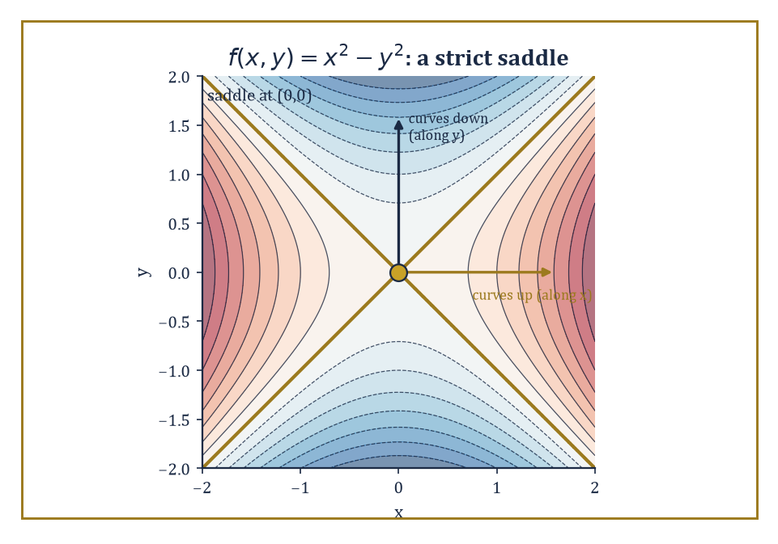
Figure 48.2 — The textbook saddle f(x,y) = x² − y²: curving up along x, down along y, and offering the origin as a resting place only to those who don’t look closely.
∇f(x) = 0
the vector of all partial derivatives vanishes entirely, so there is no direction of steepest ascent or descent left to follow. That alone is a weak certificate; it is satisfied by minima, maxima, and saddles alike.
A second-order critical point tightens the net: it additionally requires the Hessian matrix ∇²f(x) (the matrix of second partial derivatives) to be positive semidefinite, meaning every direction curves upward or stays flat — no direction of strictly negative curvature survives.
A strict saddle is a first-order critical point whose Hessian has at least one strictly negative eigenvalue: some direction curves downward, and a small step along it decreases f.
The strict-saddle property, which a function either has or doesn’t, asserts that every critical point of f is either a local minimum or a strict saddle — nothing in between, and in particular no degenerate flat saddles where the Hessian is merely semidefinite with a zero eigenvalue sitting ambiguously on the fence.
Under this property, an algorithm equipped to detect and exploit negative curvature is guaranteed, eventually, to escape every saddle it meets.
Numeric example — the textbook saddle. Consider the simplest possible saddle,
f(x, y) = x² − y²
Its gradient is
∇f(x, y) = (2x, −2y)
which vanishes only at the origin (0, 0) — the unique critical point. The Hessian is the constant matrix,
∇²f = [2 0; 0 −2]
already diagonal, so its eigenvalues can be read off directly: 2 (along the x-direction) and −2 (along the y-direction). One positive, one negative — this is a strict saddle with a two-dimensional certificate rather than a one-dimensional guess.
Geometrically: walking along the x-axis from the origin,
f(x, 0) = x²
increases — you’re climbing. Walking along the y-axis,
f(0, y) = −y²
decreases — you’re descending. A plain gradient-descent step from exactly (0,0) goes nowhere, since the gradient there is the zero vector — but nudge the starting point by even a whisker in the y-direction, say to (0, 10⁻⁶), and the negative curvature along y takes over: subsequent gradient steps accelerate away from the origin and never look back.
This is the mechanism behind perturbed gradient descent — inject a small random perturbation whenever the gradient is nearly zero, and any strict saddle you land near becomes, with high probability, a launching pad rather than a resting place.
Try it now — Classify the critical point of f(x, y) = x² − y² at the origin. Answer →
The strict-saddle property matters because it converts a purely local guarantee (perturbed gradient descent escapes strict saddles) into something close to a global one: if every critical point in the entire landscape is either a genuine local minimum or an escapable strict saddle, then an algorithm that keeps escaping saddles can only ever converge to a local minimum, full stop — there is no third kind of resting place left to get stuck at.
Establishing that a given nonconvex problem has this property is landscape analysis in its purest form, and it typically proceeds by studying the geometry of sublevel sets,
{x : f(x) ≤ c}
do they stay connected as c grows, or do new disconnected components appear, signaling an isolated spurious minimum? — together with the connectivity of the set of global minimizers itself, and, for statistical estimation problems specifically, a condition called restricted strong convexity: the demand that f behaves like a convex, well-conditioned bowl not everywhere, but merely in a neighborhood of the true underlying parameter, which is usually all an algorithm initialized sensibly will ever need.
Abstract example — a saddle carved out of symmetry. Many strict saddles arise not from bad luck but from symmetry: whenever a problem has an exact symmetry (swap two variables, flip a sign, rotate a factor), the symmetric point is almost always a saddle. Consider the smallest possible instance of matrix factorization, thinking of it as trying to write the 1×1 number ‘1’ as a product of two scalar factors u and w,
h(u, w) = (uw − 1)²
Its critical points satisfy
∇h = (2w(uw−1), 2u(uw−1)) = 0
Either uw = 1, giving the entire hyperbola of solutions,
{(u, w) : uw = 1}
a connected curve of global minima, the kind of landscape connectivity The Landscape of Nonconvex Optimization flagged as desirable — or else both w(uw−1) = 0 and u(uw−1) = 0 with uw ≠ 1, which forces u = 0 and w = 0 simultaneously. So the origin is the only critical point that is not a global minimum.
Its Hessian, computed directly from the second partial derivatives,
∂²h/∂u² = 2w², ∂²h/∂w² = 2u², ∂²h/∂u∂w = 4uw − 2
evaluates at (0,0) to
[0 −2; −2 0]
whose eigenvalues are ±2 (the eigenvalues of any matrix of the form [0 c; c 0] are +c and −c). One positive, one negative: the origin is a strict saddle.
In one clean picture, this is the entire content of the benign-nonconvexity theorems for matrix factorization — a connected continuum of good points, and exactly one bad point, which isn’t even dangerous.
Understanding the landscape — where the minima live, whether they’re connected, and whether the remaining critical points are escapable — is the geometric prerequisite for everything that follows. It tells you what an algorithm is allowed to hope for before you’ve committed to running one.
The next section supplies the algorithm most commonly asked to do the hoping: stochastic gradient descent, which trades a perfect gradient for a noisy but cheap one, and somehow still gets the job done.
Keep only this · Section 48.2: Critical Points, Saddles, and Landscape Geometry
The idea. A critical point is classified by its Hessian; at a strict saddle some eigenvalue is negative, which gives gradient methods a direction of escape.
Core.
strict saddle: λ_min(∇²f) < 0
escape along the eigenvector of λ_min
Typical mistake. Fearing every saddle equally. Strict saddles are escapable; degenerate ones, with zero curvature, are the hard cases.
Minimal example. f = x² + 3y²: Hessian diag(2, 6), a minimum.
Practice. Easy to challenge; full worked answers, with the usual mistake, are in Answers to the Practice Sets at the back.
Easy — Classify the origin for f(x, y) = x² + 3y². Answer →
Medium — Find and classify the critical points of f(x, y) = x⁴ − 2x² + y². Answer →
Challenge — For the function of the previous exercise, gradient descent starts at (0, 0.5). Where does it go, and what does a tiny perturbation in x change? Answer →

Section 48.3: Stochastic Gradient Methods
In praise of the gradient that is wrong on purpose, cheaply, and on average correct
Training a machine-learning model means adjusting it to reduce its average error over millions of examples. Computing the exact downhill direction means looking at every example at every step, which is ruinously slow. Stochastic gradient descent looks at one example, or a small batch, finds the downhill direction for that, and takes a step. Each step is slightly wrong but right on average, and the errors largely cancel. On a simple bowl, starting at 10 and stepping a tenth of the slope each time, exact steps give 9, 8.1 and 7.29; this section’s noisy steps give 8.9, 8.11 and 7.199, wandering a little but tracking the same descent at a fraction of the cost.
Stochastic gradient descent (SGD) is the pragmatist’s answer to a genuine computational bind: many objectives of interest are averages over an enormous number of terms,
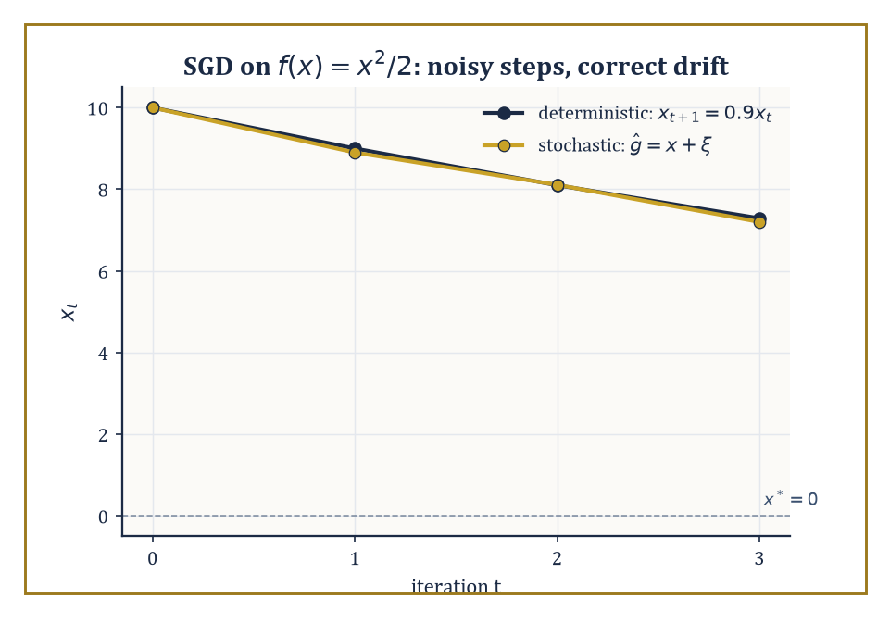
Figure 48.3 — The worked descent on f(x) = x²/2: the stochastic path (10, 8.9, 8.11, 7.199) fluctuates around the deterministic one but tracks its downward drift closely.
f(x) = (1/n) Σᵢ fᵢ(x)
where n might be measured in the millions (one term per data point). Computing the exact gradient ∇f(x) means touching every single fᵢ, which becomes ruinously expensive as n grows.
SGD instead replaces the true gradient by an unbiased estimate ĝ(x) built from a single randomly chosen term, or a small mini-batch of them:
ĝ(x) = ∇fᵢ(x) for a randomly drawn index i
Unbiased means the following holds — on average, across all the randomness, the estimator gets it precisely right, even though on any given step it is almost certainly wrong by some amount:
𝔼[ĝ(x)] = ∇f(x)
The update rule is the familiar
xₜ₊₁ = xₜ − η·ĝ(xₜ)
with η the step size, except now the path it traces is a genuinely random walk biased, on average, downhill.
Numeric example — a noisy descent, step by step. Let f(x) = x²/2, so the true gradient is ∇f(x) = x and the unique minimizer is x* = 0. Build a stochastic gradient estimator,
ĝ(x) = x + ξ, ξ drawn uniformly from {−1, +1}
This is unbiased since 𝔼[ξ] = 0, so 𝔼[ĝ(x)] = x exactly — but each individual draw is off by a full unit. Start at x₀ = 10 with step size η = 0.1, and suppose the noise realizations happen to come out as ξ₁ = +1, ξ₂ = −1, ξ₃ = +1.
Step 1: x₁ = x₀ − η(x₀ + ξ₁) = 10 − 0.1(11) = 8.9
Step 2: x₂ = x₁ − η(x₁ + ξ₂) = 8.9 − 0.1(7.9) = 8.11
Step 3: x₃ = x₂ − η(x₂ + ξ₃) = 8.11 − 0.1(9.11) = 7.199
Compare this to the deterministic path using the true gradient,
xₜ₊₁ = (1 − η)xₜ = 0.9xₜ
which gives 10 → 9 → 8.1 → 7.29. The stochastic path (10, 8.9, 8.11, 7.199) fluctuates around the deterministic one but tracks its overall downward trend closely — this is the entire phenomenon in miniature: individual steps are noisy, but the drift is correct, and over many iterations the noise averages out while the signal accumulates.
Try it now — For f(x) = x²/2 with stochastic gradient x + ξ, step η = 0.5 and x₀ = 4, compute x₁ when ξ = +1. Answer →
In the nonconvex setting SGD’s guarantee weakens gracefully rather than collapsing: instead of converging to the global minimum, it converges (in expectation, or almost surely, or with high probability, depending on how careful the analysis wants to be) to a first-order critical point — somewhere the gradient is small.
Left entirely alone, it can and does linger near strict saddles for a while, since the mean update near a saddle is nearly zero and there’s no systematic force pushing it off the fence.
But the noise itself is the escape mechanism: because ĝ(x) is random, it very rarely points in precisely the direction of zero curvature, and the negative-curvature component of the noise gets amplified step after step, eventually flinging the iterate away from the saddle — the same mechanism as the deliberate perturbations of Critical Points, Saddles, and Landscape Geometry, except SGD gets it for free, as a side effect of the very noise that made it cheap in the first place.
Three practical knobs govern how well this works: the mini-batch size (larger batches reduce the variance of ĝ but cost more per step), the learning-rate schedule (constant step sizes converge to a noise-dominated neighborhood of a critical point; decaying step sizes, roughly ηₜ ∝ 1/√t, are needed for exact convergence), and momentum (accumulating a running average of past gradients to smooth out the zig-zag that noisy updates otherwise produce).
Numeric example — what a bigger batch buys you. Suppose each individual noise term ξ has variance σ² = 1, as in the example above, since ξ ∈ {−1,+1} uniformly gives
Var(ξ) = 𝔼[ξ²] − 𝔼[ξ]² = 1 − 0 = 1
A mini-batch estimator averages m independent draws,
ĝ_batch(x) = x + (1/m)Σⱼ₌₁ᵐ ξⱼ
Since the ξⱼ are independent, the variance of their average is σ²/m. With a batch of m = 4, the variance of the noise term drops to
1/4 = 0.25
i.e. a standard deviation of 0.5 instead of 1 — the estimator is twice as precise, at four times the per-step computational cost. This square-root relationship (halve the noise, quadruple the batch) is the standard economic trade-off practitioners weigh constantly: doubling the batch size buys only a 1/√2 ≈ 29% reduction in noise, which is why, past a certain point, it is usually cheaper to run more noisy steps than fewer clean ones.
SGD’s real triumph is not any particular convergence rate but the fact that it made large-scale nonconvex optimization routine at all: its per-iteration cost is independent of n, the dataset size, so a model can be trained on a billion examples using the same per-step arithmetic as one trained on a thousand.
This is the algorithm underneath essentially every modern machine-learning system, and the next section asks how to do better than plain SGD without giving up that scalability — first by reducing the variance directly, and then by letting the step size adapt itself, coordinate by coordinate, to the terrain it happens to be crossing.
Keep only this · Section 48.3: Stochastic Gradient Methods
The idea. Stochastic gradient descent replaces the exact gradient by a cheap unbiased estimate; step sizes and batch sizes control the noise it injects.
Core.
xₖ₊₁ = xₖ − ηₖ g(xₖ), E[g] = ∇f
batch of B: variance σ²/B
Robbins–Monro: Σηₖ = ∞, Σηₖ² < ∞
Typical mistake. Expecting SGD with a constant step to converge exactly. It settles into a noise ball whose size scales with η.
Minimal example. σ² = 1, batch 4: variance 1/4, standard deviation 1/2.
Practice. Easy to challenge; full worked answers, with the usual mistake, are in Answers to the Practice Sets at the back.
Easy — Each gradient sample has variance 1. What are the variance and standard deviation for a batch of 16? Answer →
Medium — For xₖ₊₁ = (1 − η)xₖ − ηξₖ with Var ξ = 1, find the long-run variance when η = 0.1. Answer →
Challenge — Which schedules satisfy Σηₖ = ∞ and Σηₖ² < ∞: ηₖ = 1/k, 1/√k, 1/k²? Explain what each condition does. Answer →

Section 48.4: Variance Reduction and Adaptive Methods
Two ways to make a noisy gradient behave itself: subtract the noise, or outsmart it
Fit a single number x to three data points, 1, 3 and 8, by making the average of the halved squared errors (x − 1)²/2, (x − 3)²/2 and (x − 8)²/2 as small as possible. Each term has its own slope, x minus its data point. At x = 0 the three slopes are −1, −3 and −8, and the slope of the average is their average, −4.
Stochastic gradient descent, from Stochastic Gradient Methods, saves work by asking one randomly chosen term for its slope instead of all of them. The answer is −1, −3 or −8: right on average, but off by as much as 4 on any single try. With three terms that hardly matters. With a million it is the main cost of the method.
Here is a trick borrowed from statistics. Suppose that at an earlier point, x = 2, you did the slow thing once: you computed the full average slope there, −2, and you kept each term’s own slope there as well, 1, −1 and −6. Now, instead of asking a random term for its slope, ask it how much its slope has changed since x = 2, and add that change to the known average:
term 1: change −1 − 1 = −2, estimate −2 + (−2) = −4
term 2: change −3 − (−1) = −2, estimate −2 + (−2) = −4
term 3: change −8 − (−6) = −2, estimate −2 + (−2) = −4
Every term gives −4, the exact answer, with no noise at all. The terms disagree wildly about their slopes, but they agree about how much their slopes have changed. In general the changes do not agree perfectly, but they disagree less and less as x approaches the earlier point.
That is variance reduction: keep an exact average from a recent snapshot, and sample only the correction. The first worked example below is this calculation, written as the SVRG estimator. The second half of the section takes the other way to tame a noisy gradient: adaptive methods, which leave the noise alone and change the step size instead.
Variance reduction attacks the noise in SGD head-on for the finite-sum setting,
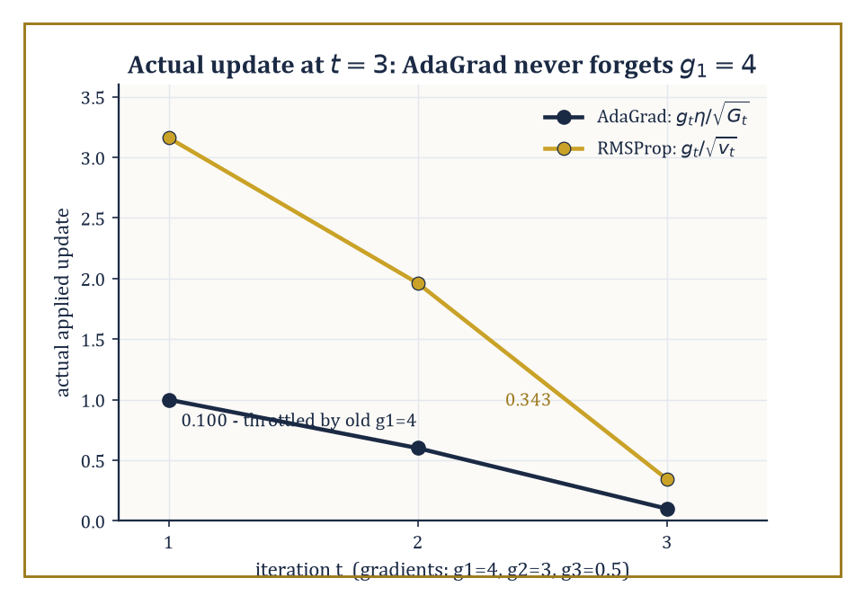
Figure 48.4 — The actual applied update at t = 3 for gradients (4, 3, 0.5): AdaGrad’s ever-growing accumulator throttles it to 0.100, while RMSProp’s short memory allows 0.343.
f(x) = (1/n)Σᵢ fᵢ(x)
The family of methods — SVRG, SAGA, SARAH, among others — shares a common trick: instead of using a raw stochastic gradient ∇fᵢ(x), construct a control-variate estimator that combines the current sample with a correction computed at some reference point x̃, a periodically refreshed ‘snapshot’:
ĝ = ∇fᵢ(x) − ∇fᵢ(x̃) + ∇f(x̃)
This is still unbiased, since the snapshot terms cancel in expectation,
𝔼ᵢ[ĝ] = ∇f(x) − ∇f(x̃) + ∇f(x̃) = ∇f(x)
but crucially its variance shrinks to zero as x approaches x̃, because the difference ∇fᵢ(x) − ∇fᵢ(x̃) — the part that still depends on the random index i — itself shrinks to zero.
Under strong convexity, or the weaker Polyak–Łojasiewicz (PL) condition — which demands only the following for some μ > 0, a bound relating gradient size to sub-optimality without requiring convexity at all —
‖∇f(x)‖² ≥ 2μ(f(x) − f*)
this restores the fast linear convergence rate of full gradient descent while still touching only one or a few fᵢ per step. Nonconvex finite-sum problems admit analogous, somewhat weaker, guarantees.
Numeric example — variance reduction with the noise removed by hand. Take three component functions with a = (1, 3, 8),
fᵢ(x) = (x − aᵢ)²/2, f(x) = (1/3)Σfᵢ(x)
so f has true gradient ∇f(x) = x − ā where
ā = (1+3+8)/3 = 4
At the current point x = 0, the true gradient is
∇f(0) = 0 − 4 = −4
Check it component-wise:
f₁′(0) = −1, f₂′(0) = −3, f₃′(0) = −8, average = (−1−3−8)/3 = −4
Now fix a snapshot point x̃ = 2, with true gradient
∇f(2) = 2 − 4 = −2
and components
f₁′(2) = 1, f₂′(2) = −1, f₃′(2) = −6, average = −2
as required. Build the SVRG estimator for a randomly sampled index, say i = 3:
ĝ₃ = f₃′(0) − f₃′(2) + ∇f(2) = (−8) − (−6) + (−2) = −4
the true gradient. Try i = 1 instead:
ĝ₁ = (−1) − (1) + (−2) = −4
And i = 2:
ĝ₂ = (−3) − (−1) + (−2) = −4
Every single sample gives the right answer, with zero variance. This isn’t a coincidence of these particular numbers — it’s because every fᵢ here is a quadratic with the same curvature (coefficient ½ on x²), so
fᵢ′(x) − fᵢ′(x̃) = (x − aᵢ) − (x̃ − aᵢ) = x − x̃
regardless of aᵢ: the sample-dependent part cancels exactly, leaving only the deterministic correction x − x̃ plus the snapshot gradient. In general, with unequal curvatures, some residual variance survives this cancellation — but it shrinks steadily as x moves toward x̃, which is the entire mechanism variance reduction exploits.
Try it now — A coordinate sees gradients 4 and then 3. What is AdaGrad’s effective step size after the second? Answer →
Adaptive methods take a different tack entirely: rather than reducing the noise in the gradient estimate, they reshape the step itself, coordinate by coordinate, using the history of gradient magnitudes observed so far.
AdaGrad accumulates the sum of squared past gradients per coordinate,
Gₜ = Σ[s≤t] gₛ²
and divides the step size by √Gₜ, so coordinates that have seen large gradients get smaller effective steps and coordinates that have stayed quiet get comparatively larger ones — useful when different parameters naturally live on very different scales.
RMSProp and Adam replace that ever-growing sum with an exponentially decaying moving average of squared gradients,
vₜ = β vₜ₋₁ + (1−β)gₜ²
so old gradient information is gradually forgotten rather than accumulated forever; Adam additionally keeps a momentum-style moving average of the gradients themselves.
These are, by a wide margin, the default optimizers used to train deep networks in practice, even though a fully satisfying theoretical account of why they so often outperform plain SGD — and precisely when they don’t — remains an active and somewhat contested area of research.
Numeric example — AdaGrad never forgets (and that’s the problem). Suppose a single coordinate sees gradients g₁ = 4, g₂ = 3, g₃ = 0.5 over three steps — a large early gradient followed by two much smaller ones. AdaGrad’s accumulator builds up as:
G₁ = 4² = 16, G₂ = 16 + 3² = 25, G₃ = 25 + 0.5² = 25.25
With base learning rate η = 1, the effective step size at t = 3 is
η/√G₃ = 1/√25.25 ≈ 1/5.025 ≈ 0.199
giving an actual update of
g₃ × 0.199 ≈ 0.0995
tiny, even though the current gradient g₃ = 0.5 isn’t itself especially small; the update is being throttled by a large gradient from two steps ago that has long since become irrelevant.
Now compare RMSProp with decay β = 0.9 and v₀ = 0:
v₁ = 0.9(0) + 0.1(16) = 1.6, v₂ = 0.9(1.6) + 0.1(9) = 2.34, v₃ = 0.9(2.34) + 0.1(0.25) = 2.131
The actual update at t = 3 is
g₃/√v₃ = 0.5/√2.131 ≈ 0.5/1.460 ≈ 0.3425
more than three times larger than AdaGrad’s, because the exponential average has partly forgotten the old g₁ = 4 and is responding mainly to recent, smaller gradients. This single comparison is the entire historical motivation for RMSProp and Adam over plain AdaGrad: an ever-growing accumulator eventually stalls every coordinate’s learning rate to near zero, however irrelevant the gradient that caused it has become.
Variance reduction and adaptation are, in this sense, the two principal refinements available once you’ve decided plain SGD is too noisy or too poorly scaled to be efficient on its own — one attacks the randomness directly, the other reshapes the geometry the randomness has to navigate, and modern practice frequently reaches for both.
The next section turns to problems where the dimension itself is the enemy: high-dimensional statistical estimation, where the number of unknowns can dwarf the number of observations, and nonconvexity is not a nuisance to be tolerated but the natural, unavoidable formulation of the problem.
Keep only this · Section 48.4: Variance Reduction and Adaptive Methods
The idea. Variance reduction removes the noise of stochastic gradients with control variates; adaptive methods scale each coordinate’s step by the history of its gradients.
Core.
SVRG: ∇fᵢ(x) − ∇fᵢ(x̃) + ∇f(x̃)
AdaGrad: η/√(Σ gₜ²)
Adam: m̂ = m/(1 − β₁ᵗ)
Typical mistake. Treating Adam as a universally better SGD. Its adaptivity can generalize worse and needs tuning too.
Minimal example. Gradients 4, 3, 0.5: AdaGrad divisor √25.25 ≈ 5.02.
Practice. Easy to challenge; full worked answers, with the usual mistake, are in Answers to the Practice Sets at the back.
Easy — Continue the Try it now: a third gradient 0.5 arrives. What is the divisor now? Answer →
Medium — Adam with β₁ = 0.9 starts at m₀ = 0 and sees g₁ = 4. Compute m₁ and the bias-corrected m̂₁. Answer →
Challenge — Show that the SVRG estimate gᵢ = ∇fᵢ(x) − ∇fᵢ(x̃) + ∇f(x̃) is unbiased, and that its variance vanishes at x = x̃. Answer →

Section 48.5: High-Dimensional and Structured Nonconvex Problems
Where the unknowns outnumber the data, and convexity becomes a luxury good
A cluster of high-dimensional statistical estimation problems — sparse regression (recovering a vector with mostly zero entries), low-rank matrix completion (filling in the missing entries of a matrix known to have low rank), phase retrieval (recovering a signal from only the magnitudes, not the signs or phases, of its measurements), and blind deconvolution — share a family resemblance: they are naturally nonconvex the moment you write them down in their own natural parameters.
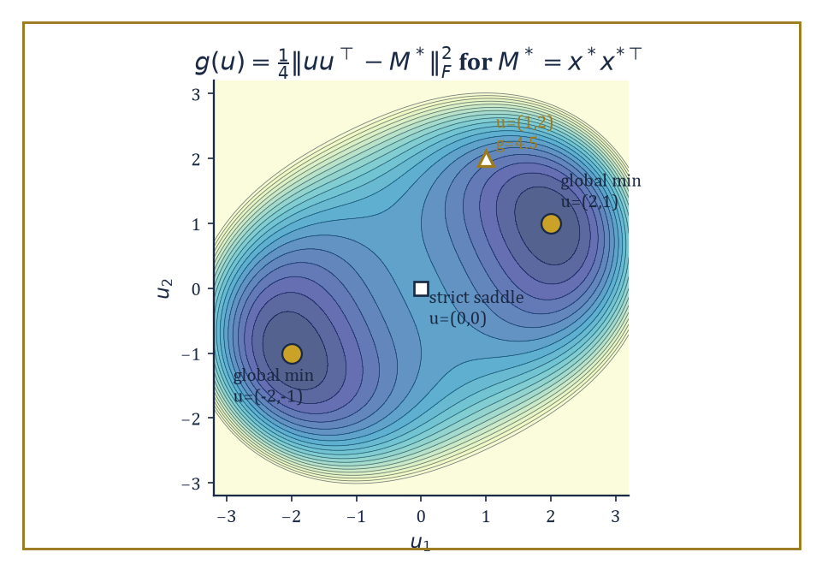
Figure 48.5 — The rank-1 recovery landscape g(u): two symmetric global minima at ±(2,1), one escapable saddle at the origin, and a substantial penalty for the merely plausible-looking (1,2).
Ask directly for a low-rank matrix,
M = UVᵀ
and you are optimizing over factors U and V, and that factorized objective is nonconvex (the map (U,V) ↦ UVᵀ is bilinear, not linear, and the same M has infinitely many factorizations).
One classical fix is convex relaxation: replace ‘rank’ with the nuclear norm (the sum of singular values, the tightest convex surrogate for rank) or replace ‘sparsity’ with the ℓ¹ norm, and solve a convex problem instead.
These relaxations provably recover the truth once the measurement operator satisfies a restricted isometry property (RIP) or a restricted eigenvalue condition — roughly, that it doesn’t distort the length of any sparse or low-rank vector too badly, so that fitting the data still pins down the truth uniquely.
Numeric example — a nonconvex landscape for rank-1 recovery. Suppose the ground truth is a rank-1 matrix M* = x*x*ᵀ for x* = (2, 1), so
M* = [4 2; 2 1]
Rather than solving a convex nuclear-norm problem, work directly with the nonconvex factorized objective, minimizing over a single factor u ∈ ℝ²,
g(u) = ¼‖uuᵀ − M*‖²_F
At u = x* = (2,1):
uuᵀ = [4 2; 2 1] = M*, so g(x*) = 0
the global minimum. By the sign symmetry of the factorization, u = −x* = (−2,−1) is also a global minimum:
(−2)(−2)=4, (−2)(−1)=2, (−1)(−2)=2, (−1)(−1)=1
reproducing M* again. Now evaluate the same objective at a nearby-looking but wrong point, u = (1, 2):
uuᵀ = [1 2; 2 4]
The difference from M* is
[(1−4) (2−2); (2−2) (4−1)] = [−3 0; 0 3]
with squared Frobenius norm
9 + 0 + 0 + 9 = 18, giving g(1,2) = 18/4 = 4.5
a substantial penalty for what looks, at a glance, like a modest perturbation of the truth (same coordinates, swapped). This is the shape of the whole enterprise: the nonconvex objective has exactly the two symmetric global minima ±x* and nothing else pretending to be one, and results in this area (matrix-sensing landscape theorems, in the style of Section 48.2’s strict-saddle discussion) establish that every other critical point of g is a strict saddle — so a perturbed gradient method, run directly on the factors, provably finds x* up to the unavoidable sign ambiguity, with no relaxation and no nuclear norm in sight.
Try it now — Write M* = xxᵀ for x* = (1, 3). Answer →
The reason nonconvex methods — projected gradient descent (take a gradient step, then project back onto the constraint set, such as the set of sparse or low-rank objects), alternating minimization (optimize over U with V fixed, then over V with U fixed, repeat), and Wirtinger flow (a gradient method tailored to phase retrieval’s complex-valued, magnitude-only measurements) — often match or beat their convex relaxation cousins is computational: the convex relaxations frequently require solving a semidefinite program or an ℓ¹-penalized regression over a much larger lifted variable (an n×n matrix instead of a length-n vector, say), whereas the nonconvex method works directly with the natural, small parameterization the entire time.
The price is that the analysis is harder and typically only local: it establishes restricted strong convexity and restricted smoothness in a neighborhood of the truth, valid once the sample size clears some threshold, and then shows a sensible initialization (often obtained via a cheap spectral method) lands inside that neighborhood to begin with.
Abstract example — when statistics and computation disagree. Not every high-dimensional problem that is statistically solvable is also efficiently solvable, and the gap between the two is itself a subject of study, the computational–statistical gap. Consider sparse PCA in miniature: a covariance matrix
Σ = θ·vvᵀ + I
where v is an unknown k-sparse unit vector (only k of its n coordinates are nonzero) hidden inside an otherwise featureless identity background, and θ measures how strong the planted signal is.
Information-theoretically — meaning if you were willing to search over every one of the (n choose k) possible support sets by brute force — a signal strength θ on the order of the following (with m the number of samples) suffices to recover v’s support with high probability:
θ ≈ √(k log n / m)
But every known polynomial-time algorithm (methods based on the top eigenvector, or on convex relaxations of the sparsity constraint) appears to require a substantially larger θ to succeed, closer to
θ ≈ √(k² log n / m)
a gap of a full factor of √k in the required signal strength (equivalently, a factor of k in the number of samples needed for a fixed signal strength), believed — and in restricted computational models, provable — to be unavoidable for any efficient method.
The moral for structured nonconvex optimization is sobering: ‘more data would fix it’ and ‘a better algorithm would fix it’ are not always the same claim, and telling them apart is itself a research program, one that borrows tools from cryptography and average-case complexity that would look entirely out of place in Chapter 30 (Volume 3)’s convex world.
Structured nonconvexity, then, is the precise point at which advanced optimization stops being purely about algorithms and starts being inseparable from high-dimensional statistics: the landscape’s good behavior is a probabilistic fact about random data, established with the tools of concentration of measure, and the algorithm’s success is contingent on that fact holding.
The next section leaves single-objective minimization behind altogether, for problems with two competing players and no single number either of them is simply trying to minimize.
Keep only this · Section 48.5: High-Dimensional and Structured Nonconvex Problems
The idea. Many high-dimensional nonconvex problems — low-rank recovery, phase retrieval, dictionary learning — have landscapes in which every local minimum is global and every saddle is strict.
Core.
f(x) = ¼‖xxᵀ − M*‖²_F
symmetry x ↦ −x gives two global minima
rank-r n × n matrix: r(2n − r) degrees of freedom
Typical mistake. Thinking a nonconvex problem must have bad local minima. Symmetry creates saddles, not traps, in many structured problems.
Minimal example. x* and −x* give the same M*.
Practice. Easy to challenge; full worked answers, with the usual mistake, are in Answers to the Practice Sets at the back.
Easy — Why can the solution of xxᵀ = M* be found only up to sign? Answer →
Medium — For f(x) = ¼‖xxᵀ − M‖²_F with M = [1 3; 3 9], show that x = 0 is a critical point and find its curvature directions. Answer →
Challenge — How many numbers determine a rank-2 matrix of size 100 × 100, compared with an arbitrary one, and why does that make recovery from few measurements plausible? Answer →

Section 48.6: Minimax Optimization and GANs
Two gradients enter a section; only sometimes does either of them leave
Two players share one game. Player X picks a number x, player Y picks a number y, and X pays Y the amount x × y. X wants the payment small and Y wants it large. If Y picks a positive number, X does best with a negative x, and the more negative the better. If Y picks a negative number, X wants x positive. Y reasons the same way about X. The only position from which neither can gain by moving alone is x = 0, y = 0, where the payment is 0 whatever the other player does.
Gradient descent finds a low point by stepping downhill. Try letting both players do that at once: X steps downhill in x, while Y steps uphill in y. At a point (x, y), X’s downhill direction is −y and Y’s uphill direction is +x, so the pair moves in the direction (−y, x). Those are the arrows of the rotation field in Vector Fields Revisited (Volume 2). They do not point toward the balance point at the origin. They point around it.
Following the arrows exactly would carry the pair round a circle for ever, never closer to (0, 0) and never further away. Taking real steps is worse. A straight step of size η along an arrow leaves the circle along its tangent, and a tangent always lands outside the circle. Starting at distance 1 from the origin:
η = 0.5: new distance √1.25 ≈ 1.118
η = 0.1: new distance √1.01 ≈ 1.005
η = 0.01: new distance √1.0001 ≈ 1.00005
Notice what the distance never does: it never comes out at 1 or less. Smaller steps slow the outward spiral, but no step size stops it. Every step lands further from the answer than the one before.
So the question in this section is not how to find a low point, but how to find a balance point between two players pulling in opposite directions. A problem of this shape is a minimax problem, and the balance point is a Nash equilibrium. The first worked example below runs the spiral above with η = 0.5, and the second shows the repair: look one step ahead before committing, and the same game spirals inward.
A minimax problem asks for
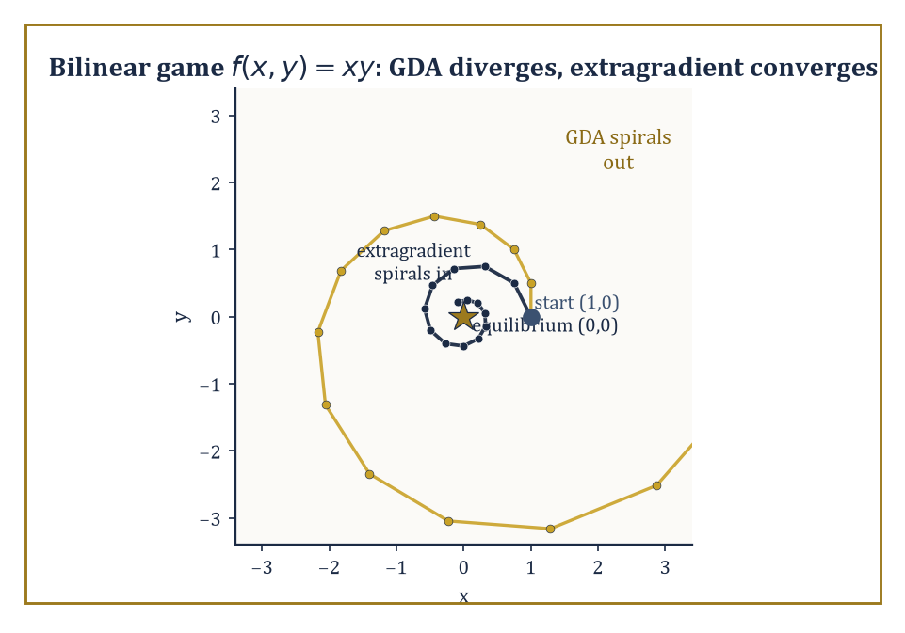
Figure 48.6 — Same bilinear game, same starting point, same step size: gradient descent-ascent spirals away from the equilibrium while extragradient spirals politely into it.
minₓ max[y] f(x,y)
one variable x tries to minimize the objective while another variable y, adversarially, tries to maximize it, with y, as the order in the notation implies, choosing after seeing what x has chosen.
These arise wherever there are two opposing forces rather than one — in classical game theory, in robust optimization (x is a decision, y is ‘nature’ or an adversary choosing the worst-case disturbance), and, in one of the more consequential recent examples, in the training of generative adversarial networks (GANs), where a generator (x) tries to produce fake data indistinguishable from real, while a discriminator (y) tries to tell them apart.
Single-objective optimality (a critical point, a local minimum) no longer makes sense as a target, since improving f for x’s sake generally makes it worse for y’s; the right notion of a solution is a Nash equilibrium, a pair (x*, y*) at which neither player can improve their own outcome by unilaterally changing their choice — or, in settings with a genuine order of play, a Stackelberg equilibrium, where one player commits first and the other best-responds.
Both can be phrased as variational inequalities, a general framework for ‘no direction of unilateral improvement exists’ that subsumes ordinary critical points as the special case of a single player.
Numeric example — the simplest minimax game diverges. Take the bilinear game
f(x,y) = xy
whose unique equilibrium is (0,0) — the saddle point of the surface, just as in Section 48.2’s f(x,y)=x²−y² example, except now one variable is minimizing and the other maximizing along the two axes at once. Gradient descent-ascent (GDA) updates both simultaneously:
xₜ₊₁ = xₜ − η·∂f/∂x = xₜ − η yₜ, yₜ₊₁ = yₜ + η·∂f/∂y = yₜ + η xₜ
Start at (x₀,y₀) = (1,0) with η = 0.5.
Step 1: x₁ = 1 − 0.5(0) = 1, y₁ = 0 + 0.5(1) = 0.5
Step 2: x₂ = 1 − 0.5(0.5) = 0.75, y₂ = 0.5 + 0.5(1) = 1.0
Step 3: x₃ = 0.75 − 0.5(1.0) = 0.25, y₃ = 1.0 + 0.5(0.75) = 1.375
Track the squared distance from the equilibrium, r²ₜ = xₜ² + yₜ²:
r²₀ = 1, r²₁ = 1 + 0.25 = 1.25, r²₂ = 0.5625 + 1 = 1.5625, r²₃ = 0.0625 + 1.890625 ≈ 1.953
It’s growing, and in fact growing by a constant factor each step: algebraically,
xₜ₊₁² + yₜ₊₁² = (xₜ − ηyₜ)² + (yₜ + ηxₜ)² = xₜ² + yₜ² + η²(xₜ² + yₜ²) = (1+η²)(xₜ² + yₜ²)
so r²ₜ₊₁ = (1+η²)r²ₜ exactly. With η = 0.5, that factor is 1.25 — check:
1×1.25=1.25 ✓, 1.25×1.25=1.5625 ✓, 1.5625×1.25≈1.953 ✓
The iterates spiral outward geometrically forever, never converging, despite starting a mere unit away from the correct answer. Naive simultaneous gradient descent-ascent does not work on this, the simplest possible minimax problem there is.
Try it now — For the game min_x max_y xy, simultaneous gradient play is (x, y) ↦ (x − ηy, y + ηx). From (1, 0) with η = 0.1, take one step and compute the distance from the origin. Answer →
This failure is not a defect of the example; it is the central obstruction of the whole subject. Under a convex-concave assumption — f convex in x for every fixed y, and concave in y for every fixed x — extragradient and optimistic-gradient variants (which take a tentative lookahead step before committing to the real update, using the gradient at the lookahead point rather than the current one) do converge, provably.
Once convexity-concavity is abandoned — nonconvex-nonconcave minimax, which is what a GAN’s generator-versus-discriminator game actually is — the guarantees mostly evaporate, and the empirical behavior matches: limit cycles (the iterates orbit the equilibrium forever, neither approaching nor escaping), oscillation, and outright divergence are all commonly observed in practice, which is why GAN training has a well-earned reputation for being finicky, sensitive to hyperparameters, and prone to a failure mode called mode collapse in which the generator gives up on diversity and produces the same handful of outputs regardless of input.
Numeric example — the lookahead that saves the day. Apply extragradient to the identical bilinear game and starting point. Each step first computes a lookahead half-move using the current gradients — exactly one GDA step — and then uses the gradient at that lookahead point to update from the original position. Lookahead from (1, 0):
x̄ = 1 − 0.5(0) = 1, ȳ = 0 + 0.5(1) = 0.5
identical to GDA’s first step so far. Real update:
x₁ = x₀ − η·ȳ = 1 − 0.5(0.5) = 0.75, y₁ = y₀ + η·x̄ = 0 + 0.5(1) = 0.5
Already
r²₁ = 0.75² + 0.5² = 0.5625 + 0.25 = 0.8125
down from r²₀ = 1 — shrinking, not growing. Second step: lookahead from (0.75, 0.5) gives
x̄ = 0.75 − 0.5(0.5) = 0.5, ȳ = 0.5 + 0.5(0.75) = 0.875
real update
x₂ = 0.75 − 0.5(0.875) = 0.3125, y₂ = 0.5 + 0.5(0.5) = 0.75
Now
r²₂ = 0.3125² + 0.75² = 0.09766 + 0.5625 = 0.66016
smaller again. The sequence of squared distances, 1 → 0.8125 → 0.660, is contracting steadily toward the true equilibrium at the origin — the behavior GDA failed to produce with the same starting point, same step size, and almost the same arithmetic. The one extra lookahead half-step is the entire difference between divergence and convergence.
Minimax optimization extends the reach of the whole theory from a single objective to a competitive setting, and the extragradient idea above is only the simplest of a family of correction schemes designed to tame the rotational dynamics that plain gradient descent-ascent cannot handle.
Designing training algorithms for GANs and related adversarial architectures that are provably reliable outside the convex-concave comfort zone remains one of the liveliest open interfaces between optimization theory and machine-learning practice. The next section asks a different, more austere question: forgetting any particular algorithm, how fast could the best possible algorithm ever hope to go?
Keep only this · Section 48.6: Minimax Optimization and GANs
The idea. Minimax problems pit two players against each other; simultaneous gradient play can cycle or diverge, while extragradient and optimistic methods converge on bilinear games.
Core.
GDA on xy: radius × √(1 + η²) per step
extragradient on xy: radius × √(1 − η² + η⁴)
Typical mistake. Applying minimization intuition to games. A saddle point of f is an equilibrium, not a minimum.
Minimal example. After 100 steps of η = 0.1, GDA’s radius has grown by 1.01⁵⁰ ≈ 1.64.
Practice. Easy to challenge; full worked answers, with the usual mistake, are in Answers to the Practice Sets at the back.
Easy — By what factor has the radius grown after 100 simultaneous steps with η = 0.1? Answer →
Medium — Show that extragradient on xy multiplies the radius by √((1 − η²)² + η²) per step, and evaluate it for η = 0.1. Answer →
Challenge — Is (0, 0) a local saddle-point equilibrium of f(x, y) = x² − y² + xy (x minimizes, y maximizes)? Answer →

Section 48.7: Complexity Lower Bounds and Optimal Rates
In which the series stops asking what’s known and starts asking what’s knowable
An oracle complexity lower bound is a theorem of a particular, almost paranoid shape: for a stated class of functions (say, all functions that are smooth with a given Lipschitz-continuous gradient, or all such functions that are additionally convex, or strongly convex, or nonconvex with a Lipschitz Hessian), and for any algorithm that is only permitted to query a gradient oracle — hand it a point, it hands back the gradient there, and nothing else — there exists some function in the class on which the algorithm needs at least a certain number of queries to find an approximately optimal point.
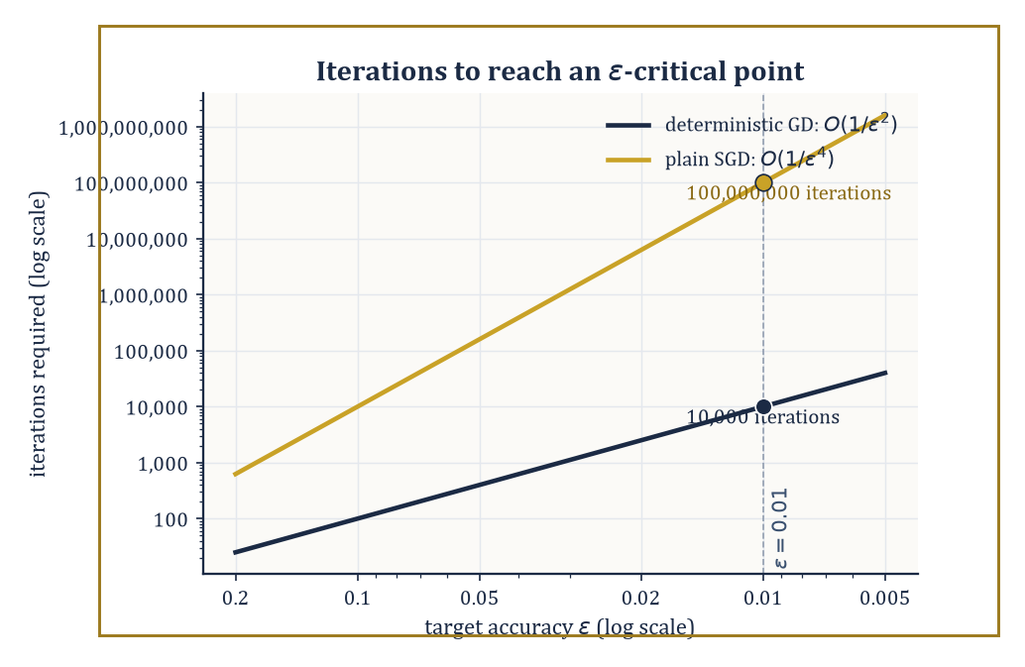
Figure 48.7 — O(1/ε²) versus O(1/ε⁴): at ε = 0.01 the gap between deterministic and stochastic iteration counts is already four orders of magnitude, and it only widens.
It is a statement not about any specific algorithm’s failure, but about every conceivable algorithm’s failure, on some worst-case adversarially chosen function.
When a matching upper bound exists — an actual algorithm, such as gradient descent or Nesterov’s accelerated gradient method from Chapter 30 (Volume 3), that achieves that same rate — the two bounds sandwich the truth exactly, and the question ‘what is the best possible rate’ closes for good, at least within that oracle model.
Numeric example — why the exponent is the whole story. In the nonconvex setting, the standard target is an ε-critical point: a point x with the gradient small, even if global optimality can’t be certified,
‖∇f(x)‖ ≤ ε
Under standard smoothness assumptions, deterministic gradient descent needs O(1/ε²) iterations to find one, while plain SGD, hobbled by the variance of its gradient estimates, needs O(1/ε⁴). Set ε = 0.01 and compare, treating the hidden constants as 1 for illustration.
Deterministic: 1/ε² = 1/(0.01)² = 1/0.0001 = 10,000 iterations
Stochastic: 1/ε⁴ = 1/(0.01)⁴ = 1/(10⁻⁸) = 100,000,000 iterations
That’s ten thousand times more. This is not a rounding difference; it is the difference between a computation so short you wouldn’t notice it (10,000 iterations, gone in well under a second on anything built this century) and one that, at a million iterations per second, still takes a leisurely hundred seconds — nearly two minutes spent achieving what determinism would have delivered in a blink.
The gap is the price of noise: every doubling of precision (halving ε) costs deterministic GD a factor of 4 in iteration count, but costs SGD a factor of 16 — which is precisely why variance reduction (Variance Reduction and Adaptive Methods), which restores something closer to the deterministic rate for finite sums, is not a minor refinement but close to essential once high precision is required.
Try it now — Gradient descent needs about 1/ε² iterations to reach ‖∇f‖ ≤ ε, and SGD about 1/ε⁴. Compare them for ε = 0.1. Answer →
Structure earns you a better rate, and the theory is precise about how much better: under the Polyak–Łojasiewicz condition introduced in Variance Reduction and Adaptive Methods, gradient descent’s rate improves from the generic sublinear nonconvex rate to a linear (geometric) one, matching what strong convexity alone would give in the convex world, even though the PL condition says nothing about convexity at all — it only bounds how gradient magnitude relates to sub-optimality.
Under the strict-saddle property of Critical Points, Saddles, and Landscape Geometry, perturbed gradient methods achieve essentially the same rate as unperturbed gradient descent for finding critical points, plus only a small additional cost, polynomial in the dimension, for the perturbations doing the work of escaping saddles.
These lower bounds are established through what’s called information-based complexity: one constructs an explicit worst-case ‘resisting’ function, engineered so that until an algorithm has made enough queries, no amount of cleverness can distinguish it from several other functions with very different minimizers — so no algorithm, however clever, can have found the right one yet.
Abstract example — a function built to resist you. The canonical resisting construction, due to Nesterov, is a chain function: a quadratic built so information about the objective can only travel one coordinate at a time. A miniature two-coordinate version,
f(x₁,x₂) = ½(x₁ − 1)² + ½(x₁ − x₂)²
is minimized, as direct calculus confirms, at x₁ = x₂ = 1. The point of the construction is structural, not this tiny instance’s exact rate: the gradient’s second coordinate,
∂f/∂x₂ = x₂ − x₁
is identically zero whenever x₂ has not yet ‘heard’ about x₁ (for instance, starting from x₁ = x₂ = 0, the first gradient step moves x₁ toward 1 but leaves the x₂-component of the gradient at exactly 0 until x₁ has moved).
In the full N-coordinate chain, summed along a chain of N variables,
½(x₁−1)² + ½Σ(xᵢ − xᵢ₊₁)²
a gradient-only algorithm started at the origin can only make coordinate xₖ respond after roughly k rounds of these one-step-at-a-time relays, because each coordinate’s gradient stays at zero until its neighbor up the chain has already moved. Make N large enough relative to the target accuracy ε, and the number of iterations needed to get information all the way down the chain is forced to scale as claimed by the lower bound — a function that is, by design, as slow to solve as the theorem says any function in its class could be.
Lower bounds convert the informal, slightly embarrassed admission ‘we don’t currently know a faster algorithm for this’ into the considerably more satisfying mathematical statement ‘no faster algorithm exists, within this oracle model, full stop’ — the gradient-oracle equivalent of a speed limit backed by the laws of physics rather than a suggestion from the council.
The next section asks what all this optimization machinery is for, once the objective being minimized is itself an estimate of something statistical rather than a fixed target handed down from on high.
Keep only this · Section 48.7: Complexity Lower Bounds and Optimal Rates
The idea. Lower bounds say how many oracle calls any method of a given type needs; when an algorithm matches the bound, it is optimal, and only changing the assumptions can do better.
Core.
GD (nonconvex, smooth): O(1/ε²)
SGD: O(1/ε⁴)
chain functions: one new coordinate per query
Typical mistake. Hoping a cleverer method beats a lower bound under the same assumptions. It cannot; change the assumptions instead.
Minimal example. ε = 0.01: 10⁴ against 10⁸.
Practice. Easy to challenge; full worked answers, with the usual mistake, are in Answers to the Practice Sets at the back.
Easy — Compute both counts for ε = 0.01. Answer →
Medium — Halving ε multiplies each method’s cost by what factor? Answer →
Challenge — Explain why Nesterov’s chain function forces a first-order method to use at least about d queries in dimension d. Answer →

Section 48.8: Optimization for Statistical Learning
In which minimizing the training loss turns out to be doing more work than you asked it to
The interface between optimization and statistical learning asks a question that would have seemed almost impertinent in Chapter 30 (Volume 3): does it matter how you minimize the loss, not just whether you minimize it? The surprising answer is yes, emphatically — the step size, the amount and kind of regularization, when you stop training, and the batch size all leave fingerprints on the statistical quality of the solution you end up with, quite independently of how low the training loss itself got.
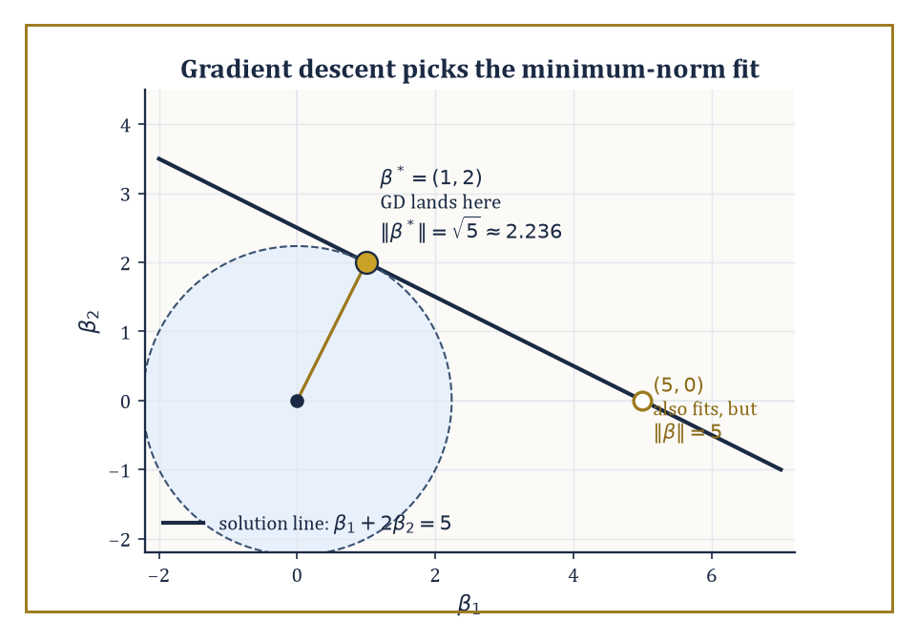
Figure 48.8 — Every point on the line β₁ + 2β₂ = 5 fits the data perfectly; gradient descent from zero picks, unannounced, the one closest to the origin, β* = (1,2), over equally valid alternatives like (5,0).
The clearest instance is implicit regularization: in an overparameterized model (more parameters than data points, so infinitely many settings of the parameters fit the training data exactly), gradient descent started from a particular initialization — typically all-zero, or small random values — does not land on an arbitrary interpolating solution.
It systematically prefers a specific one, and for the simplest overparameterized model, ordinary linear least squares with more unknowns than equations, that preferred solution has an exact, classical description: the minimum-norm interpolant, the one among all data-fitting solutions with the smallest Euclidean length.
Numeric example — gradient descent picks the tidiest answer. Take the smallest instructive underdetermined case: one data point, two parameters. The design row is X = [1, 2], the target is y = 5, and any β = (β₁, β₂) with the following fits the data quite — a whole line of solutions in the plane:
β₁ + 2β₂ = 5
The minimum-norm one is given by the pseudoinverse formula,
β* = Xᵀ(XXᵀ)⁻¹y
Here XXᵀ = 1² + 2² = 5 (a 1×1 matrix, so the scalar 5), giving
β* = [1;2]·(1/5)·5 = [1;2]·1 = (1, 2)
Check the fit:
1(1) + 2(2) = 1 + 4 = 5 ✓
Its norm is
‖β*‖ = √(1² + 2²) = √5 ≈ 2.236
Compare another wholly valid fit, β = (5, 0): also satisfies
1(5) + 2(0) = 5 ✓
but
‖β‖ = √(25+0) = 5
more than twice as large. It is a classical fact (traceable to the geometry of linear least squares: gradient descent from zero never leaves the row space of X, and within that one-dimensional row space here, only β* lies on the solution line) that gradient descent initialized at β₀ = (0,0) on this problem converges to β* = (1,2), the minimum-norm solution — not to (5,0), not to any of the infinitely many other equally data-fitting alternatives. The algorithm, asked only to drive the training loss to zero, quietly also chose the smallest, and typically best-generalizing, way of doing so.
Try it now — Find the minimum-norm solution of [1, 2]w = 10. Answer →
This phenomenon generalizes, with less exact but still substantial force, to the interpolation regime of modern overparameterized models (including, notoriously, large neural networks trained past the point of fitting their training data exactly): the path gradient descent takes, not merely its endpoint, encodes a statistical preference, and understanding that preference is now understood to be part of the statistical procedure itself, not a footnote to it.
A second thread ties optimization to statistics through online learning: a sequential prediction setting where, at each round t, the learner commits to a point xₜ before seeing that round’s loss function ℓₜ, incurs ℓₜ(xₜ), and only then gets to see ℓₜ and update.
The natural performance measure is regret — the learner’s total loss compared to the best single fixed point chosen with the benefit of hindsight,
minₓ Σₜ ℓₜ(x)
and bounding this regret, achievable with the same online-gradient-descent update as ordinary SGD, is simultaneously an optimization guarantee and (via standard online-to-batch conversion arguments) a statistical generalization guarantee for models trained by SGD on streaming or randomly-ordered data.
Numeric example — regret, computed honestly. Run online gradient descent on three rounds of losses ℓₜ(x) = (x − cₜ)²/2 with targets c = (1, −1, 1), starting at x₁ = 0 with step size η = 0.5.
Round 1: predict x₁ = 0, incur loss (0−1)²/2 = 0.5; gradient x₁ − c₁ = −1, so x₂ = x₁ − 0.5(−1) = 0.5
Round 2: predict x₂ = 0.5 against c₂ = −1, incur loss (0.5−(−1))²/2 = (1.5)²/2 = 1.125; gradient x₂ − c₂ = 1.5, so x₃ = 0.5 − 0.5(1.5) = −0.25
Round 3: predict x₃ = −0.25 against c₃ = 1, incur loss (−0.25−1)²/2 = (−1.25)²/2 = 0.78125
Total algorithm loss:
0.5 + 1.125 + 0.78125 = 2.40625
Now the benchmark: the single best fixed x in hindsight minimizes Σ(x−cₜ)²/2 over all three rounds at once, achieved at
x* = mean(c) = (1 − 1 + 1)/3 = 1/3
Its total loss is
(1/3−1)²/2 + (1/3+1)²/2 + (1/3−1)²/2 = (4/9)/2 + (16/9)/2 + (4/9)/2 = 2/9 + 8/9 + 2/9 = 12/9 = 4/3 ≈ 1.3333
The regret — algorithm loss minus best-in-hindsight loss — is
2.40625 − 1.3333 ≈ 1.073
That the regret is positive is entirely expected: the online learner had to commit to x₂ = 0.5 before knowing c₂ was going to swing all the way to −1, a mistake the hindsight benchmark never has to make. What online-learning theory actually promises is not zero regret but sublinear regret — that this gap, divided by the number of rounds T, shrinks toward zero as T grows, so the learner’s per-round disadvantage relative to the best fixed choice vanishes even though it is never told the future.
The lesson of this section, stated as starkly as the evidence allows: optimization, in the context of statistical learning, is not a subroutine bolted onto statistics from outside, minimizing a number handed to it by a separate statistical procedure.
It is part of the statistical procedure — the choice of algorithm, initialization, step size, and stopping time is itself a form of implicit modeling, one that current theory can characterize in simple cases and is still working, with considerable urgency, to characterize in the complicated ones that get deployed.
Where this returns
Optimization chooses parameters; model selection chooses among models. The two meet in Validation, Falsification, and Model Selection: penalties such as AIC and ridge both trade fit against complexity, and the implicit bias of this section is a penalty that nobody wrote down.
Keep only this · Section 48.8: Optimization for Statistical Learning
The idea. In learning, the optimizer is part of the model: its implicit bias selects among the many fits, and online methods are judged by regret.
Core.
min-norm: w = Xᵀ(XXᵀ)⁻¹y
ridge (scalar): w = xy/(x² + λ)
regret = Σℓₜ(xₜ) − min_x Σℓₜ(x)
Typical mistake. Measuring a learner only by its training loss. Every interpolating fit has zero training loss; the optimizer decides which one you get.
Minimal example. One equation, two unknowns: infinitely many fits, one of minimum norm.
Practice. Easy to challenge; full worked answers, with the usual mistake, are in Answers to the Practice Sets at the back.
Easy — Minimize (y − xw)² + λw² with x = 1, y = 2, λ = 1. Answer →
Medium — Why does gradient descent from 0 on least squares ‖Xw − y‖² find the minimum-norm solution? Answer →
Challenge — Online gradient descent with η = 0.5 starts at x₁ = 0 and faces losses (x − c)²/2 with c₁ = 2, c₂ = 0. Compute the regret. Answer →

Section 48.9: Looking Ahead: From Advanced Optimization to Deep Learning, Distributed Methods, and Open Problems
The view from the top of a chapter built almost wholly out of things that shouldn’t have worked
Gather up the tools of this chapter and the shape of what’s been built becomes clear. Nonconvex landscape geometry (Sections 48.1–48.2) told us when local search can be trusted despite the absence of global convexity — strict saddles, benign nonconvexity, landscape connectivity.
Stochastic and adaptive methods (Sections 48.3–48.4) told us how to run that local search cheaply, at scale, with noisy information, and how to reshape the geometry the noise has to cross.
Structured high-dimensional problems (High-Dimensional and Structured Nonconvex Problems) showed nonconvexity arising not as an obstacle but as the honest formulation of a statistical estimation task, complete with its own gap between what’s statistically possible and what’s computationally efficient.
Try it now — Four workers each compute a gradient on 32 examples and the results are averaged. What variance does the average have if one example has variance σ²? Answer →
Minimax optimization (Minimax Optimization and GANs) extended everything to competitive, two-player settings where a single number to minimize no longer exists. Complexity lower bounds (Complexity Lower Bounds and Optimal Rates) told us, with total rigor, just how good any of this could ever get. And optimization for statistical learning (Optimization for Statistical Learning) closed the loop by showing the algorithm itself performing statistics whether or not anyone asked it to.
None of this is a finished cathedral; it is scaffolding around several very active construction sites.
The training of deep neural networks specifically raises landscape questions this chapter has only gestured at — how the architecture itself (depth, width, skip connections, the normalization layers that rescale activations mid-network, the attention mechanisms that weight which inputs matter to which outputs) reshapes the loss landscape, sometimes making it dramatically more benign than a naive parameter count would suggest and sometimes not.
Distributed and federated optimization asks how to run these same algorithms when the data, and the compute, are scattered across many machines that may disagree with each other’s statistics (heterogeneity) and can only communicate occasionally and expensively (communication efficiency) — an entire secondary optimization problem layered on top of the one this chapter has been solving.
Second-order and quasi-Newton methods, which use curvature information the way Newton’s method did back in Chapter 30 (Volume 3), are being revisited for problems at a scale where computing, let alone inverting, a full Hessian is unthinkable, forcing clever low-memory approximations.
And a healthy list of open problems remains stubbornly open: sharp, general rates for nonconvex-nonconcave minimax problems (Minimax Optimization and GANs showed you the easy convex-concave case and the outright pathological bilinear failure; the vast territory in between is still being mapped); a fully satisfying theoretical account of why adaptive methods work as well as they empirically do; and a precise characterization of which modern architectures enjoy benign nonconvexity and which merely got lucky with their initialization.
The deeper lesson of the whole chapter, if it has to be compressed into one sentence on the way out, is that nonconvexity is not an obstacle to be apologized for but a landscape to be understood — and that understanding it, structure by structure, has produced algorithms that succeed spectacularly far outside the tidy convex regime where the theory was originally, and modestly, built.
Advanced optimization is the mathematics of hard, high-dimensional, and stochastic decision-making, and the series continues: the next chapter, Numerical Methods (Advanced), asks a closely related but distinct question — not only how to find the minimizer of a function you can only sample noisily, but how to compute, reliably and to guaranteed precision, whatever it is a differential equation, an integral, or a linear system is quietly trying to tell you, when doing so is as hopeless as finding a global minimum by inspection alone.
We have learned, at least, to climb the nonconvex landscape without assuming there’s only one valley in it.
So ends Chapter 48, two chapters short of the end, having spent its length arguing that the absence of convexity is a research program rather than a eulogy. What began, chapters ago, as gradient descent politely rolling downhill in a single well-behaved bowl has become gradient descent picking its way across an entire mountain range, occasionally noisy, occasionally adversarial, and only locally trustworthy — and somehow that is enough, more often than pessimism would have predicted, to reach somewhere good.
Ahead lies Chapter 49, Numerical Methods (Advanced), where the question shifts from finding the best point to computing, with certified accuracy, quantities that no closed form will ever hand you directly — differential equations, integrals, linear systems at a scale where ‘exact’ and ‘practical’ have long since stopped meaning the same thing. The gradient estimators, the error bounds, and the faint but persistent smell of numerical trouble met in this chapter will all be back, wearing slightly different hats.
Skip ahead. Mind the saddle points on the way out.
Keep only this · Section 48.9: Looking Ahead: From Advanced Optimization to Deep Learning, Distributed Methods, and Open Problems
The idea. Beyond this chapter: deep-network landscapes, distributed and federated optimization, second-order methods at scale, and open problems on rates and generalization.
Core.
distributed SGD = large-batch SGD + communication
benign landscapes explain much, but not all, of deep learning’s success
Typical mistake. Thinking the worst-case hardness of nonconvex optimization makes training hopeless. Real problems have structure the worst case lacks.
Minimal example. 10⁸ parameters in 4-byte floats: 400 MB per exchange.
Practice. Easy to challenge; full worked answers, with the usual mistake, are in Answers to the Practice Sets at the back.
Easy — A model has 10⁸ parameters stored as 4-byte floats. How much data does one full gradient exchange send? Answer →
Medium — Gradient descent from 0 is applied to [1 1]w = 2. Which solution does it reach? Answer →
Challenge — Explain, using two sections of this chapter, why gradient methods train large models despite worst-case hardness. Answer →
Chapter 48 recap · Optimization (Advanced)
• Without convexity, local minima, saddles and plateaus appear, and global optimization is hard in the worst case.
• Strict saddles have a direction of negative curvature; gradient methods with a little noise escape them.
• Stochastic gradients trade exactness for cheap steps; batch size and step-size schedules control the noise.
• Variance reduction and adaptive methods (AdaGrad, RMSProp, Adam) speed up stochastic optimization in different ways.
• Many structured nonconvex problems — low-rank recovery, phase retrieval — have benign landscapes; minimax problems need methods such as extragradient.
• Complexity lower bounds say what no method can beat; in learning, the optimizer’s implicit bias acts as model selection.

Check Your Understanding — Chapter 48
Answers are in the Answer Key at the back of the book — have a go before you look.
1. [Explain] In the worked example f(x) = x⁴ − x³ − 4x² + 4, a hillwalker starting near x ≈ −1.088 and only ever walking downhill ends up at a local minimum with f ≈ 1.954, while the true global minimum near x ≈ 1.838 has f ≈ −4.310. Why doesn’t gradient descent notice the better valley next door?
See the answer →
2. [Explain] The function f(x,y) = x² − y² has its only critical point at the origin, with Hessian eigenvalues +2 and −2. Why is this a strict saddle, and why does plain gradient descent started exactly at (0,0) fail to move even though the point is not a minimum?
See the answer →
3. [Compute] Using the rank-1 recovery objective g(u) = ¼‖uuᵀ − M*‖²_F with M* = [4 2; 2 1] (ground truth x* = (2,1)), compute g at the plausible-looking but wrong point u = (1,2), and explain what this shows about the landscape.
See the answer →
4. [Explain] Deterministic gradient descent needs O(1/ε²) iterations to reach an ε-critical point, while plain SGD needs O(1/ε⁴). Why does halving ε cost deterministic GD only a factor of 4 but costs SGD a factor of 16, and why does this make variance reduction more than a minor refinement?
See the answer →
5. [Compute] Run two steps of gradient descent on f(x) = x² from x₀ = 1 with learning rate η = 0.1, and identify the convergence rate.
See the answer →
6. [Compute] Repeat the previous descent with η = 1.1. What happens, and what is the stability condition on η for f(x) = x²?
See the answer →
7. [Concept] Convexity is often described as the property that separates easy optimization from hard. What precisely does it buy you?
See the answer →
8. [Prove] Show that for a convex function, every local minimum is a global minimum.
See the answer →
9. [Explain] Stochastic gradient descent is noisier than full gradient descent, yet the noise is often described as helpful. How can randomness improve an optimizer?
See the answer →
10. [Challenge] A network with far more parameters than training examples can fit pure noise, yet the same architecture trained on real data often generalizes well. Why is that not a contradiction?
See the answer →

Problems — Chapter 48
The questions above test whether the ideas landed. These ask you to use them. Solutions are in Solutions to the Problems at the back. Work them before you look.
1. [Compute] f(x) = x² / 2. Gradient descent with step length 1, starting at x = 3. Compute the next point.
2. [Prove] Show that f(x) = x² is convex: the graph lies under its chords. A useful identity is t(1 − t)(x − y)² ≥ 0.
3. [Compute] A stochastic gradient has variance 1 when the batch size is 1. If the noise terms are independent and you average a batch of 4, what is the variance of the average?
4. [Explain] Doubling the batch cuts the noise by √2, not by 2. Why, past a point, is it cheaper to take more steps than to keep enlarging the batch?

Math, Actually

Chapter 49

Numerical Methods (Advanced)
High Performance, Structure, and the Art of Computing at Scale
Chapter 48 left us having squeezed almost every drop of optimality out of optimization: gradients tamed, constraints herded into line, even the non-convex badlands surveyed with the appropriate degree of terror. Numerical methods proper began much earlier in the series, in Chapter 29 (Volume 3), where root-finding, interpolation, quadrature, and the discretization of differential equations were introduced as the sensible person’s substitute for solving things exactly — exact solutions being, for most equations that matter, a courtesy mathematics declines to extend. This chapter resumes that program where the phrase ‘small enough to solve on the back of an envelope, or at worst a patient laptop’ stops being true.
It stops being true in three ways, and the whole of what follows is really an extended meditation on each of them. First, scale: the matrices arising from a three-dimensional PDE discretized on a mesh fine enough to be useful have millions or billions of unknowns, at which point storing them densely — the elementary approach — requires more memory than exists. Second, structure: those same matrices are almost entirely zero, because a grid point only feels its immediate neighbors, and an algorithm that fails to notice this is not merely slow but insultingly wasteful.
Third, uncertainty: the model itself, and the data feeding it, are rarely known precisely, and a single deterministic number output with no error bar attached is a confidence trick, however sincerely meant. Elementary numerical analysis, admirably, gets the mathematics of consistency, stability, and convergence right; it never had to meet a matrix this large, this sparse, or this unsure of itself.
A confession, offered in the spirit of full disclosure rather than self-pity: advanced numerical methods is the subject in which the gap between a textbook algorithm — three elegant lines, a Greek letter or two, a satisfied full stop — and a production code that runs on real hardware is at its widest and least forgivable.
Rounding error accumulates in ways your convergence proof did not anticipate; cache hierarchies punish an algorithm that reads memory in the wrong order regardless of how few flops it uses; communication between processors costs more than the arithmetic it enables; and reproducibility, that unglamorous virtue, turns out to require real mathematical care once floating-point addition stops being associative. Every algorithm in this chapter is therefore, secretly, a software-engineering problem wearing a theorem as a disguise. The mathematics remains the foundation. The implementation is where the art — and a good deal of the swearing — happens.
If elementary numerical methods taught us to discretize, this chapter teaches us to discretize at scale, with structure, and without lying to ourselves about how sure we are of the answer. The next chapter, the fiftieth and last, turns outward to applied mathematics and modeling proper — the business of deciding what equation to solve in the first place. Before we get there, we still have to learn how to solve the ones we’ve already chosen, when they are enormous, sparse, high-dimensional, and reluctant to sit still. Let’s compute at scale.
What you already know, and the assumption now removed
Chapter 29 (Volume 3), Numerical Methods, built the elementary toolkit. You already know:
• Gaussian elimination and LU factorization solve dense systems in O(n³) operations; condition numbers measure sensitivity.
• Root-finding, interpolation, quadrature, and Euler and Runge–Kutta steps for ODEs.
• Finite differences for PDEs, and the rule that consistency plus stability gives convergence.
This chapter removes one assumption: feasibility at scale — that the problem fits in memory, that O(n³) is affordable, that the data are certain, and that a short simulation is enough. The consequences: iteration instead of elimination (Iterative Methods for Linear Systems, Preconditioning and Multigrid); a few eigenvalues instead of all (Sparse Eigenvalue Problems and SVD); accuracy per unknown (Spectral and High-Order Methods, Adaptive Finite Elements and Multilevel Methods); uncertain inputs (Uncertainty Quantification); and long times (Structure-Preserving and Geometric Integration).
Before you begin — Chapter 49
By the end of this chapter you will be able to:
1. Estimate memory traffic and arithmetic intensity, and choose sparse storage.
2. Run Jacobi and conjugate-gradient iterations and predict their convergence from the condition number.
3. Explain why preconditioning and multigrid make large elliptic problems cheap.
4. Use power iteration, Lanczos and the SVD for large eigenvalue problems and low-rank approximation.
5. Compare spectral, high-order and adaptive finite-element accuracy.
6. Propagate uncertainty by Monte Carlo and polynomial chaos, and integrate Hamiltonian systems without energy drift.
Prerequisites. Chapter 29 (Volume 3), Numerical Methods, throughout; eigenvalues and the SVD from Linear Algebra (Volume 2); expectation and variance from Expectation, Variance, and Conditioning; Hamilton’s equations from Lagrangian and Hamiltonian Mechanics for Section 49.8.
Estimated study time. About 11 hours, exercises included.

Section 49.1: What Advanced Numerical Methods Actually Are
In Which the Matrices Get Big and the Excuses Run Out
You know, from any job that involves fetching things, that the fetching can cost more than the work. Cooking from a recipe whose ingredients are all on the counter is a different afternoon from cooking the same recipe with four trips to the shop in it, even though the chopping and stirring are identical.
Numerical analysis was taught to you the other way round. Count the multiplications and additions an algorithm performs, compare the counts, prefer the smaller one. That measure is not wrong, and Chapter 29 (Volume 3) uses it honestly. What it assumes is that the numbers are already on the counter.
On any machine built in the last thirty years they are not, and so the quantity worth knowing is a ratio rather than a total. Not how many operations does this perform, but how many operations does it perform for each number it must go and fetch.
The uncomfortable part is that the old measure gives no hint of the new one. Two algorithms can perform the same number of operations and differ by a factor of fifty in how long they take, and nothing in the operation count — the one thing you were trained to compute — records the difference. You are not measuring the expensive thing.
So count both. Multiply a thousand-by-a-thousand matrix by a vector, with each number stored in eight bytes:
work done 2n² − n = 1,999,000 operations
numbers fetched n² × 8 = 8,000,000 bytes
operations per byte fetched 0.25
A quarter of an operation for every byte hauled out of memory, against a processor able to perform something in the region of ten to fifty operations in the time it takes to haul one. The arithmetic is not the bottleneck and has not been for a long while; the machine spends the overwhelming majority of that calculation waiting.
What the figure 0.25 never does is tell you a speed. It is a property of the algorithm and says nothing on its own about how long anything takes; pair it with a machine that moves memory twice as fast and the ratio is unchanged while the runtime halves. It is a diagnosis, not a measurement, and this chapter is largely about what to do once the diagnosis comes back.
Advanced numerical methods address problems whose size, structure, or uncertainty exceeds the reach of the elementary algorithms of Chapter 29 (Volume 3). The emphasis shifts, almost entirely, away from dense linear algebra and uniform grids and toward sparse matrices, hierarchical bases, adaptive discretizations, and probabilistic models of error and uncertainty.

Figure 49.1 — Dense versus compressed-sparse-row storage for the same n = 1000 tridiagonal matrix — roughly two hundred zeros’ worth of savings.
The change is not cosmetic. A dense n×n matrix costs n² memory and roughly n³ flops to solve directly by Gaussian elimination; once n reaches even a modest million — wholly ordinary for a three-dimensional PDE mesh — n² already exceeds what any machine can store, and n³ exceeds what any machine will finish computing before the heat death of the universe, or at any rate before your grant runs out.
The subject that follows is, in large part, the discovery that one never needs the dense picture: almost every large matrix that arises from a real physical problem is sparse, because physics is local, and locality is a resource waiting to be exploited.
There is a useful, slightly melancholy analogy here with the census: a dense matrix insists on recording the relationship between every pair of unknowns, however irrelevant, in the same way a census that asked each citizen to describe their relationship to every other citizen would generate mostly blank forms and a truly heroic filing problem; a sparse matrix, sensibly, only records the relationships that exist.
Numeric example — arithmetic intensity and the memory wall. Consider a dense matrix–vector product with A of size n = 1000, stored in double precision (8 bytes per entry):
y = Ax
The flop count is exact: each of the n² = 1,000,000 entries contributes one multiply and (almost) one add.
2n² − n = 1,999,000 flops
The memory traffic is dominated by reading the matrix itself, since the vectors x and y are negligible by comparison at 8 kilobytes each:
n² × 8 bytes = 8,000,000 bytes, i.e. 8 megabytes
The arithmetic intensity — flops performed per byte fetched from memory — is therefore:
AI = 1,999,000 / 8,000,000 ≈ 0.25 flops per byte
A typical modern processor can perform on the order of 10–50 flops for every byte it can move from main memory in the same time (the exact ratio is the machine’s ‘roofline’ balance point); an operation with AI ≈ 0.25 sits nowhere near that ceiling, meaning the processor spends nearly all its time waiting for numbers to arrive, not computing on them. This is why dense matrix–vector multiplication is called memory-bound, and why simply having ‘more flops available’ — the traditional boast of a new supercomputer — does almost nothing to speed it up.
The entire discipline of exploiting sparsity, discussed next, exists in large part to raise the numerator (or, more precisely, to shrink the denominator by never fetching the zeros in the first place).
Try it now — A dense matrix–vector product with n = 2,000 in double precision: how many bytes must be read, how many flops are done, and what is the arithmetic intensity? Answer →
Structure — sparsity, low rank, hierarchy, symmetry — is therefore not a nicety but the principal resource that advanced numerical algorithms are designed around. A sparse matrix stores only its nonzero entries, typically in a compressed format such as CSR (compressed sparse row): one array of the nonzero values, one array recording which column each value belongs to, and one short array of row pointers.
For a matrix arising from a one-dimensional finite-difference or finite-element discretization, each row has only two or three nonzero entries regardless of how large n becomes, because each grid point only interacts with its immediate neighbors. The saving compounds: not only does the matrix fit in memory when the dense version would not, but the sparse matrix–vector product touches only the nonzero entries, so its flop count and memory traffic both scale linearly in n rather than quadratically.
Low rank (a matrix well approximated by the product of two much thinner matrices) and hierarchy (a multiscale organization in which coarse features are cheap and fine features are added as corrections) are the same idea one level up, and both reappear repeatedly in this chapter — in multigrid, in randomized SVD, and in multilevel Monte Carlo alike.
Numeric example — dense versus sparse storage. Take the tridiagonal matrix that arises from a standard one-dimensional discretization (each interior row has entries on the main diagonal and its two neighbors) with n = 1000.
Dense storage requires:
n² = 1,000,000 entries, i.e. 8 megabytes in double precision
The matrix actually has only 3n − 2 nonzero entries, since the two corner rows have one fewer neighbor each:
3n − 2 = 2998 nonzero entries
Stored in CSR format, that is 2998 values, 2998 column indices, and about 1001 row pointers:
2998 values × 8 bytes each = 23,984 bytes
(2998 column indices + 1001 row pointers) × 4 bytes each (32-bit integers) ≈ 15,996 bytes
total ≈ 23,984 + 15,996 = 39,980 bytes, about 39 kilobytes
The ratio of dense to sparse storage is:
8,000,000 / 39,980 ≈ 200
So the sparse representation is roughly two hundred times smaller for this modest n, and the gap widens linearly as n grows, since dense storage scales as n² while sparse storage scales as n. This is not an optimization; below a certain problem size dense storage is merely wasteful, and above it, it is impossible.
Everything in this chapter is a variation on that single realization: complexity is no longer measured only in flops, but in memory traffic, communication volume between processors, and how gracefully an algorithm scales as more of them are added. The sections that follow are, in effect, a catalog of the ways one can be clever about matrices, meshes, spectra, and uncertainty once the naive dense approach has excused itself from the section.
Keep only this · Section 49.1: What Advanced Numerical Methods Actually Are
The idea. Advanced numerical methods are what is needed when problems are too large, too structured or too uncertain for the elementary algorithms: sparsity, iteration, hierarchy, and respect for structure.
Core.
intensity = flops/bytes moved
matvec ≈ 0.25 flop/byte; matmul ≈ n/12 flop/byte
tridiagonal: 3n − 2 entries
Typical mistake. Measuring cost by flops alone. On modern hardware moving the data often costs more than the arithmetic.
Minimal example. n = 10⁶ tridiagonal: about 24 MB sparse against 8 TB dense.
Practice. Easy to challenge; full worked answers, with the usual mistake, are in Answers to the Practice Sets at the back.
Easy — Compare dense and tridiagonal storage for n = 10⁶ in double precision. Answer →
Medium — Estimate the arithmetic intensity of a dense matrix–matrix product of size n = 1,000. Answer →
Challenge — A machine does 10¹² flops/s but moves 10¹¹ bytes/s. What fraction of peak does a matrix–vector product reach? Answer →

Section 49.2: Iterative Methods for Linear Systems
Approximating Our Way to an Exact Answer, Politely
Same structure, new language
Minimizing ½xᵀAx − bᵀx over x is the same problem as solving Ax = b when A is symmetric positive definite. Conjugate gradients is an optimization method of Optimization (Volume 3) in disguise, and the chain functions of Complexity Lower Bounds and Optimal Rates — quadratics that reveal one new coordinate per gradient — are exactly the hard cases for Krylov methods, whose subspace also grows by one dimension per step.
When a linear system Ax = b is too large to solve directly (recall from What Advanced Numerical Methods Actually Are that direct Gaussian elimination costs O(n³) flops and, worse, tends to destroy sparsity by filling in zero entries with nonzero ones as it proceeds), the practical alternative is to build a sequence of increasingly good approximations using only matrix–vector products — never forming A explicitly beyond that.
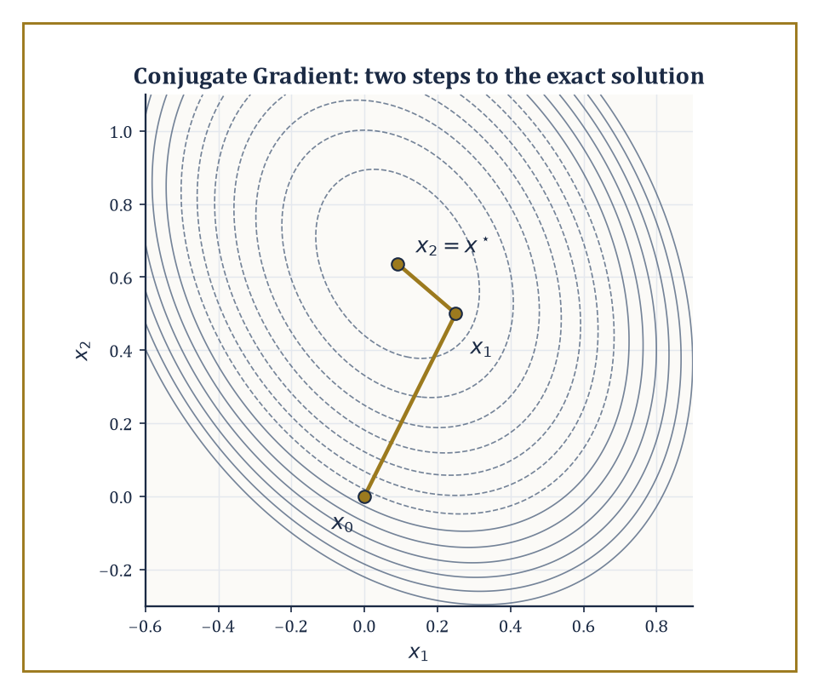
Figure 49.2 — The two Conjugate Gradient steps of the worked example, plotted against the level sets of the quadratic they minimize.
The natural space in which to build such approximations is the Krylov subspace, generated by repeatedly applying A to the initial residual:
Kₘ(A, r₀) = span{r₀, Ar₀, A²r₀, …, Aᵐ⁻¹r₀}, where r₀ = b − Ax₀
Krylov methods — Conjugate Gradient (CG), MINRES, GMRES, BiCGSTAB, and their relatives — construct the m-th approximation xₘ by extracting the best available vector from x₀ + Kₘ(A, r₀) according to some notion of ‘best’: smallest error in a natural norm for CG, smallest residual for MINRES and GMRES.
Because the only operation required is a matrix–vector product, these methods are matrix-free: A need never be stored explicitly at all, only a subroutine that computes Av for a given v, which is exactly what a sparse or structured matrix offers cheaply.
Numeric example — Conjugate Gradient by hand. Solve Ax = b with A = [4 1; 1 3] and b = [1, 2], starting from x₀ = [0, 0].
This A is symmetric positive-definite: its eigenvalues are found from
λ² − 7λ + 11 = 0
and both roots are positive.
Initialize the residual and search direction:
r₀ = b − Ax₀ = [1, 2], p₀ = r₀ = [1, 2]
Step 1:
Ap₀ = [4·1+1·2, 1·1+3·2] = [6, 7]
α₀ = (r₀ᵀr₀)/(p₀ᵀAp₀) = 5/20 = 1/4
Update:
x₁ = x₀ + α₀p₀ = [1/4, 1/2]
r₁ = r₀ − α₀Ap₀ = [1 − 1.5, 2 − 1.75] = [−1/2, 1/4]
Step 2:
β₀ = (r₁ᵀr₁)/(r₀ᵀr₀) = (5/16)/5 = 1/16
so the new direction is
p₁ = r₁ + β₀p₀ = [−7/16, 3/8]
Then:
Ap₁ = [−11/8, 11/16], p₁ᵀAp₁ = 55/64, α₁ = (5/16)/(55/64) = 4/11
Updating:
x₂ = x₁ + α₁p₁ = [1/4 − 7/44, 1/2 + 3/22] = [1/11, 7/11]
Checking directly against the original equations 4x + y = 1 and x + 3y = 2 gives, by substitution, x = 1/11 and y = 7/11 precisely — CG has found the exact solution in precisely two steps, and one can verify r₂ = [0, 0] outright.
This finite termination in at most n steps (here n = 2) is not a coincidence; it follows from the Cayley–Hamilton theorem, since the Krylov space can grow no larger than the dimension of the ambient space. In practice n is in the millions and one stops long before exhaustion, satisfied with a residual small enough for the application at hand.
Try it now — Take two Jacobi steps for A = [4 1; 1 3], b = (1, 2), from x₀ = (0, 0), and compare with the exact solution. Answer →
For symmetric positive-definite systems, CG is optimal among Krylov methods in a precise sense: among all vectors reachable from x₀ + Kₘ(A, r₀), it selects the one minimizing the A-norm of the error,
‖x − xₘ‖_A = √((x − xₘ)ᵀA(x − xₘ))
and it does so using only short recurrences that require storing a handful of vectors regardless of m — the reason CG scales to enormous sparse systems where storing all previous search directions explicitly would be impossible.
For nonsymmetric systems, no such short recurrence with an optimality guarantee exists in general (a fact with a precise theoretical pedigree, not merely an engineering inconvenience), and GMRES is the standard fallback: it minimizes the Euclidean residual ‖b − Axₘ‖ over x₀ + Kₘ(A, r₀) using the Arnoldi process to build an orthonormal basis.
This comes at the cost of having to store all m basis vectors — hence the near-universal practice of restarted GMRES(m), which discards the accumulated basis every m steps and starts afresh, trading some convergence speed for bounded memory.
BiCGSTAB and its relatives sacrifice the strict minimization property in exchange for short recurrences even in the nonsymmetric case, a compromise that works remarkably well in practice and rather less predictably in theory — the sort of arrangement a mathematician tolerates only because the alternative, restarted GMRES with a memory budget too small for the problem, tolerates it rather worse.
The initial guess x₀ deserves a word too, since it is the one ingredient every Krylov method depends on that the theory tends to wave past: a good initial guess (the solution from a previous, nearby time step, say, or from a coarser discretization) shrinks the initial residual r₀ and therefore the entire Krylov space the method has to search through, while a poor one costs nothing beyond wasted iterations — there is no danger in guessing badly, only in not bothering to guess well when a better guess was sitting nearby the whole time.
Abstract example — the residual polynomial viewpoint. Every Krylov method’s m-th residual can be written as follows, for some polynomial pₘ of degree at most m with pₘ(0) = 1:
rₘ = pₘ(A) r₀
This follows directly from rₘ ∈ r₀ + AKₘ(A, r₀), unwinding the definition of the Krylov space.
CG and GMRES differ only in which norm they minimize this polynomial’s action in:
CG minimizes ‖pₘ(A) r₀‖_(A⁻¹) when A is SPD; GMRES minimizes ‖pₘ(A) r₀‖ in the ordinary Euclidean norm for general A
This single observation explains why convergence theory for both methods is stated in terms of the spectrum (for symmetric A) or the field of values (for nonsymmetric A): a Krylov method converges quickly when there exists a low-degree polynomial, small at every eigenvalue of A and equal to 1 at the origin, and such a polynomial is easy to construct exactly when the eigenvalues are tightly clustered away from zero — which is precisely the property a good preconditioner, the subject of the next section, is designed to manufacture.
Keep only this · Section 49.2: Iterative Methods for Linear Systems
The idea. Iterative methods improve an approximate solution using only matrix–vector products; Krylov methods such as CG and GMRES choose the best approximation from a growing subspace.
Core.
CG: ‖e_k‖_A ≤ 2((√κ − 1)/(√κ + 1))ᵏ‖e₀‖_A
r_k = p_k(A)r₀, p_k(0) = 1
Typical mistake. Expecting CG to need n steps in practice. Its rate depends on κ and on how the eigenvalues cluster, not on n.
Minimal example. κ = 100: CG’s factor per step is 9/11 ≈ 0.82.
Practice. Easy to challenge; full worked answers, with the usual mistake, are in Answers to the Practice Sets at the back.
Easy — For κ = 100, what is CG’s contraction factor per step? Answer →
Medium — Roughly how many CG steps reduce the error by 10⁶ when κ = 100? Answer →
Challenge — Show that if A has only two distinct eigenvalues λ₁, λ₂, CG converges in at most two steps. Answer →

Section 49.3: Preconditioning and Multigrid
Solving a Different, Nicer Problem That Happens to Have the Same Answer
Iterative solvers for large systems of equations converge quickly when a problem is well balanced and slowly when it is lopsided, with some directions far more sensitive than others. The ratio of the most to the least sensitive, the condition number, controls the speed. Preconditioning means first transforming the problem into an equivalent one with the same answer and a better balance. In this section’s example the two sensitivities differ by a factor of 50; simply rescaling each equation by its own diagonal entry brings that down to about 1.15, and the solver then finishes in a handful of steps. Multigrid, the other idea here, attacks the imbalance by working on coarse and fine grids together.
A preconditioner M is an approximation to A that is, crucially, much cheaper to invert than A itself; instead of solving Ax = b directly, one solves the equivalent system:
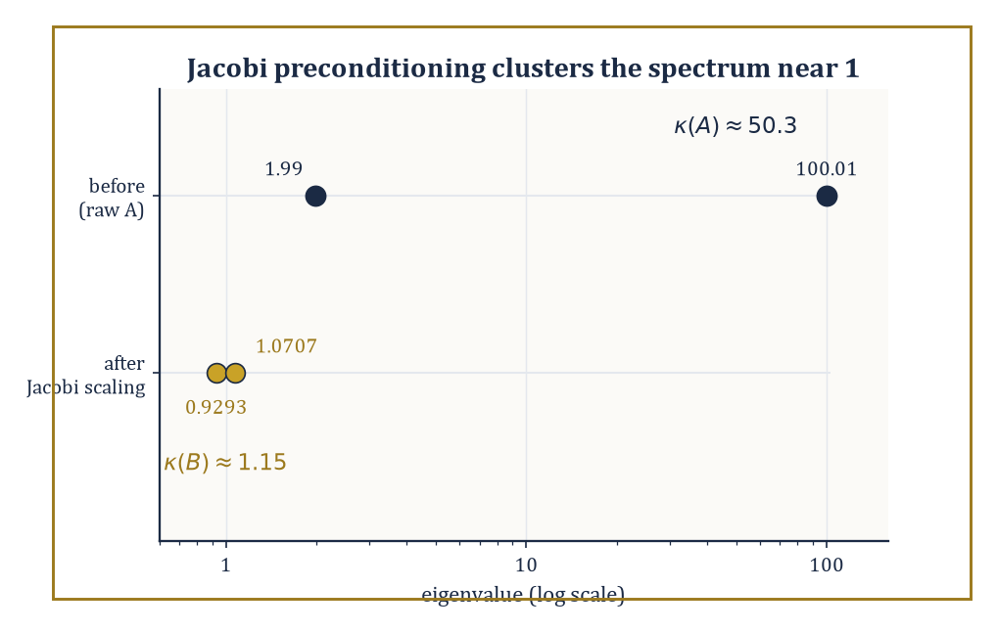
Figure 49.3 — Jacobi scaling herds the worked example’s two eigenvalues from a 50-to-1 spread down to a barely-there 1.15.
M⁻¹Ax = M⁻¹b
This system (or a symmetrized variant) has the same solution but — if M has been chosen well — a far more favorable spectrum for a Krylov method to chew through.
The previous section ended on the observation that Krylov convergence is governed by how easily a low-degree polynomial can be made small across the matrix’s eigenvalues; preconditioning attacks the problem directly by clustering those eigenvalues near 1, so that a very low-degree polynomial suffices.
Algebraic preconditioners — incomplete LU factorization (ILU), sparse approximate inverses, algebraic multigrid — build M from the matrix entries alone, with no reference to any underlying geometry, which makes them broadly applicable but somewhat blind. Geometric preconditioners, especially multigrid, use the grid the matrix came from and are correspondingly more powerful when that grid exists.
Numeric example — Jacobi preconditioning shrinks a condition number. Take the symmetric positive-definite matrix A = [100 1; 1 2]. Its eigenvalues solve:
λ² − 102λ + 199 = 0
λ = (102 ± √9608)/2 ≈ (102 ± 98.02)/2, i.e. λ₁ ≈ 100.01 and λ₂ ≈ 1.99
The condition number is:
κ(A) = λ₁/λ₂ ≈ 50.3
This is respectable, but CG’s error bound worsens with √κ, so this is already an unpleasant system to iterate on. Apply the simplest possible preconditioner, symmetric Jacobi scaling: let D = diag(100, 2) and form B = D^(−1/2) A D^(−1/2).
Direct computation gives:
B₁₁ = 100/100 = 1, B₂₂ = 2/2 = 1, B₁₂ = B₂₁ = 1/√(100·2) = 1/√200 ≈ 0.0707
So:
B = [1 0.0707; 0.0707 1], whose eigenvalues are 1 ± 0.0707, namely about 1.0707 and 0.9293
The new condition number is:
κ(B) ≈ 1.0707/0.9293 ≈ 1.15
This is down from 50.3 to essentially 1, using nothing more sophisticated than dividing each row and column by the square root of its own diagonal entry. This is the entire content of diagonal (Jacobi) preconditioning: it costs almost nothing and, whenever the poor conditioning comes from wildly differing diagonal magnitudes (as it does here), it does almost all the work.
Try it now — Find κ for A = diag(1, 100) before and after Jacobi preconditioning. Answer →
Multigrid is the more ambitious answer, and for elliptic problems (the class that includes the Poisson equation and most steady-state diffusion problems) it achieves something remarkable: optimal complexity, meaning the total work to solve the system to a fixed accuracy grows only linearly in the number of unknowns, O(n), rather than the worse-than-linear growth every other general-purpose method suffers.
The mechanism rests on a division of labor. Simple iterative smoothers, such as weighted Jacobi or Gauss–Seidel, are hopeless at reducing smooth, long-wavelength error but excellent at annihilating oscillatory, short-wavelength error within just a few sweeps.
Multigrid exploits this asymmetry by smoothing on the fine grid until only smooth error remains, then transferring that residual to a coarser grid — on which the remaining smooth error looks comparatively oscillatory and can itself be smoothed away cheaply, recursing all the way down to a grid small enough to solve directly, before interpolating the correction back up.
Geometric multigrid needs an actual grid hierarchy to do this transferring; algebraic multigrid (AMG) constructs a synthetic coarse ‘grid’ directly from the matrix’s connectivity pattern, extending the idea to unstructured meshes and general sparse matrices where no natural coarsening is visible to the eye.
Abstract example — a two-level cycle on a 1-D problem. Consider a 1-D discretization with a fine grid of 7 interior points (spacing h) and a coarse grid of 3 interior points obtained by keeping every other fine point (spacing H = 2h).
Decompose any error on the fine grid into Fourier modes:
sin(kπx), for k = 1, …, 7
Weighted Jacobi smoothing damps the high-wavenumber modes (k close to 7, oscillating rapidly from one grid point to the next) by a large factor per sweep but barely touches the low-wavenumber modes (k close to 1, varying gently across the domain) — this is the asymmetry the method relies on. After a few smoothing sweeps, only the smooth, low-k error survives on the fine grid.
Crucially, that same low-k mode, when sampled only at the 3 coarse points, is resolved just as accurately as a high-k mode would have been on the fine grid — smooth functions need few points to represent — so the coarse grid can now smooth it away cheaply, or recurse further if the hierarchy continues.
The correction computed on the coarse grid is then interpolated back and added to the fine-grid approximation. No step in this cycle required forming a dense matrix or an explicit polynomial; the entire O(n) complexity comes from the fact that each level does a fixed, small amount of work per unknown, and there are only O(log n) levels.
The upshot, stated plainly: preconditioning is very often the difference between a Krylov method that converges in a dozen iterations and one that has not visibly moved after ten thousand, and multigrid — where it applies — is the gold standard against which every other preconditioner for elliptic problems is measured, because nothing else routinely achieves optimal linear complexity on large problems.
Keep only this · Section 49.3: Preconditioning and Multigrid
The idea. Preconditioning replaces Ax = b by an equivalent system with smaller condition number; multigrid smooths high-frequency error on the fine grid and removes smooth error on coarse grids.
Core.
solve M⁻¹Ax = M⁻¹b, κ(M⁻¹A) ≪ κ(A)
multigrid work: n(1 + 1/2ᵈ + 1/4ᵈ + ⋯)
Typical mistake. Thinking multigrid is just a faster smoother. Smoothers stall on smooth error; the coarse grid removes it.
Minimal example. A = [4 0; 0 1]: κ = 4.
Practice. Easy to challenge; full worked answers, with the usual mistake, are in Answers to the Practice Sets at the back.
Easy — Find κ for A = [4 0; 0 1]. Answer →
Medium — In 2-D, each coarse grid has a quarter of the points of the finer one. Bound the total number of points over all levels in terms of the finest grid’s n. Answer →
Challenge — For the 1-D Poisson matrix, weighted Jacobi with ω = 2/3 multiplies error mode k by 1 − 2ω sin²(kπ/(2n)). Show that high-frequency modes (k ≥ n/2) shrink by at least a factor 3, and say what happens to k = 1. Answer →

Section 49.4: Sparse Eigenvalue Problems and SVD
Finding a Handful of Eigenvalues Without Meeting All the Others
You have seen this before
Eigenvalues decided stability for the pendulum in Linear State-Space Models and Linearization and Local Structure. At scale the question is the same — where are the eigenvalues nearest the imaginary axis? — but the matrix has millions of rows, and only a few eigenvalues can be afforded.
For a large sparse matrix, computing the full eigendecomposition — every eigenvalue and eigenvector — is neither affordable nor, usually, wanted; most applications need only a handful of extremal or otherwise interesting eigenvalues (the lowest vibrational frequencies of a structure, the ground-state energy of a quantum system, the dominant modes of a dataset).
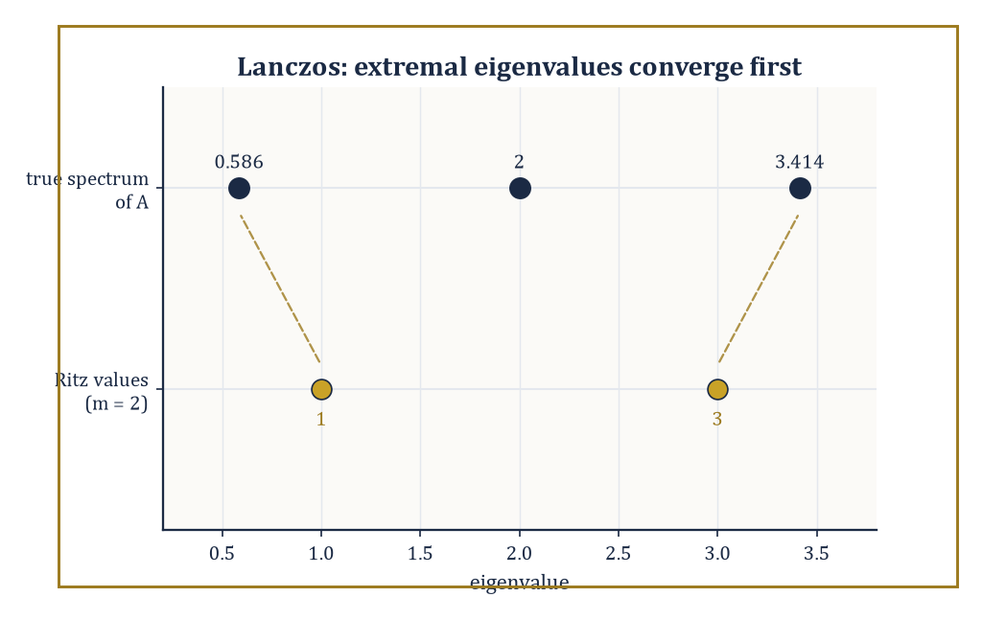
Figure 49.4 — After just two Lanczos steps, the Ritz values 1 and 3 already flank the true extremal eigenvalues 0.586 and 3.414.
Krylov methods once again supply the machinery: the Lanczos algorithm, for symmetric matrices, and its nonsymmetric generalization, Arnoldi, build an orthonormal basis {q₁, …, qₘ} of the Krylov space Kₘ(A, q₁) and simultaneously produce a small m×m matrix — tridiagonal for Lanczos, upper Hessenberg for Arnoldi — that represents A’s action restricted to that subspace.
The eigenvalues of this small matrix, called Ritz values, are the algorithm’s best available approximations to eigenvalues of A, and they typically converge to the extremal eigenvalues astonishingly fast, often within a number of steps far smaller than n.
Shift-and-invert redirects the method toward interior eigenvalues that would otherwise be ignored in favor of the extremes: it replaces A by (A − σI)⁻¹ for a shift σ near the eigenvalues of interest, since:
(A − σI)⁻¹ has eigenvalues 1/(λᵢ − σ)
An eigenvalue λᵢ close to σ becomes enormous in the transformed spectrum and is therefore the one a Krylov method, which always chases the extremes first, finds fastest — a pleasing bit of judo in which the very bias that makes Lanczos indifferent to interior eigenvalues is turned around and used to hunt them down deliberately.
The one price is that each Krylov step now requires solving a linear system with A − σI rather than a single matrix–vector product, so shift-and-invert is only as cheap as the sparse factorization (or preconditioned solve, courtesy of Preconditioning and Multigrid) behind it.
The Jacobi–Davidson method sidesteps some of that cost by expanding the search space with a correction equation rather than a fixed shift, and contour-integral techniques (the FEAST-type family) count and extract every eigenvalue enclosed by a chosen contour in the complex plane via a handful of resolvent evaluations — both are the methods of choice when the spectrum is clustered, defective, or otherwise unkind to a straightforward Krylov approach.
Numeric example — two steps of Lanczos. Let A = [2 1 0; 1 2 1; 0 1 2], a standard discrete-Laplacian-type matrix whose exact eigenvalues are 2 − √2 ≈ 0.586, 2, and 2 + √2 ≈ 3.414. Start Lanczos from q₁ = [1, 0, 0].
Compute:
Aq₁ = [2, 1, 0], α₁ = q₁ᵀ(Aq₁) = 2
The residual has norm β₁ = 1:
w₁ = Aq₁ − α₁q₁ = [0, 1, 0], β₁ = 1, q₂ = [0, 1, 0]
Next:
Aq₂ = [1, 2, 1], α₂ = q₂ᵀ(Aq₂) = 2
w₂ = Aq₂ − α₂q₂ − β₁q₁ = [1, 2, 1] − [0, 2, 0] − [1, 0, 0] = [0, 0, 1]
After only two steps, the projected tridiagonal matrix is:
T₂ = [2 1; 1 2], whose eigenvalues are 2 ± 1, i.e. 1 and 3
Compare with the true extremal eigenvalues 0.586 and 3.414: after just two matrix–vector products — no factorization of A, no dense eigensolver, nothing beyond Aq for two vectors q — the Ritz values 1 and 3 already sit within about 0.41 of the true extremes, and the gap closes further, typically very fast, with each additional step.
This is the entire appeal of Krylov eigensolvers: they extract the dominant spectral information first, cheaply, without ever needing the rest of the spectrum.
Try it now — Run two steps of power iteration on [2 1; 1 2] from (1, 0), without normalizing. Answer →
The singular value decomposition of a large matrix is computed by close relatives of the same machinery — either Lanczos-type methods applied to AᵀA (or, more stably, to the augmented matrix [0 A; Aᵀ 0]) or, increasingly, by randomized algorithms that multiply A by a small number of random test vectors and exploit concentration-of-measure phenomena to capture its dominant range with high probability at a fraction of the cost of a deterministic method.
Whichever route is taken, the outcome is a low-rank approximation keeping only the r largest singular values:
A ≈ Σᵣ σᵢ uᵢ vᵢᵀ
The Eckart–Young theorem guarantees this truncation is the best possible rank-r approximation in both the spectral and Frobenius norms — not merely a convenient one.
This makes the SVD simultaneously a numerical tool (for solving ill-conditioned or rank-deficient least-squares problems) and a model-reduction device (for compressing a large dataset or a large simulation down to its dominant modes), which is why it underlies both classical numerical analysis and principal component analysis in equal measure — the same decomposition, wearing different hats depending on whether the section down the corridor calls itself Numerical Linear Algebra or Statistics.
Randomized SVD algorithms deserve a further word, since they can feel like a magic trick the first time one meets them: multiply A by a small random matrix Ω with, say, r + 10 columns, orthonormalize the result to get a matrix Q whose columns approximately span A’s dominant range, and then work with the tiny matrix QᵀA instead of A itself.
That this crude-sounding procedure works reliably is a consequence of measure concentration in high dimension — a random subspace of modest dimension almost never misses a matrix’s dominant directions by more than a small, controllable amount — and the practical upshot is a dominant-mode extraction algorithm that touches A only a handful of times, making it competitive with, and often faster than, deterministic Krylov methods on genuinely enormous matrices.
Numeric example — best rank-1 approximation and the Eckart–Young theorem. Let M = [1 2; 2 1], symmetric with eigenvalues 3 and −1, from trace 2 and determinant −3.
Its eigenvectors are:
v₁ = [1, 1]/√2 (for eigenvalue 3), v₂ = [1, −1]/√2 (for eigenvalue −1)
Since a negative eigenvalue corresponds to a singular value with a sign flip absorbed into the left singular vector, the SVD is:
M = 3·u₁v₁ᵀ + 1·u₂v₂ᵀ, with σ₁ = 3, σ₂ = 1, u₁ = v₁ = [1,1]/√2, u₂ = −v₂ = [−1,1]/√2
Checking:
3·u₁v₁ᵀ = (3/2)[1 1; 1 1] = [1.5 1.5; 1.5 1.5]
1·u₂v₂ᵀ = (1/2)[−1 1; 1 −1] = [−0.5 0.5; 0.5 −0.5]
summing recovers exactly [1 2; 2 1] = M
The best rank-1 approximation, by Eckart–Young, is:
M₁ = 3u₁v₁ᵀ = [1.5 1.5; 1.5 1.5]
and the approximation error is:
M − M₁ = [−0.5 0.5; 0.5 −0.5], with Frobenius norm √(4×0.25) = 1
This is σ₂, precisely as the theorem promises — the discarded singular value is, itself, the size of the error one is forced to accept.
Keep only this · Section 49.4: Sparse Eigenvalue Problems and SVD
The idea. For huge sparse matrices, only a few eigenvalues are wanted; Krylov methods such as Lanczos find them from matrix–vector products, and the truncated SVD gives the best low-rank approximation.
Core.
power iteration rate: |λ₂/λ₁|
Rayleigh quotient: xᵀAx/xᵀx
Eckart–Young: truncated SVD is optimal
Typical mistake. Computing all eigenvalues of a huge matrix to get the largest few. That costs O(n³) and is never needed.
Minimal example. [2 1; 1 2]: eigenvalues 3 and 1.
Practice. Easy to challenge; full worked answers, with the usual mistake, are in Answers to the Practice Sets at the back.
Easy — Compute the Rayleigh quotient of (1, 1) for A = [2 1; 1 2]. Answer →
Medium — Find the best rank-1 approximation of diag(5, 2) and its error in spectral and Frobenius norm. Answer →
Challenge — For [2 1; 1 2], how many power-iteration steps gain six digits? Answer →

Section 49.5: Spectral and High-Order Methods
When the Answer Is Smooth, Ask a Smooth Question
Spectral methods represent the solution not in a piecewise-polynomial basis local to each grid cell (as low-order finite differences and finite elements do) but in a global basis of functions spanning the whole domain at once — trigonometric polynomials (Fourier) for periodic problems, or Chebyshev and Legendre polynomials for problems on an interval.
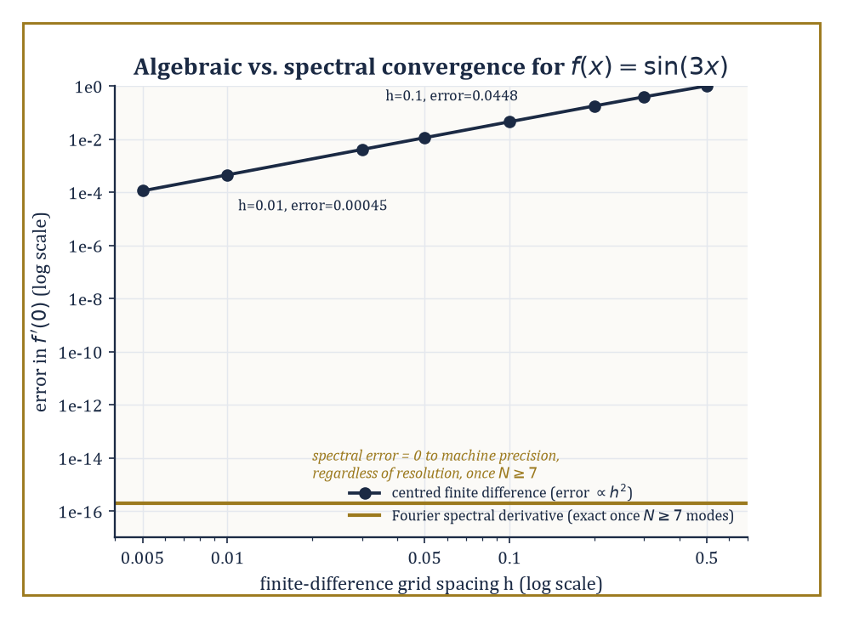
Figure 49.5 — Finite differences chip away at the error one power of h at a time; the Fourier spectral derivative gets sin(3x) exactly right.
The payoff, when the true solution is analytic (infinitely differentiable and locally equal to its own Taylor series), is exponential convergence: the error shrinks not like hᵖ for some fixed order p, as it does for finite differences, but like e⁻ᶜᴺ in the number of basis functions N, so that doubling the resolution doesn’t merely improve the answer, it can add several new correct digits outright.
Collocation methods enforce the governing equation at a set of chosen points; Galerkin and tau formulations enforce it weakly, in an inner-product sense, against the same basis.
All three produce linear systems that are dense (every basis function typically overlaps with every other) but very small, which is an entirely acceptable trade against the near-perfect accuracy on offer. Domain decomposition and spectral elements extend the idea to geometries too complicated for a single global basis to handle gracefully, by gluing many small spectral patches together.
It is worth pausing on why the basis choice matters so much: a global polynomial or trigonometric function ‘sees’ the entire domain at once, so a single coefficient can encode information that a local, piecewise basis would need many degrees of freedom, spread across many elements, to represent — the price is that every basis function typically interacts with every other, so the resulting linear system, though small, is dense rather than sparse, a trade this section’s earlier obsession with sparsity (What Advanced Numerical Methods Actually Are) is happy to accept once the dimension involved is small enough.
Numeric example — spectral accuracy versus finite-difference accuracy. Let f(x) = sin(3x), whose exact derivative at x = 0 is:
f′(0) = 3cos(0) = 3
A standard centered finite-difference estimate uses:
(f(h) − f(−h))/(2h) = sin(3h)/h
With h = 0.1:
sin(0.3)/0.1 = 0.29552/0.1 = 2.9552 (error 0.0448)
With h = 0.01:
sin(0.03)/0.01 = 0.029996/0.01 = 2.9996 (error 0.00045)
The error shrunk by a factor of about 99.6 when h shrank by a factor of 10, consistent with the theoretical second-order rate:
error ∝ h², (0.1/0.01)² = 100
Now consider the Fourier spectral derivative. Because f(x) = sin(3x) is a single Fourier mode of wavenumber 3, any Fourier discretization resolving that wavenumber — which requires only N ≥ 7 grid points, by the Nyquist criterion for wavenumber 3 — computes the derivative exactly:
ik·f̂(k) with k = 3, giving precisely 3cos(3x)
This has no truncation error whatsoever, regardless of how the finite-difference error would have continued shrinking. This is the essence of spectral accuracy: a band-limited (or, more generally, analytic) function is captured to machine precision by a finite, often small, number of modes, whereas an algebraically convergent method must keep refining forever to catch up, and even then never quite arrives.
Try it now — Approximate the derivative of sin(3x) at 0 by the central difference with h = 0.1. Answer →
High-order finite elements and discontinuous Galerkin (DG) methods aim to have both virtues at once: the geometric flexibility of finite elements, which handle complicated domains and non-smooth material properties that a single global spectral basis cannot, combined with the high-order accuracy of a spectral method, achieved by raising the polynomial degree p used within each element rather than (or in addition to) shrinking the element size h.
This gives the practitioner two independent dials — h-refinement (more, smaller elements, at fixed low order) and p-refinement (fewer, larger elements, at higher order) — and the central practical design question of the whole field is how to turn them.
Where the solution is smooth within an element, increasing p is far more cost-effective than decreasing h; where the solution has a kink, a boundary layer, or worse, increasing p buys little and refining h (or, better, doing both adaptively, the subject of the next section) is unavoidable.
Discontinuous Galerkin methods add one further freedom by permitting the numerical solution to be discontinuous across element boundaries, patched together only weakly through numerical fluxes borrowed from the finite-volume tradition; this makes DG unusually well suited to hyperbolic problems — advection, wave propagation, shocks — where the true solution may itself be discontinuous, and where forcing continuity, as ordinary finite elements do, would mean fighting the physics rather than representing it.
Abstract example — the h-version versus the p-version. Standard finite-element error theory gives, for a solution u with s bounded derivatives, an h-version error bound at fixed polynomial degree p:
‖u − uₕ‖ ≤ C h^(min(p,s−1)) ‖u‖
Refining the mesh buys a fixed algebraic rate that saturates once p exceeds the solution’s smoothness.
For the p-version at fixed mesh, when u is analytic on each element, the corresponding bound takes the exponential form:
‖u − uₚ‖ ≤ C e⁻ᵇᵖ
Here b > 0 depends on how far u’s singularities lie from the real axis — informally, on the size of its region of analyticity.
The qualitative content, worked through on a smooth model problem such as:
−u″ = π²sin(πx) on [0,1], with u(0) = u(1) = 0 (exact solution u(x) = sin(πx), certainly analytic)
is that a fixed-order h-refinement sequence needs its element count to keep growing forever to add each further correct digit, while a p-refinement sequence on a single element adds roughly a fixed number of correct digits for every unit increase in p — the discrete-Fourier-mode phenomenon of the previous example, transplanted into the finite-element setting.
This is why spectral-element codes, which combine a modest h with an aggressive p, dominate applications — turbulence simulation, seismic wave propagation — where the solution is smooth almost everywhere and only occasionally, locally, is not.
Keep only this · Section 49.5: Spectral and High-Order Methods
The idea. When the solution is smooth, global polynomials or trigonometric series converge faster than any power of 1/N; high-order elements raise the polynomial degree instead of shrinking the mesh.
Core.
central difference: error O(h²)
h-version: O(hᵖ); spectral, smooth u: O(exp(−cN))
Typical mistake. Using spectral methods on non-smooth solutions. A discontinuity destroys the exponential rate.
Minimal example. Halving h quarters a second-order error.
Practice. Easy to challenge; full worked answers, with the usual mistake, are in Answers to the Practice Sets at the back.
Easy — Repeat the Try it now with h = 0.05. By what factor did the error shrink? Answer →
Medium — An h-version method has error C·h³. How does the error change when h goes from 0.1 to 0.05, and when h stays and the degree rises? Answer →
Challenge — A spectral method has error about 10exp(−N) and a second-order method about 1/N². Which needs fewer unknowns for an error of 10⁻⁸? Answer →

Section 49.6: Adaptive Finite Elements and Multilevel Methods
Spending Your Computational Budget Where the Trouble Is
Adaptive finite-element methods refine the mesh — or raise the local polynomial degree — where the error is estimated to be large, rather than everywhere uniformly, and are driven by an iterative loop usually summarized as SOLVE, ESTIMATE, MARK, REFINE: solve the problem on the current mesh, estimate the local error contributed by each element using only computable quantities (never the unknown exact solution, which rather defeats the purpose), mark a subset of elements whose estimated error is largest, and refine only those.
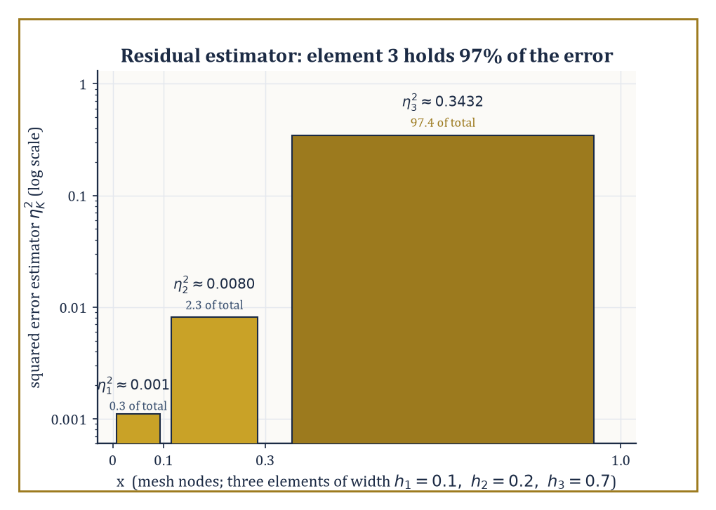
Figure 49.6 — On the three-element mesh of the worked example, the large coarse element on the right carries nearly all the estimated error — and gets marked for refinement alone.
A posteriori error estimators come in several families — residual-based estimators, which measure how badly the computed solution fails to satisfy the governing equation locally; hierarchical estimators, which compare the solution on two nested approximation spaces; and recovery-based estimators, which compare a computed gradient against a smoothed, post-processed version of itself.
Convergence of the resulting adaptive algorithm — that it drives the true error to zero, and does so at an optimal rate — has been proved rigorously for a wide class of elliptic problems, which is more than can be said for most heuristics in numerical computing, and it is the practical method of choice whenever a solution has a singularity, a sharp boundary layer, or any other feature confined to a small part of the domain.
The classic illustration, repeated in every course on the subject for good reason, is a re-entrant corner: near a sharp, non-convex corner in an otherwise ordinary elliptic problem, the true solution’s derivatives blow up, and a uniform mesh refined everywhere would need an impractical number of elements globally just to control the error near that one corner — adaptivity, by contrast, piles elements up exactly there, geometrically, while leaving the smooth interior of the domain coarse, and recovers the optimal convergence rate that a uniform mesh could never achieve no matter how much it was refined.
Numeric example — a residual-based estimator and Dörfler marking. Solve −u″ = 1 on [0,1] with u(0) = u(1) = 0, using piecewise-linear finite elements on a non-uniform three-element mesh with nodes at 0, 0.1, 0.3, 1.0, giving element sizes h₁ = 0.1, h₂ = 0.2, h₃ = 0.7.
Because the computed solution is piecewise linear, uₕ’’ = 0 within each element, so the interior residual on element K is f = 1, and the standard estimator is:
η_K = h_K‖f‖_(L²(K)) = h_K√(h_K) = h_K^(3/2), since ‖f‖²_(L²(K)) = ∫[K] 1² dx = h_K for constant f = 1
Computing:
η₁ = 0.1^1.5 ≈ 0.0316, η₂ = 0.2^1.5 ≈ 0.0894, η₃ = 0.7^1.5 ≈ 0.5857
The squared estimators are:
η₁² ≈ 0.0010, η₂² ≈ 0.0080, η₃² ≈ 0.3432, summing to about 0.3522
Element 3 alone contributes:
0.3432/0.3522 ≈ 97.4%
of the total squared error estimate. Dörfler marking with a bulk parameter θ = 0.5 (mark the smallest set of elements whose combined squared estimator exceeds half the total) therefore marks element 3 alone for refinement, leaving elements 1 and 2 untouched — even though the underlying forcing f = 1 is perfectly smooth everywhere, the estimator correctly identifies that the large, coarse element 3 is contributing almost all the discretization error, purely because of its size, and directs the computational budget there first.
Try it now — Element error indicators η² are 0.5, 0.3 and 0.2. Which elements does Dörfler marking with θ = 0.5 refine? Answer →
Multilevel methods generalize the two-grid idea from Preconditioning and Multigrid into a full hierarchy of discretizations — multigrid, multilevel Monte Carlo (taken up properly in the next section), and hierarchical bases — and exploit a single underlying fact: solutions of elliptic problems, and more generally smooth quantities of interest, look smoother and smoother as one coarsens the discretization, so that the bulk of the answer can be captured cheaply on a coarse level, leaving only a small correction — a ‘detail’ or ‘surplus’ — to be resolved at each successively finer level.
This is the algorithmic expression of an idea familiar from wavelets and multiresolution analysis: represent a function not by its raw fine-grid values but by a coarse approximation plus a sequence of ever-smaller corrections.
Numeric example — a hierarchical (multilevel) decomposition. Take the smooth function u(x) = x² sampled on a fine grid of 5 equally spaced points, indices 0–4, giving values [0, 1, 4, 9, 16]. Let the coarse grid keep only the even-indexed points, 0, 2, 4, with values [0, 4, 16].
Linear interpolation from the coarse grid predicts the odd-indexed fine values as the midpoint of their coarse neighbors:
index 1: predicted value = (0 + 4)/2 = 2; index 3: predicted value = (4 + 16)/2 = 10
The hierarchical surpluses — the corrections the fine grid must add on top of the coarse interpolant — are therefore:
d₁ = 1 − 2 = −1, d₃ = 9 − 10 = −1
The original fine-grid vector is recovered as the coarse values, linearly interpolated, plus the surpluses at the odd nodes:
index 1 = 2 + (−1) = 1 ✓, index 3 = 10 + (−1) = 9 ✓
Notice how small and uniform the surpluses are (both exactly −1) compared with the coarse values themselves (0, 4, 16): the coarse grid has captured almost all of the function’s variation, because x² is smooth, and only a small, structured residual remains to be resolved at the fine scale.
This is the phenomenon multigrid’s coarse-grid correction exploits: smooth error is nearly free to represent coarsely, so a hierarchy of grids, each doing a small fixed amount of work, suffices to resolve the whole problem — the mechanism behind the O(n) complexity claimed back in Preconditioning and Multigrid.
Adaptivity and multilevel structure are, in a real sense, the two principal routes to efficiency whenever a problem has localized features (adaptivity chases them) or multiple interacting scales (multilevel methods span them), and a great many state-of-the-art large-scale solvers are, on inspection, disciplined combinations of both ideas at once.
Keep only this · Section 49.6: Adaptive Finite Elements and Multilevel Methods
The idea. Adaptive finite elements estimate the error element by element, refine where it is large, and repeat; multilevel decompositions organize the resulting meshes for fast solvers.
Core.
solve → estimate → mark → refine
Dörfler: mark the smallest set with Σηᵢ² ≥ θΣηⱼ²
Typical mistake. Refining uniformly when the error is local. Uniform refinement spends most unknowns where the error is already small.
Minimal example. θ = 0.7 with 0.5, 0.3, 0.2: mark two elements.
Practice. Easy to challenge; full worked answers, with the usual mistake, are in Answers to the Practice Sets at the back.
Easy — Repeat the Try it now with θ = 0.7. Answer →
Medium — Hierarchically decompose u = x³ on the grid x = 0, 1, 2, 3, 4 with coarse points 0, 2, 4. Answer →
Challenge — Linear elements have L² error about Ch² on a uniform mesh. How many more elements reduce the error by 100 in 1-D and in 2-D? Answer →

Section 49.7: Uncertainty Quantification
Putting Honest Error Bars on an Answer You Weren’t Sure Of Anyway
Uncertainty quantification (UQ) takes seriously the fact that a computational model’s inputs — physical parameters, boundary data, even the choice of model itself — are rarely known precisely, and asks how that input uncertainty propagates through the (possibly very expensive) computation to produce uncertainty in the output.
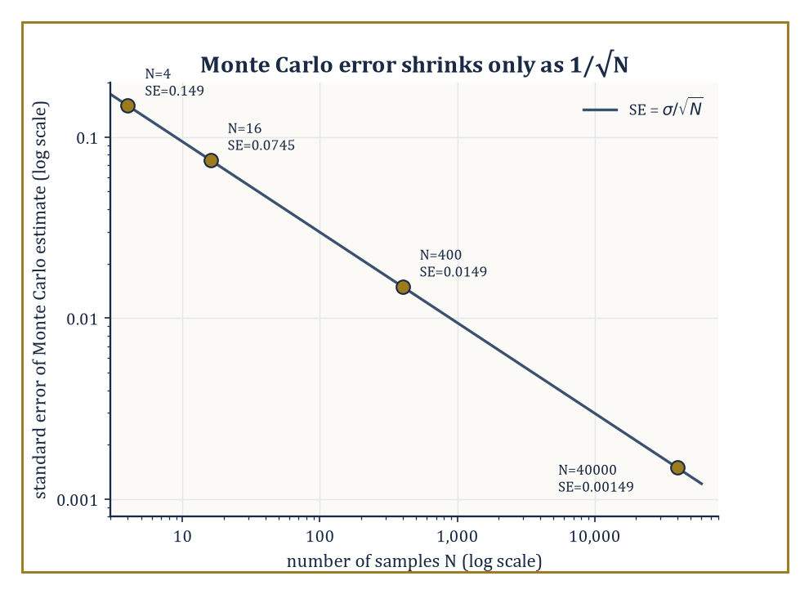
Figure 49.7 — The worked example’s four sample sizes sit on the 1/√N line — one more correct digit costs a hundredfold more samples.
Forward UQ starts from a known or assumed distribution over the inputs and asks what distribution results for a quantity of interest; the crudest and most robust tool is plain Monte Carlo sampling: draw many independent input samples, run the model on each, and average.
Its great virtue is that it makes no assumption whatsoever about the model’s smoothness; its great vice is that its error decreases only as 1/√N in the number of samples N, so that reducing the error by a factor of ten costs a hundred times as many (expensive) model evaluations.
Numeric example — the 1/√N Monte Carlo rate. Let X ~ Uniform(0,1) and the quantity of interest be g(X) = X². The true mean is:
E[X²] = ∫₀¹ x² dx = 1/3 ≈ 0.3333
The variance of g(X) is:
Var(X²) = E[X⁴] − E[X²]² = ∫₀¹ x⁴ dx − (1/3)² = 1/5 − 1/9 = 9/45 − 5/45 = 4/45 ≈ 0.0889
so the standard deviation is σ ≈ 0.2981. The standard error of a Monte Carlo estimate from N samples is σ/√N.
At N = 4 samples:
SE ≈ 0.2981/2 ≈ 0.149
This is a large uncertainty relative to the answer being estimated. Quadrupling the effort to N = 16 only halves the error, to about 0.0745; reaching a modest SE of about 0.0149 requires N = 400 samples, and squeezing out one further correct decimal digit (SE ≈ 0.00149) requires N = 40,000.
This relentless square-root law is the single fact that motivates almost everything else in this section: quasi-Monte Carlo (which replaces random sampling with more evenly spread deterministic point sets to improve the rate for smooth integrands), multilevel Monte Carlo (which, just as in Section 49.6’s hierarchy, does most of the sampling cheaply on a coarse model and corrects with a few expensive fine-model samples), and surrogate models, discussed next, which try to avoid repeated expensive model evaluations altogether.
Try it now — For X ~ Uniform(0, 1) and g = X², estimate the Monte Carlo standard error with N = 10,000 samples. Answer →
Where plain sampling is too expensive, surrogate models replace the true computational model with a cheap approximation built from a modest number of evaluations: polynomial chaos expansions (PCE) represent the output as a series in orthogonal polynomials of the random inputs, while Gaussian process surrogates fit a probabilistic interpolant with its own built-in uncertainty estimate.
Stochastic Galerkin and stochastic collocation methods discretize the parameter space directly (much as a spatial PDE is discretized), and inherit the same curse of dimensionality that plagues any grid-based method in high dimension — the number of points needed grows exponentially with the number of uncertain parameters — which motivates sparse grids (which retain accuracy while including far fewer points than a full tensor grid) and reduced-basis techniques.
Inverse UQ runs the whole process backwards: given noisy data, it calibrates the model’s parameters and reports a posterior distribution over them (typically via Bayesian inference), while honestly confronting model discrepancy — the uncomfortable but unavoidable fact that even a perfectly calibrated model is still not nature, only a structured guess about it.
Bayesian model calibration turns this discomfort into arithmetic rather than despair: it treats the gap between model and reality as an additional random term to be estimated alongside the physical parameters, so that a calibrated model reports not a single best-fit answer but a posterior distribution honestly wide enough to admit that the model itself might be part of the problem — a discipline every applied mathematician could stand to practice rather more often than they do.
Worked example — polynomial chaos reads off the mean and variance. Let X ~ Uniform(−1,1) and the quantity of interest be g(X) = X². The Legendre polynomials, orthogonal with respect to this distribution, begin:
P₀(x) = 1, P₁(x) = x, P₂(x) = (3x² − 1)/2
Since g is itself a degree-2 polynomial, it has an exact, finite chaos expansion. Writing x² = a·P₀(x) + b·P₂(x) and matching coefficients:
3b/2 = 1, so b = 2/3; a − b/2 = 0, so a = 1/3
That is, exactly:
x² = (1/3)P₀(x) + (2/3)P₂(x)
Direct substitution confirms this:
(1/3) + (2/3)·(3x²−1)/2 = 1/3 + x² − 1/3 = x²
Because E[P₀] = 1 and E[Pₖ] = 0 for k ≥ 1 under this normalization, the mean of g(X) is the leading coefficient:
E[X²] = a = 1/3
This matches the direct calculation:
∫₋₁¹ x²·(1/2) dx = 1/3
The variance is read off just as directly, as a sum of squared coefficients weighted by ‖Pₖ‖² = 1/(2k+1); here only the k = 2 term contributes:
Var(X²) = b²·(1/5) = (2/3)²·(1/5) = 4/45 ≈ 0.0889
which matches:
E[X⁴] − E[X²]² = 1/5 − 1/9 = 4/45
computed directly. This is the entire practical payoff of polynomial chaos: once the expansion coefficients are known (from a handful of model evaluations, not millions), every statistic of interest — mean, variance, and more — falls out of them algebraically, with no further sampling required.
The overall effect of this section’s machinery is to turn a deterministic simulation, which reports one number and implicitly claims to be sure of it, into a genuinely probabilistic prediction — a distribution, or at least an honest error bar — and that conversion is not an optional refinement but an essential component of any computational science that intends to be believed.
Keep only this · Section 49.7: Uncertainty Quantification
The idea. Uncertainty quantification propagates random inputs through a model: Monte Carlo is robust but slow (1/√N); polynomial chaos expands the output in orthogonal polynomials of the inputs.
Core.
MC error ≈ σ/√N
g(X) = Σ cₖPₖ(X): mean c₀, variance Σₖ≥₁ cₖ²‖Pₖ‖²
Typical mistake. Expecting ten times the samples to give ten times the accuracy. It gives √10 ≈ 3.2 times.
Minimal example. Halving the MC error needs four times the samples.
Practice. Easy to challenge; full worked answers, with the usual mistake, are in Answers to the Practice Sets at the back.
Easy — How many samples halve a Monte Carlo error? Answer →
Medium — For X ~ Uniform(−1, 1) and g(X) = 2 + 3X, read off the mean and variance from the expansion in Legendre polynomials. Answer →
Challenge — A pendulum’s length is uncertain, L ~ Uniform(0.9, 1.1) m. Estimate the standard deviation of the period T = 2π√(L/g) by linearization. Answer →

Section 49.8: Structure-Preserving and Geometric Integration
Respecting the Physics Enough Not to Let the Energy Wander Off
Simulate a planet orbiting the sun with the simplest step-by-step method and something odd happens: the planet slowly spirals outward, gaining energy from nowhere, because each step makes a small error that always pushes the same way. Over millions of orbits the simulation becomes nonsense, however small the step. Geometric integrators avoid this by respecting the structure of the physics rather than merely shrinking the error per step. A symplectic method still makes errors, but its energy wobbles around the true value instead of drifting away. In this section’s twelve-step example, the simple method’s energy climbs without limit while the symplectic method’s stays close to the truth.
Geometric numerical integration designs time-stepping methods that deliberately preserve structural properties of the continuous system being simulated, rather than merely minimizing the local truncation error the way a generic Runge–Kutta method does.
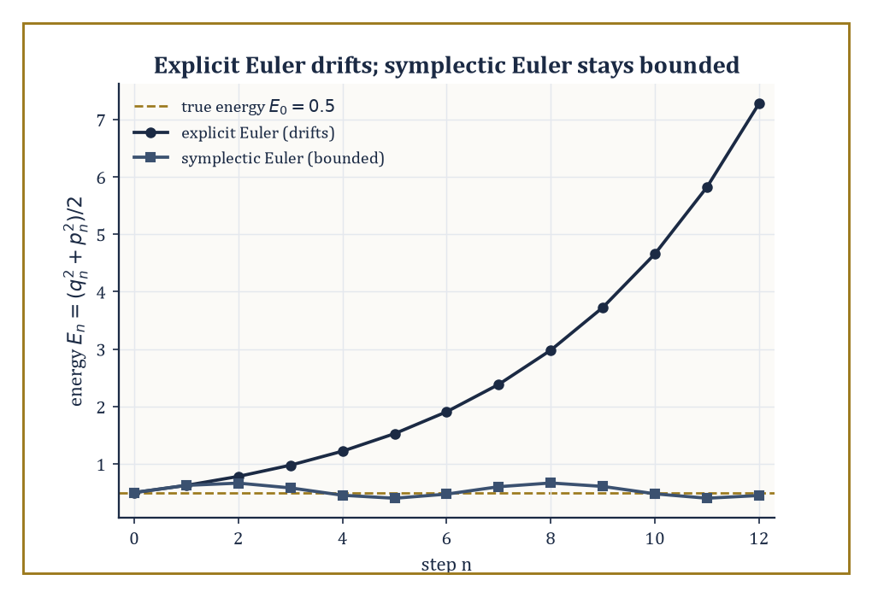
Figure 49.8 — The worked example’s twelve steps: explicit Euler’s energy climbs without limit, symplectic Euler’s just wobbles politely around the truth.
A Hamiltonian system is one governed by the equations:
dq/dt = ∂H/∂p, dp/dt = −∂H/∂q, for some energy function H(q,p)
For such a system, the relevant structure is symplecticity, a precise geometric statement about how the flow distorts phase-space volume and orientation, and symplectic Runge–Kutta methods, variational integrators (derived by discretizing the underlying action principle rather than the differential equation directly), and discrete gradient methods are the principal families built to respect it.
The payoff is not better short-term accuracy — a symplectic method is not, in general, more accurate at any single step than a good non-symplectic one of the same order — but qualitatively superior long-time behavior: a backward error analysis shows that a symplectic method solves a nearby Hamiltonian system, which forces its energy error to stay bounded and oscillate near the true value indefinitely, rather than drifting away as a generic method’s error does.
Numeric example — explicit Euler drifts, symplectic Euler doesn’t. Take the simple harmonic oscillator with:
H(q,p) = (p² + q²)/2, dq/dt = p, dp/dt = −q
The true energy is conserved exactly along any real trajectory. Start from q₀ = 1, p₀ = 0 (energy E₀ = 0.5) and step with h = 0.5.
Explicit Euler updates both variables from old values:
qₙ₊₁ = qₙ + h pₙ, pₙ₊₁ = pₙ − h qₙ
Step 1:
q₁ = 1 + 0 = 1, p₁ = 0 − 0.5 = −0.5, E₁ = (1 + 0.25)/2 = 0.625
Step 2:
q₂ = 1 + 0.5(−0.5) = 0.75, p₂ = −0.5 − 0.5(1) = −1.0, E₂ = (0.5625 + 1)/2 = 0.78125
Step 3:
q₃ = 0.75 + 0.5(−1.0) = 0.25, p₃ = −1.0 − 0.5(0.75) = −1.375, E₃ = (0.0625 + 1.890625)/2 ≈ 0.9766
The energy climbs steadily — 0.5, 0.625, 0.781, 0.977 — a clear, unbounded drift; explicit Euler spirals outward.
Now use symplectic Euler, which updates q first and then uses the new q in the p update:
qₙ₊₁ = qₙ + h pₙ, pₙ₊₁ = pₙ − h qₙ₊₁
Step 1 is identical, since p₀ = 0 makes no difference yet:
q₁ = 1, p₁ = 0 − 0.5(1) = −0.5, E₁ = 0.625
Step 2:
q₂ = 1 + 0.5(−0.5) = 0.75, p₂ = −0.5 − 0.5(0.75) = −0.875, E₂ = (0.5625 + 0.765625)/2 ≈ 0.6641
Step 3:
q₃ = 0.75 + 0.5(−0.875) = 0.3125, p₃ = −0.875 − 0.5(0.3125) = −1.03125, E₃ = (0.09766 + 1.06348)/2 ≈ 0.5806
The symplectic energies — 0.5, 0.625, 0.664, 0.581 — fluctuate rather than climb, staying much closer to the true value of 0.5 instead of drifting ever upward; this bounded oscillation, not monotone growth, is the qualitative signature backward error analysis predicts, and it is the entire reason symplectic integrators are preferred for long-time simulation even though, step for step, they are no more locally accurate than the method that got it so visibly wrong.
Try it now — Take one symplectic Euler step for the oscillator H = (p² + q²)/2 with h = 0.1 from (1, 0). Answer →
Discrete gradient methods take a different but related route to structure preservation, aiming for exact conservation rather than merely bounded oscillation: a discrete gradient ∇̄H(q, q′) is constructed to satisfy, by design:
∇̄H(q,q′)·(q′ − q) = H(q′) − H(q)
This forces the resulting scheme to conserve the Hamiltonian to machine precision at every single step, not only on average over long times.
Variational integrators, meanwhile, are derived by discretizing Hamilton’s action principle itself and only then deriving the resulting difference equations, which guarantees the discrete scheme inherits a discrete version of Noether’s theorem — conserved quantities tied to the system’s symmetries, such as angular momentum for a rotationally invariant system, survive the discretization exactly, not approximately.
These methods are the tools of choice wherever long-time fidelity matters and cannot be fudged: molecular dynamics simulations that must run for billions of steps without the temperature quietly drifting, and celestial mechanics calculations that must track planetary orbits over millions of years without the solar system numerically disintegrating — a standard one would not care to be blamed for, however honest the small-print disclaimer in the paper’s methods section.
Numeric example — the implicit midpoint rule conserves energy here. The implicit midpoint rule is:
qₙ₊₁ = qₙ + h·(pₙ+pₙ₊₁)/2, pₙ₊₁ = pₙ − h·(qₙ+qₙ₊₁)/2
It is both symplectic and, for quadratic Hamiltonians such as this oscillator, a discrete-gradient method — so it should conserve energy precisely, not merely approximately.
Taking one step with h = 0.5 from q₀ = 1, p₀ = 0 requires solving the coupled linear system simultaneously:
q₁ = 1 + 0.25(0 + p₁), p₁ = 0 − 0.25(1 + q₁)
Substituting the first into the second:
p₁ = −0.25 − 0.25(1 + 0.25p₁) = −0.5 − 0.0625p₁, so 1.0625p₁ = −0.5, giving p₁ = −0.470588…
q₁ = 1 + 0.25(−0.470588) = 0.882353
The new energy is:
E₁ = (q₁² + p₁²)/2 = (0.778547 + 0.221453)/2 = 1.0/2 = 0.5
This is exactly the starting energy, to the precision of this hand calculation, confirming the theoretical guarantee directly rather than merely citing it.
Running example · The pendulum as a numerical problem
Last stage of the running pendulum. Simulate θ̈ = −9.8 sin θ from θ = 1 rad at rest with step h = 0.1 s. The exact energy H = p²/2 + 9.8(1 − cos θ) stays at 4.505.
• Explicit Euler: after 100 steps (10 s) H ≈ 52.6, beyond the separatrix value 19.6 of Flows, Maps, and Phase Portraits. The simulated pendulum has begun to spin over the top — a qualitatively false answer.
• Symplectic Euler: over 200 steps H stays between 3.9 and 5.3, oscillating around the true value. The pendulum keeps swinging.
The equation of Chapter 26 (Volume 3), the plant of Control Theory, the phase portrait of Dynamical Systems & Chaos and the Hamiltonian of Lagrangian and Hamiltonian Mechanics are one object; this box is why the last of those views decides which integrator to trust.
Keep only this · Section 49.8: Structure-Preserving and Geometric Integration
The idea. Geometric integrators preserve structural properties of the flow — symplecticity, energy, invariants — so that long simulations stay qualitatively right even when each step is no more accurate.
Core.
symplectic Euler: qₙ₊₁ = qₙ + hpₙ, pₙ₊₁ = pₙ − h∂H/∂q(qₙ₊₁)
explicit Euler on the oscillator: Eₙ₊₁ = (1 + h²)Eₙ
Typical mistake. Choosing a method by local accuracy alone for long simulations. Energy drift is a qualitative error that small steps only postpone.
Minimal example. h = 0.5: explicit Euler multiplies the energy by 1.25 each step.
Practice. Easy to challenge; full worked answers, with the usual mistake, are in Answers to the Practice Sets at the back.
Easy — By what factor does explicit Euler multiply the oscillator’s energy in ten steps of h = 0.1? Answer →
Medium — Show that explicit Euler multiplies q² + p² by exactly 1 + h² for the oscillator. Answer →
Challenge — Show that the symplectic Euler map for the oscillator has determinant 1, while explicit Euler’s has 1 + h². Answer →

Section 49.9: Looking Ahead: From Advanced Numerics to Exascale, Machine Learning, and Verified Computation
The View From the End of This Chapter
We have now acquired the core of advanced numerical methods: iterative linear algebra and Krylov subspaces, preconditioning and multigrid, sparse eigenproblems and the SVD, spectral and high-order methods, adaptivity and multilevel structure, uncertainty quantification, and structure-preserving integration.
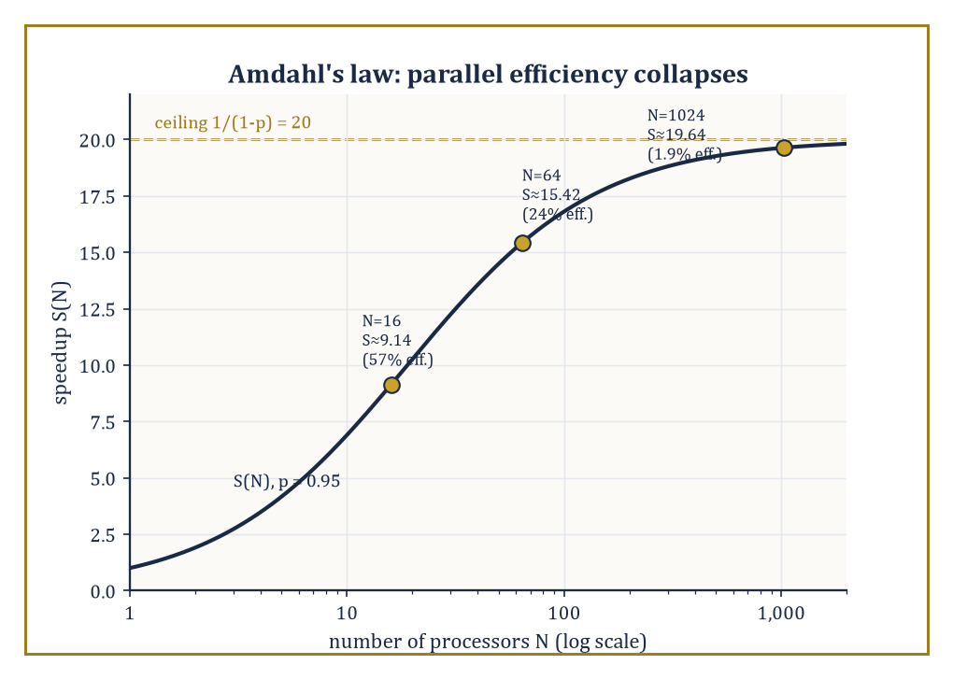
Figure 49.9 — Amdahl’s law at p = 0.95: speedup keeps climbing toward its ceiling of 20, but efficiency has already collapsed to under 2% by N = 1024 processors.
Three frontiers lie immediately beyond this material, and each deserves at least a glance before we leave the section. The first is exascale computing: as machines grow not by getting individually faster but by acquiring ever more processing cores, the bottleneck shifts decisively from arithmetic to communication and synchronization, and the algorithms that win are the ones redesigned to minimize how much data must move between processors and how often those processors must wait for each other, even at the cost of doing somewhat more arithmetic overall.
Numeric example — Amdahl’s law and the collapse of parallel efficiency. Suppose a computation has a parallel fraction p = 0.95 — 95% of the work can be split across processors, 5% is stubbornly sequential, an optimistic figure for most real codes. Amdahl’s law gives the speedup on N processors as:
S(N) = 1/((1−p) + p/N)
At N = 16:
p/N = 0.059375, denominator = 0.05 + 0.059375 = 0.109375, S(16) = 1/0.109375 ≈ 9.14
This is an efficiency of S(16)/16 ≈ 57%, already leaking almost half the theoretical benefit.
At N = 64:
p/N = 0.014844, S(64) = 1/0.064844 ≈ 15.42 (efficiency ≈ 24%)
At N = 1024:
p/N ≈ 0.000928, S(1024) = 1/0.050928 ≈ 19.64 (efficiency ≈ 1.9%)
Barely one part in fifty of the processors’ work is contributing net speedup, even though the speedup itself is still (slowly) climbing toward its ceiling of:
1/(1−p) = 20
This is the phenomenon that makes exascale computing hard in a way that simply buying more cores cannot fix: unless the sequential fraction and the communication overhead are attacked directly — the entire point of communication-avoiding algorithm redesign — adding processors past a certain point buys almost nothing, a sobering fact that no amount of enthusiastic press-release language about ‘a billion billion calculations per second’ will alter.
Try it now — Amdahl’s law: with a parallel fraction p = 0.95, what speedup do 10 processors give? Answer →
The second frontier is the increasingly porous boundary with machine learning: learned discretizations that replace a hand-derived stencil with one fitted to data, neural preconditioners trained to approximate the action of an expensive inverse operator, and data-driven model reduction that learns a low-dimensional surrogate directly from simulation output rather than deriving one analytically.
It is tempting, and not entirely wrong, to read this as machine learning annexing numerical analysis’s territory unannounced; the more accurate reading is that every one of these techniques still leans on the mathematics of this chapter to be trustworthy at all — a neural preconditioner is only useful if it is cheap to apply and reliably clusters the spectrum, the criteria Preconditioning and Multigrid set out, and a learned surrogate is only useful if someone can bound how far it might be wrong, which returns us directly to Section 49.7’s uncertainty quantification and to the third frontier below.
The third, and in some ways the most conservative, is verified computation — interval arithmetic and residual-based a posteriori bounds that supply not just an approximate answer but a rigorous, mathematically guaranteed enclosure of the true one, at the cost of some pessimism in how tight that enclosure can be made.
Numeric example — interval arithmetic is sound but pessimistic. Let f(x) = x² − 2x = (x−1)² − 1, and evaluate it rigorously over X = [1,3] using naive interval arithmetic.
Since 0 ∉ X:
X² = [1²,3²] = [1,9]
2X = [2,6]
X² − 2X = [1−6, 9−2] = [−5,7]
Compare with the true range: since (x−1)² − 1 has its minimum at x = 1, the left endpoint of the interval, and increases monotonically thereafter, the exact range is:
f(1) = −1, f(3) = 9−6 = 3, so the exact range of f on [1,3] is [−1,3]
The naive interval bound [−5,7] does contain the true range [−1,3], as the theory guarantees it must — interval arithmetic is sound by construction, never wrong, only ever conservative — but it is considerably wider than necessary.
The looseness arises from the ‘dependency problem’: naive interval arithmetic treats the two occurrences of x in x² and −2x as if they were independent unknowns ranging freely over [1,3], rather than remembering they are the same quantity, and this loss of correlation is what more refined verified-computation techniques (mean-value forms, Taylor models, and their relatives) are built to recover, tightening the enclosure without ever sacrificing the underlying guarantee.
The same ideas explored across this chapter — sparse and iterative linear algebra, hierarchy, adaptivity, uncertainty, structure — reappear, essentially unchanged in spirit, in computational fluid dynamics, climate modeling, computational electromagnetics, and across the numerical solution of the partial differential equations of mathematical physics generally.
The deeper lesson, if the chapter has one, is that the discretization of continuous problems, once it must be done at scale and with structure, stops being a subfield of analysis and becomes a discipline in its own right — one that fuses analysis, linear algebra, probability, and computer architecture into a single computational science, in which a wrong answer delivered instantly is no better than a right one delivered never, and the entire art lies in the space between.
Advanced numerical methods are, in the end, the mathematics of reliable computation at a scale no single mind can check by hand — which is either a humbling thought or a liberating one, depending on how the tenure review went that year. We have learned to exploit sparsity instead of drowning in zeros, to precondition instead of merely waiting, to go where the error actually is instead of refining everywhere out of politeness, to quantify what we don’t know instead of pretending otherwise, and to respect the physics enough to let a planet keep its orbit for a few million years without numerical assistance in going somewhere it shouldn’t.
The series continues, and it turns now, for its fiftieth and final chapter, from method to purpose: applied mathematics and modeling — the rather more philosophical question, postponed throughout this chapter by cheerful necessity, of which equation one ought to be solving in the first place, and what the answer is for. Everything computed here has assumed the model was already given; the next chapter asks where models come from, and how one decides whether they deserve to be trusted at all. We have learned to compute at scale. It remains, at last, to ask what for.
Keep only this · Section 49.9: Looking Ahead: From Advanced Numerics to Exascale, Machine Learning, and Verified Computation
The idea. Ahead: exascale machines where communication and energy dominate, machine-learned surrogates and solvers, and verified computation that proves its own error bounds.
Core.
Amdahl: S = 1/((1 − p) + p/N), S → 1/(1 − p)
interval arithmetic: sound enclosures, possibly wide
Typical mistake. Expecting speedup to grow with processors forever. The serial fraction caps it.
Minimal example. p = 0.95: speedup never exceeds 20.
Practice. Easy to challenge; full worked answers, with the usual mistake, are in Answers to the Practice Sets at the back.
Easy — What speedup does p = 0.95 allow with unlimited processors? Answer →
Medium — Find the speedup for p = 0.99 with N = 100. Answer →
Challenge — Evaluate f(x) = x² − 2x over X = [0, 2] with naive interval arithmetic, and compare with the form (x − 1)² − 1. Answer →
Chapter 49 recap · Numerical Methods (Advanced)
• At scale, memory traffic and sparsity matter as much as operation counts.
• Krylov methods such as conjugate gradients solve sparse systems iteratively, at a rate governed by √κ.
• Preconditioning reduces κ; multigrid removes smooth error on coarse grids and solves elliptic problems in O(n) work.
• Lanczos and Arnoldi find a few eigenvalues of huge matrices; the truncated SVD gives the best low-rank approximation.
• Spectral and high-order methods converge very fast for smooth solutions; adaptive refinement puts unknowns where the error is.
• Uncertainty quantification pushes random inputs through models; geometric integrators preserve structure such as energy over long times.

Check Your Understanding — Chapter 49
Answers are in the Answer Key at the back of the book — have a go before you look.
1. [Explain] Why is dense matrix–vector multiplication described as ‘memory-bound’, and what does sparsity do about it?
See the answer →
2. [Compute] Applying Jacobi (diagonal) preconditioning to A = [100 1; 1 2], what happens to the condition number, and why does that matter for Krylov convergence?
See the answer →
3. [Compute] For M = [1 2; 2 1] (eigenvalues 3 and −1), what is the best rank-1 approximation in the Frobenius norm, and how large is the error you’re forced to accept?
See the answer →
4. [Explain] In the harmonic-oscillator example, why does explicit Euler’s energy drift upward while symplectic Euler’s just oscillates, even though neither method is more accurate per step?
See the answer →
5. [Compute] For M = [1 2; 2 1], compute the 2-norm condition number and say what it implies for solving Mx = b.
See the answer →
6. [Compute] A conjugate-gradient solve faces a system with condition number κ = 100. What is the per-iteration error reduction factor, and roughly how many iterations reduce the error by 10⁻⁶?
See the answer →
7. [Explain] Subtracting two nearly equal floating-point numbers can destroy most of the significant digits. Why does this happen when both inputs are stored to full precision?
See the answer →
8. [Prove] Show that the stationary iteration xₖ₊₁ = Gxₖ + c converges for every starting vector precisely when the spectral radius ρ(G) < 1.
See the answer →
9. [Explain] A single relaxation sweep removes high-frequency error quickly and then stalls. Why does multigrid fix this, when it uses the same relaxation?
See the answer →
10. [Challenge] Two runs of the same parallel simulation on the same exascale machine can produce different results. Why, and is that a bug?
See the answer →

Problems — Chapter 49
The questions above test whether the ideas landed. These ask you to use them. Solutions are in Solutions to the Problems at the back. Work them before you look.
1. [Compute] The system 2x + y = 5, x + 2y = 4. One Jacobi step from (0, 0), using the newest values only from the previous iteration. Then solve the system exactly and compare.
2. [Compute] A₁ = [2 0; 0 2] and A₂ = [2 0; 0 1/2]. For each, the 2-norm condition number is the ratio of the largest singular value to the smallest. Compute both.
3. [Explain] A residual r = b − Ax is small, and the condition number is large. Why is x still allowed to be far from the true solution?
4. [Compute] Estimate a root of x² − 2 by one bisection step on [1, 2], and by one Newton step from 1. Which lands closer to √2?

Math, Actually

Chapter 50

Where Mathematics Meets the World
From Phenomenon to Equation, and the Art of Making Mathematics Speak About the World
Fifty chapters. If you have read them all in order — and if you have not, no matter, the book still works, though the chapters past thirty or so require a certain faith — you began at Chapter 1 (Volume 1) with the proposition that three apples and two apples make five apples, and you now stand somewhere considerably further on, having lately passed through the numerical-methods chapter just before this one: the grim, necessary business of persuading a machine to approximate what cannot be solved by hand, and of knowing, to several decimal places, exactly how wrong one is prepared to be. That chapter ended, as such chapters do, with error bounds and a faint smell of solder.
This, the fiftieth and last, is not about a new piece of mathematics at all. Every tool the series has forged — algebra to sharpen the pencil, calculus to track the change, probability to hedge the ignorance, analysis to keep the whole enterprise honest, numerical method to compute what refuses to be solved in closed form — has been built, if we are honest, for use. This chapter is that use. It is called modeling, a word with a slightly apologetic ring to it, as though the mathematics knows it is about to be asked to say something about the actual, muddy, non-Platonic world, and would rather not.
A model, we shall see, is not a small imitation of the universe; it is a lie, told carefully, in the hope that it turns out to be a useful one. Every equation in this chapter describes something that does not, strictly, exist — a frictionless pendulum, a population with no immigrants, a market with no fools — and every one of them is nonetheless indispensable, because the alternative to a useful lie is not the entire unmanageable truth; it is silence.
Nine sections lie ahead: what modeling is, how it is done, how to measure a system before daring to write an equation for it, the discrete-versus-continuous choice, the honest admission of randomness, three case studies drawn from mechanics, biology, and epidemiology, the arrival of data as a modeling ingredient in its own right, the business of finding out whether any of it was true, and, last, a turn to look back down the whole journey and ask what it was all for.
Then the series ends — not with a flourish but with the mathematics turning, at last, to face outward, toward the phenomenon it was built to describe. Do mind the draft at the top; the view is rather good.
Running example · One fishery, ten steps
This chapter takes the modeling process apart stage by stage, each with its own example. The Capstone Case Study, in Ten Steps then puts it back together on one model — a harvested fishery — and links every step to the chapter whose tools it uses, across all four volumes. Read it last; it is the payoff of the series.
Before you begin — Chapter 50
By the end of this chapter you will be able to:
1. Build a model from a phenomenon: quantities, mechanisms, equation, simplification.
2. Use dimensional analysis and scaling to reduce a model to its dimensionless groups.
3. Choose between discrete and continuous, deterministic and stochastic descriptions.
4. Analyze classical case studies — mechanics, predator and prey, epidemics — by their equilibria.
5. Fit models to data and choose between them with AIC and BIC.
6. Carry one model through all ten steps of the process, and say where it fails.
Prerequisites. The whole series, in practice: differential equations from Chapter 26 (Volume 3), linearization and bifurcations from Dynamical Systems & Chaos, statistics from Statistics & Probability, and numerical methods from Chapter 29 (Volume 3) and Numerical Methods (Advanced).
Estimated study time. About 12 hours, exercises and the capstone case study included.

Section 50.1: What Mathematical Modeling Is
In Which the World Is Asked Politely to Hold Still
You have poured a cup of tea and found it too hot to drink. This is not, on the face of it, a mathematical situation. You wait; it cools; at some point it becomes drinkable, and you have never once needed an equation to manage the process. You also know, without anybody having told you, roughly how the cooling goes. It is quick at the start, while the cup is still steaming. It slows down later. And it stops — the tea ends up at the temperature of the section and stays there, because there is nowhere else for it to go.
That is a considerable amount of knowledge about heat, and every bit of it came from drinking tea.
Now let somebody ask a question your experience cannot answer. You have a meeting in ten minutes. Will the tea be cool enough to drink — call it sixty degrees — before you have to leave? Standing over the cup with a thermometer would settle it, but only by waiting, and waiting is the one thing the question forbids. Your experience of tea is extensive. It offers you nothing better than ‘a few minutes’. It will not produce a number, and it will certainly not produce one before you pour.
So the question has to be put another way, and the new version is stranger than it first looks. Not ‘how does tea cool?’, but ‘what would I have to believe about this cup in order to work out, in advance, when it will be drinkable?’
That is worth slowing down for, because the difficulty buried in it is the difficulty of this entire chapter. To compute anything at all you need a rule. A rule is a sentence about the tea. And any sentence about the tea has to leave almost all of the tea out.
Consider what is actually in front of you. The mug has a thickness and a glaze, and a handle that carries heat away at its own rate. The tea has a film on its surface that slows evaporation, and evaporation is doing a share of the cooling. The section has a draft under the door, a radiator along one wall, and a person about to walk past and stir the air. Every one of those things changes the answer.
You cannot keep them all. A rule that accounted for every one of them would not be a rule at all; it would be a second cup of tea, every bit as hard to predict as the first, with the added disadvantage of being imaginary. So things have to be thrown away.
And here is the uncomfortable part, which does not go away with practice. Nothing in the mathematics tells you which things are safe to throw away. Discard the draft and you will probably be fine. Discard the evaporation and your answer may be wrong by minutes. The mathematics will process whatever you hand it, with perfect obedience and no opinion whatever about whether what you handed it was sensible.
What gets done instead will look like an evasion, and it is only fair to say that it never entirely stops looking like one. You do not find a principled method for deciding what matters. Instead you state, out loud and in advance, which question you are answering. Then you keep only the features that question depends on — and you write down, as part of the answer rather than as an apology bolted on afterwards, the conditions under which you are prepared to defend it.
Numbers now, and the smallest collection of them that will do the job. We are going to keep three, and throw away the rest of the world.
Keep one number for the tea: how hot it is. Keep one number for the section: how hot it is, which we will fix at twenty degrees and not think about again. Keep one number for the mug: how quickly heat escapes from it. Gone are the handle, the glaze, the film, the draft and the person walking past.
Then add the single observation that makes the whole arrangement work, which is due to Newton and which can be stated without any notation whatever: the tea loses heat in proportion to how much hotter it is than the room. Twice as far above room temperature, cooling twice as fast. That is the entire mechanism.
Take the gap between the tea and the section — seventy degrees at the moment of pouring, the tea being at ninety and the section at twenty — and let it decay away smoothly, so that what remains of the gap after t minutes is 70 × exp(−t/20) degrees. That comes to a fraction under five per cent of the gap lost in the first minute, and the same fraction of whatever is left in every minute after. Every row below can be checked on a calculator:
after 0 minutes gap 70.0 tea 90.0
after 5 minutes gap 54.5 tea 74.5
after 10 minutes gap 42.5 tea 62.5
after 11.19 minutes gap 40.0 tea 60.0
after 20 minutes gap 25.8 tea 45.8
after 60 minutes gap 3.5 tea 23.5
So the tea is drinkable a shade under eleven and a quarter minutes after pouring, and you may go to your meeting. That number came out of three quantities and one sentence about heat, and getting it did not require you to own a thermometer.
Now look at the bottom row. There is something this column will never do, and that is reach twenty. The gap is cut, and cut again, and is never closed; an hour in, this model still has the tea three and a half degrees above the section, and by tomorrow morning the gap it reports is far too small to measure, or even to write down comfortably, and still not zero. Real tea does not behave like that. Real tea arrives at room temperature and stops.
That is not a flaw to be tidied away, and it is the most important thing on this chapter. The model is wrong, in a way you can put your finger on — and it is useful anyway, because the place where it goes wrong is an hour out, and the question you asked was about the first eleven minutes. Knowing where a model stops being true is not an embarrassment appended to the end of the work. It is part of the model, and a model handed over without it is not finished.
That is a mathematical model. There is a quantity that changes: the temperature. There are quantities held fixed for this particular run — the section at twenty degrees, the mug at five per cent a minute. There is a rule tying them together. And there is the range over which you are willing to stand behind the whole arrangement. Those four things have names, and they are what the rest of this section sets out.
A mathematical model is a mathematical structure built to represent selected features of a real system, for the purpose of understanding it, predicting it, or controlling it. Four ingredients make it up.
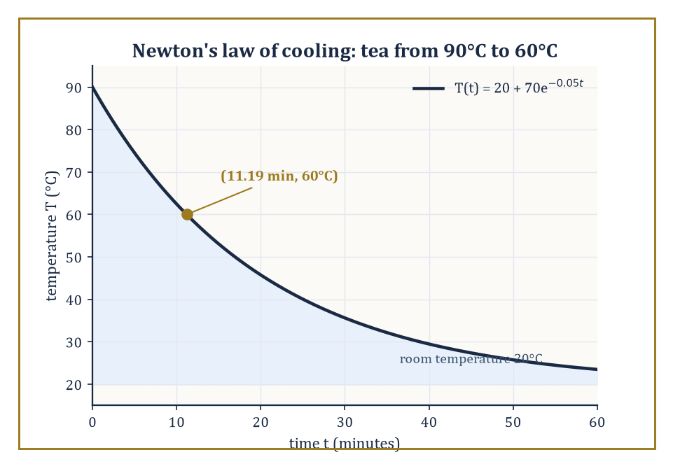
Figure 50.1 — The tea’s temperature decays exponentially toward room temperature, hitting a drinkable 60°C at t ≈ 11.19 minutes — where the model, and not a moment sooner, says it must.
Variables are the quantities that change within the model — a population size, a temperature, a stock price.
Parameters are the quantities held fixed for a given run of the model but that could, in principle, be different for a different system — a growth rate, a reaction constant, an interest rate; the same equation with a different parameter describes a different rabbit warren, a different chemical, a different bank.
Equations (or, for a computational model, algorithms) relate the variables and parameters to one another and to time.
And — the ingredient every over-eager modeler forgets to state out loud, usually to their later embarrassment — a domain of validity: the range of conditions over which the model’s claims may actually be trusted, outside of which it is the wrong tool, however elegant the algebra inside it.
The word ‘selected’ in the first sentence is doing the real work. A model does not represent a system; it represents the handful of features of that system the modeler has decided matter for the question at hand, and deliberately discards the rest.
The discarding is not laziness, it is the entire craft, since a structure that tried to represent every feature of the real system would be just as hard to understand as the real system itself, and would have earned the modeler nothing at all for the effort of building it.
Numeric example — Newton’s law of cooling, and where it stops being true. A cup of tea is poured at 90°C into a section held at a constant 20°C. Empirically, for a cooling liquid well above room temperature and not too close to it, the rate of heat loss is roughly proportional to the temperature difference — Newton’s law of cooling — giving the model
T(t) = Tₑₙᵥ + (T0 − Tₑₙᵥ)e⁻ᵏᵗ
with T0 = 90, Tₑₙᵥ = 20, and a cooling constant k = 0.05 per minute (a parameter one would measure for this particular mug, this particular room, this particular draft). Question: how long until the tea reaches a drinkable 60°C? Set T(t) = 60:
60 − 20 = (90 − 20)exp(−0.05t)
40 = 70·exp(−0.05t)
exp(−0.05t) = 40/70 = 0.5714
Taking logarithms,
−0.05t = ln(0.5714) = −0.5596
t = 0.5596/0.05 ≈ 11.19 minutes
Notice what the domain of validity is tacitly assuming: that k stays constant (it will not, if someone opens a window at minute six), that Tₑₙᵥ stays constant (it will not, in a small kitchen with the kettle still going), and that the mechanism itself — heat loss dominated by a temperature-difference-proportional process — remains the right description as T approaches Tₑₙᵥ, where in reality measurement noise and slow convective effects start to dominate the signal entirely. The equation does not know any of this; only the modeler does.
Try it now — Newton’s law of cooling, T′ = −k(T − 20), with T(0) = 90°C and k = 0.05 per minute: find T(10). Answer →
Models are judged along three axes that pull in different directions.
Fidelity is agreement with observation — how faithfully the model’s output matches what is measured.
Tractability is amenability to analysis or computation — can anyone solve the thing, or simulate it in a lifetime, on a budget?
Usefulness is relevance to the question being asked — a model that predicts a protein’s fold to the nearest ångström is a triumph of fidelity and utterly useless for forecasting next week’s rainfall.
No model optimizes all three simultaneously; that is not a failure of imagination but close to a theorem. A model detailed enough to have high fidelity to every microscopic feature of a real system is, very often, the model too complicated for anyone to analyze or even simulate at the scale the question requires.
The modeler’s entire craft is the navigation of that trade-off — deciding, deliberately, what to sacrifice.
Abstract example — two models of the same traffic jam. Consider modeling congestion on a motorway. One approach treats the stream of cars as a continuous fluid: a density ρ(x,t) (cars per kilometer) obeying a conservation-law partial differential equation,
∂ρ/∂t + ∂(ρv(ρ))/∂x = 0
where the speed v is assumed to be some decreasing function of local density — the Lighthill–Whitham–Richards model. This buys enormous tractability: wave speeds for a growing jam can be extracted in closed form, and the PDE machinery of an earlier chapter applies wholesale. It sacrifices fidelity at the level of any individual driver — there is no ‘car’ in the model, only a density, so questions like ‘does this following distance cause a rear-end collision’ cannot even be posed.
A second approach — a cellular-automaton or agent-based model such as Nagel–Schreckenberg — places discrete cars on a discretized road, each obeying a simple local rule (accelerate if clear ahead, brake if too close, occasionally and randomly slow down for no good reason, as real drivers do). This sacrifices tractability — there is no closed-form solution, only simulation — in exchange for fidelity at the individual-vehicle scale, including the emergence of stop-and-go waves from nothing but local rules and a bit of randomness, a surprising phenomenon the fluid model can only put in by hand.
Neither model is ‘more correct’; each is useful for a different question, which is the point of the three-way trade-off above.
modeling, then, is the applied face of mathematics, and it is the reason the preceding forty-nine chapters of this series were built at all — every tool sharpened on the way up exists, ultimately, to be pointed at something.
Everything from here on is an exercise in choosing, wisely and with open eyes about the cost of the choice, what to keep and what to throw away.
Keep only this · Section 50.1: What Mathematical Modeling Is
The idea. A mathematical model is a deliberate, testable simplification of a phenomenon; its value lies in what it predicts and in knowing where it stops being true.
Core.
T(t) = T_a + (T₀ − T_a)exp(−kt)
a model = assumptions + equations + a domain of validity
Typical mistake. Asking whether a model is true. Ask whether it is useful, and where it fails.
Minimal example. Tea at 90°C in a 20°C room, k = 0.05/min: about 62.5°C after 10 minutes.
Practice. Easy to challenge; full worked answers, with the usual mistake, are in Answers to the Practice Sets at the back.
Easy — With the same tea, when does it reach 30°C? Answer →
Medium — Model the traffic on a road with three cars, and on a motorway with thousands. Which description fits each, a fluid density or individual agents, and why? Answer →
Challenge — Newton’s law linearizes radiative cooling: T⁴ − T_a⁴ ≈ 4T_a³(T − T_a) in kelvin. How far off is it for tea at 90°C in a 20°C room? Answer →

Section 50.2: The Modeling Process: From Phenomenon to Equation
Nine Tidy Stages, Taken in No Particular Order
The modeling process, laid out as a list, looks reassuringly linear: observation and question formulation; identification of the relevant quantities and mechanisms; choice of mathematical framework — ordinary differential equation, partial differential equation, stochastic process, discrete structure; derivation or postulation of the governing equations; nondimensionalization and simplification (the subject of the next section); analysis or simulation; confrontation with data; and revision.
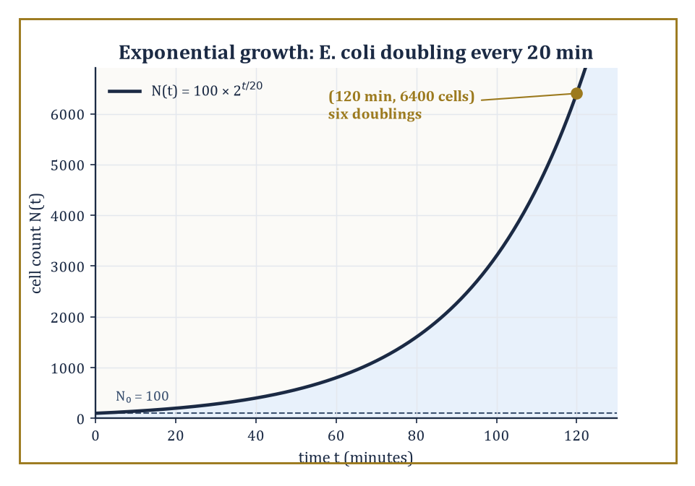
Figure 50.2 — Six doublings, no curve-fitting: the bacterial count derived straight from the mechanism lands on 6,400 cells at the two-hour mark, precisely as the equation demands.
Note that ‘question formulation’ comes before everything else, and deliberately so: the same rabbit population might be modeled as a smooth continuum if the question is ‘how many rabbits, roughly, in five years’, or as an explicitly discrete, individual-tracking stochastic process if the question is instead ‘what is the probability this particular reintroduced colony of eleven rabbits dies out by winter’ — same animal, same field, a completely different answer to stage three because the question asked was different.
In practice the list is a loop, entered at any point and traversed in whatever order the phenomenon demands — a modeler frequently discovers, three stages in, that the chosen framework cannot capture the mechanism at all, and returns to stage three having learned something valuable from the failed attempt.
No textbook diagram of this process, this one included, has ever survived contact with an actual research problem without a great many arrows pointing backwards.
Numeric example — walking the process for bacterial growth. Observation: a culture of E. coli, 100 cells at time zero, is left to grow in nutrient-rich broth. Mechanism, identified from first principles of cell biology: each cell, roughly every 20 minutes (its doubling time T_d, a measured parameter of this organism under these conditions), splits into two daughter cells. Framework: this mechanism is naturally discrete-in-generation, but because doublings happen asynchronously across a large population it is well approximated by continuous exponential growth,
N(t) = N0·2^(t/T_d)
Derivation is done — the equation follows directly from the mechanism, no curve-fitting involved. Analysis: after 2 hours (120 minutes),
t/T_d = 120/20 = 6
N(120) = 100 × 2⁶ = 100 × 64 = 6400 cells
Confrontation with data: a real culture, sampled at 2 hours, might show something close to 6400 — or, if nutrients are running low, noticeably less. Revision: the discrepancy is not a failure of the model so much as a signal that a new mechanism (nutrient depletion) has entered the regime of validity, motivating the next paragraph.
Try it now — A culture of 100 bacteria doubles every 20 minutes. How many are there after 2 hours? Answer →
Models built the way the bacterial example was built — from conservation laws, constitutive relations, or force balances, i.e. from a claim about mechanism — are called mechanistic.
Models built instead from an observed pattern, with no claim about the underlying mechanism, are called phenomenological: fit a curve that looks like the data and use it to interpolate or extrapolate, without asserting why the data has that shape.
Both styles are entirely legitimate mathematics; the choice depends on how much is actually known about the mechanism and on what the model needs to do — a modeler faced with a novel system, with no established theory to lean on, has no honest choice but to start phenomenologically, and to treat any claim of mechanism drawn from the curve alone with deep suspicion until independent evidence for it turns up.
A mechanistic model can be trusted to extrapolate into regimes never observed, because it encodes a claim about cause; a phenomenological model can only be trusted to interpolate within the range it was fitted to, because it encodes nothing but the shape of what was already seen, and shapes have an unpleasant habit of changing the moment one looks just past the edge of the data.
Numeric example — a mechanistic model, Michaelis–Menten enzyme kinetics. An enzyme E binds a substrate S to form a complex ES, which then releases product P and free enzyme: E + S ⇌ ES → E + P. Applying the law of mass action to this mechanism (a genuine chemical claim, not a curve fit) and assuming the ES complex reaches a quasi-steady concentration, one derives the reaction velocity
v = Vₘₐₓ·[S] / (Kₘ + [S])
where Vₘₐₓ and Kₘ are combinations of the underlying rate constants. Given Vₘₐₓ = 100 μM/min and Kₘ = 20 μM, at a substrate concentration [S] = 30 μM:
v = 100 × 30 / (20 + 30) = 3000/50 = 60 μM/min
Because this is mechanistic, it licenses a further, testable prediction with no new curve-fitting: a competitive inhibitor is known, from the same mechanism, to increase the apparent Kₘ without changing Vₘₐₓ — so doubling the apparent Kₘ to 40 while holding [S] = 30 predicts
v = 100 × 30/(40+30) = 3000/70 ≈ 42.9 μM/min
a specific number a purely phenomenological sigmoidal fit to the uninhibited data alone would have no principled way to produce.
The process is as much a craft as a science, and experience and judgment matter more than any flowchart suggests.
Modelers switch frameworks mid-derivation more often than textbooks admit — an epidemiologist might begin writing a smooth ordinary differential equation for an outbreak, realize the case count is still in single figures where chance dominates trend, and abandon the ODE in favor of a stochastic branching process (Stochastic Models and Uncertainty) solely because the early numbers are too small for the continuum framework to mean anything yet.
That switch is not a failure of planning; it is stage nine — revision — arriving earlier than the list implies it should, and a modeler who never has to backtrack has almost certainly not yet asked a hard enough question.
Keep only this · Section 50.2: The Modeling Process: From Phenomenon to Equation
The idea. Modeling is a process: observe, identify the mechanism, choose the framework, derive, simplify, analyze, confront with data, and revise.
Core.
exponential growth: N = N₀eʳᵗ, r = ln 2/T_double
Michaelis–Menten: v = V_max S/(K_m + S)
Typical mistake. Starting from an equation and looking for a phenomenon to fit. Start from the mechanism.
Minimal example. Doubling time 20 min: r = ln 2/20 ≈ 0.035 per minute.
Practice. Easy to challenge; full worked answers, with the usual mistake, are in Answers to the Practice Sets at the back.
Easy — Convert a doubling time of 20 minutes into a growth rate r. Answer →
Medium — With V_max = 10 and K_m = 2, compute v at S = 2 and S = 18. Answer →
Challenge — Show that the Michaelis–Menten law becomes a straight line in 1/v against 1/S, and say what the slope and intercept give. Answer →

Section 50.3: Scaling, Dimensional Analysis, and Dimensionless Models
How to Learn a Great Deal About an Equation Before Writing It Down
Dimensional analysis extracts constraints on the form of a physical relation only from the dimensions — length, time, mass, and so on — of the quantities involved, without needing to know the underlying physics at all.
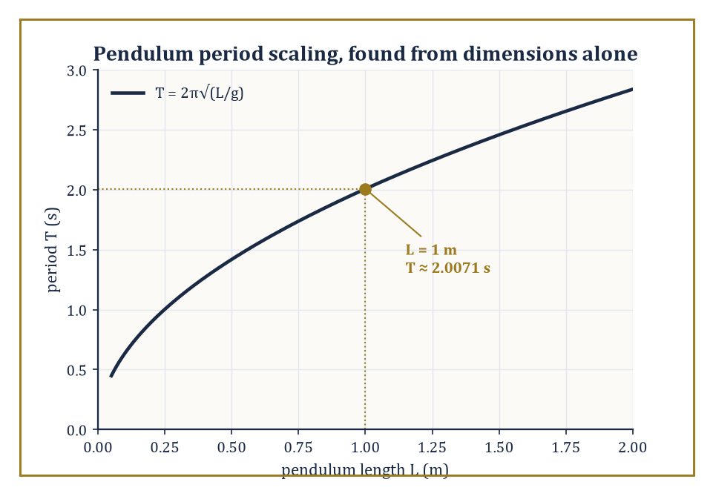
Figure 50.3 — Dimensional analysis alone fixes the shape of the curve, T = C√(L/g); only the constant C = 2π still awaits the physics Case Studies: Mechanics, Biology, and Epidemiology will supply.
Its central tool is Buckingham’s Pi theorem: if a relation involves n physical quantities built from k independent fundamental dimensions, then the relation can be rewritten in terms of exactly n − k independent dimensionless groups (traditionally called Π groups), and every dimensionally consistent relation among the original quantities must, in fact, be expressible purely as a relation among these groups.
This is a remarkable piece of mathematics doing the work of physics for free, before a single experiment has been run or a single law of motion invoked — it will not tell you the constant in front of an equation (that genuinely does require physics, or at least one measurement), but it will tell you, correctly and for nothing, exactly what variables the equation is and is not allowed to depend on, which is very often most of the battle.
Numeric example — the pendulum period, derived without doing any physics. Suppose the period T of a simple pendulum’s small swing depends only on its length L, the gravitational acceleration g, and its mass m. Dimensions:
[T] = time, [L] = length, [g] = length/time², [m] = mass
Since mass appears in none of the other quantities, it cannot combine with them to cancel out and must drop from the relation entirely — dimensional analysis has just told us, correctly, that a heavier pendulum bob swings no slower or faster than a lighter one, with zero physics invoked. That leaves three quantities, T, L, g, built from two fundamental dimensions, length and time, so
n − k = 3 − 2 = 1
exactly one dimensionless group. By inspection,
Π = T·√(g/L)
is dimensionless (check:
[T]·√([L/T²]/[L]) = time · √(1/time²) = time · (1/time) = 1
dimensionless, correct). The Pi theorem says any valid relation must take the form Π = C, a pure number — so
T = C·√(L/g)
for some constant C that dimensional analysis alone cannot supply. Plugging in L = 1 m, g = 9.8 m/s², and the value C = 2π (which Case Studies: Mechanics, Biology, and Epidemiology will derive from the physics, not merely assume):
T = 2π·√(1/9.8) = 2π × 0.31944 ≈ 2.0071 seconds
matching the textbook value for a one-meter pendulum to four figures.
Try it now — Water (ν = 1.0 × 10⁻⁶ m²/s) flows at 0.1 m/s in a pipe of diameter 0.01 m. Compute the Reynolds number. Answer →
Nondimensionalization is the practical use of this idea inside a working model: rescale every variable in the governing equations by a characteristic value (a characteristic length, time, or concentration) so that the resulting equation contains no dimensional quantities at all, only dimensionless parameters — pure numbers.
These dimensionless parameters have names because they recur constantly and classify the qualitative regime a system is in: the Reynolds number for fluid flows, the Froude number for surface-wave-dominated flows, the Damköhler number for reaction-versus-transport competition, and — met again in Case Studies: Mechanics, Biology, and Epidemiology — the basic reproduction number for epidemics.
A crucial payoff: two physically very different systems with the same dimensionless parameter behave, in the relevant respect, identically, which is how a scale model in a wind tunnel can say anything true about a full-size aircraft.
Numeric example — Reynolds number for pipe flow. Water flows through a pipe of diameter D = 0.02 m at average speed v = 0.5 m/s; the kinematic viscosity of water is ν ≈ 1.0 × 10⁻⁶ m²/s. The Reynolds number is
Re = vD/ν = (0.5 × 0.02)/(1.0 × 10⁻⁶) = 0.01/0.000001 = 10,000
Since pipe flow typically transitions from laminar to turbulent somewhere around Re ≈ 2,300–4,000, a value of 10,000 says the flow is comfortably turbulent. Note the payoff mentioned above directly: a pipe eight times wider carrying water eight times slower would have the same Re = 10,000 and therefore the same qualitative (turbulent) behavior, despite being a completely different physical size — the dimensionless number, not the raw numbers, is what governs the regime.
Scaling is the companion skill of estimating the relative size of the different terms in an equation, in order to work out which of them may be safely discarded in a given regime — the single most cost-effective act of simplification available to a modeler, because it is arithmetic, not analysis, and it can be done on the back of an envelope before any serious work begins.
Numeric example — does gravity or surface tension shape a droplet?. The Bond number
Bo = Δρ·g·L²/σ
compares gravitational to surface-tension forces at length scale L, where Δρ is the density difference across the surface, g is gravitational acceleration, and σ is surface tension. For a small water droplet of radius L = 1 mm = 10⁻³ m, with Δρ ≈ 1000 kg/m³ and σ ≈ 0.072 N/m for water:
Bo = 1000 × 9.8 × (10⁻³)² / 0.072 = 1000 × 9.8 × 10⁻⁶ / 0.072 = 9.8 × 10⁻³ / 0.072 ≈ 0.136
Since Bo is well below 1, surface tension dominates gravity at this scale — the gravitational term in the governing equation may be dropped, and indeed small droplets are very nearly spherical, as surface tension alone would produce. For a bucket of water, L ≈ 0.3 m:
Bo = 1000 × 9.8 × (0.3)² / 0.072 = 1000 × 9.8 × 0.09/0.072 ≈ 12,250
vastly greater than 1, so now it is the surface-tension term that is negligible, and buckets of water are, correctly, not spherical.
Scaling and dimensional analysis are the first and often the most powerful tools a modeler reaches for, because they cost almost nothing — a page of algebra, no simulation, no data — and because they catch a large fraction of would-be modeling errors before a single differential equation is written down.
A term with the wrong dimensions in a proposed equation is not a subtle mistake to be caught by careful simulation weeks later; it is an immediate, mechanical contradiction, visible on inspection, and a surprising number of published errors in applied mathematics would never have survived five minutes of this particular, unglamorous kind of checking.
You have seen this before
The pendulum whose period this section derived without physics ran through Chapters 45 to 49 as the running example, from Control Theory to Structure-Preserving and Geometric Integration: a plant, a phase portrait, a Hamiltonian and a numerical test. Dimensional analysis gives the form T = C√(L/g); Linear State-Space Models gave C = 2π from the eigenvalues.
Keep only this · Section 50.3: Scaling, Dimensional Analysis, and Dimensionless Models
The idea. Dimensional analysis finds the dimensionless groups a law can depend on; scaling shows which terms dominate and reduces the number of parameters.
Core.
Buckingham Π: n variables, m dimensions ⇒ n − m groups
Re = vD/ν, Bo = ρgL²/σ
Typical mistake. Thinking dimensional analysis gives the constant. It gives the form, T = C√(L/g); C = 2π needs the physics.
Minimal example. Pendulum: T = C√(L/g), so four times the length doubles the period.
Practice. Easy to challenge; full worked answers, with the usual mistake, are in Answers to the Practice Sets at the back.
Easy — By dimensional analysis T = C√(L/g). What happens to T when L is multiplied by 4? Answer →
Medium — Compute the Bond number ρgL²/σ for a water drop with L = 1 mm (ρ = 1,000 kg/m³, σ = 0.072 N/m). Which force shapes it? Answer →
Challenge — The drag F on a sphere depends on ρ, v, D and the viscosity μ. How many dimensionless groups are there, and what is the form of the law? Answer →

Section 50.4: Discrete and Continuous Models
Or: Should Time Tick, or Should It Flow?
Discrete models — difference equations, cellular automata, agent-based models, graph-based models — evolve a finite or countable state through discrete steps of time.
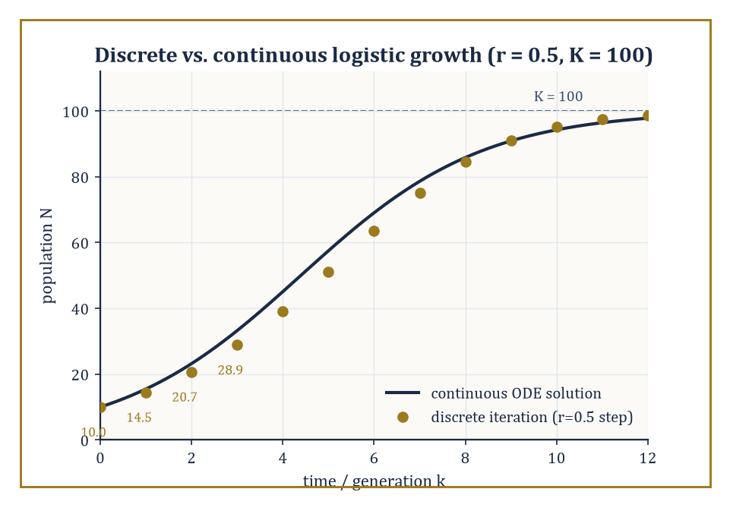
Figure 50.4 — For a modest growth rate the discrete iterates sit right on the continuous S-curve — the agreement that stops holding, unannounced, once r climbs past about 2.
Continuous models — ordinary differential equations, partial differential equations, delay equations, integral equations — evolve a continuum-valued state through continuous time.
Which framework a phenomenon demands is decided by its natural scale (does the system change in indivisible jumps, like a cell dividing or a molecule reacting, or does it change smoothly, like a temperature field diffusing through a metal bar?) and by which mathematics is available to analyze it once chosen.
A cellular automaton, for instance, is a discrete model taken to its logical extreme: a grid of cells, each in one of a finite number of states, updated in lockstep according to a fixed local rule depending only on a cell’s own state and its neighbors’ — no equation in the traditional sense at all, and yet, as Section 50.1’s traffic example already hinted, capable of producing rich, unpredictable, emergent large-scale behavior from nothing but simple local arithmetic repeated many times.
The choice between discrete and continuous is not always innocent: the ‘same’ model, written discretely versus continuously, can behave qualitatively differently, as the very next example shows.
Numeric example — a discrete population that overshoots its own ceiling. The discrete logistic difference equation
Nₖ₊₁ = Nₖ + r·Nₖ·(1 − Nₖ/K)
with growth-rate parameter r = 0.5, carrying capacity K = 100, and initial population N0 = 10, is iterated by hand:
N1 = 10 + 0.5×10×(1 − 10/100) = 10 + 5×0.9 = 10 + 4.5 = 14.5
N2 = 14.5 + 0.5×14.5×(1 − 14.5/100) = 14.5 + 7.25×0.855 = 14.5 + 6.19875 = 20.69875
N3 = 20.69875 + 0.5×20.69875×(1 − 0.2069875) = 20.69875 + 10.349375×0.7930125 ≈ 20.69875 + 8.20718 ≈ 28.906
The population climbs steadily toward K = 100, as expected — but for this same difference equation, larger values of r (roughly r > 2) are known to make Nₖ overshoot K, undershoot back, and settle into sustained oscillation or outright chaos, a qualitative behavior with no counterpart at all in the continuous logistic ODE
dN/dt = rN(1 − N/K)
whose solution is a smooth S-curve that approaches K monotonically for every positive r. The discretization is not a mere numerical detail; for large r it is a different dynamical system.
Try it now — For Nₖ₊₁ = Nₖ + rNₖ(1 − Nₖ/K) with r = 0.5, K = 100 and N₀ = 10, find N₁. Answer →
Continuum limits of discrete models, and discretizations of continuum models, are the rigorous bridges connecting the two worlds, and they run in both directions.
Mean-field limits of interacting particle systems let an enormous number of discrete, randomly interacting individuals collapse, as their number grows without bound, onto a single smooth deterministic equation for their average behavior — this is just how the individual, stochastic collisions of billions of gas molecules give rise to the smooth, continuous, entirely deterministic equations of fluid dynamics, and it is why the SIR equations of Case Studies: Mechanics, Biology, and Epidemiology can be trusted once an epidemic’s case count is large, even though the true underlying process is really the discrete, stochastic one of Stochastic Models and Uncertainty.
Hydrodynamic limits and homogenization (replacing a finely structured discrete medium — a lattice of individual atoms, a composite material’s microscopic weave — with an equivalent smooth one) run the same trick in materials science and statistical mechanics.
The clearest and most elementary instance of such a bridge, however, requires no lattice, no gas, and no advanced theorem at all — only a bank account.
Numeric example — compound interest becomes e. A sum grows by a total annual rate of r = 1 (a deliberately dramatic 100%, chosen to make the arithmetic vivid), compounded n times per year, by the discrete growth factor (1 + r/n)ⁿ. Computing this factor for increasing n:
n = 1: (1+1)¹ = 2.0
n = 2: (1.5)² = 2.25
n = 4: (1.25)⁴ = 1.5625² = 2.44140625
n = 12: (1 + 1/12)¹² ≈ 2.61303
n = 365: (1 + 1/365)³⁶⁵ ≈ 2.71457
As n → ∞ — compounding continuously — the factor converges to Euler’s number, e ≈ 2.71828. This is, quite literally, the discrete difference-equation model of growth (‘add a bit of interest every 1/n of a year’) converging, as the time step shrinks to zero, onto the continuous exponential ODE
dy/dt = y
whose solution is
y = y0·eᵗ
Every mean-field or hydrodynamic limit in the paragraph above is the same trick — discrete steps shrinking to a continuum — dressed up in more elaborate clothing.
Hybrid models combine discrete and continuous components in a single system, used when different parts of the phenomenon demand different descriptions and no single framework serves the whole.
Abstract example — a tumor that is discrete at the edge and continuous in the middle. A model of an invasive tumor might treat individual cells at the tumor’s growing edge as discrete agents, each making a discrete decision every time step — divide, migrate, or die — based on the local nutrient concentration it senses.
Meanwhile the oxygen and nutrient concentration diffusing through the surrounding tissue is modeled as a continuous reaction–diffusion partial differential equation, since tracking every individual diffusing molecule discretely would be computationally hopeless and scientifically pointless.
The two components are coupled: the PDE supplies each discrete cell with the local nutrient value driving its decision rule, and the discrete cells’ consumption of nutrient feeds back into the PDE as a sink term.
Neither a fully discrete model (infeasible at the molecular scale) nor a fully continuous one (which erases the individual cell-to-cell variability that actually determines whether the tumor invades along one path or another) would serve alone; the hybrid keeps the granularity that matters at each scale.
The discrete–continuous dichotomy is one of the fundamental choices a modeler makes, and — as the overshooting population above should make clear — it is rarely a choice without consequences for what the model can and cannot do.
It is worth saying plainly that neither side of the dichotomy is the ‘more realistic’ one in general: the world is not secretly discrete with continuity as a convenient fiction, nor secretly continuous with discreteness as a computational nuisance; which description is apt depends entirely on the scale at which the question is being asked, and a competent modeler must be equally fluent in both, ready to cross the bridge in either direction as the question demands.
One caution follows from the bridge running both ways. A continuum model that works is evidence about the scale at which it was tested, and only that scale. The equations of fluid flow predict how water leaves a tap with great accuracy, yet water is made of molecules about a third of a nanometer apart. A single cubic millimeter holds about 3.3 × 10¹⁹ of them (10⁻³ g ÷ 18 g per mole × 6.02 × 10²³ per mole), so many that their graininess averages away. Nothing in the success of the smooth equations announced the molecules; they had to be found by other means.
Space and time are in the same position. Physics treats both as continuous, and that description has passed every test down to distances of roughly 10⁻¹⁹ meters, the scale probed in particle colliders. The Planck length, where quantum gravity is expected to matter, is about 1.6 × 10⁻³⁵ meters, some sixteen powers of ten smaller. Smoothness down to 10⁻¹⁹ meters is consistent with a spacetime that stays smooth below that and with one that is grainy far below it; the tested range cannot tell them apart.
Timing of gamma-ray bursts has ruled out the simplest versions of graininess, in which light’s speed would depend on its energy, but no experiment has detected any graininess at all, and none has ruled it out at the Planck scale itself. The modeler’s summary is the honest one: the continuum is the right description at the scales we can reach, and it is silent about the scales we cannot.
Keep only this · Section 50.4: Discrete and Continuous Models
The idea. Discrete models count in steps; continuous models assume change spread smoothly in time or space. Each is right in its regime, and the passage between them can change the dynamics.
Core.
(1 + r/n)ⁿ → eʳ
discrete logistic: K is stable iff 0 < r < 2
Typical mistake. Assuming a difference equation behaves like its differential equation. Large steps overshoot.
Minimal example. Monthly compounding at 100%: (1 + 1/12)¹² ≈ 2.613, near e.
Practice. Easy to challenge; full worked answers, with the usual mistake, are in Answers to the Practice Sets at the back.
Easy — Compute (1 + 1/12)¹². Answer →
Medium — For the discrete logistic, the multiplier at N = K is 1 − r. For which r is K stable? Test r = 2.5. Answer →
Challenge — Show that Euler’s method with step Δt on dN/dt = rN(1 − N/K) is the discrete logistic with rate rΔt, and say what that implies for the step size. Answer →

Section 50.5: Stochastic Models and Uncertainty
The World Declines to Be Deterministic, and Is Quite Right To
Stochastic models build randomness into the mathematics explicitly, as a first-class ingredient of the equations themselves, rather than treating it as an embarrassing residual noise to be averaged away at the end: birth–death processes, stochastic differential equations, random walks, branching processes, Markov chains all belong to this family.
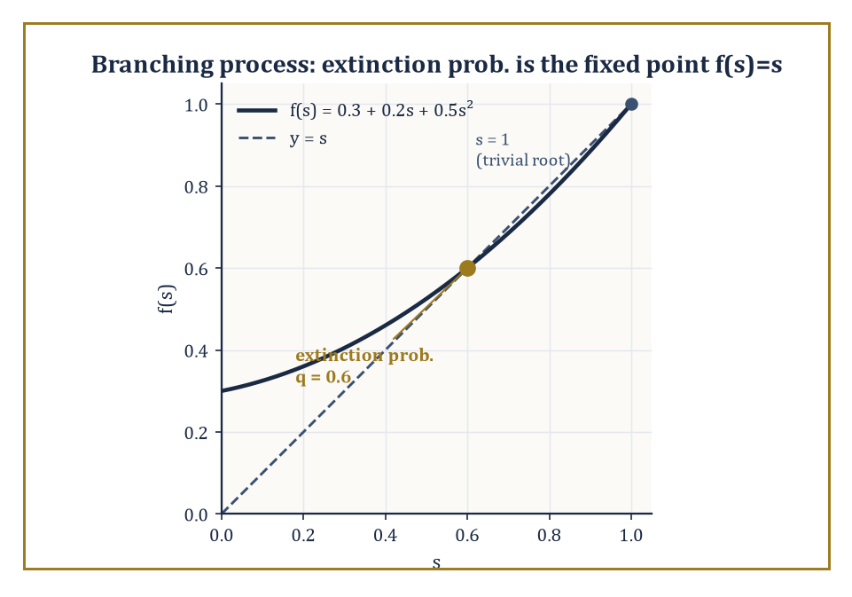
Figure 50.5 — Where the offspring-generating curve crosses the line y = s below 1 is the extinction probability — 0.6, even though the mean-field model insists the population only ever grows.
They earn their keep whenever fluctuations matter — in small populations, in noisy environments, wherever the modeler’s knowledge of initial conditions or mechanism is genuinely incomplete — and above all whenever a system is small enough that ‘the average behavior’, the thing a deterministic model reports, and ‘what happens on this particular occasion’ can come apart in a way that matters to the question being asked.
A Markov chain generalizes the idea to any system that moves between a set of states with probabilities depending only on its current state, not its history — a useful working definition of ‘memorylessness’ that recurs across the whole family.
A branching process is the simplest serious example of the dynamical kind: starting from one individual, each individual in every generation independently produces a random number of offspring according to some fixed probability distribution, and the population either dies out or grows forever — there is no other long-run option, a dichotomy sharp enough to be worth computing exactly.
Numeric example — a growing population that dies out 60% of the time. Suppose each individual has 0 offspring with probability p0 = 0.3, exactly 1 offspring with probability p1 = 0.2, and exactly 2 offspring with probability p2 = 0.5. The mean number of offspring per individual is
μ = 0×0.3 + 1×0.2 + 2×0.5 = 0.2 + 1.0 = 1.2
Since μ > 1, a deterministic (mean-field) model of the same process —
dN/dt or Nₖ₊₁ = 1.2·Nₖ
— would predict, with complete confidence, unbounded growth forever. The true stochastic process disagrees. The extinction probability q is the smallest root in [0,1] of f(s) = s, where f(s) = p0 + p1s + p2s² is the offspring probability-generating function:
0.3 + 0.2s + 0.5s² = s ⟹ 0.5s² − 0.8s + 0.3 = 0 ⟹ s² − 1.6s + 0.6 = 0
(multiplying by 2). The discriminant is
1.6² − 4×0.6 = 2.56 − 2.4 = 0.16
so √0.16 = 0.4, and the roots are
s = (1.6 ± 0.4)/2, giving s = 1.0 or s = 0.6
The smallest root in [0,1) is q = 0.6. So even with a healthy 20% average growth per generation, the line founded by a single individual dies out completely 60% of the time — extinction and explosive growth are both entirely normal outcomes of the identical stochastic process, a fact the mean alone hides completely.
Try it now — Each individual has 0, 1 or 2 offspring with probabilities 0.2, 0.3 and 0.5. Find the probability that the line dies out. Answer →
Uncertainty quantification — treated at length in its own right earlier in the series — extends this same idea to a model’s parameters, and even to its structure, treating them as uncertain quantities to be propagated through to the predictions rather than fixed numbers plugged in once and then quietly forgotten about.
This matters because a model is often far more sensitive to some parameters than others; propagating the uncertainty properly, rather than reporting a single confident number, tells the modeler which unmeasured quantity is actually worth the expense of measuring more precisely, and which is safe to leave vague.
Bayesian calibration is the standard mechanism for doing the propagating: begin with a prior probability distribution over an unknown parameter, encoding what is believed before seeing the data at hand, and update it into a posterior distribution once data arrives, via Bayes’s rule.
Model discrepancy, a further refinement, explicitly accounts for the systematic gap between even the best-calibrated model and reality — the honest admission that no amount of data will make a structurally wrong mechanism right, only a well-fitted one, and that the two failures look deceptively similar from the outside until this distinction is drawn.
Numeric example — updating a belief about an infection probability. Let p be the probability that an individual exposed to a pathogen becomes infected — an unknown parameter of an epidemic model. A weak, symmetric prior belief is encoded as a Beta(2,2) distribution, centered on 0.5 but not dogmatic about it. A small challenge study observes 7 infections out of 10 exposures. Because the Beta distribution is conjugate to the binomial likelihood, the posterior is exactly
Beta(2+7, 2+3) = Beta(9,5), with posterior mean 9/(9+5) = 9/14 ≈ 0.643
— pulled from the prior’s 0.5 toward the raw observed frequency of 7/10 = 0.7, but not all the way, because the weak prior still has some say with only ten data points behind it. Now suppose, instead, the same 70% infection rate had been observed over 100 exposures (70 infections): the posterior becomes
Beta(2+70, 2+30) = Beta(72,32), with mean 72/104 ≈ 0.692
— much closer to the raw frequency, because a hundred data points overwhelm a weak prior far more thoroughly than ten do. This is uncertainty quantification in miniature: the parameter is never a bare number but a distribution, one that narrows and shifts, in a mathematically precise and reproducible way, as evidence accumulates.
Stochasticity and uncertainty, then, are not defects in a model to be regretted and eliminated with a bigger computer; they are features of the world, and of our knowledge of it, that a good model represents honestly rather than papers over.
Numeric example — why noise matters more when the numbers are small. A simple symmetric random walk of N independent ±1 steps has variance N and standard deviation √N, so the size of the fluctuation relative to N itself scales as
√N/N = 1/√N
For N = 100, the relative fluctuation is
1/√100 = 1/10 = 10%
for N = 10,000, it drops to
1/√10,000 = 1/100 = 1%
This single scaling law is why the branching-process calculation above had teeth: with only a handful of infected individuals at an outbreak’s start, the ‘noise’ is comparable in size to the ‘signal’, so a supercritical process (mean growth rate above 1, μ = 1.2 in the earlier example) can still fizzle out by sheer chance — the 60% extinction probability computed there. Once case counts reach the thousands, this same 1/√N law says the relative noise has shrunk to the point of irrelevance, and the smooth, deterministic compartmental models of Case Studies: Mechanics, Biology, and Epidemiology become trustworthy again. Stochastic and deterministic models are not rivals; they are the correct description of the identical phenomenon at two different scales.
Where this returns
Uncertainty about a parameter, and noise in small populations, are step 7 of The Capstone Case Study, in Ten Steps, where an uncertain growth rate becomes an uncertain safe harvest.
Keep only this · Section 50.5: Stochastic Models and Uncertainty
The idea. Stochastic models put chance into the mechanism; they matter most when numbers are small, and Bayesian updating turns data into beliefs about parameters.
Core.
extinction: smallest root of q = G(q)
Beta(a, b) prior + k of n ⇒ Beta(a + k, b + n − k)
relative noise ∝ 1/√N
Typical mistake. Trusting the mean when numbers are small. A population with mean growth can still die out.
Minimal example. p₀ = 0.3, p₁ = 0.2, p₂ = 0.5: extinction probability 0.6.
Practice. Easy to challenge; full worked answers, with the usual mistake, are in Answers to the Practice Sets at the back.
Easy — What is the mean number of offspring in the Try it now, and what does it say? Answer →
Medium — Start with a Beta(1, 1) prior for an infection probability and observe 3 infections among 10 exposed. Give the posterior and its mean. Answer →
Challenge — Compare the relative fluctuation 1/√N of a population of 100 with one of 10⁶, and say which needs a stochastic model. Answer →

Section 50.6: Case Studies: Mechanics, Biology, and Epidemiology
Where the Abstract Process Finally Gets Its Hands Dirty
An epidemic starts with one infected person in a town where nobody is immune. On average that person infects 0.3 others per day and stays infectious for 10 days, so before recovering they infect about 0.3 × 10 = 3 people. Each of those infects about 3 more, and so on:
generation 1: 1 case
generation 2: 3 cases
generation 3: 9 cases
generation 4: 27 cases
Now suppose two-thirds of the town is already immune. Each infected person still meets the same number of people, but only one in three of them can catch it, so each infects about 1. The generations run 1, 1, 1, 1: the outbreak neither grows nor dies away. With any more immunity than that, it shrinks.
That is the epidemic case study at the end of this section in miniature: find the balanced state, nudge it, and see whether the nudge grows or dies away. The other two case studies ask the same question of different systems. A pendulum hanging straight down, nudged, swings to and fro about the bottom. Rabbits and foxes at their balance point, nudged, neither return to it nor run away from it, but circle round it for ever.
Each case starts from a mechanism, writes it as differential equations, finds the equilibrium, and reads its fate off a linearization. The section carries out that process three times, beginning with the oldest and best-behaved example, mechanics.
Classical mechanics supplies the template every other applied field imitates, whether or not it advertises the fact.
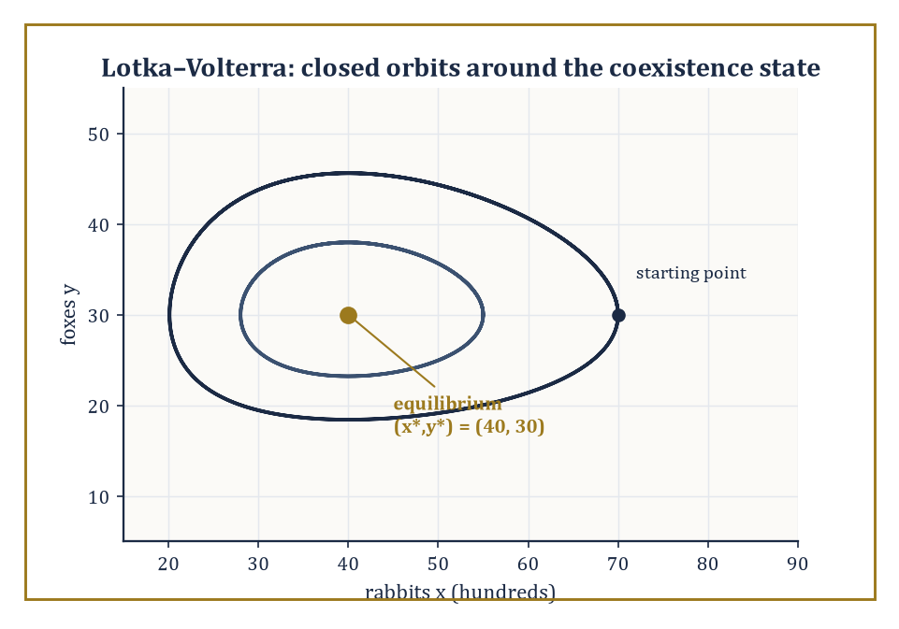
Figure 50.6 — Rabbits and foxes never settle at (40, 30) — they orbit it forever, a center rather than an attractor, exactly as the purely imaginary eigenvalues predict.
Newton’s laws give forces directly, coordinate by coordinate, which is straightforward for a free particle and rapidly becomes a bookkeeping nightmare once constraints enter — a bead on a wire, a pendulum’s string, a piston in a cylinder.
The Lagrangian formulation gives an equivalent, often far more convenient, route via a single scalar function, kinetic energy minus potential energy:
L = T − V
from which the equations of motion follow automatically via the Euler–Lagrange equation
d/dt(∂L/∂θ̇) − ∂L/∂θ = 0
for each generalized coordinate θ — no need to resolve the awkward constraint forces (the tension in that pendulum’s string, precisely) by hand at all, since a well-chosen coordinate builds the constraint in from the start and the tension simply never has to be computed.
The same template — a conservation law, dressed in a constitutive relation tailored to the specific material at hand — reappears, essentially unchanged in its logical structure, in elasticity, fluid dynamics, and plasticity; only the constitutive law linking stress to strain (or strain rate) changes from one to the next, which is why a mechanical engineer and a fluid dynamicist, for all their apparent differences, are doing recognizably the same kind of mathematics.
Numeric example — deriving the pendulum equation, properly this time. For a simple pendulum of mass m and length L, angle θ from vertical, position
(x,y) = (L sinθ, −L cosθ)
so speed² = L²θ̇², kinetic energy
T = ½mL²θ̇²
and potential energy
V = −mgL cosθ
(taking the pivot as the reference height). The Lagrangian is
L = T − V = ½mL²θ̇² + mgL cosθ
Then
∂L/∂θ̇ = mL²θ̇, so d/dt(∂L/∂θ̇) = mL²θ̈
and
∂L/∂θ = −mgL sinθ
The Euler–Lagrange equation gives
mL²θ̈ − (−mgL sinθ) = 0, i.e. mL²θ̈ + mgL sinθ = 0
and dividing through by mL²:
θ̈ + (g/L) sinθ = 0
The mass m cancels completely — Galileo’s observation about pendulums, re-derived here from Lagrangian mechanics rather than an inclined plane. With L = 1 m and g = 9.8 m/s²:
θ̈ = −9.8 sinθ
For small oscillations, sinθ ≈ θ, giving simple harmonic motion
θ̈ ≈ −9.8θ
angular frequency
ω = √9.8 ≈ 3.1305 rad/s
and period
T = 2π/ω = 2π/3.1305 ≈ 2.0071 seconds
exactly the value Scaling, Dimensional Analysis, and Dimensionless Models obtained from dimensional analysis plus a borrowed constant, this time with C = 2π derived rather than assumed, as promised.
Try it now — For SIR with β = 0.3 and γ = 0.1 per day, find R₀ and the herd-immunity threshold. Answer →
Biological modeling ranges across scales from enzyme kinetics and ion channels up through population dynamics, pattern formation (the Turing mechanism, by which a uniform field of two diffusing, reacting chemicals can spontaneously organize into spots or stripes), to physiological control systems.
The models here are characteristically nonlinear, often spatially structured, and stubbornly parameterized by quantities that are difficult or expensive to measure directly — which is why the data-driven and Bayesian techniques of the last two sections find so much of their natural habitat here.
Numeric example — where predator and prey settle, and why they don’t stay there. The classical Lotka–Volterra predator–prey model is
dx/dt = αx − βxy (prey, say rabbits)
dy/dt = δxy − γy (predator, say foxes)
with α the rabbits’ intrinsic growth rate, β the predation-encounter rate, δ the foxes’ reproduction efficiency per rabbit eaten, and γ the foxes’ death rate in the absence of food. The nontrivial (coexistence) equilibrium is found by setting both derivatives to zero with x,y ≠ 0: from dx/dt = 0,
α = βy, so y* = α/β
from dy/dt = 0,
δx = γ, so x* = γ/δ
With α = 1.5/yr, β = 0.05, δ = 0.02, γ = 0.8/yr:
x* = 0.8/0.02 = 40 (hundreds of rabbits, say)
y* = 1.5/0.05 = 30 (foxes)
Linearizing the equations about this point produces a pair of purely imaginary eigenvalues — meaning the equilibrium is a center, not an attractor: real trajectories orbit around (40,30) in closed loops rather than settling onto it, a famous feature of the model. This qualitative prediction — sustained cycles, never damping — is both confirmed by real predator–prey data (the classic lynx–hare fur-trapping records) and gently embarrassed by it, since real cycles typically do damp somewhat, a discrepancy that points, correctly, to a missing ingredient (commonly, a resource limitation on the prey population itself) that the bare model has left out.
Epidemiological models — the SIR model (Susceptible, Infected, Recovered) and its many descendants — illustrate the entire modeling cycle in one compact package: compartmental structure derived from the first-principles mechanism of transmission and recovery, a basic reproduction number obtained by linearizing about the disease-free state, intervention scenarios explored by simulation, and confrontation with real incidence data.
The COVID-19 pandemic put both the genuine power and the real limitations of this modeling family in front of a very wide, and often very critical, public audience.
Numeric example — computing R0 and the herd-immunity threshold. In the SIR model,
dS/dt = −βSI/N, dI/dt = βSI/N − γI, dR/dt = γI
with transmission rate β = 0.3 per day and recovery rate γ = 0.1 per day (so the mean infectious period is 1/γ = 10 days). Near the start of an outbreak, S ≈ N, so
dI/dt ≈ (β − γ)I
the infected compartment grows exactly when β > γ, i.e. when the basic reproduction number
R0 = β/γ = 0.3/0.1 = 3
exceeds 1 — a threshold condition obtained solely by linearizing about the disease-free equilibrium and checking the sign of a single eigenvalue, the same technique used to classify the pendulum and the logistic equilibria elsewhere in this chapter. R0 = 3 means each infected individual, in an otherwise fully susceptible population, infects three others on average before recovering. The herd-immunity threshold — the immune fraction needed to push the effective reproduction number below 1 — is
1 − 1/R0 = 1 − 1/3 = 2/3 ≈ 66.7%
Case studies are where the nine tidy stages of The Modeling Process stop being tidy and start being real; they are, in the fullest sense, the modeler’s apprenticeship.
Keep only this · Section 50.6: Case Studies: Mechanics, Biology, and Epidemiology
The idea. Three classical case studies — the pendulum, predator and prey, the epidemic — are analyzed by the same moves: find the balanced states, linearize, read the eigenvalues.
Core.
SIR: R₀ = β/γ, threshold 1 − 1/R₀
Lotka–Volterra coexistence: (c/d, a/b)
Typical mistake. Treating R₀ as a property of the pathogen alone. It depends on contact rates, which behavior changes.
Minimal example. R₀ = 1.5: one third must be immune.
Practice. Easy to challenge; full worked answers, with the usual mistake, are in Answers to the Practice Sets at the back.
Easy — What herd-immunity threshold corresponds to R₀ = 1.5? Answer →
Medium — For x′ = x − 0.5xy, y′ = −0.75y + 0.25xy, find the coexistence equilibrium. Answer →
Challenge — At the Lotka–Volterra coexistence point the eigenvalues are ±i√(ac). Compute them for the previous exercise and explain why the conclusion is fragile. Answer →

Section 50.7: Data-Driven and Hybrid Modeling
Letting the Data Do Some of the Thinking
Data-driven models infer structure directly from observations rather than from a stated mechanism: statistical regression, machine-learning surrogates, sparse identification of nonlinear dynamics (SINDy), dynamic mode decomposition, and physics-informed neural networks all belong to this family.
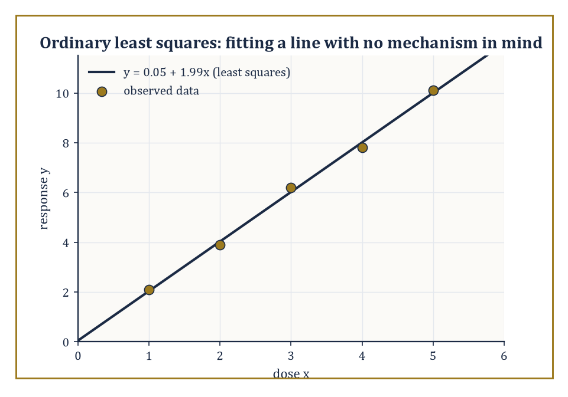
Figure 50.7 — The least-squares line y ≈ 0.05 + 1.99x hugs all five points without asserting a single word about why dose and response should be related at all.
They come into their own precisely where mechanistic modeling struggles — when the underlying mechanism is unknown, or is known in principle but too complex, too coupled, or too poorly characterized to write down and solve in any useful closed form, as is routinely the case in climate science, neuroscience, and economics, three fields where nobody seriously claims to have the exact governing equations in hand.
The simplest and oldest member of the family, and still the workhorse underneath a great many of the fancier ones, is ordinary least-squares regression: given data, find the line (or curve, for the nonlinear generalizations) that minimizes the sum of squared vertical distances between the observed points and the fitted curve — a single, elegant optimization criterion from which an enormous amount of applied statistics ultimately descends.
Numeric example — fitting a line with no mechanism in mind. Five measurements of a response y to a stimulus dose x, with no theory available for why the relationship should take any particular form: (1, 2.1), (2, 3.9), (3, 6.2), (4, 7.8), (5, 10.1). The means are
x̄ = (1+2+3+4+5)/5 = 3
ȳ = (2.1+3.9+6.2+7.8+10.1)/5 = 30.1/5 = 6.02
Deviations from the mean: x − x̄ gives −2, −1, 0, 1, 2; y − ȳ gives −3.92, −2.12, 0.18, 1.78, 4.08. The sum of products,
Sxy = (−2)(−3.92) + (−1)(−2.12) + (0)(0.18) + (1)(1.78) + (2)(4.08) = 7.84 + 2.12 + 0 + 1.78 + 8.16 = 19.9
The sum of squared x-deviations,
Sxx = 4 + 1 + 0 + 1 + 4 = 10
The least-squares slope is
Sxy/Sxx = 19.9/10 = 1.99
and the intercept is
ȳ − slope×x̄ = 6.02 − 1.99×3 = 6.02 − 5.97 = 0.05
The fitted model y ≈ 0.05 + 1.99x asserts nothing whatsoever about why the response is very nearly twice the dose; it only asserts that, within the observed range of doses one to five, it reliably is.
Try it now — Fit a line to (0, 1), (1, 3), (2, 5). Answer →
Sparse identification of nonlinear dynamics (SINDy) pushes the same regression idea much further, toward genuine equation discovery rather than mere curve-fitting: build a library of candidate terms that might plausibly appear in a governing equation — constants, x, x², x³, sinx, and so on, as many as the modeler’s physical intuition suggests including — regress the observed rate of change dx/dt against this whole library at once, and apply a sparsity penalty that discards any candidate whose fitted coefficient is too small to be distinguished from noise.
The philosophical bet underneath the method is essentially Occam’s razor again, imported wholesale from Validation, Falsification, and Model Selection: of all the terms that could in principle appear, only a genuine physical law’s worth of them will, and the rest are decorative.
What survives the thresholding is, if the method has worked, the true differential equation, recovered without the modeler ever having assumed its functional form in advance — a much stronger claim than an ordinary regression fit ever makes.
Numeric example — recovering dx/dt = −2x from noisy data. Suppose the true, unknown-to-the-modeler dynamics are simple exponential decay,
dx/dt = −2x
and noisy trajectory data is regressed against the candidate library {1, x, x², x³}. The unconstrained least-squares fit returns coefficients (0.01, −1.98, 0.003, −0.001) for the four terms respectively — every coefficient except the one on x is small, consistent with measurement noise rather than genuine signal. Applying a sparsity threshold of 0.1 (discard any coefficient smaller in magnitude than that) zeroes out the constant, x², and x³ terms, leaving the sparse recovered model
dx/dt ≈ −1.98x
a close match to the true law dx/dt = −2x, and, crucially, an actual differential equation carrying a mechanistic claim (linear decay, proportional to current state), not merely a curve valid only over the range of the observed data, as the pure regression example above was.
Hybrid models combine a mechanistic backbone with a data-driven component filling in the part that is unknown: a differential equation whose right-hand side is partly a known conservation law and partly a learned function, a stochastic model whose structural form is fixed but whose rates are estimated from data.
The aim is the best of both worlds — the interpretability and extrapolation-safety of mechanism, combined with the flexibility of a method that does not require the unknown part to be known in advance.
Abstract example — a reactor model that cannot lie about mass balance. Consider a chemical reactor of volume V, with flow rate Qᵢₙ of fresh reagent in and Qₒᵤₜ of product out, and an unknown, genuinely messy catalytic reaction consuming the reagent at some rate r([C]) nobody has fully characterized. Mass conservation — a non-negotiable physical law — fixes the overall structure:
d[C]/dt = Qᵢₙ/V − (Qₒᵤₜ/V)[C] − r([C])
The first two terms come from exact bookkeeping of flow and cannot be argued with; only the reaction-rate term r([C]) is replaced by a small neural network trained against observed concentration measurements. Whatever the network learns, the conservation structure surrounding it guarantees the overall model cannot violate mass balance — the mechanistic backbone constrains the data-driven component to only ever supply the one piece of genuine ignorance, the reaction kinetics, and nothing more.
The rise of data-driven methods does not abolish mechanistic modeling; it enlarges the toolkit, and shifts the division of labor between what is asserted from principle and what is learned from observation — a shift the next section will show how to police.
Keep only this · Section 50.7: Data-Driven and Hybrid Modeling
The idea. Data-driven models learn relations from measurements; hybrid models combine learned parts with conservation laws or mechanisms that must not be violated.
Core.
slope = Σ(x − x̄)(y − ȳ)/Σ(x − x̄)²
x′ = −kx: k = ln(x₀/x₁)/Δt
Typical mistake. Trusting a data-driven model outside the range of its data. It has no mechanism to extrapolate with.
Minimal example. x(0) = 8, x(1) = 2.2: k ≈ 1.29.
Practice. Easy to challenge; full worked answers, with the usual mistake, are in Answers to the Practice Sets at the back.
Easy — Fit a least-squares line to (1, 2), (2, 3), (3, 5). Answer →
Medium — Estimate k in x′ = −kx from x(0) = 8 and x(1) = 2.2. Answer →
Challenge — Why build mass conservation into a learned reactor model instead of learning everything from data? Answer →

Section 50.8: Validation, Falsification, and Model Selection
In Which Every Model Is Guilty Until Proven Useful
Same structure, new language
AIC and BIC are penalized objectives: fit plus a price for complexity. The ridge penalty and the implicit bias of Optimization for Statistical Learning are the same trade-off seen from optimization, and hypothesis testing in Hypothesis Testing is falsification made quantitative.
A model is validated — never ‘proven’, only validated, a weaker and more honest claim — by comparing its predictions against observations that played no part in building it.
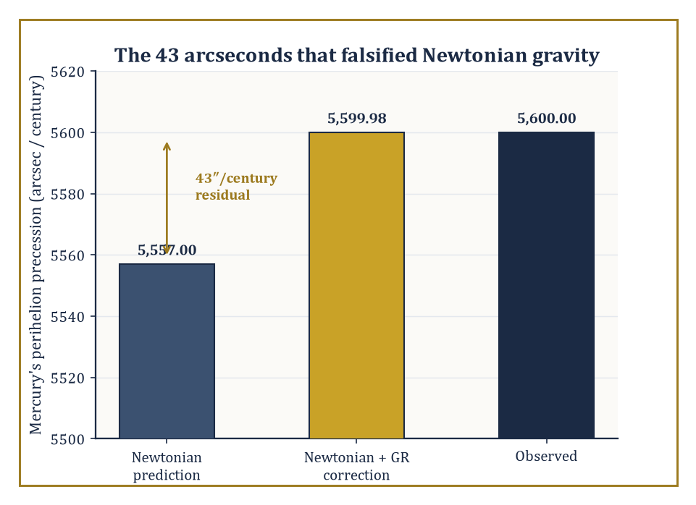
Figure 50.8 — A 43-arcsecond gap sat in plain view for decades until general relativity closed it, uninvited and to the arcsecond, with no parameter tuned after the fact.
This restriction is not pedantry. A model fitted and then tested only on the very data used to fit it will always look better than it deserves to, for the same reason a tailor’s suit fits the tailor’s own mannequin perfectly: the two were made for each other.
Holding back data breaks that collusion by construction, since the model was never shown the answer it is now being asked to predict.
Cross-validation (holding back part of the data during fitting, then checking against the held-back portion, often repeated across several different held-back subsets and averaged), out-of-sample testing, and genuine prospective prediction (forecasting something that has not happened yet, so that not even the modeler could have peeked) are the standard tools, in roughly increasing order of how hard they are to fake — it is disconcertingly easy to fool oneself with cross-validation if the held-back data secretly resembles the training data too closely, but almost impossible to fool oneself with a prediction about next month that next month has not yet had the chance to contradict.
Falsification — a decisive, reproducible disagreement between prediction and observation — is the sharpest instrument of progress available to a modeler: it does not merely criticize a model, it forces its revision or its abandonment, with no room for face-saving.
Numeric example — the 43 arcseconds that broke Newtonian gravity. Mercury’s elliptical orbit precesses — its perihelion, the point of closest approach to the Sun, slowly rotates around the Sun over time. The total observed precession is about 5,600 arcseconds per century relative to the fixed stars. Newtonian mechanics, accounting for the gravitational perturbations of all the other known planets, predicts about 5,557 arcseconds per century. The residual is
5,600 − 5,557 = 43 arcseconds per century
This resisted every attempt, for decades, to explain it with an undiscovered planet, a ring of unseen dust, or an oblate Sun consistent with every other observation available. That 43-arcsecond gap was a falsification sitting in plain view: an otherwise spectacularly successful theory was quietly, measurably, stubbornly wrong. When general relativity arrived, it predicted an additional perihelion precession of 42.98 arcseconds per century directly from first principles, with no free parameter tuned after the fact to match — very possibly the single most persuasive piece of evidence for the theory at the moment of its proposal, precisely because it resolved a number the reigning model had already, demonstrably, got wrong.
Try it now — Two models fit n = 20 points. A has k = 2 and RSS = 50; B has k = 3 and RSS = 45. Compare AIC = n ln(RSS/n) + 2k. Answer →
Model selection is the more everyday cousin of falsification: choosing among several competing, non-falsified models by explicitly balancing goodness of fit against complexity, using criteria such as the Akaike Information Criterion (AIC), the Bayesian Information Criterion (BIC), cross-validation error, or Bayesian evidence.
In its simplified least-squares form,
AIC ≈ n·ln(RSS/n) + 2k
where n is the number of data points, RSS the residual sum of squares, and k the number of fitted parameters — lower AIC is preferred.
The two terms are in open conflict by design: ln(RSS/n) can only fall, or at worst stay flat, as more parameters are added and the fit improves (a model with more knobs to turn can always match the training data at least as well), while the 2k term rises steadily to punish that temptation.
BIC replaces the 2k penalty with k·ln(n), a heavier tax on complexity once n is reasonably large, reflecting a slightly different philosophical commitment — AIC is built to find the model that predicts best, BIC to find the model that is, in a Bayesian sense, most probably the true one, and the two do not always agree.
This machinery is Occam’s razor made computable: a formal, arithmetic preference for the model that achieves adequate fit with fewer parameters, rather than a vague philosophical injunction toward simplicity that everyone quotes and nobody quite knows how to apply.
Numeric example — does the extra parameter earn its keep?. Two models are fitted to n = 20 data points. Model A, a straight line, has k = 2 parameters and residual sum of squares RSS_A = 50. Model B, a quadratic, has k = 3 parameters and RSS_B = 42.
AIC_A = 20·ln(50/20) + 2×2 = 20·ln(2.5) + 4 = 20×0.9163 + 4 = 18.326 + 4 = 22.326
AIC_B = 20·ln(42/20) + 2×3 = 20·ln(2.1) + 6 = 20×0.7419 + 6 = 14.839 + 6 = 20.839
Since AIC_B < AIC_A, the quadratic is preferred: its improved fit (RSS falling from 50 to 42) outweighs the two-point penalty charged for its extra parameter. Had the quadratic instead only reduced RSS to 48, the arithmetic runs
AIC_B = 20·ln(48/20)+6 = 20×0.8755+6 = 17.51+6 = 23.51
which exceeds AIC_A = 22.326 — so the simpler line would then be preferred, the extra parameter judged not to have earned its keep. This is Occam’s razor doing arithmetic rather than moralizing, and it can, as shown, go either way depending on just how much the extra complexity buys.
Validation and selection close the modeling loop opened in The Modeling Process: they convert the output of analysis, simulation, and data-fitting back into an honest, checkable judgment about the model’s actual relation to the world it was built to describe — which, after all, was the entire point of the exercise.
Every earlier section in this chapter built the machinery to construct a model; this section, deliberately placed last, exists to keep that machinery honest, and a modeler who skips it has not finished the job, however elegant the equation left sitting on the page.
Keep only this · Section 50.8: Validation, Falsification, and Model Selection
The idea. A model earns trust by surviving tests it could have failed; model selection trades fit against complexity.
Core.
AIC = n ln(RSS/n) + 2k
BIC = n ln(RSS/n) + k ln n
Typical mistake. Validating a model on the data used to fit it. Test on what it did not see.
Minimal example. A prediction that could not fail is not a test.
Practice. Easy to challenge; full worked answers, with the usual mistake, are in Answers to the Practice Sets at the back.
Easy — A model predicts a value between 5.5 and 6.4. The observation is 7.0. What follows? Answer →
Medium — Compute BIC for the two models of the Try it now. Answer →
Challenge — Explain why AIC and BIC can disagree, and for which n BIC is the stricter. Answer →

Section 50.9: The Capstone Case Study, in Ten Steps
One model of a harvested fishery, from first question to known failure
Every section of this chapter so far has shown one stage of modeling on its own example. This section runs a single model through all of them, start to finish, so that the whole process can be seen once in one piece. The model is a fishery: a fish population that grows, competes for food, and is harvested. Each step names the chapter or section whose tools it uses; follow the link if a step feels too quick.
Nothing here is new mathematics. The point is the order of the steps, and the habit of asking, at the end, where the model breaks.
Worked example — Step 1 of 10: Define the quantities. The state is the fish biomass N(t), in tonnes, at time t, in years. The parameters are the intrinsic growth rate r (per year), the carrying capacity K (tonnes), the stock the habitat supports without fishing, and the harvest rate h (per year), the fraction of the stock caught each year.
Write the units down before any equation: an equation whose terms have different units is wrong before it is solved.
Uses: The Modeling Process: From Phenomenon to Equation
Try it now — With ε = h/r = 0.3 and K = 10,000 tonnes, find the fished equilibrium, and the yield if r = 0.5 per year. Answer →
Worked example — Step 2 of 10: Choose the functions. Per-capita growth must be about r when fish are few and fall to zero at K. The simplest function with both properties is linear: g(N) = r(1 − N/K). Constant fishing effort catches a fixed fraction of whatever is there, so the catch is hN.
Both choices are the simplest ones that respect the facts. Simplest is a choice, and step 10 will test it.
Uses: What Mathematical Modeling Is, Case Studies: Mechanics, Biology, and Epidemiology
Worked example — Step 3 of 10: Derive the equation. Rate of change = growth − catch:
dN/dt = rN(1 − N/K) − hN
A yearly census would give the difference equation of Discrete and Continuous Models; the continuous version is its limit when births and catches are spread through the year.
Uses: Discrete and Continuous Models; differential equations from Chapter 26 (Volume 3)
Worked example — Step 4 of 10: Nondimensionalize. Measure stock in units of K and time in units of 1/r: x = N/K, τ = rt, and ε = h/r. Then
dx/dτ = x(1 − x) − εx
Three parameters (r, K, h) have become one, ε, the harvest rate measured against the growth rate. Every fishery of this type, large or small, fast or slow, is one point on the ε-axis.
Uses: Scaling, Dimensional Analysis, and Dimensionless Models
Worked example — Step 5 of 10: Analyze the dynamics. Equilibria: x = 0 and x* = 1 − ε. With f(x) = x(1 − x) − εx, f′(x) = 1 − 2x − ε, so f′(0) = 1 − ε and f′(x*) = −(1 − ε).
For ε < 1 the fished stock x* is stable and extinction is unstable. At ε = 1 the two equilibria meet and exchange stability: a transcritical bifurcation. Beyond it, the only stable state is extinction.
The sustained yield is hN* = hK(1 − h/r), largest at h = r/2: the maximum sustainable yield rK/4, taken from a stock held at K/2.
Uses: Linearization and Local Structure, Bifurcations; maximizing a quadratic, Optimization (Volume 3)
Worked example — Step 6 of 10: Approximate numerically. Euler’s method with step Δτ = 0.5, ε = 0.5 and x₀ = 0.1 gives
0.1 → 0.120 → 0.143 → 0.168 → 0.196 → 0.226 → ⋯ → 0.5
Near x* each step multiplies the error by 1 − Δτ(1 − ε) = 0.75, so the iteration converges. A step with Δτ(1 − ε) > 2 would make that multiplier less than −1, and the numbers would oscillate and blow up although the true stock settles quietly: the overshoot of the discrete logistic map, produced here by the method, not the fish.
Uses: Chapter 29 (Volume 3); Chaos in One-Dimensional Maps; Structure-Preserving and Geometric Integration
Worked example — Step 7 of 10: Add uncertainty. The growth rate is never known exactly. Suppose r is uniform on [0.4, 0.6] per year and h = 0.25 per year. Then ε = h/r ranges over [0.417, 0.625], and x* = 1 − h/r over [0.375, 0.583].
The mean of x* is 1 − h·E[1/r] = 1 − 0.25 × ln(1.5)/0.2 ≈ 0.493, slightly below the 0.5 obtained by plugging in the mean r. Because 1/r is convex, averaging the inputs first is optimistic (Jensen’s inequality). For a small stock, demographic noise adds a risk of extinction that the deterministic model cannot see.
Uses: Uncertainty Quantification, Stochastic Models and Uncertainty, Expectation, Variance, and Conditioning
Worked example — Step 8 of 10: Estimate the parameters. While the stock is far below K and unfished, N ≈ N₀eʳᵗ, so ln N is linear in t. Surveys at t = 0, 1, 2, 3 years give 100, 163, 274 and 446 tonnes. A least-squares line through (t, ln N) has slope
r̂ ≈ 0.500 per year
and intercept giving N₀ ≈ 99.7 tonnes. K is estimated separately, from the level at which an unfished stock levels off; take K = 10,000 tonnes.
Uses: Data-Driven and Hybrid Modeling, Linear Models and Regression
Worked example — Step 9 of 10: Test a prediction. Prediction: at h = 0.2 per year the stock settles at N* = K(1 − h/r) = 6,000 tonnes, giving a yield of 1,200 tonnes per year. With r between 0.45 and 0.55, the prediction interval is about 5,560 to 6,360 tonnes.
Suppose the stock, observed after several years of this harvest, settles near 5,800 tonnes. The prediction could have failed and did not: the model survives this test. A settled stock of 4,000 tonnes would have falsified it.
Uses: Validation, Falsification, and Model Selection, Hypothesis Testing
Worked example — Step 10 of 10: Explain where the model fails. Every assumption of step 2 has a known failure. At low density many fish species reproduce less well per capita (the Allee effect); then the stock collapses through a saddle-node bifurcation at a harvest rate well below ε = 1 (Challenge exercise below). Fish take years to mature, so growth responds to the stock of several years ago: a delay equation, which can oscillate. Small stocks are subject to chance. And fishing effort is not constant; fleets respond to prices.
The logistic fishery is the right first model and the wrong last one. Knowing which of its conclusions survive — that overharvesting past the growth rate is fatal — and which do not — the exact safe threshold — is the point of the exercise.
Uses: Bifurcations, Stochastic Models and Uncertainty; delay equations, Chapter 26 (Volume 3)
That is the whole of the modeling process in one place. The next section looks back over the series that supplied each step.
Keep only this · Section 50.9: The Capstone Case Study, in Ten Steps
The idea. One model, run through every step: quantities, functions, equation, scaling, dynamics, numerics, uncertainty, estimation, testing and failure. Each step uses a chapter you have already read.
Core.
dx/dτ = x(1 − x) − εx, ε = h/r
x* = 1 − ε, stable for ε < 1
MSY = rK/4 at h = r/2
Typical mistake. Stopping after step 5. A model that has not been estimated, tested and broken has not been finished.
Minimal example. ε = 0.5: the stock settles at half the carrying capacity.
Practice. Easy to challenge; full worked answers, with the usual mistake, are in Answers to the Practice Sets at the back.
Easy — Find the maximum sustainable yield for r = 0.5 per year and K = 10,000 tonnes. Answer →
Medium — In step 6, with ε = 0.5, what is the largest Euler step Δτ that converges, and what happens with Δτ = 5? Answer →
Challenge — Add an Allee effect: dx/dτ = x(1 − x)(x − a) − εx with a = 0.2. At what harvest ε does the fished stock disappear, and through which bifurcation? Answer →

Section 50.10: Looking Back and Looking Ahead: The Series and What Lies Beyond
The View From the Last Chapter
Where this returns
This is the last chapter of the series, but its ideas began much earlier: exponential growth in Logarithms & Potencies (Volume 1), eigenvalues in Linear Algebra (Volume 2), differential equations in Chapter 26 (Volume 3), and probability in Statistics & Probability. Everything in the capstone came from somewhere in those volumes.
We have reached the last chapter.
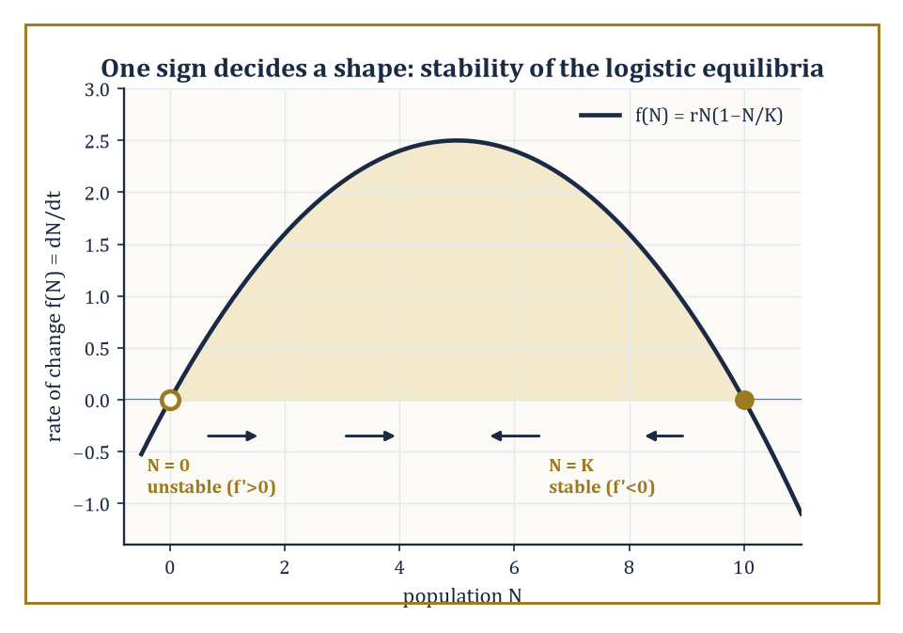
Figure 50.9 — Two signs, one open circle and one filled: the whole S-shaped fate of the logistic population is decided by nothing more than which way the arrows point at N = 0 and N = K.
The series that began, fifty chapters ago, with the counting of apples has risen through algebra, geometry, calculus, analysis, probability, computation, and the great structural theories of modern mathematics, each chapter adding tools the ones above would eventually need, very often without the chapter doing the adding having any idea what the tool would one day be used for.
This chapter has been about use: about taking that entire accumulated apparatus and turning it, deliberately, toward phenomena that do not know or care that they are being modeled — tea cooling, bacteria dividing, pendulums swinging, epidemics spreading, reactors reacting.
None of those phenomena has read this series, or any other; they go on doing what they do, and the equations are our attempt, always partial and always provisional, to keep up.
Looking back, the entire journey has aimed at three things at once: technical competence in the core subjects of pure and applied mathematics; a sense of the unity of the subject — the discovery, over and over, that the same structure reappears in wildly different guises; and a style of thought that combines genuine precision with a willingness to approximate, to simplify, and to confront the mathematics honestly with the world, as this chapter’s nine sections have tried to do.
Worked example — one equation, four unrelated jobs. Four numbers were computed in the sections behind us: tea cooling from 90°C to 60°C in about 11.19 minutes (What Mathematical Modeling Is); a bacterial culture reaching 6,400 cells after six doublings (The Modeling Process); the discrete-compounding growth factor climbing, step by step, toward e ≈ 2.71828 as the compounding interval shrank to nothing (Discrete and Continuous Models); and an epidemic with basic reproduction number R0 = 3 (Case Studies: Mechanics, Biology, and Epidemiology).
Underneath four entirely unrelated vocabularies — temperature, cell counts, currency, infections — all four are governed by the identical linear differential equation
dy/dt = k·y
(or its discrete difference-equation twin), and by the single eigenvalue k that decides, in every case, whether the quantity in question grows, decays, or sits at a threshold. This is what ‘the same structure reappearing in different guises’ means in practice: not a philosophical flourish, but the literally identical piece of algebra, learned once, doing four unrelated jobs across four unrelated sections of this chapter alone — let alone across the other forty-nine.
Try it now — Tea cools with k = −0.05 per minute and bacteria grow with r = +0.035 per minute. Find the halving time of the first and the doubling time of the second. Answer →
Numeric example — one sign decides a shape. The logistic equation
dN/dt = rN(1 − N/K)
has two equilibria, N = 0 and N = K. Writing
f(N) = rN − rN²/K
its derivative is
f′(N) = r − 2rN/K
At N = 0:
f′(0) = r > 0
— a positive eigenvalue, meaning the equilibrium is unstable, so any tiny founding population grows away from extinction rather than settling back into it. At N = K:
f′(K) = r − 2r = −r < 0
— a negative eigenvalue, meaning this equilibrium is stable, so any small perturbation away from carrying capacity decays back toward it. The entire qualitative shape of the logistic S-curve — climbing away from zero, leveling off at K, with nothing else it is permitted to do — is contained in nothing more than the signs of these two numbers, which is the eigenvalue machinery of linear algebra, forged many chapters before this one for wholly abstract reasons, doing quiet and indispensable service in an applied setting.
Looking ahead, the tools will not stop evolving: new physical regimes (quantum devices at room temperature, climates outside any historical envelope), new sources of data (sensors on everything, cheaply, all the time), new computational architectures, and new mathematical structures not yet invented will all demand extensions of everything built in this chapter.
Specific techniques will age; the Reynolds number will still be computed, but perhaps alongside dimensionless groups for phenomena not yet named.
What will not need replacing is the modeling process itself — observation, mechanism, framework, derivation, simplification, analysis, confrontation, revision, in whatever order the phenomenon demands — because that disciplined translation between world and mathematics is the one permanently useful skill underneath every specific technique this chapter has taught, and it will outlive every one of them.
The deeper lesson of the journey is that mathematics is, at once, a pure creation of the mind and the most effective language yet found for describing the structure of the world — and that these two faces are not in tension but reinforce each other.
Pure structures become useful because they turn out, unexpectedly and without having been designed for the purpose, to capture something real; real phenomena become intelligible because they turn out to be organized by pure structures all along.
Abstract example — an idea invented for no reason at all. Complex numbers were introduced, centuries ago, purely to let the algebra of polynomial root-finding close up neatly — a bookkeeping convenience for a problem entirely internal to mathematics, with no physical motivation whatsoever at the time.
Centuries later, the identical structure turned out to be the indispensable language of alternating-current circuit analysis, of quantum mechanics’s wavefunctions, and — directly relevant to this very chapter — of the Fourier techniques underlying much of the signal-processing machinery behind the data-driven methods of Data-Driven and Hybrid Modeling.
Nobody arranged this. The structure was invented for its own internal elegance, and reality, apparently, had been waiting for it the whole time.
Applied mathematics and modeling, then, are the place where the series meets the world — the chapter, fittingly the last one, where everything built for its own sake finally has to answer for itself.
And so the series, begun fifty chapters ago with three apples and two apples, is finished. Behind us: the numerical-methods chapter, still faintly warm from the last simulation left running; before that, forty-eight further chapters of algebra, geometry, calculus, analysis, probability, and structure, patiently waiting to be needed again, as they periodically will be, by anyone who climbs back down to borrow them.
It has been a long road, and if it has occasionally felt like a meditation on infinity, on the slow accretion of tenure-track certainty, and on the specific existential dread of a professor watching an integral fail to converge in front of a lecture hall — well, that was rather the point. Mathematics does not flinch from any of that; it merely insists on writing it down correctly, checking the arithmetic twice, and moving on regardless. That, as much as any theorem in these fifty chapters, is the actual lesson.
The series is built. The world, as it always was, is waiting — and now, at least, we have the equations to go and ask it some proper questions. End of Chapter 50. The book, mercifully, also reads backwards: every chapter is still there when you want it.
Keep only this · Section 50.10: Looking Back and Looking Ahead: The Series and What Lies Beyond
The idea. Looking back: the series built tools for their own sake, and modeling is where they meet the world; looking ahead, the process outlasts any technique.
Core.
dy/dt = ky: sign of k decides growth or decay
logistic: f′(0) = r, f′(K) = −r
Typical mistake. Expecting the techniques to be the lasting part. The process — model, test, revise — is.
Minimal example. Logistic with r = 0.5: perturbations of K decay with time scale 1/r = 2.
Practice. Easy to challenge; full worked answers, with the usual mistake, are in Answers to the Practice Sets at the back.
Easy — For the logistic equation with r = 0.5 per year, how quickly does a small perturbation of K decay? Answer →
Medium — Name the eigenvalue that decides the fate in three models of this chapter: tea, the fishery, and the SIR epidemic at its start. Answer →
Challenge — Explain, with one example from the series, how a structure invented for internal reasons later became the language of a phenomenon. Answer →
Chapter 50 recap · Where Mathematics Meets the World
• A model is a deliberate simplification: choose what to keep, state it, and test it.
• The process runs from observation and mechanism to equation, simplification, analysis and confrontation with data, and then loops.
• Dimensional analysis and scaling reduce the parameters to dimensionless groups and show which effects dominate.
• Discrete and continuous, deterministic and stochastic descriptions each have their regime; small populations need noise.
• Equilibria and their eigenvalues organize mechanics, ecology and epidemiology alike; data-driven and hybrid models add what mechanisms miss.
• Validation and model selection keep models honest; the ten-step fishery shows the whole process, including where the model fails.

Check Your Understanding — Chapter 50
Answers are in the Answer Key at the back of the book — have a go before you look.
1. [Explain] Why can no single model maximize fidelity, tractability, and usefulness all at once?
See the answer →
2. [Explain] Using dimensional analysis alone, why must the pendulum bob’s mass m drop out of the formula for its period?
See the answer →
3. [Model] A branching process has offspring probabilities p0=0.3, p1=0.2, p2=0.5, giving a mean of 1.2 offspring per individual. Explain why this population can still die out, and find the probability that it does.
See the answer →
4. [Explain] Why is the AIC formula, n·ln(RSS/n) + 2k, built as a contest between two opposing terms, and what does that achieve?
See the answer →
5. [Compute] An SIR epidemic model has transmission rate β = 0.3 per day and recovery rate γ = 0.1 per day. Find R₀ and the herd-immunity threshold.
See the answer →
6. [Model] A cup of tea at 90 °C cools in a 20 °C room, reaching 60 °C after 10 minutes. Using Newton’s law of cooling, find the rate constant and the temperature after 20 minutes.
See the answer →
7. [Explain] Adding parameters to a model always improves its fit to the data you already have. Why does that not mean it will predict new data better?
See the answer →
8. [Prove] Show that the carrying capacity K is an asymptotically stable equilibrium of the logistic equation Ṅ = rN(1 − N/K), for r > 0.
See the answer →
9. [Explain] Models are described as validated but never proved. Why is that not merely modest phrasing?
See the answer →
10. [Challenge] Every model eventually meets data it cannot fit. When should it be patched with another term, and when abandoned?
See the answer →

Problems — Chapter 50
The questions above test whether the ideas landed. These ask you to use them. Solutions are in Solutions to the Problems at the back. Work them before you look.
1. [Compute] Fit a line through the origin, y = ax, to the points (1, 1) and (2, 3), by least squares. Minimize (1 − a)² + (3 − 2a)².
2. [Concept] A model that fits the sample perfectly and fails on the next measurement has matched the noise. What, in one sentence, should the next experiment change?
3. [Compute] A constant model, predicting the mean, on the data 2, 4, 6. What constant minimizes the sum of squared errors, and what is that sum?
4. [Concept] The series’ last claim is that a model is a choice of which features to keep. Name one feature the small-angle pendulum keeps, and one it throws away.

Epilogue — Looking Back over the Whole
This is the end of the book, and it is worth a moment.
Fifty chapters ago you were counting sheep with tally marks. Since then you have built the numbers, learned to solve for what you do not know, measured change and accumulation, taken calculus into many dimensions, solved the equations of change, met the abstract structures that organize all of it, and finally turned the whole apparatus back on the world — on signals, games, data, machines, and physical law. Nothing in that sequence was assumed before it had been built.
None of it is finished. Every chapter of this book is the front edge of a field that is still growing, and the Further Reading appendix names the books that will take you further in any direction you choose. The point of a survey was never to be the last word. It was to make sure that when you open one of those books, nothing in it is wholly unfamiliar.
Go back to the chapter that surprised you most. Then pick up a pencil.

Answer Key
Answers to every “Check Your Understanding” question, grouped by chapter and in the same order they were asked.
Chapter 38: Category Theory
1. [Explain] Building V ≅ V* requires first choosing a basis of V to construct a dual basis, and a different choice gives a different isomorphism with no way to prefer one. η_V, defined the same way — evaluate each functional at v — for every vector space with no arbitrary choice at any step, needs no such decision. That choice-free, uniform recipe is exactly what naturality formalizes.
← Back to question
2. [Compute] A ×_C B = {(1,p), (2,p), (3,q), (3,r)}. The pair (2,q) is excluded because f(2)=x but g(q)=y, so f(2)≠g(q), violating the defining condition f(a)=g(b) that a pullback pair must satisfy.
← Back to question
3. [Compute] Exactly two. The Yoneda lemma says Nat(Hom(2,–), F) ≅ F(2), and F(2)={1,2} has two elements. Concretely, the whole natural transformation is completely forced by the single free choice of α₂(id₂) ∈ {1,2}; its values at the objects 1 and 4 are then determined by naturality, so there is no further freedom.
← Back to question
4. [Compute] Applying Hom_ℤ(–,ℤ) to the resolution gives the cochain ℤ –(×5)→ ℤ (since Hom_ℤ(ℤ,ℤ) ≅ ℤ). Ext⁰ is the kernel of this map, which is {0} because ×5 is injective on ℤ. Ext¹ is the cokernel of the same map, ℤ/5ℤ. So Ext¹_ℤ(ℤ/5, ℤ) ≅ ℤ/5, a group of order 5.
← Back to question
5. [Concept] The single object is a placeholder carrying no information; all the content sits in the arrows, and there is one arrow per element of the monoid. Composition of arrows is the monoid operation, and the identity arrow is the identity element. Associativity of composition is exactly the monoid’s associativity. For strings: one object, one arrow per string, composition is concatenation, identity is the empty string. This is the first sign of a recurring lesson — a category need not be a category “of” anything; the axioms describe a shape, and many familiar structures already have it.
← Back to question
6. [Compute] The product is the Cartesian product, with 2 × 3 = 6 elements: the pairs (a,1) through (b,3). The coproduct is the disjoint union, with 2 + 3 = 5 elements. The difference is not arithmetic but directional: the product comes with two projections out of it, and a map into a product is determined by a pair of maps; the coproduct comes with two injections into it, and a map out of a coproduct is determined by a pair of maps. Multiplication and addition of sizes are a consequence of that, not the definition.
← Back to question
7. [Prove] Strategy: you are not asked to build an inverse from nothing — you already have one, and only need to show the functor carries it across. The pivotal step is that a functor preserves both composition and identities: F(g ∘ f) = F(g) ∘ F(f) and F(id_A) = id_(F(A)). Take g to be the inverse of f, apply F to the two equations that say so, and read off what the results assert about F(g). The remaining work is substitution. Target: F(g) is a two-sided inverse of F(f), so F(f) is an isomorphism, and F(f)⁻¹ = F(f⁻¹).
← Back to question
8. [Explain] Because it says you can learn everything about an object without ever opening it. Instead of inspecting what X contains, you probe it: for each object Y you ask which maps X → Y exist, and how those sets change as Y varies. Yoneda says that data — the whole functor Hom(X, –) — pins X down up to isomorphism. This is the categorical version of black-box testing: the behavior of an object under all possible probes is its identity. It is also why the change of viewpoint in Chapter 38 matters, since it licenses defining things by how they respond rather than by what they are made of.
← Back to question
9. [Prove] Strategy: naturality is a statement that a square commutes, so stack the two squares you already have and show the outer rectangle commutes. The pivotal step is that the naturality squares for α and for β share an edge — the arrow G(f) — so the right-hand side of one is the left-hand side of the other. Write the two commuting equations, then substitute one into the other along that shared edge. The rest is associativity of composition. Target: β_B ∘ α_B ∘ F(f) = H(f) ∘ β_A ∘ α_A, which is exactly the naturality square for β ∘ α.
← Back to question
10. [Challenge] The insight: the label is fair as a warning about *use*, and unfair as a claim about *content*. Fair, because a categorical restatement of something you already understand adds vocabulary without adding knowledge, and it is easy to mistake the restatement for progress. Unfair, because the abstraction earns its keep whenever the same argument would otherwise be written out separately for groups, spaces, modules and sheaves — and because results like Yoneda and adjunction are not restatements of anything, they are theorems with content. A complete answer would give one example of each side: a case where the categorical language only renames, and a case where it proves something the concrete languages could not reach.
← Back to question
Chapter 39: Information Theory
1. [Model] Self-information is −log₂p(x). With p = 0.25, that’s −log₂(0.25) = 2 bits. A rarer event (lower probability) would carry more bits of surprise; a certain event would carry zero.
← Back to question
2. [Explain] The function −p log₂p is strictly concave, so by Jensen’s inequality spreading probability mass as evenly as possible (the uniform distribution) always maximizes the expected surprise, while concentrating mass on a few outcomes lowers it. A biased coin (e.g. p = 0.1 heads) is more predictable than a fair coin, so its entropy (about 0.469 bits) is strictly less than the fair coin’s maximal 1 bit.
← Back to question
3. [Compute] No. The Kraft inequality requires Σ2^(−ℓᵢ) ≤ 1. Here that sum is 2⁻¹ + 2⁻² + 2⁻² + 2⁻³ = 0.5 + 0.25 + 0.25 + 0.125 = 1.125, which exceeds 1, so no prefix code with these lengths can be built.
← Back to question
4. [Challenge] For any rate R below capacity C, coding schemes exist whose error probability can be driven to zero as block length grows; for any rate R above C, no scheme, however long or clever, can push the error probability below some fixed positive floor. Because that floor never shrinks to zero above C, capacity is a perfectly sharp threshold rather than a zone of gradually increasing difficulty.
← Back to question
5. [Model] For a binary symmetric channel, C = 1 − H(p). With p = 0.11: H(0.11) = −0.11·log₂(0.11) − 0.89·log₂(0.89) = 0.350 + 0.150 = 0.500 bits. So C = 1 − 0.500 = 0.500 bits per channel use. At a million channel uses per second the link can carry about 500 kbit/s reliably — half its raw signaling rate is spent defeating the noise.
← Back to question
6. [Concept] I(X;Y) = H(X) − H(X|Y). Independence means knowing Y leaves your uncertainty about X untouched, so H(X|Y) = H(X) and the mutual information is exactly zero. The sensor is not merely inaccurate — it is uninformative. No amount of post-processing, averaging or recalibration can extract information about X that the measurement never contained.
← Back to question
7. [Prove] Strategy: work inside the logarithm, not outside it. The pivotal step is the chain rule for probabilities, p(x,y) = p(x)·p(y|x), which turns the single logarithm into a sum: log p(x,y) = log p(x) + log p(y|x). Substitute that into the definition of H(X,Y) = −ΣΣ p(x,y) log p(x,y) and the expectation splits into two sums. The remaining work is bookkeeping: in the first sum, marginalize over y using Σ[y] p(x,y) = p(x). Target: the first sum collapses to H(X), the second is the definition of H(Y|X).
← Back to question
8. [Prove] Strategy: rather than optimizing H directly, compare p against the uniform distribution u. The pivotal step is that relative entropy is never negative: D(p‖u) ≥ 0, with equality only when p = u. Now write D(p‖u) out with u(x) = 1/|χ| and split the logarithm. The remaining algebra is routine. Target: D(p‖u) = log₂|χ| − H(X), so the non-negativity of D is exactly the bound, and the equality condition of D is exactly the uniform case.
← Back to question
9. [Explain] Z depends on X only through Y, so any processing applied to Y — filtering, denoising, a neural network, anything — is itself part of the chain. The inequality says such processing can preserve information at best, never create it. If the channel from X to Y discarded a bit, that bit is gone from Y, and nothing computed from Y alone can restore it. This is why error correction must add redundancy beforehand: recovery has to be paid for at the transmitter, not conjured at the receiver.
← Back to question
10. [Compute] H = −0.9·log₂(0.9) − 0.1·log₂(0.1) = 0.137 + 0.332 = 0.469 bits per symbol. Ideal compression therefore needs about 10,000 × 0.469 ≈ 4,690 bits, against 10,000 bits for the naive encoding — a compression ratio of roughly 2.1:1. The predictability of the source, not its alphabet size, is what buys the saving.
← Back to question
Chapter 40: Wavelets & Signal Analysis
1. [Explain] The window’s frequency resolution goes roughly as Δf ≈ 1/T, so shrinking the window duration T to pin down timing necessarily widens Δf and blurs nearby frequencies together, while lengthening T to sharpen frequency resolution smears any transient across the whole window. This isn’t a fixable engineering shortcoming — it’s forced by the Heisenberg uncertainty principle, Δt·Δω ≥ 1/2, which caps how narrow a function can be in time and frequency simultaneously.
← Back to question
2. [Compute] Three of the four detail coefficients (from the pairs (2,2), (2,2), and (6,6)) come out exactly zero, since the wavelet has zero mean and sees no change within a constant pair. Only the pair (2,6) straddling the jump produces a non-zero detail coefficient, d₂ = (2−6)/√2 ≈ −2.828 — the transform locates the discontinuity without being told where to look.
← Back to question
3. [Explain] Each Vⱼ consists of functions constant on intervals of length 2⁻ʲ, which grow without bound as j → −∞, so any non-zero function surviving in every Vⱼ would have to be constant over intervals of unbounded length — in the limit, constant on all of ℝ. A non-zero constant function has infinite energy and so isn’t square-integrable, meaning no such function can exist in L²(ℝ); the trivial-intersection axiom is therefore forced, not an extra assumption.
← Back to question
4. [Explain] The Haar wavelet has only M = 1 vanishing moment (it’s orthogonal to constants but not to linear functions), so applied to the ramp [1,2,...,8] every one of its detail coefficients comes out the same non-zero value, ≈ −0.7071, registering the constant slope as ‘detail’ everywhere. A wavelet with M = 2 vanishing moments, such as db2, is by construction orthogonal to linear functions too, and would return exactly zero for every one of those coefficients instead.
← Back to question
5. [Compute] Pairing (5,5) and (5,5): each average is (5+5)/√2 = 10/√2 = 7.071, and each detail is (5−5)/√2 = 0. So the transform is [7.071, 7.071, 0, 0] — both details vanish. Energy checks out: 5²×4 = 100 and 7.071²×2 = 100. The lesson is the whole basis of wavelet compression: a signal that is locally smooth puts almost all of its energy into a few coarse coefficients and leaves the detail coefficients near zero, so discarding the small ones costs almost nothing.
← Back to question
6. [Compute] First pair (8,4): a₁ = 12/√2 = 8.485, d₁ = 4/√2 = 2.828. Second pair (2,2): a₂ = 4/√2 = 2.828, d₂ = 0. The transform is [8.485, 2.828, 2.828, 0]. Energy before: 64 + 16 + 4 + 4 = 88. Energy after: 72 + 8 + 8 + 0 = 88. They agree, as they must — the Haar transform is orthonormal, so it rotates the signal vector without changing its length.
← Back to question
7. [Explain] Because a wavelet coefficient is localized in both position and scale, its size measures how much is happening at one place and one level of detail. Photographs are mostly smooth over most of their area, so the overwhelming majority of coefficients are tiny; the large ones cluster at edges and texture. Keeping the large ones therefore keeps the structure the eye actually uses and discards the near-zero fluctuations. This is why the degradation looks like softening rather than the blocky wreckage of an over-compressed block transform: the error is spread across scales instead of being trapped inside fixed tiles.
← Back to question
8. [Prove] Strategy: this is orthonormality in its smallest possible case, and it needs nothing but algebra. The pivotal observation is that the 1/√2 factors are there precisely so that the squares add correctly. Substitute a = (x₀+x₁)/√2 and d = (x₀−x₁)/√2 into a² + d², expand both squares, and watch what happens to the cross terms. The remaining work is one line of expansion. Target: the +2x₀x₁ and −2x₀x₁ cancel, the halves recombine, and you are left with x₀² + x₁².
← Back to question
9. [Explain] A vanishing moment means the wavelet is orthogonal to a polynomial of that degree, so anything locally polynomial contributes nothing to the detail. Real signals are usually smooth with occasional abrupt features — a slow trend interrupted by an edge or a transient. A wavelet blind to the trend reports almost nothing across the smooth stretches and reacts only where the smoothness breaks. That concentrates the information into few coefficients, which is what makes both compression and denoising work: what is left large is exactly what was genuinely irregular.
← Back to question
10. [Challenge] The insight: localization is not free, and much of engineering does not want it. Fourier converts convolution into multiplication, diagonalizes every linear time-invariant system, and comes with the FFT; for a stationary signal passing through a filter, that is exactly the right machinery, and a wavelet basis would only blur the sharp frequency answer the problem actually has. Wavelets win when the signal is non-stationary — when *where* something happened matters as much as *what* frequency it was. A complete answer would name the property each transform diagonalizes, and give one problem where each choice is the right one.
← Back to question
Chapter 41: Game Theory & Decision Mathematics
1. [Model] Because √x is concave, the agent’s utility of a certain amount grows more slowly than money itself, so the expected utility of the gamble (150) corresponds to a certainty equivalent of 150²=$22,500 rather than the full $25,000 expected value. The $2,500 shortfall is the risk premium: the most the agent would pay to replace the uncertain gamble with a guaranteed payout, which is what risk aversion means under expected-utility theory.
← Back to question
2. [Compute] The mixing probabilities are chosen purely by the indifference principle — just enough to make the other player indifferent between their own two options — not by any joint optimization over outcomes. Because the players can’t coordinate directly, they sometimes end up at the mismatched, zero-payoff cells (Opera,Fight) or (Fight,Opera), which drags the expected payoff below what either pure coordinated outcome delivers. Mixing solves the existence problem (an equilibrium exists even though pure best responses cycle) but not the coordination problem.
← Back to question
3. [Explain] Nash equilibrium only requires no player wants to deviate given the path played; since the Entrant stays out, the Incumbent’s ‘Fight’ policy is never tested and costs nothing, so it’s a valid best response along that path. Subgame perfection additionally requires the strategy be optimal at every node, including ones off the equilibrium path — and at the node reached after Entry, Accommodate (payoff 2) strictly beats Fight (payoff −1) for the Incumbent, so the Fight threat is not credible and the equilibrium fails subgame perfection.
← Back to question
4. [Model] Cooperating forever is worth 3/(1−δ), while defecting once for a payoff of 5 and then suffering permanent mutual defection at 1 per round is worth 5+δ/(1−δ). Cooperation is sustainable exactly when 3/(1−δ) ≥ 5+δ/(1−δ), which simplifies to 4δ≥2, i.e. δ≥1/2 — the players must value next round’s payoff at least half as much as this round’s.
← Back to question
5. [Model] For firm 1, if firm 2 plays High the payoffs are 3 against 5, so Low is better; if firm 2 plays Low they are 0 against 1, so Low is better again. Low strictly dominates, and by symmetry the same holds for firm 2. The unique Nash equilibrium is (Low, Low), paying (1,1). What is uncomfortable is that both firms would earn 3 under (High, High) — the equilibrium is worse for everyone than an available alternative. Individually rational play has produced a collectively poor outcome, which is the Prisoner’s Dilemma wearing a business suit.
← Back to question
6. [Explain] A Nash equilibrium asks only that no player can improve by deviating *alone*. Pareto efficiency asks whether some *joint* change could make everyone better off. These test different things: the first is about unilateral incentives, the second about collective outcomes, and nothing forces them to agree. In the pricing game above, moving from (Low,Low) to (High,High) helps both — but neither firm can get there by moving alone, since each unilateral step to High is punished. The definition is not defective; it is faithfully reporting that self-interest and collective benefit can point in different directions, which is the substantive finding rather than a modeling error.
← Back to question
7. [Model] Bidding $100: you win and pay the second price, $80, for a surplus of $20. Bidding $90: you still win, still pay $80, surplus still $20. Bidding $70: you lose and get nothing, surplus $0. Since your payment depends on the other bid rather than your own, raising your bid above your value risks winning at a price above $100, and lowering it below your value risks losing a profitable item — while neither ever improves the price you pay when you do win. Bidding your true value is therefore weakly dominant, which is the property that makes the format attractive to designers.
← Back to question
8. [Prove] Strategy: argue by contradiction, and let the player shift probability mass. The pivotal step is that a mixed strategy’s expected payoff is a weighted average of the expected payoffs of the pure strategies in its support. If two of those pure payoffs differed, the player could move weight from the worse to the better and strictly increase the average — contradicting equilibrium. The remaining work is writing the expectation as a sum and performing that shift explicitly. Target: all pure strategies in the support earn the same expected payoff, and none outside the support earns more.
← Back to question
9. [Explain] Because a player only randomizes when they have no strict preference, and their own mixing probability cannot influence their own payoff comparison — it is the opponent’s behavior that determines which of your pure options is better. So for you to be willing to mix at all, the opponent must be mixing in whatever proportion makes your two options equal. Each player’s probability is therefore pinned down by the other’s indifference condition. It feels inverted because we instinctively look for the mix that maximizes our own payoff, but in equilibrium the mix is doing a different job: sustaining the opponent’s willingness to mix.
← Back to question
10. [Challenge] The insight: it falsifies an assumption, not the mathematics. The equilibrium follows rigorously *given* the payoff matrix, so a mismatch tells you the matrix is wrong — the numbers in a laboratory game are money, while the payoff a person actually maximizes may include fairness, reputation, guilt, or a suspicion the game is repeated. Re-specify the payoffs to include those and the observed cooperation can itself become the equilibrium. A complete answer would distinguish the two possible failures — a wrong solution concept versus wrongly measured payoffs — and say what evidence would separate them.
← Back to question
Chapter 42: Statistics & Probability
1. [Explain] Expectation is defined as integration against the probability measure, and the Lebesgue integral is linear regardless of any relationship between the variables — no independence assumption is needed. Independence only becomes necessary for the separate fact that variances add, i.e. Var(X+Y)=Var(X)+Var(Y), which additionally requires Cov(X,Y)=0.
← Back to question
2. [Compute] The sum has mean 100×3.5=350 and variance 100×(35/12)≈291.67, so standard deviation ≈17.08. Standardizing gives z=(365−350)/17.08≈0.88, and P(S₁₀₀>365)≈1−Φ(0.88)≈1−0.8106≈0.19, or about 19%.
← Back to question
3. [Explain] Those guarantees require ‘regularity’: the support of the model must not depend on θ. Here the support [0,θ] depends directly on θ, so the likelihood isn’t smooth in the way the theory needs. The MLE θ̂=max(X₁,…,Xₙ) is biased, converges at rate n rather than the usual √n, and its limiting distribution is exponential rather than Gaussian.
← Back to question
4. [Compute] The chance of at least one false rejection is 1−(0.95)²⁰≈1−0.3585≈0.64, roughly a 64% chance of a spurious ‘significant’ result somewhere in the batch. The Bonferroni correction runs each individual test at level α/20=0.0025 instead, so by the union bound the family-wise error rate is capped at 20×0.0025=0.05, restoring the intended 5% guarantee for the whole collection.
← Back to question
5. [Model] The standard error is s/√n = 8.0/√64 = 8.0/8 = 1.0 mm. A 95% interval is the mean ± 1.96 standard errors: 50.0 ± 1.96 × 1.0, giving [48.04, 51.96] mm. Note how the interval tightens: to halve its width you would need four times as many components, because the √n in the denominator punishes you for wanting precision.
← Back to question
6. [Explain] Because in the frequentist framework the true mean is a fixed number, not a random one — it is either in your interval or it is not, and no probability attaches to that. What is random is the interval, which shifts with each new sample. The 95% describes the *procedure*: if you repeated the sampling many times and built an interval each time, about 95% of those intervals would cover the true mean. The confidence lives in the method, not in the one interval you happen to be holding. A Bayesian credible interval does support the natural reading, but it requires a prior and answers a different question.
← Back to question
7. [Model] The rates are p̂_A = 0.050 and p̂_B = 0.065, a difference of 0.015. Under the null the pooled rate is (50+65)/2000 = 0.0575, giving a standard error of √(0.0575 × 0.9425 × (1/1000 + 1/1000)) = √0.0001084 = 0.0104. So z = 0.015 / 0.0104 = 1.44, which corresponds to a two-sided p-value of about 0.15 — well above 0.05. The 30% relative improvement looks impressive and is not significant, which is the usual fate of small absolute differences at this sample size.
← Back to question
8. [Prove] Strategy: start from the definition and expand, rather than trying to manipulate the result. The pivotal step is that E is linear and E[X] is a constant, so it passes through the expectation untouched. Write Var(X) = E[(X − E[X])²], expand the square inside the expectation into three terms, and apply linearity to split them. The remaining work is noticing that the middle term contains E[X] twice. Target: the cross term collapses to −2(E[X])², which combines with the +(E[X])² to leave a single −(E[X])².
← Back to question
9. [Explain] Because it is a statement about selection, not about causation. Extreme observations are extreme partly through genuine effect and partly through luck, and luck does not persist into the next measurement. When you select on an extreme value you have selected, on average, for a favorable dose of noise, and the next observation has no reason to repeat it. The effect appears whenever two variables are imperfectly correlated, in either direction — the tallest sons also have shorter fathers. Nothing is pulling anything; the pattern is what imperfect correlation looks like.
← Back to question
10. [Challenge] The insight: the p-value conditions the wrong way round. It is P(data at least this extreme | null true), not P(null true | data). Converting between the two requires a prior on the null, which the p-value never supplies — so if the hypothesis was implausible to begin with, a p of 0.03 leaves it implausible still. The error survives because the correct statement is about a hypothetical long run of experiments nobody performs, while the wrong one answers the question the researcher actually has. A complete answer would state both conditional probabilities explicitly and name what extra ingredient is needed to get from one to the other.
← Back to question
Chapter 43: Probability Theory (Advanced)
1. [Compute] {ω : X(ω) ≤ 1} = [e⁻¹, 1], which has Lebesgue measure 1 − e⁻¹ ≈ 0.6321, so P(X ≤ 1) = 1 − e⁻¹. Since P(X ≤ t) = 1 − e⁻ᵗ for all t ≥ 0, X is Exponential(1) — derived directly from the definition of a random variable as a measurable function, with no pre-packaged density formula invoked.
← Back to question
2. [Concept] Let X, Y be independent fair coin flips and Z = X XOR Y. Every pair among {X,Y,Z} is independent (e.g. P(X=1,Z=1) = 1/4 = P(X=1)P(Z=1)), yet the event {X=1,Y=1,Z=1} is impossible since Z would have to be 0, so P(X=1,Y=1,Z=1) = 0 while the product of the three marginals is 1/8 ≠ 0. Mutual independence is a strictly stronger condition than pairwise independence.
← Back to question
3. [Explain] The optional stopping theorem requires an integrability condition — a bounded stopping time, or a uniformly integrable stopped process — and neither holds here: E[τ] = ∞, and the stopped process is not uniformly integrable even though it converges almost surely. A finite (a.s.) stopping time alone is not sufficient; without genuine integrability control the theorem’s conclusion can fail.
← Back to question
4. [Compute] Since B₄ ~ N(0,4), standardizing gives Z = B₄/2 ~ N(0,1), so P(B₄ ≥ 2) = 1 − Φ(1) ≈ 0.1587. The reflection principle (justified by the strong Markov property restarting Brownian motion at the first hitting time of level 2) gives P(max[s≤4] Bₛ ≥ 2) = 2 × 0.1587 ≈ 0.3174.
← Back to question
5. [Model] For a fair game the ruin probability is linear in the starting capital: the chance of reaching N before 0, starting from k, is k/N. With k = 10 and N = 20 that is 10/20 = 0.5. With N = 100 it falls to 10/100 = 0.1. The martingale property is what forces linearity — the expected fortune never changes, so the probabilities must weight the two endpoints to keep the average at the starting value: 0.5 × 20 = 10, and 0.1 × 100 = 10.
← Back to question
6. [Explain] Because it answers the question “what is the best estimate of X given the information in G” — and the answer depends on which information you actually receive. Before you observe anything, that answer is itself uncertain, so it is a random variable, measurable with respect to G. Ordinary expectation is the special case where G contains no information: there is one answer, a constant. This is why the tower property reads E[E[X|G]] = E[X] rather than being a triviality — averaging the information-dependent estimates over all possible information returns you to the unconditional average.
← Back to question
7. [Prove] Strategy: do not try to compute either side. Work from the defining property of conditional expectation instead. The pivotal step is that E[X | G] is defined as the G-measurable random variable satisfying ∫[A] E[X|G] dP = ∫[A] X dP for every A in G. Now choose the one set that makes both sides collapse to an unconditional expectation. The remaining work is recognizing what that choice gives. Target: taking A = Ω turns the defining equation into E[E[X|G]] = E[X], so the tower property is the definition evaluated at the whole space.
← Back to question
8. [Explain] For any ordinarily differentiable path, summing squared increments over a partition sends the total to zero as the mesh shrinks, because each increment is of order Δt and its square of order Δt². Brownian increments are of order √Δt, so their squares are of order Δt and the sum survives, converging to t. That non-vanishing second-order term is precisely why ordinary calculus fails here and Itô calculus is needed: the term that classical Taylor expansion discards is exactly the term that does not disappear, and it is the source of the extra ½σ²f″ in Itô’s formula.
← Back to question
9. [Compute] B₁ is normally distributed with mean 0 and variance 1. By symmetry about zero, P(B₁ > 0) = 0.5. For the second, P(B₁ > 1) = 1 − Φ(1) = 1 − 0.8413 = 0.1587. Notice the asymmetry in usefulness: the first answer needed no table because symmetry settled it, while the second required the actual normal distribution — a reminder that “what is the chance it went up” and “what is the chance it went up by a specific amount” are questions of quite different difficulty.
← Back to question
10. [Challenge] The insight: the theorem constrains stopping times, and the doubling strategy violates the constraint. Optional stopping requires a bounded stopping time, bounded increments, or integrability — the doubling strategy has none of these, since it needs unbounded capital and unbounded time. It wins with probability one and has infinite expected loss on the vanishing probability of an arbitrarily long losing run, and those reconcile exactly. A complete answer would state one version of the optional stopping theorem with its hypotheses and identify which hypothesis the strategy breaks.
← Back to question
Chapter 44: Computational Geometry
1. [Explain] Because the hull problem can simulate sorting: lifting n real numbers onto the parabola y = x² produces points that are all on the hull, in the same left-to-right order as the sorted numbers, so a faster-than-O(n log n) hull algorithm would sort faster than the proven Ω(n log n) comparison-sorting lower bound allows. Hull computation therefore inherits sorting’s floor.
← Back to question
2. [Explain] Triangulate the polygon, then three-color the triangulation’s vertices so that every triangle has exactly one vertex of each color (always possible by induction on the triangulation’s dual tree). Place a guard at every vertex belonging to whichever color class is smallest — since the three classes partition n vertices, that class has at most ⌊n/3⌋ vertices, and because every triangle owns a vertex of that color, every triangle, and hence the whole polygon, is seen.
← Back to question
3. [Compute] The empty-circle property: a Delaunay triangle’s circumcircle contains no other site in its interior. In the worked example, the circumcenter (2, 1.5) was shown to be distance 2.5 from all three sites, and with no fourth site present to fall inside that circle, the empty-circle condition holds trivially, confirming P1P2P3 is a legitimate Delaunay triangle.
← Back to question
4. [Explain] It is the loss of a small, meaningful difference when two large, nearly equal numbers are subtracted and rounding error swallows the true result — as in the toy example where the exact orientation value 4,500 rounded to exactly 0 under 3-significant-figure arithmetic, falsely declaring three non-collinear points collinear. The orientation test is vulnerable because its entire output is a single sign decided by just this kind of subtraction, and that sign is what convex hull, Delaunay, and arrangement algorithms use for every structural decision.
← Back to question
5. [Compute] The orientation test computes the cross product (x₂−x₁)(y₃−y₁) − (y₂−y₁)(x₃−x₁) = (4−0)(4−0) − (0−0)(2−0) = 16 − 0 = 16. A positive value means counterclockwise, so the three points turn left. The magnitude is twice the triangle’s area, giving area 8, and a value of exactly zero would mean the points are collinear — which is the case that makes this innocent-looking determinant so dangerous in floating-point arithmetic.
← Back to question
6. [Explain] A point is a hull vertex only if it lies outside the convex hull of all the others, so any point in the interior is discarded. For data drawn uniformly from a disk the expected number of hull vertices grows like n^(1/3); from a square, like log n. Both are vastly smaller than n. The intuition is that being on the hull requires being extreme in some direction, and as points accumulate it becomes ever harder for a new point to beat all the existing ones. This is why output-sensitive hull algorithms are worthwhile: the output is usually tiny compared with the input.
← Back to question
7. [Compute] Each pair of segments can cross at most once, so the maximum is C(10,2) = 10 × 9 / 2 = 45. In general the bound is n(n−1)/2, which is Θ(n²). A sweep-line algorithm reports intersections in O((n + k) log n) time for k intersections, so when k is close to the worst-case n²/2 the algorithm cannot beat quadratic — nothing can, since merely writing the output takes that long. The gain appears when k is small, which is the usual case for real geometry.
← Back to question
8. [Prove] Strategy: induct on n, and use the fact that a simple polygon always admits a diagonal — that existence result is the geometric content, and you may take it as given. The pivotal step is that a diagonal splits the polygon into two simple polygons whose vertex counts overlap in exactly the two endpoints of the diagonal, so if they have k and m vertices then k + m = n + 2. Apply the inductive hypothesis to each piece and add. The remaining work is arithmetic. Target: (k − 2) + (m − 2) = n + 2 − 4 = n − 2, with the base case being a triangle at n = 3.
← Back to question
9. [Explain] Because the two encode the same information with the roles of points and regions exchanged. Each Voronoi cell corresponds to an input site, each Voronoi vertex to a Delaunay triangle — being equidistant from its three sites, it is that triangle’s circumcenter — and each Voronoi edge to a Delaunay edge, since a shared boundary between two cells means those two sites are nearest neighbors. Duality means either structure can be computed from the other in linear time, so an algorithm for one is an algorithm for both. The empty-circle property of Delaunay and the nearest-site property of Voronoi are the same statement read from opposite sides.
← Back to question
10. [Challenge] The insight: an asymptotically faster algorithm that occasionally produces an impossible answer is not faster, it is broken. Geometric algorithms branch on predicates, and a single misjudged orientation can make a hull non-convex, a triangulation self-overlapping, or a sweep miss an event and crash — failures that are qualitative, not small numerical errors. Since predicate evaluations are a modest share of total work, exact arithmetic often costs a constant factor while buying correctness. A complete answer would contrast the cost of exact predicates against the cost of a wrong branch, and name a concrete failure such as a hull that fails to close.
← Back to question
Chapter 45: Control Theory
1. [Explain] Closing the loop turns the dynamics into ẋ = −(1+k)x + d, whose steady state is xₛₛ = d/(1+k) rather than xₛₛ = d. Since the denominator grows with k no matter what d actually is (e.g. k=9 gives xₛₛ=0.1, k=99 gives xₛₛ=0.01), the controller suppresses the disturbance’s effect purely by noticing that x has drifted and pushing back proportionally — it never needs to know d’s value.
← Back to question
2. [Compute] No. AB = diag(−1,−2)·[1;0] = [−1;0], so the controllability matrix 𝒞 = [B AB] = [1 −1; 0 0] has a zero second row, giving rank 1 instead of the full rank 2 needed. The input never reaches the second state (the eigenvalue −2 mode), so it can’t be steered — the same mode that turned out to be invisible in the transfer function earlier in the chapter.
← Back to question
3. [Explain] For a controllable and observable system, K and L can be designed completely independently, each by an ordinary pole-placement calculation, and the resulting combined closed-loop system’s eigenvalues are the union eig(A−BK) ∪ eig(A−LC) — no coupled higher-order eigenvalue problem to solve. This works because the estimation error e = x − x̂ evolves on its own, uncoupled from how the controller uses the estimate.
← Back to question
4. [Concept] The Lie bracket [f1,f2] of the two control vector fields (drive, turn) captures the net motion produced by alternating the two controls in sequence, a direction unavailable to either control by itself. At heading θ=0 the bracket works out to (0,−1,0) — pure motion in the y-direction, exactly perpendicular to the car’s heading — which is why patiently alternating drive-turn-reverse-turn walks the car sideways.
← Back to question
5. [Model] At steady state ẋ = 0, so 0 = −x + k(r − x), giving x(1 + k) = kr and x = kr/(1 + k). With k = 9 and r = 100: x = 900/10 = 90 km/h, a steady-state error of 10 km/h. As k increases the error shrinks like r/(1 + k) — k = 99 would leave 1 km/h — but it never reaches zero for any finite gain. Proportional control alone always leaves an offset, which is exactly the gap integral action exists to close.
← Back to question
6. [Explain] Because the integrator’s output is the accumulated history of the error, and it stops changing only when the error is exactly zero. A proportional controller needs a non-zero error to produce any command at all, so at equilibrium some error must remain to sustain the command. An integrator keeps winding up as long as any error persists, so the only state it can settle in is the one with zero error — it supplies the steady command with no error required to justify it. The cost is a slower, more oscillatory response and the risk of integrator windup when the actuator saturates.
← Back to question
7. [Compute] The characteristic polynomial is det(A − λI) = λ² − (trace)λ + det = λ² + 3λ + 2, since the trace is −3 and the determinant is (0)(−3) − (1)(−2) = 2. Factorizing gives (λ + 1)(λ + 2), so the eigenvalues are −1 and −2. Both have negative real part, so the system is asymptotically stable, with the slower mode (λ = −1) setting a time constant of 1 second and therefore dominating how long the transient takes to die out.
← Back to question
8. [Prove] Strategy: the solution is x(t) = eᴬᵗx(0), so the whole question is what the matrix exponential does as t grows. The pivotal step is that in a Jordan basis the exponential is block-diagonal, and each block contributes terms of the form tᵐ exp(λt). Now compare the two factors as t → ∞. The remaining work is the standard limit. Target: since exponential decay beats polynomial growth whenever Re(λ) < 0, every entry of eᴬᵗ tends to zero, so x(t) → 0 from any initial condition.
← Back to question
9. [Explain] Because the control law needs the state, and outside a simulation you do not have it — you have measurements. If the system is unobservable, some component of the state produces no signature in the output at all, so no estimator can reconstruct it from any length of measurement history. Feeding a wrong estimate into a state-feedback law commands the wrong action. Controllability says the input can steer the state; observability says the output can reveal it; and closing a loop needs both, which is what makes the separation principle useful rather than merely elegant.
← Back to question
10. [Challenge] The insight: high gain trades one error for several worse problems. Real plants have delays and unmodeled fast dynamics, and at high gain the loop’s phase margin erodes until the feedback that was correcting the error starts reinforcing it — the system oscillates or goes unstable. High gain also amplifies measurement noise directly into the actuator and demands control effort that saturates real hardware, at which point the loop is effectively open. A complete answer would name at least one stability limit and one hardware limit, and note that the model’s accuracy, not the mathematics, is what runs out first.
← Back to question
Chapter 46: Dynamical Systems & Chaos
1. [Explain] For rational α = 1/3, xₙ = nα mod 1 returns to 0 after 3 steps because n(1/3) hits an integer, giving a periodic orbit revisiting {0, 1/3, 2/3} forever. For irrational α, xₙ = nα mod 1 can never return to 0, because that would force nα to be an integer and hence α rational — a contradiction. So the orbit is quasi-periodic: it fills the circle densely without ever repeating a point.
← Back to question
2. [Explain] LaSalle’s principle says trajectories converge to the largest invariant subset of {V̇ = 0}. Here {V̇ = 0} is the entire x-axis, but on that axis ẏ = −x, which is nonzero unless x = 0 — so any point on the x-axis other than the origin immediately leaves it. The largest invariant subset of {V̇ = 0} is therefore {(0,0)}, so every trajectory is forced to converge to the origin despite V̇ never being strictly negative.
← Back to question
3. [Compute] f′(x*) = 2 − r = −1 exactly when r = 3, pinning the bifurcation threshold down without any numerical search. Beyond r = 3 the fixed point becomes unstable and hands off to a stable period-2 orbit — the first step of the period-doubling cascade that eventually accumulates at r∞ ≈ 3.569946 and tips into chaos.
← Back to question
4. [Compute] Losing one decimal digit of accuracy takes about ln 10 / ln 2 ≈ 3.32 iterations. A positive Lyapunov exponent means any initial measurement uncertainty, however tiny, grows exponentially and swamps the system within a predictable horizon of roughly 1/λ iterations, after which two trajectories that started arbitrarily close together are, for practical purposes, completely unrelated — the precise arithmetic meaning of sensitive dependence on initial conditions.
← Back to question
5. [Compute] The non-zero fixed point is x* = 1 − 1/r = 1 − 0.4 = 0.6. Stability is decided by the derivative there, f′(x*) = 2 − r = 2 − 2.5 = −0.5. Since |−0.5| < 1, the fixed point is stable, and the negative sign means nearby orbits spiral in by alternating above and below rather than approaching from one side. As r rises toward 3 this derivative approaches −1 and the convergence slows, which is the approach to the first period-doubling.
← Back to question
6. [Explain] Because the entire future is fixed by the present state — run the same initial condition twice and you get the same trajectory twice, which no random process does. What chaos destroys is not determinism but *predictability from imperfect knowledge*: nearby states diverge exponentially, so any uncertainty in the initial condition, however small, grows until the prediction is worthless. The randomness is in your measurement, amplified by the dynamics. This distinction has teeth: a chaotic system can be synchronized with a copy of itself, and a genuinely random one cannot.
← Back to question
7. [Compute] The error must grow by a factor of 10⁶, so we need 2ⁿ = 10⁶, giving n = log₂(10⁶) = 6 × 3.32 = 19.9 doublings. At 2 days each, that is about 40 days. The punchline is how weakly this depends on the initial accuracy: improving the measurement a thousandfold buys only another 10 doublings, about 20 days. Exponential divergence means forecast horizons extend logarithmically in effort, which is why weather prediction has a practical ceiling no amount of instrumentation removes.
← Back to question
8. [Prove] Strategy: a period-2 orbit of f is a fixed point of f∘f, so work with the second iterate. The pivotal step is that the two fixed points of f are automatically fixed points of f∘f, so they factor out of the quartic — divide them out and what remains is a quadratic carrying the genuine period-2 points. Then ask when that quadratic first has real roots. The remaining work is the polynomial division and a discriminant. Target: the discriminant vanishes at r = 3, which is also where f′(x*) = 2 − r passes through −1, so the fixed point loses stability at exactly the moment the 2-cycle appears.
← Back to question
9. [Explain] By living in at least three dimensions and having fractal structure. Boundedness confines the orbit to a finite region; non-intersection follows from determinism, since two crossings would give one state two futures. In two dimensions those constraints would force the orbit to close into a loop, by the Poincaré–Bendixson theorem — which is why chaos in continuous systems needs three dimensions. With a third dimension the trajectory can stretch and fold indefinitely, passing arbitrarily close to earlier points without ever touching them, and the closure of that path is a set of fractional dimension.
← Back to question
10. [Challenge] The insight: it is a property of the dynamics, but it only has consequences because our knowledge is finite. Sensitive dependence is measurable in the equations — the Lyapunov exponent is a property of the map, not of the observer — so the system really does separate nearby states exponentially whether anyone is watching. But that separation becomes *unpredictability* only for an observer with imperfect initial data; a hypothetical exact measurement would predict forever. A complete answer would separate the objective quantity (the exponent) from the epistemic consequence (the forecast horizon), and note that quantum mechanics makes exact initial data unavailable in principle.
← Back to question
Chapter 47: Mathematical Physics
1. [Model] d/dt(∂L/∂ẋ) − ∂L/∂x = 2ẍ − (−8x) = 0, so ẍ = −4x, matching F = −kx = ma. With ω = √(k/m) = 2 rad/s and the given initial conditions, x(t) = 0.5 cos(2t).
← Back to question
2. [Explain] Perturbation theory produces correction terms with denominators like m·ω for integer vectors m; when the unperturbed frequency ratio is close to rational, this denominator comes arbitrarily close to zero and blows the correction up (the small-divisor problem). Frequency ratios that resist rational approximation in a precise Diophantine sense — the golden ratio being the extreme case — keep those denominators bounded away from zero, so KAM theory guarantees their tori survive small perturbations largely intact.
← Back to question
3. [Concept] Both are related by A′ = A + dχ with χ = xy, and dA = dA′ = dx∧dy in each case, giving the identical uniform magnetic field B = 1. This is gauge invariance: the potential A carries genuine bookkeeping freedom, while the field F = dA is the only thing that is measurable.
← Back to question
4. [Explain] The infinite-square-well Schrödinger equation forces the wavefunction to vanish at both walls, which only admits discrete solutions Eₙ = n²π²ħ²/(2mL²) — a genuinely quantum departure from classical mechanics, where a confined particle can carry any energy. For n = 1, L = 1 nm, this works out to about 0.376 eV, a scale comparable to real chemical bond energies.
← Back to question
5. [Model] On Earth: T = 2π√(1.00/9.81) = 2π × 0.3193 = 2.01 s. On the Moon: T = 2π√(1.00/1.62) = 2π × 0.7857 = 4.94 s, about 2.5 times longer. The ratio is √(9.81/1.62) = √6.06 = 2.46, which is the whole content of the formula — period scales with the inverse square root of gravity, and the bob’s mass never appears at all.
← Back to question
6. [Explain] Because it explains where conservation laws come from, rather than merely listing them. Energy conservation is not a separate empirical fact but a consequence of the laws being the same today as yesterday; momentum conservation follows from their being the same here as there; angular momentum from rotational symmetry. What had looked like three independent discoveries turns out to be one theorem applied three times. It also tells you where to look in a new theory — identify the symmetry group and the conserved quantities follow — which is why it remains the organizing principle in field theory and particle physics, far outside the mechanics it was proved for.
← Back to question
7. [Compute] v = √(2 × 9.81 × 6.371 × 10⁶) = √(1.250 × 10⁸) = 1.118 × 10⁴ m/s, about 11.2 km/s. The square root is doing something worth noticing: to escape a planet with four times the surface gravity at the same radius you would need only twice the speed. It also explains why escape velocity is independent of the escaping object’s mass — the mass cancels between kinetic and potential energy, exactly as it does in the pendulum.
← Back to question
8. [Prove] Strategy: differentiate H along the motion and let the equations of motion do the work. The pivotal step is to apply the chain rule, dH/dt = (∂H/∂q)q̇ + (∂H/∂p)ṗ — there is no ∂H/∂t term because H does not depend on time explicitly — and then substitute Hamilton’s equations q̇ = ∂H/∂p and ṗ = −∂H/∂q. The remaining work is inspecting the two resulting terms. Target: they are equal in magnitude and opposite in sign, so dH/dt = 0 and H is a constant of the motion.
← Back to question
9. [Explain] Maxwell’s equations do predict a definite wave speed c from the electric and magnetic constants, with no reference to any observer — but that only raises the question of which frame that speed is measured in. Nineteenth-century physics answered “the frame of the aether”, which would make Maxwell’s equations take a different form for a moving observer. Einstein’s move was to keep the equations frame-independent and give up absolute time instead. So the postulate is not a derivation but a choice about which piece of prior physics to abandon, and the Lorentz transformations, time dilation and length contraction are the price of that choice.
← Back to question
10. [Challenge] The insight: the two theories disagree about what spacetime *is*. Quantum field theory is built on a fixed background geometry against which fields fluctuate and operators are defined; general relativity makes the geometry itself dynamical, so there is no fixed stage to quantize against. Treating the metric as one more quantum field produces a theory that is not renormalizable — infinities appear that cannot be absorbed into finitely many parameters — which is a structural failure rather than a computational inconvenience. A complete answer would name the background-independence problem and the non-renormalizability result, and say why either alone would be less serious than the two together.
← Back to question
Chapter 48: Optimization (Advanced)
1. [Explain] Local minimality only guarantees f(x*) ≤ f(x) for x in a neighborhood of x*, not across the whole domain — the definition says nothing about points on the far side of an intervening critical point. Here the local maximum at x = 0 separates the two basins, so a gradient-following algorithm starting in the left basin never sees, and has no mechanism to compare against, the deeper basin on the right; it stops once its own local gradient vanishes.
← Back to question
2. [Explain] A strict saddle is a critical point where the Hessian has at least one strictly negative eigenvalue (curving downward in some direction) alongside a positive one (curving upward in another) — the (+2,−2) pair here, confirmed by f increasing along the x-axis and decreasing along the y-axis. Gradient descent from precisely (0,0) stalls because ∇f(0,0) is the exact zero vector, so the update step is zero; only a nonzero perturbation off the origin lets the negative curvature along y take over and push the iterate away.
← Back to question
3. [Compute] uuᵀ at (1,2) is [1 2; 2 4]; subtracting M* gives [−3 0; 0 3], whose squared Frobenius norm is 9+0+0+9=18, so g(1,2) = 18/4 = 4.5 — a substantial penalty compared to g(±x*) = 0. This shows the nonconvex factorized landscape has exactly two symmetric global minima and nothing else masquerading as one; even a coordinate-swapped near-miss is penalized heavily, which is the kind of landscape fact that lets a perturbed-gradient method recover x* with no convex relaxation needed.
← Back to question
4. [Explain] Since the deterministic rate scales as 1/ε², halving ε multiplies the exponent’s input by 2, giving 2² = 4 times the iterations; the stochastic rate scales as 1/ε⁴, so halving ε gives 2⁴ = 16 times the iterations. At ε = 0.01 this is already a 10,000-fold gap (10,000 vs 100,000,000 iterations), and because variance reduction (Variance Reduction and Adaptive Methods) restores something close to the deterministic rate for finite sums, it becomes essential rather than optional whenever high precision is required.
← Back to question
5. [Compute] The gradient is f′(x) = 2x, so the update is xₖ₊₁ = xₖ − η·2xₖ = xₖ(1 − 2η) = 0.8 xₖ. From x₀ = 1: x₁ = 0.8, x₂ = 0.64. Convergence is geometric with ratio 0.8, so the error shrinks by 20% per step and reaching 10⁻⁶ takes about log(10⁻⁶)/log(0.8) ≈ 62 iterations. The rate depends only on the product ηL, where L = 2 is the curvature — which is why tuning the learning rate is really tuning it relative to the problem’s conditioning.
← Back to question
6. [Compute] The multiplier becomes 1 − 2η = 1 − 2.2 = −1.2, so x₁ = −1.2, x₂ = 1.44, x₃ = −1.728: the iterate oscillates in sign and grows in magnitude. Convergence requires |1 − 2η| < 1, which gives 0 < η < 1, or in general η < 2/L for curvature L. Just past that threshold the method does not slow down gracefully — it diverges, which is why a training run can look healthy and then explode after a learning-rate increase that seemed modest.
← Back to question
7. [Concept] It collapses the distinction between local and global. In a convex problem any point with zero gradient is a global minimum, so a local search is a global search and you can stop when the gradient vanishes without wondering what lies over the next ridge. It also gives certificates: duality provides a lower bound, so you can bound how far from optimal you currently are. Neither survives non-convexity, which is why the modern non-convex results have to replace “find the global minimum” with weaker but achievable goals — reaching a stationary point, or showing that all local minima happen to be good enough.
← Back to question
8. [Prove] Strategy: argue by contradiction using only the definition of convexity, with no calculus — the result holds for non-differentiable convex functions too. The pivotal step is that if some point y beat the local minimum x, you may look along the segment between them and apply the convexity inequality f(λy + (1−λ)x) ≤ λf(y) + (1−λ)f(x). Now take λ small enough that the point stays inside the neighborhood where x was assumed minimal. The remaining work is comparing the two sides. Target: the inequality forces a value strictly below f(x) arbitrarily close to x, contradicting local minimality — so no such y exists.
← Back to question
9. [Explain] Because the obstacles in high-dimensional non-convex landscapes are mostly saddle points rather than bad local minima, and a saddle traps only an optimizer that arrives along exactly the wrong direction. Deterministic descent can creep along a nearly flat direction for a long time; the stochastic gradient’s noise has a component along the escaping direction and kicks the iterate off the ridge. The same noise also acts as an implicit regularizer, discouraging the optimizer from settling into sharp minima that a small perturbation would leave. The cost is that it never fully converges without a decaying step size.
← Back to question
10. [Challenge] The insight: capacity measures what a model *can* fit, not what training actually selects. The architecture is capable of memorizing noise, but gradient descent from small initialization does not explore that capacity uniformly — among the infinitely many parameter settings that fit the data, it reliably reaches particular ones, and those happen to be simple in a sense classical capacity counting does not measure. This is implicit regularization: the algorithm is part of the model. A complete answer would say why classical uniform-convergence bounds go vacuous here, and name what has to be measured instead — properties of the solution the optimizer finds, not of the hypothesis class it could have searched.
← Back to question
Chapter 49: Numerical Methods (Advanced)
1. [Explain] Its arithmetic intensity works out to about 0.25 flops per byte fetched, far below a modern processor’s roofline balance point of roughly 10–50 flops per byte, so the processor spends nearly all its time waiting for data rather than computing. Sparse storage (e.g. CSR) fixes this by never reading or storing the zero entries, so both flop count and memory traffic drop from O(n²) to O(n).
← Back to question
2. [Compute] Scaling by D = diag(100, 2) turns A into B = [1 0.0707; 0.0707 1], whose condition number is about 1.15, down from κ(A) ≈ 50.3. Since a Krylov method converges quickly exactly when a low-degree polynomial can be made small across the matrix’s eigenvalues, clustering those eigenvalues near 1 lets a very low-degree polynomial do the job, turning a slow iteration into a fast one at almost no cost.
← Back to question
3. [Compute] By the Eckart–Young theorem the best rank-1 approximation is M₁ = 3u₁v₁ᵀ = [1.5 1.5; 1.5 1.5], built from the dominant singular value σ₁ = 3. The error M − M₁ has Frobenius norm exactly 1, which equals the discarded singular value σ₂ — no other rank-1 matrix can do better.
← Back to question
4. [Explain] Explicit Euler is not symplectic, so nothing constrains its error and the computed energy climbs steadily (0.5, 0.625, 0.781, 0.977…) without bound. Symplectic Euler, by backward error analysis, exactly solves a nearby Hamiltonian system, which forces its energy to stay bounded and merely oscillate near the true value (0.5, 0.625, 0.664, 0.581…) rather than drift away over long-time integration.
← Back to question
5. [Compute] The eigenvalues are 1 + 2 = 3 and 1 − 2 = −1. For a symmetric matrix the 2-norm condition number is the ratio of largest to smallest magnitude: κ = |3|/|−1| = 3. That is small, so the system is well conditioned — a relative perturbation of 10⁻⁸ in b produces at most about 3 × 10⁻⁸ relative error in x. Conditioning is a property of the matrix, not of the algorithm: no solver rescues an ill-conditioned system, and a well-conditioned one forgives a mediocre solver.
← Back to question
6. [Compute] The classical bound gives a factor of (√κ − 1)/(√κ + 1) = (10 − 1)/(10 + 1) = 9/11 = 0.818 per iteration. To reach 10⁻⁶ you need about log(10⁻⁶)/log(0.818) ≈ 69 iterations. The dependence on √κ rather than κ is the whole point of conjugate gradients — a simple iteration would need roughly κ = 100 in the exponent instead — and it is also why preconditioning aims to shrink κ before the solver ever starts.
← Back to question
7. [Explain] Because the leading digits agree and cancel, leaving a result whose significant digits come from the low-order end of each input — the part already contaminated by rounding. If two numbers agree to eight digits and are stored to sixteen, their difference has eight meaningful digits and eight digits of noise, so the *relative* error explodes even though the absolute error never grew. Nothing was computed wrongly; the information was never there. The remedy is algebraic — rewrite the expression to avoid the subtraction, as with the stable form of the quadratic formula.
← Back to question
8. [Prove] Strategy: subtract the fixed point to turn the iteration into a pure power iteration on the error. The pivotal step is that if x* satisfies x* = Gx* + c, then eₖ = xₖ − x* obeys eₖ₊₁ = G eₖ, so eₖ = Gᵏe₀ and the whole question reduces to whether Gᵏ → 0. The remaining work is the standard fact about powers of a matrix in Jordan form. Target: Gᵏ → 0 for every e₀ if and only if every eigenvalue has modulus below 1, which is exactly ρ(G) < 1.
← Back to question
9. [Explain] Because “high-frequency” is relative to the grid spacing. Relaxation damps error components that oscillate over a few cells and barely touches smooth ones, so after a few sweeps the remaining error is smooth — and a smooth error on a fine grid is a high-frequency error on a coarse one. Multigrid transfers the problem down, where the stalled component is again cheap to attack, and recurses. Nothing about the smoother improves; the error is repeatedly re-presented on a grid where the smoother is effective, which is what turns an iteration count that grows with problem size into one that does not.
← Back to question
10. [Challenge] The insight: floating-point addition is not associative, and parallel reductions do not fix their summation order. If the runtime schedules partial sums differently — because thread counts, work stealing or message arrival order changed — the rounding differs, and in a chaotic or ill-conditioned system that difference can amplify. It is not a bug in the usual sense, since every run is equally valid, but it is a serious practical problem for debugging and regulatory verification. A complete answer would distinguish *reproducibility* from *accuracy*, and note that deterministic reduction orders can be imposed at a cost in performance.
← Back to question
Chapter 50: Where Mathematics Meets the World
1. [Explain] The section treats this as close to a theorem: a model detailed enough to have high fidelity to every microscopic feature of a system is usually too complex to analyze or simulate at the needed scale. The traffic-jam example makes it concrete — the fluid (PDE) model of congestion is highly tractable but has no notion of an individual car, while the agent-based model captures individual-driver fidelity (and emergent stop-and-go waves) at the cost of any closed-form solution. Neither is ‘more correct’; the modeler must deliberately choose what to sacrifice for the question at hand.
← Back to question
2. [Explain] Mass is the only quantity among T, L, g, and m whose dimension involves mass at all, so it cannot combine with the others to cancel units in any dimensionally consistent relation — it simply has nowhere to go. The Buckingham Pi theorem then leaves exactly one dimensionless group, Π = T√(g/L), forcing T = C√(L/g) with no m present, meaning a heavier and lighter pendulum bob swing at the same rate.
← Back to question
3. [Model] A mean above 1 only describes the average trend of a deterministic mean-field model; the actual stochastic process can still hit zero individuals by chance, especially while the population is small, since randomness and the mean can come apart. The extinction probability is the smallest root in [0,1) of f(s)=s, where f(s)=p0+p1s+p2s²; solving 0.5s²−0.8s+0.3=0 gives roots s=1 and s=0.6, so the extinction probability is q=0.6 — the line dies out 60% of the time despite 20% average growth per generation.
← Back to question
4. [Explain] The first term, n·ln(RSS/n), can only fall (or stay flat) as more parameters k are added, because a model with more knobs can always fit the training data at least as well; the second term, 2k, rises steadily to tax that added complexity. Balancing the two makes Occam’s razor computable: a model is preferred only when an improved fit outweighs the penalty for its extra parameters, as the worked example shows a quadratic beating a line only when its RSS drops enough to offset the extra parameter’s cost.
← Back to question
5. [Compute] R₀ = β/γ = 0.3/0.1 = 3, so each infected person infects three others in a fully susceptible population. The epidemic turns over when the effective reproduction number falls to 1, which needs the susceptible fraction reduced to 1/R₀ = 1/3. So the herd-immunity threshold is 1 − 1/R₀ = 2/3, about 67% immune. Note how unforgiving the arithmetic is: R₀ = 10 would demand 90%, and the required coverage rises much faster than R₀ itself suggests at first glance.
← Back to question
6. [Model] The model is T(t) = Tₑₙᵥ + (T₀ − Tₑₙᵥ)e⁻ᵏᵗ. At t = 10: (60 − 20)/(90 − 20) = 40/70 = 0.5714 = e⁻¹⁰ᵏ, so k = −ln(0.5714)/10 = 0.0560 per minute. At t = 20: T = 20 + 70·exp(−1.119) = 20 + 70 × 0.3265 = 20 + 22.9 = 42.9 °C. The excess over room temperature halves roughly every 12.4 minutes, which is the useful way to carry this model around in your head.
← Back to question
7. [Explain] Because the fit is being improved against both the signal and the noise, and only the signal recurs. Extra parameters let the model bend toward the particular random deviations of this sample, which the next sample will not repeat — so in-sample error falls while out-of-sample error eventually rises. This is why goodness of fit alone cannot select a model, and why AIC, BIC and cross-validation exist: they either penalize complexity explicitly or measure performance on data the fit never saw. A model that fits the data perfectly has usually learned the noise.
← Back to question
8. [Prove] Strategy: for a one-dimensional flow, stability is settled entirely by the sign of the derivative of the right-hand side at the equilibrium. The pivotal step is to compute f′(N) for f(N) = rN(1 − N/K) — expand to rN − rN²/K first, so the differentiation is trivial — and then evaluate at N = K. The remaining work is substitution. Target: f′(K) = −r, which is negative for r > 0, so perturbations decay and K is asymptotically stable; the same computation at N = 0 gives +r, showing the extinction state is unstable.
← Back to question
9. [Explain] Because validation is an asymmetric test. Agreement with data is consistent with the model being right, but it is equally consistent with an untested alternative that agrees on everything measured so far — no finite set of successes rules those out. Disagreement, by contrast, is decisive: one reliable contradiction is enough. So evidence can only fail to refute a model, never establish it, and confidence comes from surviving many severe and varied attempts rather than from accumulating confirmations. Newtonian gravity was the best-validated theory in science and was still wrong about Mercury.
← Back to question
10. [Challenge] The insight: the test is whether the repair is independently motivated or purely cosmetic. Adding a term that follows from mechanism you have reason to believe in, and which predicts something *else* you can check, strengthens the model. Adding a term whose only job is to absorb the discrepancy explains nothing and cannot fail — it has bought fit at the cost of falsifiability. Mercury’s 43 arcseconds is the canonical case: the proposed patch was a new planet, Vulcan, which made a checkable prediction and was refuted, and the eventual answer replaced the theory outright. A complete answer would state the criterion in terms of new testable consequences, and give one example of each outcome.
← Back to question

Solutions to the Problems
Full workings for the problem sets at the end of each chapter. The Answer Key handles the Check Your Understanding questions. This section handles the problems.

Chapter 38
1. It is a monoid. Composition of morphisms is the product, and the identity morphism is the identity element. Associativity is the category axiom, and it is the monoid axiom.
2. The product is the cartesian product. It has 2·3 = 6 elements. The two projections are the two coordinates.
3. It sends it to the same map of underlying sets. A functor preserves identities and composition, which this one does because a homomorphism, as a function, already does.
4. An isomorphism needs a morphism the other way, and the two composites have to be the identities. A one-way morphism can exist between sets of different sizes.

Chapter 39
1. H = −2·(1/2) log₂(1/2) = − log₂(1/2) = 1 bit.
2. The only outcome has probability 1, and 1·log₂(1) = 0. There is no uncertainty, so the entropy is 0.
3. 2⁻¹ + 2⁻² + 2⁻² = 1/2 + 1/4 + 1/4 = 1. Equality holds, so a prefix code with these lengths exists and uses the alphabet fully.
4. They are independent. Knowing one does not reduce the entropy of the other.

Chapter 40
1. The integral is 1/2 + (−1)·(1/2) = 0. It is orthogonal to the constant function.
2. Energy is the sum of squares, 9 + 16 = 25. Parseval says an orthonormal change of coordinates preserves this number.
3. Because the transform is a change of basis, not an expansion into a redundant dictionary. Downsampling by 2 after the two filters keeps the count: 4 + 4 = 8.
4. The detail coefficients of a smooth piece decay faster. The price is a longer filter.

Chapter 41
1. Whatever pure pair is proposed, the player who is losing can switch and win. Every cell has a player who gains by deviating, so none is a Nash equilibrium.
2. Against an opponent who plays 1/2, every strategy of yours, pure or mixed, has expected payoff 0. Deviating does not help, so the mixture is a Nash equilibrium.
3. A rational player uses it. The opponent, knowing that, faces a smaller game. If both have one, the equilibrium is the cell where the two dominant strategies meet.
4. You bid 3/4, your true value. In a second-price auction the price, if you win, is the other bid, not yours. Bidding your value is a dominant strategy: overbidding risks paying more than the object is worth to you, and underbidding risks losing an object you would have been glad to buy.

Chapter 42
1. The mean is 4. The deviations are −2, 0, and 2. The squared sum is 8, and 8/3 is the population variance.
2. Prior 1/2 each. The probability of heads is (1/2)·1 + (1/2)·(1/2) = 3/4. The joint probability of the two-headed coin and heads is 1/2. So the posterior is (1/2) / (3/4) = 2/3.
3. The inequality uses only the variance. A normal random variable with that variance puts much less than 1/4 of its mass outside [−2, 2]. Chebyshev refuses to assume a shape, and pays for that refusal with a loose bound.
4. It stays 10. The new sum is 40 + 10 = 50, and 50/5 = 10.

Chapter 43
1. There are three sequences with exactly two heads, out of eight equally likely sequences. The probability is 3/8.
2. Tails, tails, heads: (1/2)³ = 1/8.
3. Zero. Almost surely means the exceptional set is a null set, not that the exceptional set is empty.
4. (1/6) / (1/2) = 1/3.

Chapter 44
1. Shoelace gives |4·3 − 0| / 2 = 6. Base 4 and height 3 give (1/2)·4·3 = 6.
2. The triangle they span. Three edges. A fourth point inside that triangle does not change the hull.
3. A and B are on opposite sides of the line through C and D, and C and D are on opposite sides of the line through A and B. The segments cross at (1/2, 1/2).
4. A second tree on the other coordinate, nested inside the first, so a query can discard large pieces of the point set in both coordinates instead of only one.

Chapter 45
1. Substitute: ẋ = −x − 3x + 2 = −4x + 2. The steady state solves 4x = 2, so x = 1/2. The coefficient −4 is negative, so the steady state is stable.
2. It measured x. The correction −3x pushes back whenever x leaves 0, and the steady state is where that push balances the disturbance.
3. ẋ = −x + 2, so the steady state is x = 2. Feedback cut the effect of the disturbance from 2 down to 1/2, a factor of 4, which is 1 + 3, one plus the gain.
4. The error shrinks because the restoring term grows with the gain. A real actuator and a real sensor have delays. A large gain turns a delay into an overshoot, and the overshoot can grow instead of die.

Chapter 46
1. f′(x) = r − 2 r x. At x* this is r − 2r(1 − 1/r) = r − 2r + 2 = 2 − r. At r = 3 the derivative is −1, so its absolute value is 1. That is the parameter where the fixed point stops attracting and a period-2 orbit is born.
2. x* = 1 − 1/2 = 1/2. The derivative is 2 − 2 = 0. The fixed point is superattracting.
3. The equation is deterministic, and the state is still a point. The error doubles often enough that the forecast ball grows to the size of the attractor. Past that time the exact equation and a guess from the attractor are equally informative.
4. Each step multiplies by 2, and 10⁻³ / 10⁻⁶ = 10³ ≈ 2¹⁰, since 2¹⁰ = 1024. About 10 steps.

Chapter 47
1. The period is 2π √(L/g). When L = g this is 2π.
2. How large the angle may become before the substitute stops being a faithful stand-in. The solvable equation is not the pendulum. It is a nearby system, and the error has to be estimated.
3. 4 and 9. The well forces a whole number of half-waves, and the energy follows the square of that number.
4. The magnetic field, the curl of the potential, is unchanged. The potential itself is not unique, so a particular formula for it is not, by itself, a physical fact.

Chapter 48
1. The derivative is x, so the step subtracts 1·x. From 3 one lands on 0, the minimum, in a single step.
2. Expand t x² + (1 − t) y² − (t x + (1 − t) y)². It equals t(1 − t)(x − y)², which is at least 0. So the chord lies above the graph.
3. Variances of independent terms add, and dividing by 4² after summing four of them, or equivalently dividing the variance by the batch size, gives 1/4.
4. Because the next doubling of the batch costs twice the computation and buys only about a 29 percent reduction in the noise. A new step, with the smaller batch, often reduces the objective by more than that.

Chapter 49
1. The Jacobi updates are x = (5 − y)/2 and y = (4 − x)/2, with the old values on the right. From (0, 0) one gets (5/2, 2). The exact solution: y = 5 − 2x, then x + 2(5 − 2x) = 4, so x + 10 − 4x = 4, hence x = 2 and y = 1. The first Jacobi point is on the correct side of the start and is not yet the solution.
2. Both matrices are diagonal and positive, so the singular values are the diagonal entries. The first condition number is 2/2 = 1. The second is 2 / (1/2) = 4.
3. The map from residual to error multiplies by A⁻¹. A large condition number means that inverse stretches some directions a great deal. A small residual in a stretched direction corresponds to a large error.
4. Bisection’s midpoint is 1.5, and the kept interval is [1, 1.5]. Newton from 1 lands on 1.5 as well. They tie on this first step. The next Newton step, from 1.5, is 1.5 − (2.25 − 2)/3 = 1.5 − 0.25/3 = 17/12 ≈ 1.4167, and √2 ≈ 1.4142, so Newton pulls ahead on the second step.

Chapter 50
1. The derivative is −2(1 − a) − 4(3 − 2a). Set it to 0: (1 − a) + 2(3 − 2a) = 0, so 1 − a + 6 − 4a = 0, hence 7 = 5a and a = 7/5.
2. It should hold out measurements the fit was not allowed to see, or it should simplify the model until the fit on the held-out measurements stops getting worse.
3. The mean is 4, and it is the least-squares constant. The squared errors are 4, 0, and 4, and the sum is 8.
4. It keeps the restoring tendency proportional to the angle, which is why the period comes out in closed form. It throws away the difference between the sine and the angle, which is the error that grows as the swing grows.

Answers to the Practice Sets
Worked answers to every Try it now check and every Keep only this practice question, section by section. Each answer shows the reasoning, not only the result, and names the mistake that question most often provokes. Follow “← Back” to return to the question.
Chapter 38: Category Theory
Section 38.1: What Category Theory Is
Try it now. A bijection between two 3-element sets is a choice of image for 1 (3 ways), then for 2 (2 ways), then 3 is forced: 3 × 2 × 1 = 6 isomorphisms. The swap (x, y) ↦ (y, x) is linear and is its own inverse (swap twice and you are back), so it is an isomorphism in Vect. Common mistake: answering “one isomorphism” because the two sets “are the same size”; being isomorphic is a yes/no fact, but the isomorphisms themselves can be many, and category theory cares which one you pick. ← Back
Easy. Set: bijections. Grp: bijective homomorphisms (the inverse function is then automatically a homomorphism). Vect: invertible linear maps (the inverse is automatically linear). Top: homeomorphisms, continuous bijections whose inverse is also continuous. Common mistake: saying “continuous bijections” for Top; the map t ↦ (cos 2πt, sin 2πt) from [0, 1) onto the circle is a continuous bijection, but its inverse tears the circle open at (1, 0) and is not continuous. ← Back
Medium. With the new basis f₁ = e₁, f₂ = 2e₂, the dual basis is f₁* = e₁* and f₂* = e₂/2 (because f₂(f₂) must be 1 and f₂(2e₂) = 1 forces f₂ = e₂/2). The new map sends f₂ = 2e₂ to e₂/2, so by linearity it sends e₂ to e₂/4. The old map sent e₂ to e₂. Different maps, both isomorphisms: the isomorphism V ≅ V* depends on a choice. Common mistake: forgetting that the dual basis changes when the basis changes, and concluding that the two maps agree. ← Back
Challenge. The single object is ∗ and the arrows ∗ → ∗ are the elements g ∈ G; composition is g∘h = gh, associative because the group operation is, and the identity arrow is the identity element e because eg = ge = g. For any arrow g, the arrow g⁻¹ satisfies g⁻¹∘g = g⁻¹g = e = id and g∘g⁻¹ = e = id, so g is an isomorphism. Every arrow is invertible: the category is a groupoid. Common mistake: listing the group’s elements as objects; in this category there is one object and the elements are the arrows. ← Back
Section 38.2: Categories, Functors, and Natural Transformations
Try it now. g(c) = x and h(x) = α, so (h∘g)(c) = α. h∘g has domain B = {a, b, c}, so it is defined at c. g∘f and h∘g∘f have domain A = {1, 2}, and c is not in A, so neither is defined at c. Common mistake: trying to evaluate (g∘f)(c); a composite takes its domain from the first map applied, here f. ← Back
Easy. On objects it gives P(X); on arrows, P(f)(S) = f(S) = {f(s) : s ∈ S}, which is a subset of Y, so P(f): P(X) → P(Y). Identity: P(id_X)(S) = id_X(S) = S, so P(id_X) = id_(P(X)). Composition: P(g∘f)(S) = g(f(S)) = P(g)(P(f)(S)). It is a functor (the covariant power-set functor). Common mistake: sending f to the preimage map T ↦ f⁻¹(T); that also works, but it reverses direction (P(Y) → P(X)) and is a contravariant functor. ← Back
Medium. U(φ): 0 ↦ 0, 1 ↦ 2, 2 ↦ 4, 3 ↦ 0, 4 ↦ 2, 5 ↦ 4. Check: 4 + 5 = 9 ≡ 3, and φ(3) = 0; φ(4) + φ(5) = 2 + 4 = 6 ≡ 0. They agree. As a function U(φ) has the same table, but in Set nothing obliges it to respect addition any more. Common mistake: computing 2 · 9 = 18 and forgetting to reduce; 18 ≡ 0 mod 6 too, but write the reduction to see that both sides land in ℤ/6. ← Back
Challenge. We need T∘ev_V = ev_W∘T. Take v ∈ V and ψ ∈ W*. Left side: T(ev_V(v)) = ev_V(v)∘T, which sends ψ to ev_V(v)(Tψ) = (Tψ)(v) = ψ(T v). Right side: ev_W(T v) sends ψ to ψ(T v). Both send every ψ to ψ(T v), so the two functionals agree, and since v was arbitrary the square commutes. Common mistake: writing T* = T and declaring it obvious; T acts on V and has to be unwound through T* to be compared. ← Back
Section 38.3: Universal Properties and Representable Functors
Try it now. A × B has 3 × 2 = 6 elements. The universal property says there is exactly one map u: {∗} → A × B with π₁∘u = p and π₂∘u = q, namely u(∗) = (3, y). Common mistake: answering 5 (= 3 + 2); that is the size of the disjoint union, the coproduct. ← Back
Easy. Both are ℝ² ⊕ ℝ³ = ℝ⁵, dimension 2 + 3 = 5. The product comes with projections to ℝ² and ℝ³; the coproduct with inclusions from them. In Vect a finite product and coproduct coincide. Common mistake: answering dimension 6 (= 2 × 3) for the product; that is the tensor product, which is not the categorical product. ← Back
Medium. The equalizer is E = {x : f(x) = g(x)} with its inclusion. f(1) = a = g(1): yes. f(2) = a, g(2) = b: no. f(3) = b = g(3): yes. f(4) = b, g(4) = a: no. So E = {1, 3}. Any map h: X → {1, 2, 3, 4} with f∘h = g∘h lands in {1, 3} and factors uniquely through the inclusion. Common mistake: taking the elements where f and g differ; the equalizer is where they agree. ← Back
Challenge. Let (P, p₁, p₂) and (Q, q₁, q₂) both be products. Q’s property applied to p₁, p₂ gives a unique u: P → Q with q₁∘u = p₁, q₂∘u = p₂; P’s property applied to q₁, q₂ gives a unique v: Q → P with p₁∘v = q₁, p₂∘v = q₂. Then v∘u: P → P satisfies p₁∘(v∘u) = p₁ and p₂∘(v∘u) = p₂. But id_P also does, and uniqueness in P’s property says there is only one such map, so v∘u = id_P. Likewise u∘v = id_Q. So u is an isomorphism, and it is the only one compatible with the projections. Common mistake: proving that some isomorphism exists and stopping; the content is that the comparison map is unique, which is what uniqueness in the definition buys. ← Back
Section 38.4: Limits and Colimits
Try it now. The pullback is the set of pairs (a, b) with f(a) = g(b). f(1) = x matches no b, since g only takes the value y. f(2) = y matches g(p) = y and g(q) = y. So A ×_C B = {(2, p), (2, q)}. Common mistake: including (1, p) because both coordinates exist; the condition f(a) = g(b) is what defines the pullback. ← Back
Easy. Set: initial ∅ (one map, the empty function, into every set), terminal {∗}. Grp: the trivial group is both initial and terminal (exactly one homomorphism in each direction). Vect: the zero space {0} is both. Common mistake: saying ∅ is a group; a group must contain an identity element, so the empty set is not one, and the trivial group takes its place. ← Back
Medium. Take the disjoint union {1, 2, 3, 4} (4 elements) and glue the images of a together: 1 ∼ 3. The classes are {1, 3}, {2}, {4}, so the pushout has 3 elements. In general |A ⊔_C B| = |A| + |B| − |C| when both maps are injective, here 2 + 2 − 1 = 3. Common mistake: forgetting to glue and answering 4, which is the coproduct, not the pushout. ← Back
Challenge. The pullback is P = {(a, c) : f(a) = c} ⊆ A × C. Each a gives exactly one pair, (a, f(a)), so a ↦ (a, f(a)) is a bijection A → P with inverse (a, c) ↦ a. It is compatible with the projections: P → A is the inverse, and P → C sends (a, f(a)) to f(a), which is f. Universal check: given u: X → A and v: X → C with f∘u = v, the unique mediating map is u itself. Common mistake: expecting the pullback to be A × C; the condition f(a) = c cuts the product down to the graph of f. ← Back
Section 38.5: Adjoint Functors
Try it now. The adjunction says Hom(F(X), G) ≅ Hom(X, U(G)): a homomorphism out of a free group is the same as a free choice of where each generator goes. Each of a, b can go to any of 3 elements, so there are 3² = 9 homomorphisms. Common mistake: counting 3! = 6 bijections; the generators need not go to different elements, and nothing needs to be injective. ← Back
Easy. A linear map out of the free space on {e₁, e₂, e₃} is the same as a function {e₁, e₂, e₃} → (ℤ/2)², and (ℤ/2)² has 4 elements. So there are 4³ = 64 linear maps. Common mistake: counting only the injective maps, or only the 4 × 3 = 12 choices; each of the three basis vectors chooses its image independently, so the counts multiply. ← Back
Medium. F(X) is the monoid of words in a and b under concatenation, with the empty word as identity; U forgets the monoid structure. The unit sends each letter to the one-letter word: η(a) = “a”, η(b) = “b”. Common mistake: sending b to the set of all words containing b; the unit is the inclusion of generators, one element to one element. ← Back
Challenge. U: Grp → Set has a left adjoint (the free group functor), so U is a right adjoint and preserves limits, products included: U(G × H) ≅ U(G) × U(H), which is the familiar fact that G × H has pairs as elements. Coproducts are colimits, and a right adjoint need not preserve them: the coproduct of ℤ/2 and ℤ/2 in Grp is the free product, which is infinite (abab⋯ never collapses), while U(ℤ/2) ⊔ U(ℤ/2) has 4 elements. Common mistake: concluding that U preserves nothing; it preserves every limit, and fails only for colimits. ← Back
Section 38.6: The Yoneda Lemma
Try it now. There is one morphism a → b exactly when a divides b. 2 divides 2 and 4 but not 1. So Hom(2, 1) = ∅, Hom(2, 2) = {2 → 2}, Hom(2, 4) = {2 → 4}. Common mistake: including 2 → 1 because 1 divides 2; the arrow goes from the divisor to the multiple, so 1 → 2 exists and 2 → 1 does not. ← Back
Easy. A homomorphism φ: ℤ → G is fixed by φ(1), because φ(n) = n·φ(1); any element can be chosen. So there are 5 homomorphisms ℤ → ℤ/5, one per element, and 3 corresponds to φ(n) = 3n mod 5. Common mistake: counting only the injective homomorphisms; ℤ → ℤ/5 is never injective, but all 5 maps exist. ← Back
Medium. By Yoneda, Nat(Hom(4, –), F) ≅ F(4) = {1, 2, 4}, so there are 3. Check directly: Hom(4, b) is non-empty only for b = 4, so a transformation is one choice α₄(id₄) ∈ F(4), with no other squares to check. Common mistake: answering 1 by counting objects with a map from 4; the count is the size of F(4), not of the hom-sets. ← Back
Challenge. A linear map T: ℝ → V is fixed by T(1) = v, since T(t) = tv; conversely every v gives such a map. So Hom(ℝ, V) ≅ V, naturally in V (a linear map S: V → W sends T to S∘T, whose value at 1 is S v). If Hom(ℝ, V) ≅ Hom(ℝ, W) naturally, composing with these natural isomorphisms gives a natural isomorphism V ≅ W, so the spaces are isomorphic. This is Yoneda with the test object ℝ, which suffices in Vect because ℝ generates everything. Common mistake: probing with ℝ and concluding the same in Grp with the trivial group; the test object must detect elements, and the trivial group has only one map into each group. ← Back
Section 38.7: Monads and Algebras
Try it now. μ concatenates the inner lists in order: [1, 2] followed by [] followed by [3] gives [1, 2, 3]. η wraps a single element as a one-element list: η(5) = [5]. Common mistake: dropping the empty list as an element and writing [1, 2, [], 3]; μ removes one layer of brackets, so the empty inner list contributes nothing. ← Back
Easy. η applied to the whole list wraps it: η([4, 7]) = [[4, 7]]. Flattening gives μ([[4, 7]]) = [4, 7], the original list. The other unit law, μ∘T(η), wraps each element: [[4], [7]], which also flattens to [4, 7]. Common mistake: applying η to each element when checking μ∘η; that is the other law, μ∘T(η). Both hold, but they are different checks. ← Back
Medium. Left: μ flattens to [1, 2, 3, 4, 5], and α sums it to 15. Right: T(α) sums each inner list, giving [3, 12], and α sums that to 15. Both are 15, so the law holds here, as it must because addition is associative. Common mistake: also requiring α to respect multiplication; the list-monad algebras are exactly monoids, and only the monoid operation (here +) and its identity (0) are involved. ← Back
Challenge. F: Set → Mon sends X to the free monoid of words in X; U forgets back to the set of words. So U F(X) = List(X), and T = U∘F. The unit η_X: X → U F X is the unit of the adjunction, x ↦ [x]. The multiplication is μ = U(ε_F): ε at the monoid F(X) is the monoid map F U F(X) → F(X) that evaluates a word of words by multiplying in F(X), that is, by concatenating. So μ flattens. Common mistake: defining μ by some other rule, such as interleaving; the adjunction forces μ to be the monoid multiplication of the free monoid, which is concatenation. ← Back
Section 38.8: Looking Ahead: From Categories to Higher Categories, Topoi, and Applied Category Theory
Try it now. Vertical composition is componentwise: (β∘α)_A = β_A∘α_A: F(A) → H(A). Naturality of the composite follows by stacking the two naturality squares. Common mistake: composing the functors instead (H∘G∘F); 2-morphisms compose along their components, not by composing the functors they connect. ← Back
Easy. Both 2³ = 8. Each subset S gives its characteristic map χ_S (true on S, false off it), and each map χ gives the subset χ⁻¹(true). Common mistake: counting 3 subsets (the singletons) or 7 (forgetting the empty set). ← Back
Medium. The unit is the one-point set {∗}. The map {∗} × A → A, (∗, a) ↦ a, is a bijection with inverse a ↦ (∗, a), so {∗} × A ≅ A. Common mistake: choosing ∅ as the unit; ∅ × A = ∅, so ∅ is the unit for ⊔, not for ×. ← Back
Challenge. Need H(f)∘(β_A∘α_A) = (β_B∘α_B)∘F(f). Using naturality of β, H(f)∘β_A = β_B∘G(f), so the left side is β_B∘G(f)∘α_A. Using naturality of α, G(f)∘α_A = α_B∘F(f), so this is β_B∘α_B∘F(f), the right side. Common mistake: assuming the result because each square commutes separately without writing the two rewrites in order. ← Back
Section 38.9: Abelian Categories and Homological Algebra (Optional, Advanced)
Try it now. Kernel: the n with n ≡ 0 mod 6, that is 6ℤ. Cokernel: (ℤ/6)/φ(ℤ), and φ is surjective, so the cokernel is the trivial group 0. Common mistake: calling the cokernel ℤ/6; the cokernel measures what the image misses, and here the image is everything. ← Back
Easy. First map: 0 ↦ 0, 1 ↦ 2, injective. Its image is {0, 2}. Second map: 0, 1, 2, 3 ↦ 0, 1, 0, 1, with kernel {0, 2}, which equals the image. The second map is onto ℤ/2. So the sequence is exact, and it does not split, because ℤ/4 ≇ ℤ/2 ⊕ ℤ/2 (ℤ/4 has an element of order 4). Common mistake: concluding from the sizes 2 · 2 = 4 that ℤ/4 must be ℤ/2 ⊕ ℤ/2. ← Back
Medium. Apply Hom(–, ℤ) to the resolution 0 → ℤ –(×3)→ ℤ: it gives Hom(ℤ, ℤ) –(×3)→ Hom(ℤ, ℤ), that is ℤ –(×3)→ ℤ (a map ℤ → ℤ is multiplication by an integer, and precomposing with ×3 multiplies it by 3). Ext¹ is the cokernel of this map: ℤ/3ℤ = ℤ/3. Common mistake: computing Hom(ℤ/3, ℤ), which is 0 (no element of finite order in ℤ), and calling that Ext¹; Hom is Ext⁰. ← Back
Challenge. In Grp the product ℤ/2 × ℤ/2 has 4 elements. The coproduct is the free product ℤ/2 ∗ ℤ/2 = ⟨a, b | a² = b² = 1⟩, whose elements include the alternating words ab, abab, ababab, …, all different, so it is infinite (it is the infinite dihedral group). Four elements against infinitely many: the two constructions differ. Common mistake: using the direct sum ℤ/2 ⊕ ℤ/2 as the coproduct in Grp; that is the coproduct in Ab, where the two generators are forced to commute. ← Back
Chapter 39: Information Theory
Section 39.1: What Information Theory Is
Try it now. −log₂(1/8) = log₂ 8 = 3 bits, and −log₂(1/4) = 2 bits. Halving the probability adds exactly one bit. Common mistake: answering 1/8 bit; the surprise grows as the probability shrinks, through the logarithm of 1/p. ← Back
Easy. Each card has probability 1/32, so I = log₂ 32 = 5 bits: five yes/no questions that each halve the deck will always find it. Common mistake: answering 32; that is the number of possibilities, and information is its logarithm. ← Back
Medium. P(even) = 1/2, so the first step gives 1 bit. Given even, each of 2, 4, 6 has probability 1/3, so the second step gives log₂ 3 ≈ 1.585 bits. Total 1 + 1.585 = 2.585 bits = log₂ 6, the bits for learning the face at once. Common mistake: using 1/6 in the second step; once you know the face is even, only three possibilities remain. ← Back
Challenge. Additivity gives I((1/2)ⁿ) = n·I(1/2) = n. If x = I(2^(−1/n)), then n copies multiply to 1/2, so n·x = 1 and x = 1/n; hence I(2^(−m/n)) = m/n. So I(2⁻ʳ) = r for every positive rational r, and continuity extends this to every real r. Writing p = 2⁻ʳ, r = −log₂ p, so I(p) = −log₂ p. Common mistake: stopping at whole n; without the step for 1/n and continuity, only powers of 1/2 are covered. ← Back
Section 39.2: Entropy and Its Properties
Try it now. H = −(1/4)log₂(1/4) − (3/4)log₂(3/4) = 0.5 + 0.311 = 0.811 bits. It lies between the 0.469 bits of the p = 0.1 coin and the 1 bit of a fair coin. Common mistake: computing only −(1/4)log₂(1/4) = 0.5 and forgetting the tails term. ← Back
Easy. Each face has probability 1/8, so H = 8 × (1/8) × 3 = 3 bits = log₂ 8, the maximum for eight outcomes. Common mistake: dividing by 8 again and writing 3/8. ← Back
Medium. H(X, Y) = 0.5(1) + 2 × 0.1(3.322) + 0.3(1.737) = 0.5 + 0.664 + 0.521 = 1.685 bits. The marginal of X is (0.6, 0.4), so H(X) = 0.971. Then H(Y | X) = 1.685 − 0.971 = 0.714 bits, less than H(Y) = 0.971, because knowing X helps predict Y. Common mistake: adding H(X) + H(Y) = 1.942 as the joint entropy; that holds only for independent variables. ← Back
Challenge. D(p‖u) = Σ p(x) log₂(p(x)/(1/n)) = Σ p(x) log₂ p(x) + Σ p(x) log₂ n = −H(X) + log₂ n. Gibbs’ inequality says D ≥ 0, so H(X) ≤ log₂ n, with equality exactly when p = u. Common mistake: proving it only for n = 2 by calculus on H(p); the KL route works for every n at once. ← Back
Section 39.3: Typical Sets and the Asymptotic Equipartition Property
Try it now. The probability is 0.9⁹⁰ × 0.1¹⁰. Its log₂ is 90 log₂ 0.9 + 10 log₂ 0.1 = 90(−0.152) + 10(−3.322) = −13.68 − 33.22 = −46.9. Divided by −100 this is 0.469, the entropy. Common mistake: using the probability of “some sequence with 90 heads”, which includes the binomial coefficient; the AEP is about one specific sequence. ← Back
Easy. H = 1, so the typical set has about 2²⁰ elements, which is every sequence. Nothing can be compressed: 20 bits are needed for 20 fair flips. Common mistake: expecting compression from the AEP for every source; it saves bits only when H is below 1 bit per binary symbol. ← Back
Medium. About 2⁴⁶·⁹ / 2¹⁰⁰ = 2⁻⁵³·¹ ≈ 10⁻¹⁶. A vanishing fraction of the sequences carries almost all of the probability. Common mistake: dividing exponents instead of subtracting them (46.9/100); for powers of 2, the ratio is 2 raised to the difference. ← Back
Challenge. Its probability is 0.9¹⁰⁰, so −(1/100) log₂ 0.9¹⁰⁰ = −log₂ 0.9 = 0.152, far from H = 0.469; it fails the typicality test. It is the most likely single sequence, but there is only one of it, with probability 0.9¹⁰⁰ ≈ 2.7 × 10⁻⁵. The typical sequences are each less likely but so numerous that together they carry nearly all the probability. Common mistake: confusing “most likely sequence” with “most likely kind of sequence”. ← Back
Section 39.4: Source Coding and Data Compression
Try it now. Kraft: 2⁻¹ + 2⁻¹ + 2⁻² = 1.25 > 1, so no. Two one-bit words use up both 0 and 1, leaving nothing for a third word to start with. Common mistake: thinking the third word could be “00”; it would begin with the codeword “0” and break the prefix condition. ← Back
Easy. Merge the two 0.25s into 0.5; merge that with the other 0.5. Lengths 1, 2, 2, for example 0, 10, 11. Average = 0.5(1) + 0.25(2) + 0.25(2) = 1.5 bits, which equals H. Common mistake: giving all three symbols two bits (average 2); Huffman gives the most likely symbol the shortest word. ← Back
Medium. Merge 0.1 + 0.2 = 0.3. Now 0.4, 0.3, 0.3: merge the two 0.3s into 0.6. Finally merge 0.4 and 0.6. Lengths: 0.4 → 1, 0.3 → 2, 0.2 → 3, 0.1 → 3. Average = 0.4 + 0.6 + 0.6 + 0.3 = 1.9 bits, just above H = 1.846 and below H + 1. Common mistake: merging 0.4 with 0.3 at the second step; always merge the two smallest weights. ← Back
Challenge. −log₂ p = 1.32, 1.74, 2.32, 3.32, so ℓ = 2, 2, 3, 4. Kraft: 1/4 + 1/4 + 1/8 + 1/16 = 0.6875 ≤ 1. Average = 0.4(2) + 0.3(2) + 0.2(3) + 0.1(4) = 2.4 bits, between H = 1.846 and H + 1 = 2.846, but worse than Huffman’s 1.9. In general ℓ ≥ −log₂ p gives 2^(−ℓ) ≤ p, so the Kraft sum is at most Σ p = 1. Common mistake: rounding down; ⌊−log₂ p⌋ can break Kraft. ← Back
Section 39.5: Mutual Information and Channel Capacity
Try it now. If Y = X, knowing Y removes all uncertainty about X: I = H(X) − H(X | Y) = 1 − 0 = 1 bit. If Y is independent, H(X | Y) = H(X), so I = 0. Common mistake: answering 2 bits in the first case by adding H(X) + H(Y); the two bits are the same bit. ← Back
Easy. C = 1 − H(0.9) = 1 − H(0.1) = 1 − 0.469 = 0.531 bits per use, the same as ε = 0.1, because the receiver can flip every bit back. Common mistake: answering 0.1 or 0, as if heavy flipping destroyed information; only ε = 0.5 does that. ← Back
Medium. BEC: C = 1 − 0.25 = 0.75 bits per use. BSC: C = 1 − H(0.25) = 1 − 0.811 = 0.189 bits per use. Erasures announce themselves; silent flips do not, and that costs four times as much capacity here. Common mistake: assuming equal noise rates give equal capacities. ← Back
Challenge. With X uniform, P(Y = 0) = ½(1 − ε) + ½ε = ½, so Y is uniform and H(Y) = 1. Given X = x, Y equals x with probability 1 − ε and differs with probability ε, so H(Y | X = x) = H(ε) for each x, and H(Y | X) = H(ε). Hence I = 1 − H(ε). Uniform input maximizes H(Y), so this is the capacity. Common mistake: computing H(X | Y) by assuming it equals H(ε) without checking that Y is uniform; here both routes agree, but the H(Y) route is the one that needs no extra work. ← Back
Section 39.6: The Channel Coding Theorem
Try it now. Decoding fails when 2 or 3 of the 3 copies flip: 3ε²(1 − ε) + ε³ = 3(0.04)(0.8) + 0.008 = 0.096 + 0.008 = 0.104. Better than 0.2, at the cost of rate 1/3. Common mistake: counting only the case of three flips (0.008); two flips already outvote the correct copy. ← Back
Easy. No. C = 0.531, and 0.6 > C, so by the converse the error probability stays bounded away from zero however long the code. Common mistake: thinking a clever enough code beats capacity; the converse rules out every code. ← Back
Medium. Majority fails when 3, 4 or 5 copies flip: 10(0.1)³(0.9)² + 5(0.1)⁴(0.9) + (0.1)⁵ = 0.0081 + 0.00045 + 0.00001 = 0.00856. The rate is 1/5. Common mistake: forgetting the binomial coefficients 10 and 5, which count the ways to choose which copies flip. ← Back
Challenge. With n copies the error falls toward 0, but the rate 1/n also falls toward 0. The theorem says something much stronger: at any fixed rate below C, here up to 0.531 bits per use, the error can still be driven to 0. Repetition buys reliability by giving up rate; good codes do not. Common mistake: reading “Pₑ → 0” without asking what happens to the rate. ← Back
Section 39.7: Rate-Distortion Theory
Try it now. R(0.25) = 1 − H(0.25) = 1 − 0.811 = 0.189 bits per symbol. Tolerating one wrong bit in four cuts the cost to under a fifth of a bit. Common mistake: computing H(0.25) = 0.811 and stopping; that is the cost saved, not the rate needed. ← Back
Easy. R = ½ log₂(16/1) = ½ × 4 = 2 bits per sample. Common mistake: forgetting the ½ and answering 4. ← Back
Medium. R(D/2) − R(D) = ½ log₂(2σ²/D) − ½ log₂(σ²/D) = ½ log₂ 2 = 0.5 bit, whatever σ² and D are. Each halving of distortion costs half a bit per sample, about 3 dB of quality per half bit. Common mistake: expecting the cost to double; the logarithm turns ratios into fixed increments. ← Back
Challenge. Send nothing and let the decoder always output the more likely symbol, 0. It is wrong exactly when the source emits 1, with probability 0.2, so the distortion is 0.2 at zero rate. Any larger D is met too. Common mistake: plugging D = 0.3 into H(p) − H(D) = 0.722 − 0.881 and getting a negative rate; the formula holds only up to min(p, 1 − p). ← Back
Section 39.8: Continuous Channels and Gaussian Channels
Try it now. The density is 2 on [0, 1/2], so h = −∫ 2 log₂ 2 dx over an interval of length 1/2 = −log₂ 2 = −1 bit. Differential entropy can be negative; for a uniform density it is log₂ of the interval’s length. Common mistake: insisting entropy must be non-negative; that holds for discrete entropy, not for densities. ← Back
Easy. C = ½ log₂(1 + 3) = ½ × 2 = 1 bit per use. Common mistake: using log₂ 3 instead of log₂(1 + 3); the 1 is the noise itself. ← Back
Medium. C = B log₂(1 + SNR) = 10⁶ × log₂ 16 = 4 × 10⁶ bits per second = 4 Mbit/s. Common mistake: using the per-use formula ½ log₂ 16 = 2 and multiplying by 10⁶; a bandwidth of B hertz allows 2B uses per second, and the ½ cancels the 2. ← Back
Challenge. Try a water level ν with both channels active: (ν − 1) + (ν − 4) = 2 gives ν = 3.5, which is below N₂ = 4, so channel 2 would get negative power. Drop it: all power goes to channel 1, P₁ = 2, ν = 3 ≤ 4. Capacity = ½ log₂(1 + 2/1) = ½ log₂ 3 = 0.792 bits per use. Common mistake: splitting the power evenly (1 each), which gives ½ log₂ 2 + ½ log₂ 1.25 = 0.5 + 0.161 = 0.661 bits, less than water-filling. ← Back
Section 39.9: Looking Ahead: From Classical Information Theory to Networks, Quantum Information, and Learning
Try it now. R₁ + R₂ ≤ ½ log₂(1 + (P₁ + P₂)/N) = ½ log₂ 3 = 0.792 bits per use. Common mistake: adding the single-user capacities, ½ log₂ 2 + ½ log₂ 2 = 1 bit; the users interfere, so the joint limit is lower. ← Back
Easy. 1 bit = ln 2 nats, so 10 bits = 10 × 0.693 = 6.93 nats. Common mistake: dividing by ln 2 instead (14.4); nats are the larger unit, so there are fewer of them. ← Back
Medium. R₁ ≤ ½ log₂(1 + 3/1) = ½ log₂ 4 = 1 bit per use. Common mistake: including P₂ in user 1’s individual bound; that bound assumes user 2’s signal has already been decoded and removed. ← Back
Challenge. Each individual bound allows 1 bit, but the sum bound is ½ log₂(1 + 6) = ½ log₂ 7 = 1.404 < 2. So no; at most 1.404 bits in total, for example 1 bit for one user and 0.404 for the other. Common mistake: checking only the individual bounds; all three inequalities must hold. ← Back
Chapter 40: Wavelets & Signal Analysis
Section 40.1: What Wavelets and Signal Analysis Are
Try it now. Pair (4, 4): a = 8/√2 ≈ 5.657, d = 0. Pair (1, 3): a = 4/√2 ≈ 2.828, d = −2/√2 ≈ −1.414. The flat pair gives zero detail; the pair that changes does not. Common mistake: dividing by 2 instead of √2; that is the averaging convention, which does not preserve energy. ← Back
Easy. Pairs (5, 5) and (5, 5): a = 10/√2 ≈ 7.071 each, d = 0 each. A constant signal has no detail at all. Common mistake: expecting small non-zero details from rounding; the differences are exactly 0. ← Back
Medium. a = 4/√2, d = 2/√2. Then a² + d² = 16/2 + 4/2 = 8 + 2 = 10 = 9 + 1. Energy is preserved. Common mistake: squaring 4/√2 as 16/√2; the square of √2 is 2. ← Back
Challenge. The step is (a, d) = M(x₀, x₁) with M = [1/√2 1/√2; 1/√2 −1/√2]. Its columns (1/√2, 1/√2) and (1/√2, −1/√2) have length 1 and dot product ½ − ½ = 0, so M is orthogonal and det M = −½ − ½ = −1: a 45° rotation composed with a reflection. Orthogonal matrices keep lengths, so a² + d² = x₀² + x₁². Common mistake: checking only that the columns have length 1; they must also be perpendicular. ← Back
Section 40.2: Time-Frequency Analysis and the Uncertainty Principle
Try it now. Δf ≈ 1/T = 1/0.05 = 20 Hz. Tones closer than 20 Hz blur together. Common mistake: computing 1/50 = 0.02 Hz by forgetting to convert milliseconds to seconds. ← Back
Easy. They are 20 Hz apart, so Δf ≤ 20 Hz, and T ≥ 1/20 = 0.05 s = 50 ms. Common mistake: using 440 Hz itself; what matters is the gap between the frequencies, not their size. ← Back
Medium. Only to within about the window length, 50 ms: the click is smeared over ten times its own duration. Locating it to 5 ms would need T ≈ 5 ms, which gives Δf ≈ 200 Hz and merges the two tones. One fixed window cannot do both jobs. Common mistake: assuming the click’s own length sets the time precision; with a fixed window, the window sets it. ← Back
Challenge. σₜ = √(½) and σ_ω = √(½), so σₜσ_ω = ½, the bound exactly. The variance of exp(−t²) as a density is ½ because exp(−t²) = exp(−t²/(2 · ½)), a normal shape with variance ½. Common mistake: using f instead of |f|²; the uncertainty principle measures spread of energy, so the variance is taken with |f|². ← Back
Section 40.3: The Continuous Wavelet Transform
Try it now. ψ(t/2) is +1 on [0, 1) and −1 on [1, 2). So W = (1/√2)[∫₀¹ t dt − ∫₁² t dt] = (1/√2)[0.5 − 1.5] = −1/√2 ≈ −0.707. Unlike a constant, a ramp is seen by Haar. Common mistake: forgetting the factor 1/√a, which keeps the scaled wavelet at unit energy. ← Back
Easy. W(a, b) = (7/√a) ∫ ψ((t − b)/a) dt = 7√a ∫ ψ(u) du after substituting u = (t − b)/a, and ∫ ψ = 0. So W = 0 at every scale and position. Common mistake: computing it only for Haar; the argument uses nothing but the zero mean. ← Back
Medium. ψ(t − 1.5) is +1 on [1.5, 2) and −1 on [2, 2.5). x is 0 on the first piece and 1 on the second, so W = 0 − ∫[2, 2.5] 1 dt = −0.5. Common mistake: placing the wavelet on [0, 1); the translation b = 1.5 moves its support to [1.5, 2.5). ← Back
Challenge. The CWT is linear in x: W_(x+c)(a, b) = W_x(a, b) + W_c(a, b). The second term is 0 because ψ has zero mean (Easy above). So the transforms agree. Common mistake: claiming the wavelet transform loses the whole signal; it loses only the constant, which the scaling function keeps in the discrete version. ← Back
Section 40.4: Multiresolution Analysis
Try it now. Not in V₀, because it is not constant on [0, 1). It is in V₁, because it is constant on each half-interval. Common mistake: thinking f must be in V₀ because it is zero outside [0, 1); V₀ requires one constant value on each whole unit interval. ← Back
Easy. On [0, ½): c + d = 3. On [½, 1): c − d = 5. So c = 4, d = −1, and f = 4φ − ψ. Common mistake: taking ψ to be −1 on the first half; with ψ = +1 on [0, ½) and −1 on [½, 1), d comes out −1. ← Back
Medium. The projection onto V₀ replaces f on each unit interval by its average: (3 + 5)/2 = 4 on [0, 1), 0 elsewhere. That is 4φ, matching the coefficient c above; the detail −ψ is what the projection throws away. Common mistake: projecting by keeping the left value 3; orthogonal projection onto piecewise constants is the average. ← Back
Challenge. φ(2t) is 1 for 2t ∈ [0, 1), that is t ∈ [0, ½); φ(2t − 1) is 1 for t ∈ [½, 1). Their sum is 1 on [0, 1) and 0 elsewhere, which is φ(t). Since V₁ is spanned by the functions √2 φ(2t − k), the equation writes φ, which spans V₀ with its shifts, as a combination of V₁’s basis, so V₀ ⊂ V₁. Common mistake: verifying the equation at one point, such as t = 0.25; it must hold on every interval, including outside [0, 1), where both sides are 0. ← Back
Section 40.5: Orthonormal Wavelet Bases
Try it now. 4t − 1 ∈ [0, 1) means t ∈ [¼, ½). On [¼, 3/8) the value is +2, on [3/8, ½) it is −2. Squared norm = 4 × ⅛ + 4 × ⅛ = 1. Common mistake: using the factor √2 at every scale; the factor is 2^(j/2), which is 2 when j = 2. ← Back
Easy. dbN has 2N taps and support width 2N − 1, so db3 has 6 taps and support of width 5. Common mistake: answering 3 taps; the N in dbN counts vanishing moments, and the taps are twice that. ← Back
Medium. ψ₀,₀ = +1 on [0, ½), −1 on [½, 1). ψ₁,₀ = √2 on [0, ¼), −√2 on [¼, ½), 0 elsewhere. On [0, ½), ψ₀,₀ = 1, so the integral is √2 × ¼ − √2 × ¼ = 0; on [½, 1), ψ₁,₀ = 0. Total 0: orthogonal. Common mistake: expecting non-overlapping supports; these supports overlap, and orthogonality comes from cancellation. ← Back
Challenge. Σ numerators = 1 + √3 + 3 + √3 + 3 − √3 + 1 − √3 = 8, so Σh = 8/(4√2) = 2/√2 = √2. Squares: (4 + 2√3) + (12 + 6√3) + (12 − 6√3) + (4 − 2√3) = 32, so Σh² = 32/(16 × 2) = 1. Common mistake: squaring (1 + √3) as 1 + 3 = 4 and dropping the cross term 2√3; here the cross terms cancel in pairs, but only after all four are written. ← Back
Section 40.6: The Discrete Wavelet Transform and Filter Banks
Try it now. Low-pass: (2 + 6)/√2 = 8/√2 ≈ 5.657. High-pass: (2 − 6)/√2 = −4/√2 ≈ −2.828. The same numbers as the pairwise Haar step on (2, 6) in What Wavelets and Signal Analysis Are. Common mistake: keeping every output of the convolution; downsampling keeps every second one. ← Back
Easy. x₀ = (a + d)/√2 = (4/√2)/√2 = 2. x₁ = (a − d)/√2 = (12/√2)/√2 = 6. The pair [2, 6] returns exactly. Common mistake: dividing by 2 only once, giving 2√2 and 6√2. ← Back
Medium. Level 1: 16 (8 low, 8 high). Level 2 works on the 8 low outputs: 8. Level 3: 4. Level 4: 2. Total 16 + 8 + 4 + 2 = 30, less than 2N = 32: linear time. Common mistake: counting 16 per level for log₂ 16 = 4 levels, 64 in all; each level works only on the previous low half. ← Back
Challenge. Undo the update first: x₀ = s₀ − ⌊(d₋₁ + d₀ + 2)/4⌋ = 2 − ⌊0/4⌋ = 2 (with d₋₁ = d₀ = −1); x₂ = s₁ − ⌊(d₀ + d₁ + 2)/4⌋ = 8 − ⌊3/4⌋ = 8. Then undo the prediction: x₁ = d₀ + ⌊(x₀ + x₂)/2⌋ = −1 + 5 = 4; x₃ = d₁ + ⌊(x₂ + x₄)/2⌋ with x₄ = x₂ = 8, so x₃ = 2 + 8 = 10. Result [2, 4, 8, 10]. Common mistake: undoing the predict step first; lifting steps must be undone in reverse order. ← Back
Section 40.7: Vanishing Moments, Approximation, and Compression
Try it now. d = (1 − 2)/√2 = −1/√2 ≈ −0.707. Every adjacent pair of the ramp differs by 1, so every detail is −0.707. Haar does not ignore a ramp. Common mistake: expecting zeros because the ramp is smooth; Haar has one vanishing moment and kills only constants. ← Back
Easy. ∫ ψ = ∫[0, ½] 1 dt − ∫[½, 1] 1 dt = ½ − ½ = 0. Common mistake: integrating over [0, ½] only; the wavelet’s whole support is [0, 1). ← Back
Medium. (1 − 4)/√2 = −3/√2 ≈ −2.121 and (9 − 16)/√2 = −7/√2 ≈ −4.950. For a quadratic the details are non-zero and grow along the signal, because Haar sees the slope. Common mistake: pairing (4, 9) as well; one level pairs disjoint neighbors (1, 4) and (9, 16). ← Back
Challenge. ⟨x, ψ⟩ = ∫ (α + βt) ψ(t) dt = α ∫ ψ + β ∫ t ψ = α·0 + β·0 = 0, by the 0th and 1st vanishing moments. The same holds for every shifted and scaled copy, because a shift or scale of a linear function is still linear. Common mistake: proving it only for x(t) = t; the constant term needs the 0th moment too. ← Back
Section 40.8: Applications: Denoising, Images, and Beyond
Try it now. Hard: keep |c| > 1 unchanged, zero the rest: [2.5, 0, −3.0, 0]. Soft: shrink the survivors by 1 toward zero: [1.5, 0, −2.0, 0]. Common mistake: soft-thresholding −3.0 to −4.0; shrinking moves toward zero, so −3.0 becomes −2.0. ← Back
Easy. ln 4096 = 8.318, so 2 ln n = 16.636, √16.636 = 4.079, and λ = 0.5 × 4.079 ≈ 2.04. Common mistake: using log₂ 4096 = 12; the formula uses the natural logarithm. ← Back
Medium. Rows: [100, 100] → (200/√2, 0); [100, 140] → (240/√2, −40/√2). Columns: LL = (200/√2 + 240/√2)/√2 = 440/2 = 220; LH = (200/√2 − 240/√2)/√2 = −20; HL = (0 − 40/√2)/√2 = −20; HH = (0 + 40/√2)/√2 = 20. Check: 220² + 3 × 20² = 48,400 + 1,200 = 49,600 = 3 × 100² + 140². Common mistake: averaging (dividing by 2 at each step), which gives LL = 110 and breaks the energy check. ← Back
Challenge. Soft thresholding subtracts λ from every surviving coefficient, so a true coefficient of 5 comes back as about 4: a systematic bias of λ toward zero. In return the output is a continuous function of the input, with no jump at |c| = λ, which avoids the isolated spikes hard thresholding leaves and makes the estimator stable. It is acceptable when smoothness of the result matters more than the exact size of large features. Common mistake: calling soft thresholding unbiased because it keeps the sign; the size is biased. ← Back
Section 40.9: Looking Ahead: From Classical Wavelets to Frames, Shearlets, and Learned Representations
Try it now. ⟨x, v₁⟩ = 0, ⟨x, v₂⟩ = √3/2, ⟨x, v₃⟩ = −√3/2. Sum of squares 0 + ¾ + ¾ = 1.5 = (3/2)‖x‖². Common mistake: expecting the sum to equal ‖x‖² = 1; a tight frame of three vectors in ℝ² has bound 3/2, not 1. ← Back
Easy. S(0, 1) = (0 + 1, 1) = (1, 1). S(1, 1) = (1 + 1, 1) = (2, 1). Horizontal lines stay put; vertical ones tilt. Common mistake: multiplying the row (0, 1) by S on the right; S acts on column vectors. ← Back
Medium. ⟨x, v₁⟩ = 1. ⟨x, v₂⟩ = −0.5 + 0.866 = 0.366. ⟨x, v₃⟩ = −0.5 − 0.866 = −1.366. Squares: 1 + 0.134 + 1.866 = 3.0 = (3/2) × 2 = (3/2)‖x‖². Common mistake: using ‖x‖ = 2; ‖(1, 1)‖² = 2, so ‖x‖ = √2. ← Back
Challenge. Write x = r(cos θ, sin θ) and vₖ at angles θₖ = 0°, 120°, 240°. Then ⟨x, vₖ⟩ = r cos(θ − θₖ), and Σ cos²(θ − θₖ) = Σ ½(1 + cos(2θ − 2θₖ)) = 3/2 + ½ Σ cos(2θ − 2θₖ). The angles 2θₖ = 0°, 240°, 480° ≡ 120° are spread evenly, so the three cosines sum to 0. Hence Σ ⟨x, vₖ⟩² = (3/2) r² = (3/2)‖x‖². Common mistake: checking two vectors x and concluding for all; the identity cos² = ½(1 + cos 2·) is what makes it hold for every θ. ← Back
Chapter 41: Game Theory & Decision Mathematics
Section 41.1: Decision Theory: Utility and Expected Utility
Try it now. EV = 0.5 × 0 + 0.5 × 100 = $50. EU = 0.5 × 0 + 0.5 × 10 = 5. CE solves √CE = 5, so CE = $25. The agent would accept $25 for certain instead of the gamble: a risk premium of $25. Common mistake: computing √50 ≈ 7.07 as the expected utility; you must average the utilities, not take the utility of the average. ← Back
Easy. EU = 0.5 × 0 + 0.5 × 10,000 = 5,000, so CE = √5,000 ≈ $70.71, above the EV of $50. The agent would pay more than the average to keep the gamble: risk-loving, because u is convex. Common mistake: calling every agent who maximizes expected utility risk-neutral; only linear u is. ← Back
Medium. EV = $1,000. EU = 0.5 × 20 + 0.5 × 40 = 30, so CE = 30² = $900. Risk premium = 1,000 − 900 = $100. Common mistake: writing CE = √30; you invert u, and the inverse of √ is squaring. ← Back
Challenge. Write u₀, u₁, u₅ for the utilities of $0, $1M, $5M. A ≻ B means u₁ > 0.10u₅ + 0.89u₁ + 0.01u₀, that is 0.11u₁ > 0.10u₅ + 0.01u₀. D ≻ C means 0.10u₅ + 0.90u₀ > 0.11u₁ + 0.89u₀, that is 0.10u₅ + 0.01u₀ > 0.11u₁. The two inequalities contradict each other, whatever u is. Common mistake: trying particular utility functions; the contradiction holds for all of them at once, which is why the paradox matters. ← Back
Section 41.2: Games in Normal Form
Try it now. The cell (Defect, Cooperate) is (5, 0): player 1 gets 5 and player 2 gets 0. The sum is 5. Common mistake: reading the column player’s payoff first; the convention is (row player, column player). ← Back
Easy. Rock beats Scissors, so the cell is (1, −1). Every cell is (1, −1), (−1, 1) or (0, 0), each summing to 0: zero-sum. Common mistake: writing (1, 0) because the loser “gets nothing”; in a zero-sum convention the loser pays what the winner gains. ← Back
Medium. Cells = 2 × 3 × 4 = 24 strategy profiles, each with 3 payoffs, so 72 numbers. Common mistake: adding 2 + 3 + 4 = 9; every combination of choices is a separate outcome. ← Back
Challenge. Player 1’s best response compares u₁(s, t) across s for fixed t; adding k to every entry shifts all of them equally, so the ranking is unchanged. Player 2’s payoffs are untouched. So best responses, and therefore Nash equilibria, are the same. If every cell sums to c, subtracting c from player 1’s payoffs makes every sum 0. Common mistake: adding k to only some cells, which changes comparisons and can change the equilibria. ← Back
Section 41.3: Dominance, Best Responses, and Nash Equilibrium
Try it now. Player 1, given L: U gives 4, D gives 2, so U is a best response. Player 2, given U: L gives 3, M gives 1, R gives 2, so L is a best response. Neither player gains by deviating alone. Common mistake: checking only the reduced 2 × 2 game; a Nash equilibrium must resist deviations to every original strategy, including the eliminated M. ← Back
Easy. (A, A): deviating gives 0 < 2, so equilibrium. (B, B): deviating gives 0 < 1, so equilibrium. The mixed cells are not, since each player gains by switching. Two pure equilibria, one better for both. Common mistake: keeping only (A, A) because it is better; (B, B) is also stable, which is the whole problem of coordination. ← Back
Medium. Against Cooperate: Defect gives 5, Cooperate gives 3. Against Defect: Defect gives 1, Cooperate gives 0. Defect is strictly better in both cases. Common mistake: comparing (D, D) = 1 with (C, C) = 3 and concluding Cooperate is better; dominance compares strategies against the same opponent move. ← Back
Challenge. Suppose s* is a Nash equilibrium and sᵢ* is the first of its strategies to be eliminated, at some round, by a strategy tᵢ that strictly dominates it against all surviving opponent profiles. Up to that round no part of s* has been removed, so s₋ᵢ* is still surviving, and uᵢ(tᵢ, s₋ᵢ) > uᵢ(sᵢ, s₋ᵢ). Then i gains by deviating from s, contradicting equilibrium. Common mistake: arguing only about the first round; the induction needs “first equilibrium strategy removed”, at whatever round that happens. ← Back
Section 41.4: Mixed Strategies and Existence of Equilibrium
Try it now. Player 2 gets 1·p from Opera and 2·(1 − p) from Fight. Indifference: p = 2 − 2p, so p = 2/3. Common mistake: using player 1’s own payoffs to choose p; each player mixes to make the other indifferent. ← Back
Easy. Let player 1 play A with probability p. Against C: 2p − (1 − p) = 3p − 1. Against D: −p + (1 − p) = 1 − 2p. Equalize: 3p − 1 = 1 − 2p, p = 2/5. Value = 3(2/5) − 1 = 1/5. Common mistake: equalizing the rows instead of the columns; player 1’s mix must make player 2’s columns equally good. ← Back
Medium. Against A: 2q − (1 − q) = 3q − 1. Against B: −q + (1 − q) = 1 − 2q. Equalize: q = 2/5. Value = 3(2/5) − 1 = 1/5, the same as player 1’s guarantee, as the minimax theorem promises. Common mistake: expecting q to equal 1 − p; the two mixes need not be related that way. ← Back
Challenge. Let player i’s mix put weights pₖ > 0 on pure strategies sₖ with expected payoffs vₖ against the others’ mixes. The mix earns Σ pₖvₖ. If some vⱼ were larger than another vₖ with pₖ > 0, moving weight from sₖ to sⱼ would raise Σ pₖvₖ, so the mix would not be a best response. Hence all used vₖ are equal (and no unused one is larger). Common mistake: concluding that every pure strategy, used or not, has the same payoff; unused ones can do worse. ← Back
Section 41.5: Extensive-Form Games and Sequential Rationality
Try it now. At the last node the Incumbent compares Fight (3) with Accommodate (2) and fights. The Entrant then compares Enter, which now leads to −3, with Stay Out, 0, and stays out. SPE: (Stay Out, Fight if entry), payoffs (0, 5). Common mistake: answering “Stay Out” alone; a strategy must say what the Incumbent would do at the node, even though it is never reached. ← Back
Easy. Two: the whole game, and the subgame starting at the Incumbent’s decision after entry. Stay Out ends the game, so it starts no further subgame. Common mistake: counting terminal outcomes as subgames; a subgame starts at a decision node. ← Back
Medium. Player 2 compares Take (2) with Pass (1) and takes. Player 1 foresees this and compares Take (1) with Pass, which leads to 0, and takes. Outcome (1, 0), although (3, 1) would be better for both. Common mistake: letting player 2 pass because (3, 1) is “fair”; at that node player 2 strictly prefers 2. ← Back
Challenge. Nash: given Fight, the Entrant compares Enter (−3) with Stay Out (0), so Stay Out is a best response. Given Stay Out, the Incumbent’s plan is never used, so any plan, Fight included, is a best response (payoff 5 either way). So it is Nash. Subgame perfection: in the subgame after entry, Fight gives −1 and Accommodate 2, so Fight is not optimal there. The threat is not credible, and the profile fails subgame perfection. Common mistake: rejecting it as a Nash equilibrium; it is one, which is exactly why the refinement was needed. ← Back
Section 41.6: Repeated Games and the Folk Theorems
Try it now. 3/(1 − 0.6) = 3/0.4 = 7.5. 5 + 0.6/0.4 = 5 + 1.5 = 6.5. Cooperating is worth more, consistent with δ = 0.6 ≥ ½. Common mistake: computing 5/(1 − δ) for the deviation; the deviator gets 5 once and then 1 forever. ← Back
Easy. 3/(1 − δ) ≥ 6 + δ/(1 − δ). Multiply by 1 − δ: 3 ≥ 6(1 − δ) + δ = 6 − 5δ, so δ ≥ 3/5. A bigger temptation needs more patience. Common mistake: keeping 5 in the punishment term; the deviator’s later payoff is the (D, D) value 1. ← Back
Medium. 3/(1 − 0.9) = 3/0.1 = 30. Common mistake: writing 3 × 0.9/(1 − 0.9) = 27, which starts the sum one round late. ← Back
Challenge. Feasible: alternating (C, C) and (D, D), or mixing them half and half, gives ½(3, 3) + ½(1, 1) = (2, 2). Each player’s minmax level is 1 (the opponent can hold them to 1 by defecting), and 2 > 1, so it is individually rational. By the folk theorem it can be sustained in equilibrium for δ close enough to 1. Common mistake: thinking only (3, 3) or (1, 1) can occur in repeated play; any convex combination of stage payoffs is feasible. ← Back
Section 41.7: Cooperative Games and Bargaining
Try it now. Two orderings. In (1, 2), player 1 adds 0 and player 2 adds 10; in (2, 1), player 2 adds 0 and player 1 adds 10. Averages: 5 each. Common mistake: giving all $10 to whoever completes the pair; the Shapley value averages over both orders. ← Back
Easy. Maximize x₁x₂ subject to x₁ + x₂ = 100: x₁ = x₂ = 50. Common mistake: expecting the stronger party to get more; with equal walk-away points and linear utility the split is equal. ← Back
Medium. Maximize (x₁ − 30)(x₂ − 10) with x₁ + x₂ = 100. The surplus over disagreement is 100 − 40 = 60, split equally: x₁ = 30 + 30 = 60, x₂ = 10 + 30 = 40. Common mistake: splitting 100 equally and then adding the disagreement points, which exceeds the pie. ← Back
Challenge. Core conditions: x₁ + x₃ ≥ 10, x₂ + x₃ ≥ 10, x₁ + x₂ + x₃ = 10, all xᵢ ≥ 0. From the total and the first condition, x₂ ≤ 0, so x₂ = 0; likewise x₁ = 0. Then x₃ = 10. So the core is {(0, 0, 10)}: competition between the two left-glove owners hands everything to the scarce right glove. The Shapley value (5/3, 5/3, 20/3) is not in it. Common mistake: forgetting the condition for coalition {2, 3}, which is what forces x₁ = 0. ← Back
Section 41.8: Auctions and Mechanism Design
Try it now. The bid of 10 wins and pays the second-highest bid, 7. Profit = 10 − 7 = 3. Common mistake: charging the winner their own bid of 10; that is the first-price rule. ← Back
Easy. b = (3/4)(0.8) = 0.6. Bidders shade below their value in a first-price auction, because they pay what they bid. Common mistake: using n/(n − 1), which would overbid. ← Back
Medium. (4 − 1)/(4 + 1) = 3/5 = 0.6. In a second-price auction with truthful bids, revenue is the second-highest value, so expected revenue is 0.6. Revenue equivalence says the first-price auction earns the same on average. Common mistake: using n/(n + 1) = 0.8, which is the expected highest value. ← Back
Challenge. Let b* be the highest rival bid. If b* < v, bidding v already wins and pays b; bidding higher also wins and pays b, so no gain. If b* > b, where b is the overbid, both bids lose: no difference. If v < b* < b, the overbid wins and pays b* > v, a loss, while bidding v loses and earns 0. So overbidding never helps and sometimes hurts. Common mistake: forgetting the middle case v < b* < b, which is the only one where the bids differ. ← Back
Section 41.9: Looking Ahead: From Classical Game Theory to Evolutionary, Algorithmic, and Behavioral Extensions
Try it now. p* = 2/6 = 1/3. At that frequency a Hawk and a Dove earn the same against the population. Common mistake: inverting the ratio (C/V = 3), which is not a probability. ← Back
Easy. p* = V/C = 4/8 = ½: half the population plays Hawk. Common mistake: using the formula when C ≤ V; then all-Hawk is the ESS, but here C > V so the mixed formula applies. ← Back
Medium. Total cost with fraction x on road 2: x·x + (1 − x)·1 = x² − x + 1. Its derivative 2x − 1 = 0 gives x = ½ and cost ¼ + ½ = ¾. At equilibrium everyone takes road 2 (cost x ≤ 1), total cost 1. Price of anarchy 1/(3/4) = 4/3. Common mistake: computing the optimum as the cost of one driver; the social cost weights each road’s cost by its traffic. ← Back
Challenge. In an all-Hawk population a Hawk earns (V − C)/2 ≥ 0 per contest, a Dove mutant earns 0. If C < V, (V − C)/2 > 0 and the mutant does strictly worse, so it cannot invade. If C = V, both earn 0 against Hawks; the second ESS condition compares payoffs against the mutant: a Hawk earns V against a Dove, a Dove earns V/2 against a Dove, and V > V/2, so Hawk still wins. All-Hawk is an ESS. Common mistake: stopping at the tie when C = V without the second condition. ← Back
Chapter 42: Statistics & Probability
Section 42.1: Probability Spaces and Random Variables
Try it now. The primes on a die are 2, 3 and 5, so the event is {2, 3, 5} and P = 3/6 = ½. Common mistake: counting 1 as prime, which gives 4/6. ← Back
Easy. The pairs (1,6), (2,5), (3,4), (4,3), (5,2), (6,1) give 7: six of 36, so P = 1/6. Common mistake: counting unordered pairs (three of them) out of 21; the 36 ordered pairs are the equally likely outcomes. ← Back
Medium. Sum 10: (4,6), (5,5), (6,4) — 3 ways. Sum 11: (5,6), (6,5) — 2 ways. Sum 12: (6,6) — 1 way. Total 6, so P = 6/36 = 1/6. Common mistake: counting (5,5) twice. ← Back
Challenge. ℱ contains Ω; the complement of {1, 2} is {3, 4, 5, 6} and vice versa, and ∅ and Ω are complements; any union of members is again a member. So ℱ is a σ-algebra. X⁻¹({1}) = {2, 4, 6}, which is not in ℱ, so X is not measurable. With only this information you cannot tell whether the roll is even. Common mistake: thinking any function on Ω is a random variable; measurability depends on ℱ. ← Back
Section 42.2: Expectation, Variance, and Conditioning
Try it now. E[2X + 1] = 2(3.5) + 1 = 8. Var(2X + 1) = 2² Var(X) = 4 × 35/12 = 35/3 ≈ 11.67; the added constant does not change spread. Common mistake: writing Var(2X + 1) = 2 Var(X) + 1; the factor is squared and the constant drops out. ← Back
Easy. Total probability: 0.6 × 0.02 + 0.4 × 0.05 = 0.012 + 0.020 = 0.032, so 3.2%. Common mistake: averaging the two rates, (2% + 5%)/2 = 3.5%, which ignores that A makes more. ← Back
Medium. Bayes: P(A | D) = P(D | A)P(A)/P(D) = 0.012/0.032 = 0.375. Although A makes 60% of output, it makes only 37.5% of the defects. Common mistake: answering 0.02, the defect rate of A, which is P(D | A), not P(A | D). ← Back
Challenge. Let μ = E[X]. Var(X) = E[(X − μ)²] = E[X² − 2μX + μ²] = E[X²] − 2μE[X] + μ² = E[X²] − μ². For a die, E[X²] = (1 + 4 + 9 + 16 + 25 + 36)/6 = 91/6 and μ² = 49/4, so Var = 182/12 − 147/12 = 35/12. Common mistake: using E[X²] = (E[X])² = 12.25, which would give variance 0. ← Back
Section 42.3: Independence and Classical Limit Theorems
Try it now. Var(X̄) = Var(X)/n = (35/12)/100 ≈ 0.0292, so SD ≈ √0.0292 ≈ 0.171. Common mistake: dividing the standard deviation by n instead of √n; variance falls like 1/n, standard deviation like 1/√n. ← Back
Easy. P ≤ Var(X̄)/0.5² = 0.0292/0.25 ≈ 0.117. Chebyshev is crude but needs no normal approximation. Common mistake: using 0.5 instead of 0.5² in the denominator. ← Back
Medium. Mean 350, SD √(291.67) ≈ 17.08. z = (380 − 350)/17.08 ≈ 1.76, and P(Z ≥ 1.76) ≈ 0.039, about 4%. Common mistake: using the single-roll SD 1.71 for the sum; the sum’s SD is √n times bigger. ← Back
Challenge. P(Xₙ ≠ 0) is the length of Iₙ, and the lengths are 1, ½, ½, ⅓, ⅓, ⅓, …, which tend to 0: convergence to 0 in probability. But at each stage k the intervals of length 1/k sweep across all of [0, 1], so every ω lies in at least one of them per stage, infinitely many in all; Xₙ(ω) = 1 infinitely often and Xₙ(ω) does not converge to 0 for any ω. Common mistake: concluding from the shrinking lengths that each fixed ω is eventually missed. ← Back
Section 42.4: Parametric Models and Likelihood
Try it now. The likelihood p¹²(1 − p)⁸ is largest where its log, 12 ln p + 8 ln(1 − p), has zero derivative: 12/p = 8/(1 − p), so p̂ = 12/20 = 0.6. Common mistake: maximizing p¹²(1 − p)⁸ by setting p = 1, forgetting the tails factor. ← Back
Easy. For the Poisson model the MLE is the sample mean: (3 + 1 + 2)/3 = 2. Common mistake: using the sample variance; it estimates λ too, but it is not the MLE. ← Back
Medium. I = n/(p(1 − p)) = 100/0.25 = 400. Var ≥ 1/400, so SD ≥ 1/20 = 0.05. The sample proportion attains it. Common mistake: forgetting the square root and reporting 0.0025 as the standard deviation. ← Back
Challenge. L(θ) = θ⁻³ for θ ≥ 4.7 (all data must lie in [0, θ]) and 0 otherwise. θ⁻³ decreases in θ, so θ̂ = max = 4.7. The maximum of n uniform draws has mean nθ/(n + 1) = 3θ/4 here, always below θ, so the MLE underestimates on average; (n + 1)/n × max = 6.27 is unbiased. Common mistake: setting the derivative of θ⁻³ to zero; the maximum is at the edge of the allowed region, not at a critical point. ← Back
Section 42.5: Estimation and Confidence Intervals
Try it now. E = ((n − 1)/n)σ² = (4/5)(10) = 8. It underestimates by σ²/n = 2. Common mistake: assuming the MLE is unbiased because it is “maximum likelihood”; the n − 1 correction exists precisely because it is not. ← Back
Easy. SE = σ/√n = 10/10 = 1. CI = 52.4 ± 1.96 = [50.44, 54.36]. Common mistake: using σ/n = 0.1 as the standard error. ← Back
Medium. 1.96 × 10/√n ≤ 1 gives √n ≥ 19.6, n ≥ 384.16, so n = 385. Common mistake: rounding down to 384, which leaves the half-width slightly above 1. ← Back
Challenge. Σ (Xᵢ − X̄)² = Σ (Xᵢ − μ)² − n(X̄ − μ)². Taking expectations: E[Σ (Xᵢ − μ)²] = nσ², and E[n(X̄ − μ)²] = n Var(X̄) = n(σ²/n) = σ². So the expectation is nσ² − σ² = (n − 1)σ². Common mistake: assuming each (Xᵢ − X̄)² has mean σ²; using X̄ instead of μ removes one degree of freedom. ← Back
Section 42.6: Hypothesis Testing
Try it now. SE = 15/6 = 2.5, z = (106 − 100)/2.5 = 2.4. |z| > 1.96, so reject H₀; the two-sided p-value is about 0.016. Common mistake: using σ = 15 as the standard error; the test statistic divides by σ/√n. ← Back
Easy. P(|Z| ≥ 1.6) = 2 × 0.0548 = 0.110. Since 0.110 > 0.05, H₀ is not rejected. Common mistake: reporting the one-sided 0.055 for a two-sided test. ← Back
Medium. 1 − 0.95¹⁰ ≈ 1 − 0.599 = 0.401, about 40%. Bonferroni tests each at 0.05/10 = 0.005, keeping the family-wise rate at most 0.05. Common mistake: adding 10 × 0.05 = 0.5; that is only an upper bound, not the probability. ← Back
Challenge. Reject when |X̄ − 100| > 1.96 × 2.5 = 4.9, that is X̄ > 104.9 or X̄ < 95.1. Under μ = 105: P(X̄ > 104.9) = P(Z > −0.04) ≈ 0.516, and P(X̄ < 95.1) = P(Z < −3.96) ≈ 0. Power ≈ 0.52: a real 5-point effect is missed almost half the time. Common mistake: computing the power under μ = 100, which just returns α. ← Back
Section 42.7: Linear Models and Regression
Try it now. ŷ(6) = 0.05 + 11.94 = 11.99. At x = 3, ŷ = 0.05 + 5.97 = 6.02, and the residual is 6.2 − 6.02 = 0.18. Common mistake: computing the residual as ŷ − y; the convention is observed minus fitted. ← Back
Easy. x − x̄ = −2, −1, 0, 1, 2; y − ȳ = −3.92, −2.12, 0.18, 1.78, 4.08. Products: 7.84, 2.12, 0, 1.78, 8.16, sum 19.9. Common mistake: using y instead of y − ȳ; it happens to give the same Sₓᵧ here because Σ(x − x̄) = 0, but the habit fails for Sᵧᵧ. ← Back
Medium. x = 40: β₀ + β₁x = 0, p = 1/(1 + 1) = 0.5. x = 60: the linear part is 1, p = 1/(1 + e⁻¹) ≈ 0.731. Common mistake: reading the linear part as the probability; it is the log-odds. ← Back
Challenge. Minimize Q(a, b) = Σ (yᵢ − a − bxᵢ)². ∂Q/∂a = −2 Σ (yᵢ − a − bxᵢ) = 0 gives Σ yᵢ = na + b Σ xᵢ, that is ȳ = a + b x̄. So the point (x̄, ȳ) is on the line. Common mistake: using only the slope equation ∂Q/∂b = 0, which does not give this fact. ← Back
Section 42.8: Bayesian Inference
Try it now. Posterior Beta(1 + 7, 1 + 3) = Beta(8, 4), with mean 8/12 = 2/3 ≈ 0.667. Common mistake: adding the counts the other way round, Beta(4, 8); the first parameter collects heads. ← Back
Easy. Mode of Beta(a, b) is (a − 1)/(a + b − 2) = 8/12 = 2/3 ≈ 0.667. It equals the MLE with the prior’s pseudo-counts added (1 head, 1 tail). Common mistake: using the mean formula a/(a + b) = 0.643; mean and mode differ for skewed distributions. ← Back
Medium. Beta(702, 302), mean 702/1004 ≈ 0.699, essentially the MLE 0.700. The prior’s two pseudo-flips are swamped. Common mistake: averaging the prior mean 0.5 and the MLE 0.7 equally; the weights are 4 and 1000. ← Back
Challenge. Prior: π(p) ∝ p^(a − 1)(1 − p)^(b − 1). Likelihood for k heads in n: ∝ pᵏ(1 − p)^(n − k). Product: ∝ p^(a + k − 1)(1 − p)^(b + n − k − 1), which is the kernel of Beta(a + k, b + n − k). The posterior is in the same family, with updated parameters. Common mistake: keeping the binomial coefficient C(n, k); it does not depend on p and disappears into the normalizing constant. ← Back
Section 42.9: Looking Ahead: From Classical Statistics to Modern Inference and Probability Theory
Try it now. Stay twice: 0.9 × 0.9 = 0.81; leave and return: 0.1 × 0.5 = 0.05. Total 0.86, the (1, 1) entry of P². Common mistake: answering 0.81, forgetting the path that leaves and comes back. ← Back
Easy. H = −½ log₂ ½ − ½ log₂ ½ = 1 bit, the largest possible for two outcomes. Common mistake: answering ½; each term is ½ × 1, and there are two of them. ← Back
Medium. Row 1: 0.9 × 0.9 + 0.1 × 0.5 = 0.86 and 0.9 × 0.1 + 0.1 × 0.5 = 0.14. Row 2: 0.5 × 0.9 + 0.5 × 0.5 = 0.70 and 0.5 × 0.1 + 0.5 × 0.5 = 0.30. P² = [0.86 0.14; 0.70 0.30]; each row sums to 1. Common mistake: squaring each entry, which gives rows that do not sum to 1. ← Back
Challenge. πP = π with π = (a, 1 − a): a = 0.9a + 0.5(1 − a), so 0.6a = 0.5 and a = 5/6. π = (5/6, 1/6). Check: (5/6)(0.86) + (1/6)(0.70) = (4.3 + 0.7)/6 = 5/6. Common mistake: solving Pπ = π with π as a column; for a row-stochastic P the stationary distribution is a row vector on the left. ← Back
Chapter 43: Probability Theory (Advanced)
Section 43.1: Probability Measures and Random Variables Revisited
Try it now. P(X ≤ 2) = 1 − e⁻² ≈ 1 − 0.1353 = 0.8647. P(X > 3) = e⁻³ ≈ 0.0498, the length of the interval (0, e⁻³). Common mistake: computing P(X > 3) as 1 − e⁻³; the event X > 3 is ω < e⁻³, the short interval near 0. ← Back
Easy. X ≤ ¼ means ω ≤ ½ (ω ≥ 0), so P = ½. Common mistake: answering ¼; the probability is the length of the set of ω, not the threshold. ← Back
Medium. X ≤ t ⇔ ln ω ≥ −t/2 ⇔ ω ≥ e^(−t/2), so P(X ≤ t) = 1 − e^(−t/2): exponential with rate ½ (mean 2). Common mistake: concluding rate 2; scaling X by 2 stretches waiting times, so the rate halves. ← Back
Challenge. For any M, μₙ([−M, M]) = P(|Z| ≤ M/√n) with Z standard normal, and this tends to 0 as n → ∞. So no compact set keeps mass 1 − ε for every n: the mass spreads out and escapes. Common mistake: thinking only a drifting mean can break tightness; growing variance does it too. ← Back
Section 43.2: Independence, Product Spaces, and Kolmogorov’s Extension
Try it now. If X = Y = 1, then Z = 0, so P(X = 1, Y = 1, Z = 1) = 0. The product is ½ × ½ × ½ = ⅛. They differ, so X, Y, Z are not mutually independent. Common mistake: stopping after checking pairs; each pair is independent here, and only the triple test fails. ← Back
Easy. P(X = 1, Z = 1) = P(X = 1, Y = 0) = ¼, and P(X = 1)P(Z = 1) = ½ × ½ = ¼. The other three cells work the same way, so X and Z are independent. Common mistake: assuming Z depends on X because it is built from X; knowing X alone tells you nothing about Z. ← Back
Medium. Cov(Xᵢ, Xⱼ) = min(i, j): [1 1 1; 1 2 2; 1 2 3]. Deleting the third row and column leaves [1 1; 1 2], which is the specification for n = 2. Consistent. Common mistake: writing variances 1, 1, 1 for the partial sums; the variance of a sum of n independent N(0, 1) steps is n. ← Back
Challenge. A process on one probability space has a single law for X₁, and it must equal the X₁-marginal of the law of (X₁, X₂). The two specifications give X₁ variance 1 and variance 2, which cannot both hold, so no process exists. Consistency is exactly the requirement that such conflicts never occur. Common mistake: thinking the theorem builds something anyway; it needs consistency as a hypothesis. ← Back
Section 43.3: Conditional Expectation
Try it now. E[X | D₁] = D₁ + E[D₂] = D₁ + 3.5, because D₂ is independent of D₁. At D₁ = 4 it is 7.5. Common mistake: answering 7, the unconditional mean; the information D₁ = 4 shifts the best guess up by half a pip. ← Back
Easy. E[D₁ + 3.5] = 3.5 + 3.5 = 7 = E[X]. Common mistake: averaging only over D₂ again and getting D₁ + 3.5; the outer expectation averages over D₁. ← Back
Medium. X = 4 comes from (1, 3), (2, 2), (3, 1), equally likely. D₁ is 1, 2 or 3, average 2. (By symmetry E[D₁ | X] = X/2 in general.) Common mistake: answering 3.5; conditioning on the sum changes the distribution of D₁. ← Back
Challenge. Error of D₁ + 3.5 is D₂ − 3.5, with mean square Var(D₂) = 35/12 ≈ 2.92. Error of 7 is X − 7, with mean square Var(X) = 35/6 ≈ 5.83. The conditional expectation halves the error, as the projection property guarantees. Common mistake: expecting the constant 7 to do as well because both guesses are unbiased; unbiasedness does not measure spread. ← Back
Section 43.4: Martingales in Discrete Time
Try it now. E[S₅ | S₄ = 2] = 2 + E[ξ₅] = 2. For the second: E[S₄² | S₃ = 1] = 1² + 1 = 2 (S₄ is 2 or 0, squares 4 and 0, average 2), so E[S₄² − 4 | S₃ = 1] = −2 = S₃² − 3, as the martingale Sₙ² − n predicts. Common mistake: computing E[S₄ | S₃ = 1]² = 1 instead of E[S₄² | S₃ = 1] = 2. ← Back
Easy. P = b/(a + b) = 3/5. E[τ] = ab = 2 × 3 = 6. Common mistake: answering 2/5; the farther barrier is the less likely to be hit, so +2 is hit first more often. ← Back
Medium. E[Sₙ₊₁² | Fₙ] = E[(Sₙ + ξ)² | Fₙ] = Sₙ² + 2Sₙ E[ξ] + E[ξ²] = Sₙ² + 1. So E[Sₙ₊₁² − (n + 1) | Fₙ] = Sₙ² − n. Common mistake: forgetting that ξ² = 1 always; E[ξ²] = 1, not 0. ← Back
Challenge. Martingale: E[Zₙ/μⁿ] = Z₀ = 1, so E[Zₙ] = μⁿ. E[Z₄] = 1.5⁴ = 5.0625. Common mistake: concluding the population must reach about 5; with positive probability it dies out, and the mean averages extinction with explosive growth. ← Back
Section 43.5: Convergence Theorems and the Strong Law
Try it now. P(first red) = ½. After a red draw and the extra red ball, the urn has 2 red and 1 blue, so P(second red | first red) = 2/3. Common mistake: keeping ½; the urn reinforces whatever was drawn. ← Back
Easy. √(0.3 × 0.7/10,000) = √0.000021 ≈ 0.0046. Common mistake: using 0.3/√n; the variance of one trial is p(1 − p) = 0.21. ← Back
Medium. ½ × 2/3 = ⅓. (By symmetry the same as red then blue, ½ × ⅓ = ⅙, doubled with blue then red to make the ⅓ of mixed pairs.) Common mistake: squaring ½ to get ¼ as if draws were independent. ← Back
Challenge. With R red among N balls, the next draw is red with probability R/N, giving fraction (R + 1)/(N + 1), and blue with probability (N − R)/N, giving R/(N + 1). Expected next fraction: (R/N)(R + 1)/(N + 1) + ((N − R)/N)(R/(N + 1)) = R(R + 1 + N − R)/(N(N + 1)) = R/N. Common mistake: tracking the count R, which is not a martingale (it only grows). ← Back
Section 43.6: Brownian Motion
Try it now. B₄ ~ N(0, 4), so P(B₄ > 2) = P(Z > 1) ≈ 0.1587. Reflection doubles it: P(max ≥ 2) = 2 × 0.1587 ≈ 0.317. Common mistake: standardizing with variance 4 instead of standard deviation 2, getting P(Z > 0.5). ← Back
Easy. B₃ − B₁ ~ N(0, 3 − 1), so the variance is 2. Common mistake: adding variances 3 + 1 = 4; the increment over [1, 3] has variance equal to its length. ← Back
Medium. Write B₅ = B₂ + (B₅ − B₂), with the increment independent of B₂. Cov(B₂, B₅) = Var(B₂) + 0 = 2 = min(2, 5). Common mistake: multiplying variances, 2 × 5; covariance comes from the shared stretch [0, 2]. ← Back
Challenge. Each increment is N(0, 1/n), so its square has mean 1/n and variance 2(1/n)² (the variance of Z² is 2 for standard normal Z). The n squares are independent: mean n × 1/n = 1, variance n × 2/n² = 2/n → 0. So the sum converges to 1 in mean square: quadratic variation 1. Common mistake: assuming the sum tends to 0 as for a smooth curve; for smooth f, Σ (Δf)² ≈ Σ (f′/n)² → 0, but Brownian increments are of size 1/√n, not 1/n. ← Back
Section 43.7: Continuous-Time Martingales and Stopping Times
Try it now. Optional stopping on Bₜ: P(+1 first) = 2/(1 + 2) = 2/3. On Bₜ² − t: E[τ] = 1 × 2 = 2. Common mistake: answering ½; the barriers are not symmetric, and the nearer one is hit first more often. ← Back
Easy. b/(a + b) = 1/(3 + 1) = ¼. Common mistake: using a/(a + b) = ¾, which is the probability of hitting −1 first. ← Back
Medium. E[τ] = ab = 1 × 3 = 3, from E[B_τ²] = E[τ] and E[B_τ²] = ¼ × 9 + ¾ × 1 = 3. Common mistake: using (a + b)² = 16. ← Back
Challenge. The martingale has constant mean 0, so E[N₃] = λ × 3 = 6. Nₜ is Poisson(λt), so Var(N₃) = 6 as well. Common mistake: treating Nₜ itself as a martingale; it only increases, and the compensator λt is what is subtracted to make it fair. ← Back
Section 43.8: Markov Processes and Generators
Try it now. 2qt = 1, so the probability is ½ + ½e⁻¹ ≈ 0.5 + 0.184 = 0.684. Common mistake: using e^(−qt); the chain leaves 0 at rate q and returns at rate q, so the gap closes at rate 2q. ← Back
Easy. Q = [−2 2; 2 −2]. Each row sums to 0, because probability leaving a state equals probability arriving elsewhere. Common mistake: writing [0 2; 2 0], which leaves out the diagonal outflow. ← Back
Medium. Formula: ½ + ½e⁻² ≈ 0.5677. Composition: 0.684² + 0.316² ≈ 0.4678 + 0.0999 = 0.5677. They agree. Common mistake: computing only 0.684², forgetting the path that goes to 1 and back. ← Back
Challenge. Lf = −θx (since f′ = 1, f″ = 0). With m(t) = E[Xₜ], d m/dt = E[Lf(Xₜ)] = −θ m, so m(t) = x e^(−θt): exponential reversion to 0. Common mistake: keeping the σ² term; it multiplies f″, which is 0 for a linear f. ← Back
Section 43.9: Looking Ahead: From Advanced Probability to Stochastic Calculus, SPDEs, and Ergodic Theory
Try it now. d(Bₜ²) = 2Bₜ dBₜ + dt. The dB term has mean 0, so E[Bₜ²] = t. Common mistake: using the ordinary chain rule, d(B²) = 2B dB, which would give E[Bₜ²] = 0. ← Back
Easy. By Birkhoff’s theorem it equals the length of the set, 0.3. Common mistake: expecting dependence on the starting point; for an ergodic rotation every start gives the same limit. ← Back
Medium. f′ = 3x², f″ = 6x, so d(Bₜ³) = 3Bₜ² dBₜ + 3Bₜ dt. Common mistake: writing ½ × 6x = 6x; the factor ½ halves it to 3x. ← Back
Challenge. Apply Itô to f(t, x) = exp(x − t/2): ∂ₜf = −f/2, ∂ₓf = f, ∂ₓₓf = f. So dM = −M/2 dt + M dB + ½M dt = M dB, with no dt term: M is a martingale, and E[Mₜ] = M₀ = 1. Common mistake: expecting E[exp(Bₜ)] = exp(E[Bₜ]) = 1; in fact E[exp(Bₜ)] = exp(t/2), and the −t/2 is what cancels it. ← Back
Chapter 44: Computational Geometry
Section 44.1: What Computational Geometry Is
Try it now. Pairs: 0·0 − 4·0 = 0; 4·3 − 0·0 = 12; 0·0 − 0·3 = 0. Sum 12, area 12/2 = 6, the familiar ½ × 4 × 3. Common mistake: forgetting the wrap-around pair from the last vertex back to the first. ← Back
Easy. (1 − 0)(2 − 0) − (1 − 0)(2 − 0) = 2 − 2 = 0: the three points are collinear. Common mistake: concluding “left turn” because the points go up and to the right; only the sign of the determinant decides. ← Back
Medium. Pairs: 0·2 − 0·0 = 0; 0·2 − 2·2 = −4; 2·0 − 2·2 = −4; 2·0 − 0·0 = 0. Sum −8, signed area −4. The magnitude is the area 4; the minus sign says the vertices were listed clockwise. Common mistake: reporting area −4; area is the absolute value. ← Back
Challenge. Translate so that P = (0, 0); neither quantity changes. With Q = (a, b), R = (c, d), orient = ad − bc. The shoelace sum for (0, 0), (a, b), (c, d) is 0 + (ad − cb) + 0 = ad − bc, which is twice the signed area. Common mistake: proving it for one numerical triangle; the translation step is what makes the general case one line. ← Back
Section 44.2: Convex Hulls
Try it now. A, B, C and D, the corners of the square. E and F lie strictly inside it, so the rubber band never touches them. Common mistake: including F because it is “near the top”; its y-coordinate 4 is below the top edge y = 5. ← Back
Easy. The triangle (0, 0), (4, 0), (2, 4). The point (2, 1) is inside it: it lies above the base y = 0 and below both sides, which reach height 2 at x = 1 and x = 3 and height 4 at x = 2. Common mistake: making (2, 1) a hull vertex because it is not on the base; being off the base does not make it extreme. ← Back
Medium. V = 8, E = 12, F = 6, and 8 − 12 + 6 = 2. Common mistake: counting 24 edges by counting 4 per face; each edge borders two faces and is counted twice. ← Back
Challenge. Given numbers x₁, …, xₙ, form the points (xᵢ, xᵢ²). They lie on a parabola, so every one is a hull vertex, and the hull in counterclockwise order lists them by increasing x. A hull algorithm thus sorts, with O(n) extra work. Comparison sorting needs Ω(n log n) comparisons, so hull-finding does too. Common mistake: concluding the bound from one slow example; the reduction shows that every fast hull algorithm would be a fast sorting algorithm. ← Back
Section 44.3: Line-Segment Intersection and Arrangements
Try it now. Against the first segment: orient((0,0),(2,2),(0,2)) = 2·2 − 2·0 = 4 and orient((0,0),(2,2),(2,0)) = 2·0 − 2·2 = −4: opposite signs. Against the second: orient((0,2),(2,0),(0,0)) = 2·(−2) − (−2)·0 = −4 and orient((0,2),(2,0),(2,2)) = 2·0 − (−2)·2 = 4: opposite signs. Both pairs straddle, so they cross (at (1, 1)). Common mistake: checking only one segment; both must straddle the other. ← Back
Easy. C(10, 2) = 45. Common mistake: 10 × 10 = 100, which counts each pair twice and includes segments paired with themselves. ← Back
Medium. V = C(4, 2) = 6, E = 4² = 16 (each line is cut into 4 pieces by the other 3), F = 1 + 4 + 6 = 11. V − E + F = 6 − 16 + 11 = 1. Common mistake: using V − E + F = 2; that form counts a point at infinity, and the planar arrangement with unbounded edges gives 1. ← Back
Challenge. (1,010) × log₂ 1000 ≈ 1,010 × 9.97 ≈ 10,070 operations, against C(1000, 2) = 499,500 pair tests: about 50 times fewer. Common mistake: forgetting the k term; it matters when crossings are many, and here it barely moves the total. ← Back
Section 44.4: Polygon Triangulation and Art Galleries
Try it now. n − 2 = 4 triangles and n − 3 = 3 diagonals, whatever the shape, provided it is simple. Common mistake: answering 6 triangles by fanning from the center; adding an interior point is not triangulating by diagonals. ← Back
Easy. ⌊12/3⌋ = 4. Common mistake: rounding up for n = 13 or 14; ⌊13/3⌋ = ⌊14/3⌋ = 4 too. ← Back
Medium. 4 triangles × 180° = 720° = (6 − 2) × 180°. Common mistake: 6 × 180° = 1,080°, counting triangles from a center point, which adds 360° at that point. ← Back
Challenge. The interior angles of the polygon sum to (n − 2) × 180°. Diagonals join existing vertices, so every triangle’s corners are polygon vertices, and the triangles’ angles exactly fill the polygon’s angles. With t triangles, 180t = (n − 2) × 180, so t = n − 2. Common mistake: proving it only for convex polygons by fanning from one vertex; the angle argument covers every simple polygon. ← Back
Section 44.5: Voronoi Diagrams and Delaunay Triangulations
Try it now. The triangle has a right angle at (0, 0), so the circumcenter is the midpoint of the hypotenuse from (6, 0) to (0, 8): (3, 4). Distance to each site: √(9 + 16) = 5. Common mistake: averaging the three sites, (2, 8/3), which is the centroid, not the circumcenter. ← Back
Easy. The midpoint is (0, 3) and the segment is vertical, so the bisector is the horizontal line y = 3. Common mistake: writing x = 3; the bisector is perpendicular to the segment. ← Back
Medium. Distance from (1, 1) to the center (3, 4) is √(4 + 9) = √13 ≈ 3.61 < 5, so it is inside. The triangle fails the empty-circle test and cannot be Delaunay. Common mistake: testing whether (1, 1) is inside the triangle; the Delaunay test is about the circle. ← Back
Challenge. Triangles = 2n − 2 − h = 20 − 2 − 4 = 14. Edges = 3n − 3 − h = 30 − 3 − 4 = 23. Euler check with the outer face: V − E + F = 10 − 23 + (14 + 1) = 2. Common mistake: using 2n − 4 for every triangulation; that holds only when the hull is a triangle (h = 3). ← Back
Section 44.6: Geometric Searching and Range Queries
Try it now. Squared distances: to P1, 9 + 1 = 10; to P2, 1 + 1 = 2; to P3, 1 + 9 = 10. P2 is nearest, so (3, 1) lies in P2’s cell. Common mistake: comparing distances without squaring consistently; squared distances give the same ranking and avoid square roots. ← Back
Easy. log₂ 4096 = 12. Common mistake: √4096 = 64, which is the query bound’s √n term, not the depth. ← Back
Medium. Need 3 ≤ x ≤ 8 and 1 ≤ y ≤ 6. A: x = 2, no. B: yes. C: x = 9, no. D: y = 7, no. E: (8, 1), on the boundary, yes. F: yes. Answer: B, E, F. Common mistake: excluding E because it sits on the box’s edge; a closed range includes its boundary. ← Back
Challenge. A query box’s edge is a vertical or horizontal line segment. Go down two levels of the tree: the split on x and then on y divide the region into four, and a vertical line meets at most two of the four. So the number of cells it meets satisfies Q(n) = 2Q(n/4) + O(1), which solves to O(√n). Four sides give O(√n) cells crossed; cells wholly inside report their k points directly. Common mistake: expecting O(log n) as for one-dimensional search; in two dimensions a line can cut many cells. ← Back
Section 44.7: Arrangements of Lines and Hyperplanes
Try it now. (2, 3) is on y = x + 1, since 2 + 1 = 3. Dually, (2, 3) ↦ the line y = 2x − 3, and y = x + 1 ↦ the point (1, −1). Is (1, −1) on y = 2x − 3? 2 − 3 = −1, yes. Incidence is preserved. Common mistake: forgetting the minus sign in (m, −c). ← Back
Easy. 1 + 5 + C(5, 2) = 1 + 5 + 10 = 16. Common mistake: 2⁵ = 32. ← Back
Medium. It crosses each of the 5 lines once, so it is cut into 6 pieces, each inside one face: it passes through 6 faces and splits each, adding 6 faces (16 → 22 = 1 + 6 + 15). Common mistake: adding 5 faces, one per crossing; the pieces, not the crossings, split faces. ← Back
Challenge. F(0) = 1 (the whole plane). The k-th line meets the k − 1 earlier lines in k − 1 distinct points, which cut it into k pieces; each piece splits one face in two. So F(k) = F(k − 1) + k, and F(n) = 1 + (1 + 2 + ⋯ + n) = 1 + n(n + 1)/2 = 1 + n + C(n, 2). Common mistake: assuming general position silently; it is what guarantees k − 1 distinct crossing points. ← Back
Section 44.8: Robustness, Degeneracies, and Exact Computation
Try it now. (1)(2.0000001) − (1)(2) = 0.0000001 = 10⁻⁷ > 0: a left turn, by a whisker. An error of 10⁻⁶ is ten times the true value, so the computed sign could be wrong. Common mistake: trusting the sign of any small result; the sign is reliable only when the value exceeds the error bound. ← Back
Easy. (1/3)(2/3) − (1/3)(2/3) = 2/9 − 2/9 = 0 exactly: collinear. In binary floating point 1/3 and 2/3 are rounded, and the computed value may be a tiny non-zero number of either sign. Common mistake: assuming decimal-looking inputs are exact in a computer; 1/3 has no finite binary expansion. ← Back
Medium. y = x and y = −x: (0, 0). y = x and y = ε: (ε, ε). y = −x and y = ε: (−ε, ε). Three distinct vertices form a tiny triangle, so the arrangement is in general position. Common mistake: moving all three lines by the same ε, which keeps them concurrent. ← Back
Challenge. Most orientation tests in practice are far from zero, and for them the floating-point value’s sign is certain once |value| exceeds a computable error bound proportional to the size of the products. Only the rare near-degenerate cases fall below the bound and are recomputed exactly. The average cost is close to plain floating point, and every answer is correct. Common mistake: thinking exact arithmetic must be used everywhere; it is needed only where the fast answer is in doubt. ← Back
Section 44.9: Looking Ahead: From Classical CG to Motion Planning, Meshing, and High-Dimensional Geometry
Try it now. V = 4, E = 5 (four sides and the diagonal), F = 2. χ = 4 − 5 + 2 = 1, the same as one filled triangle: both are disks. Common mistake: counting the diagonal twice, once for each triangle. ← Back
Easy. ln 1000 ≈ 6.908; k ≈ 32 × 6.908 ≈ 221. Common mistake: using log₁₀ 1000 = 3, which gives 96. ← Back
Medium. 8/ε² = 8/0.0625 = 128; k ≈ 128 × 13.82 ≈ 1,769. Halving ε quadruples k. Common mistake: doubling k when ε halves; ε appears squared. ← Back
Challenge. Adding a point inside a triangle and joining it to the three corners adds 1 vertex, 3 edges and replaces 1 face by 3, a net +2 faces. Change in χ: +1 − 3 + 2 = 0. So χ stays 1 however finely the disk is triangulated this way. Common mistake: forgetting that the original face disappears, which gives +3 faces and a change of +1. ← Back
Chapter 45: Control Theory
Section 45.1: What Control Theory Is
Try it now. No control: xₛₛ = d = 2. With k = 4: xₛₛ = d/(1 + k) = 2/5 = 0.4, five times smaller. Common mistake: dividing by k instead of 1 + k; the plant’s own −x term also pushes back. ← Back
Easy. 1/(1 + k) ≤ 0.05 gives 1 + k ≥ 20, so k ≥ 19. Common mistake: k ≥ 20, which forgets the plant’s own 1. ← Back
Medium. Error ∝ e⁻¹⁰ᵗ; e⁻¹⁰ᵗ = 0.01 gives t = ln 100/10 ≈ 4.605/10 ≈ 0.46 time units. Common mistake: using log₁₀, which gives 0.2. ← Back
Challenge. Open loop: ẋ = −x − 1 + 1.5, so xₛₛ = 0.5; the plan was wrong by 0.5 and nothing corrects it. Feedback: xₛₛ = 1.5/10 = 0.15, without knowing d at all. Feedback degrades gracefully when the model is wrong; a plan does not. Common mistake: concluding open loop is better because it is exact when d is known; it is exact only then. ← Back
Section 45.2: Linear State-Space Models
Try it now. Velocity stays 3, so x₁(2) = 1 + 3 × 2 = 7. Common mistake: forgetting the initial position; the state needs both numbers. ← Back
Easy. g/L = 4.9, so A = [0 1; −4.9 0]. Common mistake: putting L in the numerator; a longer pendulum is slower, so the restoring coefficient must shrink. ← Back
Medium. det(λI − A) = λ² + 9.8 = 0, so λ = ±i√9.8 ≈ ±3.130i. Period 2π/3.130 ≈ 2.007 s. Common mistake: reading the eigenvalues as ±9.8i; the frequency is the square root of g/L. ← Back
Challenge. sI − A = [s −1; 0 s], with inverse (1/s²)[s 1; 0 s]. Then (sI − A)⁻¹B = (1/s²)[1; s], and C times it is 1/s². Two integrations, two factors of 1/s. Common mistake: inverting the matrix entry by entry; the inverse of an upper-triangular 2 × 2 matrix keeps the off-diagonal term. ← Back
Section 45.3: Controllability and Observability
Try it now. AB = [1; 0], so [B AB] = [0 1; 1 0], with determinant −1 ≠ 0: full rank, controllable. Common mistake: computing BA, which is not defined here; the test uses AB. ← Back
Easy. AB = [−1; 0], so [B AB] = [1 −1; 0 0], rank 1 < 2: not controllable. Common mistake: concluding controllable because B ≠ 0; one non-zero column cannot reach a two-dimensional space. ← Back
Medium. CA = [0 1][0 1; −9.8 0] = [−9.8 0]. The matrix [C; CA] = [0 1; −9.8 0] has determinant 9.8 ≠ 0: observable. Gravity couples the angle into the acceleration, so the velocity record reveals the angle. Common mistake: assuming velocity can never reveal position; that is true for the double integrator, not for the pendulum. ← Back
Challenge. CA = [0 1][0 1; 0 0] = [0 0], so [C; CA] = [0 1; 0 0] has rank 1. Physically, two carts that differ only by a constant shift in position have identical velocity records forever; no measurement of velocity can tell them apart. Common mistake: expecting the pendulum’s answer; without a restoring force, position never affects the velocity. ← Back
Section 45.4: Stability: Lyapunov and Input-Output
Try it now. V̇ = x·(−x⁵) = −x⁶ < 0 for x ≠ 0: the origin is globally asymptotically stable. Common mistake: worrying that the linearization ẋ = 0 is inconclusive; the Lyapunov function settles it. ← Back
Easy. γ₁γ₂ = 1.2 > 1: the theorem gives no guarantee. The loop may still be stable; the test is only sufficient. Common mistake: concluding the loop is unstable. ← Back
Medium. With P = diag(p₁, p₂): diag(−2p₁, −8p₂) = diag(−1, −1), so p₁ = 1/2 and p₂ = 1/8. Both positive, so A is stable. Common mistake: forgetting the factor 2, since A appears twice. ← Back
Challenge. V̇ = x₂ẋ₂ + 9.8 sin x₁ · ẋ₁ = x₂(−9.8 sin x₁ − cx₂) + 9.8 sin x₁ · x₂ = −cx₂² ≤ 0. So the energy can only fall: the downward rest position is stable. Because V̇ = 0 whenever x₂ = 0, this alone does not prove convergence; LaSalle’s principle in Lyapunov Stability and Invariant Sets finishes the job. Common mistake: claiming asymptotic stability from V̇ ≤ 0 alone. ← Back
Section 45.5: State Feedback, Pole Placement, and Observers
Try it now. det(sI − (A − BK)) = s² + k₂s + k₁. Target (s + 1)² = s² + 2s + 1, so K = [1 2]. Common mistake: swapping k₁ and k₂; k₁ multiplies position and sets the constant term. ← Back
Easy. (s + 3)² = s² + 6s + 9, so K = [9 6]. Common mistake: K = [3 3], placing the numbers of the poles directly into K. ← Back
Medium. A − BK = [0 1; 9.8 − k₁ −k₂] has characteristic polynomial s² + k₂s + (k₁ − 9.8). Target (s + 1)(s + 3) = s² + 4s + 3, so k₂ = 4 and k₁ = 12.8. Common mistake: k₁ = 3; the gain must first cancel gravity’s 9.8 before it can add stiffness. ← Back
Challenge. A − LC = [−l₁ 1; −l₂ 0], with characteristic polynomial s² + l₁s + l₂. Target (s + 5)² = s² + 10s + 25, so L = [10; 25]. Common mistake: writing A − CL; L is a column and stands on the left of C. ← Back
Section 45.6: Optimal Control: LQR and the Maximum Principle
Try it now. Riccati: 0 − P² + 1 = 0, so P = 1, K = 1, and the closed loop is ẋ = −x. Check with the formula: pole −√(0 + 1) = −1. Common mistake: taking P = −1; P must be positive. ← Back
Easy. −√(4 + 1) = −√5 ≈ −2.236. Riccati check: 4P − P² + 1 = 0 gives P = 2 + √5, K = 2 + √5, and a − K = −√5. Common mistake: −√(2 + 1), forgetting to square a. ← Back
Medium. Q = 1: P = 1, pole −1. Q = 4: P² = 4, P = 2, pole −2. Weighting the state error four times as heavily doubles the speed. Common mistake: expecting four times the speed; the pole grows like √Q. ← Back
Challenge. The pole −√(a² + Q/R) → −a: the plant’s unstable pole a is mirrored to −a. When control is extremely expensive LQR still must stabilize, since an unstable state would make the cost infinite, and the cheapest way is to reflect the pole, not to move it further. Common mistake: expecting the pole to approach 0 or a; an unstable or marginal loop has infinite cost. ← Back
Section 45.7: Frequency-Domain Methods
Try it now. |G| = 5/√(25 + 25) = 1/√2 ≈ 0.707, which is −3.01 dB; phase −arctan(1) = −45°. The corner sits at the pole magnitude, whatever it is. Common mistake: evaluating at s = 5 instead of s = j5. ← Back
Easy. 180° − 150° = 30°, below the 45° rule of thumb: stable but lightly damped. Common mistake: reporting 150°. ← Back
Medium. 10^(12/20) = 10^0.6 ≈ 3.98, about four. Common mistake: 10^(12/10) ≈ 15.8; amplitude ratios use 20 log₁₀. ← Back
Challenge. Characteristic polynomial: s³ + 3s² + 3s + (1 + K). Routh row s¹: (3·3 − (1 + K))/3 = (8 − K)/3, so Kᵤ = 8. At Kᵤ, 3s² + 9 = 0 gives s = ±j√3, so Tᵤ = 2π/√3 ≈ 3.63 s. Then K_p = 4.8, Tᵢ ≈ 1.81 s, T_d ≈ 0.45 s. Common mistake: forgetting the 1 in 1 + K, which gives Kᵤ = 9. ← Back
Section 45.8: Nonlinear and Robust Control
Try it now. Take u = −x² − 3x, so ẋ = −3x and x(t) = x(0)e⁻³ᵗ. From x(0) = 1, x(1) = e⁻³ ≈ 0.050. Common mistake: u = −3x alone, which leaves x² to win for large x. ← Back
Easy. V̇ ≤ −(K − D)|s| = −3|s| < 0 for s ≠ 0: the sliding surface is reached in finite time. Common mistake: needing K > 2D; K > D suffices. ← Back
Medium. Choose u = 9.8 sin θ + v, giving θ̈ = v. Then v = −4θ − 4θ̇ gives s² + 4s + 4 = (s + 2)², both poles at −2, for every angle, not only small ones. Common mistake: using sin θ ≈ θ; the point of the method is to keep the exact sine. ← Back
Challenge. The leftover is −0.2 sin θ, so θ̈ = −0.2 sin θ − 4θ − 4θ̇. Near 0 this is s² + 4s + 4.2 = 0, with roots −2 ± 0.447i: still stable, slightly oscillatory. The linear feedback has enough margin to absorb a 2% model error. Common mistake: assuming any model error destroys a cancellation design; it shifts the poles, and margin decides whether that matters. ← Back
Section 45.9: Looking Ahead: From Classical Control to Hybrid, Networked, and Learning-Based Control
Try it now. Minimum energy spreads the effort equally: u₀ = u₁ = u₂ = 2. MPC applies only u₀ = 2, then measures and re-plans. Common mistake: applying all three planned moves; that is open loop again. ← Back
Easy. Remaining distance 4.5 over two steps: u₁ = u₂ = 2.25. Common mistake: keeping the old plan, which ends at 5.5. ← Back
Medium. xₖ₊₁ = 0.7xₖ, and |0.7| < 1: stable. Common mistake: using the continuous-time test (negative real part); discrete-time stability needs magnitude below 1. ← Back
Challenge. Over many steps the log of |x| changes by p ln 0.5 + (1 − p) ln 2 = (1 − 2p) ln 2 per step, which is negative exactly when p > 1/2. With alternating arrival and loss, the two-step factor is 0.5 × 2 = 1: the boundary case. Common mistake: averaging the factors themselves, 0.5p + 2(1 − p), which gives the wrong threshold p > 2/3; growth multiplies, so it is the logarithms that average. ← Back
Chapter 46: Dynamical Systems & Chaos
Section 46.1: What Dynamical Systems Actually Are
Try it now. x₁ = 2, x₂ = 3, x₃ = 3.5. The fixed point solves x = 0.5x + 2, so x = 4, and each step halves the distance to it. Common mistake: expecting the orbit to pass 4; with multiplier 0.5 it approaches from one side. ← Back
Easy. x = 0.8x + 1 gives x = 5. The multiplier 0.8 has size below 1, so orbits approach it. Common mistake: solving x = 0.8x, which gives 0. ← Back
Medium. The orbit returns when 3n/8 is an integer, first at n = 8: period 8. Common mistake: answering 3 or 8/3; the period is the denominator of the reduced fraction. ← Back
Challenge. 4x(1 − x) = 4 sin²(πθ) cos²(πθ) = (2 sin(πθ) cos(πθ))² = sin²(2πθ), which is x evaluated at 2θ. The mod 1 does not matter, since sin² has period 1 in θ. Common mistake: checking one value of θ; the identity must hold for all. ← Back
Section 46.2: Flows, Maps, and Phase Portraits
Try it now. φ₂(3) = 3e², then φ₁(3e²) = 3e³, and φ₃(3) = 3e³. Equal: running for 2 then 1 is running for 3. Common mistake: multiplying the times, e², instead of adding them. ← Back
Easy. x(t) = 1/(1/2 − t) = 2/(1 − 2t), which blows up at t = 1/2. Common mistake: t = 1 from the example with x(0) = 1; a larger start blows up sooner. ← Back
Medium. 0.01eᵗ = 1 gives t = ln 100 ≈ 4.6. Common mistake: t = 100; growth is exponential, not linear. ← Back
Challenge. Ė = yẏ + 9.8 sin x · ẋ = y(−9.8 sin x) + 9.8 sin x · y = 0. The separating level is the energy of the upright rest state, x = π, y = 0: E = 9.8 × 2 = 19.6. Below it the pendulum swings; above it, it spins over the top. Common mistake: taking E = 9.8, the value at x = π/2. ← Back
Section 46.3: Linearization and Local Structure
Try it now. Jacobian [0 1; −9.8 cos x 0] at x = π is [0 1; 9.8 0], with eigenvalues ±√9.8 ≈ ±3.13: real, opposite signs, a saddle. Common mistake: forgetting that cos π = −1, which turns the center into a saddle. ← Back
Easy. Eigenvalues −1 and −3, real and negative: a stable node. Common mistake: calling it a spiral; spirals need complex eigenvalues. ← Back
Medium. J = [0 1; −9.8 −0.5]; λ² + 0.5λ + 9.8 = 0, so λ = −0.25 ± i√9.7375 ≈ −0.25 ± 3.12i: a stable spiral. Common mistake: treating the 0.5 as negligible and reporting a center. ← Back
Challenge. Purely imaginary eigenvalues are not hyperbolic, so the theorem does not apply: a small nonlinear term could turn the linear center into a weak spiral either way. Here the conserved energy E of Flows, Maps, and Phase Portraits settles it: orbits lie on closed level curves of E near the minimum, so the equilibrium really is a center. Common mistake: concluding center from the linearization alone. ← Back
Section 46.4: Periodic Orbits and Poincaré Maps
Try it now. ṙ = 0 at r = 2. With g(r) = 4r − r³, g′(2) = 4 − 12 = −8 < 0: stable. Common mistake: taking r = 4; the cycle is where 4 − r² = 0. ← Back
Easy. One revolution takes 2π, during which r shrinks by exp(−2π): P(r) = exp(−2π)r ≈ 0.0019r. Its only fixed point is 0. Common mistake: using period 1; θ̇ = 1 needs time 2π for a full turn. ← Back
Medium. Cycles at r = 1 and r = 2. With g(r) = 2r − 3r² + r³, g′(r) = 2 − 6r + 3r²: g′(1) = −1 (stable), g′(2) = 2 (unstable). Common mistake: assuming every cycle is stable; they alternate here. ← Back
Challenge. At r = 1, ṙ = 3 > 0; at r = 3, ṙ = −15 < 0. So orbits cross both circles into the annulus and never leave: it is a trapping region. It contains no equilibrium, since θ̇ = 1 ≠ 0. A bounded planar orbit with no equilibrium in its limit set approaches a periodic orbit, so one lies in the annulus. Common mistake: checking only one boundary circle; both must point inward. ← Back
Section 46.5: Lyapunov Stability and Invariant Sets
Try it now. V̇ = x(−x) + y(−2y) = −x² − 2y² < 0 away from the origin: asymptotically stable. Common mistake: needing to solve the system first; Lyapunov’s method never does. ← Back
Easy. f(−0.5) = −0.5 + 0.125 = −0.375 < 0, so x decreases toward −1, as the basin (−∞, 0) predicts. Common mistake: expecting +1 because |x₀| is closer to 1 than to 0; the sign decides. ← Back
Medium. The largest {V ≤ c} inside the disk has √(2c) = 3, so c = 4.5. V(2, 2) = 4 ≤ 4.5: certified. Common mistake: taking c = 9, which is the radius squared, not V. ← Back
Challenge. V̇ = −cy² ≤ 0, as in the Challenge exercise of Stability: Lyapunov and Input-Output. {V̇ = 0} is the line y = 0. On it ẏ = −9.8 sin x, which is non-zero unless sin x = 0, so the only invariant subsets are the equilibria (kπ, 0). Near the bottom the only one is (0, 0), so LaSalle gives convergence there. Common mistake: stopping at V̇ ≤ 0, which proves only stability. ← Back
Section 46.6: Chaos in One-Dimensional Maps
Try it now. x* = 1 − 1/r = 0.6; f′(x) = r(1 − 2x) = 2 − r = −0.5, and |−0.5| < 1: stable, approached with alternating sign. Common mistake: testing f′ < 0; for maps the test is |f′| < 1. ← Back
Easy. x* = 1 − 1/3.2 = 0.6875; f′ = 2 − 3.2 = −1.2, magnitude above 1: unstable. Common mistake: saying stable because x* still exists; existing and attracting are different. ← Back
Medium. √(0.2 × 4.2) = √0.84 ≈ 0.9165, so the points are (4.2 ± 0.9165)/6.4 ≈ 0.7995 and 0.5130. Check: 3.2 × 0.5130 × 0.4870 ≈ 0.7995. Common mistake: checking f(p) = p; a period-2 point satisfies f(f(p)) = p. ← Back
Challenge. 1/3 → 2/3 → 1/3: period 2. 1/7 → 2/7 → 4/7 → 1/7: period 3. In binary 1/3 = 0.010101… and 1/7 = 0.001001…; doubling shifts the digits one place left, so a repeating block of length k returns after k shifts. Common mistake: expecting rationals to be fixed; only 0 is fixed. ← Back
Section 46.7: Strange Attractors and Lyapunov Exponents
Try it now. x = y = ±√(β(ρ − 1)) = ±√24 ≈ ±4.90, z = ρ − 1 = 9. Common mistake: using ρ instead of ρ − 1. ← Back
Easy. The derivative is 3 everywhere, so λ = ln 3 ≈ 1.099. Common mistake: λ = 3; the exponent is a logarithm. ← Back
Medium. λ₁ + λ₂ = 0.5 ≥ 0 but adding λ₃ gives −2 < 0, so j = 2 and D = 2 + 0.5/2.5 = 2.2. Common mistake: dividing by the sum of all exponents. ← Back
Challenge. 10⁻¹⁰exp(0.906t) = 1 gives t = ln(10¹⁰)/0.906 ≈ 23.03/0.906 ≈ 25.4 time units. Each tenfold improvement in the initial data buys only ln 10/0.906 ≈ 2.5 more time units: forecast horizons grow logarithmically with precision. Common mistake: expecting a 10¹⁰ times longer forecast from 10¹⁰ times better data. ← Back
Section 46.8: Bifurcations
Try it now. x = ±2; f′(x) = −2x, so x = 2 is stable (−4) and x = −2 unstable (+4). Common mistake: assigning stability by sign of x without computing f′. ← Back
Easy. μ = −1: none. μ = 0: one (x = 0, half-stable). μ = 1: two (±1). Common mistake: listing x = ±i for μ = −1; equilibria must be real states. ← Back
Medium. x = 0, ±2; f′(x) = μ − 3x². At 0: f′ = 4, unstable. At ±2: 4 − 12 = −8, stable. Common mistake: missing x = 0 after dividing by x. ← Back
Challenge. Equilibria x = 0 and x = μ; f′(x) = μ − 2x, so f′(0) = μ and f′(μ) = −μ. For μ < 0, 0 is stable and μ unstable; for μ > 0 the roles swap. The two branches cross at μ = 0 and trade stability. Common mistake: thinking one equilibrium disappears; both persist. ← Back
Section 46.9: Looking Ahead: From Classical Dynamics to Ergodic Theory, Hyperbolicity, and Applications
Try it now. (0.2 + 0.2, 0.1 + 0.2) = (0.4, 0.3), already in [0, 1). Common mistake: applying mod 1 to the matrix instead of to the result. ← Back
Easy. The expanding eigenvalue is (3 + √5)/2 ≈ 2.618, so λ = ln 2.618 ≈ 0.962. Common mistake: ln 3 from the trace. ← Back
Medium. 2θ mod 1 lies in [0, 1/4) when θ ∈ [0, 1/8) or θ ∈ [1/2, 5/8): total length 1/4. Lebesgue measure is invariant. Common mistake: computing the image, [0, 1/2), which has length 1/2; invariance is tested on preimages. ← Back
Challenge. If an open set U were attracted onto a set A of zero area, the images fⁿ(U) would have area tending to 0. But area preservation keeps area(fⁿ(U)) = area(U) > 0 for every n. Contradiction. Common mistake: thinking chaos and attractors always go together; conservative chaos has none. ← Back
Chapter 47: Mathematical Physics
Section 47.1: What Mathematical Physics Is
Try it now. T = 2π√(0.25/9.8) ≈ 1.004 s, half the period of the one-meter pendulum, because the length is a quarter. Common mistake: expecting a quarter of the period; T grows like √L. ← Back
Easy. T ∝ √L, so it doubles. Common mistake: quadrupling it. ← Back
Medium. θ₀² ≈ 1.097, so the factor is 1 + 1.097/16 ≈ 1.069 and T ≈ 2.007 × 1.069 ≈ 2.14 s. The exact value is about 2.15 s; the small-angle 2.007 s is 7% short. Common mistake: using 60 in place of radians, which gives an absurd factor of 226. ← Back
Challenge. Relative error (θ − sin θ)/θ: at 0.1, about 0.0017, or 0.17% (θ²/6 predicts 0.17%); at 1, 1 − sin 1 ≈ 0.159, or 16%. The error grows like θ², so a tenfold amplitude makes it a hundredfold. Common mistake: expecting the error to grow in proportion to θ. ← Back
Section 47.2: Lagrangian and Hamiltonian Mechanics
Try it now. L = ½ẋ² − 2x². ∂L/∂ẋ = ẋ and ∂L/∂x = −4x, so Euler–Lagrange gives ẍ = −4x, oscillation at ω = 2. Common mistake: adding the energies; L is kinetic minus potential. ← Back
Easy. p = ∂L/∂θ̇ = mℓ²θ̇, the angular momentum. Common mistake: p = mθ̇, the linear momentum formula, which ignores the lever arm. ← Back
Medium. d/dt(mℓ²θ̇) = mℓ²θ̈ and ∂L/∂θ = −mgℓ sin θ, so θ̈ = −(g/ℓ) sin θ. The mass cancels. Common mistake: a sign error from the potential; V = −mgℓ cos θ, so −V = +mgℓ cos θ. ← Back
Challenge. dH/dt = (∂H/∂q)q̇ + (∂H/∂p)ṗ = (∂H/∂q)(∂H/∂p) + (∂H/∂p)(−∂H/∂q) = 0. Equivalently, {H, H} = 0. Common mistake: forgetting the minus sign in ṗ = −∂H/∂q, which would double the terms instead of canceling them. ← Back
Section 47.3: Symplectic Geometry and Integrable Systems
Try it now. A rotation maps the disk to itself, so the area stays π. Liouville’s theorem says every Hamiltonian flow preserves area, rotation or not. Common mistake: expecting the disk to spread; Hamiltonian flows can shear a region but never change its area. ← Back
Easy. The periods are 2π and 4π/3; their least common multiple is 4π, so the motion is periodic with period 4π. Common mistake: concluding quasi-periodic; a rational frequency ratio closes the orbit. ← Back
Medium. No. Periodicity needs ω₂/ω₁ rational, and √2 is irrational, so the orbit fills its torus densely. Common mistake: approximating √2 by 1.414 = 707/500 and calling it periodic; the approximation is not the system. ← Back
Challenge. It has one degree of freedom and one conserved quantity, H, so the Liouville–Arnold condition (n = 1 conserved quantity) is met. Each level set H = E below the separatrix is a closed curve, a one-dimensional torus, on which the motion is periodic. The separatrix itself, through the saddle, is the exception. Common mistake: expecting integrability to need a closed-form solution; it is about conserved quantities. ← Back
Section 47.4: Continuum Mechanics and Classical Field Theories
Try it now. Characteristics: x = x₀ + u₀t = x₀(1 − t). At t = 1 all of them meet at x = 0: a shock forms at t = 1. Common mistake: expecting a shock at t = 0 because u is decreasing; it takes time for the faster fluid to catch up. ← Back
Easy. s = (3 + 1)/2 = 2. Common mistake: s = 3 − 1 = 2 happens to agree here; the rule is the average, as u_L = 4, u_R = 0 (speed 2, not 4) shows. ← Back
Medium. No: u_L < u_R violates the entropy condition. The physical solution is a rarefaction fan, u = x/t for t < x < 3t. Common mistake: computing a shock speed of 2 and stopping; a speed can be computed for an inadmissible shock too. ← Back
Challenge. Invariance under time translation gives conservation of H = pθ̇ − L = ½mℓ²θ̇² − mgℓ cos θ, the energy (up to the constant mgℓ). It is the conserved energy of the phase portrait in Flows, Maps, and Phase Portraits and, with friction, the Lyapunov function of Stability: Lyapunov and Input-Output. Common mistake: expecting momentum; momentum comes from translation in space. ← Back
Section 47.5: Electromagnetism and Maxwell’s Equations
Try it now. B = E/c = 300/(2.998 × 10⁸) ≈ 1.0 × 10⁻⁶ T. Common mistake: B = cE, which gives a field large enough to wreck a laboratory. ← Back
Easy. ε₀E²/2 = 8.854 × 10⁻¹² × 9 × 10⁴/2 ≈ 3.98 × 10⁻⁷ J/m³; with the equal magnetic share the total is ε₀E² ≈ 7.97 × 10⁻⁷ J/m³. Common mistake: forgetting the magnetic half. ← Back
Medium. dA = dx ∧ dy and dA′ = −dy ∧ dx = dx ∧ dy. They differ by d(xy) = y dx + x dy, a gauge change. Common mistake: concluding the fields differ because the potentials do. ← Back
Challenge. Because d(dA) = 0 for every form, dF = 0 holds identically. In vector language, B = ∇ × A and ∇·(∇ × A) = 0. So no choice of potential can produce a magnetic monopole. Common mistake: treating ∇·B = 0 as an extra law to impose once a potential is used; it comes for free. ← Back
Section 47.6: Special Relativity and Minkowski Space
Try it now. γ = 1/√(1 − 0.64) = 1/0.6 ≈ 1.667. Common mistake: 1/(1 − 0.8) = 5, forgetting to square and take the root. ← Back
Easy. γ × 10 ≈ 16.7 s. Common mistake: 10/1.667 = 6 s; moving clocks run slow, so more of your time passes. ← Back
Medium. s² = 25 − 9 = 16 > 0: timelike, and the proper time is √16 = 4. Common mistake: adding the squares, as in Euclidean distance. ← Back
Challenge. (0.5 + 0.5)/(1 + 0.25) = 0.8c, not c. Common mistake: 1.0c from ordinary addition. ← Back
Section 47.7: General Relativity and Curved Spacetime
Try it now. r_s = 2GM/c² = 2 × 6.674 × 10⁻¹¹ × 5.972 × 10²⁴/(2.998 × 10⁸)² ≈ 8.9 × 10⁻³ m, about 9 mm. Common mistake: dividing by c instead of c². ← Back
Easy. r_s is proportional to M: 10 × 2.95 ≈ 29.5 km. Common mistake: scaling by √10 or 10². ← Back
Medium. The geodesic is the equatorial arc, a quarter of the circle: πR/2 ≈ 10,008 km. Common mistake: using the straight chord through the Earth, R√2 ≈ 9,010 km, which leaves the surface. ← Back
Challenge. Excess = 3 × π/2 − π = π/2, so the area is (π/2)R², exactly one eighth of the sphere’s 4πR². It is the triangle cut out by the equator and two meridians 90° apart. Common mistake: expecting angle sum 180°; that holds only where curvature is zero. ← Back
Section 47.8: Quantum Mechanics: Operators, Spectra, and States
Try it now. 4. The levels grow like n². Common mistake: 2, as if levels were equally spaced like the harmonic oscillator’s. ← Back
Easy. E₂ − E₁ = 4E₁ − E₁ = 3E₁. Common mistake: 4E₁, the level itself rather than the difference. ← Back
Medium. [x̂², p̂] = x̂[x̂, p̂] + [x̂, p̂]x̂ = 2iħx̂. Common mistake: (iħ)², treating the commutator as multiplicative. ← Back
Challenge. Δp ≥ ħ/(2Δx) = 1.0546 × 10⁻³⁴/(2 × 10⁻¹⁰) ≈ 5.3 × 10⁻²⁵ kg m/s. Only a Gaussian wavepacket achieves equality. Common mistake: using h instead of ħ, which is 2π times too large. ← Back
Section 47.9: Looking Ahead: From Classical Mathematical Physics to Quantum Field Theory and Beyond
Try it now. exp(−ΔE/kT) = exp(−1.934) ≈ 0.145: about one particle in the upper level for every seven in the lower. Common mistake: using ΔE/kT without the exponential. ← Back
Easy. exp(−ΔE/kT) → e⁰ = 1: both levels become equally populated. Common mistake: expecting the upper level to win; the Gibbs ratio never exceeds 1. ← Back
Medium. Z = 1 + 0.1445, so P(ground) = 1/1.1445 ≈ 0.874. Common mistake: 1 − 0.1445 = 0.856, treating the ratio as a probability. ← Back
Challenge. ⟨E⟩ = ΔE·exp(−βΔE)/(1 + exp(−βΔE)) = 0.05 × 0.1445/1.1445 ≈ 0.0063 eV. The same follows from −∂ ln Z/∂β. Common mistake: averaging the two levels equally, 0.025 eV. ← Back
Chapter 48: Optimization (Advanced)
Section 48.1: The Landscape of Nonconvex Optimization
Try it now. f′ = 4x³ − 4x = 4x(x² − 1), so x = 0, ±1. f″ = 12x² − 4: at 0, −4 (local max); at ±1, 8 (minima, f = −1, both global). Common mistake: stopping at x = 0 after dividing by x. ← Back
Easy. f′ = 3x² − 3 = 0 at x = ±1; f″ = 6x. x = 1: local min, f = −2; x = −1: local max. No global minimum, since f → −∞ as x → −∞. Common mistake: calling x = 1 the global minimum. ← Back
Medium. f′ = 4x³ − 12x² + 8x = 4x(x − 1)(x − 2). x = 0 and x = 2 are global minima (f = 0); x = 1 is a local maximum (f = 1). Common mistake: expanding and losing the factorization; factor first. ← Back
Challenge. f′(0.9) = 4(0.9)(−0.1)(−1.1) = 0.396 > 0, so the step moves left, toward 0. f′(1.1) = 4(1.1)(0.1)(−0.9) = −0.396 < 0, so it moves right, toward 2. Starts 0.2 apart end at different minima because x = 1 separates the basins. Common mistake: expecting both to reach the same answer because the minima have equal value. ← Back
Section 48.2: Critical Points, Saddles, and Landscape Geometry
Try it now. Hessian diag(2, −2): one positive and one negative eigenvalue, a strict saddle. Common mistake: calling it a minimum because the gradient vanishes. ← Back
Easy. Hessian diag(2, 6), both positive: a strict local (indeed global) minimum. Common mistake: needing the eigenvalues equal. ← Back
Medium. ∇f = (4x³ − 4x, 2y) = 0 at (0, 0) and (±1, 0). Hessian diag(12x² − 4, 2): at (0, 0), diag(−4, 2), a strict saddle; at (±1, 0), diag(8, 2), minima. Common mistake: missing the saddle because the y-direction curves upward. ← Back
Challenge. On the line x = 0 the x-component of the gradient is 0, so x stays 0 and y decays to 0: the iterates converge to the saddle, along its stable manifold. Any perturbation x ≠ 0 grows, since the curvature −4 pushes x away, and the iterates escape to a minimum (±1, 0). The bad starts form a set of measure zero. Common mistake: concluding that gradient descent gets stuck at saddles in general. ← Back
Section 48.3: Stochastic Gradient Methods
Try it now. x₁ = 4 − 0.5(4 + 1) = 1.5. With ξ = −1 it would be 2.5; the average step is the true one, x₁ = 2. Common mistake: dropping the noise and reporting 2 as the actual iterate. ← Back
Easy. Variance 1/16, standard deviation 1/4. Common mistake: standard deviation 1/16; it falls like 1/√B. ← Back
Medium. Stationary variance v satisfies v = (1 − η)²v + η², so v = η²/(1 − (1 − η)²) = η/(2 − η) = 0.1/1.9 ≈ 0.053. Halving η roughly halves it. Common mistake: expecting the variance to vanish; with a constant step it does not. ← Back
Challenge. 1/k: Σ1/k diverges and Σ1/k² converges — both hold. 1/√k: Σ1/k diverges, so the second fails. 1/k²: Σ1/k² converges, so the first fails. The first condition lets the iterates travel any distance; the second makes the accumulated noise finite. Common mistake: thinking faster-decaying steps are always safer; 1/k² stops before reaching the minimum. ← Back
Section 48.4: Variance Reduction and Adaptive Methods
Try it now. η/√(4² + 3²) = η/5. Common mistake: η/√3, using only the latest gradient — that is closer to RMSProp with heavy forgetting. ← Back
Easy. √(16 + 9 + 0.25) = √25.25 ≈ 5.02: barely changed, because AdaGrad never forgets the large early gradients. Common mistake: expecting the step to grow back once gradients shrink. ← Back
Medium. m₁ = 0.9 × 0 + 0.1 × 4 = 0.4; m̂₁ = 0.4/(1 − 0.9) = 4. The correction undoes the pull toward the zero start. Common mistake: using m₁ = 0.4 directly, which makes the first step ten times too small. ← Back
Challenge. Averaging over i: E[∇fᵢ(x)] − E[∇fᵢ(x̃)] + ∇f(x̃) = ∇f(x) − ∇f(x̃) + ∇f(x̃) = ∇f(x). At x = x̃ every gᵢ equals ∇f(x̃), so there is no randomness left. Near the snapshot the variance is small, which allows a constant step. Common mistake: thinking the full gradient ∇f(x̃) is computed at every step; it is computed once per snapshot. ← Back
Section 48.5: High-Dimensional and Structured Nonconvex Problems
Try it now. M* = [1 3; 3 9]: rank 1, every column a multiple of x. Common mistake: computing xᵀx* = 10, the inner product. ← Back
Easy. (−x)(−x)ᵀ = xxᵀ, so x* and −x* give the same matrix. The problem has two global minima, and the function is nonconvex because the midpoint 0 between them is not a minimum. Common mistake: treating the sign ambiguity as a flaw of the method; it is in the problem. ← Back
Medium. ∇f = (xxᵀ − M)x vanishes at 0. The Hessian there is −M, with eigenvalues −10 (eigenvector (1, 3)) and 0. The direction x* has negative curvature: 0 is a strict saddle, escaped toward ±x*. Common mistake: concluding 0 is a minimum because f(0) is finite and ∇f(0) = 0. ← Back
Challenge. r(2n − r) = 2 × 198 = 396, against 10,000 entries. Measuring a few times 396 numbers can therefore pin down the matrix, which is why low-rank recovery succeeds with far fewer than 10,000 measurements. Common mistake: counting 2 × 100 × 2 = 400 and forgetting the r² redundancy of the factorization. ← Back
Section 48.6: Minimax Optimization and GANs
Try it now. (1, 0.1), at distance √1.01 ≈ 1.005. Each step multiplies the distance by √(1 + η²): the iterates spiral outward. Common mistake: expecting convergence because each player improves its own payoff. ← Back
Easy. (√1.01)¹⁰⁰ = 1.01⁵⁰ ≈ 1.645. Common mistake: 1.005 × 100; growth multiplies. ← Back
Medium. Lookahead (x − ηy, y + ηx); update x⁺ = x − η(y + ηx) = (1 − η²)x − ηy, y⁺ = y + η(x − ηy) = ηx + (1 − η²)y. This is a scaled rotation with factor √((1 − η²)² + η²) = √(1 − η² + η⁴). For η = 0.1: √0.9901 ≈ 0.995 < 1, so it converges. Common mistake: evaluating the second gradient at the old point, which is plain GDA again. ← Back
Challenge. ∇f = (2x + y, −2y + x) vanishes at the origin. f_xx = 2 > 0, so x is at a minimum along x; f_yy = −2 < 0, so y is at a maximum along y. It is a local minimax point. Common mistake: testing the full Hessian for definiteness, as if both players minimized. ← Back
Section 48.7: Complexity Lower Bounds and Optimal Rates
Try it now. 1/ε² = 100 and 1/ε⁴ = 10,000. Each SGD step is cheaper, but the exponent soon dominates. Common mistake: comparing the constants and ignoring the exponents. ← Back
Easy. 1/ε² = 10⁴ and 1/ε⁴ = 10⁸: a factor of ten thousand apart. Common mistake: 10² and 10⁴, which are the counts for ε = 0.1. ← Back
Medium. GD: 2² = 4. SGD: 2⁴ = 16. Common mistake: 2 for both. ← Back
Challenge. The chain links coordinate k + 1 only to coordinate k. Starting at 0, each gradient query can make at most one new coordinate non-zero, so after k queries the iterate lives in the first k coordinates. The minimizer has all d coordinates non-zero, so the error stays large until k is of order d. Common mistake: thinking the bound concerns hard-to-compute gradients; it concerns how little information each gradient reveals. ← Back
Section 48.8: Optimization for Statistical Learning
Try it now. w = Xᵀ(XXᵀ)⁻¹y = (1, 2) × 10/5 = (2, 4). Gradient descent from 0 finds exactly this one. Common mistake: (10, 0) or (0, 5), which solve the equation but have larger norm. ← Back
Easy. w = xy/(x² + λ) = 2/2 = 1, shrunk from the unregularized 2. Common mistake: dividing by λ alone. ← Back
Medium. Every gradient 2Xᵀ(Xw − y) lies in the row space of X, so iterates starting at 0 stay there. The only solution in the row space is the minimum-norm one. Common mistake: attributing it to a hidden penalty term; it comes from where the iterates can go. ← Back
Challenge. Round 1: loss 2, gradient −2, so x₂ = 0 + 1 = 1. Round 2: loss ½. Total 2.5. The best fixed point is the mean, x = 1, with losses ½ + ½ = 1. Regret = 1.5. Common mistake: comparing with the best point for each round separately, which gives total 0. ← Back
Section 48.9: Looking Ahead: From Advanced Optimization to Deep Learning, Distributed Methods, and Open Problems
Try it now. The average uses 128 examples: σ²/128. Data parallelism is a larger batch. Common mistake: σ²/32, forgetting the averaging across workers. ← Back
Easy. 4 × 10⁸ bytes = 400 MB. Communication, not arithmetic, often limits distributed training. Common mistake: 400 kB, dropping three powers of ten. ← Back
Medium. The row space is spanned by (1, 1), so it reaches (1, 1), the minimum-norm solution, as in Optimization for Statistical Learning. Common mistake: (2, 0), which also fits. ← Back
Challenge. Critical Points, Saddles, and Landscape Geometry: strict saddles are escaped by noisy gradient methods. High-Dimensional and Structured Nonconvex Problems: many structured problems have no spurious local minima. If both hold, any local method that avoids saddles finds a global minimum. Worst-case hardness concerns functions without such structure. Common mistake: claiming the landscape of every network is benign; that is an open question. ← Back
Chapter 49: Numerical Methods (Advanced)
Section 49.1: What Advanced Numerical Methods Actually Are
Try it now. n² × 8 = 32 MB read; 2n² = 8 × 10⁶ flops; intensity 8 × 10⁶/(3.2 × 10⁷) = 0.25 flop per byte, the same as for n = 1,000. Common mistake: expecting larger problems to have higher intensity; for matrix–vector products it is fixed. ← Back
Easy. Dense: 10¹² × 8 bytes = 8 TB. Tridiagonal: about 3 × 10⁶ × 8 bytes = 24 MB. Common mistake: storing the zeros; sparse formats store only the non-zero entries (plus their positions). ← Back
Medium. About 2n³ flops over 3n² × 8 bytes: n/12 ≈ 83 flops per byte. Matrix products reuse data, which is why libraries are built around them. Common mistake: 0.25, the matrix–vector value. ← Back
Challenge. At 0.25 flop/byte the memory supplies data for 2.5 × 10¹⁰ flops/s, 2.5% of peak. The method is memory-bound, so reorganizing it to reuse data helps more than a faster processor. Common mistake: assuming peak speed because the flop count is small. ← Back
Section 49.2: Iterative Methods for Linear Systems
Try it now. x₁ = (1/4, 2/3); x₂ = ((1 − 2/3)/4, (2 − 1/4)/3) = (1/12, 7/12). Exact: x = (1/11, 7/11) ≈ (0.091, 0.636). Two steps already have the right shape. Common mistake: updating with the new values inside the step, which is Gauss–Seidel. ← Back
Easy. (√100 − 1)/(√100 + 1) = 9/11 ≈ 0.818. Common mistake: (100 − 1)/(100 + 1) ≈ 0.98, the rate of steepest descent, not CG. ← Back
Medium. k ≈ ln(10⁶)/ln(11/9) ≈ 13.8/0.201 ≈ 69 (ignoring the factor 2). Common mistake: dividing by ln 0.818 and getting a negative count; use the reciprocal. ← Back
Challenge. CG’s k-th residual is the best p_k(A)r₀ over polynomials with p_k(0) = 1. The polynomial p(λ) = (1 − λ/λ₁)(1 − λ/λ₂) has degree 2, p(0) = 1, and vanishes at both eigenvalues, so p(A)r₀ = 0. CG does at least this well, so r₂ = 0. Common mistake: relying on the n-step result; clustering is what makes CG fast. ← Back
Section 49.3: Preconditioning and Multigrid
Try it now. Before: κ = 100/1 = 100. Jacobi divides by the diagonal, giving the identity, κ = 1. Common mistake: expecting such perfection in general; it happens here because A is diagonal. ← Back
Easy. Eigenvalues 4 and 1, so κ = 4. Common mistake: κ = 4 − 1 = 3; the condition number is a ratio. ← Back
Medium. n(1 + 1/4 + 1/16 + ⋯) = (4/3)n. In 1-D the factor is 2. That is why a multigrid cycle costs O(n). Common mistake: n log n, counting each level as costing n. ← Back
Challenge. For k ≥ n/2, sin²(kπ/(2n)) lies in [1/2, 1], so the multiplier 1 − (4/3)sin² lies in [−1/3, 1/3]. For k = 1, sin² ≈ (π/(2n))², tiny, so the multiplier is close to 1: smooth error barely moves. Hence the coarse grid, on which that mode is no longer smooth. Common mistake: using ω = 1, for which the highest mode is barely damped. ← Back
Section 49.4: Sparse Eigenvalue Problems and SVD
Try it now. (2, 1), then (5, 4). The ratio of components approaches 1 and the growth factor approaches 3, the dominant eigenvalue, with eigenvector (1, 1). Common mistake: reading the eigenvalue from the first step alone; convergence is gradual. ← Back
Easy. Ax = (3, 3); xᵀAx = 6, xᵀx = 2; quotient 3, the exact eigenvalue, since (1, 1) is an eigenvector. Common mistake: forgetting to divide by xᵀx. ← Back
Medium. diag(5, 0). Error diag(0, 2): spectral norm 2 and Frobenius norm 2, both σ₂. Common mistake: diag(5, 2) − diag(2, 2), shrinking both entries. ← Back
Challenge. Rate |λ₂/λ₁| = 1/3 per step; ln(10⁶)/ln 3 ≈ 12.6, so about 13 steps. Lanczos would do far better on a large matrix with the same ratio. Common mistake: dividing 6 by log₁₀ 3 ≈ 0.477 and getting 12.6 — which is the same answer; the mistake is using ln on one side and log₁₀ on the other. ← Back
Section 49.5: Spectral and High-Order Methods
Try it now. (sin 0.3 − sin(−0.3))/0.2 = sin(0.3)/0.1 ≈ 2.955; exact 3; error 0.045. Common mistake: the one-sided difference (sin 0.3 − 0)/0.1, which happens to give the same here because sin is odd; in general it is only first order. ← Back
Easy. sin(0.15)/0.05 ≈ 2.9888, error 0.0112: about a quarter of 0.045, as second order predicts. Common mistake: expecting half. ← Back
Medium. Halving h divides the error by 2³ = 8. Raising the degree at fixed h changes the exponent, which for a smooth solution reduces the error much faster than halving h. Common mistake: dividing by 3. ← Back
Challenge. Spectral: 10exp(−N) = 10⁻⁸ gives N ≈ ln(10⁹) ≈ 21. Second order: N = 10⁴. The spectral method needs about 500 times fewer unknowns — for a smooth solution. Common mistake: concluding spectral methods always win; the comparison assumed smoothness. ← Back
Section 49.6: Adaptive Finite Elements and Multilevel Methods
Try it now. The total is 1.0. Take the largest until their sum reaches θ × 1.0 = 0.5: the first element alone. Common mistake: marking every element above the mean. ← Back
Easy. 0.5 < 0.7, and 0.5 + 0.3 = 0.8 ≥ 0.7: mark the first two. Common mistake: stopping at 0.5 because it is the largest. ← Back
Medium. Values 0, 1, 8, 27, 64. Coarse values 0, 8, 64. Details: at x = 1, 1 − (0 + 8)/2 = −3; at x = 3, 27 − (8 + 64)/2 = −9. Common mistake: computing details at the coarse points, where they are zero by construction. ← Back
Challenge. Error 100 times smaller needs h 10 times smaller. In 1-D that is 10 times as many elements; in 2-D, 10² = 100 times. Adaptivity matters most in higher dimensions. Common mistake: 100 times in 1-D, confusing error with h. ← Back
Section 49.7: Uncertainty Quantification
Try it now. Var g = E[X⁴] − (E[X²])² = 1/5 − 1/9 = 4/45, σ ≈ 0.298, standard error σ/√N ≈ 0.003. Common mistake: dividing by N instead of √N. ← Back
Easy. Four times as many, since the error scales like 1/√N. Common mistake: twice as many. ← Back
Medium. g = 2P₀ + 3P₁. Mean c₀ = 2; variance 3² × E[X²] = 9 × 1/3 = 3. Common mistake: variance 9, forgetting ‖P₁‖² = 1/3 under the uniform density. ← Back
Challenge. dT/dL = T/(2L) ≈ 2.007/2 ≈ 1.004 s/m at L = 1. σ_L = 0.2/√12 ≈ 0.0577 m. So σ_T ≈ 1.004 × 0.0577 ≈ 0.058 s. A ±10% length gives about ±5% period. Common mistake: σ_L = 0.1, the half-width, instead of the standard deviation. ← Back
Section 49.8: Structure-Preserving and Geometric Integration
Try it now. q₁ = 1 + 0.1 × 0 = 1, p₁ = 0 − 0.1 × 1 = −0.1. Energy (1 + 0.01)/2 = 0.505. Common mistake: using the old q in the p update; that is explicit Euler, which coincides on this first step only because p₀ = 0. ← Back
Easy. (1 + h²)¹⁰ = 1.01¹⁰ ≈ 1.105: a 10.5% gain in one second of simulated time. Common mistake: 1 + 10 × 0.1 = 2. ← Back
Medium. qₙ₊₁² + pₙ₊₁² = (q + hp)² + (p − hq)² = q² + 2hqp + h²p² + p² − 2hpq + h²q² = (1 + h²)(q² + p²). Common mistake: losing the cross terms instead of seeing them cancel. ← Back
Challenge. Symplectic: q′ = q + hp, p′ = p − hq′ = −hq + (1 − h²)p, matrix [1 h; −h 1 − h²], det = 1 − h² + h² = 1: area preserved. Explicit: [1 h; −h 1], det = 1 + h²: area grows each step. Common mistake: expecting determinant 1 to mean energy is conserved exactly; it means phase-space area is, and energy then stays bounded. ← Back
Section 49.9: Looking Ahead: From Advanced Numerics to Exascale, Machine Learning, and Verified Computation
Try it now. 1/((1 − p) + p/N) = 1/(0.05 + 0.095) ≈ 6.9. Common mistake: 10 × 0.95 = 9.5. ← Back
Easy. 1/(1 − 0.95) = 20. Common mistake: infinite. ← Back
Medium. 1/(0.01 + 0.0099) ≈ 50: half the processors are effectively wasted. Common mistake: 99. ← Back
Challenge. Naive: X² = [0, 4] and 2X = [0, 4], so [0, 4] − [0, 4] = [−4, 4]. The form (x − 1)² − 1: x − 1 ∈ [−1, 1], its square [0, 1], minus 1: [−1, 0], the exact range. Both enclose the truth; the second avoids using X twice independently. Common mistake: computing [−1, 1]² as [−1, 1] by multiplying the interval by itself as two independent intervals. ← Back
Chapter 50: Where Mathematics Meets the World
Section 50.1: What Mathematical Modeling Is
Try it now. T(10) = 20 + 70exp(−0.5) ≈ 62.5°C. Common mistake: 90exp(−0.5) ≈ 54.6, which cools toward 0°C instead of the room. ← Back
Easy. 70exp(−0.05t) = 10 gives t = ln 7/0.05 ≈ 38.9 minutes. Common mistake: solving 90exp(−0.05t) = 30. ← Back
Medium. Three cars: agents; a density of three cars per kilometer averages over nothing. Thousands: a density ρ(x, t) is meaningful because each stretch of road contains many cars, and its conservation law gives traffic waves. Common mistake: choosing one description for both; the scale decides. ← Back
Challenge. T = 363.15 K, T_a = 293.15 K. Exact ratio (T⁴ − T_a⁴)/(4T_a³(T − T_a)) ≈ 1.42: the linear form underestimates radiative loss by about 30% at the start. The approximation is good only when T − T_a is small compared with T_a. Common mistake: using Celsius in T⁴, which gives nonsense. ← Back
Section 50.2: The Modeling Process: From Phenomenon to Equation
Try it now. Six doublings: 100 × 2⁶ = 6,400. Common mistake: 100 × 2 × 6 = 1,200, adding doublings instead of multiplying. ← Back
Easy. r = ln 2/20 ≈ 0.0347 per minute. Common mistake: r = 1/20 = 0.05, which ignores the logarithm. ← Back
Medium. S = 2: v = 20/4 = 5, half of V_max (that is what K_m means). S = 18: v = 180/20 = 9. Nine times the substrate gives less than twice the rate: saturation. Common mistake: expecting v to grow in proportion to S. ← Back
Challenge. 1/v = (K_m + S)/(V_max S) = 1/V_max + (K_m/V_max)(1/S). The intercept is 1/V_max and the slope K_m/V_max. Common mistake: fitting the curve by eye; the linear form lets a regression estimate both parameters, though it magnifies the error of small v. ← Back
Section 50.3: Scaling, Dimensional Analysis, and Dimensionless Models
Try it now. Re = vD/ν = 0.1 × 0.01/10⁻⁶ = 1,000, below the transition near 2,300: laminar. Common mistake: using the radius instead of the diameter. ← Back
Easy. It doubles. Common mistake: quadrupling. ← Back
Medium. Bo = 1,000 × 9.8 × 10⁻⁶/0.072 ≈ 0.14 < 1: surface tension dominates, so the drop is nearly spherical. Common mistake: L = 1 instead of 10⁻³ m, giving 136,000. ← Back
Challenge. Five variables (F, ρ, v, D, μ) and three dimensions (M, L, T): 5 − 3 = 2 groups. Take F/(ρv²D²) and Re = ρvD/μ, so F = ρv²D² φ(Re) for some function φ. Common mistake: counting F as a parameter rather than as one of the variables. ← Back
Section 50.4: Discrete and Continuous Models
Try it now. N₁ = 10 + 0.5 × 10 × 0.9 = 14.5. Common mistake: 0.5 × 10 × 0.9 = 4.5, forgetting to add the current population. ← Back
Easy. ≈ 2.613, approaching e ≈ 2.718 as the compounding becomes continuous. Common mistake: 1 + 12/12 = 2. ← Back
Medium. Stable when |1 − r| < 1, i.e. 0 < r < 2. For r = 2.5 the multiplier is −1.5: unstable, the population overshoots and oscillates. Common mistake: using the continuous test (r > 0 always stable). ← Back
Challenge. Euler: Nₖ₊₁ = Nₖ + Δt·rNₖ(1 − Nₖ/K), the discrete logistic with r replaced by rΔt. It is stable at K only if rΔt < 2, so Δt < 2/r; larger steps produce oscillations that the ODE does not have. The capstone case study meets the same condition in step 6 of The Capstone Case Study, in Ten Steps. Common mistake: blaming the model for oscillations that the method created. ← Back
Section 50.5: Stochastic Models and Uncertainty
Try it now. q solves q = 0.2 + 0.3q + 0.5q², i.e. 0.5q² − 0.7q + 0.2 = 0, so q = 0.4 or 1. The extinction probability is the smaller root, 0.4. Common mistake: taking q = 1 because it is always a root. ← Back
Easy. 0.3 × 1 + 0.5 × 2 = 1.3 > 1: supercritical, so survival has positive probability (1 − 0.4 = 0.6). Common mistake: concluding survival is certain because the mean exceeds 1. ← Back
Medium. Beta(1 + 3, 1 + 7) = Beta(4, 8), with mean 4/12 = 1/3. Common mistake: Beta(3, 7), forgetting the prior. ← Back
Challenge. 1/√100 = 10% and 1/√10⁶ = 0.1%. The small population needs noise in its model; for the large one the deterministic equation is accurate. Common mistake: thinking the absolute fluctuation √N is what matters; it grows, but the relative one shrinks. ← Back
Section 50.6: Case Studies: Mechanics, Biology, and Epidemiology
Try it now. R₀ = β/γ = 3; threshold 1 − 1/R₀ = 2/3 of the population immune. Common mistake: 1/R₀ = 1/3. ← Back
Easy. 1 − 1/1.5 = 1/3. Common mistake: 2/3, the value for R₀ = 3. ← Back
Medium. x* = c/d = 0.75/0.25 = 3 and y* = a/b = 1/0.5 = 2. Common mistake: swapping the roles, x* = a/b. ← Back
Challenge. √(1 × 0.75) ≈ 0.866, so λ = ±0.866i: a linear center, with neutral cycles of period about 2π/0.866 ≈ 7.3. Purely imaginary eigenvalues are not hyperbolic, so any small change to the model — crowding among prey, say — can turn the cycles into spirals, inward or outward. Common mistake: concluding from the linearization that real populations cycle forever. ← Back
Section 50.7: Data-Driven and Hybrid Modeling
Try it now. The points lie exactly on y = 1 + 2x, so least squares returns it with zero residual. Common mistake: averaging the slopes between neighbors without checking for an exact fit. ← Back
Easy. x̄ = 2, ȳ = 10/3. Σ(x − x̄)(y − ȳ) = (−1)(−4/3) + 0 + (1)(5/3) = 3, Σ(x − x̄)² = 2, slope 1.5, intercept 10/3 − 3 = 1/3. Common mistake: dividing by n instead of Σ(x − x̄)². ← Back
Medium. k = ln(8/2.2) ≈ 1.29. Common mistake: (8 − 2.2)/8 = 0.725, a linear rate. ← Back
Challenge. A learned model fits the data it saw; outside that range it may create or destroy mass. Imposing the balance law forces every prediction to respect it, reduces what must be learned to the unknown reaction terms, and makes the model extrapolate more safely. Common mistake: expecting enough data to make the constraint unnecessary; data never covers every regime. ← Back
Section 50.8: Validation, Falsification, and Model Selection
Try it now. AIC_A = 20 ln 2.5 + 4 ≈ 22.33; AIC_B = 20 ln 2.25 + 6 ≈ 22.22. B is lower, but by 0.11: practically a tie. Common mistake: declaring B clearly better; differences below about 2 are not decisive. ← Back
Easy. The observation lies outside the prediction interval: the model is falsified for this situation, and some assumption must be revisited. Common mistake: widening the interval after seeing the data. ← Back
Medium. BIC_A = 20 ln 2.5 + 2 ln 20 ≈ 24.32; BIC_B = 20 ln 2.25 + 3 ln 20 ≈ 25.21. BIC prefers A. Common mistake: using log₁₀ 20. ← Back
Challenge. Both reward fit equally; they differ in the price per parameter, 2 for AIC and ln n for BIC. When ln n > 2, i.e. n ≥ 8, BIC charges more and prefers simpler models, as in the Medium exercise. Common mistake: thinking one criterion is right; they answer different questions — prediction (AIC) and identifying the true model (BIC). ← Back
Section 50.9: The Capstone Case Study, in Ten Steps
Try it now. x* = 1 − ε = 0.7, so N* = 7,000 tonnes. h = εr = 0.15 per year, yield hN* = 1,050 tonnes per year. Common mistake: computing the yield as εN*; the harvest rate is h, not ε. ← Back
Easy. h = r/2 = 0.25, N* = K/2 = 5,000, yield 1,250 tonnes per year = rK/4. Common mistake: harvesting at h = r, which gives N* = 0 and no yield at all. ← Back
Medium. The multiplier 1 − Δτ(1 − ε) = 1 − 0.5Δτ must lie in (−1, 1), so Δτ < 4. With Δτ = 5 it is −1.5: the numbers oscillate with growing amplitude while the true stock settles. Common mistake: concluding that the fishery oscillates. ← Back
Challenge. Non-zero equilibria solve (1 − x)(x − a) = ε. The left side is a downward parabola with maximum at x = (1 + a)/2 = 0.6, value 0.4 × 0.4 = 0.16. For ε < 0.16 there are two equilibria (the upper stable, the lower a threshold); at ε = 0.16 they merge and vanish: a saddle-node bifurcation. Beyond it the stock collapses. The logistic model’s safe limit ε < 1 overstates the true one more than sixfold. Common mistake: looking for a transcritical crossing at ε = 1 as before. ← Back
Section 50.10: Looking Back and Looking Ahead: The Series and What Lies Beyond
Try it now. ln 2/0.05 ≈ 13.9 minutes and ln 2/0.035 ≈ 19.8 minutes. One equation, dy/dt = ky, and one number, the sign and size of k. Common mistake: using 1/k, which is the e-folding time, not the halving time. ← Back
Easy. f′(K) = −r = −0.5, so the deviation decays like exp(−0.5t), with time scale 1/r = 2 years. Common mistake: using f′(0) = r, the rate at the other equilibrium. ← Back
Medium. Tea: −k < 0, decay. Fishery: f′(0) = 1 − ε, positive when ε < 1, so a small stock grows. SIR: β − γ at the disease-free state, positive when R₀ > 1. Common mistake: thinking each model needs its own theory; one linearization serves all three. ← Back
Challenge. Complex numbers were introduced to make polynomial algebra close up; they later became the natural language of oscillations (eigenvalues ±iω of the pendulum in Linear State-Space Models) and the state space of quantum mechanics in Quantum Mechanics: Operators, Spectra, and States. Common mistake: treating the fit as designed; the structure came first. ← Back

Symbol & Notation Glossary
Notation particular to, or redefined within, each chapter — organized by where it first appears rather than strict alphabetical order, since the same symbol can mean different things on different chapters.
Chapter 38: Category Theory
F ⊣ G — F is left adjoint to G, meaning Hom_D(F(c),d) ≅ Hom_C(c,G(d)) naturally — the free/forgetful pattern generalized. (Section 38.5)
α: F ⇒ G — A natural transformation: a family of morphisms α_A: F(A)→G(A), one per object, satisfying the naturality (commuting-square) condition. (Section 38.2)
Hom(A,B) — The set of all morphisms (arrows) from object A to object B in a category. (Section 38.2)
≅ (naturally isomorphic) — Most uses of ≅ in this chapter mean ordinary isomorphism of specific objects (e.g. F({a,b}) ≅ ℤ*ℤ in Section 38.5); only in the Yoneda and adjunction bijections does it carry the stronger, choice-free sense of a natural transformation invertible at every object. (Section 38.2)
⊗ — The combining operation of a monoidal category, e.g. the tensor product in Vect, where dim(V⊗W) = dim(V)·dim(W). (Section 38.8)
A ×_C B — The pullback of f: A→C and g: B→C — the set of pairs (a,b) with f(a) = g(b). (Section 38.4)
Chapter 39: Information Theory
−log₂p(x) — Self-information: the number of bits of ‘surprise’ carried by an outcome x, larger for rarer events and zero for certain ones. (Section 39.1)
H(X) — Entropy of a random variable X — the expected self-information, i.e. the average number of bits needed to describe X’s outcome. (Section 39.2)
H(X|Y) — Conditional entropy: the average remaining uncertainty about X once Y is known. (Section 39.2)
D(p‖q) — Kullback–Leibler divergence (relative entropy): the bit-cost of believing distribution q when the truth is p; not symmetric in p and q. (Section 39.2)
I(X;Y) — Mutual information: how many bits observing Y reduces the uncertainty about X, equal to H(X)−H(X|Y). (Section 39.5)
C — Channel capacity: the maximum mutual information achievable over a channel by the best choice of input distribution, i.e. the ultimate reliable-communication ceiling. (Section 39.5)
h(X) — Differential entropy (lowercase h): the continuous-alphabet analogue of H(X), defined via an integral over a density; unlike H(X) it can be negative. (Section 39.8)
Chapter 40: Wavelets & Signal Analysis
ψ (mother wavelet) — The single small, localized ‘seed’ waveform — zero mean, bounded support — from which an entire family of analysis functions is generated by scaling and translating. (Section 40.1)
W(a, b) — The continuous wavelet transform: the correlation of the signal with a copy of ψ scaled by a and translated by b, giving a time-scale (not time-frequency) reading at that point. (Section 40.3)
Vⱼ, Wⱼ, ⊖ — Vⱼ is the nested ‘approximation’ subspace at resolution j; Wⱼ is the ‘detail’ subspace, defined as the orthogonal complement of Vⱼ inside Vⱼ₊₁ (written Wⱼ = Vⱼ₊₁ ⊖ Vⱼ) — the extra information gained going one resolution level finer. (Section 40.4)
ψⱼ,ₖ(t) = 2^(j/2)ψ(2ʲt − k) — The doubly-indexed family of scaled-and-translated copies of the mother wavelet (scale index j, position index k) that forms an orthonormal basis of L²(ℝ); the 2^(j/2) factor keeps every member at unit length. (Section 40.5)
⟨x, ψⱼ,ₖ⟩ — The wavelet coefficient of signal x at scale j, position k — an inner product whose squared magnitudes sum to the signal’s total energy (Parseval’s identity) for an orthonormal wavelet basis. (Section 40.5)
A‖x‖² ≤ Σᵢ|⟨x, eᵢ⟩|² ≤ B‖x‖² — The defining frame inequality: a possibly-redundant collection {eᵢ} is a frame (with A = B meaning ‘tight’) if this energy sandwich holds for every x, generalizing orthonormal bases to allow deliberate redundancy. (Section 40.9)
Chapter 41: Game Theory & Decision Mathematics
𝔼[u(L)] — Expected utility of lottery L — the probability-weighted sum of utilities of its outcomes, the quantity a rational vNM agent maximizes rather than raw expected monetary value. (Section 41.1)
Φ (potential function) — A single shared function over strategy profiles such that any player’s unilateral gain from switching strategies equals the resulting change in Φ, used to prove pure Nash equilibria exist in potential games like the congestion example. (Section 41.2)
δ — The discount factor (0<δ<1) weighting next round’s payoff against this round’s in a repeated game; how large δ needs to be is exactly what determines whether cooperation can be sustained by a punishment threat. (Section 41.6)
v(S) — The characteristic function of a cooperative game: the total value coalition S can guarantee its members regardless of what everyone outside S does, the basic object the core, Shapley value, and nucleolus are all built from. (Section 41.7)
(x₁−d₁)(x₂−d₂) — The Nash product being maximized in bargaining theory — each party’s gain over their disagreement point dᵢ — whose maximizer is the unique Nash bargaining solution. (Section 41.7)
p* — The evolutionarily stable mixture frequency (e.g. the fraction of a population playing Hawk) at which no rare mutant strategy earns a higher average payoff than the resident population. (Section 41.9)
Chapter 42: Statistics & Probability
(Ω, ℱ, P) — The formal triple defining a probability space: the sample space of outcomes, the collection of measurable events, and the probability measure assigning each event a mass between 0 and 1. (Section 42.1)
E[X∣𝒢] — Conditional expectation — the 𝒢-measurable random variable that best approximates X given the information recorded in the σ-algebra 𝒢, formally the L² orthogonal projection of X onto that information. (Section 42.2)
φ(t) = E[exp(itX)] — The characteristic function of X, a generating-function encoding of its whole distribution that turns convolution (the distribution of a sum) into ordinary multiplication. (Section 42.2)
→ᵈ , →ᵖ , a.s. — The three distinct notions of a sequence of random variables converging — in distribution, in probability, and almost surely — ordered from weakest to strongest. (Section 42.3)
θ̂ — The ‘hat’ notation marking an estimator: a data-computed guess (e.g. the MLE) for the true, fixed but unknown parameter θ. (Section 42.4)
I(θ) — Fisher information — the expected curvature of the log-likelihood at θ, which sets the Cramér–Rao floor under how any unbiased estimator can pin down the parameter. (Section 42.4)
π(θ∣x) ∝ L(θ)·π(θ) — Bayes’ theorem in proportionality form: the posterior belief about θ is (up to a normalizing constant) the likelihood of the data times the prior belief. (Section 42.8)
Chapter 43: Probability Theory (Advanced)
μ_X (or P_X) — the law/distribution of a random variable X — the push-forward of the probability measure P onto ℝ via X, which subsumes both discrete pmfs and continuous densities as a single object. (Section 43.1)
μₙ ⇒ μ — weak convergence of probability measures: ∫f dμₙ → ∫f dμ for every bounded continuous f, the notion used to make sense of a sequence of measures (not just numbers) converging. (Section 43.1)
E[X | G] — conditional expectation of X given a sub-σ-algebra G — the best G-measurable approximation to X, equivalently the orthogonal L² projection of X onto functions measurable with respect to G. (Section 43.3)
(Fₙ) — a filtration: an increasing sequence of σ-algebras F₀⊆F₁⊆F₂⊆… representing information accumulated by time n, used to define adapted processes, martingales, and stopping times. (Section 43.4)
⟨X⟩_t — the quadratic variation process of X — the increasing process making Xₜ² − ⟨X⟩_t a local martingale; for Brownian motion ⟨B⟩_t = t exactly. (Section 43.7)
L (generator), Lf = lim[t→0](Pₜ f − f)/t — the infinitesimal generator of a Markov semigroup, capturing the instantaneous drift/diffusion of the process and appearing in the backward equation ∂_t u = Lu. (Section 43.8)
Chapter 44: Computational Geometry
orient(P,Q,R) — The orientation test: the sign of a 2×2 determinant that tells whether the path P→Q→R turns left, right, or is collinear, computed with no trigonometry or square roots. (Section 44.1)
Θ(n^⌊d/2⌋) — The tight bound on how many faces a convex hull of n points in ℝᵈ can have — the formal source of the ‘curse of dimensionality’ invoked throughout the chapter. (Section 44.2)
C(n,k) — The number of ways to choose k items from n: Section 44.3 uses C(n,2) to count vertices of a line arrangement, and Section 44.7 extends it to C(n,d) for a hyperplane arrangement in ℝᵈ. (Section 44.3)
O(n log n + I) — Output-sensitive running time: the sweep-line algorithm’s cost, which grows with the actual number of intersections I found rather than pessimistically assuming the worst case. (Section 44.3)
(a,b) ↦ y = ax − b — The point–line duality transform, which swaps points and lines while preserving incidence, letting hull and arrangement results be translated into each other. (Section 44.7)
χ = V − E + F — The Euler characteristic, reused here as computational topology’s simplest invariant (χ=1 for a filled disk, χ=0 for a hollow loop) rather than just the polyhedron-counting identity of Section 44.2. (Section 44.9)
Chapter 45: Control Theory
A, B, C, D — The constant matrices of a linear state-space model ẋ = Ax + Bu, y = Cx + Du: A is internal dynamics, B is how the input pushes the state, C is what’s sensed, D is direct input-to-output feedthrough. (Section 45.2)
𝒞 (script C) — The controllability matrix [B AB A²B ... Aⁿ⁻¹B]; the system is controllable exactly when this has full rank n. (Section 45.3)
𝒪 (script O) — The observability matrix stacking C, CA, CA², ...; the system is observable exactly when this has full rank n. (Section 45.3)
K — The state-feedback gain in the control law u = −Kx, chosen (by pole placement or by solving a Riccati equation later in the chapter) to relocate the closed-loop poles A − BK. (Section 45.5)
P — A positive-definite matrix that certifies stability by solving either the Lyapunov equation AᵀP + PA = −Q or, in a different section, the algebraic Riccati equation for optimal LQR feedback — same letter, two distinct equations depending on context. (Section 45.4)
‖T‖∞ — The H∞ norm: the worst-case peak gain, over all frequencies, of a closed-loop transfer function — the design objective for H∞ loop shaping’s worst-case uncertainty; μ-synthesis (Section 45.7) refines this further for structured uncertainty specifically. (Section 45.7)
[f₁,f₂] — The Lie bracket of two control vector fields, measuring the net motion obtainable by alternating two controls in sequence even though neither achieves that motion alone. (Section 45.8)
Chapter 46: Dynamical Systems & Chaos
ẋ = f(x) — Dot notation for the time derivative dx/dt; defines the vector field that generates a continuous-time flow. (Section 46.1)
φₜ — The time-t flow map on phase space, satisfying the group law φₜ(φₛ(x)) = φₜ₊ₛ(x) — flowing forward by t time units from a state. (Section 46.2)
Df(x₀) — The Jacobian matrix of partial derivatives of the vector field evaluated at an equilibrium x₀, used to build the local linear approximation of the flow. (Section 46.3)
V̇ — The time derivative of a candidate Lyapunov function along trajectories (∇V·f); V̇ ≤ 0 everywhere certifies that the equilibrium is stable. (Section 46.5)
λ₁ — The largest Lyapunov exponent — the average exponential rate at which two infinitesimally close trajectories separate; λ₁ > 0 is the precise quantitative signature of chaos. (Section 46.7)
D_KY — The Kaplan–Yorke dimension, a formula that converts a computed spectrum of Lyapunov exponents into an estimate of a strange attractor’s fractal dimension. (Section 46.7)
Chapter 47: Mathematical Physics
{f,g} — The Poisson bracket of two phase-space functions; its algebra is the classical shadow of the quantum commutator, and {x,p}=1 is the single relation everything else in the subject is built from. (Section 47.2)
ω = Σ dpᵢ∧dqᵢ — The canonical symplectic 2-form on phase space, whose closedness and non-degeneracy is what makes Hamilton’s equations the natural flow of a geometric structure rather than an arbitrary recipe. (Section 47.3)
★ (Hodge star) — Used in d★F = J to turn the field-strength 2-form F into the object that pairs with the source current, compressing two of Maxwell’s four equations into one line. (Section 47.5)
ds² — The Minkowski spacetime interval, ds² = −c²dt² + dx² + dy² + dz²; unlike the Euclidean ds² of earlier geometry chapters it can be negative, zero, or positive, and the sign classifies events as timelike, null, or spacelike. (Section 47.6)
Γᵘ_(αβ) — Christoffel symbols encoding how the metric — and hence the notion of ‘straight’ — varies from point to point on a curved spacetime; they appear directly in the geodesic equation. (Section 47.7)
[Â,B̂] — The operator commutator on a Hilbert space; its non-vanishing for position and momentum ([x̂,p̂]=iħ) is the direct algebraic source of the Heisenberg uncertainty principle. (Section 47.8)
Chapter 48: Optimization (Advanced)
∇f(x) = 0 — The gradient (vector of all partial derivatives) vanishes — a first-order critical point, satisfied by minima, maxima, and saddles alike, so it alone certifies nothing about quality. (Section 48.2)
∇²f(x) — The Hessian matrix of second partial derivatives; its eigenvalue signs classify a critical point as a local minimum (all strictly positive) or a strict saddle (at least one strictly negative) — an eigenvalue of exactly zero leaves a degenerate case the Hessian alone cannot resolve, as Section 48.2 itself notes. (Section 48.2)
𝔼[ĝ(x)] — Expectation of a stochastic gradient estimator; ‘unbiased’ means this equals the true gradient ∇f(x) even though any single draw is wrong. (Section 48.3)
χ — The Euler characteristic of a surface, used in Morse theory’s count #minima − #saddles + #maxima = χ to show topology forces a minimum number of critical points. (Section 48.1)
minₓ max[y] f(x,y) — A minimax problem: one variable minimizes while a second, adversarial variable maximizes the same objective — the notation for two-player optimization games such as GAN training. (Section 48.6)
O(1/ε²) vs O(1/ε⁴) — Big-O iteration-complexity bounds for reaching an ε-critical point; deterministic gradient descent needs the former, plain SGD the latter, a gap that quantifies the cost of gradient noise. (Section 48.7)
Chapter 49: Numerical Methods (Advanced)
Kₘ(A, r₀) — The Krylov subspace span{r₀, Ar₀, A²r₀, …, Aᵐ⁻¹r₀}, the growing search space from which Krylov methods like CG and GMRES pull their approximate solutions. (Section 49.2)
‖x‖_A — The A-norm (energy norm), √(xᵀAx), the specific error measure that Conjugate Gradient is proven to minimize at every step. (Section 49.2)
M⁻¹ — A preconditioner’s inverse; applying it to Ax = b clusters the system’s eigenvalues near 1 so a Krylov method converges in far fewer iterations. (Section 49.3)
Ritz value — An eigenvalue of the small tridiagonal (Lanczos) or Hessenberg (Arnoldi) matrix built from a Krylov basis, used as a fast-converging approximation to an eigenvalue of the full matrix A. (Section 49.4)
A ≈ Σᵣ σᵢ uᵢ vᵢᵀ — The truncated singular value decomposition keeping only the r largest singular values, the provably best possible rank-r approximation of A. (Section 49.4)
η_K — An a posteriori local error estimator attached to mesh element K, used to decide which elements to refine in adaptive finite elements. (Section 49.6)
∇̄H(q, q′) — A discrete gradient of the Hamiltonian, constructed so a time-stepping scheme conserves energy at every step rather than merely on average. (Section 49.8)
Chapter 50: Where Mathematics Meets the World
Π — A dimensionless group (a pure-number combination of physical quantities) as produced by the Buckingham Pi theorem — not the product operator. (Section 50.3)
Re — The Reynolds number, a dimensionless ratio (vD/ν) whose size alone determines whether a flow is laminar or turbulent, regardless of the system’s actual physical scale. (Section 50.3)
R0 — The basic reproduction number of an epidemic, β/γ, the average number of secondary infections one infected person causes in a fully susceptible population; the epidemic grows exactly when it exceeds 1. (Section 50.6)
L = T − V — The Lagrangian (kinetic energy minus potential energy) used to derive equations of motion — not to be confused with the pendulum’s length L, also called L, two sections earlier. (Section 50.6)
θ̇, θ̈ — Newton’s dot notation for the first and second time derivatives of the angle θ, used throughout the Euler–Lagrange derivation of the pendulum equation. (Section 50.6)
f(s) — The offspring probability-generating function of a branching process; the smallest root in [0,1] of f(s) = s gives the population’s extinction probability. (Section 50.5)

Appendix — Further Reading
This is the last volume of the series. What follows is not a bibliography; it is a shelf for the reader who has chosen one region and wants the textbook that region deserves. One or two books per region of the series, chosen because they are the ones people finish, rather than the ones that look most impressive unopened. Where a book is famously difficult, it is marked as such, because discovering that on your own at chapter three is dispiriting and avoidable.

Volume 1 — Arithmetic to Calculus (Chapters 1–12)
Silverman, A Friendly Introduction to Number Theory — as advertised; the friendliest serious entry to Chapter 1 (Volume 1).
Euclid, Elements — still worth an afternoon, if only to see how much of Chapter 5 (Volume 1) has not changed in twenty-three centuries.
Spivak, Calculus — the standard rigorous first course. Slow, beautiful, and hard; the exercises are the point.
Stewart, Calculus — the pragmatic alternative. Less elegant, more worked examples, and the one most courses actually use.

Volume 2 — Multivariable to Foundations (Chapters 13–25)
Strang, Introduction to Linear Algebra — the clearest available treatment of Chapters 20 and 21 (Volume 2), and the lectures are free.
Axler, Linear Algebra Done Right — the same subject built without determinants; read it second, not first.
Bracewell, The Fourier Transform and Its Applications — for Chapter 17 (Volume 2), written by someone who plainly enjoyed the subject.
Needham, Visual Complex Analysis — Chapter 23 (Volume 2) done through pictures; unlike anything else in the subject.
Halmos, Naive Set Theory — Chapter 25 (Volume 2), short, and far gentler than the title implies.

Volume 3 — Equations to Abstract Algebra (Chapters 26–37)
Strogatz, Nonlinear Dynamics and Chaos — nominally Chapter 46, but the best written differential-equations book on this list.
Evans, Partial Differential Equations — the standard graduate reference for Chapter 27 (Volume 3). Difficult, and worth it.
Trefethen and Bau, Numerical Linear Algebra — Chapter 29 (Volume 3), and unusually well written for a numerical text.
Munkres, Topology — the standard course in Chapter 32 (Volume 3); patient and complete.
do Carmo, Differential Geometry of Curves and Surfaces — the classical Chapter 31 (Volume 3) text, still unbeaten for a first pass.
Rudin, Principles of Mathematical Analysis — famously terse. Respected more than it is enjoyed; pair it with a gentler book.
Dummit and Foote, Abstract Algebra — enormous, thorough, and the usual answer for Chapter 37 (Volume 3).

Volume 4 — Category Theory to the Frontier (Chapters 38–50)
Leinster, Basic Category Theory — the humane entry to Chapter 38.
Mac Lane, Categories for the Working Mathematician — the canonical reference. Not a first book, and does not pretend to be.
Cover and Thomas, Elements of Information Theory — the standard text for Chapter 39, and unusually readable.
Wasserman, All of Statistics — Chapter 42 at speed, for readers who want the whole landscape quickly.
Bishop, Pattern Recognition and Machine Learning — where Chapters 42 and 43 lead if you follow them into applications.
Åström and Murray, Feedback Systems — Chapter 45, freely available, and written for people who build things.
de Berg et al., Computational Geometry: Algorithms and Applications — the standard reference for Chapter 44.

If you read only one
Courant and Robbins, What Is Mathematics? — an honorable ancestor of this book, and still the best single volume for someone who wants to know what the subject is like from the inside.

Subject Index
abelian category — Section 38.9
action-angle variables — Section 47.3
AdaGrad — Section 48.4
adaptive finite elements — Section 49.6
adjoint functor — Section 38.5
admissibility condition — Section 40.3
Akaike Information Criterion — Section 50.8
Allais paradox — Section 41.1
Amdahl’s law — Section 49.9
arithmetic intensity — Section 49.1
art gallery theorem — Section 44.4
asymptotic equipartition property — Section 39.3
basic reproduction number — Section 50.6
basin of attraction — Section 46.5
Bayesian calibration — Section 50.5
benign nonconvexity — Section 48.1
Berry–Esseen theorem — Section 43.5
BIBO stability — Section 45.4
binary symmetric channel — Section 39.5
Bonferroni correction — Section 42.6
bootstrap — Section 42.5
branching process — Section 50.5
Brownian motion — Section 43.6
Buckingham Pi theorem — Section 50.3
Burgers’ equation — Section 47.4
canonical quantization — Section 47.2
catastrophic cancellation — Section 44.8
category — Section 38.2
Cayley’s theorem — Section 38.6
central limit theorem — Section 42.3
certainty equivalent — Section 41.1
channel capacity — Section 39.5
channel coding theorem — Section 39.6
computational-statistical gap — Section 48.5
conditional expectation — Section 42.2, Section 43.3
Conjugate Gradient — Section 49.2
conjugate prior — Section 42.8
controllability — Section 45.3
convex hull — Section 44.2
coproduct — Section 38.3
Cramér–Rao bound — Section 42.4
curse of dimensionality — Section 44.1
Daubechies wavelet — Section 40.5
Delaunay triangulation — Section 44.5
differential entropy — Section 39.8
discrete logistic equation — Section 50.4
discrete wavelet transform — Section 40.6
domain of validity — Section 50.1
dominated strategy — Section 41.3
Doob–Meyer decomposition — Section 43.7
Eckart–Young theorem — Section 49.4
Ellsberg paradox — Section 41.1
entropy — Section 39.2
equilibrium (fixed point) — Section 46.1
Euler–Lagrange equation — Section 47.2
evolutionarily stable strategy — Section 41.9
expected utility — Section 41.1
extragradient method — Section 48.6
falsification — Section 50.8
Fano’s inequality — Section 39.2
Feigenbaum’s constant — Section 46.6
Fisher information — Section 42.4
Floquet multiplier — Section 46.4
folk theorem — Section 41.6
functor — Section 38.2
gauge freedom — Section 47.5
Gauss–Markov theorem — Section 42.7
geodesic equation — Section 47.7
Gibbs measure — Section 47.9
GMRES — Section 49.2
Haar wavelet — Section 40.1
Hartman–Grobman theorem — Section 46.3
Heisenberg uncertainty principle — Section 47.8
Huffman coding — Section 39.4
implicit regularization — Section 48.8
infinitesimal generator — Section 43.8
Itô’s formula — Section 43.9
Johnson–Lindenstrauss lemma — Section 44.9
Kalman decomposition — Section 45.3
KAM theory — Section 47.3
kd-tree — Section 44.6
Kolmogorov extension theorem — Section 43.2
Kraft inequality — Section 39.4
Krylov subspace — Section 49.2
Lagrangian mechanics — Section 50.6
Lanczos algorithm — Section 49.4
LaSalle’s invariance principle — Section 46.5
law of total variance — Section 42.2
Lie bracket — Section 45.8
lifting scheme — Section 40.6
linear-quadratic regulator (LQR) — Section 45.6
Liouville’s theorem — Section 47.3
logistic map — Section 46.6
Lorenz attractor — Section 46.7
Lotka–Volterra model — Section 50.6
Lyapunov exponent — Section 46.7
Lyapunov function — Section 45.4, Section 46.5
Mallat algorithm — Section 40.6
martingale — Section 43.4
martingale convergence theorem — Section 43.5
mathematical model — Section 50.1
maximum-likelihood estimator — Section 42.4
mechanistic model — Section 50.2
minimax theorem — Section 41.4
mixed strategy — Section 41.4
mode collapse — Section 48.6
model-predictive control — Section 45.9
monad — Section 38.7
Monte Carlo sampling — Section 49.7
Morse theory — Section 48.1
multigrid — Section 49.3
multiresolution analysis — Section 40.4
mutual information — Section 39.5
Nash bargaining solution — Section 41.7
Nash equilibrium — Section 41.3, Section 48.6
natural transformation — Section 38.2
Noether’s theorem — Section 47.4
Nyquist stability criterion — Section 45.7
observability — Section 45.3
optional stopping theorem — Section 43.4
oracle complexity lower bound — Section 48.7
orientation test — Section 44.1
p-value — Section 42.6
pairwise vs. mutual independence — Section 43.2
phenomenological model — Section 50.2
Poincaré map — Section 46.4
Poincaré–Bendixson theorem — Section 46.4
point-line duality — Section 44.7
Poisson bracket — Section 47.2
pole placement — Section 45.5
Polyak–Łojasiewicz condition — Section 48.4
polynomial chaos expansion — Section 49.7
Pontryagin maximum principle — Section 45.6
potential game — Section 41.2
Poynting vector — Section 47.5
preconditioning — Section 49.3
price of anarchy — Section 41.9
probability space — Section 42.1, Section 43.1
product (categorical) — Section 38.3
Prokhorov’s theorem — Section 43.1
pullback — Section 38.4
pushout — Section 38.4
rate-distortion function — Section 39.7
refinement equation — Section 40.4
reflection principle — Section 43.6
regret (online learning) — Section 48.8
regular conditional distribution — Section 43.3
restricted isometry property — Section 48.5
revelation principle — Section 41.8
Reynolds number — Section 50.3
saddle-node bifurcation — Section 46.8
scalogram — Section 40.3
Schwarzschild radius — Section 47.7
self-information — Section 39.1
separation principle — Section 45.5
Shapley value — Section 41.7
shearlet — Section 40.9
shoelace formula — Section 44.1
short-time Fourier transform — Section 40.2
shrinkage (Bayesian) — Section 42.8
signaling game — Section 41.5
singular value decomposition — Section 49.4
Slutsky’s theorem — Section 42.3
small-gain theorem — Section 45.4
soft thresholding — Section 40.8
sparse identification of nonlinear dynamics (SINDy) — Section 50.7
sparse matrix (CSR format) — Section 49.1
spectral method — Section 49.5
spectrogram — Section 40.2
stable and unstable manifold — Section 46.3
state-space model — Section 45.2
stochastic gradient descent — Section 48.3
strict saddle — Section 48.2
subgame-perfect equilibrium — Section 41.5
subobject classifier — Section 38.8
sufficient statistic — Section 42.4
sweep line algorithm — Section 44.3
symbolic perturbation — Section 44.8
symplectic form — Section 47.3
symplectic integrator — Section 49.8
tight frame — Section 40.9
tightness (of measures) — Section 43.1
time dilation — Section 47.6
tit-for-tat — Section 41.6
topological conjugacy — Section 46.1
transfer function — Section 45.2
typical set — Section 39.3
universal property — Section 38.3
universal threshold — Section 40.8
vanishing moments — Section 40.7
variance reduction (SVRG) — Section 48.4
Voronoi diagram — Section 44.5
water-filling — Section 39.8
Yoneda lemma — Section 38.6
zero-sum game — Section 41.2
zone theorem — Section 44.3

Also by Lothar J. Musiol
Physics, Actually
Physics, Actually, Volume 1: Motion, Forces, Time, and Relativity
Physics, Actually, Volume 2: Gravity, Cosmology, and the Limits of Spacetime
Physics, Actually, Volume 3: The Standard Model, Chaos, and the Edge of Knowledge
Life, Actually: From the First Cell to the Edited Genome and the Search for Life Elsewhere
Math, Actually
Math, Actually, Volume 1: From Arithmetic to Calculus
Math, Actually, Volume 2: From Multivariable Calculus to Set Theory & Logic
Math, Actually, Volume 3: From Differential Equations to Abstract Algebra
Math, Actually, Volume 4: From Category Theory to the Frontier
Quanta, Actually
Quanta, Actually, Volume 1: The Quantum World
Quanta, Actually, Volume 2: The Quantum Conversation
Quanta, Actually, Volume 3: Complete Quantum Electrodynamics Course
Science Sparks
Science Sparks: Physics, Life, and Mathematics — The Same Few Rules, Told in Highlights
Look First
Look First, Volume 1: The Universe Has No Now
Look First, Volume 2: A Trip Is Not a New Life
Electrical Engineering Series
Foundations of Electronics (Book 1)
Circuits, Components, and Control (Book 2)
Semiconductor Physics and Devices (Book 3)
RF, Microwave, and Transceivers (Book 4)
Communications, Wireless, and SDR (Book 5)
Power and Energy (Book 6)
Packaging, Layout, EMC, and Test (Book 7)
History
The Dolphins' View of History
Fiction
The Murder That Hadn't Happened Yet (The Relativistic Investigation Bureau, Book 1)
The Warning That Was Sent Too Late (The Relativistic Investigation Bureau, Book 2)
Schrödinger’s Paperwork (Lolly Wren’s Curious Science Adventures, Book 1)
The Permitted Options (Lolly Wren’s Curious Science Adventures, Book 2)
Protocol Flamingo (The Invasion Storybooks, Book 1), as George Herbert Fontaine
How-To
Your First Book That Sells
Your First YouTube Channel That Rocks

A Note Before You Go
If this book made you see something ordinary — a coin toss, a thermostat, a weather forecast — a little differently, it did its job. Physics, Actually and Life, Actually take the same approach to the physical world and to living things.
Thank you for reading all fifty chapters.
Lothar J. Musiol

